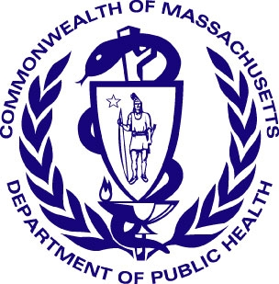
Health Care Workforce Center
Massachusetts department of public Health

Project Summary April 2011

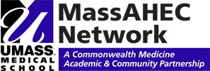
Results from a Survey of Past Massachusetts
J-1 Visa Waiver Program Participants

Importance
The survey evaluates the effectiveness of the J-1 Visa Waiver Program in increasing the number of physicians in Massachusetts’ underserved areas while also assessing retention. A secondary purpose was to evaluate programmatic functions and identify areas for improvement.
Methodology

The survey was developed from a review of relevant literature and a review of other workforce surveys such as the Primary Care Office Massachusetts State Loan Repayment Program Past Participant Survey.

Contact information was obtained for 151 visa waiver past participants using MDPH Primary Care Office databases and the Massachusetts Board of Registration in Medicine online physician profile search engine. Fifty-one physicians returned completed surveys; six surveys were returned as undeliverable for a response rate of 35%.

Findings

After finishing the J-1 Visa waiver requirement, 86.3% of survey respondents continued to work with underserved populations. 66% remained at their visa waiver practice site, with 40% remaining between one to five years, and 4% remaining between five to ten years.

89% of survey respondents had previous experiences working with underserved populations thus demonstrating a personal commitment to practicing in these areas. Additionally, 91% respondents noted that a chance to provide health care in an underserved area was ‘very important’, ‘somewhat important’, or ‘important’ in deciding to apply to the J-1 Visa Waiver Program.

Respondents choosing to leave their service obligation site cited professional opportunities as a main reason (46%). Salary and benefits were important factors (32%) while proximity to family and the location/community of the service obligation site was also indicated by 23% of respondents.

For the following aspects of the J-1 Visa Waiver application process, over two thirds of respondents rated the following aspects of the program as ‘good’ or ‘excellent’: understanding of application instructions (76%), staff responsiveness and support (69%), notification and selection (68%) and level of application requirements (66%).

98% of respondents would recommend the J-1 Visa Waiver Program to other eligible applicants.

Recommendations

- Increase program advertisement to residency programs; 65% of respondents learned of the program by word of mouth, suggesting that many potential applicants are not effectively reached through other marketing means such as the Primary Care Office website and medical school residency programs.

- Establish a system to track participants over time to periodically assess retention in medically underserved areas.

- Decrease time between application submission and notification of support for the visa waiver request.

send comments to:

Joan bohlke, MPP
MassAHEC Health workforce Manager
Primary Care Office/ MDPH
250 Washington Street
Boston, MA 02118
email: joan.bohlke@state.ma.us

MDPH Primary Care Office Contact:

Julia Dyck, MPA/H
Director
Primary Care Office
Massachusetts Department of Public Health
250 Washington Street
Boston, MA 02118
Email: julia.dyck@state.ma.us

Strengthening the Primary Care Workforce in Massachusetts Underserved Areas: an Evaluation of the Massachusetts State Loan Repayment Program, August 2010.

