 | Massachusetts Department of Environmental Protection  Environmental Results Program  Return to Compliance Plan |  |  | Facility Name  Facility ID#  Town
Important: When filling out forms on the computer, use only the tab key to move your cursor - do not use the return key.  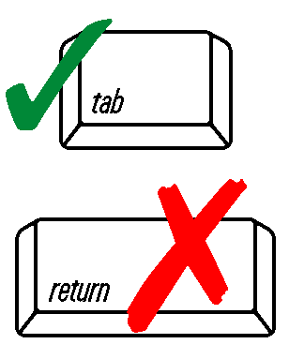  DEP USE ONLY  Date Received | Instructions
Complete a separate Return to Compliance Plan for each compliance question answer that requires one.

Only submit a Return to Compliance Plan for violations that you were unable to correct before certifying.

Completing this form does not relieve the facility of its affirmative responsibility to operate in compliance with applicable regulations. Failure to operate in full compliance with the applicable regulations may result in enforcement actions that may include fines or penalties.
 | Return to Compliance Plan
 | 1. What is the Compliance Question number for which you are reporting noncompliance?
 | Question number
 | 2. What is the specific violation? Reference the requirement number or workbook section number (which describes the requirements) from the ERP Workbook.
 | Requirement number
 | Provide a brief description of the requirement:
 | Brief Description
 | 3. What corrective action will you take to return to compliance?
 | Describe Corrective Action
 | 4. Return to compliance date - date you will be back in compliance after completing your corrective action:
 | MM/DD/YYYY
 | Signature

