 | Massachusetts Department of Environmental Protection  Environmental Results Program  Return to Compliance Plan  New Emergency Engines & Emergency Turbines | Facility Name  MassDEP Facility ID# (if known)
- Complete a separate Return to Compliance (RTC) Plan for each compliance question answer that requires one.
- Submit a RTC Plan only for violations you were unable to correct before certifying.
- Completing this form does not relieve the facility of its affirmative responsibility to operate in compliance with applicable regulations. Failure to operate in full compliance with the applicable regulations may result in enforcement actions that may include fines or penalties.
Important: When filling out forms on the computer, use only the tab key to move your cursor - do not use the return key.  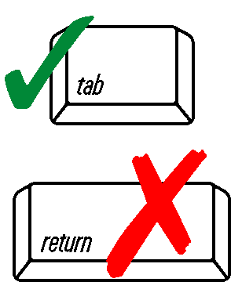 | 1. For which Compliance Question are you reporting noncompliance? |  | Question Number
 | 2. What is the specific violation?  Please reference the requirement number and description from the workbook. |  | Requirement Number
 | Brief description of requirement:
 | 3. What corrective action will you take to return to compliance?
 | 4. Return to Compliance Date  Date the facility will be back in compliance after completing correction action(s). |  | Date: MM/DD/YYYY
- You must send MassDEP a written notification, signed by a Responsible Official, that you have returned to compliance with all requirements identified in your Return to Compliance Plan no later than 30 days after the date provided in 4. above to:

MassDEP ERP – Emergency E&T
P.O. Box 120 - 165
Boston, MA 02112 - 0165

