 | Massachusetts Department of Environmental Protection  Environmental Results Program  Return to Compliance Plan for  Outdoor Hydronic Heaters |  | Name of Manufacturer  City/Town & State of Manufacturer  Name/Model Number of OHH
Important: When filling out forms on the computer, use only the tab key to move your cursor - do not use the return key.  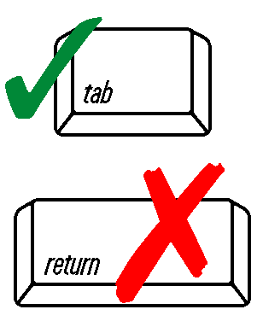  DEP USE ONLY  Date Received  ____________ | Instructions
Complete a separate Return to Compliance Plan for each compliance question answer that requires one.

Submit a Return to Compliance Plan only for violations that you were unable to correct before certifying.

Completing this form does not relieve you of your affirmative responsibility to operate in compliance with applicable regulations. Failure to operate in full compliance with the applicable regulations may result in enforcement actions that may include fines or penalties.
 | Return to Compliance Information
 | 1. What is the Compliance Question Number for which you are reporting noncompliance?
 | Question number
 | 2. What is the specific violation?
 | Regulatory Requirement Cited in Question
 | Briefly describe the violation:
 | Description
 | 3. What corrective action will you take to return to compliance?
 | Description
 | 4. Return to Compliance Date: When will you be back in compliance after completing corrective action?
 | MM/DD/YYYY | Signature

