

Review of Environmental Concerns and Evaluation of Prevalence Data for Birth Defects Associated with Chromosome 18 Abnormalities in Holliston, MA and Four Surrounding Communities

March 2013

Bureau of
Environmental Health,
Community Assessment Program

Massachusetts
Department Of
Public Health
TABLE OF CONTENTS

I. Introduction 1
II. Background 1
III. Methods for Analyzing Birth Defect Data 3
A. Case Identification / Definition 3
B. Calculation and Interpretation of Prevalence Data 4
C. Evaluation of Risk Factor Information 5
D. Determination of Geographic Distribution of Birth Defects 6
IV. Results 6
A. Prevalence 6
B. Review of Risk Factor Information 7
C. Geographic Distribution 7
V. Environmental Concerns 8
A. Municipal Drinking Water 8
B. Kidde-Fenwal Combustion Research Center 10
VI. Discussion 13
VII. Limitations 15
VIII. Conclusions 16
IX. Recommendations 17

LIST OF FIGURES

Figure 1: Location of Communities of Concern: Ashland, Holliston, Hopkinton, Millis and Sherborn

Figure 2: Location of Municipal Groundwater Wells, Holliston, MA

Figure 3: Site Location of the Kidde-Fenwal Combustion Research Center

LIST OF TABLES

Table 1: Prevalence Rates of Birth Defects Associated with Chromosome 18 Abnormalities among Live Births and Stillbirths

APPENDICES

Appendix A: MDPH Sodium Fact Sheet

I. Introduction
In response to concerns raised by residents of Holliston about a particular birth defect called trisomy 18 and the possible association of environmental factors, an evaluation of the prevalence of birth defects specifically associated with chromosome 18 abnormalities was conducted. This evaluation focused on Holliston as well as the four surrounding communities of Ashland, Hopkinton, Millis and Sherborn (Figure 1). Staff in the Community Assessment Program (CAP) of the Massachusetts Department of Public Health (MDPH), Bureau of Environmental Health (BEH) reviewed and analyzed data from the MDPH’s Bureau of Family Health and Nutrition, Center for Birth Defects Research and Prevention (MCBDRP). CAP also reviewed available environmental data obtained from the Holliston Water Department and the Massachusetts Department of Environmental Protection (MassDEP) to address concerns expressed about possible environmental exposures from contaminants in municipal drinking water and activities at the nearby Kidde-Fenwal Combustion Research Center.

II. Background
Birth Defects Associated with Chromosomal Abnormalities
Chromosomes are thread-like structures in the cells of the body that contain genes. Each chromosome is made up of DNA that is tightly coiled around proteins that support its structure. It is estimated that each person has about 20,000 - 25,000 genes that not only determine traits like eye and hair color but also direct the growth and development of every part of the body.
Birth defects associated with chromosomal abnormalities are caused by a variety of factors. Some are due to errors in the number of chromosomes. For example, a trisomy is an abnormality in which an individual has three copies of a particular chromosome, instead of two. Individuals with Down syndrome typically have three copies of chromosome 21. Individuals with trisomy 18, also known as Edwards syndrome, have an extra copy of chromosome 18. In most cases, an embryo with the wrong number of chromosomes does not survive and the pregnant woman has a miscarriage. This often happens very early in pregnancy, before a woman may even realize she is pregnant.
Other birth defects associated with chromosomal abnormalities are due to errors in the structure of one or more chromosomes. Individuals may have the correct number of chromosomes but have small pieces of a chromosome (or chromosomes) that have been deleted, duplicated, inverted, misplaced or exchanged with part of another chromosome. These structural rearrangements may have no effect if all of the chromosomes are present, but just rearranged. In other cases, the rearrangements may result in pregnancy loss or birth defects.
Some birth defects associated with chromosomal abnormalities are due to errors that may occur during cell division. These types of errors can result in mosaicism, a condition in which an individual has cells with different genetic make-ups. For example, individuals may be missing a chromosome in some, but not all, of their cells. Some individuals with chromosomal mosaicism may be mildly affected, but the severity of the condition depends largely on the percentage of abnormal cells (USNLM 2011; March of Dimes 2009a).
In this report, unless otherwise specified, the term chromosomal abnormality associated birth defect refers to a birth defect associated with any of the types of errors described above. It is important to note that it is not known why these errors occur.
Environmental Concerns
In general, five conditions must be present for exposure to occur. First, there must be a source of the chemical or contaminant. Second, an environmental medium must be contaminated by either the source or by chemicals transported away from the source. Third, there must be a location where a person can potentially contact the contaminated medium. Fourth, there must be a means by which the contaminated medium could enter a person’s body, such as ingestion, inhalation, or dermal absorption. Finally, a population of individuals that could potentially be exposed must be present (ATSDR 2005). A completed exposure pathway exists when all five elements are present and indicates that exposure to humans occurred in the past, is occurring in the present, or will occur in the future. A potential exposure pathway exists when one or more of the five elements is uncertain and indicates that exposure to a contaminant could have occurred in the past, could be occurring in the present, or could occur in the future. An exposure pathway can be eliminated if at least one of the five elements is missing and will not likely be present in the future.
In order to evaluate the potential for health concerns related to exposures to contaminants in municipal drinking water in Holliston, the CAP reviewed Consumer Confidence Reports (CCR) for the years 2000 through 2010. These reports were prepared by the Holliston Water Department and they describe municipal water quality for each year. The CCR is required by the U.S. Environmental Protection Agency (EPA) to be provided annually to residents to inform them about the quality of their municipal drinking water.
In order to evaluate concerns about possible exposures associated with releases or activities at the Kidde-Fenwal Combustion Research Center located in Holliston, the CAP also reviewed available environmental data obtained from the MassDEP. In 2005, this facility had a release of oil or other hazardous material that was reported to the MassDEP under the statewide hazardous waste site cleanup program. This program, referred to as the Massachusetts Contingency Plan (MCP), was established in 1983 under Chapter 21E of Massachusetts General Laws (M.G.L. c21E, 310 CRM 40.0000) and authorizes the MassDEP to enforce regulations governing the investigation and cleanup of oil and hazardous material release sites, known as “21E sites.” The CAP considered possible exposure scenarios in which people could come into contact with contaminants in soil, sediment, groundwater and air emissions associated with this site and reviewed the available environmental data to determine whether there may be potential health impacts to nearby residents.

III. Methods for Analyzing Birth Defect Data

A. Case Identification / Definition
The Massachusetts Birth Defects Monitoring Program (MBDMP) established statewide data collection in 1999 with a primary focus on the identification of major structural birth defects, with or without a chromosomal abnormality, and non-chromosomal malformation syndromes. Data collection during the period of evaluation for this report was based on mandated reporting from Massachusetts birthing hospitals with follow-up by MBDMP medical abstractors who review each diagnosis. National guidelines for birth defects were introduced in 2004 and are adhered to by the MBDMP. All surveillance data are entered and maintained in a confidential electronic database. Birth defects can be evaluated by city or town, based on the mother’s residence at the time of birth.
The MBDMP collects birth defect data when all of the following criteria are met: the infant was live born or the fetus was stillborn with a gestational age greater than or equal to 20 weeks or with a weight of at least 350 grams; the infant or fetus had a birth defect that met diagnostic criteria; the diagnosis was made before the infant reached one year of age; and the infant’s mother had a permanent address in Massachusetts at the time of delivery. A birth defect may occur as a single event or in combination with other defects. It should be noted that during the time period evaluated in this report, birth defects were not reported for pregnancy losses based on a prenatal diagnosis.
For this evaluation, the birth defects surveillance data were queried for all live birth and stillbirth cases with any birth defect associated with chromosome 18 identified by the MBDMP born to Massachusetts residents between 2000 and 2008. This 9-year time period constitutes the period for which the most recent and complete data were available at the initiation of this analysis.

B. Calculation and Interpretation of Prevalence Data
Prevalence rates were calculated using data from the MBDMP for the years 2000 through 2008 to assess the occurrence of birth defects associated with abnormalities specific to chromosome 18 in the five communities of Ashland, Holliston, Hopkinton, Millis and Sherborn as a whole. Statewide prevalence was also calculated for comparison purposes.
Prevalence was calculated as the number of children diagnosed with a birth defect associated with a chromosome 18 abnormality who were born during a period of time per 10,000 live births born during the same time period. The total number of live births was acquired from the MDPH Bureau of Health Information, Statistics, Research and Evaluation, Registry of Vital Records and Statistics. Prevalence rates were adjusted for maternal age by using the age distribution of all births in Massachusetts as a coefficient. For those birth defects that are impacted by the age of the birth mother, a simple age-adjustment can give a more accurate depiction of the prevalence relative to the overall statewide rate.
Confidence intervals (CIs) are used to assess the magnitude and stability of the prevalence estimate. Specifically, a 95% CI is the range of estimated prevalence values that have a 95% probability of including the true prevalence for the population. If the confidence interval for a community does not overlap with that of the state, then the rates are considered to be statistically significantly different from one another. If the confidence intervals around the two prevalence rates that are being compared do overlap, it is likely that the difference in the two rates may be solely due to chance or natural random variation. Furthermore, wide confidence intervals reflect large variation due to small numbers and less certainty. To protect the privacy of those diagnosed with chromosomal abnormality associated birth defects and their parents and families, counts are suppressed and prevalence rates are not calculated when fewer than five birth defect diagnoses were observed in a community or geographic area.
Prevalence rates and 95% confidence intervals were calculated using SAS version 9.2. Due to low birth defect counts, a Poisson distribution was utilized for rate and confidence limit calculations. Also, as mentioned previously, because birth defects associated with chromosomal abnormalities often result in early pregnancy losses, the counts and prevalence rates quoted in this report may be an underestimate of the “true” prevalence.

C. Evaluation of Risk Factor Information
As previously mentioned, it is not known why chromosomal abnormality associated birth defects occur. However, it is well established that a woman’s risk of having a baby with certain birth defects associated with chromosomal abnormalities (mainly those due to an abnormal number of chromosomes) increases with age. Maternal age was drawn from birth certificates and as such, is limited to live births. Maternal age for diagnoses of birth defects associated with chromosome 18 abnormalities was reviewed for mothers in the five communities of Ashland, Hopkinton, Holliston, Millis and Sherborn during 2000 to 2008. To protect the privacy of those diagnosed with chromosome 18 abnormality associated birth defects and their parents and families, the information in this report is presented as a summary without any specific identifying details.

D. Determination of Geographic Distribution of Birth Defects
Birth defects associated with chromosome 18 abnormalities in the five communities of concern during 2000-2008 were evaluated with respect to geographic distribution of the mother’s residence, as reported at the time of the birth. The addresses associated with each chromosome 18 birth defect diagnosis that occurred during this time period were geocoded and mapped using a computerized geographic information system (GIS) (ESRI 2009). The spatial distribution of birth defects was reviewed to assess if there were any atypical groupings or concentrations of birth defects associated with chromosome 18 abnormalities within any geographic areas in the communities.
The MDPH is bound by state and federal patient privacy and research laws not to make public the names or any other information (e.g., place of residence) that could personally identify individuals whose child was diagnosed with a birth defect that was reported to the MBDMP. Therefore, for confidentiality reasons, it is not possible to release maps showing the locations of the mother’s residence as reported at the time of the child’s birth in public reports. However, a summary of the evaluation of the spatial distribution with any notable findings is provided.

IV. Results
During the 9-year time period of 2000-2008, there were a total of 6,743 births recorded in the five communities of Ashland, Holliston, Hopkinton, Millis and Sherborn, representing 0.9% of the total births in Massachusetts (n = 711,209).

A. Prevalence
Table 1 provides the number of birth defects specific to chromosome 18 abnormalities that were reported to the MBDMP during 2000-2008 for the five-town grouping (Ashland, Holliston, Hopkinton, Millis and Sherborn) as compared to that of the state of Massachusetts. It should be noted that these birth defects are associated with chromosome 18 abnormalities but are not limited to trisomy 18. There were a total of five diagnoses of birth defects associated with chromosome 18 abnormalities in the five communities during this time period, representing 4% (n = 123) of those ascertained by the MBDMP statewide for the same period. Although the age-adjusted prevalence rates for chromosome 18 abnormality associated birth defects for the five-town grouping (approximately 6 per 10,000 live births) was greater than that for the state (approximately 2 per 10,000 live births), the difference was not statistically significant indicating that it may be due to random chance or natural variation.
The prevalence of chromosome 18 abnormality associated birth defects and the prevalence of trisomy 18 in each of the five communities during 2000-2008 cannot be directly reported due to small numbers and confidentiality concerns. As discussed earlier, to protect the privacy of those diagnosed with a birth defect and their families, counts and prevalence estimates are not provided when fewer than five diagnoses were reported in a community. A geneticist within the MBDMP was consulted who reported diversity in the types of abnormalities related to chromosome 18 in the five communities.

B. Review of Risk Factor Information
Maternal age is an important risk factor for certain birth defects associated with chromosomal abnormalities (mainly those due to an abnormal number of chromosomes), and more specifically, trisomy 18, as the prevalence of these defects has been shown to increase with advancing maternal age (Irving et al. 2011; Savva et al. 2010; Naguib et al. 1999).
Among women in the five communities of concern who had a child with a birth defect associated with a chromosome 18 abnormality during 2000-2008, the maternal age at birth ranged from 33 to 40 with an average of 37 years. This is in comparison to the age of all mothers in the five communities who had a live birth during 2000-2008, which ranged from 15 to 47 with an average of 33 years (n = 6,743).

C. Geographic Distribution
The spatial distribution of birth defects associated with chromosome 18 abnormalities in Ashland, Holliston, Hopkinton, Millis and Sherborn during 2000-2008 was reviewed to assess if there were any atypical concentrations within any particular areas in the communities. Overall, there were no unusual patterns. Although the residences for two children were within relatively close proximity to one another, they were located in an area of greater population density. The residences of the other children were more distant (that is, at least one mile apart). In addition, these diagnoses occurred over the course of seven years, indicating no clustering in terms of time.

V. Environmental Concerns

A. Municipal Drinking Water
Nearly all residents of Holliston obtain their drinking water from the municipal water supply, which is supplied by five groundwater wells (Wells #1, 2, 4, 5 and 6) located throughout the community (Figure 2). The municipal water supplied to residents does not come from one specific well but rather, combinations of wells are used at different times (Town of Holliston 2011). The system also includes five water storage tanks. Approximately three percent of town residents obtain their drinking water from private wells (A. McCobb, Holliston Health Department, personal communication, 2012).
CAP reviewed the 2000 through 2010 Holliston Consumer Confidence Reports, which are required by the EPA to inform residents about the quality of their municipal drinking water. Source water pumped from Well #4 (Washington Street) is consistently high in iron and manganese. Well #6 (Brook Street) has also consistently had water high in manganese. These minerals are naturally occurring in the environment but can make water a rusty or yellow color. The water from each of these wells undergoes a two-step process of oxidation and filtration at the treatment plants to reduce the levels of iron and manganese. The USEPA established a health guideline of 0.3 mg/l for manganese, which is considered to be a protective limit for adults from potential neurologic effects over a lifetime of exposure. A level of ≤0.3 mg/l is also recommended for infants and children less than 3 years of age based on the fact that formula-fed infants and children already receive adequate manganese in their formula but may receive additional manganese if the fortified formula is prepared with water that also contains manganese (USEPA 2004). Levels of manganese were not reported in the Consumer Confidence Reports from 2000 to 2005. Although the maximum concentration of manganese detected in the distribution system after treatment (0.65 mg/l detected once in 2009) was above 0.3 mg/l, the average detected concentrations from 2006 through 2010 ranged from 0.01 to 0.03 mg/l (Town of Holliston 2001-2011). For that reason, health effects would not be expected. It is also important to note that manganese exposure has not been associated with birth defects (ATSDR 2008).
The maximum concentration of sodium detected in the distribution system in Holliston during 2000-2010 consistently exceeded the Massachusetts guideline for sodium in drinking water of 20 mg/l; however, for the most part, the average concentration was below the state guideline. Sodium is a naturally occurring element found in water and soil. It is an essential nutrient, necessary for the normal functioning of the body and maintenance of body fluids. The Massachusetts guideline of 20 mg/l in drinking water represents a level of sodium in water that physicians and sodium-sensitive individuals should be aware of in cases where sodium exposures are carefully controlled. People who have difficulty regulating fluid volume as a result of several diseases such as hypertension and kidney failure are particularly affected by elevated levels of sodium (MDPH 2007). MDPH’s fact sheet on sodium in drinking water is included as Attachment B.
In 2004, the presence of total coliform bacteria was detected in municipal drinking water samples, however coliform bacteria was not confirmed in repeat samples. In 2005, municipal water samples tested positive for both total coliform bacteria and E. coli bacteria resulting in the issuance of a “boil water order” by the MassDEP. The boil water order issued by MassDEP was lifted after one week but the town continued to maintain a chlorine residual for the remainder of the year. The cause of the contamination was believed to be flooding due to an extreme rainfall event which inundated several septic systems (Town of Holliston 2005, 2006). Exposure to such bacterial contamination can result in diarrheal illness but no long term health effects have been associated with such exposure, including birth defects.
Finally, in September 2011, a municipal drinking water sample showed the presence of E. coli bacteria. A follow-up sample revealed elevated levels of total coliform bacteria from the Jennings Road Tank, violating drinking water standards. Reportedly, the tank was immediately taken out of service and disinfected with chlorine. Additional testing was conducted and the tank was put back into service after approval from the MassDEP (Regan 2011; R. Sharpin, Holliston Water Department, personal communication, 2011). Although corrective actions such as boiling water prior to consumption were not suggested, it is possible that people could have experienced diarrheal illness.

B. Kidde-Fenwal Combustion Research Center
The Kidde-Fenwal Combustion Research Center at 90 Brook Street in Holliston is located off Mayflower Landing near the town border with Sherborn (Figure 3). The facility began operations in 1961 and provides flammability and combustibility (explosivity) testing for fire suppression systems. The 1.8 acre parcel is located at the end of a dead-end road within a 23.7 acre parcel that was used as a gravel pit from 1938 to 1961. The facility consists of three buildings as well as several ancillary structures, totaling approximately 5,300 square feet. The site is located in a rural section of Holliston and is surrounded by wetlands and wooded land. The facility is completely enclosed by a 7-foot high chain link fence. The nearest residence is approximately 0.25 miles away (MACTEC 2006, 2007; MassGIS 2008). The discussion below includes information related to reportable releases under the MCP and air emissions.
Reportable Releases
As part of a Phase I Environmental Site Assessment, the MassDEP was notified of beryllium detected in soil at the facility at concentrations reportable under the MCP in December 2005. The facility was assigned an MCP Release Tracking Number (RTN) 2-16027 by the MassDEP. Subsequent assessment activities at the site included the collection of soil, sediment and groundwater samples. Results of these samples revealed mercury in sediment located in the wetland adjacent to the southern portion of the facility. The source of the mercury was unknown but likely originated from testing materials used historically at the facility and transported to the wetland via a storm water outfall pipe. Remediation activities included the removal of approximately 44 tons of sediment from an area encompassing about 950 square feet. In 2007, a Class A-2 RAO was issued for this release, indicating that remedial work was completed, a permanent solution was achieved and, although contamination has not been reduced to background concentrations, a level of “no significant risk” of harm to health, safety, public welfare, and the environment exists currently and in the foreseeable future. In addition, no “activity and use limitations” on the property were required by MassDEP based upon current and foreseeable future conditions (MACTEC 2007).
In order to address community concerns about possible exposures of nearby residents to environmental contaminants at the Kidde-Fenwal site, the CAP reviewed available environmental data and considered potential ways that people may come into contact with contaminants associated with this site. A screening evaluation was conducted to identify the maximum contaminant concentration detected in environmental media (e.g., soil, sediment, groundwater) at the Kidde-Fenwal site and compare it to health-based comparison values. These comparison values are set well below levels that are known or anticipated to result in adverse health effects. It is important to note that contaminant concentrations that exceed comparison values will not necessarily affect one’s health. In order for a contaminant to impact one’s health, it must not only be present in the environmental media, but an individual must also come into contact with it. Therefore, if a concentration of a contaminant is greater than the appropriate comparison value, the potential for exposure to the contaminant should be further evaluated to determine whether exposure is occurring and whether health effects might be possible as a result of that exposure (ATSDR 2005). Concentration levels that are considered typical or “background” were also used to analyze the environmental data from the Kidde-Fenwal site (MassDEP 2002; USGS 1984).
Due to the location of the site and its complete enclosure by a chain link fence, any potential exposures to contaminants in soil or sediment are limited to employees at the facility, visitors to the site, and utility, landscape, and other such workers. Nearby residents are unlikely to access the site under existing conditions and trespassing would be expected to be limited, if at all. A review of available environmental data demonstrated that contaminants were not detected in soil or sediment at concentrations that exceeded both comparison values and typical background levels (MACTEC 2007; ATSDR 2005, 2008, 2011; MassDEP 2002; USEPA 1989, 2010; USGS 1984). For that reason, adverse health effects would not be expected if exposure to contaminants in soil or sediment at the site occurred in the past or were to occur in the future.
The site is located approximately 1,000 feet from a public water supply (Well #6) and is within an Approved Zone II area. A Zone II area is defined as the area of an aquifer that contributes water to a well under the most severe pumping and recharge conditions that can be realistically anticipated (MACTEC 2007; MassDEP 2011a). Because the Town of Holliston provides municipal drinking water to the Kidde-Fenwal facility itself as well as to the surrounding area and no known private drinking water wells are located within 500 feet of the site, this exposure pathway was eliminated in the past, present and future for nearby residents. Results of municipal drinking water testing were discussed earlier in this report (see Section V, part A.).
Air Emissions
The MassDEP issued a Plan Approval (Application #C-P-92-007) in 1992 for the construction of a concrete building to be used for controlled fire tests at the Kidde-Fenwal facility. This approval allowed for fire tests of wood products, heptane pan fires and restaurant grease fires. The approval stipulated that the smoke and fumes be exhausted outside through a particulate control system, which was designed to meet state requirements for opacity specified in 310 CMR 7.06 (MassDEP 1992; Fenwal Safety Systems 1995). The system consists of fabric filters in series with an estimated control efficiency of 95% for particulate emissions (MassDEP 1992).
Fenwal Safety Systems informed MassDEP in 1993 (according to its letter of March 28, 1995 to MassDEP) that the particulate removal system was not capable of performing as required by the Permit Approval. A Notice of Noncompliance (CE-NON-93-7008) was issued by the MassDEP on July 1, 1993. Subsequently, the facility discontinued any further test burns. The letter also indicated that the company hired a consultant to obtain recommendations of systems that would meet the requirements of the Plan Approval. However, implementing such a system was found to be cost-prohibitive. As a result, Fenwal Safety Systems requested that an exemption to the opacity requirements of 310 CMR 7.06 be granted to the facility. Under the maximum test program proposed, the total quantity of “smoke particulate” that would be produced is 129 pounds per year (Fenwal Safety Systems 1995). In general, emissions of less than one ton (2,000 pounds) per year are considered by the MassDEP to be “insignificant activities,” which do not require a Plan Approval (R. Stanley, MassDEP Central Regional Office, Bureau of Waste Prevention, personal communication, 2012).
Based on the emissions data and the infrequency of occurrence, the MassDEP issued an applicability determination on June 8, 1995 for test burns at the Kidde-Fenwal facility. The following five conditions were specified in the approval: (1) all test burns must be divided into Class A materials (solid combustibles such as wood) and Class B materials (flammable liquids such as toluene or acetone); (2) no more than 5 burns of Class A materials or 4 burns of Class B materials may occur daily for a maximum duration of 10 minutes; (3) the total number of test burns may not exceed 99 per year; (4) care must be taken to prevent a condition of air pollution; and (5) burns should be conducted between the hours of 10am and 4pm, when possible (MassDEP 1995). It should be noted that the Holliston Board of Health has no records of any complaints from residents regarding this facility (A. McCobb, Holliston Board of Health, personal communication, 2012).
Exposure to contaminants in smoke from the burns in the past, present and future for nearby residents was/is possible. Visual observations by MDPH staff from the road and the perimeter of the property indicate that no open burning occurs on-site and the stacks on the buildings are not significantly taller than the rooflines. Such low stacks are not likely to disperse emissions as far as higher stacks. The facility appears to be a fairly small operation (e.g., parking is available for less than 10 vehicles) and the property is nearly completely surrounded by trees and forested areas. Given the restrictions on the amount, duration and frequency of the test burns coupled with the low stack heights and the forested location of the facility, widespread off-site migration of contaminants from the burns would be unlikely. As a result, exposure would not be expected to result in adverse health effects in nearby residents, the closest of which are located approximately ¼-mile away.

VI. Discussion
Birth defects, sometimes called congenital anomalies, are abnormalities of structure, function or metabolism present before birth. Although birth defects are rare when compared to other adverse reproductive outcomes, such as low birthweight or prematurity, they are the leading cause of death in the first year of life in the United States (MCBDRP 2010). Each year, approximately 120,000 babies (1 in 33) are born with birth defects in the United States (March of Dimes 2010). More specifically, about 1 in 150 is born with a chromosomal abnormality and about 1 in 5,000 is born with trisomy 18 (March of Dimes 2009a).
The causes of birth defects are poorly understood. For 60-70% of major birth defects, no known cause has been identified. Certain genetic and environmental factors have been associated with some defects. These include: prenatal environmental factors, such as infections (e.g., rubella), exposures to medications, chemical contamination of environmental media (e.g., drinking water), drug or alcohol abuse, and nutritional deficiencies (e.g., folic acid) (MCBDRP 2010).
It is worthy to note that a woman’s risk of having a baby with certain birth defects associated with chromosomal abnormalities (mainly those due to an abnormal number of chromosomes) increases markedly with age (March of Dimes 2009b; MCBDRP 2010). Monitoring birth defects by maternal age is particularly important since the number of births to older mothers has been increasing over time in Massachusetts. The percentage of women giving birth in Massachusetts who are aged 35 or over has more than doubled (roughly 11% in 1989 to approximately 28% in 2007 (MCBDMP 2010)). In all five communities that were evaluated, the proportion of mothers who were age 30 and older for all live births during 2000-2008 was greater than that for the state as a whole. Specifically, the proportion of live births born to mothers that were age 30 or older ranged from 72 to 95% in the five communities of concern compared to 55% in the state. Of those mothers in the five communities evaluated that had a child with a birth defect associated with a chromosome 18 abnormality during 2000-2008, the average maternal age was approximately 37 years, with a range from 33 to 40.
As noted by the MBDMP geneticist who was consulted to review the diagnoses of birth defects specific to chromosome 18 abnormalities that occurred among residents of the five communities during 2000-2008, the types of abnormalities that occurred were diverse. As a result, it is not expected that they would have been caused by a single, common mechanism.
Trisomy 18
The following section on trisomy 18 is provided to address the specific concerns expressed by the residents and for informational purposes only.
Trisomy 18 is one type of chromosomal abnormality associated birth defect that is known to occur more frequently with increasing maternal age (Texas DSHS 2007; Irving et al. 2011; Naguib et al. 1999). One study based on data from the United Kingdom and Australia estimated that the prevalence of trisomy 18 is roughly constant until age 30 (about 1 to 2 per 10,000 births), and then increases exponentially before beginning to level off again at age 45 (roughly 50 per 10,000 births) (Savva et al. 2010). Although the risk of trisomy 18 has also been associated with increasing paternal age, the association disappears once maternal age is taken into consideration (Texas DSHS 2007; Naguib et al. 1999; Baty et al. 1994).
Researchers are looking at a wide variety of environmental exposures and risk factors as possible causes of birth defects. Because most of the structural development of the fetus occurs during early pregnancy, studies usually focus on the “periconceptional” period, the month before and three months after conception. For the developing pregnancy, the “environment” includes any exposure to the fetus as well as to the mother (MCBDRP 2010). Environmental exposures and risk factors that have been studied include, but are not limited to, drinking water contaminants, residence near waste disposal sites (i.e., landfills or incinerators) and contaminated land, pesticides in agricultural areas, air pollution and industrial pollution sources, food contamination, and disasters involving environmental pollution. Other studies have focused on possible associations between maternal occupational exposures and birth defects. Overall, findings have been inconsistent and no strong conclusions can be drawn about the potential of specific environmental or occupational exposures to cause congenital abnormalities (Dolk and Vrijheid 2004; Shi and Chia 2001). Likewise, no environmental factors have been definitively reported to affect the risk of trisomy 18 (Texas DSHS 2007). Periconceptional use of multivitamins has not been associated with a reduction in the risk for common autosomal trisomies, including trisomy 18 (Botto et al. 2004).

VII. Limitations
Prevalence rates for certain birth defects associated with chromosomal abnormalities, such as trisomy 18, may be lower in Massachusetts than that for the United States due to differences in criteria between surveillance systems. For example, birth defects were not reported in Massachusetts during the time period assessed when they were prenatally diagnosed and the pregnancy was electively terminated. In the case of trisomy 18, it is estimated that between 49-57% of cases may have been missed due to elective termination (MCBDRP 2010, Peller et al. 2004, Forrester et al. 1998). In addition, spontaneous abortions that are delivered prior to 20 weeks of gestation and at less than 350 grams were not included in the case definition. It is important to note, however, the use of birth defect data for Massachusetts as a whole for comparison to the five communities is reasonable and informative because elective terminations and spontaneous abortions are not included either locally or statewide. Therefore, assuming the statewide and local rates are similar, an unusual pattern at the local level would still be apparent when compared to the state.

VIII. Conclusions
Based on the MDPH’s evaluation of the available birth defect data and risk factor information related to trisomy 18 as well as environmental data and exposure pathway analysis, the MDPH concludes that:
- The age-adjusted prevalence rate of birth defects associated with chromosome 18 abnormalities in the five-town area of Ashland, Holliston, Hopkinton, Millis and Sherborn was greater than that for the state during 2000-2008 but was not statistically significantly different. Counts and prevalence rates for the individual communities were not provided because the number of diagnoses was less than five.
- The general pattern of prevalence of birth defects associated with chromosome 18 abnormalities in the five communities of Ashland, Holliston, Hopkinton, Millis and Sherborn during 2000-2008 did not appear unusual. Based on an evaluation by the Massachusetts Birth Defects Monitoring Program’s geneticist, the diversity of abnormalities specifically related to chromosome 18 that were observed implies different mechanisms, and would likely not be caused by a single mechanism. Due to small numbers and confidentiality concerns, additional specific information cannot be reported.
- Review of risk factor information suggests that maternal age may have played a role in the prevalence of birth defects associated with chromosome 18 abnormalities in the five communities of Ashland, Holliston, Hopkinton, Sherborn and Millis.
- Analysis of the geographic distribution of birth defects associated with chromosome 18 abnormalities based on the mother’s residence at the time of birth in the five communities did not reveal any atypical spatial patterns. Although the residences of two children were within relatively close proximity to one another, they were located in an area of greater population density. The residences of the other children were more distant (that is, at least one mile apart).
- A review of the quality of the municipal drinking water for the town of Holliston revealed that levels of contaminants, such as manganese, in the distribution system after treatment are not expected to pose health concerns. Individuals who are on a sodium restricted diet or who wish to monitor their sodium intake should be aware that levels in the municipal drinking water may be elevated.
- Incidentally eating or touching soil or sediment at the Kidde-Fenwal facility is not expected to result in adverse health effects for nearby residents, if exposure to contaminants occurred in the past or were to occur in the future. The reason for this is because no contaminants were detected in soil or sediment at concentrations that exceeded both comparison values and typical background levels, based on available environmental data collected at the Kidde-Fenwal site.
- Exposure to contaminants in groundwater at the Kidde-Fenwal facility was eliminated as a potential pathway in the past, present and future for nearby residents because the town of Holliston provides municipal drinking water to the facility as well as the surrounding area and no known private drinking water wells are located within 500 feet of the site.
- Exposure to contaminants in smoke from test burns conducted at the Kidde-Fenwal facility could be possible in the past, present and future for nearby residents. However, given the restrictions on the amount, duration and frequency of the burns as well as the low stack heights and the forested location of the facility, exposure would not be expected to result in adverse health effects in nearby residents, the closest of which are approximately ¼-mile away.

IX. Recommendations
In response to the findings of this evaluation, three recommendations are made:
(1) The MDPH recommends no further investigation of the prevalence of birth defects associated with chromosome 18 abnormalities in the communities of Ashland, Holliston, Hopkinton, Millis and Sherborn at this time.
(2) For routine information about recent water quality tests conducted on drinking water in the community of Holliston, contact the Holliston Water Department at 508-429-0603 or 508-429-0621.
(3) For more information regarding the air emissions at the Kidde-Fenwal Combustion Research Center, the MassDEP Central Region may be contacted at 508-792-7650.
X. References
Agency for Toxic Substance and Disease Registry (ATSDR). 2011. Soil comparison values. Atlanta: U.S. Department of Health and Human Services. Last updated September.

ATSDR. 2008. Draft Toxicological Profile for Manganese. Atlanta: U.S. Department of Health and Human Services. September.

ATSDR. 2005. Public health assessment guidance manual. Atlanta: U.S. Department of Health and Human Services.

Baty BJ, Blackburn BL and Carey JC. 1994 Natural history of trisomy 18 and trisomy 13: I. Growth, physical assessment, medical histories, survival and recurrence risk. American Journal of Medical Genetics 49: 175-188.

Botto LD, Mulinare J, Yang Q, Liu Y and Erickson JD. 2004. Autosomal trisomy and maternal use of multivitamin supplements. American Journal of Medical Genetics 125a: 113-116.

Dolk H and Vrijheid M. 2004. The impact of environmental pollution on congenital anomalies. British Medical Bulletin 68: 25-45.

Environmental Systems Research Institute (ESRI). 2009. ArcGIS, ArcView license, ver. 9.3.1, Redlands, California.

Fenwal Safety Systems. 1995. Letter to Thomas P. Cussan, MassDEP Air Quality Control Section Chief, from Joseph A. Senecal, Manager, Holliston Test Facility. Marlborough, Massachusetts. March 28.

Forrester MB, Merz RD and Yoon PW. 1998. Impact of prenatal diagnosis and elective termination on the prevalence of selected birth defects in Hawaii. American Journal of Epidemiology 148(2): 1206-1211.

Irving C, Richmond S, Wren C, Longster C and Embleton N.D. 2011. Changes in fetal prevalence and outcome for trisomies 13 and 18: a population-based study over 23 years. The Journal of Maternal-Fetal and Neonatal Medicine 24(1): 137-141.

MACTEC Engineering and Consulting, Inc. (MACTEC). 2007. Response Action Outcome Statement and Release Abatement Measure Completion Report. Release Tracking Number 2-16027. Kidde-Fenwal Research Center, Holliston, Massachusetts. December 14.

MACTEC. 2006. Phase I Initial Site Investigation Report and Tier Classification Release Tracking Number 2-16027. Kidde-Fenwal Research Center, Holliston, Massachusetts. December 6.

March of Dimes. 2010. Birth defects. Available at http://www.marchofdimes.com/baby/birthdefects_common.html. Last updated: June.

March of Dimes. 2009a. Chromosomal abnormalities. Available at http://www.marchofdimes.com/baby/birthdefects_chromosomal.html. Last updated: December.

March of Dimes. 2009b. Pregnancy after 35. Available at http://www.marchofdimes.com/pregnancy/trying_after35.html. Last updated: May.

Massachusetts Center for Birth Defects Research and Prevention (MCBDRP). 2010. Massachusetts Birth Defects 2006-2007. Massachusetts Department of Public Health, Bureau of Family Health and Nutrition. Boston: October.

Massachusetts Department of Environmental Protection (MassDEP). 2012. Code of Massachusetts Regulations Title 310 Section 7 (310 CMR 7). Available at http://www.mass.gov/dep/service/regulations/310cmr07.pdf. Accessed March 2012.

MassDEP. 2011a. Code of Massachusetts Regulations Title 310 Section 22 (310 CMR 22). Available at http://www.mass.gov/dep/service/regulations/310cmr22.pdf. Accessed September 2011.

MassDEP. 2011b. 2008 Enforcement Actions. Available at http://www.mass.gov/dep/public/press/enf08.htm. Accessed September 2011.

MassDEP. 2008. Memorandum to Lee Dillard Adams, MassDEP Deputy Regional Director, from Cecilia M. Catalan, Bureau of Waste Prevention, regarding follow-up review of Kidde-Fenwal, Inc. located at 90 Brooks Street in Holliston, MA. Worcester, Massachusetts. April 24.

MassDEP. 2007. Release Amendment Form for Release Tracking Number 2-16027. Available at: http://public.dep.state.ma.us/fileviewer/Default.aspx?formdataid=206838&documentid=0.

MassDEP. 2002. Background levels of polycyclic aromatic hydrocarbons and metals in soil. Office of Research and Standards.

MassDEP. 1995. Letter to Joseph Senecal, Fenwal Safety Systems, Inc., from Thomas P. Cussan, MassDEP Regional Permit Chief, regarding Holliston Test Burns. Worcester, Massachusetts. June 8.

MassDEP. 1992. Letter to Steve Roy, Fenwal Safety Systems, from Thomas P. Cussan, MassDEP Air Quality Control Section Chief, regarding plan approval for fire test building at Fenwal, 90 Brook St., Holliston, MA., Application #C-P-92-007, Transmittal #19792. Worcester, Massachusetts. June 16.

Massachusetts Department of Public Health (MDPH). 2007. Bureau of Environmental Health. Sodium in Drinking Water Fact Sheet. Revised May 2007.

Massachusetts Office of Geographic Information (MassGIS). 2008. USGS Color Ortho Imagery, 30 cm.

Naguib KK, Al-Awadi SA, Moussa MAA, Bastaki L, Gouda S, Redha MA, Mustafa F, Tayel SM, Abulhassan SA and Murthy DSK. 1999. Trisomy 18 in Kuwait. International Journal of Epidemiology 28: 711-716.

Peller AJ, Westgate MN and Holmes LB. 2004. Trends in congenital malformations, 1974-1999: effect of prenatal diagnosis and elective termination. American College of Obstetricians and Gynecologists 104(5): 957-964.

Regan, K. 2011. Water sample shows bacteria, Dept. says. Holliston Patch. September 11. Available at http://holliston.patch.com/articles/water-sample-shows-bacteria-dept-says.

Savva G, Walker K and Morris J.K. 2010. The maternal age-specific live birth prevalence of trisomies 13 and 18 compared to trisomy 21 (Down syndrome). Prenatal Diagnosis 30: 57-64.

Shi L and Chia SE. 2001. A review of studies on maternal occupational exposures and birth defects, and the limitations associated with these studies. Occupational Medicine 51(4): 230-244.

Texas Department of State Health Services (DSHS). 2007. Birth defects risk factor series: Trisomy 18 (Edwards syndrome). Available at: http://www.dshs.state.tx.us/birthdefects/risk/risk11-trisomy18.shtm. Revised March.

Town of Holliston. 2011. Annual Drinking Water Quality Report: 2010 Consumer Confidence Report. Available at: http://www.townofholliston.us/Water/Holliston%202010%20Annual%20Drinking%20Water%20Quality%20Report.pdf.

Town of Holliston. 2010. Annual Drinking Water Quality Report: 2009 Consumer Confidence Report.

Town of Holliston. 2009. Annual Drinking Water Quality Report: 2008 Consumer Confidence Report.

Town of Holliston. 2008. Annual Drinking Water Quality Report: 2007 Consumer Confidence Report.

Town of Holliston. 2007. Annual Drinking Water Quality Report: 2006 Consumer Confidence Report.

Town of Holliston. 2006. Annual Drinking Water Quality Report: 2005 Consumer Confidence Report.

Town of Holliston. 2005. Annual Drinking Water Quality Report: 2004 Consumer Confidence Report.

Town of Holliston. 2004. Annual Drinking Water Quality Report: 2003 Consumer Confidence Report.

Town of Holliston. 2003. Annual Drinking Water Quality Report: 2002 Consumer Confidence Report.

Town of Holliston. 2002. Annual Drinking Water Quality Report: 2001 Consumer Confidence Report.

Town of Holliston. 2001. Annual Drinking Water Quality Report: 2000 Consumer Confidence Report.

United States Environmental Protection Agency (USEPA). 2011. Envirofacts Warehouse website. Available at www.epa.gov/enviro/index.html. Accessed September 30. Results based on data last updated on September 12, 2011.

USEPA. 2010. Human health risk assessment. Available at: http://www.epa.gov/reg3hwmd/risk/human/index.htm. Last updated November.

USEPA. 2004. Drinking Water Health Advisory for Manganese. January.

USEPA. 1989. Risk Assessment Guidance for Superfund Volume I: Human Health Evaluation Manual (Part A). December.

United States Geological Survey (USGS). 1984. Shacklette HT, Boerngen JG. Element concentrations in soils and other surficial materials of the conterminous United States. U.S. Geological Survey Professional Paper 1270. Washington, D.C.: United States Government Printing Office.

United States National Library of Medicine (USNLM). 2011. Genetics home reference. Available at: http://ghr.nlm.nih.gov/handbook/basics/chromosome. Last updated November 28.

Vrijheid M, Dolk H, Abramsky SL, Alberman E and Scott JES. Socioeconomic inequalities in risk of congenital anomaly. Archives of Disease in Childhood 82: 349-352.

Yang J, Carmichael SL, Cranfield M, Song J, Shaw GM, and the National Birth Defects Prevention Study. 2008. Socioeconomic status in relation to selected birth defects in a large multicentered U.S. case-control study. American Journal of Epidemiology 167: 145-154.
Figure 1
Location of Communities of Concern:
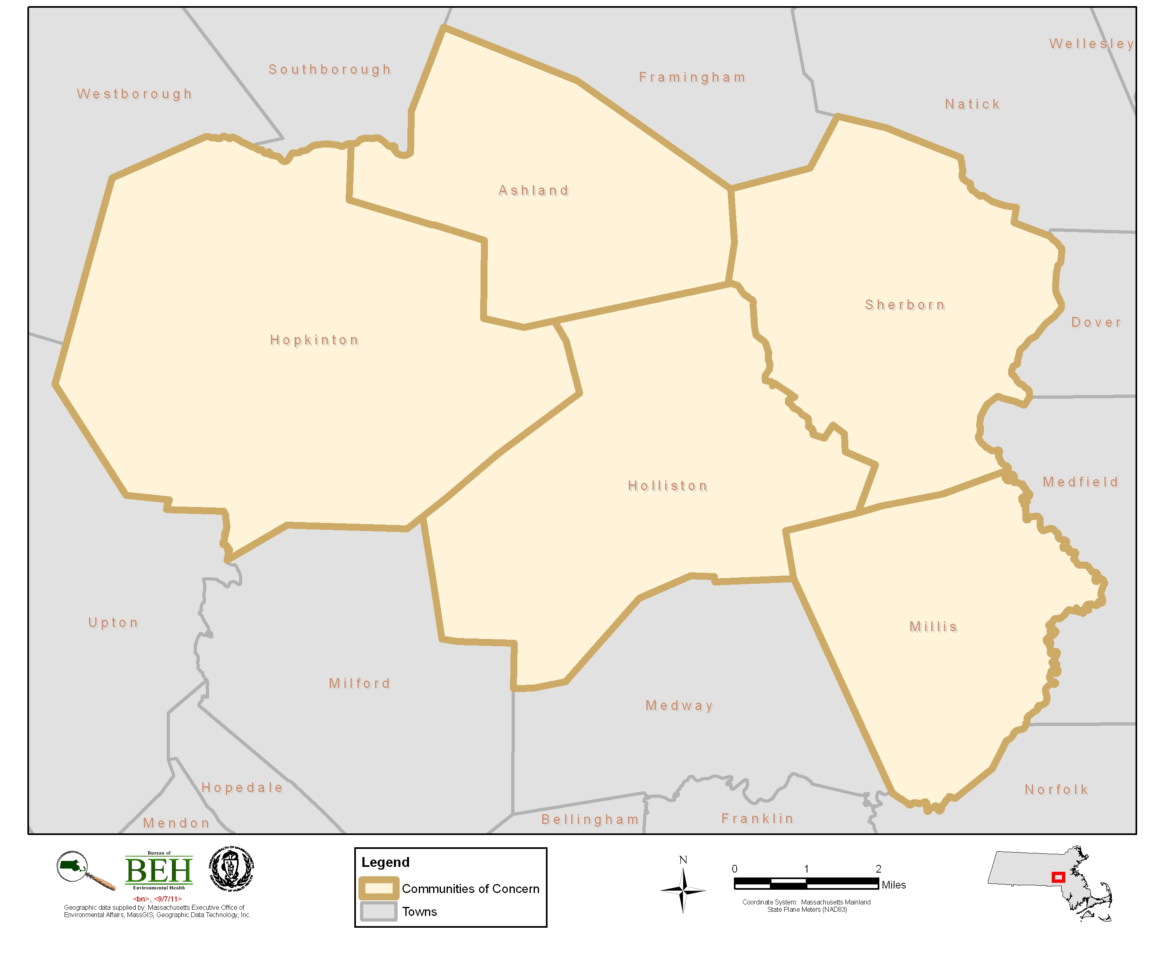
Ashland, Holliston, Hopkinton, Millis and Sherborn
Figure 2
Location of Municipal Groundwater Wells
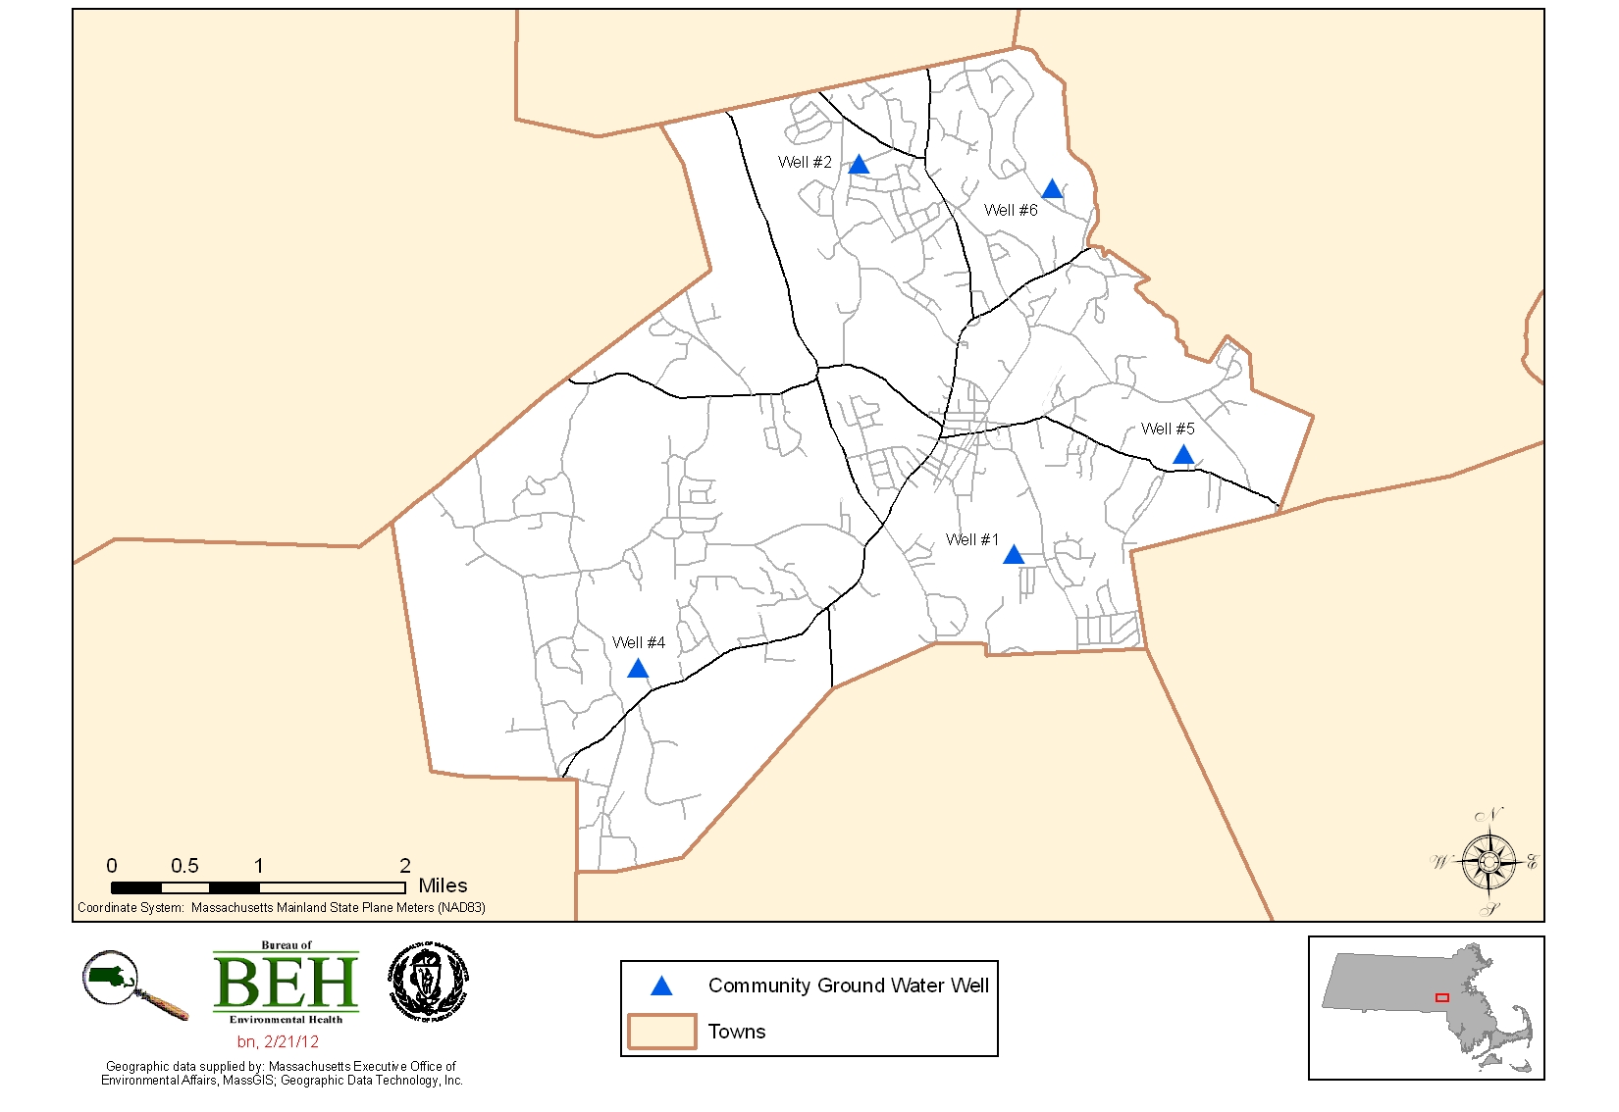
Holliston, Massachusetts
Figure 3
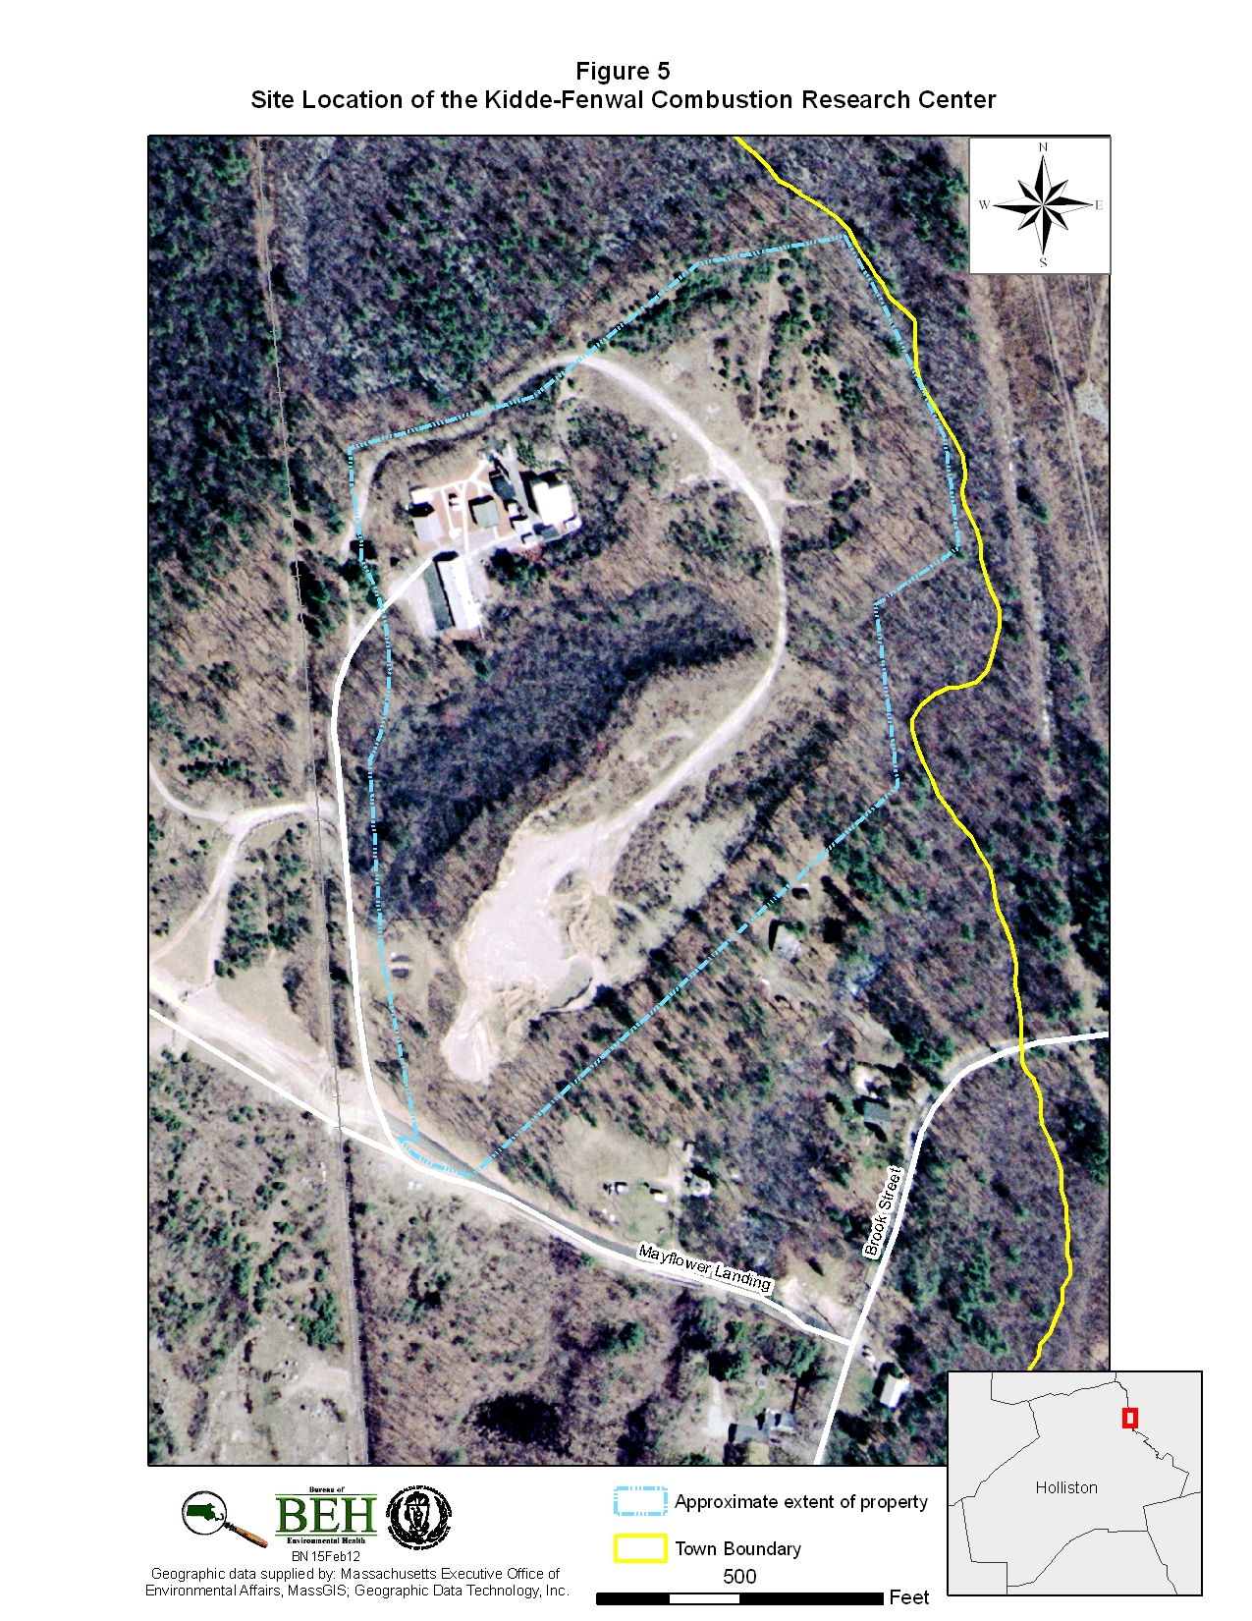
Site Location of the Kidde-Fenwal Combustion Research Center
Table 1
Prevalence Rates of Birth Defects Associated with Chromosome 18 Abnormalities among Live Births and Stillbirths
2000 - 2008

Geographic Area | Counts |  | Age-Adjusted Prevalence Rate
Geographic Area | Diagnoses | Births | Rate per 10,000 Live Births | 95% CI
5-town grouping | 5 | 6,743 | 5.7 | 1 - 11
MA | 123 | 711,209 | 1.7 | 1 - 2

Sodium in Drinking Water Fact Sheet
Is sodium found in drinking water?
Yes, sodium is a naturally occurring element found in water and soil. Drinking water contributes only a small fraction (less than 10%) to the overall daily sodium intake which ranges from 115 to 750 milligrams per day (mg/d) for infants, 325 to 2700mg/d for children and 1100 to 3300 mg/d for adults.
The Massachusetts Department of Environmental Protection (MassDEP) currently requires all water suppliers to notify the Massachusetts Department of Public Health/Bureau of Environmental Health (MDPH/BEH), MassDEP, and local Boards of Health of the detected concentrations of sodium in drinking water. Notification is required so that individuals who are on a sodium restricted diet or wish to monitor their sodium intake for other reasons will have this information.
What is sodium’s purpose?
Sodium is an essential mineral which is necessary for the normal functioning of the body and maintenance of body fluids. Nerve function and muscle contraction are also affected by sodium intake.
Where do we get sodium?
Sodium cannot be stored or manufactured in the body and must be consumed in some drinking water and in foods such as animal foods, low-fat dairy products, some canned foods, pickles, and olives.
What is the current guideline for sodium in drinking water and who should be concerned about this guideline?
The MassDEP guideline of 20 milligrams of sodium per liter of water represents a level of sodium in water that physicians and sodium-sensitive individuals should be aware of in cases where sodium exposures are carefully controlled. People who have difficulty regulating fluid volume as a result of several diseases such as hypertension and kidney failure are particularly affected by elevated levels of sodium.
Hypertension is the medical name for high blood pressure and is a common chronic medical problem in the United States. It is responsible for a major portion of cardiovascular disease and stroke deaths.
Kidney failure occurs when an excess of sodium in the body causes fluid concentrations to change and the kidney fails to remove fluid. The result is a kidney shut-down and the build-up of fluid in the body which can lead to edema and hypertension.
Edema is the collection of water in and around the body tissues. Mild cases of edema affect women prior to the start of their menstrual periods, and many pregnant women suffer with this condition.
How is sodium measured in my body?
Your doctor or health professional measures sodium by taking your blood or checking a urine sample (or both). If your sodium levels are elevated, your physician may prescribe a diet low in sodium. Reducing sodium intake not only prevents high blood pressure, but may also prevent heart disease, according to clinical trial data from the National Heart, Lung, and Blood Institute of the National Institutes of Health.
Where do I go for more information?
If you have any questions about sodium and your health, call your physician or health professional.
If you have any questions regarding sodium in drinking water, call the Massachusetts Department of Environmental Protection’s Drinking Water Program at (617) 292-5770.
References
Clayman, Charles B., Family Medical Guide. The American Medical Association. Random House. New York. 1994.
Gershoff, S. The Tufts University Guide to Total Nutrition. Harper Perennial Publishers.
Mabee, Marcia S., MPH, PhD. The CSTE Washington Report.
Massachusetts Department of Environmental Protection. Sodium (in Public Drinking Water). Division of Water Supply, Water Quality Assurance Program. 1993.
U.S. Department of Health and Human Services. The Surgeon General’s Report on Nutrition and Health. Publication No. 88-50210.
U.S. Food and Drug Administration. Focus on Food Labeling. FDA Consumer. The magazine of the U.S. Food and Drug Administration. May 1993.
This fact sheet was prepared by the Environmental Health Education and Outreach Program in the Bureau of Environmental Health, Massachusetts Department of Public Health.

This report was supported in part by funds from a cooperative agreement with the Agency for Toxic Substances and Disease Registry (ATSDR), U.S. Department of Health and Human Services. This document has not been reviewed and cleared by ATSDR.
After regulations were passed in February 2009, reporting was mandated from all providers who diagnosed a birth defect.
In 2011, the MBDMP began collecting data on birth defects identified prenatally as well as those from other pregnancy losses.
Air pollution is defined per 310 CMR 7.0 as the presence in the ambient air space of one or more air contaminants or combinations thereof in such concentrations and of such duration as to: (a) cause a nuisance; (b) be injurious, or be on the basis of current information, potentially injurious to human or animal life, to vegetation, or to property; or (c) unreasonably interfere with the comfortable enjoyment of life and property or the conduct of business (MassDEP 2012).

