Massachusetts
Department Of
Public Health


Review of the Prevalence of Type 1 Diabetes among Children and Adolescents in Weston, Wellesley and Newton

February 2012

Bureau of
Environmental Health,
Community Assessment
Program

TABLE OF CONTENTS

I. INTRODUCTION/Background 1
II. Methods for Analyzing Type 1 Diabetes Prevalence 1
A. Case Identification/Definition 3
1. Schools 4
2. Hospitals/Providers 5
B. Estimating Prevalence 6
C. Calculation of the 95% Confidence Interval 8
D. Residential History and Geographic Distribution of Cases of Type 1 Diabetes 9
E. Family History 10
III. Results 10
A. General Participant Information 11
B. Prevalence Estimate Calculations for the Three Communities 12
C. Prevalence Estimate Calculations for the Census Tracts of Concern 16
IV. Residential History 17
V. Family History 18
VI. Geographic Distribution of Residence at Diagnosis 19
VII. Discussion 20
VIII. CONCLUSIONS 25
IX. Recommendations 26
X. References 27

List of FIGURES
Figure 1: Census Tracts in Weston, Wellesley, and Newton, MA
Figure 2: Population Density Map of Weston Children/Adolescents (Ages 0-19)
Figure 3: Population Density Map of Wellesley Children/Adolescents (Ages 0-19)
Figure 4: Population Density Map of Newton Children/Adolescents (Ages 0-19)

List of TABLES
Table 1: Participant Information from Consent Forms
Table 2: Prevalence Estimates of Type 1 Diabetes in Children/Adolescents Ages 0 – 19 Years in Weston, Wellesley, and Newton as of December 31, 2009
Table 3: Prevalence Estimates of Type 1 Diabetes in Children/Adolescents Ages 5 – 14 Years in Weston, Wellesley, and Newton as of December 31, 2009
Table 4: Prevalence Estimates of Type 1 Diabetes in Children/Adolescents Ages 0 – 19 Years in Selected Census Tracts in Weston, Wellesley, and Newton as of December 31, 2009
Table 5: Residential and Family History Information from Consent Forms for 3 Communities
Table 6: Residential and Family History Information from Consent Forms for 5 Census Tracts
Table 7: Counts of Type 1 Diabetes Diagnoses in Children Ages 5 -14 Years in Weston, Wellesley, and Newton as of December 31, 2009

List of APPENDICES
Appendix A: Consent Form
Appendix B: Provider Survey Form

INTRODUCTION/Background
In February 2008, a Weston resident (Ms. Ann Marie Kreft) contacted the Massachusetts Department of Public Health (MDPH) Associate Commissioner and Director of the Bureau of Environmental Health (BEH) to report concerns regarding what she perceived to be an unusual number of children with a diagnosis of type 1 diabetes in the three communities of Weston, Wellesley and Newton. The primary concerns focused on children with type 1 diabetes that lived within a few miles of each other in an area where Weston, Wellesley and Newton are contiguous. Additional concerns focused on the possible relationship to environmental exposure opportunities in those communities. Residents expressed concern about a number of potential sources of environmental pollution in the area including the Charles River, former land use activities, and hazardous waste sites. While diabetes is not a reportable disease in Massachusetts, the MDPH/BEH has developed a surveillance system through funding from the U.S. Centers for Disease Control and Prevention’s (CDC) Environmental Public Health Tracking (EPHT) program. In 2006, MDPH was one of seven states to receive funds from the CDC to develop an environmental public health tracking system.

Methods for Analyzing Type 1 Diabetes Prevalence
To evaluate whether a cluster of type 1 diabetes might exist, it is necessary to first identify all children ages 0 through 19 from Weston, Wellesley or Newton with type 1 diabetes to determine the prevalence in the three communities. A disease cluster can be thought of as an unusual occurrence of a disease in space and time. To investigate a perceived disease cluster, the following questions are typically asked:
- Is there an excess number of individuals diagnosed with a disease versus what might be expected?
- Is the disease occurring in an unusual age group?
- Does the geographic distribution of place of residence (or, in some instances, place of employment for adults) for those diagnosed with the disease appear unusual?
- Does residential history appear to play a role in the observed prevalence of the disease?
- Is the prevalence of a known or potential risk factor for the disease (for example, family history) different in the population being studied than would be expected?
- If there appears to be an excess, are there some shared exposures?
- Is there a grouping of dates of diagnosis such that it is plausible that a common exposure might have contributed to the occurrence of the disease?
Beginning in the 2007-2008 school year, the annual collection of diabetes prevalence data for children in grades Kindergarten through 8th grade was begun by the Massachusetts EPHT program. The source of the data is school health records for all public and private schools in Massachusetts serving grades K - 8 (approximate ages 5-14). School nurses or administrative staff are requested to provide the number of children with diabetes in their school, enumerating whether a child has Type 1, Type 2, or an unknown type of diabetes. No personal identifiers such as name or street address of a child are provided to the MDPH. Data collection for year 2 (2008-2009 school year) of the diabetes surveillance was enhanced in order to be able to estimate prevalence by community of residence in addition to estimates by county locations of the schools. The school nurse/administrator reports the city/town of residence of the student to allow for estimating the prevalence of diabetes by city/town. For both the 2007-2008 and 2008-2009 school years, participation of public and private schools was excellent with more than 99% of schools reporting.
As mentioned, the Massachusetts EPHT diabetes surveillance program collects information on children in grades K – 8. For this investigation, these efforts were expanded to include children in pre-schools and high school.

A. Case Identification/Definition
In addition to using the Massachusetts EPHT diabetes surveillance data, MDPH took a two-phased approach to identify the children and adolescents living in the communities of Weston, Wellesley, and Newton with a diagnosis of type 1 diabetes. The first effort involved MDPH contacting the public school nurse leaders and private school nurses or administrators in the three communities to ask them to facilitate the mailing of a letter and consent form to the parents/guardians of children with type 1 diabetes. The consent form requested diagnosis-related information on the child/adolescent with type 1 diabetes and, importantly, specific address information. [The consent form stated that MDPH is bound by strict privacy regulations to protect the confidentiality of any personally-identifying information provided by the parent/guardian.] The second approach was to contact hospitals and endocrinologists in the area to provide MDPH with information on the number of children ages 0 through 19 who they treat from the three communities. In addition, families who heard about the investigation from the media or another source (for example, a family whose child attended a private school outside one of the three communities) also submitted consent forms and were included in the investigation if their child met the criteria for inclusion.

Schools
As mentioned, MDPH has been collecting information on the number of children in grades K-8 who have diabetes across the state with funding from the federal Centers for Disease Control and Prevention’s Environmental Public Health Tracking Program. MDPH has achieved a near 100% participation rate from school nurses and administrative staff in public and private schools across the state. However, because residents are concerned about diagnoses in children of all ages, MDPH expanded their evaluation to include children ages 0 through 19 years.
In spring 2009, MDPH worked with the Public School Nurse Leaders for each of the three communities to facilitate mailings to the parents/guardians of children in their schools with type 1 diabetes. Given the requirements imposed by the Family Educational Rights and Privacy Act (FERPA), it was necessary to ask school nurses and administrative staff to conduct the mailing; FERPA prevents public health officials from direct access to student records. In addition to working with the public schools, MDPH worked with school nurses or school administrators at the 27 private schools in the three communities to identify children with type 1 diabetes who were residents of these communities and attended private school. MDPH sent out two rounds of letters (May 2009 and February/April 2010) through the school nurses in an effort to capture all of the diagnoses. In summary, the mailings went to public and private pre-schools, elementary schools, middle schools, and high schools in these communities.
Included in the mailings were a letter to the families from the nurse leaders, a letter from MDPH, and a consent form (see Appendix A). The consent form requested limited diagnostic and residential history information from parents to assist BEH in better understanding the prevalence and geographic distribution of children with a diagnosis of type 1 diabetes in the three communities.
Based on January 2009 information from the public school nurse leaders provided during the planning phase for the mailings, MDPH estimates that approximately 67 families received letters and consent forms from public school nurses. Of the 65 consent forms received by MDPH, 59 forms reported that the child/adolescent attended a public school. For public school students, this represents an estimated response rate of approximately 88% (59 of 67). Using information from the EPHT Program, for children in grades K through 8, 42 children/adolescents from Weston, Wellesley, and Newton were reported with type 1 diabetes. MDPH received consent forms from 38 parents/guardians in these communities. This represents a response rate of approximately 90% (38 of 42). The actual response rate would not be expected to be higher and could be lower due to later diagnoses in 2009 (captured through late mailings by a nurse/administrator) and depending on the response of private school parents/guardians.

Hospitals/Providers
MDPH/BEH has worked with Dr. Lori Laffel, Chief of the Pediatric, Adolescent and Young Adult Section at the Joslin Diabetes Center since the earliest stages of this investigation. As part of MDPH’s collaboration with Dr. Laffel, a survey for health care providers was developed. The purpose was to identify all children/adolescents in the three communities with type 1 diabetes. In April 2010, MDPH asked each physician via a mailing to report a count of individuals with type 1 diabetes (ages 0 through 19) who were treated at their facility in calendar year 2009 and who were residents of one of the three communities. MDPH provided the following International Classification of Diseases (ICD-9) codes to the providers for consistency in identifying cases of type 1 diabetes (ICD-9 Codes-250.x1 and 250.x3). In all, eight treating facilities were contacted. The facilities included: Joslin Diabetes Center, Children’s Hospital, Massachusetts General Hospital, Boston Medical Center, BayState Medical Center, Tufts New England Medical Center, UMass Memorial Medical Center, and New England Diabetes and Endocrinology Center. Initial and follow-up contact resulted in responses from all eight diabetes centers.

B. Estimating Prevalence
Prevalence, for this report, is estimated based on the number of children and adolescents (ages 0-19) who had been diagnosed with type 1 diabetes by December 31, 2009 and who were residents of either Weston, Wellesley, or Newton during the 2009 calendar year. To determine whether the prevalence of type 1 diabetes in the three communities differs from what would be expected, data were tabulated to compare the community-specific prevalence estimates to statewide prevalence estimates (available through the MDPH EPHT Program) as well as national prevalence data (as reported in the SEARCH for Diabetes in Youth Study). Further, to assess the prevalence of type 1 diabetes in the area of particular concern to the residents, MDPH calculated census tract-specific prevalence estimates.
The SEARCH Study is a multicenter observational study that identifies all existing (prevalent) cases of nongestational diabetes (including type 1 and 2 diabetes), beginning in 2001 and continuing through the present. With a population of over 2 million youth under surveillance for diabetes, the SEARCH Study represents the largest standardized registry of diabetes in U.S. youth. A detailed description of the SEARCH Study has been published by the SEARCH Study Group (2004). Based on the demographics of Weston, Wellesley, and Newton, SEARCH prevalence estimates for non-Hispanic white youth with type 1 diabetes are used for comparison (Bell RA et al. 2009). Approximately 89%, 88%, and 86% of the individuals residing in Weston, Wellesley, and Newton, respectively, are non-Hispanic whites (MAPC 2008).
A CT is a geographic subdivision of a city or town designated by the United States Census Bureau. Because age group and gender-specific population information is necessary to calculate prevalence estimates, the CT is the smallest geographic area for which disease estimates can be accurately calculated. Specifically, a CT is a smaller statistical subdivision of a county as defined by the U.S. Census Bureau. CTs usually contain between 1,500 and 8,000 persons and are designed to be homogenous with respect to population characteristics (U.S. Census Bureau 2000). The town of Weston has two CTs, the town of Wellesley has six CTs, and the city of Newton has 18 CTs (see Figure 1). The three CTs that encompass the area of concern to residents include: 3672 (Weston), 4042.01 (Wellesley), and 3748 (Newton) (see Figure 1).
To calculate a prevalence estimate, it is necessary to obtain accurate population information. The population figures used to calculate community-specific prevalence estimates were provided by each community using data collected from their annual census. For calculating prevalence estimates at the census tract level, projected population data for 2010 were used which were obtained by MDPH from Geolytics (2010); census-tract level data were not available from the communities.

C. Calculation of the 95% Confidence Interval
To help assess the stability of a prevalence estimate, the statistical significance of each estimate was assessed by calculating a 95% confidence interval (95% CI) to determine if the prevalence estimate for a geographic region (i.e., community or census tract) is “significantly different” from the prevalence estimate in a comparison area (i.e., the state or the nation). Specifically, a 95% CI is the range of estimated prevalence estimates that have a 95% probability of including the true prevalence estimate for the population. If the confidence intervals of the two geographic areas do not overlap, then the prevalence estimate in the study population is considered to be statistically significantly different from the comparison or "normal" population. Using the state of Massachusetts or the United States as a comparison population provides a stable population base for the estimation of prevalence. "Statistically significantly different" means there is less than a 5% chance that the observed difference (either increase or decrease) in the estimate is due to chance (i.e., the result of random fluctuation in the number of individuals with type 1 diabetes).
For example, if the confidence interval for the prevalence of type 1 diabetes among individuals in a given community is 2.7-2.9 cases per 1,000 children and the confidence interval for the state is 2.5-2.6 cases per 1,000 children, the prevalence of type 1 diabetes in the community is considered to be statistically significantly higher than in the state as a whole. This is because the confidence intervals do not overlap. If the confidence interval is 1.8-2.0 cases per 1,000 children in a community and the confidence interval for the state is 2.5-2.6 cases per 1,000 children, the prevalence of type 1 diabetes diagnoses would be considered statistically significantly lower than expected, based on the statewide experience. It is important to note that statistical significance alone does not necessarily imply public health significance. Determination of statistical significance is just one tool used to interpret disease patterns in a community.
In addition to the range of the estimates contained in the confidence interval, the width of the confidence interval also reflects the stability of the prevalence estimate. For example, a narrow confidence interval allows a fair level of certainty that the estimated prevalence is close to the true prevalence for the population. A wide interval leaves considerable doubt about the true prevalence, which could be lower or higher than the estimated prevalence. Wide intervals indicate unstable statistics.

D. Residential History and Geographic Distribution of Cases of Type 1 Diabetes
In addition to calculating prevalence estimates, residential history information reported on the consent form for each individual diagnosed with type 1 diabetes was mapped using a computerized geographic information system (GIS) (ESRI 2009). Current address and address at diagnosis were mapped. This allowed for an evaluation of the spatial distribution of residences at a smaller geographic level within neighborhoods. The geographic pattern was assessed using a qualitative evaluation of the point pattern of diagnoses in the community. This evaluation also included consideration of the population density of individuals less than 20 years of age residing within the three communities. For confidentiality reasons, it is not possible to include maps showing the locations of residences for individuals diagnosed with type 1 diabetes in this report. [Note: MDPH is bound by state and federal patient privacy and research laws not to reveal the name or any other identifying information of an individual diagnosed with type 1 diabetes and reported to the MDPH.]
Population density at the census block level for each of the three communities was calculated using the 2010 U.S. Census population estimates for individuals aged 0 – 19 (Geolytics 2010). (Actual 2010 population counts were not available through the 2010 U.S. Census at the time of this analysis.) Population density is presented as persons per square dry mile. Breakpoints for density divisions were assigned in each community using four quartiles. Census blocks with a population of zero individuals were excluded from the data presentation. See Figures 2, 3, and 4 for maps of the population density of children and adolescents in Weston, Wellesley, and Newton.

E. Family History
The consent form asked parents/guardians if any other family members have been diagnosed with type 1 diabetes. This information allowed MDPH to compare the percentage of children and adolescents in Weston, Wellesley, and Newton who have a positive family history for type 1 diabetes with the percentage expected to have a positive family history, based on the epidemiologic literature.

Results
As of June 2011, MDPH received 65 consent forms from the parents/guardians of children living in Weston, Wellesley and Newton who had been diagnosed with type 1 diabetes and were between 0 -19 years of age prior to December 31, 2009. The results from the health care provider survey identified 104 children, ages 0-19 years, from the three communities who were treated for type 1 diabetes during 2009 at the eight facilities contacted. (Section VII includes a discussion of these data sources and how their prevalence estimates may relate to the underlying true prevalence of type 1 diabetes in these communities.)

A. General Participant Information
Summary participant information is provided in Table 1. This information was obtained from the 65 consent forms returned to MDPH. The information in Table 1 does not represent all children/adolescents with type 1 diabetes in the three communities; those children/adolescents reported solely by the hospitals/providers and those whose parents/guardians chose not to return the consent form to MDPH could not be included in the summary participant information. In these three communities, 58% of the individuals with type 1 diabetes were reported to be females and 42% males. Seventy percent of the individuals (45 of 65) aged 0-19 years with type 1 diabetes living in Weston Wellesley or Newton were less than 10 years of age at the time of their diagnosis. Twenty-eight percent (18 of 65) were diagnosed between 0 - 4 years of age, 42% (27 of 65) between 5 – 9 years of age, 29% (19 of 65) between 10 – 14 years of age, and 1% (1 of 65) between 15 – 19 years of age.
Although providers were not asked to abstract medical records to report age at diagnosis, they did provide the breakdown of their patients by sex. Of the 104 children/adolescents from Weston, Wellesley, and Newton seen by providers in 2009, 46 (44%) are male and 58 (56%) are female. The actual percentage of males versus females in this group could, however, be different because of the possibility of duplicate reports by providers.

B. Prevalence Estimate Calculations for the Three Communities
MDPH calculated prevalence estimates and 95% confidence intervals using three different data sources:
- Consent form information reported to MDPH by parents/guardians of children/adolescents diagnosed with type 1 diabetes
- Health care provider information on the number of children/adolescents who were with diagnosed with or sought care for type 1 diabetes at their facility in 2009
- Prevalence estimates from the MDPH Environmental Public Health Tracking Program
Because each of these datasets differ with respect to the age group included and/or their likelihood of over- or under-estimating the true prevalence, MDPH has used the three datasets to provide a range of prevalence estimates. MDPH included the prevalence estimates based on data provided by school nurses to the EPHT program; more than 99% of public and private schools reported their data to MDPH, hence the data quality and completeness are very high and they provide a stable statewide prevalence estimate for comparison. Through the consent form and health care provider data, MDPH was able to expand the range of ages included to very young children (ages 0 – 4) and adolescents (ages 15 – 19), to supplement the EPHT dataset representing children in grades K – 8 (approximately ages 5 – 14). (Please see the discussion section for further information about the strengths and limitations of these datasets.)
Table 2 contains prevalence estimates for individuals ages 0-19 years for each community as a whole (using data from the consent forms and the health care provider surveys). Table 3 contains prevalence estimates for individuals approximately ages 5-14 years (using data from each of the three datasets). For comparison purposes, Tables 2 and 3 also include national prevalence estimates from the SEARCH for Diabetes in Youth Study (Bell RA et al. 2009). In addition to the SEARCH data, prevalence data for the state of Massachusetts as a whole, collected by the EPHT, are used for comparison purposes for the 5 – 14 age group. These statewide EPHT data include all races and ethnicities. As stated earlier, based on the percentage of non-Hispanic whites in Weston, Wellesley, and Newton (86 – 89%), national SEARCH data used for comparison in this report are for the non-Hispanic white population. For Massachusetts as a whole, based on 2010 US Census data, white non-Hispanics comprise 76.1% of the population (US Census Bureau 2011a).
Using both data sources reported in Table 2, the consent form information and the health care provider information, a range of prevalence estimates for each community can be used for comparison to the SEARCH Study prevalence estimate for the 0 – 19 age group:
- Newton: 1.69 – 3.62 diagnoses per 1, 000 individuals (95% CI: 1.11 – 4.68)
- Wellesley: 2.98 – 3.58 diagnoses per 1, 000 individuals (95% CI: 1.93 – 5.11)
- Weston: 3.66 – 4. 50 diagnoses per 1, 000 individuals (95% CI: 1.95 – 7.31)
- SEARCH Study: 2.00 diagnoses per 1, 000 individuals (95% CI: 1.94 – 2.06)
Comparing the range of prevalence estimates to the point prevalence estimate provided by the SEARCH Study, it appears that the prevalence of type 1 diabetes in Newton approximates the prevalence nationwide; the SEARCH Study prevalence estimate of 2.00 diagnoses per 1,000 individuals is in the middle of the range of prevalence estimates for Newton of 1.69-3.62 diagnoses per 1,000 individuals. However, in Wellesley and Weston, the prevalence of type 1 diabetes appears to be higher than the nationwide prevalence. These differences are not, however, statistically significant. This is indicated by the overlapping confidence intervals of each community with the confidence interval for the SEARCH Study. The stability of the prevalence estimates is reflected by the width of their respective confidence intervals. While the confidence interval for the SEARCH Study prevalence estimate is relatively narrow (1.94-2.06), the community-specific confidence intervals reported above are much wider, reflecting greater instability in the prevalence estimates due to smaller population bases and fewer diagnoses.
Based on the consent form information only, the same conclusions could be drawn as above (Table 2). When reviewing the data based on the health care provider information only, however, there were statistically significant differences in prevalence estimates for each of the three communities when compared to the national SEARCH data. The prevalence of type 1 diabetes was statistically significantly higher in each community than in the nation as a whole.
Table 3 contains prevalence estimates for children in the 5 to 14 age group for Weston, Wellesley, and Newton, Massachusetts as a whole, and the U.S. as a whole. The prevalence of type 1 diabetes in the state of Massachusetts as a whole (based on EPHT data) is statistically significantly higher than the prevalence in the U.S. as a whole (based on SEARCH data).
Using the three data sources reported in Table 3 - the consent form information, the health care provider information, and the EPHT data - a range of prevalence estimates for each community can be used for comparison to the statewide and national prevalence estimates for the 5 – 14 age group:
- Newton: 2.27 – 3.71 diagnoses per 1, 000 individuals (95% CI: 1.37 – 5.27)
- Wellesley: 2.53 – 3.44 diagnoses per 1, 000 individuals (95% CI: 1.26 – 5.68)
- Weston: 3.83 – 4.45 diagnoses per 1, 000 individuals (95% CI: 1.53 – 8.45)
- EPHTP statewide data: 2.53 diagnoses per 1,000 individuals (95% CI: 2.41 – 2.65)
- SEARCH Study: 2.12 diagnoses per 1, 000 individuals (95% CI: 2.03 – 2.21)
It appears that the prevalence of type 1 diabetes in Wellesley and Weston is higher than that in Massachusetts as a whole. These differences, however, are not statistically significant. Based on a comparison of the confidence intervals around the prevalence point estimates, the prevalence of type 1 diabetes among individuals between the ages of 5 and 14 years in each of the three communities does not appear to be statistically significantly different from that of similarly-aged children in Massachusetts statewide.
When compared to the SEARCH Study data for this age group, a statistically significant elevation in the prevalence of type 1 diabetes in Newton children ages 5 – 14 was found when the health care provider information was used to estimate prevalence. Based on the consent form and EPHT data, however, the prevalence estimates for Newton children ages 5 – 14 appear to be similar to the SEARCH Study data (as well as the statewide data).

C. Prevalence Estimate Calculations for the Census Tracts of Concern
In addition to calculating prevalence estimates for the three communities, MDPH calculated prevalence estimates and 95% CIs for each of the three census tracts of concern (see Figure 1). The census tracts of concern include: 3672 (Weston), 4042.01 (Wellesley), and 3748 (Newton). To protect privacy due to the small number of diagnoses in each CT, the number of diagnoses and prevalence estimate for the individual census tract could not be reported; however, the 95% confidence interval for each prevalence estimate can be provided without violating privacy rules. After reviewing the census tracts contiguous to the area of concern to some residents, MDPH decided to also include Wellesley census tract 4043.01 and Newton census tract 3747 in the evaluation. Table 4 contains the 95% confidence intervals for each of the five census tracts, and prevalence estimates and 95% confidence intervals for all five census tracts combined.
Using the address information provided in the participant consent forms, MDPH assigned a census tract location to each participant. As previously mentioned, the health care providers reported counts of children with type 1 diabetes in each community but no personally-identifying information such as address. Therefore, census tract-level prevalence estimates are based on consent form information only.
The prevalence estimate of type 1 diabetes among individuals aged 0-19 years in the five census tracts combined is higher than the national prevalence estimate. This elevation is statistically significant. While prevalence estimates are not provided for the five census tracts individually, the confidence interval for each CT is reported. For three of the five CTs - two in Wellesley (4042.01 and 4043.01) and one in Weston (3672) - their confidence intervals do not overlap with the confidence interval for the SEARCH Study, representing statistically significant elevations in these three CTs. The prevalence estimate for Newton CTs 3747 and 3748 are not statistically significantly different from the national prevalence estimate. It is important to note, however, that the confidence intervals for the 3 CTs are relatively wide indicating unstable statistics and increasing uncertainty about the true prevalence, which could be lower or higher than the calculated prevalence.

Residential History
The consent form sent to families by the school nurse leaders in the three communities requested information pertaining to the family’s residential history from two years prior to the child’s birth to the time of their diagnosis. Table 5 summarizes residential history information for the three communities. Ten of the 65 (15%) children/adolescents were diagnosed with type 1 diabetes while living in a community other than Weston, Wellesley or Newton at the time of their diagnosis. (Three of the 10 individuals reported previously living in one of these three communities prior to diagnosis, but not at the time of diagnosis.) Fifty-five (85%) children/adolescents were a resident of Weston, Wellesley, or Newton at the time of their diagnosis. Thirty-six of the 65 (55%) children/adolescents have lived in Weston, Wellesley or Newton their entire lives. Of these 36, one or both parents of 21 of the children/adolescents also lived there for one to two years prior to their child’s birth.
Table 6 summarizes residential history information for the census tracts in Weston, Wellesley, and Newton. Four of the 30 (13%) children/adolescents were diagnosed with type 1 diabetes while living outside one of the five census tracts. Twenty-six (87%) children/adolescents were a resident of one of the five census tracts at the time of their diagnosis. Seventeen of the 30 (57%) children/adolescents have lived in one of the five census tracts their entire lives. Of these 17, one or both parents of 8 of the children/adolescents also lived there for one to two years prior to their child’s birth.

Family History
In addition to residential history, parents reported information about the family’s history of type 1 diabetes on the consent forms (Tables 5 and 6). Of the 65 families with a child or adolescent with type 1 diabetes within the three communities, 21 families (32%) reported that their child has another family member with a history of type 1 diabetes. Eight of the 65 children/adolescents were reported to have a parent (7 fathers and 1 mother) with type 1 diabetes. (Of these eight individuals, three were also reported to have a sibling with type 1 diabetes and two were reported to have another family member with type 1 diabetes.) An additional two of the 65 children/adolescents were reported to have a sibling with type 1 diabetes, making a total of five sibling pairs with type 1 diabetes. Eleven of the 65 children/adolescents were reported to have another relative (not immediate) with type 1 diabetes (with two of these individuals having more than one relative with type 1 diabetes). Forty-four children/adolescents were reported to have no family member with type 1 diabetes.
Within the five census tracts, of the 30 families with a child or adolescent with type 1 diabetes, 11 children’s families (37%) reported that their child has another family member with a history of type 1 diabetes. Of these 11, two were reported to have a parent, two were reported to have a sibling, and seven were reported to have another relative (not immediate) with type 1 diabetes. Nineteen (63%) children/adolescents were reported to have no family member with type 1 diabetes.

Geographic Distribution of Residence at Diagnosis
In addition to calculating prevalence estimates, MDPH staff mapped address information reported on the consent forms for individuals diagnosed with type 1 diabetes using a computerized geographic information system (GIS) (ESRI 2009). Current address was mapped for the children/adolescents with type 1 diabetes who reside in one of the three communities and address at the time of diagnosis was mapped for those individuals who lived in one of the three communities at the time of their diagnosis. Mapping address information allows for an evaluation of the spatial distribution of the residences of children/adolescents living with type 1 diabetes, and thus a qualitative evaluation of the point pattern of type 1diabetes diagnoses in the communities.
To evaluate the spatial pattern of type 1 diagnoses, the population density of the children and adolescent population (aged 0 -19) in Weston, Wellesley, and Newton was compiled and GIS-generated population density overlay maps were developed.
MDPH staff reviewed the spatial pattern of address prior to diagnosis or at diagnosis for the 55 children who resided in Weston, Wellesley, or Newton at the time of their diagnosis and whose parents/guardians provided consent forms to MDPH. If an environmental factor or factors were potentially playing a role in the development of type 1 diabetes in children in these communities, it is important to review address information prior to diagnosis and up to the time of the child’s diagnosis. In general, the spatial pattern of address at diagnosis did not reveal any unusual patterns. As would be expected, areas where more children lived when diagnosed with type 1 diabetes were the same areas in the communities with higher numbers of children residing in those census blocks (i.e., areas of greater population density).

Discussion
Type 1 diabetes (also called juvenile-onset diabetes mellitus and insulin-dependent diabetes mellitus) is caused by an absolute insulin deficiency, the result of a loss of the insulin-producing beta cells of the pancreas. Type 1 diabetes is the most common type of diabetes in children, but it can develop in individuals at any age. Researchers estimate that about one in every 400-600 individuals under 20 years of age in the U.S. has type 1 diabetes (American Diabetes Association 2011, Children’s Hospital Boston 2011). Children are most commonly diagnosed during puberty, around 10 to 12 years of age in girls, and around 12 to 14 years of age in boys. In recent years, the incidence of type 1 diabetes has been increasing in children less than five years of age. According to information from the Joslin Diabetes Center, approximately 5 - 10% of children with type 1 diabetes have another family member who also has the disease (Laffel, Dr. Lori 2011). Brothers and sisters of children with type 1 diabetes have about a 10 percent chance of developing the disease by age 50. The identical twin of a person with type 1 diabetes has a 25 to 50 percent chance of developing type 1 diabetes (Children’s Hospital Wisconsin 2011).
Type 1 diabetes is an autoimmune disease that develops in genetically susceptible individuals whose immune cells (T lymphocytes) infiltrate the pancreas and destroy insulin-producing beta cells. HLA (human leukocyte antigen) genes account for between 30 and 50% of the genetic risk for type 1 diabetes while non-HLA genes and/or a shared environment account for the other half (Knip M et al. 2005; Steck AK and Rewers MJ 2011). Children with two particular HLA-risk genotypes (DR3/4-DQ8 or DR4/DR4) who have a family history of type 1 diabetes have more than a 1 in 5 risk for developing islet autoantibodies during childhood, and children with the same high-risk genotypes but no family history have approximately a 1 in 20 risk (Steck AK and Rewers MJ 2011.) Of those individuals with HLA-conferred predisposition to type 1 diabetes, approximately 5% are thought to progress to overt type 1 diabetes across the lifespan (Knip M et al. 2005).
The clinical presentation of type 1 diabetes is preceded by a period with no symptoms of the disease; this period can range from a few months to years. The appearance of diabetes-associated autoantibodies, of which there are five types, is the first detectable or measurable sign of the autoimmune disease process, which may or may not lead to clinical disease (Laffel L 2011; Knip M et al. 2005). The likelihood of developing the disease is correlated with the number of detectable autoantibodies.
The National Institute of Environmental Health Sciences (NIEHS) reports that almost all diseases result from a complex interaction between an individual’s genetic make-up and environmental agents, where an environmental agent is defined as anything outside the body, including food, medicines or pharmaceutical agents, bacteria and viruses, and the physical and built environment (both indoor and outdoor). Subtle differences in genetic factors cause people to respond differently to the same environmental exposure. This explains why some individuals have a fairly low risk of developing a disease as a result of an environmental insult, while others are much more vulnerable (NIEHS 2011). Researchers now think that multiple environmental factors including infections and diet may raise or lower the risk of developing diabetes throughout the period before the onset of type 1 diabetes (Dinsmoor RS 2006). While it used to be thought that type 1 diabetes was an acute onset disease in children, that thinking is no longer the case. Type 1 diabetes is now thought to be a multi-factorial, multi-stage disease. Most children are thought to have islet cell antibodies for perhaps several years before disease onset.
A range of prevalence estimates from three data sources was used to estimate prevalence. The role of possible under- and over-reporting of diagnoses should be considered for each data source. Because of its near 100% completeness, the data for the 5 – 14 age group collected by the school nurses as part of the Environmental Public Health Tracking Program can be used for evaluation of under- and/or over-reporting for the information received from the consent forms and from the health care providers (see Table 7). From the data in Table 7 for the 5 to 14 age group, it appears that counts based on the consent forms may be somewhat low while counts based on the health care provider forms are likely to be high. This is consistent with what would be expected. A few families with children with type 1 diabetes chose not to participate and did not return the consent form. However, we might expect some reporting bias by persons responding by the consent form. For example, families with a positive family history of type 1 diabetes or families with children diagnosed at very young ages, who by definition have demanding disease, may be more likely to submit the consent form than other families with sporadic disease or those whose child had an older age of onset of type 1 diabetes. Such possible reporting bias may account for the high proportion of families with a positive family history of diabetes.
With respect to the health care provider information, it is not unusual for a child to be treated for type 1 diabetes at more than one health care institution over the course of a year. Their initial diagnosis may occur at one institution and follow-up care may occur at another institution. A child who visited more than one health care provider in 2009 would have been counted more than once. Therefore, the health care provider prevalence estimates most likely are over-estimates of the true prevalence.
The SEARCH for Diabetes in Youth Study reported that the prevalence of type 1 diabetes in non-Hispanic white youth aged 0 – 19 years was 2.00/1000, which was similar for males (2.02/1000) and females (1.97/1000) (Bell RA et al. 2009). This sex distribution is consistent with our statewide EPHT data. For the 2008-2009 school year, the number of male versus female children/adolescents in grades K through 8 with type 1 diabetes was approximately the same: 883 males versus 879 females. Based on the consent form information for the 65 children/adolescents aged 0 – 19 years in Weston, Wellesley, and Newton with type 1 diabetes, 27 (42%) are males and 38 (58%) are females. Although based on national and statewide data we would expect the prevalence of type 1 diabetes to be very similar in males and females, with a slightly higher prevalence in males, this is not the case in Weston, Wellesley, and Newton. The prevalence in these three communities, based on the consent form data, appears to be higher in females than males.
Based on the EPHT data for children in the 5 to 14 age group, we reported that the prevalence of type 1 diabetes in the state of Massachusetts as a whole is statistically significantly higher than the prevalence in the U.S. as a whole (based on SEARCH data). One possible explanation for this is the difference in percentage of non-Hispanic whites in Massachusetts than in the U.S. From the SEARCH study, we know that the prevalence of type 1 diabetes is highest in non-Hispanic white youth, followed by Black, Hispanic, American Indian, and Asian Pacific Islander youth (Liese AD et al. 2006). As stated earlier, based on 2010 US Census data, white non-Hispanics constitute 76.1% of the population in Massachusetts compared to 63.7% of the U.S. population (U.S. Census Bureau 2011b).
According to the Joslin Diabetes Center (Laffel, Dr. Lori 2011), about five to ten percent of individuals who are diagnosed with type 1 diabetes have a family history of diabetes. Of the 65 children/adolescents residing in Weston, Wellesley, or Newton and reported by their parents/guardians to have been diagnosed with type 1 diabetes, 21 (32%) reported a family history of type 1 diabetes. Dr. Lori Laffel has reported that about 5% of individuals diagnosed with type 1 diabetes have a first-degree relative (parent or sibling) with type 1 diabetes (Personal Communication, March 8, 2011). Of the 65 children/adolescents residing in Weston, Wellesley, or Newton and reported by their parents/guardians to have been diagnosed with type 1 diabetes, 10 (15%) reported that a parent or sibling had been diagnosed with type 1 diabetes. Of the eight children/adolescents that have a parent with type 1 diabetes, seven have a father with a previous diagnosis of type 1 diabetes. For the five census tracts in Weston, Wellesley and Newton, 11 (37%) reported a family history of type 1 diabetes, four (13%) have a first-degree relative with type 1 diabetes, and two (7%) reported that a parent had been diagnosed with type 1 diabetes. Epidemiologic data have suggested that the risk of type 1 diabetes developing by age 20 in the offspring of fathers with type 1 diabetes is about three times the risk of type 1 diabetes developing in the offspring of mothers with type 1 diabetes (Warram JH et al. 1984; Warram JH et al. 1988). Based on these data, it appears that a family history of type 1 diabetes may have played more of a role in the prevalence of type 1 diabetes in Weston, Wellesley, and Newton, as well as in the five census tracts in Weston, Wellesley and Newton, than in the general population.

CONCLUSIONS
The following are the major conclusions from this investigation:
- The prevalence of type 1 diabetes in children and adolescents at the community level in Weston, Wellesley, and Newton is not statistically significantly different from the nationwide prevalence estimates provided by the SEARCH Study or the statewide prevalence estimates provided by the MDPH/BEH Environmental Public Health Tracking Program.
- Prevalence estimates for the three census tracts in Weston and Wellesley (3672, 4042.01, and 4043.01) are statistically significantly higher than the national prevalence estimate. This is not true for the Newton census tracts of 3747 and 3748.
- Based on information reported on the parent/guardian consent forms, it appears that family history of type 1 diabetes may have played more of a role in the prevalence of type 1 diabetes in Weston, Wellesley, and Newton as well as in the five census tracts, than in the general population. While nationally about 5 to 10% of individuals who are diagnosed with type 1 diabetes would be expected to have a family history of diabetes, 32% of the children/adolescents in Weston, Wellesley, and Newton and 37% of the children/adolescents in the five census tracts in Weston, Wellesley, and Newton with type 1 diabetes were reported to have a family history of type 1 diabetes.
- Eighty-five percent of the children/adolescents diagnosed with type 1 diabetes resided in Weston, Wellesley or Newton at the time of their diagnosis. Within the five census tracts in Weston and Wellesley, 87% percent resided in their census tract at the time of their diagnosis.

Recommendations
- MDPH will complete its review of environmental sites (that is, sites regulated under M.G.L. c. 21E) in the three census tracts in Wellesley and Weston (3672, 4042.01, and 4043.01) to evaluate the potential for exposure to contaminants associated with these sites and any potential relationship to disease prevalence. Particular attention will be paid to any environmental patterns that may emerge suggesting that children who may already be at higher risk of developing type 1 diabetes share more common opportunities for environmental exposure(s).
- MDPH will evaluate on a statewide basis the variability in the prevalence of type 1 diabetes by examining the Environmental Public Health Tracking data (for grades K – 8) to identify areas with greater than and less than expected prevalence.
- The findings from this report coupled with the findings from the environmental site reviews will direct follow-up investigative efforts.

References
American Diabetes Association (ADA). 2011. Diabetes Basics; Type 1. Available at: http://www.diabetes.org/diabetes-basics/type-1/

Bell, RA et al. 2009. Diabetes in Non-Hispanic White Youth – Prevalence, incidence, and clinical characteristics: the SEARCH for Diabetes in Youth Study. Diabetes Care, Volume 32, Supplement 2 (S102 – S111). March 2009.

Children’s Hospital Boston. 2011. Type 1 Diabetes Disease Information. Available at: http://www.childrenshospital.org/az/Site1797/mainpageS1797P0.html

Children’s Hospital Wisconsin. 2011. Type 1 Diabetes Disease Information. Available at: http://www.chw.org/display/PPF/DocID/22658/router.asp

Dinsmoor, RS. 2006. Teasing Out Environmental Factors in Diabetes. Juvenile Diabetes Research Foundation International Countdown. Fall 2006.

Environmental Systems Research Institute (ESRI). 2009. ArcMap, ArcView license, ver. 9.3, Redlands, California.

Geolytics. 2010. 2010 population projections for Massachusetts for block group, MCD, MSA, zip code, and PMSA Boston.

Joslin Diabetes Center (JDC). 2011. New to Type 1 Diabetes? Information for Parents. Available at: http://www.joslin.org/new_to_type_1_diabetes_information_for_parents.html.

Juvenile Diabetes Research Foundation (JRDF). 2011. Frequently Asked Questions. Available at: http://www.jdrf.org/index.cfm?page_id=103442

Knip M. et al. 2005. Environmental Triggers and Determinants of Type 1 Diabetes. Diabetes v.54, supplement 2, S125 – S136. December 2005.

Laffel, Dr. Lori. Personal Communication. Meeting at the Joslin Diabetes Center. March 8, 2011.

Liese AD et al. 2006. The burden of diabetes mellitus among U.S. youth: prevalence estimates from the SEARCH for Diabetes in Youth Study. Pediatrics 2006 Oct; 118(4): 1510-8.

Metropolitan Area Planning Commission (MAPC). 2008. MetroBoston DataCommon Community Snapshot. Available at: http://www.metrobostondatacommon.org/

National Institute of Environmental Health Sciences (NIEHS). 2011. Gene-Environment Interaction. Available at: http://www.niehs.nih.gov/health/topics/science/gene-env/index.cfm

Steck AK and MJ Rewers. 2011. Genetics of Type 1 Diabetes. Clinical Chemistry 57:2:176-185.

The SEARCH Study Group. 2004. SEARCH for Diabetes in Youth: a multicenter study of the prevalence, incidence and classification of diabetes mellitus in youth. Control Clin Trials 25: 458-471.

United States Census Bureau. 2011a. U.S. Census Quick Facts. Available at: http://quickfacts.census.gov/qfd/states/25000.html.

United States Census Bureau. 2011b. U.S. Census Quick Facts. Available at: http://quickfacts.census.gov/qfd/states/00000.html.

United States Census Bureau. 2000. Census of Population: General Population Characteristics, Massachusetts. U.S. Department of Commerce, Washington, DC: U.S. Government Printing Office.

Warram, JH et al. 1988. Determinants of IDDM and Perinatal Mortality in Children of Diabetic Mothers. Diabetes 37:10: 1328-1334. October 1988.

Warram, JH et al. 1984. Differences in Risk of Insulin-Dependent Diabetes in Offspring of Diabetic Mothers and Diabetic Fathers. NEJM 311:3: 149-152. July 19, 1984.

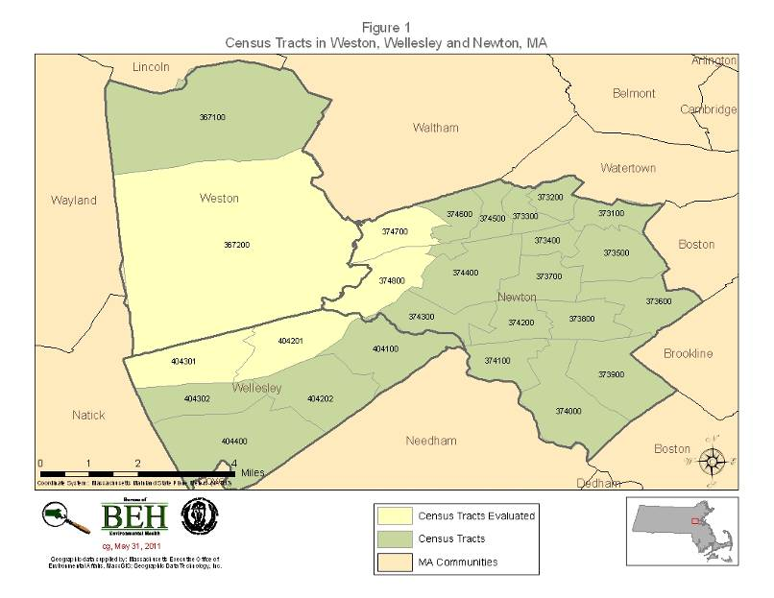

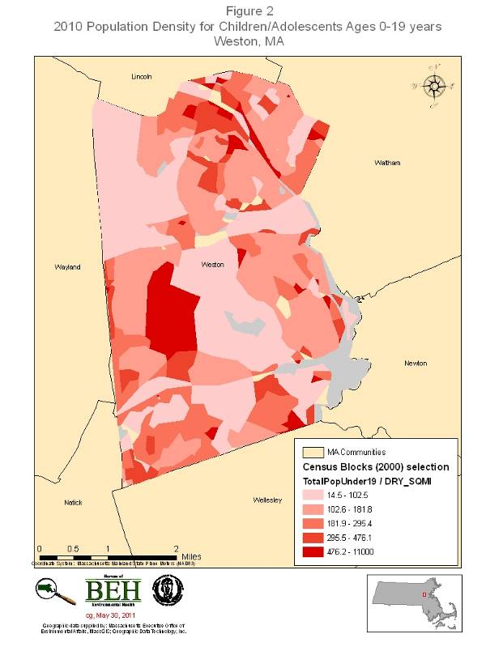
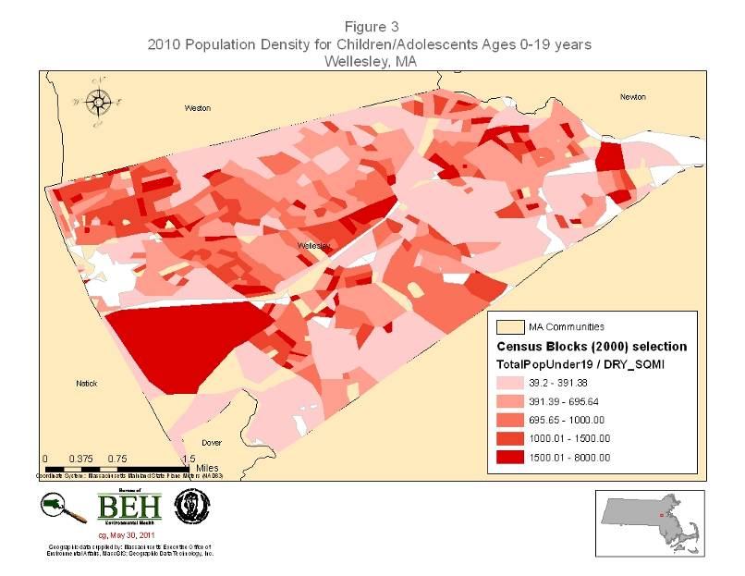

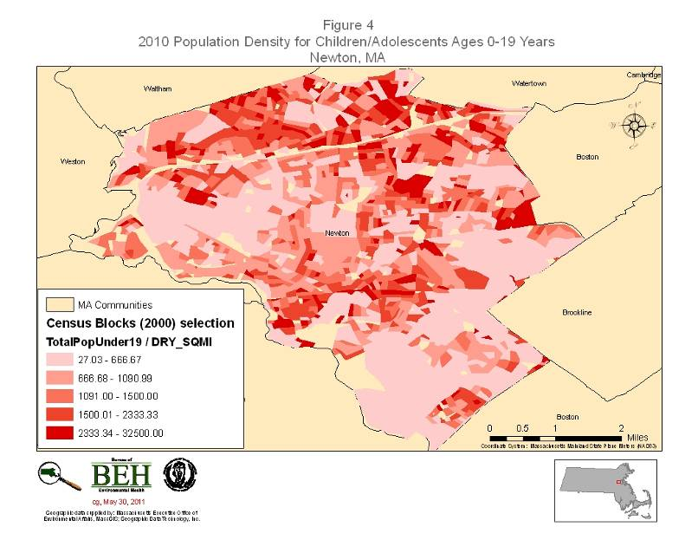

Table 1. Participant Information from Consent Forms

Table 2. Prevalence Estimates of Type 1 Diabetes in Children/Adolescents Ages 0-19 Years in Weston, Wellesley, and Newton as of December 31, 2009

Table 3. Prevalence Estimates of Type 1 Diabetes in Children/Adolescents Ages 5-14 Years in Weston, Wellesley, and Newton as of December 31, 2009
*The additional Weston child/adolescent reported to MDPH via the consent forms may have been diagnosed with type 1 diabetes after the Weston school nurse reported the number of diagnoses to the EPHTP.

Table 4. Prevalence Estimates of Type 1 Diabetes in Children/Adolescents Ages 0-19 Years in Selected Census Tracts in Weston, Wellesley, and Newton as of December 31, 2009

Table 5. Residential and Family History Information from Consent Forms for 3 Communities

Table 6. Residential and Family History Information from Consent Forms for 5 Census Tracts

Table 7. Counts of Type 1 Diabetes Diagnoses in Children Ages 5 -14 in Weston, Wellesley, and Newton as of December 31, 2009

APPENDIX A

The Commonwealth of Massachusetts
Executive Office of Health and Human Services
Department of Public Health
Bureau of Environmental Health
250 Washington Street, Boston, MA 02108-4619
Phone: 617-624-5757 Fax: 617-624-5777
TTY: 617-624-5286
DEVAL L. PATRICK
GOVERNOR
TIMOTHY P. MURRAY
LIEUTENANT GOVERNOR
JUDYANN BIGBY, M.D.
SECRETARY
JOHN AUERBACH
COMMISSIONER

Consent to Participate in Investigation of Type 1 Diabetes


In Weston, Wellesley and Newton

By signing the consent form below, you are agreeing to provide MDPH with diagnostic information about your child’s diabetes as well as residential history information. In addition, you may choose to be contacted by MDPH as part of any future investigations of type 1 diabetes. Your participation in this investigation is completely voluntary and you can withdraw at any time. Please be assured that all information collected is considered confidential and will be protected under the Commonwealth’s privacy laws. It is also important to note that MDPH staff have no current knowledge that you received this letter nor will they unless you return the consent form to MDPH agreeing to participate.

I voluntarily consent to my participation in the Investigation of Type 1 Diabetes in Weston, Wellesley and Newton. Please complete this page and the form on the back of this page.
______________________________________________________________________________
Name of Child

Parent/Guardian Name Relationship to Child
______________________________________________________________________________
Parent/Guardian Current Address Community State Zip Code

Signature of Parent/Guardian Date

Signature of MDPH Investigator Print Name Date

Consent Form, MPDH Investigation of Type I Diabetes in Weston, Wellesley, and Newton
General Information
Child's Name:
Current Address:
Date of Birth: | / /
Gender (please check one): | □ Male □ Female
School Attending:
Current Grade Level:
Diagnosis Information
Age at Diagnosis:
Address at Diagnosis:
Is your child currently on insulin: | □ Yes □ No
Has your child been off insulin since his/her diagnosis: | □ Yes □ No
Have any of the following family members been diagnosed with type 1 diabetes? | Please check all that apply  □ Mother □ Father □ Sibling □ Other ____________
Please list all residences of child, from 2 years prior to birth to diagnosis, and dates of residences: | Address: | Date moved in: | Date moved out:
Please use the back of this form if more space is needed.

Please check the box and sign below if you wish to be contacted by MDPH for any additional future investigation of type 1 diabetes.

Parent/Guardian Signature
Date

APPENDIX B

Thanks you taking the time to complete this brief survey. Please return it to MDPH in the envelope provided.

PHYSICIAN SURVEY

Name of Reporting Party:
Best contact at your facility for follow-up:
Preferred Contact Method (email or phone):
Date:
Please provide a count of individuals with type 1 diabetes (ages 0 through 19) who you have treated in calendar year 2009 who reside in the three communities listed below (ICD-9 Codes-250.x1 and 250.x3). Please place in the age category as of 2009:
Age Groups | 0-4 Years | 5-9 Years  Weston | 10-14 Years | 15-19 Years
Number of individuals treated: | M F | M F | M F | M F
Weston | M F | M F | M F | M F
Wellesley | M F | M F | M F | M F
Newton | M F | M F | M F | M F

The Poisson distribution was used to calculate confidence intervals.
The population estimates were created using 2000 census block boundaries.
Information for five individuals living in Wellesley was not included in this analysis. Two were not included because they were older than 19 years of age prior to December 31, 2009 and three were diagnosed with diabetes after December 31, 2009.
To assist in you search, here are current zip codes for the 3 communities: Weston-02493 Wellesley-02457, 02481, 02482 Newton-02456, 02458, 02459, 02460, 02461, 02462, 02464, 02465, 02466, 02467, 02468, 02495
Former Weston zip code 02193
Former Wellesley zip codes 02157, 02181, 02182
Former Newton zip codes 02158, 02159, 02160, 02161, 02162, 02164, 02165, 02166, 02167, 02168, 02195

