This Job Aid shows how to:
- Respond to a quote revision request sent by a buyer after a bid has closed

Of Special Note:
Buyers may submit revision requests for various reasons:

- Clarification or additional information is needed
- A Best and Final Offer (BAFO) is requested
- An error in your quote needs correcting (e.g. “No Bid” must be changed to “No Charge” for a specific line item for awarding purposes)

If a buyer requests a revision to your quote, you will be notified through a COMMBUYS-generated email. If the buyer attached any files to the revision request, it will be found within the Revisions tab in COMMBUYS, not the COMMBUYS-generated email. You must save changes by clicking Save & Continue on the tab where the edit was made.

Quotes in COMMBUYS may not be revised after the Bid Opening Date except at the buyer’s request.

Only users with Seller privileges can revise a quote in COMMBUYS. These instructions assume the logged in user has Seller credentials.
Screenshot | Directions
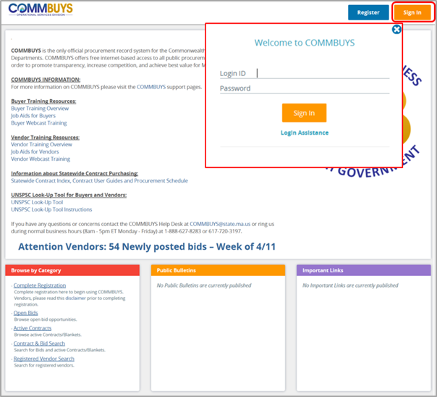 | Step 1: Launching COMMBUYS  - Enter the uniform resource locator (URL) address for COMMBUYS (https://www.commbuys.com) or (commbuys.com) in your browser.  - Once the COMMBUYS landing page displays click on the Sign In button.  - Enter your Login ID and Password and sign in to COMMBUYS.
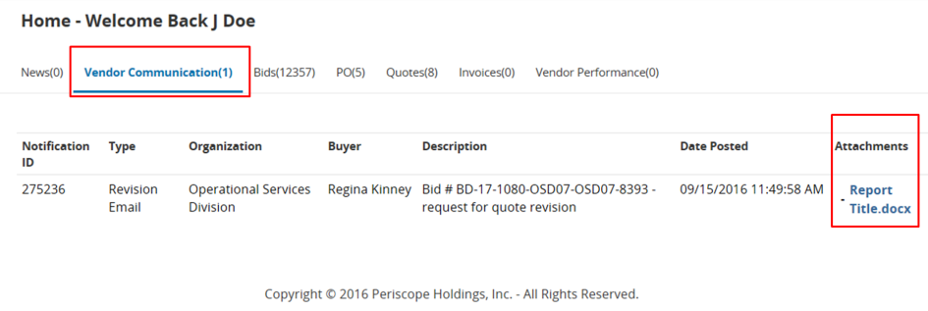 | Step 2: Locating Requests for Quote Revisions  - From the Homepage click on the Vendor Communications tab to view quote revision requests that have been sent to your company.  - Any files upload with the Revision Request will appear under the Attachments column within the Vendor Communications tab. Click on the blue hyperlinked file name to access the attachment.
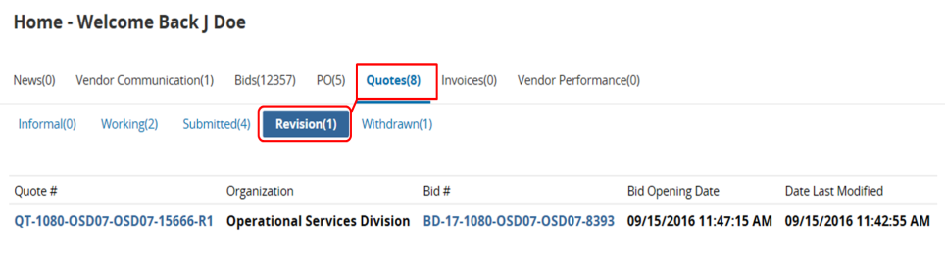 | Step 3: Locating Quotes that Require Revision  - Click on the Quotes tab, and then click on the Revision sub-tab to view quotes that need revising.  Note: Each quote that has a revision request will have an identifying marker located at the end of the quote number. The first revision request will be identified with an R1, with subsequent revision requests marked as R2, R3, etc.
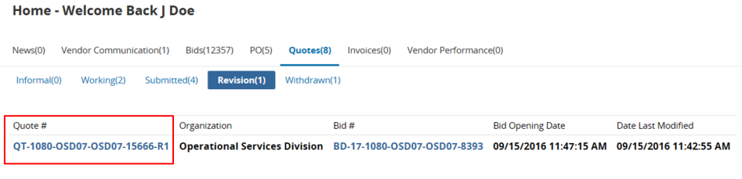 | Step 4: Reopening Quotes that Require Revision  - Click on the hyperlinked Quote # to reopen the quote and start the revision process.
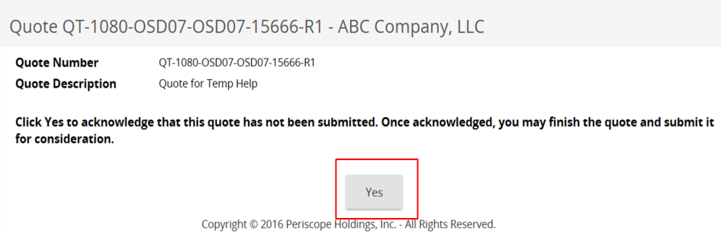 | Step 5: Acknowledging Quote Revision  - Click Yes to confirm that your revised quote has not been submitted and to begin editing your quote.
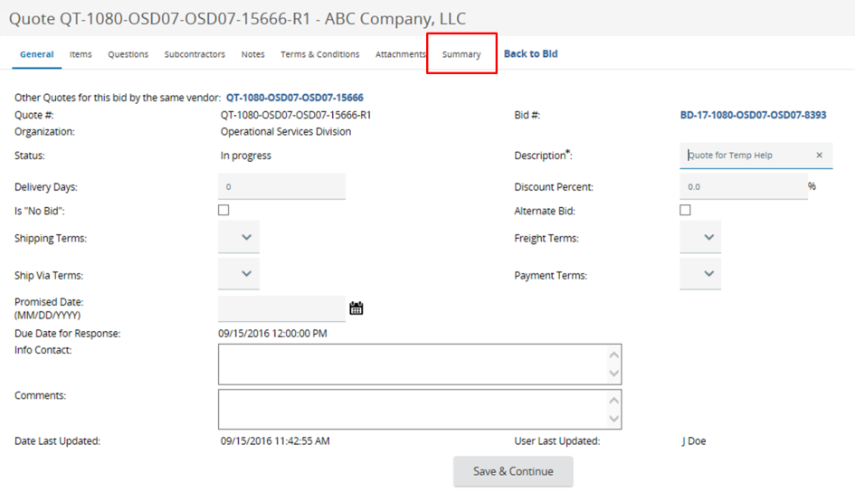 | Step 6: Revising Quotes  - The system will display the General tab. Revise your quote as prescribed by the buyer using any of the following tabs:  - General Tab – modify general quote information such as Description  - Items Tab – add, remove, or edit item information such as Unit Cost  - Questions Tab – answer any questions posed by the buyer (if necessary)  - Attachments Tab – upload or remove files and documents  - Click Save & Continue on the tab where changes are made.  - Review for completeness and compliance with the buyer’s requirements.  - Click on the Summary tab.
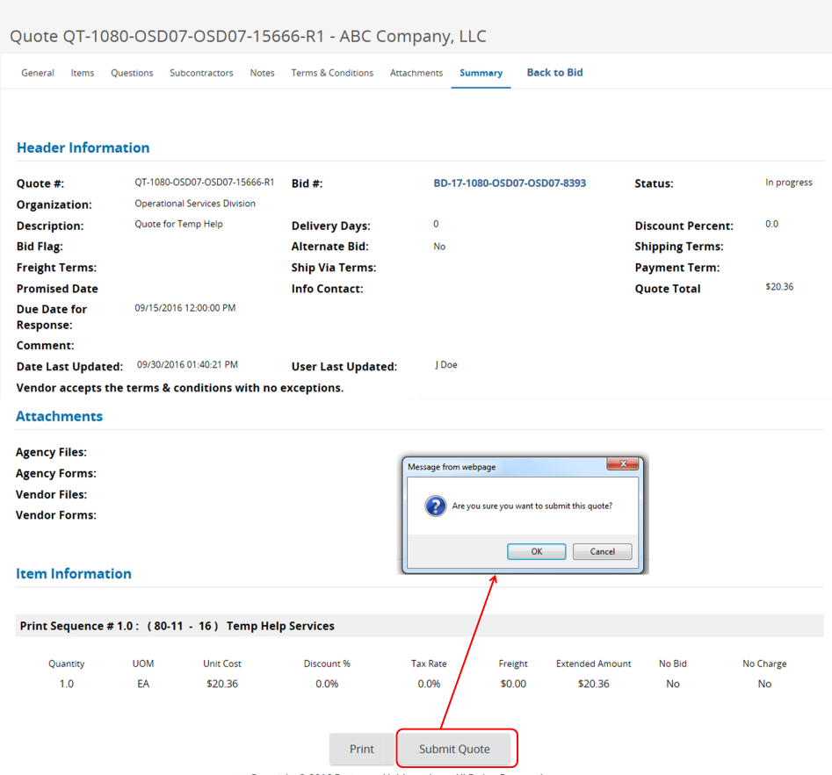 | Step 7: Resubmitting the Quote  - Review the information on the Summary tab for completeness and accuracy.  - Scroll to the bottom of the page and click Submit Quote.  - Click OK in the dialogue box to confirm your action.
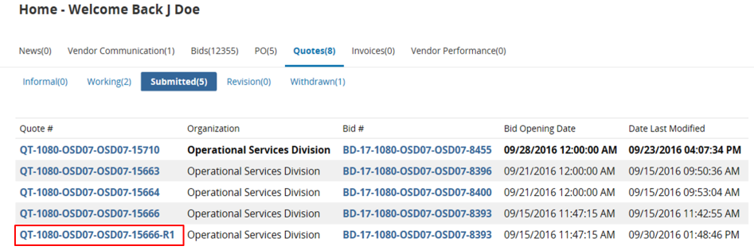 | Step 8: Confirming Submission  - From the Homepage click on the Quotes tab then the Submitted sub-tab to confirm your revised quote was submitted.  Note: You will also receive a COMMBUYS-generated email confirming your revised quote has been submitted.

