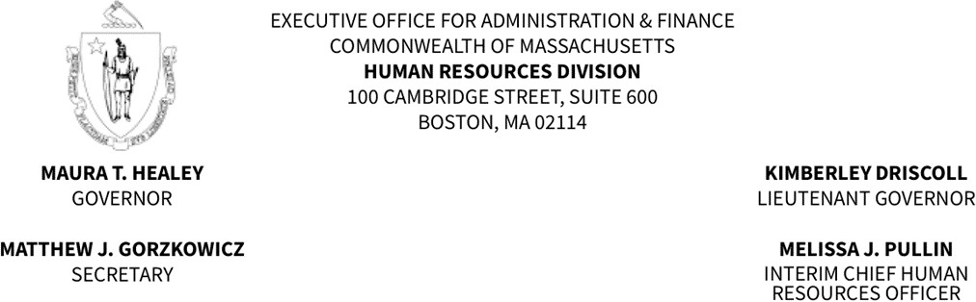

Memorandum

Revocation and Establishment of Fire Promotional Eligible Lists
To: Fire Department Appointing Authorities and Fire Chiefs
From: Bruce T. Howard, Jr., Director of Operations, Civil Service Unit
Date: July 21, 2023
RE: Revocation and Establishment of Fire Promotional Eligible Lists

On July 31, 2023, the Human Resources Division (HRD) will establish new eligible lists (Attachment A) resulting from the March 2023 Fire Promotional Examination for Lieutenant and Captain that had originally been scheduled for November 19, 2022.
Promotions made from a current eligible list will be valid only if the selected individuals receive the promotion on or before July 30, 2023. Candidates cannot be promoted after the revocation of an eligible list on which their name appears per Massachusetts General Laws, Chapter 31, Section 25.
For those departments where there is not an eligible list scheduled to be established, the department's existing eligible list will be extended for a period of time until a new eligible list can be established, but not to exceed three years from the first day of the month the examination was held, in accordance with our revocation policy.
Please be advised that all promotions made from an eligible list must be submitted to HRD through the Civil Service online system. If you have any questions or concerns, please do not hesitate to contact your Civil Service liaison. Thank you.

Attachment A: Departments and Titles
Department | Title(s)
Abington | Captain
Andover | Lieutenant
Arlington | Lieutenant
Attleboro | Lieutenant
Bedford | Captain
Billerica | Lieutenant
Bourne | Lieutenant
Brookline | Captain, Lieutenant
Burlington | Captain, Lieutenant
Canton | Lieutenant
Chelmsford | Captain
Cohasset | Captain
Dedham | Lieutenant
Dracut | Lieutenant
Everett | Captain, Lieutenant
Fairhaven | Lieutenant
Fall River | Captain
Gardner | Lieutenant
Gloucester | Captain, Lieutenant
Haverhill | Captain
Holbrook | Lieutenant
Holyoke | Captain, Lieutenant
Lawrence | Captain, Lieutenant
Lowell | Captain, Lieutenant
Lynn | Lieutenant
Malden | Lieutenant
Marshfield | Lieutenant
Medford | Captain, Lieutenant
Melrose | Lieutenant
Methuen | Captain
Milton | Lieutenant
Natick | Captain, Lieutenant
Needham | Captain, Lieutenant
New Bedford | Captain
Newton | Lieutenant
North Andover | Lieutenant
North Reading | Captain
Norwood | Captain
Pittsfield | Lieutenant
Revere | Captain, Lieutenant
Saugus | Captain
Scituate | Captain, Lieutenant
Shrewsbury | Captain
Somerville | Captain, Lieutenant
Springfield | Captain, Lieutenant
Stoughton | Lieutenant
Taunton | Captain, Lieutenant
Tewksbury | Lieutenant
Wakefield | Captain, Lieutenant
Waltham | Captain, Lieutenant
Whitman | Captain, Lieutenant
Winchester | Captain, Lieutenant
Winthrop | Captain, Lieutenant
Woburn | Captain
Worcester | Captain, Lieutenant
Wrentham | Captain, Lieutenant

