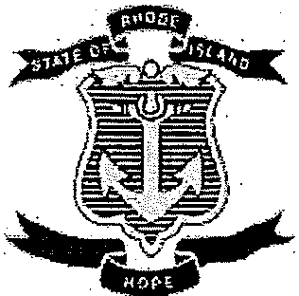

Integrated Care Initiative Implementation Council
Wednesday, June 21, 2017 from 2:30-4:00 p.m.
Child and Family Services, 1268 Eddy Street, Providence, RI

- Call to Order
- Introductions
- Approval of Minutes
- PACE Presentation
  - Melissa Simonian—Rehabilitative Services
- ICI Report—Dawn Allen
- Ombudsman Program Report—Sam Salganik
- Neighborhood Report—Rita Towers
VIII. Member Report
- Unfinished Business
  - Leadership Elections
- New Business
- Meeting Reflection
- Public Comment
- Adjourn

Upcoming meetings: Every Third Wednesday of each month from 2:30-4:00 p.m.
Next Meeting: July 19 from 2:30-4:00 p.m. at Child and Family Services.
**1:30-2:30 pm -Executive Committee meeting for Council members only.

Child and Family Services is accessible to persons with disabilities. If communication assistance (readers/ interpreters) is needed, or any other accommodation to ensure equal participation, please call 401-462-6345 or RI Relay 711 at least 72 hours prior so arrangements can be made to provide such assistance at no cost to the person requesting.

