INDOOR AIR QUALITY ASSESSMENT

Richer Elementary School
80 Foley Road
Marlborough, Massachusetts

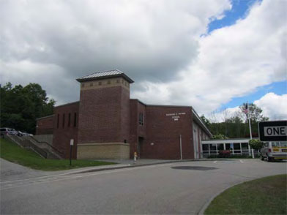

Prepared by:
Massachusetts Department of Public Health
Bureau of Environmental Health
Indoor Air Quality Program
August 2014

Background/Introduction
At the request of the Marlborough Public School Department, the Massachusetts Department of Public Health (MDPH), Bureau of Environmental Health (BEH) provided assistance and consultation regarding indoor air quality (IAQ) at the Richer Elementary School (RES) located at 80 Foley Road, Marlborough, Massachusetts. On June 6, 2014, Cory Holmes, Environmental Analyst/Regional Inspector in BEH’s IAQ Program visited the school to perform an assessment.
The original RES was constructed in the mid-1960s. A six classroom single-story addition was built in 1994. A two-story addition that houses the elevator and lobby was constructed in the early 2000’s. The school contains general classrooms, music rooms, library, art rooms, computer labs, kitchen, cafeteria, gymnasium and office space. Windows are openable throughout the building.

Methods
Air tests for carbon monoxide, carbon dioxide, temperature and relative humidity were conducted with the TSI, Q-Trak, IAQ Monitor, Model 7565. Air tests for airborne particle matter with a diameter less than 2.5 micrometers were taken with the TSI, DUSTTRAK™ Aerosol Monitor Model 8532. BEH/IAQ staff also performed visual inspection of building materials for water damage and/or microbial growth.

Results
The school houses approximately 585 students in grades K through 4 and approximately 130. Tests were taken during normal operations at the school. Results appear in Table 1.

Discussion

Ventilation
It can be seen from Table 1 that carbon dioxide levels were above 800 parts per million (ppm) in 25 of 39 areas, indicating a lack of air exchange in more than half the areas examined. Fresh air in original building classrooms is supplied by unit ventilators (univents) (Pictures 1 and 2). A univent is designed to draw air from outdoors through a fresh air intake located on the exterior wall of the building (Picture 3). Return air is drawn through an air intake located at the base of each unit where fresh and return air are mixed, filtered, heated or cooled and provided to classrooms through an air diffuser located in the top of the unit (Figure 1). However, upon closer examination BEH/IAQ staff noted that the inside/return air vent was completely sealed with a fibrous material (Pictures 4 through 6). This obstruction prevents internal air circulation into the univent (Figure 1), and can lead to accelerated deterioration of the unit as well as difficulty in maintaining temperature/comfort.
Univents were also found deactivated or obstructed with classroom items/furniture on top/front of units in a number of areas (Pictures 1 and 2; Table 1). The occupant in room 107 reported that the univent in that area was not operational. In order for univents to provide fresh air as designed, intakes/returns must remain free of obstructions. Importantly, these units must remain on and be allowed to operate while rooms are occupied.
Note that the univents in this school are original equipment, approximately 45-50 years old. Function of equipment of this age is difficult to maintain, since compatible replacement parts are often unavailable. According to the American Society of Heating, Refrigeration and Air-Conditioning Engineers (ASHRAE), the service life for a unit heater, hot water or steam is 20 years, assuming routine maintenance of the equipment (ASHRAE, 1991). Despite attempts to maintain the univents, the operational lifespan of the equipment has been exceeded. Maintaining the balance of fresh air to exhaust air will become more difficult as the equipment ages and as replacement parts become increasingly difficult to obtain.
Exhaust ventilation in classrooms in the original building is provided by vents located in the ceilings of coat closets (Pictures 7 and 8) and powered by rooftop motors. MDPH staff did not detect any draw from a number of exhaust vents at the time of the assessment, which can indicate that they were deactivated or inoperable. The location of the closet vents also allows them to be easily blocked by stored materials (Picture 8). In addition, many occupants had installed curtains over the closet doors, which can inhibit airflow (Picture 7).
Ventilation for common areas such as the gym and cafeteria is provided by air-handling units (AHUs) either mounted from the ceiling or rooftop. These units did not appear to be operating at the time of the assessment and are also likely to be original equipment from the mid 1960s. Fresh air for classrooms in the 1994 addition is provided by rooftop AHUs (Picture 9). Fresh air is distributed to classrooms via ductwork connected to ceiling-mounted air diffusers. Return vents draw air back to the AHU through ceiling-mounted grilles. A digital wall-mounted thermostat controls the heating, ventilating and air conditioning (HVAC) system (Picture 10). Thermostats have fan settings of “on” and “automatic”. The thermostats were set to the “automatic” setting at the time of the assessment. The automatic setting on the thermostat activates the HVAC system at a preset temperature. Once a preset temperature is measured by the thermostat, the HVAC system is deactivated. Therefore, no mechanical ventilation is provided until the thermostat re-activates the system. Due to tight building envelope construction, outdoor air infiltration through window frames and other unintentional sources is minimized; therefore, little air exchange occurs when AHUs are deactivated by the thermostats.
Several occupied areas did not appear to have a means for natural ventilation (i.e., windows) or mechanical ventilation supply (Table 1), including the PT room and room 101, which is reported to contain up to 11 occupants at times. Occupied areas are required under the building code to provide a source of fresh, outside air via windows and/or mechanical ventilation.
To maximize air exchange, the MDPH recommends that both supply and exhaust ventilation operate continuously during periods of occupancy. In order to have proper ventilation with a mechanical supply and exhaust system, the systems must be balanced to provide an adequate amount of fresh air to the interior of a room while removing stale air from the room. It is recommended that heating, ventilating and air conditioning (HVAC) systems be re-balanced every five years to ensure adequate air systems function (SMACNA, 1994). The date of the last balancing of these systems was not available at the time of the assessment.
Minimum design ventilation rates are mandated by the Massachusetts State Building Code (MSBC). Until 2011, the minimum ventilation rate in Massachusetts was higher for both occupied office spaces and general classrooms, with similar requirements for other occupied spaces (BOCA, 1993). The current version of the MSBC, promulgated in 2011 by the State Board of Building Regulations and Standards (SBBRS), adopted the 2009 International Mechanical Code (IMC) to set minimum ventilation rates. Please note that the MSBC is a minimum standard that is not health-based. At lower rates of cubic feet per minute (cfm) per occupant of fresh air, carbon dioxide levels would be expected to rise significantly. A ventilation rate of 20 cfm per occupant of fresh air provides optimal air exchange resulting in carbon dioxide levels at or below 800 ppm in the indoor environment in each area measured. MDPH recommends that carbon dioxide levels be maintained at 800 ppm or below. This is because most environmental and occupational health scientists involved with research on IAQ and health effects have documented significant increases in indoor air quality complaints and/or health effects when carbon dioxide levels rise above the MDPH guidelines of 800 ppm for schools, office buildings and other occupied spaces (Sundell et al., 2011). The ventilation must be on at all times that the room is occupied. Providing adequate fresh air ventilation with open windows and maintaining the temperature in the comfort range during the cold weather season is impractical. Mechanical ventilation is usually required to provide adequate fresh air ventilation.
Carbon dioxide is not a problem in and of itself. It is used as an indicator of the adequacy of the fresh air ventilation. As carbon dioxide levels rise, it indicates that the ventilating system is malfunctioning or the design occupancy of the room is being exceeded. When this happens, a buildup of common indoor air pollutants can occur, leading to discomfort or health complaints. The Occupational Safety and Health Administration (OSHA) standard for carbon dioxide is 5,000 parts per million parts of air (ppm). Workers may be exposed to this level for 40 hours/week, based on a time-weighted average (OSHA, 1997).
The MDPH uses a guideline of 800 ppm for publicly occupied buildings. A guideline of 600 ppm or less is preferred in schools due to the fact that the majority of occupants are young and considered to be a more sensitive population in the evaluation of environmental health status. Inadequate ventilation and/or elevated temperatures are major causes of complaints such as respiratory, eye, nose and throat irritation, lethargy and headaches. For more information concerning carbon dioxide, consult Appendix A.
Indoor temperature measurements the day of the assessment ranged from 71F to 78F (Table 1), which were within the MDPH recommended comfort range. The MDPH recommends that indoor air temperatures be maintained in a range of 70F to 78F in order to provide for the comfort of building occupants. In many cases concerning indoor air quality, fluctuations of temperature in occupied spaces are typically experienced, even in a building with an adequate fresh air supply. In addition, it is difficult to control temperature and maintain comfort without operating the ventilation equipment as designed (e.g., univents/exhaust vents deactivated/obstructed).
The indoor relative humidity measured the day of the assessment ranged from 47 to 60 percent, which was also within the MDPH recommended comfort range (Table 1). The MDPH recommends a comfort range of 40 to 60 percent for indoor air relative humidity. Relative humidity levels in the building would be expected to drop during the winter months due to heating. The sensation of dryness and irritation is common in a low relative humidity environment. Low relative humidity is a very common problem during the heating season in the northeast part of the United States.

Microbial/Moisture Concerns
Water-damaged ceiling tiles were observed in a number of areas throughout the building (Table 1); these can indicate active/historic leaks from either the roof/building envelope or plumbing system. Periodic leaks through the exterior wall/concrete apron along the exterior of the building were reported in room 115-A and its storeroom (Pictures 11 and 12). It was reported that attempts have been made to repair this area. Water-damaged ceiling tiles can provide a source of mold and should be replaced after a water leak is discovered and repaired. A leaking window was reported in room 204. Occupants should refrain from storing paper and other porous items in the vicinity of leaks to prevent damage and mold growth.
Open seams between the sink countertop and backsplash were observed in a number of rooms (Table 1; Picture 13). If seams are not watertight, water can penetrate the seam, causing water damage. Water penetration and chronic exposure of porous and wood-based materials can cause these materials to swell, show signs of water damage and lead to potential mold growth.
The US Environmental Protection Agency (US EPA) and the American Conference of Governmental Industrial Hygienists (ACGIH) recommend that porous materials (e.g., carpeting, gypsum wallboard) be dried with fans and heating within 24 to 48 hours of becoming wet (US EPA, 2001; ACGIH, 1989). If not dried within this time frame, mold growth may occur. Once mold has colonized porous materials, they are difficult to clean and should be removed/discarded.
Moss/plant growth was observed growing on exterior walls/windows along the north/northwest side of the building (Pictures 14 and 15), due to chronic moisture/lack of sunlight. This material can hold moisture against the building, which can lead to deterioration and water penetration issues.
Plants were noted in some classrooms (Table 1). Plants can be a source of pollen and mold which can be respiratory irritants to some individuals. Plants should be properly maintained and equipped with drip pans and should be located away from univents to prevent the aerosolization of dirt, pollen and mold.
Mold concerns were expressed regarding padded mats covering the floor in the physical therapy (PT) (Picture 16). BEH/IAQ staff removed mats and did not observe any visible mold growth or detect any associated odors. However, non-porous mats can trap moisture; therefore it was recommended to staff that the floor beneath the mats be periodically cleaned/dried and that mats be removed over the summer during hot/humid weather conditions to prevent mold growth and associated odors. As previously mentioned, the PT room did not have a means of mechanical or natural supply air ventilation, and had an exhaust vent only.
Pooling water was observed in a number of areas on the roof, particularly on the 1994 addition (Picture 17). The freezing and thawing of water during winter months can lead to roof leaks and subsequent water penetration into the interior of the building. Pooling water can also become stagnant, which can lead to mold and bacterial growth, which can be introduced into the building by rooftop ventilation equipment. In addition, stagnant pools of water can serve as a breeding ground for mosquitoes.

Other IAQ Evaluations
Indoor air quality can be negatively influenced by the presence of respiratory irritants, such as products of combustion. The process of combustion produces a number of pollutants. Common combustion emissions include carbon monoxide, carbon dioxide, water vapor and smoke (fine airborne particle material). Of these materials, exposure to carbon monoxide and particulate matter with a diameter of 2.5 micrometers (μm) or less (PM2.5) can produce immediate, acute health effects upon exposure. To determine whether combustion products were present in the indoor environment, BEH/IAQ staff obtained measurements for carbon monoxide and PM2.5.

Carbon Monoxide
Carbon monoxide is a by-product of incomplete combustion of organic matter (e.g., gasoline, wood and tobacco). Exposure to carbon monoxide can produce immediate and acute health effects. Several air quality standards have been established to address carbon monoxide and prevent symptoms from exposure to these substances. The MDPH established a corrective action level concerning carbon monoxide in ice skating rinks that use fossil-fueled ice resurfacing equipment. If an operator of an indoor ice rink measures a carbon monoxide level over 30 ppm, taken 20 minutes after resurfacing within a rink, that operator must take actions to reduce carbon monoxide levels (MDPH, 1997).
The American Society of Heating Refrigeration and Air-Conditioning Engineers (ASHRAE) has adopted the National Ambient Air Quality Standards (NAAQS) as one set of criteria for assessing indoor air quality and monitoring of fresh air introduced by HVAC systems (ASHRAE, 1989). The NAAQS are standards established by the US EPA to protect the public health from six criteria pollutants, including carbon monoxide and particulate matter (US EPA, 2006). As recommended by ASHRAE, pollutant levels of fresh air introduced to a building should not exceed the NAAQS levels (ASHRAE, 1989). The NAAQS were adopted by reference in the Building Officials & Code Administrators (BOCA) National Mechanical Code of 1993 (BOCA, 1993), which is now an HVAC standard included in the Massachusetts State Building Code (SBBRS, 2011). According to the NAAQS, carbon monoxide levels in outdoor air should not exceed 9 ppm in an eight-hour average (US EPA, 2006).
Carbon monoxide should not be present in a typical, indoor environment. If it is present, indoor carbon monoxide levels should be less than or equal to outdoor levels. On the day of the assessment, outdoor carbon monoxide concentrations ranged from non-detect (ND) to a slight level of 1 ppm (Table 1), likely due to idling vehicles. No measurable levels of carbon monoxide were detected inside the building (Table 1).

Particulate Matter
The US EPA has established NAAQS limits for exposure to particulate matter. Particulate matter includes airborne solids that can be irritating to the eyes, nose and throat. The NAAQS originally established exposure limits to PM with a diameter of 10 μm or less (PM10). In 1997, US EPA established a more protective standard for fine airborne particulate matter with a diameter of 2.5 μm or less (PM2.5). This more stringent PM2.5 standard requires outdoor air particle levels be maintained below 35 μg/m³ over a 24-hour average (US EPA, 2006). Although both the ASHRAE standard and BOCA Code adopted the PM10 standard for evaluating air quality, MDPH uses the more protective PM2.5 standard for evaluating airborne PM concentrations in the indoor environment.
Outdoor PM2.5 concentrations were measured at 2 to 5 μg/m³ (Table 1). PM2.5 levels measured indoors ranged from 2 to 10 μg/m³ (Table 1), which were below the NAAQS PM2.5 level of 35 μg/m³. Frequently, indoor air levels of particulates (including PM2.5) can be at higher levels than those measured outdoors. A number of activities that occur indoors and/or mechanical devices can generate particulate matter during normal operations. Sources of indoor airborne particulates may include but are not limited to particles generated during the operation of fan belts in the HVAC system, use of stoves and/or microwave ovens in kitchen areas; use of photocopiers, fax machines and computer printing devices; operation of an ordinary vacuum cleaner and heavy foot traffic indoors.

Volatile Organic Compounds
Indoor air concentrations can be greatly impacted by the use of products containing volatile organic compounds (VOCs). VOCs are carbon-containing substances that have the ability to evaporate at room temperature. Frequently, exposure to low levels of total VOCs (TVOCs) may produce eye, nose, throat and/or respiratory irritation in some sensitive individuals. For example, chemicals evaporating from a paint can stored at room temperature would most likely contain VOCs. In an effort to identify materials that can potentially increase indoor VOC concentrations, BEH/IAQ staff examined rooms for products containing these respiratory irritants.
Classrooms contained dry erase boards and related materials. Materials such as dry erase markers and dry erase board cleaners may contain VOCs, such as methyl isobutyl ketone, n-butyl acetate and butyl-cellusolve (Sanford, 1999), which can be irritating to the eyes, nose and throat.
Cleaning and sanitizing products were observed on/under sinks in some rooms (Table 1); spray paint products were seen in one area (Picture 18). These products contain chemicals that can be irritating to the eyes, nose and throat of sensitive individuals. The spray paint product had a label stating “DANGER! Extremely Flammable, Vapor Harmful” (Picture 19). These items should be stored in a flammable cabinet in the maintenance area. Cleaning products should be properly labeled and stored in an area inaccessible to children. In addition, a Material Safety Data Sheet (MSDS) should be available at a central location for each product in the event of an emergency. Consideration should be given to providing teaching staff with school issued cleaning products and supplies to prevent any potential for adverse chemical interactions between residues left from cleaners used by the facilities staff and those left by cleaners brought in by others.

Other Conditions
Other conditions that can affect IAQ were observed during the assessment. In many classrooms, a large number of items were on floors, windowsills, tabletops, counters, bookcases and desks (Picture 20), which provide a source for dusts to accumulate. These items (e.g., papers, folders, boxes) make it difficult for custodial staff to clean. Items should be relocated and/or be cleaned periodically to avoid excessive dust build up. In addition, dust and debris can accumulate on flat surfaces (e.g., desktops, shelving and floors) in occupied areas and subsequently be re-aerosolized causing further irritation.
Many classrooms had area carpets. The Institute of Inspection, Cleaning and Restoration Certification (IICRC), recommends that carpeting be cleaned annually (or semi-annually in soiled high traffic areas) (IICRC, 2005).
A number of exhaust vents and personal fans were found to have accumulated dust/debris (Table 1; Pictures 21 and 22). If exhaust vents are not functioning, backdrafting can occur, which can re-aerosolize accumulated dust particles. Re-activated supply, exhaust/return vents and fans can also aerosolize dust accumulated on vents/fan blades. Portable air conditioner filters, univent filters and cabinet interiors were also noted to have a build-up of dust/debris (Pictures 23 and 24). Univent filters should be changed as per the manufacturer’s recommendations (typically 2-4 times a year). Since the BEH/IAQ assessment occurred toward the last few weeks of the school year, filters were likely due for changing (e.g., over the summer).
Upholstered furniture, pillows/cushions and large stuffed animals were seen in several classrooms (Pictures 25 through 27). Upholstered furniture, pillows and cushions are covered with fabric that comes in contact with human skin. This type of contact can leave oils, perspiration, hair and skin cells. Dust mites feed upon human skin cells and excrete waste products that contain allergens. In addition, if relative humidity levels increase above 60 percent, dust mites tend to proliferate (US EPA, 1992). In order to remove dust mites and other pollutants, frequent vacuuming of upholstered furniture is recommended (Berry, M.A., 1994). It is also recommended that upholstered furniture (if present in schools), be professionally cleaned on an annual basis. If outdoor conditions or indoor activities (e.g., renovations) create an excessively dusty environment, cleaning frequency should be increased (every six months) (IICRC, 2000).

Conclusions/Recommendations
In view of the findings at the time of the visit, the following recommendations are made:
- Inspect all univents and remove fibrous material (Pictures 5 and 6) sealing return vents to restore original function as designed.
- Operate all ventilation systems throughout the building (e.g., classrooms, gym, cafeteria) continuously during periods of occupancy to maximize air exchange. If increased airflow is desired, operate univents in fan “high” mode.
- Restore exhaust ventilation throughout the building. Inspect motors and belts for proper function, and perform repairs and adjustments as necessary.
- Remove blockages/items from the surface of univent air diffusers and return vents (along front/bottom).
- Remove all blockages from exhaust vents (items on top shelf of coat closets and curtains) to ensure adequate airflow.
- Maintaining the balance of fresh air to exhaust air will become more difficult as the equipment ages (i.e., classroom univents, exhaust vents and AHUs in gym/cafeteria) and as replacement parts become increasingly difficult to obtain. Based on the age, physical deterioration and availability of parts, the BEH recommends that an HVAC engineering firm evaluate options to determine feasibility of repairing/replacing the equipment for future use.
- For continuous airflow/filtration set the thermostats for 1994 addition to the fan “on” position rather than “automatic” during the school day.
- Ensure classroom doors are closed for proper operation of mechanical ventilation system/air exchange.
- Change filters for all air handling equipment (univents and AHUs) as per the manufacturer’s instructions (typically 2-4 times a year). Thoroughly clean/vacuum out all units during each filter change.
- Consider adopting a balancing schedule of every 5 years for all mechanical ventilation systems, as recommended by ventilation industrial standards (SMACNA, 1994).
- Use openable windows in conjunction with mechanical ventilation to facilitate air exchange. Care should be taken to ensure windows are properly closed at night and weekends to avoid the freezing of pipes and potential flooding.
- Provide a means of natural/mechanical ventilation for occupied areas having none (e.g., PT room, room 101) in accordance with state/local building codes. If not feasible relocate occupants to an area with natural (windows) or mechanical ventilation.
- For buildings in New England, periods of low relative humidity during the winter are often unavoidable. Therefore, scrupulous cleaning practices should be adopted to minimize common indoor air contaminants whose irritant effects can be enhanced when the relative humidity is low. To control dusts, a high efficiency particulate arrestance (HEPA) filter equipped vacuum cleaner in conjunction with wet wiping of all surfaces is recommended. Avoid the use of feather dusters. Drinking water during the day can help ease some symptoms associated with a dry environment (throat and sinus irritations).
- Ensure building envelope/exterior (e.g., area outside room 115-A/Picture 12) and plumbing leaks are repaired and replace any remaining water-damaged ceiling tiles. Examine the area above these tiles for mold growth. Disinfect areas of water leaks with an appropriate antimicrobial, as needed.
- Investigate and make repairs to window leak in/near room 204. Until repairs are made/confirmed, refrain from storing porous materials (e.g., paper, cardboard) in the vicinity of leaks.
- Improve drainage on roof; consider consulting a building engineer/roofing contractor about possible options to eliminate water pooling.
- Periodically clean/dry underneath padded mats in the PT room. Remove mats over the summer during hot/humid conditions to prevent moisture trapping/mold growth.
- Periodically clean/power-wash moss/plant growth along exterior (north side) of building.
- Seal breaches, seams, and spaces between sink countertops and backsplashes to prevent water damage. Consider long-term plans to replace with a one-piece molded countertop.
- Ensure indoor plants are equipped with drip pans. Examine drip pans periodically for mold growth and disinfect with an appropriate antimicrobial, as needed. Move plants away from the air stream of mechanical ventilation equipment.
- Remove/clean moss from the windows and north/northwest side of building regularly.
- Refrain from storing flammable products in classrooms. Store cleaning products properly and out of reach of students. Ensure spray bottles are properly labeled. All cleaning products used at the facility should be approved by the school department with MSDSs available at a central location.
- Relocate or consider reducing the amount of materials stored in classrooms to allow for more thorough cleaning of classrooms. Clean items regularly with a wet cloth or sponge to prevent excessive dust build-up.
- Clean area carpets annually or semi-annually in soiled high traffic areas as per the recommendations of the Institute of Inspection, Cleaning and Restoration Certification (IICRC). Copies of the IICRC fact sheet can be downloaded at: http://1.cleancareseminars.net/?page_id=185 (IICRC, 2005)
- Clean personal fans, air diffusers and return vents periodically of accumulated dust.
- Clean upholstered furniture, cloth curtains, stuffed animals, and pillows on a regular schedule. If not possible/practical, consider removing from classrooms.
- Consider adopting the US EPA (2000) document, “Tools for Schools”, as an instrument for maintaining a good indoor air quality environment in the building. This document is available at: http://www.epa.gov/iaq/schools/index.html.
- Refer to resource manual and other related indoor air quality documents located on the MDPH’s website for further building-wide evaluations and advice on maintaining public buildings. These documents are available at: http://mass.gov/dph/iaq.

References
ACGIH. 1989. Guidelines for the Assessment of Bioaerosols in the Indoor Environment. American Conference of Governmental Industrial Hygienists, Cincinnati, OH.
ASHRAE. 1989. Ventilation for Acceptable Indoor Air Quality. American Society of Heating, Refrigeration and Air Conditioning Engineers. ANSI/ASHRAE 62-1989.
ASHRAE. 1991. ASHRAE Applications Handbook, Chapter 33 “Owning and Operating Costs”. American Society of Heating, Refrigeration and Air Conditioning Engineers, Atlanta, GA.
Berry, M.A. 1994. Protecting the Built Environment: Cleaning for Health, Michael A. Berry, Chapel Hill, NC.
BOCA. 1993. The BOCA National Mechanical Code/1993. 8th ed. Building Officials and Code Administrators International, Inc., Country Club Hill, IL.
IICRC. 2000. IICRC S001 Reference Guideline for Professional On-Location Cleaning of Textile Floor Covering Materials Institute of Inspection, Cleaning and Restoration Certification. Institute of Inspection Cleaning and Restoration, Vancouver, WA.
IICRC. 2005. Carpet Cleaning FAQ 4 Institute of Inspection, Cleaning and Restoration Certification. Institute of Inspection Cleaning and Restoration, Vancouver, WA.
MDPH. 1997. Requirements to Maintain Air Quality in Indoor Skating Rinks (State Sanitary Code, Chapter XI). 105 CMR 675.000. Massachusetts Department of Public Health, Boston, MA.
OSHA. 1997. Limits for Air Contaminants. Occupational Safety and Health Administration. Code of Federal Regulations. 29 C.F.R 1910.1000 Table Z-1-A.
Sanford. 1999. Material Safety Data Sheet (MSDS No: 198-17). Expo Dry Erase Markers Bullet, Chisel, and Ultra Fine Tip. Sanford Corporation. Bellwood, IL.
SBBRS. 2011. Mechanical Ventilation. State Board of Building Regulations and Standards. Code of Massachusetts Regulations, 8th edition. 780 CMR 1209.0
SMACNA. 1994. HVAC Systems Commissioning Manual. 1st ed. Sheet Metal and Air Conditioning Contractors’ National Association, Inc., Chantilly, VA.
Sundell. 2011. Sundell, J., H. Levin, W. W. Nazaroff, W. S. Cain, W. J. Fisk, D. T. Grimsrud, F. Gyntelberg, Y. Li, A. K. Persily, A. C. Pickering, J. M. Samet, J. D. Spengler, S. T. Taylor, and C. J. Weschler. 2011. Ventilation rates and health: multidisciplinary review of the scientific literature. Indoor Air, Volume 21: pp 191–204.
US EPA. 1992. Indoor Biological Pollutants. US Environmental Protection Agency, Environmental Criteria and Assessment Office, Office of Health and Environmental Assessment, research Triangle Park, NC. EPA 600/8-91/202. January 1992.
US EPA. 2000. Tools for Schools. Office of Air and Radiation, Office of Radiation and Indoor Air, Indoor Environments Division (6609J). EPA 402-K-95-001, Second Edition. http://www.epa.gov/iaq/schools/tools4s2.html.
US EPA. 2001. Mold Remediation in Schools and Commercial Buildings. US Environmental Protection Agency, Office of Air and Radiation, Indoor Environments Division, Washington, D.C. EPA 402-K-01-001. March 2001.
US EPA. 2006. National Ambient Air Quality Standards (NAAQS). US Environmental Protection Agency, Office of Air Quality Planning and Standards, Washington, DC. http://www.epa.gov/air/criteria.html.
Picture 1

Classroom univent, note front/return vent obstructed

Picture 2
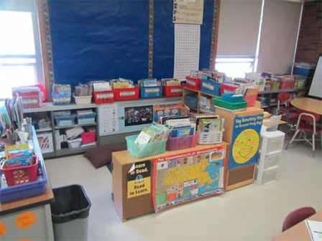
Airflow around univent obstructed by items
Picture 3
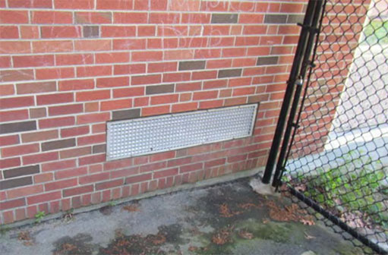
Univent fresh air intake

Picture 4
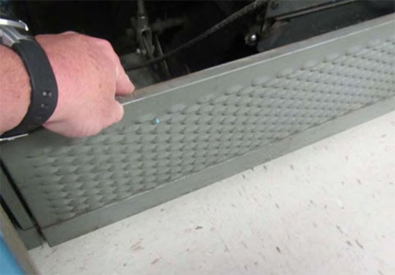
Univent return vent (along bottom front)
Picture 5
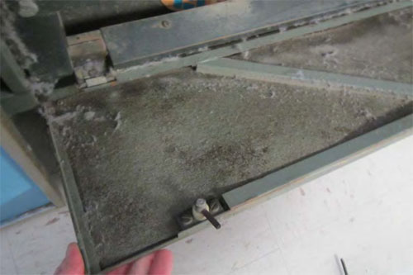
Inside shot of univent return vent sealed with fibrous material obstructing airflow

Picture 6
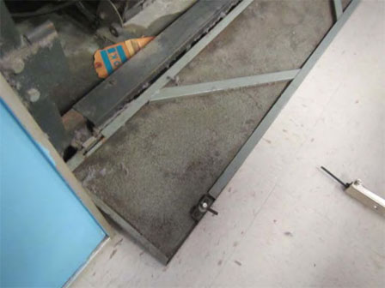
Inside shot of univent return vent sealed with fibrous material obstructing airflow
Picture 7
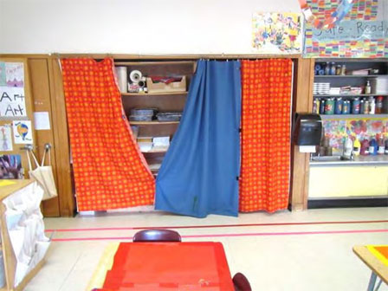
Coat closet exhaust vent, approximate position shown by arrow

Picture 8
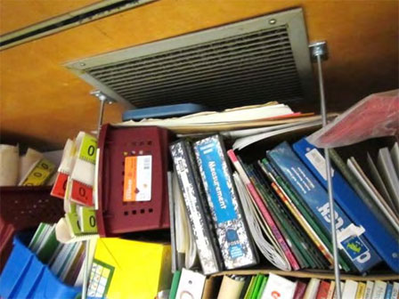
Coat closet exhaust vent, note stored materials
Picture 9
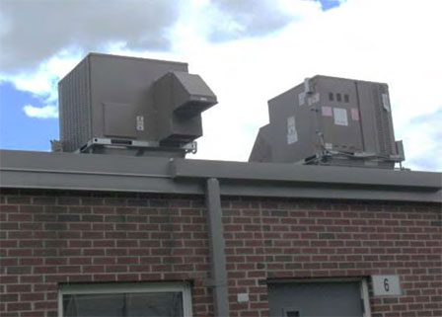
Rooftop air handling units

Picture 10
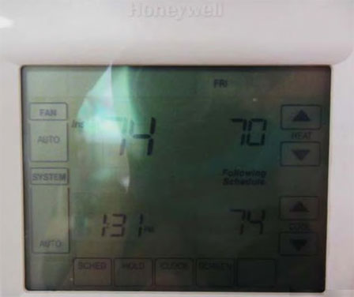
Wall-mounted thermostat, note fan in “auto” setting (arrow)
Picture 11
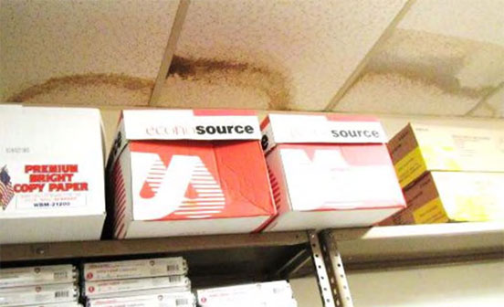
Water-damaged ceiling tiles in room 115-A/storeroom

Picture 12
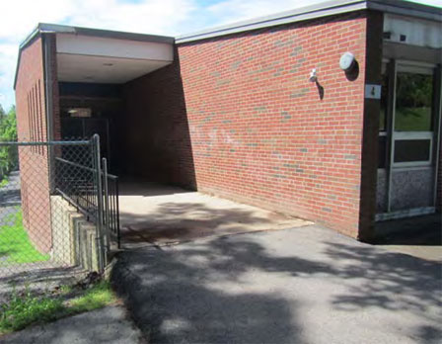
Exterior area of building believed to be source of water penetration into room 115-A/storeroom
Picture 13
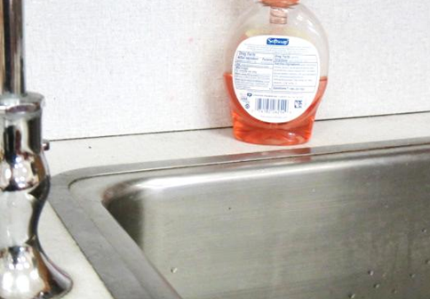
Spaces between sink countertop and backsplash

Picture 14
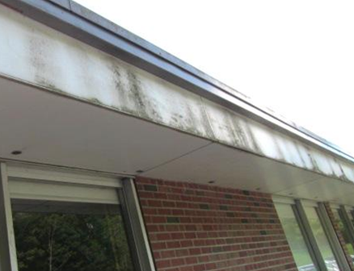
Moss growth (dark staining) on building façade along the north side of the building
Picture 15
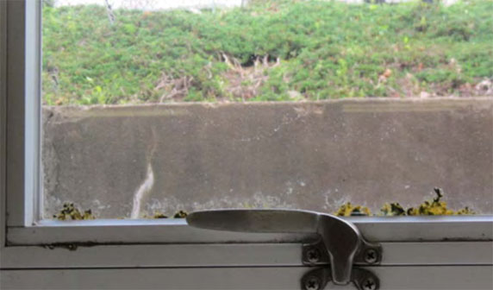
Moss growth on base of window along the north side of the building

Picture 16
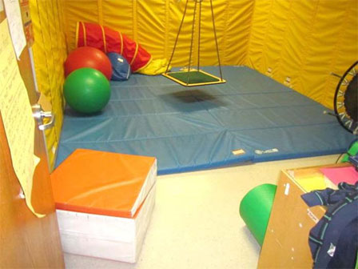
Padded mat covering floor of PT room
Picture 17
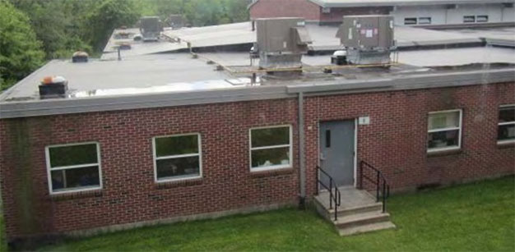
Pooling water on roof (near edge) of 1990s addition

Picture 18
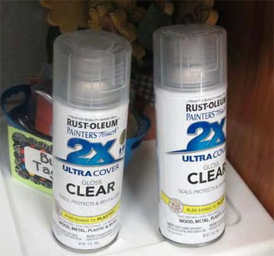
Spray paint products near sink in classroom
Picture 19
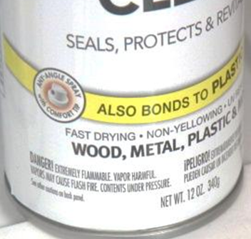
Spray paint product, note label states “DANGER! Extremely Flammable, Vapor Harmful”

Picture 20
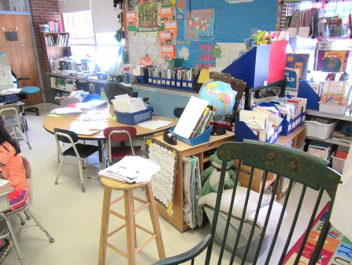
Accumulated items on flat surfaces in classroom
Picture 21
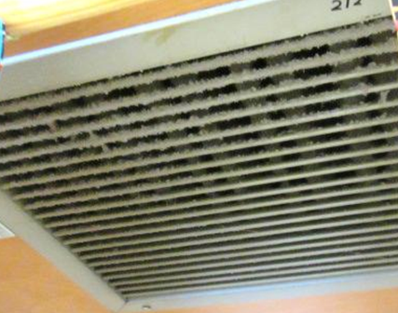
Dust/debris accumulation on coat closet exhaust vent

Picture 22
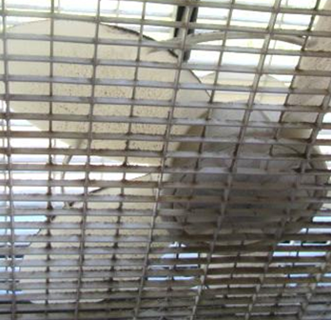
Dust/debris accumulation on personal fan
Picture 23
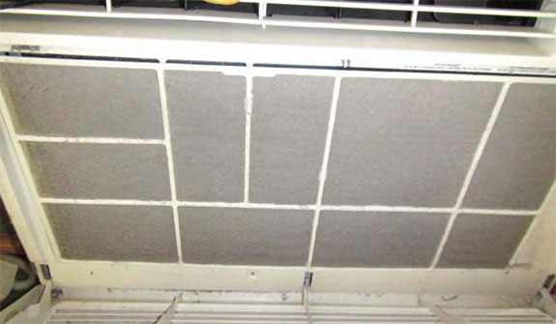
Portable air conditioner filter occluded with dust/debris

Picture 24
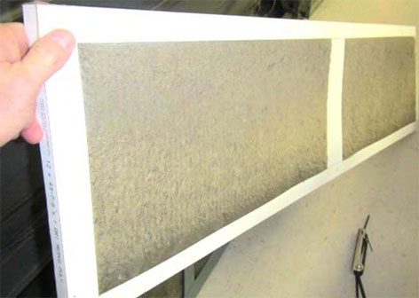
Univent filter occluded with dust/debris
Picture 25
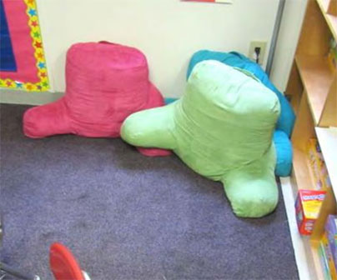
Stuffed cushions on floor/carpet

Picture 26
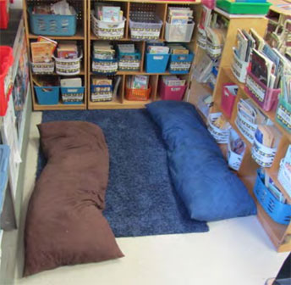
Stuffed pillows on floor/carpet
Picture 27
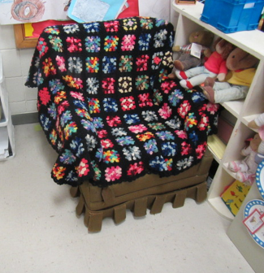
Upholstered chair in classroom
 | Carbon  Dioxide  (ppm) | Carbon Monoxide  (ppm) | Temp  (°F) | Relative  Humidity  (%) | PM2.5  (μg/m³) | Occupants  in Room | Windows  Openable | Ventilation |  |  | Remarks
 |  |  |  |  |  |  |  | Intake | Exhaust |  | Remarks
Background | 387 | ND-1 | 74 | 46 | 2-5 |  |  |  |  |  | Mostly sunny, West winds 4-15 mph, gusts up to 22 mph, cars idling
101 | 731 | ND | 74 | 54 | 6 | 2 | N | N |  | Y  Off | Up to 11 kids/occupants reported-no windows or mech fresh air supply
103 | 996 | ND | 74 | 56 | 5 | 3 | Y | Y  Obstructed |  | Y | Pillows, area rugs
105 | 849 | ND | 75 | 54 | 4 | 0 | Y | Y |  | Y  Off | Moss growth on windows, DO
106 A&B | 576 | ND | 75 | 54 | 5 | 8 | Y | Y |  | Y  Off | Area rug, AC
107 | 802 | ND | 74 | 56 | 4 | 1 | Y  Open | Y  Obstructed |  | Y  Off | Area rugs, 20 occupants gone ~ 25 mins, UV reported non-operational all year
108 | 698 | ND | 76 | 53 | 4 | 10 | Y | Y |  | Y  Off | AC-dusty filter, area rug, DO, 2 WD CT
109 | 979 | ND | 75 | 56 | 4 | 0 | Y | Y |  | Y  Off | DO, area rug, spaces between sink/countertop, WD CT
110 A | 675 | ND | 75 | 53 | 4 | 5 | Y | Y |  | N | UV divided, 2 WD CT
111 | 877 | ND | 74 | 56 | 5 | 1 | Y | Y  Obstructed |  | Y  Off/Weak | 17 occupants gone ~10-15 mins, WD CT, area carpet, DO, PF-dusty, spaces between sink/countertop
112 | 651 | ND | 75 | 54 | 4 | 25 | Y  Open | Y |  | Y | WD CT near window
113 A | 1276 | ND | 74 | 60 | 6 | 4 | Y | Y |  | Y  Off | PF-dusty, area rug, DO
113 B | 1231 | ND | 74 | 57 | 6 | 2 | Y | Y |  | N | Room divided, plants, items on/front of UV, spaces between sink/countertop
114 | 1410 | ND | 75 | 59 | 5 | 15 | Y | Y |  | Y | Pillows/cushions, spaces between sink/countertop, AC-space around unit-filter dirty
115 A | 738 | ND | 72 | 56 | 2 | 4 | N | N |  | Y | DO, no supply vent
Storeroom | 740 | ND | 71 | 55 | 2 | 0 | N | N |  | Y | 1 WD CT-exterior leaks, dehumidifier
117 | 875 | ND | 75 | 53 | 6 | 0 | N | N |  | Y
121 Modular Classroom | 1146 | ND | 75 | 55 | 7 | 0 | Y | Y |  | Y | Thermostat on “auto”, WD CT
122 A | 706 | ND | 74 | 50 | 5 | 0 | N | Y |  | N
122 | 1342 | ND | 75 | 56 | 9 | 20 | Y | Y |  | Y | Thermostat on “auto”
123 Modular Classroom | 1540 | ND | 76 | 52 | 10 | 0 | Y | Y |  | Y | Occupants just left, DO, area rug, thermostat on “auto”
124 Modular Classroom | 1425 | ND | 76 | 56 | 9 | 23 | Y | Y |  | Y | DO, WD CT, pillows area rugs, thermostat on “auto”
PT Room | 1316 | ND | 74 | 58 | 6 | 0 | N | N |  | Y  Off/Weak | Occupants had concerns of mold/odors under floor mats, no issues found-rec removal of mats during summer/humid weather to prevent trapping of moisture
Book Room | 733 | ND | 74 | 54 | 7 | 0 | Y | N |  | N | Laminator odors
2nd Floor
201 | 1286 | ND | 77 | 57 | 4 | 22 | Y | Y  Obstructed |  | Y  Off | DO
202 | 767 | ND | 76 | 51 | 4 | 19 | Y | Y |  | Y  Off | UF, DO, accumulated items, area rug, items on/front of UV
203 | 826 | ND | 76 | 51 | 5 | 18 | Y | Y |  | Y  Off | PFs-dusty, CP, pillows/cushions, area rug, spaces between sink/countertop, DO, flammable/materials-spray can
204 | 812 | ND | 76 | 51 | 5 | 19 | Y  Open | Y |  | Y  Off | Leak by window (rec not storing items near leaks), items/plant on UV, area rugs, items hanging from CT system, spaces between sink/countertop
205 | 1027 | ND | 78 | 52 | 5 | 21 | Y  Open | Y |  | Y  Off | UF, PF, area rug
206 | 943 | ND | 77 | 51 | 4 | 22 | Y | Y |  | Y  Off | Area rug
207 | 1031 | ND | 78 | 51 | 4 | 25 | Y  Open | Y  Obstructed |  | Y  Off | CF-on, area rug
208 | 1027 | ND | 77 | 52 | 4 | 25 | Y  Open | Y  Obstructed |  | Y  Off | DO, spaces between sink/countertop, 2 WD CT near exterior wall
209 | 1105 | ND | 78 | 53 | 5 | 17 | Y | Y |  | Y  Off | DO, area rug, spaces between sink/countertop
210 | 907 | ND | 76 | 52 | 2 | 22 | Y | Y |  | Y | Exhaust off, DO, spaces between sink/countertop
211 | 1080 | ND | 78 | 52 | 5 | 24 | Y | Y off |  | Y  Weak | DO, area rug
212 | 916 | ND | 76 | 54 | 3 | 17 | Y | Y |  | Y | Exhaust weak/dusty, DO, CF, spaces between sink/countertop
213 | 656 | ND | 77 | 47 | 5 | 15 | Y  Open | Y |  | Y  Dusty | DO, area rug
214 Computer Room | 479 | ND | 77 | 49 | 5 | 0 | Y  Open | Y |  | Y | AC, DO
215 | 717 | ND | 75 | 51 | 4 | 18 | Y | Y  Obstructed |  | Y | Items on/front of UV, area rugs, spaces between sink/countertop
216 | 558 | ND | 76 | 50 | 4 | 14 | Y | Y |  | Y | DO, area rugs

The service life is the median time during which a particular system or component of …[an HVAC]… system remains in its original service application and then is replaced. Replacement may occur for any reason, including, but not limited to, failure, general obsolescence, reduced reliability, excessive maintenance cost, and changed system requirements due to such influences as building characteristics or energy prices (ASHRAE, 1991).

