INCIDENT HIGHLIGHTS
DATE:
December 28, 2019
TIME:
9:00 a.m.
VICTIM:
34-year-old rigging assembly crew leader
INDUSTRY/NAICS CODE:
Staging and rigging equipment rental and construction/532490
EMPLOYER:
Commercial staging and rigging company
SAFETY & TRAINING:
Employer provided comprehensive training
SCENE:
Outdoor temporary entertainment venue
LOCATION:
Massachusetts
EVENT TYPE:
Struck by falling object

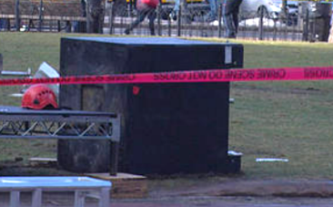

REPORT#: 19MA072 REPORT DATE: December 18, 2023

Rigging Crew Leader Crushed by Light Tower Weight — Massachusetts
SUMMARY
On December 28, 2019, a male 34-year-old rigging crew leader was fatally injured while assisting in the construction of a stage light tower. He was helping to position a light tower ballast weight when it slid off the forks of an all-terrain telehandler and crushed him. READ THE FULL REPORT> (p.3)
CONTRIBUTING FACTORS
Key contributing factors identified in this investigation include:
- Working within the fall zone of hoisted materials
- Failure to conduct a job hazard analysis
- Failure to provide required training to equipment operators
- Lack of coordination of safety and health programs at a multi-employer worksite
LEARN MORE> (p.9)
RECOMMENDATIONS
Massachusetts FACE investigators concluded that to help prevent similar occurrences, employers should:
- Ensure that employees are not within the fall zone of material being transported.
- Ensure employees routinely perform a job hazard analysis prior to the start of a job task.
- Ensure that employees who operate equipment are properly trained.
- Ensure that multi-employer worksite employers coordinate to develop, implement, and enforce safety and health programs at a shared site.
LEARN MORE> (p.9)
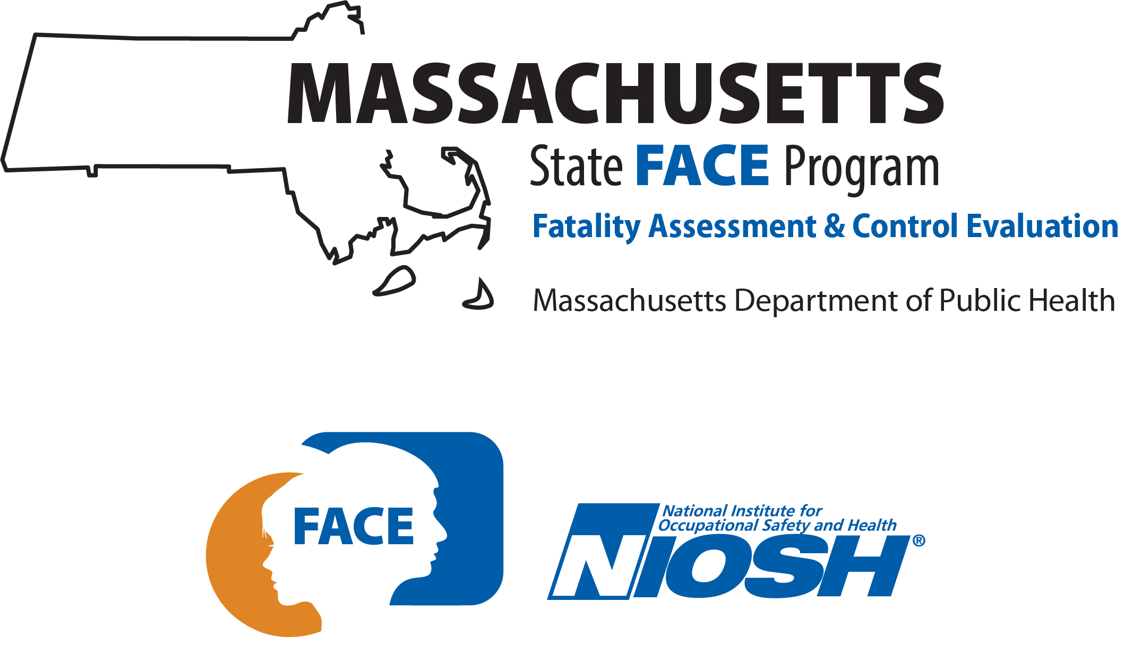
Fatality Assessment and Control Evaluation (FACE) Program

The Massachusetts Department of Public Health, in cooperation with the National Institute for Occupational Safety and Health (NIOSH), conducts investigations on the causes of work-related fatalities. The goal of this program, known as Massachusetts Fatality Assessment and Control Evaluation (Massachusetts FACE) is to prevent future fatal workplace injuries. Massachusetts FACE aims to achieve this goal by identifying and studying the risk factors that contribute to workplace fatalities, by recommending intervention strategies, and by disseminating prevention information to employers and employees.

NIOSH funded state-based FACE Programs currently include: California, Kentucky, Louisiana, Massachusetts, Michigan, New York, Oregon, and Washington.
Email | Website

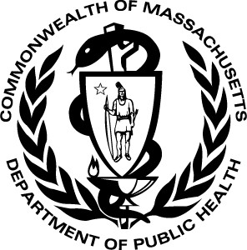

INTRODUCTION

On December 28, 2019, a male 34-year-old White non-Hispanic rigging crew leader was killed while assisting in the construction of a stage light tower. The victim was guiding the positioning of a concrete and steel ballast (weight) that was the base for the light tower. He was reportedly looking underneath the ballast as it was being moved with an all-terrain telehandler operated by an employee of another company. The ballast slid off the telehandler’s forks, striking and crushing the victim. Coworkers at the scene rolled the weight off the victim. A coworker placed a call for emergency medical services (EMS). The victim was pronounced dead at the scene.

The Massachusetts FACE Program learned of the incident from local media on the day of the event and initiated steps to collect relevant documentation to research the event. Several records were reviewed in the course of the investigation. The records included: data from the electronic death registration system (death certificate), police and EMS records, additional news coverage, and records from the Occupational Safety and Health Administration. The FACE investigator spoke with a representative from the company that employed the victim.

EMPLOYER
The direct employer of the victim was a commercial staging and rigging rental company that specialized in setting up staging and theater equipment for entertainment events. The business had been in operation for over 30 years, originally forming in a neighboring state in 1986. By 1999 the company had opened its first branch in Massachusetts. The current owner bought the company in 2015. The company’s main task is providing staging and rigging rentals, products, and services to entertainment events for clientele primarily in the New England area. The company had 32 employees in total at the time of the incident, with approximately 15 workers in Massachusetts. The workforce consisted of sales and project management, on-site leads or installation site supervisors (which included the victim), warehouse staff, and a driver.

In general, employees worked shifts based on event scheduling and using an on-call system. Work weeks could total between 70 and 80 hours per week. Most employees worked during the weekend. For the victim, 40-plus hour weeks and weekend shifts were common.

An event planning company was the lead organization for an event scheduled to take place on December 31, 2019. The event planning company had contracted with a lighting company to have a temporary outdoor entertainment venue installed in a public park. The staging and rigging rental company that employed the victim was subcontracted by that lighting company to provide the stage. Another production company was also subcontracted by the lighting company to provide construction labor for the site, including stagehands from a local theater and stage crew union. That company employed the operator of the telehandler and other workers who helped assemble the stage and components under the supervision of the rental company.

At the time of the incident, the victim’s employer had workers’ compensation insurance. As required by Massachusetts law, all employers operating in Massachusetts are required to carry workers’ compensation insurance for their employees and for themselves if they are an employee of the company. The requirement applies no matter the number of hours worked or the number of employees. At the time of the incident, employees of the company were not represented by a union.

WRITTEN SAFETY PROGRAMS and TRAINING
At the time of the incident, the company that employed the victim had a comprehensive safety and health program. The program was comprised of a series of equipment and operations training. These trainings were specific to the employee’s job tasks. Non-supervisory workers were provided with OSHA 10-hour training, and supervisors were provided with OSHA 30-hour training. In addition to this training, some workers had the following equipment and operations training renewed yearly: forklift training; aerial lift training; fall prevention trainings, including rescue and recovery; rope access certification training; and training on the principles of overhead rigging. Training was also provided by the manufacturer of the rigging equipment. Some workers were also CPR certified and had training in first aid.

The production company that employed the operator of the telehandler had a brief written safety and health program. The operator had been trained and certified to use certain formats of forklifts. However, he was not trained or certified to use the variable-reach-telehandler involved in the incident.

As discussed in the recommendations below, a job hazard analysis (JHA) or safety assessment of the worksite, materials, and equipment was not conducted by either the victim and his company or by the production company whose worker was operating the telehandler. Conducting JHAs is an important process that was lacking from both companies’ safety programs and procedures. Health and safety activities at the site were not coordinated between the multiple employers that were present.

WORKER INFORMATION
The victim was a 34-year-old White non-Hispanic male. The victim was hired in 2012 and had been a full-time employee at this staging and rigging company since 2013. His title at the time of his death was Crew Chief, a supervisory role for which he oversaw the assembly and worked with the hired crew. His typical work week ranged from 70 to 80 hours per week. The victim often took weekend shifts. The victim’s previous work experience was in theater set construction. The victim had completed the OSHA 30-hour training. He had also completed job trainings on fall prevention and aerial lift training. He had certifications in rope access, CPR, and first aid. He also had previous training in forklift operation and had a hoisting license to operate forklifts himself which was roughly one month past expiration at the time of the event.

EQUIPMENT
Seven light-supporting towers and a stage were being set up at the site. The stage consisted of eight or ten modular platforms that were connected together. The light towers had heavy weighted bases or ballasts that were set up on the ground and eight-foot sections of aluminum truss that were assembled to make the towers and cross members.

An image of the completed stage and rigging setup is shown in Figure 1. Additional light towers were set up around the venue.
The ballast weight that was involved in the incident weighed 3,200 pounds (Figure 2). It was a 36” cube consisting of concrete with rebar reinforcement within a welded steel plate shell. The sides of the steel shell were 3/8” thick and the top was 5/8” thick. Holes and connections for anchoring the rigging components were built into the ballast. Various connection pieces are visible in Figure 3 which shows the ballast in storage at the company. While some weights used by the company had cutouts or holes that ran through the weight for use when lifting with a forklift, the weight involved in the incident had four feet and a gap between the feet for lifting, as seen in Figure 2.

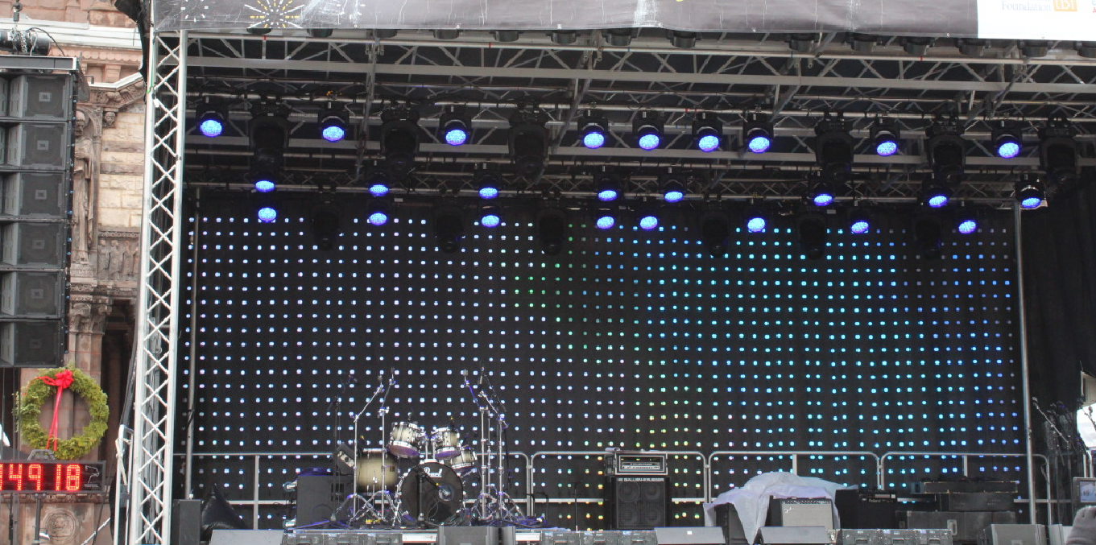
Figure 1 – Stage and rigging with lights (image from First Night Boston X/Twitter, @firstnight)
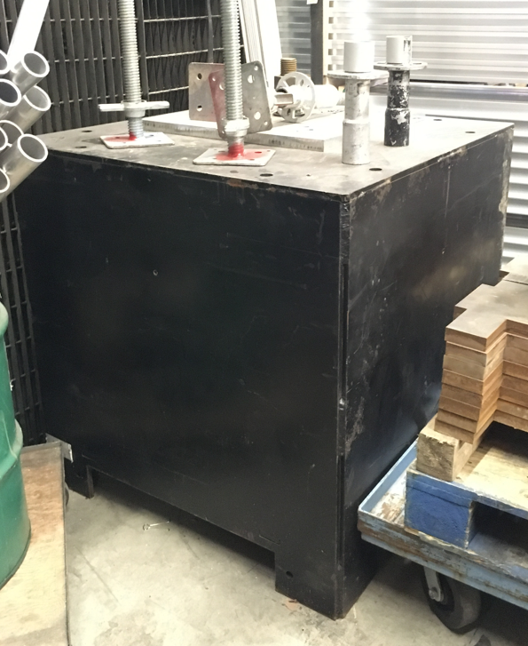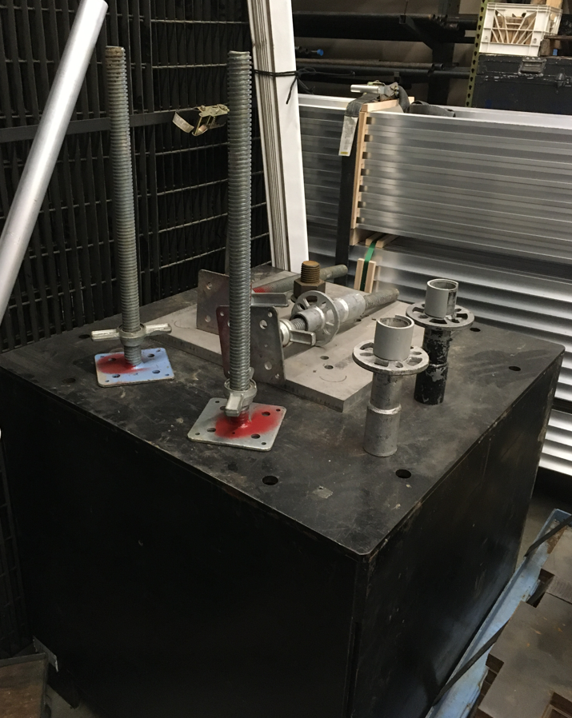
Figure 2 – Ballast weight (FACE investigator photo) Figure 3 – Rigging components (FACE investigator photo)
Also involved in the incident was a diesel-powered four-wheel steer/four-wheel drive all-terrain telehandler (Figure 4). This type of equipment is a class 7 rough terrain forklift with variable reach. It had a maximum lifting capacity of 5,500 pounds with the boom retracted. It had a lifting height of 20 feet and a load capacity of 3,900 pounds for vertical lifts. With the boom extended to its full reach of 11.5 feet, the lifting capacity was 1,750 pounds. The vehicle was six feet and two inches tall and six feet wide at its widest point at the tires. The wheelbase was seven feet and ten inches from axle to axle, and the overall length of the base unit was 13 feet and one inch plus the length of any attachment. The telehandler was equipped with a fork attachment.

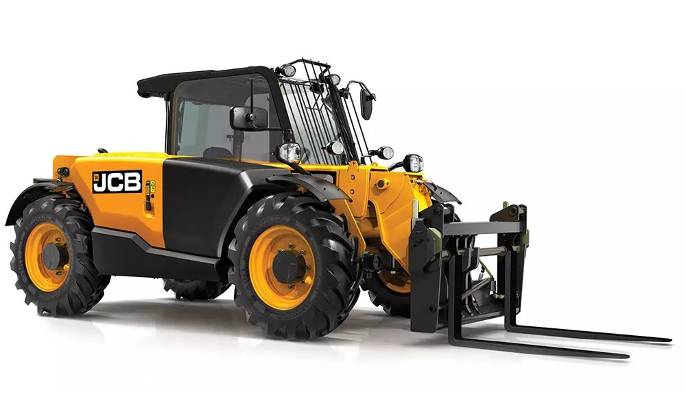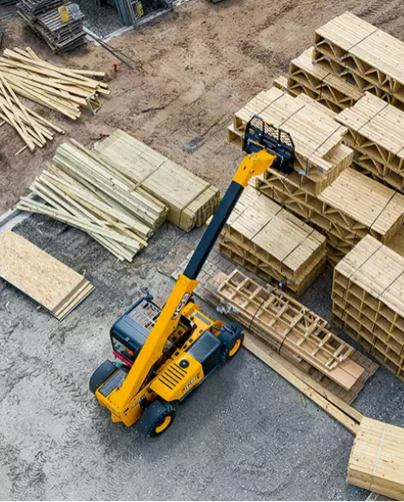
Figure 4 – Telehandler (manufacturer image) Figure 5 – Telehandler (manufacturer image)
The telehandler had three selectable steering modes: two-wheel steer; four-wheel steer that allowed for tighter turns; and crab steer that allowed for sideways movement.
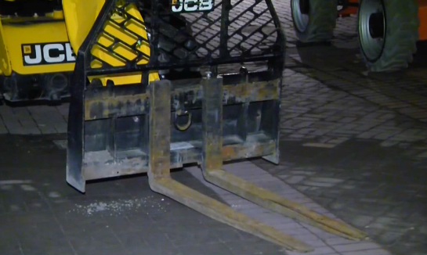
Figure 6 – Telehandler forks and backrest (scene footage)

INCIDENT SCENE
The incident occurred at a park in a city center (Figure 7). The open area public space was being converted into an entertainment venue (Figure 8). The paver stone space that held the entertainment rigging and staging was approximately 12,200 square feet of the outdoor space. The lawn space in front of the stage area was approximately 16,500 square feet. The outdoor cobblestone and green space were mostly flat.

Figure 7 – Park and paver stone area where the stage was erected (FACE investigator photo)
Figure 8 – Stage and venue in use (image from First Night Boston X/Twitter, @firstnight)

WEATHER
The weather at the time of the incident was approximately 45 degrees Fahrenheit, 63% humidity, with a nine miles per hour west wind, and clear skies [Weather Underground]. The weather is not believed to have been a factor in this incident.

INVESTIGATION
On the day of the incident, the victim arrived at the construction site at approximately 7:00 a.m. The victim was scheduled to work for four hours. The light tower component involved in the fatality was one of seven planned for installation that day. Prior to arrival, a fellow coworker had disassembled the light tower and truss from the stage for repositioning. The components needed to be moved approximately four feet from their current position. Compared to the other six light tower ballasts used by the company at the site, this weight was larger and heavier. The design of the slots for lifting the weight was also different: it had four feet and an open bottom, not cutouts that ran through the body of the weight as was the design of the smaller weights. This ballast design was new to the employee operating the telehandler.

A telehandler with a fork attachment was being used to reposition the ballast. An employee of the production company was operating the telehandler. The evidence suggests that the victim arrived after the light tower had been dismantled and the ballast was about to be moved. The equipment operator lifted the ballast approximately two feet off of the ground to move it. The victim crouched down and was looking between the ballast and the stage deck. While the exact position of the ballast relative to the stage deck at that time is not known, the evidence suggests the victim was trying to gauge the correct final placement of the light tower ballast and was in that space to guide the repositioning.

The weight of the ballast and its position on the telehandler caused the ballast to slide or tip off of the tines. The ballast first struck the victim in the head and then fell on the victim’s torso. Multiple workers at the site were able to roll the ballast off of the victim. A coworker immediately placed a call for EMS. EMS staff arrived within minutes and subsequently pronounced the victim deceased.

Figure 8 – Ballast weight on its side (scene footage)

CAUSE OF DEATH
The medical examiner listed the cause of death as blunt force injuries of the torso.

CONTRIBUTING FACTORS
Occupational injuries and fatalities are often the results of one or more contributing factors or key events in a larger sequence of events that ultimately result in the injury or fatality. Massachusetts FACE investigators identified the following unrecognized hazards as key contributing factors in this incident:
- Working within the fall zone of hoisted materials
- Failure to conduct a job hazard analysis
- Failure to provide required training to equipment operators
- Lack of coordination of safety and health programs at a multi-employer worksite

RECOMMENDATIONS/DISCUSSION

Recommendation #1: Employers should ensure that employees are not within the fall zone of material being transported.
Discussion: The fall zone of an object is the potential path the object will take if it tips or falls uncontrollably. The higher an object is lifted, the larger the fall zone becomes. Falling object hazards are a common concern in several work settings, such as construction, tree care, and stone slab transport. These hazards can exist when materials are moved using equipment. In general industry, OSHA regulation 1910.178 (m)(2) Powered Industrial Trucks requires no employee to be permitted underneath or passing underneath components or loads held by a powered industrial truck, such as a telehandler. Several preventative measures can be implemented to ensure the safety of employees. Ensuring employees are not positioned within the fall zone of an object will help prevent employees from being struck or crushed by a dropped object. Keeping the load low to the ground and no higher than is necessary to safely operate the equipment is a way to reduce the fall zone and hazard. Additionally, employers should ensure that transported materials are properly secured and stable prior to transport.

In this case, the telehandler operator was attempting to move the ballast approximately four feet from its initial position. The telehandler had lifted the ballast approximately two feet from the ground. The weight of the ballast and its position on the forks made it unstable, resulting in the ballast sliding off the forks. It is unknown if the span of the forks on the telehandler had been adjusted to optimize stability when moving the larger weight. It is also unknown if the forks had been appropriately tipped backward in order to stabilize the load against the backrest. In addition, the load could have been moved at a lower height, close to the ground.

Recommendation #2: Employers should ensure employees routinely perform a job hazard analysis prior to the start of a job task.
Discussion: A job hazard analysis (JHA) is a method for systematically analyzing a job task for potential hazards. A hazard is any situation that could result in injury or illness if left uncontrolled. When conducting a JHA, an employee considers the interconnected relationship between the worker, the task, the tools, and the work environment. The purpose of a JHA is to identify potential hazards prior to the start of a task to reduce or eliminate the hazard(s).

The first phase in a JHA is determining each step within a job task, including the necessary equipment and tools. Following the identification of each step, workers should identify hazards or potential hazards and the appropriate equipment to be used to complete the task. When new equipment is introduced to workers, they should review the owner’s manual and warning labels provided by the manufacturer. In addition, employers should ensure that employees have completed all necessary trainings to use the new equipment prior to the start of the job task.

A safety and health workplace plan based on a JHA should be developed by the employer and followed wherever workers are assigned tasks. Identification of on-the-job hazards allows for preventative measures to be taken to reduce or eliminate any potential job hazards facing workers. Preventative measures could include procedure modifications, additional training, or the use of personal protective equipment. JHAs are a proactive response to on-the-job hazards.

Neither the victim nor the worker using the telehandler conducted a JHA or specifically assessed this job site for hazards. In this case, executing a JHA would have identified the use of new equipment, the larger and heavier ballast, and allowed for consideration of the procedures used to move the ballast. A JHA would also have detailed the type of forklift used at the site and identified that the all-terrain telehandler was a different class of forklift, requiring specific training for the operator.

Recommendation #3: Employers should ensure that employees who operate equipment are properly trained.
Discussion: OSHA requires that operators of equipment like the telehandler involved in this incident be properly trained. The operator must have demonstrated competent operation of the equipment after that training. The training is required to have several elements that are specific to the particular equipment. These elements include, but are not limited to, general equipment operation and the specific controls and instruments of the unit, steering and maneuvering, visibility and restrictions on visibility that may be caused by a load, and fork or attachment operation and limitations. Other required training elements include vehicle capacity, vehicle stability, surface conditions, load stability, and interactions with other workers on foot. The employer must certify and document when the worker has been trained.

In addition, in Massachusetts, the operators of hoisting equipment, which includes the telehandler involved in this incident, are required to obtain a specific operator’s license issued by the Office of Public Safety and Inspections. Obtaining a license to operate hoisting machinery requires training and passing a written or practical examination. Similar to the OSHA training requirements, the state license is for specific classes and types of equipment. A telehandler with an extending boom is a different type of forklift that requires a different license.

In this case, the equipment operator was appropriately trained to operate a different type of forklift and not the all-terrain telehandler. The ground conditions at the site consisted of paved areas, pavers, and packed soil. It may have been appropriate to use a different forklift class, on which the operator was trained, at the site instead of the telehandler. The scope of the project and materials, as well as available equipment and trained operators, should be considered during project planning and implementation. Ensuring that equipment operator training is complete is a critical component of an employer’s safety and health program.

Recommendation #4: Employers should ensure that multi-employer worksite employers coordinate to develop, implement, and enforce safety and health programs at a shared site.
Discussion: Worksites with more than one employer require more oversight for the safety and health of all employees. When employees from multiple entities are performing job tasks within the same site, they are being exposed to all hazards on that site. It is each employer’s responsibility to implement safety precautions to protect all parties present on a site. Under OSHA’s Multi-Employer Citation Policy, employers have an obligation to identify, prevent, and control for hazards present on a multi-employer worksite. Each employer’s active prevention of hazardous worksites includes the discovery of hazardous conditions, the periodic inspection of the worksite, and the installation or maintenance of safety/health equipment or devices.

Ensuring the health and safety of employees on multi-employer worksites requires diligent oversight on all supervisory levels. The employers should collectively develop, implement, and enforce safety programs. A collaborative, proactive approach to site safety will help ensure the health and safety of all employees. In this incident, having coordinated safety and health programs, which included the completion of JHAs, would have informed all employees of the equipment being used, both the larger ballast and the telehandler.

Having a comprehensive safety and health program is essential to maintaining a safe workplace. A safety and health program should include the systematic identification, evaluation, and prevention or control of both general workplace hazards and the hazards of specific jobs and tasks. The core elements of an effective safety and health program are management leadership, worker participation, hazard identification and assessment, hazard prevention and control, education and training, and program evaluation and improvement. The program should outline safe work practices workers are expected to adhere to, specific safety protection for all tasks workers perform, how workers can identify and avoid hazards, and who workers should contact when safety and health issues or questions arise. The program should also include an explanation of the workers’ rights to protection in the workplace.

When developing a safety and health program, employers should start by performing a general hazard analysis of tasks routinely performed by employees. Those findings should be incorporated into the comprehensive program. Employers should also use their employees’ expertise throughout the program development process, and eventually during the updating process, by seeking employee input. Once the program is developed, employers should ensure that they have fully and effectively implemented their safety and health program by routinely performing assessments of tasks and immediately addressing any observed unsafe conditions. The program should also be updated when safety concerns arise and when new equipment, tasks and chemicals are introduced into the workplace.

Routine training should be provided to all employees on the program’s topics and procedures, and the training should also include hazard recognition and the avoidance of unsafe conditions. All training provided to employees should be documented. Training ensures that workers know how to safely perform required job tasks. Trainings should be performed by a competent person, which is defined by OSHA as “one who is capable of identifying existing and predictable hazards in the surroundings or working conditions which are unsanitary, hazardous, or dangerous to employees, and who has authorization to take prompt corrective measures to eliminate them.” Any training needs to be provided in the employee’s preferred language. This means the training must be provided in the language(s) and at the literacy level(s) of the employees.

The Massachusetts Department of Labor Standards (DLS) offers free consultation services to help small employers improve their safety and health programs, identify hazards, and train employees. DLS can be contacted at 508-616-0461. More information about DLS can be found on their website at mass.gov/dos/consult.

The Massachusetts Department of Industrial Accidents (DIA) has grants available for providing workplace health and safety training to employers and employees. Any company covered by the Massachusetts Workers’ Compensation Insurance Law is eligible to apply for these grants.

ADDITIONAL RESOURCES

The Center for Construction Research and Training — CPWR and CDC-NIOSH infographic How Heavy is Deadly?.

Equipment Safety: Forklifts Toolbox Talk. DHHS (NIOSH) Publication No. 2022-147.

Occupational Safety and Health Administration Powered Industrial Trucks (Forklift) eTool.

The Center for Construction Research and Training — CPWR Pre-Task Planning Assessment Checklist.

Department of Labor Standards (DLS), On-site Consultation Program, mass.gov/on-site-consultation-program.

Forklift Safety Guide, State of Washington, April 2001, depts.washington.edu/wineryhs/Content/Forklift Safety Guide.pdf.

DISCLAIMER
Mention of any company or product does not constitute endorsement by Massachusetts FACE and the National Institute for Occupational Safety and Health (NIOSH). In addition, citations to websites external to Massachusetts FACE and NIOSH do not constitute Massachusetts FACE and NIOSH endorsement of the sponsoring organizations or their programs or products. Furthermore, Massachusetts FACE and NIOSH is not responsible for the content of these websites. All web addresses referenced in this document were accessible as of the publication date.

REFERENCES
Weather Underground. Weather History. Massachusetts: TWC Product and Technology LLC.

OSHA Code of Federal Regulations. 1910.178 Powered Industrial Trucks and (l) Operator training.

OSHA Job Hazard Analysis and sample form.

OSHA Hazard Identification and Assessment.

Code of Massachusetts Regulations, Office of Public Safety and Inspections: 520 CMR 6 Hoisting Machinery and License type class guide.

OSHA Directive 02-00-124 Multi-Employer Citation Policy.

OSHA Recommended Practices for Safety and Health Programs.

