**Rights Review**

Promoting Human Rights by providing information and discussion across DDS

**Newsletter of the DDS Human Rights Advisory Committee and the DDS Office for Human Rights**

**Volume 6 Issue 1 August 2016**

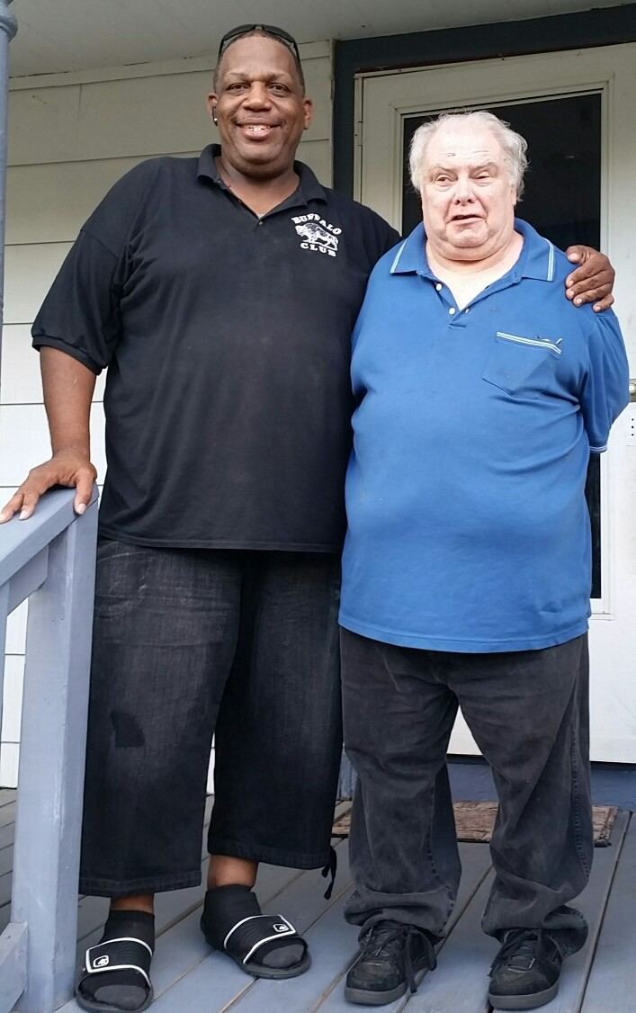

**Getting Connected**

Supporting the human rights of more than 36,000 people served by the Department of Developmental Services is a big job and a crucial one. There are a number of parts to play, all important. A lot of the work falls to the provider agencies’ Human Rights Committees. There are 240 pro- vider agencies, and many have more than one committee. These volunteers are asked to protect the rights of some of our most vulnerable people. Services, supports, and plans can be complicated and difficult to implement and to re- view. The office for Human Rights and the Human Rights Advisory Committee would like to help.

This issue of the Rights Review is our effort to introduce (or re-introduce) ourselves to the community of Human Rights Committee members, Human Rights Coordinators, advocates and self-advocates. We would like to offer ide- as, guidance, and updates. We hope that you will offer sug- gestions, let us know how we can help, and share your thoughts, concerns, accomplishments, and quandaries.

So please:

• share this newsletter with others

**Human Rights Champion**

John went to his work program one day last year and his support- ers noticed that he was not his usual self. They were concerned and asked if he was feeling

OK. John disclosed that he was having some difficulties at home, he did not feel

that he was being treated well. The agency’s Human Rights Coordinator and their Human Rights Com- mittee felt that something needed to be done to sup- port John.

They contacted the DDS regional Human Rights Spe- cialist and asked her to look into the matter. She met with John, who expressed

his desire to move out of his

• contact us, let us know what is going on with your committee

home, but also expressed

his fear of revealing this

**Leon and John at home**

• suggest topics for future newsletters

• submit articles

• ask for help

We can help each other in our mutual mission to support our folks in exercising their human rights.

"I am neither an optimist nor pessimist, but a possibilist." **Max Lerner**

desire to his brothers. After numerous discussions about human

rights and self-advocacy; a trusting relationship began to develop between John, the Human Rights Specialist and the Service Coor- dinator; John decided to inform his family that he wanted to move. John had the chance to meet several potential shared liv-

ing providers and decided to move in with Leon. He immediately settled in, decorated his room the way he wanted and invited the Human Rights Specialist and Service Coordinator to visit. He is proud of his new home and of his decision to advocate for him- self. We decided to ask John a few questions about how he went about making these changes in his life.

1

**Human Rights Champion—continued**

**John—The Interview**

Rights Review Reporter Teka Harris recently met up with

John to ask him about the changes he has made to his life

**Teka—”Why did you want to move out of your home?”**

John -” My brother was calling me names. He was smok- ing and I have COPD. They (family members) didn’t want me to have a girlfriend.”

**Teka—”Why were you afraid to tell your family you wanted to move out?”**

John -” I was afraid that they would act up. They might get mad. They kept telling me it was not a good idea.”

**Teka—”Who helped you to come up with a plan to talk to your family and tell them you wanted to move out?”**

John -” Luis (Team Leader and employment supporter), Cynthia (Human Rights Coordinator), Erin (Service Coordi- nator), Arlene (outreach worker and supporter), Teka (DDS human rights specialist)”

**Teka—”What is it like now that you’ve moved? Tell me about your new home.”**

John -” Peace and quiet. I have peace and quiet. There’s no name calling, and I can go out on the back porch to do my puzzle books. I am happy. My girlfriend hasn’t come to my house yet, but I went to her house, and we some- times go to restaurants and the movies. I would say we’re dating.”

**Teka—”What kinds of things do you do with your care- giver now?”**

John -” We just went to Washington DC. I saw the White House, the Capitol, the National’s stadium and the thing that looks like a rocket (the Washington Monument). I go to church on Sundays. I go to New Jerusalem. I’m an ush- er once a month.”

**Teka—”What would like you like to change about your life now?”**

John -” Nothing. Oh wait! I want to win fifty grand.”

**Teka—”What would you tell other people who wanted to move out, but were afraid to speak up?”**

John -” I would tell them to talk to Cynthia”

**In Reviewing Restraints**

Emergency Restraints are a part of DDS service provision. Nobody wants to perform them and nobody wants to be restrained. However, there are times when an emergency occurs and a restraint is necessary in order to prevent a serious injury from occurring. This is not something that we take lightly, and we certainly don’t want any unneces- sary or unwarranted restraints to be happening. If there is something that could be done differently to defuse a situa- tion before it escalates into an emergency, then that is what should happen. We are not looking to get staff in trouble, we want to teach better ways to support our indi- viduals.

As a Human Rights Committee member, you are called up- on to review restraints. We would like to offer you some suggestions about how to look at a restraint in conducting your review.

• Was there a real emergency which justified the need for the restraint?

• Was the restraint the least restrictive way to address the emergency?

• Were there less drastic ways of handling the situation?

• Was the restraint used safely, with the minimum amount of time and force necessary?

• Could the circumstances leading to the use of restraint

have been avoided?

• How can they be avoided in the future? Is there a plan to do so?

If a restraint is needed, and does occur, we may be able to reduce the number of future restraints with

a thoughtful review of the events that led up to it and a strategy about how to avoid it in the future.



**Regional Human Rights Forums**

**The Choice is Yours**

On June 21st, a Human Rights Forum was held at the La Sal-

**Choice Matters**

The Northeast Regional forum was held on June 29th

in Beverly

ette retreat center, in Attleboro. One hundred and fifty ad- vocates came together to celebrate choice and self- determination in an atmosphere of community; it was a fantastic day. The event was hosted by the Southeast Re- gional Human Rights Specialist, Nate Hoover.

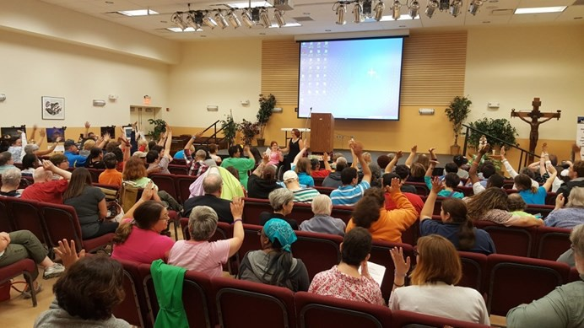

• Opening remarks by Richard Santucci, from the DDS Office for Human Rights.

• Ed Wilson, the regional manager of Self-Direction for

DDS gave an overview of Agency with Choice and Partic- ipant Direction. This is a wonderful program which ena- bles service recipients to take charge of their services by purchasing them directly, with an allocation from the DDS.

• Deanna Gagne who is a self-advocate and Change Agent

Facilitator from Bridge Building Services gave a wonder- ful interactive presentation about self advocacy and speaking up for yourself.

• After an excellent catered lunch, we had the pleasure of

learning about Bridges to Faith. This is a program that connects individuals with worshipers who share their faith, from community churches, synagogues, and mosques. It is important to support individuals to have a fulfilling spiritual life. We heard touching, personal stories from members of the group and it was a power- ful presentation that left many in the audience with teary eyes.

• To round out our day discussing choice, Susan Harring-

ton and Nate Hoover spoke to attendees about the im- portance of voting and having one’s voice heard. through civic channels.

Mass. The participants were comprised of self-advocates, family

members, provider and DDS staff. Rebecca Christie, the North- east Regional Human Rights Specialist was our host. Highlights of the program included:

• Opening remarks by DDS Regional Director Amanda

Chalmers and M.A.S.S. member Joseph Canto

• A session on “Future Planning” by two members of the Med- ical Ethics Committee, RN’s Susan Graves and Kathy Cooper. This was an important discussion about difficult decisions that we all face as we age.

• Hillary Dunn from the Disability Law Center presented

“Supported Decision Making” which is an interesting new alternative to guardianship.

• A panel discussion on “choices that matter to self-

advocates”. The panel included self advocates, providers, and a Mass Advocates Standing Strong coordinator. It was facilitated by Rich Santucci from the DDS office for Human Rights.

• Presentations by Sandra Artemis and Paula Mione, two self-

advocates who shared their life’s journey with us

• Closing remarks by M.A.S.S. member Donna Jay

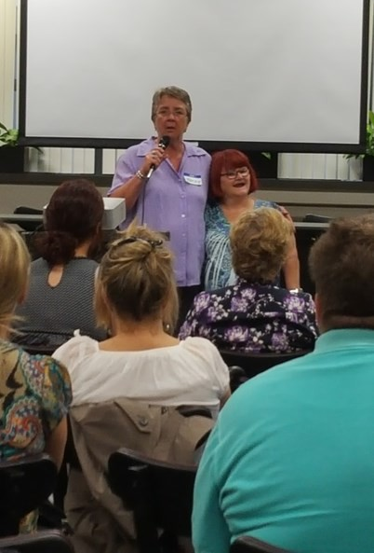

Best Practices

The folks at the Walnut Street Center in Somerville are doing some great work in supporting folks to exercise their human rights.

In late 2014 Dr. John Cutera, a consulting therapist here at WSC, approached our Clinician Jenn Thompson with the idea of starting a group called RAP (Relaxation And Peer support) the group is a self-directed, peer support group. The group includes 8 people who re- ceive varying degrees of support. The group meets weekly and each member is asked to bring at least one item that they would like to discuss.

Each week the meeting starts with a check-in with each individual. The check-in is followed by each person offering up the topic or issue that they would like to discuss. Topics include anything you can think of but often involve social skills, coping skills and conflict res- olution. The goal of the group is to support people to more independently receive peer support, brainstorm solutions and problem solve.

Ray, a member of the group says “*I like the RAP group because I get to see my friends and we talk about eve- rything. They help me.”*

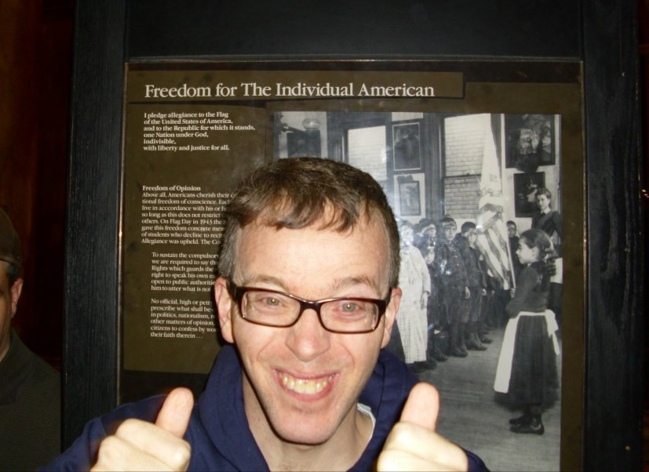

**David at the statehouse**

WSC Programs promote self-advocacy by attending all State House events such as the ADDP day at the state house/box lunch with guest speaker Charlie Baker. We also assist anyone who is interested to attend the Car- ing Force rallies like the 5th annual Caring Force State House Rally. People that attend our Day Services really enjoy being able to represent and advocate for their communities.

Resource Roundup There are a lot resources which are available to human rights committees, which not everyone knows about. We will try to highlight a new one in each edition of the Rights Review **Medical Ethics consultations**

From time to time we are faced with difficult health deci- sions about the people who we support.

Perhaps an individual does not want to follow a doctors order around a serious health issue. Maybe there is some reluctance to provide needed medical treatment for a per- son with a disability. End of life decisions can be difficult. Well-meaning families and supporters may have different values which can complicate the decision making process.

A Medical Ethics Advisory consultation can provide sup- port and consultation that honors the integrity of the per- son, the family, provider agency and DDS staff.

DDS offers a Medical Ethics Advisory committee, which is situated in Lawrence, but they are happy to meet and con- sult with folks from around the state. The Committee is composed of persons with disabilities, family members, DDS employees and community members from the fields of social work, clergy, law, medicine, nursing, psychology and ethics.

In the Western Region, DDS has a medical ethicist who can meet with folks at her office or at a program or home site.

When faced with difficult decisions, there is a real benefit to having an open, honest, non-judgmental conversation with knowledgeable, caring, people. A medical ethics con- sultation can help to sort out feelings, values, facts, and opinions in helping a team to best support an individual with medical needs. If you or your team could benefit from the services of a medical ethics consultation please contact:

Pat Cronin Betsy Johnson

Northeast committee Central/West

978-774-5000 ext 274 413-284-1500 ext 1593

[Pa t. cron in @sta te. ma. u s](mailto:Pat.cronin@state.ma.us)  [Betsy .jo h n so n @sta te. ma. u s](mailto:Betsy.johnson@state.ma.us)

**Save these Dates**

**September 13th** –**Beyond the Real Lives Law,** a confer- ence in Middleton Presented by the ARC of Greater Haverhill and Mass Advocates Standing Strong.

Join Commissioner Elin Howe, Regional Director Mandy Chalmers, Rep. Tom Sanicandro, Sen. Barrett , Sen. Barba- ra Litalien, and Rep. James Kelcourse in working with self advocates to create a meaningful future. There will be presentations, panels and group discussions, to develop action plans, including specific next steps and goals.

For more information contact Buddy Bostick, 978-373-

0552 x210 [buddy.bostick@thearcofghn.org,](mailto:buddy.bostick@thearcofghn.org)

**September 30th**—**Human Rights Forum** In Worcester, presented by the DDS office for Human Rights

Please join the Office For Human Rights, Massachusetts Advocates Standing Strong (MASS) work team and the DDS Diversity Committee as we discuss the importance of Human Rights, Self-Advocacy and Diversity to our every- day lives!

For more information contact Teka Harris, 413-205-0892

[Teka.J.Harris@state.ma.us](mailto:Teka.J.Harris@state.ma.us)

**October 15th** - **Self Advocates Making the Future**, the Mass Advocates Standing Strong Annual Conference in Worcester

This day will be jam-packed with interesting speakers, an array of fun and educational workshops, lunch, a panel discussion, open-mic, artist tables, MASS T-shirts for sale, vendor tables, some fun activities that we have never had at past conferences, a surprise drawing and a fun finale

For more information, call the MASS office at 617-624-

7549

**DIGNITY:**

**Definition:** The quality or state of being [worthy,](http://www.merriam-webster.com/dictionary/worthy%5b1%5d) honored, respected or [esteemed;](http://www.merriam-webster.com/dictionary/esteem%5b2%5d) possessing inherent nobility and worth

**~Dignity** is a state of mind developed when a person sees him or herself as a unique and va luab le member of society.

~The respect of others triggers the self- respect and sense of self-worth necessary to maintain **dignity.**

~Personal **dignity** is the key to a person’s growth and development. Court decisions, policies, statutes and regulations may at- tempt to protect basic rights; but it is in day to day interactions that a person learns most about autonomy, accomplishment

and self respect. Nothing on paper can take the place of sensitive and caring staff who relate to those with disabilities as hu- man beings with the same needs and rights we all have.

~….**This is the Basis for Dignity.**

~Di gni ty: The on e Ri ght whi c h

underli es al l others ~

**Hope -** a poem by Joe Canto

Self-advocacy is hope

Rising though the silence, above the noise of the status quo

It is my voice, lifted by my sisters and brothers in the self-advocacy family

I step into the unknown, not afraid to face whatev- er challenges come

I soar to new heights, to be free

I only have one life and I will dream

**REMEMBERING THOSE WHO LED THE WAY**

**FLORENCE FINKEL**

Florence Finkel, of Sharon Massachusetts passed away on November 9th, 2015. Florence was a parent and guardian of an individual with developmental disabilities. She was a founding member of the Massachusetts ARC

in 1955. Florence was the recipient of the DDS’ first

Gunnar Dybwad Human Rights Award. Here is her nomination:

*“Florence has worked tirelessly for many years, as an advocate, a human rights officer, a member of the DMR Statewide Advisory Council, a member of the DMR Hu- man Rights Advisory Committee and foremost as a par- ent. Her leadership has protected the interests of people residing in facilities and their families.*

*She has kept the Department’s feet to the fire to be hon- est and fair. She continues to have an uncanny ability to smell trouble and bring it to the light of day. A consum- mate organizer and negotiator, Florence is known and respected throughout the state as an asset to anyone who is trying to alter the Department’s positions.*

*Throughout her many years she has been known to be forthright and direct. Even though in recent years she*

*has had to confront her own limitations, she continues to be a powerful voice of reason and compassion. When Florence speaks, we all have reason to listen. We may not always agree, but if we listen close enough, we will understand why her point has merit.*

*It is with great pleasure that I take this opportunity to nominate Florence Finkel for this prestigious award.”*

To reach the HRAC or the Rights Review please contact:

**Rich Santucci**

Director of Human rights

Department of Developmental Services

500 Harrison Ave Boston Ma 02118 (617) 624-7738

[Rich.Santucci@state.m a.us](mailto:Rich.Santucci@state.ma.us)

**MAUREEN PERERIA**

Maureen served for years as the Department’s Hu- man Rights Specialist in the Southeast Region. A tire- less advocate, she helped people find their voices

and share their stories. Her signature Human Rights training, “It’s My Right to Eat That Cookie,” was al- ways presented with marvelous wit, humor and can- dor.

Maureen understood that policies, the Bill of Rights and all the laws of this land can never protect people who are devalued, as much as those who know

them, care about them, and share a part of their own lives with them. Maureen brought out our best selves. She improved our lives, the lives of the peo- ple we support, and their families just by being the wonderful person that she was… and we will miss her .

When you can't make them see the light, make them feel the heat.-**Ronald Reagan**

**HRAC Members:**

Chair – **Diane Iagulli** (provider)

Vice Chair – **Hillary Dunn** (Disability Law Center)

**Cheryl Authier** (provider)

**Catherine Carpenter** (family member)

**Karen Carpenter** (advocate)

**Beth Charbonnier** (self advocate)

**Rachel Fox** (provider)

**Jake Green** (self advocate)

**Kelli Hyland** (provider)

**Pam Kromm** (family member)

**Misty McMillan** (family member, provider)

**Cynthia Piechota** (provider)

**Stephanie Stone** (DDS service coordinator)

**Helen Waldron** (family member)