**Riights**

**Reviiew**

**Newsletter of the DDS Human Rights Advisory Committee**

**and the DDS Office for Human Rights**

**Volume 6 Issue 2 December 2016**



**Freedom for**



**All**

**Self Determination**—The process by which a person controls their life. This is the principle upon which our lives, our country and our service system is founded. But does it apply to all of the people who

are supported by DDS?

Even those who cannot speak, who have significant limitations?

**YES !** Human Rights and Self Determination are for eve- ryone. We are all free and independent people, even if some of us need supports.

In this Issue

• We will meet an independent woman who directs her own supports.

• We will spotlight two of our Provider agencies and their efforts to support choices for folks in very differ- ent ways.

• We will learn how to listen to people who cannot talk

It’s all part of self determination.



**“Life is a sum of all your choices"**

**Albert Camus**

It’s My Life and My Choice

Patty lives in her own apartment in Arlington, and works part time for Mass Advocates Standing Strong. She commutes to her job in down- town Boston, riding two busses and a train.

“I have been speaking up for myself for 30 years” (say’s) Patty. “I used to live in a group home, but then I spoke up and told them that I wanted to have my own apartment.” She moved into an apartment with a roommate, supported by an agency, and while she liked it more than living in the group home, it was still not exactly what she wanted. She wanted to be in control of her own life. “Living on your own is not easy, but I don’t like someone telling me what to do. When you ‘gonna cook, when you ‘gonna clean your room, when you ‘gonna have a fire drill. Providers make up their own rules; people are capable of making

their own decisions. You learn from it, even if you hate what happens, it

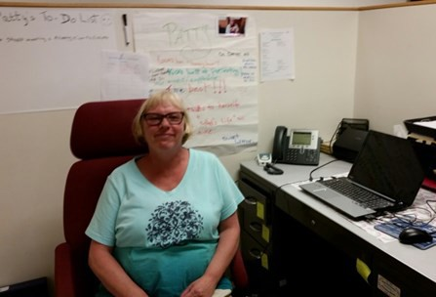

helps you to learn.”

Patty turned an agency’s mistake into a learning opportunity. Back when she received services from an agency, there was a problem with her financial records. The staff had made a mistake in totaling the fig- ures. A manager came to the house and told Patty not to worry, that she would teach the staff how to do it properly. Patty told her, “No; I want you to teach me instead”. Patty (say’s), “That’s how I learned how to take care of my money.”

**It’s My Life and My Choice** –continued



“When I went into my own apartment, it was scary at first, especially during the overnight. I had to get used to being alone, but I did get used to it. You have to take the risk.

I decided to self-direct my services in April. I chose the Agen- cy with Choice model, because I wanted some help with hir- ing the staff and doing the payroll. I started out with one agency. They gave me some staff to choose from, but there were problems. One staff that they sent me had a car with bad brakes. We had to go to the repair shop to get it fixed, while the staff was supposed to be helping me. I only get 6 hours of staffing a week, I cannot afford to waste any of it. Then they gave me a staff that did not even have a car. I

said, ‘how are we going to go food shopping?’ She said,

‘We’ll take a bus’. I said ‘no way’.

“Then I decided to try a different agency. This one is much better. I told them that I wanted a staff with a car, some- body who is young and hardworking and has a lot of energy. They sent me some people to interview, and I asked the questions that are important to me. The agency does the first interview, I do the second interview. It’s my interview. I ask them:

• Do you have a car?

• How do you clean?

• No cell phones during work

• Call me if you are going to be late. Don’t make me sit there waiting for you

• Call me a day ahead of time if you are going to be out sick

Now I have a wonderful young lady. She is 26 years old; she does everything that I ask her to, what I want to have done. She takes me here and there. She is helping me to decorate my apartment. We went to Target and bought some things for my kitchen. She helped me to measure and make sure that everything is the right size. We go food shopping. She helps me clean my apartment. If we get done early, we go to Dunkin Donuts for fun and to talk.

**I like Agency with Choice**. I have control and I get help that I need with the time sheets. I can call the case manager and ask questions if I need help with the time sheets. I don’t have to do the Want Ads, the CORI, the agency does all that. I

told them the type of staff that I wanted and they found just

what I was looking for. If you don’t get a good match with the staff, you can just hire someone else that you want. I like young people, some others like older people. You have to feel comfortable with the staff. “

**DDS Services – Have it Your Way**

There are three ways that you can receive your services from DDS; the traditional model, Agency with Choice, and the Participant Di- rected Program. You can decide which works best for you.

**The Traditional Model of services**

• You receive your services from a provider agency.

• The provider agency hires, trains, supervises and schedules the staff.

• The provider agency decides how to help you meet your goals

based on your ISP. They plan the services and the activities.

DDS has developed options that offer people more decision making and control regarding what services they need (and don’t need)

and how the services can be provided to best help them. The two Self-Directed models of services are Agency with Choice and the Participant Directed Program.

**Agency with Choice**

• You plan your services with the support of the provider agen- cy. You choose the Provider Agency that is the best fit for you.

• The Agency can provide support to you in hiring workers and

managing your service dollars. You make selections and deter- mine the schedule.

• If you like, The Agency may also work with you to make con-

nections in your community and to have social activities that fit your lifestyle.

**Participant Directed Program**

• You work with a Support Broker on an ongoing basis to cus- tomize your services through a Person Centered Planning ap- proach.

• The Support Broker helps to organize your supports and funds

to assist you in meeting your needs and achieving your goals

• You set up your own schedule and activities.

• You hire and oversee your support workers.

**Combination Option**

• You can have some of your services provided by the Tradition- al Method and some can be Self-directed.

• You may want to keep your traditional residential services, but

self-direct your employment supports or other day activities

**The Choice is Yours**

Provider Spotlight



**TILL Inc.**

**Supporting Choice**

Think about following a map or a taking a guided tour. One comes with choices to be made, the other with none at all. When using a map you choose the route you would like to take, but when you are on a guided tour... You are just along for the ride.

At the home that I work at, all of the individuals are nonver- bal and are highly medically involved. In spite of these chal- lenges, our goal is to provide them with the highest quality of life, independence and learning. We incorporate many practices, tools and methods to accomplish this goal. One such practice was to have the support staff explain Human Rights Topics during our weekly house meetings. My team and I would draw a wealth of information from our training

guidebooks but quickly learned the value was limited only to those who could understand the verbalizations. As I looked across the room and it was full of blank stares… It felt like the individuals were not getting anything out of it. I thought to myself, we can do better, but how?

These guys and gals needed a voice. They needed someone to advocate for them to make a change in how we teach. So now the challenge became for my staff and me to re- engineer and adapt to their learning style.

How could we improve engagement about choice making?? It was a pretty simple answer... We needed to explore how everyone would best learn from the information that was being provided. We realized that pictures and physical ob- jects were the best learning tools. Just like the old saying goes “A picture is worth 1000 words”.

I put together a picture book of all the Human Rights topics that we discuss and then also implemented a choice making book for the individuals to use with pictures of everything from snacks to places to go on vacation. Pictures, iPads and physical objects became the new teaching tools at the Wal- nut Street residence. Individuals and staff started to become more engaged, you could tell by their demeanor that they got a sense of accomplishment and involvement. It became exciting! They were starting to be able to make choices for themselves. It was amazing to witness the change in their facial expressions and body language. It is something they look forward to everyday.

The ladies and gentlemen at Walnut Street have now done an array of activities and have really become a part of the communi- ty. We volunteer with Boy Scouts of America, a local food pantry and Make a Wish Foundation. Two of the individuals are season ticket holders at the North Shore Music Theater. We have part- nered up with Zot Artz, which is a company that makes adaptive painting tools, where we have made murals using their wheel- chairs. We have also opened a club house for all the houses in TILL to utilize. We have a variety of different activities like Bingo, arts and crafts, movie night, karaoke, dances and have had peo- ple come in to perform live music for us as well.

It gives me such a great sense of pride to see how the individuals

and staff at Walnut Street have grown over the last six years. We have created a home that everyone loves to be a part of. We are always looking to be the best of the best in everything we do.

The individuals in Lynnfield are no longer on the guided tour,

along for the ride; they are using a map and making choices

to their own destination. Jennifer Polischuk Residential Manager

TILL, Inc.

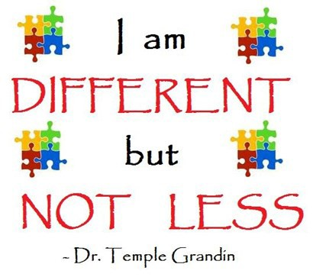

“It’s the repetition of affirmations that leads to belief. And once that belief becomes a deep con- viction, things begin to happen.” -**Muhammad Ali**

Provider Spotlight

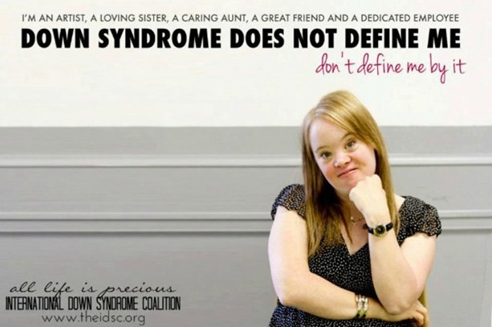

**CLASS INC**

“Vote for Missy.” “Laurel wants your vote.” “Vote for me please.”

This November, the national presidential election wasn’t the only presidential election discussed by individuals at CLASS. Every two years, more than 300 individuals at CLASS nominate their peers to be Human Rights presi- dents of their department. In the weeks leading up to the election, individuals running for this coveted office run their campaigns and make their speeches, vying for the votes of their constituents. Once elected, Human Rights presidents represent their departments and take on the responsibility as advocates.

Then the meetings begin. Human Rights presidents meet with their peers in the day programs and solicit infor- mation on issues that are important to them. After indi- viduals advocate for themselves, making suggestions for improving their programs and the facilities, their presi- dents develop a report, one they take directly to the CLASS CEO every two months in President’s Club meetings.

Hosted by the Human Rights Coordinator and CLASS CEO Bob Harris, the meeting convenes with elected represent- atives, five in total, during a lunch facilitated by CLASS staff members.

Through this forum, presidents become part of the deci- sion-making process, effecting positive change for them- selves and their peers. DDS Commissioner Elin Howe vis- ited the group to hear their concerns around employment and, as a direct result of their advocacy, CLASS presidents secured employment funding through DDS for several individuals who didn’t have it before. They are now gain- fully employed. Another positive outcome was securing a Merrimack College student volunteer who is focused on assisting individuals in developing and enhancing their reading skills. Finally, one individual’s effective peer ad- vocacy made it possible for wheelchair-accessible vans to be available to more individuals across CLASS programs. Now, many more individuals enjoy community activities with their peers.

President’s Club has allowed many people to express themselves and their concerns in a constructive manner, as well as empowering them to be part of the solution. It provides a safe environment for people to learn and practice good, effective leadership skills and develop more confidence through representation and public speaking. They are learning valuable social skills and set examples for those who wish to succeed them.

“I saw such a difference in the self-confidence of one of the individuals after holding the seat of President,” said a CLASS Case Coordinator. “The effect of this initiative can best be expressed through a quote from a past President,

‘I like to make my own choices’ – and that’s the way it

should be.”

Jen Arsenault John Byrne Class, Inc

Definition of ***choice***

*noun* \ˈchȯis\

1. **the power to decide :**

*“you can choose what you want”*

2. **the act of picking:**

*“there are several options to choose from”*

**3. the person or thing chosen:**

*“she was the first choice”*

Resource



Roundup

**New technology that can help in supporting individuals who have seizures**

What if there was a way to provide better support and protection for individuals with minimal intrusion on their privacy?

According to the American Academy of Neurology, wristbands, smartwatches, and other wearable devic- es allow for more real-time monitoring of seizures and other neurologic symptoms—and, possibly, more pre- cise treatment.

Individuals who have seizures or other neurological conditions can wear a wristband or smart-watch which can alert



staff that they are having a seizure or other neurological activity. This is more precise and immediate than any video monitor, and is not depend- ent on staff watch-

ing a video monitor

screen.

The devices also

serve to record neurological data. Unlike old- fashioned methods of data collection, which rely on handwritten patient logs and calendars, these wrist- bands and smartphone apps record events and chang- es in real time, revealing a more comprehensive and objective portrait of daily symptoms. “With this more precise information, we can often spot problems even before a patient is aware of them,” says Joseph I. Sirven, MD, a professor of neurology at the Mayo Clin- ic in Phoenix, AZ, a Fellow of the American Academy

of Neurology (FAAN), and a member of the Neurology

Now editorial advisory board.

Video cameras in bedrooms of individuals have sometimes been thought of as being a good way for caregivers to monitor and assure a rapid response to seizure activity. There are several issues with this solution.

A video camera in a bedroom is an extraordinary invasion of privacy.

It may not be effective. Unless caregivers are watching the monitor screen at all times they may not observe the sei- zure activity.

For many individuals who have seizures and other medical conditions which require monitoring and a rapid response, wearable devices which can monitor neurological activity and vital signs may be a great solution.

Here are a few links to explore this exciting technology which can be more effective and less intrusive in protecting the health and privacy of individuals.

[https: / /www.em patica.com / pro duct -em brace](https://www.empatica.com/product-embrace)

[http: / / sm art-mo nito r.com/](http://smart-monitor.com/)

[https: / / patients.aan.com/ reso urces/ neuro lo gy no w/](https://patients.aan.com/resources/neurologynow/index.cfm?event=home.showArticle&amp;id=ovid.com%3A%2Fbib%2Fovftdb%2F01222928-201511040-00023)

[index .cfm? ev ent=hom e.sho wArticle& id=o v id.com %3A%](https://patients.aan.com/resources/neurologynow/index.cfm?event=home.showArticle&amp;id=ovid.com%3A%2Fbib%2Fovftdb%2F01222928-201511040-00023)

[2 Fbib%2 Fo vft db%2 F0 12 229 28 -2 0 15 11 04 0 -0 00 23](https://patients.aan.com/resources/neurologynow/index.cfm?event=home.showArticle&amp;id=ovid.com%3A%2Fbib%2Fovftdb%2F01222928-201511040-00023)

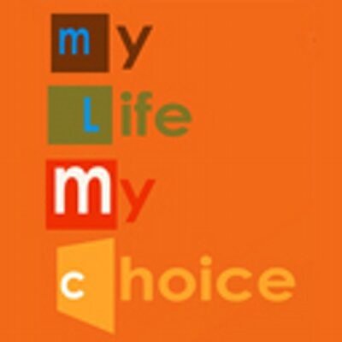

To reach the HRAC or the Rights Review please contact:

**Rich Santucci**

Director of Human rights

Department of Developmental Services

500 Harrison Ave Boston Ma 02118 (617) 624-7738

[Rich .San tu cci@ sta te. ma. u s](mailto:Rich.Santucci@state.ma.us)

Creating a culture of listening and observing

**Deb Plumer,** Coastal Connections in Amesbury

**It starts with Staff training:**

• DON’T do everything for an individual but

rather to find ways people can participate as much as possible in any given task.

• **Learn how each person MAKES AND EXPRESSES their choices**.

For example, an individual may look in a particular direction to indicate wanting to go there or may walk towards a particular place or thing.

• Teachable moments can occur at all times in all settings.

• All behavior is communication; figure out what is being said.

Our staff are encouraged to use their own interests as guides when engaging with individuals, whether it’s arts & crafts, exercising, or music. This taps in to a more natural experience for everyone. Staff learn to involve each individual in the process as much as possible and to be flexible in allowing how participation will take place. For example, a person may not be able to take off their own coat inde- pendently; however, if staff assists except for taking one arm out, then the person is participating and learning.

Staff have many tools available to interact with people. We have a daily group activity of reviewing human rights. Each person has their own notebook. During the discussion, some participants could ver- bally respond, others could sign and point to a picture to indicate their answer. For others, choosing their own notebook might be

the choice they are able to make. There are always visual aids and plenty of supplies available. Staff are supported in bringing their ideas to create ways for choice and self-determination to be exer- cised. The daily schedule includes morning meetings, discovery time, lunch and guided meditation. All participants are free to move throughout the program areas rather than staying in one room for the day. A teachable moment can be holding up two coats and ask- ing a person, “Which one is yours?” or helping people identify others in the group be asking “Where’s Tom?” or “Dan, can you say hello to Tom?”

People are not just recipients of service; they are actively engaged participants, to whatever extent they can. We provide as much support as is needed, not too little, not too much. Every person has the right to try for themselves--- **“let me do it before you help me.”** By supporting individuals to actively participate in their day and by observing their gestures, expressions and actions, we can better un- derstand the meaning behind their behavior and support the choices that they are making.

“Start by doing what’s necessary; then do what’s possible; and suddenly you are doing the impossible.” -**Francis of Assisi**



**Diversity**

People see and identify themselves as staff see them, rather than how they see themselves.

That is the struggle.

People have to accept themselves for who they are.

That’s diversity.

**Pauline Bosma**, Coordinator of the Rainbow Sup- port Group, M.A.S.S. member

**Correction**

In our last issue, we had an article about Medical Ethics.

We gave the wrong contact information for Betsy Johnson, the medical ethicist from the Central/West region. The correct phone number is 413-575-5956



6



**The real life work of Human Rights Committees**



Background

Doug lives in a group home for people who need medical sup- ports. His sister is his guardian. She loves him very much, but can be a bit anxious and protective. Doug is a bit of a wise guy. He enjoys teasing staff, especially female staff. He would like to have a girlfriend, but doesn’t have one. Sometimes the teasing with

female staff can be “flirty” which makes some people uncomforta- ble.

The Tablet

Doug asked one of the staff to help him to purchase a tablet. He loved it and began spending a lot of time in his bedroom with the tablet. One day a staff member discovered that Doug was looking at “sexy images” on the tablet. Nothing illegal, nothing that could get him in trouble. He was looking at things like the “Victoria’s Secret” website. Staff became worried. They held a staff meeting and decided that Doug shouldn’t be looking at such things. They called his sister, and she agreed with them. They told Doug that he could only use the tablet under staff supervision. Doug got angry and said, “you might as well just take it away from me.”

The Action

Doug talked with the human rights officer at his home. He said that he wasn’t hurting anybody and wanted to know why they were treating him like a child. The human rights officer helped Doug to file a grievance with the Human Rights Committee.

The Meeting

Doug came to the meeting with his human rights officer and pre- sented his side of the story. The house manager and the psycholo- gist presented their concerns. They worried if Doug was looking at “sexy pictures” that his “fresh remarks” towards female staff

would get worse. They also worried that he was spending too much time alone in his room. The Human Rights Committee asked if there was data to support these concerns. They asked if anyone was talking to Doug about looking at the “sexy pictures” and how that was different than talking to real women, including staff. The answer to both of those questions was “no”.

The Outcome

The committee made some recommendations. They said that if you think the tablet is causing Doug to behave differently you need to take data to prove it. They suggested that the psycholo- gist or a counselor should speak with Doug about the meaning of the pictures he was viewing and how that is different than inter-

acting with real women. They recommended that staff could

show Doug some other things he could do on the tablet. As it happens, Doug had an interest in Wrestling, and did not know that he could watch wrestling matches on the tablet. Finally the committee suggested that the staff negotiate with Doug as to a reasonable amount of time to spend in his room by himself with the tablet.

In this story, everything worked out in the end. Doug felt empow- ered that he had a voice in his life. Staff and Doug’s sister felt good that their concerns were not being ignored, as Doug would be receiving support and counseling around his interactions with women. The human rights officer, who was a little afraid that she would get in trouble for speaking up, found out that her advocacy was valued. It was a great day for Human Rights!



**HRAC Members:**

Chair – **Diane Iagulli** (provider)

Vice Chair – **Hillary Dunn** (Disability Law Center)

**Catherine Carpenter** (family member)

**Karen Carpenter** (advocate)

**Beth Charbonnier** (self advocate)

**Rachel Fox** (provider)

**Jake Green** (self advocate)

**Kelli Hyland** (provider)

**Pam Kromm** (family member)

**Misty McMillan** (family member, provider)

**Cynthia Piechota** (provider)

**Stephanie Stone** (DDS service coordinator)

**Helen Waldron** (family member)

**Sexual Assault Nurse Examiners (SANE)** Sexual abuse is certainly an uncomfortable and un- pleasant thing to think about; yet it does occur. Peo- ple with disabilities are a vulnerable group and are more likely to be victimized than others. In the event that anyone , whether they have a disability or not, is subjected to sexual abuse or assault, a designated SANE hospital can provide expert care and counsel- ing. We have included a list of all 32 designated SANE hospitals on the last page of this newsletter

7

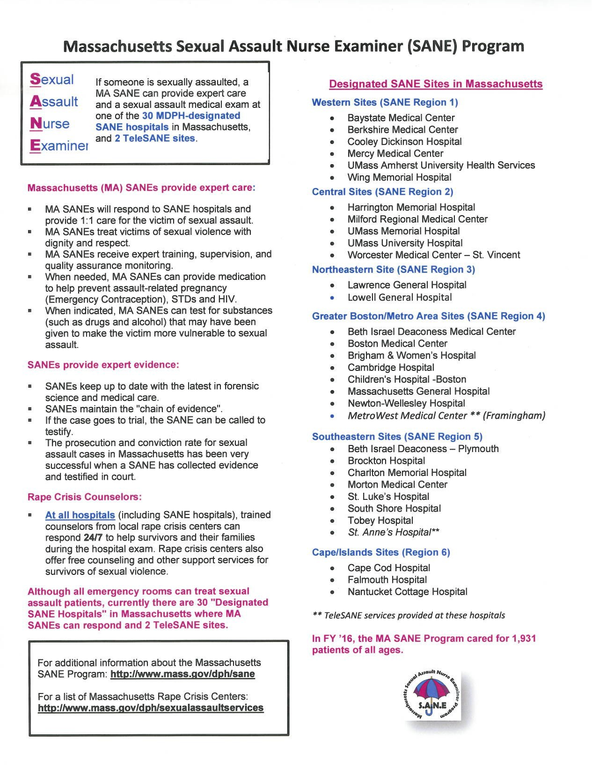

8