Newsletter of the DDS Human Rights Advisory Committee
and the DDS Office for Human Rights

Community Inclusion Edition

Volume 7 Issue 1 March 2017

Promoting social inclusion

The New DDS policy on social inclusion states:

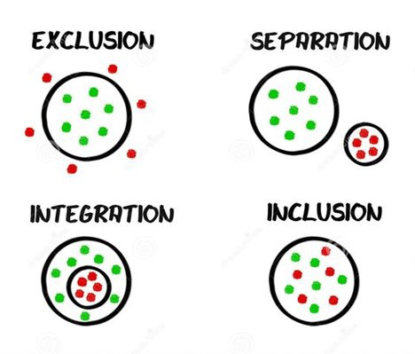
All supports offered by the Department of De- velopmental Services shall be provided in a manner that enhances opportunities for individ- uals to become fully engaged members of their community. Supports should actively work to ensure that people are not just “in” the commu- nity but “of” it.

In this edition of the Rights Review we will look at some of the ways in which people are engag- ing in a meaningful way with their community. It is one of the most basic human rights. We can all help to make it happen.

Extra Special Teas

When you walk up to Extra Special Teas in Great Barrington, you are drawn in by the bright colors, the tantalizing aromas, and the calm- ing music. Located in a beautifully decorated old Victorian house, it is an environment which is both stimulating and soothing. Extra Special Teas is many things; a tea house that serves delicious snacks, a community based day service and employer for people with disa- bilities, a center for community events.

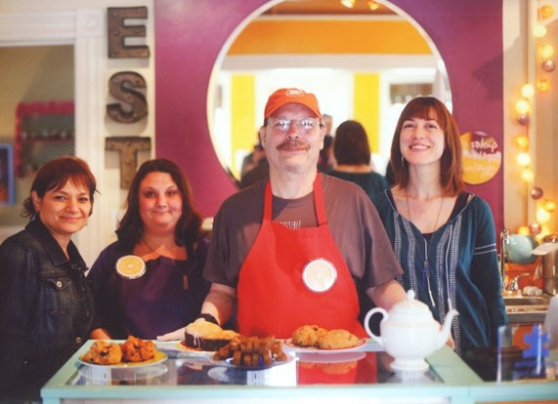
Extra Special Teas was started by founder Cherri Sanes. She was looking for day services for her transition age son, Jache, who has autism. Cheri and Jake knew what they wanted. Cheri “When Jache grew up, I had a vision for his life: to be part of the community, to love what he is doing, to be with people his own age. I wanted to create a place to promote community. I thought about creating a community hub which could also serve as a safe haven for all people and their families, a way to educate the public. I thought of opening a tea house. Tea is communal and healthy and we could serve healthy snacks. This is how Extra Special Teas was started.”

Cheri’s philosophy: “We don’t put limits on anyone or anything. Let’s see what people can do. I wanted to create a happy vibrant environ- ment. We use lots of bright colors, we want people to feel welcome. Everyone has something to contribute – we want the public to see that. They leave here feeling better. We want to be an inspiration.”

Cherri worked with the DDS Berkshire area office to bring her vision into reality; a community based day service situated in the midst of a thriving tea house. The original focus was to support young adults who are on the autism spectrum, but they are open to serving other folks with disabilities too. Cherie ,“A young man named Tristan lives in a DDS funded group home in the neighborhood. One day, before we opened, I was working at the site and Tristan rode up on his bicy- cle. He said, I hear you are opening up a teahouse. I am looking for a job and would like to work here. We decided to give him a try. “

Tristan has been working at the Tea house ever since. Tristan says, ” this is my first job in 14 years. I like the job a lot. I ride my bike to work every day. I help out with a lot of things, I work the dishwash- er, I stamp the bags, I help carry things around. I am going to learn how to bake, because I like to cook. I have a lot of ideas about what to cook, like a scone with a butter filling. People here are nice to me,
I have made a lot of new friends here. I am proud of where I work. I tell people at my church and my friends and family about my job. When I am at home I feel like Clark Kent, but when I am at work I feel like Superman”

Participants are treated to variety of stimulating, fun and purposeful activities. An art therapist works with them to create works which are incorporated into the tea house. The participants work on de- signs that are printed onto t-shirts and wrappers for power bars which are baked and sold by the participants.

The program rents space each week at a commercial bakery and par- ticipants create a wonderful variety of healthy, gluten free snacks which are sold in the tea house. A garden in the backyard is a source of vegetables and herbs which are used in the tea house. Plans are underway for a pottery business; the items can be created at the tea house and fired at a local kiln. They will soon be selling tea and other items on their website. This will create jobs for participants in pick- ing orders and shipping.

The community has embraced Extra Special Teas . Local people love what they are. They have hosted for several chamber of commerce events, book signings, and other community gatherings. We recently spoke with Betsy Andrus, the Executive Director of the Southern Berkshire Chamber of Commerce about Extra Special Teas. “They
are a part of our community because they are so community mind- ed. They participate in civic activities, host events, are members of the chamber of commerce and other local organizations. They have created an opportunity for their participants to be part of the community. “
And of course, the participants love it. Cherri’s son Jache is not verbal but she knows that he is happy. Cherri – “ Every morning we get into the car to come to the teahouse.
Jache starts giggling and laughing the whole way there. He cannot say so, but he loves it here. “

Starting up a tea house, opening up a program, getting funded and licensed by the DDS; this is an enormous un- dertaking. We asked Cherri, What made you think you could do this?

“Never underestimate the power of a special needs moth- er. Everything that I ever did in my life came together in this project. I love to cook, I love to entertain. I want peo- ple with special needs to be included in their community. I know that I am on my life’s path.

There have been a lot of challenges to overcome. But we stay true to our mission and things have always worked out” When asked , What would you say to other special needs parents?; Cherri replied ; “There is hope. There is something out there for everyone, something brighter.”

Cherri and her son Jache, enjoying a moment

Extra Special Teas

2 Elm St Great Barrington MA 01230

http://ww w. extraspecialteas.org

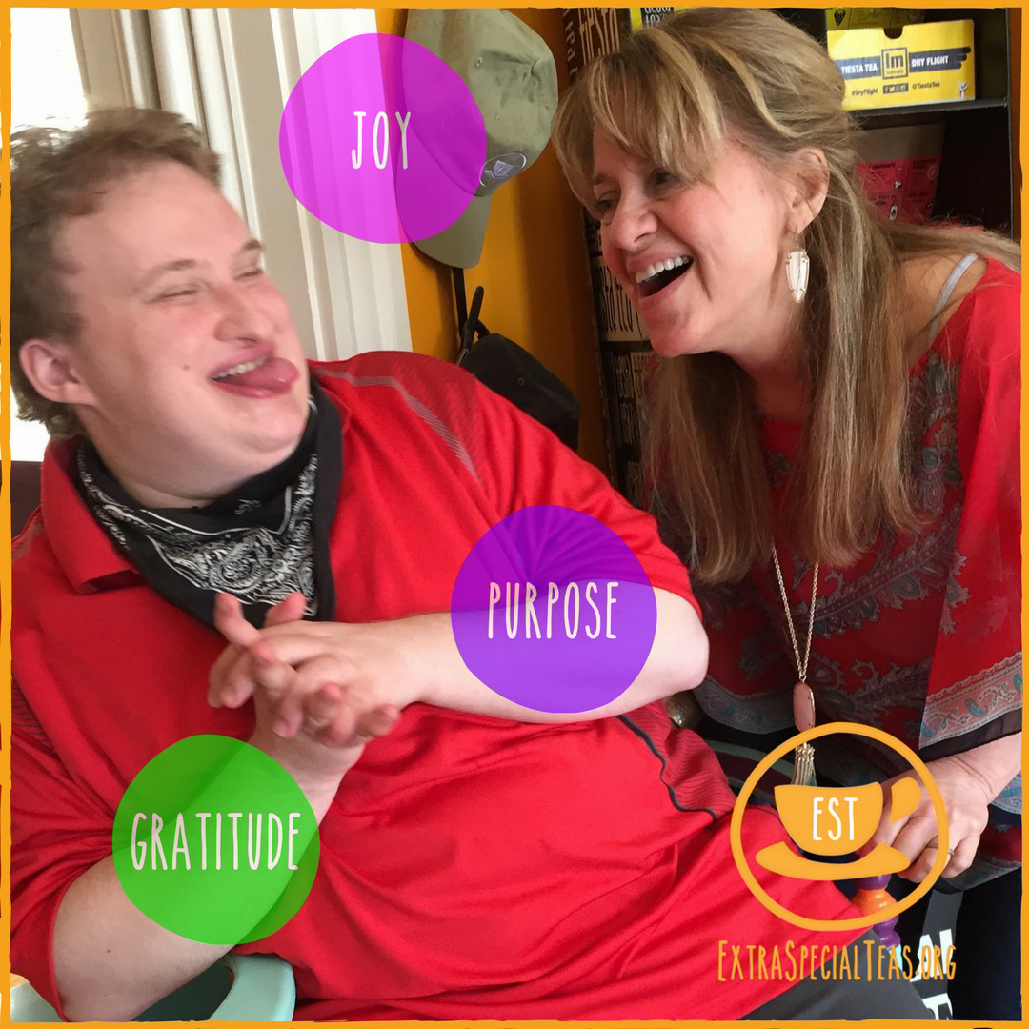
2

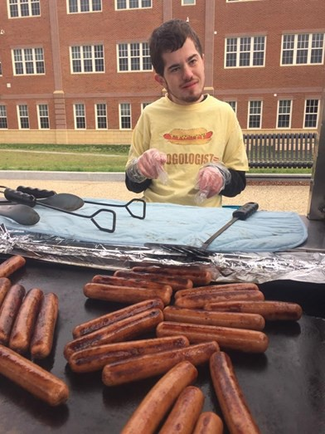
Our son - his life; A transition story
By Jeanna Shea

Our son, John Shea is an active 22 year old young man who lives at home in Plymouth County with us and his two young- er siblings. John was born with hydrocephalus, better known as "water on the brain". This resulted in other disabilities: cerebral palsy, intellectual disabilities, cortical visual impair- ment (legally blind), and epilepsy. He walks with a walker. He talks, though sometimes needs interpretation. These chal- lenges have never stopped him from engaging in a full life.

When John was approaching his momentous 22nd birthday we thought about the type of life that he would like to live. He will always require assistance for his personal skills and our goal was to have reasonable accommodation for him by
building a handicapped accessible apartment onto our home. This would allow him privacy and independence while still being close to the family. Through various funding, loans and hard work we were able to complete his "bachelor
pad" for him.
Then we began to think about what John would like to do during the day. For our son, a traditional day program was not going to be a great choice. We visited some day habilitation programs and some supported employment programs, but none of them were a good fit for John. Staying at home all day or being stuck in a building all day was not an option. We knew he wanted to be physically, mentally and socially active to have a meaningful and purposeful life. He loves people and he enjoys being “where the action is.”

We heard about self directed services, which could enable a per- son to design their own supports in order to live a meaningful life of their own choosing. We asked John what he wanted to do for job and he answered “sell hot dogs at Fenway”. Although Fen- way did not seem feasible, selling hot dogs seemed like a great idea!

Self-directed services was way to make it happen. We found a great deal on a hotdog cart and through a combination of our sav- ings and other funding we bought the cart and got into the hot
dog business. The Agency with Choice model of self-direction helped make the transition to adult services a smooth one. The ARC of Greater Plymouth made it easier for us to hire a great staff person, who is also a wonderful companion, working side by side with John at “DogHouseDog”.

DogHouseDog" is now a thriving business. John is cooking and selling hot dogs at High School football games, public events and parties. In December, John was an important part of our town’s Christmas celebration, “Holidays in Halifax” selling warm hot dogs on a cold night!

When John is not busy selling hot dogs he is an active member of his community. He works part time for “John and Son’s Barber- shop”, volunteers for meals on wheels and his church, exercises at the YMCA, and takes the train to Boston to explore the city. He is learning how to cook, how to paint and how to do public speaking.

Our son has a great life, doing what he loves. John is a wage earner, socializes with people of all ages, has responsibility to meet some of his own needs, works on staying physically fit, helps others through volunteerism, is involved with his family and is maturing while experiencing life in his community.”

John says “I like selling hot dogs and eating them too”. And so do his customers!

Human Rights

Champion

Making a difference in the community

Robert Schneider is a problem solver. Robert has been a participant at Massachusetts Association for the Blind (MAB) Community Services and MAB Works for over 20 years. He is a man with many talents from woodworker to community advocate.

As a participant of MAB Works in Alston, he noticed that the neighborhood needed some attention. The busy traffic really impeded folks from getting around and ac- cessing their community. There were several things that he thought needed to be fixed. These included:

• a pole was in the center of a sidewalk.
• some sidewalks were in disrepair with potholes.
• There was a lack of ramps for someone in a wheel- chair to use in front of a grocery store and at the end of the street making the sidewalks inaccessible.
• there were construction vehicles from a nearby site parking on the sidewalk in no parking zones pre- venting people from using the sidewalks.
• the lights at the top of the street in a busy intersec- tion were not working properly and the crosswalk light was out.

Robert compiled a book with photos he took of these problems, included explanations and then came up with solutions to fix them. He requested an appointment and met with Senator Sal DiDomenico’s Chief of Staff, Christie Getto Young, at the State House. He brought his book to fully explain what the concerns were and asked for some assistance with the repairs.
Senator DiDomenico and Christie Young visited MAB, held a community meeting and introduced themselves to eve- ryone. They gave time for everyone to share their con- cerns and ask questions. The Senator told Robert that
Robert works at MAB in many capacities. He is a wood- worker and has made many items. He made the bench that they do their gardening on, built a shed and a fence at his mom’s house, made birdhouses and delivered them to all the MAB houses; he repairs things that are
broken. He will go to the store to price out items and pick
them up needed to get a job done; he clears snow in the winter. The program was recently remodeled and he helped do some of finish work.

Robert says: “They did fix some things, but there is still some more left to do. The crosswalk light works, but it is too slow, I would like it faster!” With Robert Schneider
on the job, we have not doubt that all the work WILL get
done. And the community will be a better place for it.

The Self Advocacy Movement

Self Advocates need to work together. A train needs tracks to travel on.
Trust and communication are the tracks.

The advocacy movement works best when we work together.

Joseph Canto—Mass Advocates Standing
Strong

4

Resource
Roundup

Widening the Circle

It can be difficult for any of us to find and make friends especially for our service recipients. That’s where the Widening the Circle project can help. The idea for the project came from a parent; “We have done a great job in getting individuals out of institutions and into the com- munity. What can we do to help them to get more con- nected to their community, to make real friends?

Commissioner Elin Howe took this question to heart. She looked for an organizational partner who could help with this important work. The Mass ARC shared these values and wanted to get involved . That is how the Widening the Circle project was born.

The project provides training and consultation for provid- er agencies, staff, families, and self advocates who want to help our individuals to widen their circle of friends.
Jim Ross, one of the founders of the project says, “The
opportunity to form friendships between people with and without disabilities can be found where people live, work and play” .

Jim and his colleague, Mary Ann Brennan have developed a variety of resources which they are happy to share. There is NO CHARGE.

• Introduction to friends training—this 2 hour training is focused on helping individuals to establish and maintain friendships. Participants have included provider organizations, family groups, staff, and self advocates.

• Individual consultation—personalized support and problem solving around specific individuals, or chal- lenges.

• Organizational consultation—resources to help your agency to be better able to support and encourage friendships for service recipients

• Training for trainers—training for people to perform the introduction to friends training.

• Training materials and curriculum—the project is happy to share their materials and resources and encourages organizations and others to customize the materials to best meet their needs.

This is an excellent opportunity to make a difference in the lives of individuals.

If you are interested in in scheduling an “Introduction to Friends” training for your group, in becoming a trainer, in getting a consultation or just learning more about the Wid- ening the Circle Project, contact:
• Jim Ross at jbriii@comcast.net,
• Mary Ann Brennan at brennen01@charter.net
• or visit their website
http://thearcofmass.org/programs/widening-the-circle/

Everyone needs friends! People with friends are happier, healthier, and safer.

To reach the HRAC or the Rights Review please contact:
Rich Santucci
Director of Human Rights
Department of Developmental Services
500 Harrison Ave Boston Ma 02118 (617) 624-7738
Rich .San tu cci@ sta te. ma. u s

When restrictions
may be needed

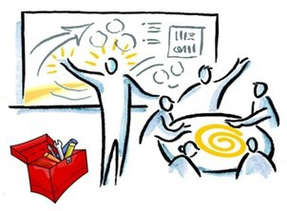

How to successfully include Self Advocates on your Human Rights Committee
By Massachusetts Advocates Standing Strong
For more information about MASS and Self Advocacy call
1-617-624-7549

Provide a good orientation to the committee

• Explain and discuss the purpose of the committee.
• Tell what the meetings will be like and what their role will be on the committee.
• Ask the person what support they will need in order to be successful.

Help the person to prepare for the meeting

• Discuss the agenda and decisions to be made ahead of the meeting.
• Send notes and materials out at least one week
ahead of time.
• Use at least fourteen-point font or large print as needed.
• Keep materials simple and clear, avoid acronyms.
• Use visuals to support ideas.
• Assist the person to make travel arrangements to and from meetings if needed.
• Allow the person to bring a support person if desired.

Encourage meaningful participation at the meeting

• Be sure your meeting gives everyone a chance to par- ticipate equally.
• Provide opportunities for self advocates to play val- ued roles on the committee.
• Ask their opinion, or ask them to report on a topic.
• Encourage other committee members to get to know the person.
• Encourage respect and teamwork amongst all mem- bers.
• Use people first language.
• Have fun!
There may be instances when the department or its providers need to impose limits on the freedom of movement, the privacy, the right to have visitors, or the pos- sessions of individuals in order to prevent them or others from be-
ing exposed to unreasonable risk. This may occur as a compo- nent of a behavioral support plan, or may take the form of an environmental modification or device. Individuals should be actively engaged in the planning process; understanding the need for and nature of the limitation, and the criteria by which the limitation will be eliminated.

In order for a restriction to be imposed, there is a process which must be followed:

• There must be a compelling safety concern. The individu- al or others are exposed to risks which are unreasonable, beyond the risks of typical developmental experiences.
• The proposed limitation is the least restrictive method to
mitigate the risk. There must be evidence that less restric- tive alternatives have been tried.
• The proposed limitation would be effective in limiting the
risk. It directly addresses the safety concerns.
• There is a teaching plan and strategies to support alterna- tive, less risky behavior on the part of the individual which could lead to eliminating the restriction.
• There is a plan to fade the restrictive intervention. It in-
cludes measurable criteria to eliminate the restriction or to assess its ongoing need. Restrictions are not intended to be long term unless absolutely necessary. They must address current safety concerns, not historic ones.
• Consent is given by the individual or guardian. They un-
derstand the safety risks, the proposed restriction, and agree that despite impact on other rights, that the pro- posed restriction is appropriate and needed.
• The Human Rights Committee for the provider must re-
view any restrictions being proposed.
• The ISP team must also review any restrictions being pro- posed.

We would never want to impose restrictions upon individuals unless it is absolutely necessary to do so. If you are a member of a Human Rights Committee, or an ISP team your thorough review of this process is essential to insure that Human Rights are being respected and protected.

The real life work of Human Rights Committees

Inclusion is for everyone

Betty is a member of the Women's Guild at her church in Attleboro. She has been a member for years and partici- pates in both the monthly meetings and the fundraisers for the Church. Members had always been very friendly to Betty at the meetings and at mass until things seemed to change at couple of recent events.

At last years’ Christmas banquet, Betty arrived early and sat at a table with her direct support professional, expecting that others would sit at the table of eight with her. As church members arrived, all found places to sit, other than
with Betty, even after being invited to do so by Betty herself. This year, the staff did some planning to address this and decided that Betty would arrive a little later to join others already sitting, but as she entered, she was told by the
event chairperson, that they had a table reserved for her. They beckoned Betty over to a small table for two (for her- self and staff) away from the other tables for church mem- bers. Betty was disappointed. She did not understand why she was not welcomed.

The staff person brought the issue to the human rights com- mittee. They discussed the impact that this was having on Betty’s self respect and dignity. They talked about what they could do to support Betty to be included as a member of the parish and welcomed in their activities and events.

Will, the program director, was familiar with the church and told the committee that he would contact a friend who is also a member of the parish. Another committee member, Eileen, is also friendly with the priest from the church and would speak to him as well as to the chairperson of the Christmas banquet. Will and Eileen would be in contact dur- ing this process and would report back to the committee at the next meeting.

At that next HRC meeting, Will and Eileen reported on their conversations with the President of the Women's Guild and the parish priest. Eileen had told them that she knew no one meant to be unkind or insulting to Betty, but wanted to
increase awareness to this issue. Betty is a very socia- ble person who always wants everyone together and would never have done that to others. Furthermore,
it was pointed out that although everyone knows of abuse and mistreatment, not everyone is aware of rights, dignity and respect and there should be in- creased awareness of this as well. The parish repre- sentatives took all of this to heart and apologized for the unfortunate circumstances with assurances that things would be better. They had not realized how much of a negative impact they were having on Betty.

At this year’s Christmas banquet, things were differ- ent. All the members of the Women’s Guild celebrat- ed the holiday together. There were no tables segre- gated from the others and everyone sat together and enjoyed the evening’s festivities!

HRAC Members:

Chair – Diane Iagulli (provider)
Vice Chair – Hillary Dunn (Disability Law Center)
Cheryl Authier (provider)
Catherine Carpenter (family member)
Karen Carpenter (advocate)
Beth Charbonnier (self advocate)
Rachel Fox (provider)
Jake Green (self advocate)
Kelli Hyland (provider)
Pam Kromm (family member)
Cynthia Piechota (provider)
Stephanie Stone (DDS service coordinator)
Helen Waldron (family member)

