
THE COMMONWEALTH OF MASSACHUSETTS
EXECUTIVE OFFICE FOR ADMINISTRATION AND FINANCE
HUMAN RESOURCES DIVISION
ONE ASHBURTON PLACE, BOSTON, MA 02108
THOMAS H. TRIMARCO
Secretary

JOHN O’LEARY
Chief Human Resources Officer

MITT ROMNEY
Governor

KERRY HEALEY
Lieutenant Governor

PLEASE POST PROMINENTLY

READING LIST ANNOUNCEMENT

TO: Police Department Appointing Authorities
Police Chiefs
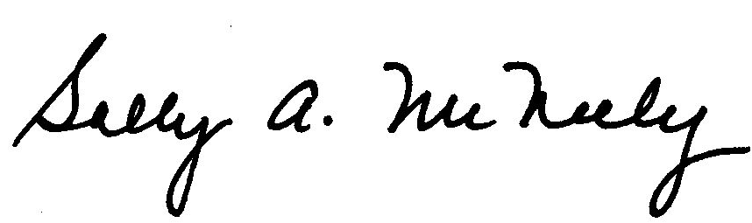
FROM: Sally A. McNeely, Director

Organizational Development Group/Civil Service Unit

DATE: November 12, 2006

SUBJECT: READING LIST FOR PROMOTIONAL EXAMINATIONS

DEPUTY POLICE CHIEF
POLICE CHIEF

EXAMINATION DATE  Saturday, May 12, 2007

Examinations for this series are scheduled for May 12, 2007. Candidates are responsible for reading the following texts. (Please note carefully which edition is listed for each.) All chapters, appendices, glossaries, etc., are included unless otherwise noted. All examination questions will be based on these materials.

Iannone, N. F., & Iannone, M. P. (2001). Supervision of Police Personnel (6th ed.). Pearson Education, Inc./Prentice Hall. (ISBN: 0136492290)

Swanson, C. R., Chamelin, N. C., Taylor, R. W., & Territo, L. (2006). Criminal Investigation (9th ed.). McGraw-Hill, Inc. (ISBN: 0073212784) All chapters except chapter 17.

Swanson, C. R., Taylor, R. W., & Territo, L. (2005). Police Administration (6th ed.). Pearson Education, Inc./Prentice Hall. (ISBN: 0131123114)

Thibault, E. A., Lynch, L. M., & McBride, R. B. (2007). Proactive Police Management
(7th ed.). Pearson Education, Inc./Prentice Hall. (ISBN: 013219368X)

Kappeler, V. E., & Gaines, L. K. (2005). Community Policing: A Contemporary Perspective (4th ed.). Anderson Publishing Co-Lexis Nexis. (ISBN: 1593459629)

(Continued on Reverse Side)

Collins, J. M. of the Law Firm of Collins & Weinberg. (2006). Police Desk Reference: Criminal Investigation Procedures: 2006/2007. Municipal Police Institute, Inc.

Champeon, S. R., (2006) Police Desk Reference to the Massachusetts Criminal Laws 2005/2006. Municipal Police Institute, Inc., (based on a manual prepared by Collins, J. M. & the staff of the Law Firm of Collins & Weinberg)….

Collins, J. M. & Glidden, R. C., (2006), Law Enforcement Guide to Firearms Law (11th ed.), Municipal Police Institute, Inc.

The primary source of examination questions that measure knowledge of law and court decisions governing police work in Massachusetts is the Massachusetts General Laws (amended as of November 12, 2006). The three Chief's Guides are secondary sources of information about law and court decisions. In the event of a conflict between the information contained in the Massachusetts Chiefs of Police Association guides and that contained in the General Laws, the General Laws will be the definitive source.

Publishers of Reading List Texts

Anderson Publishing Company-Lexis Nexis, 1275 Broadway, Albany, NY 12204; (800.223.1940); http://bookstore.lexis.com/bookstore/catalog

McGraw-Hill, Inc., P.O. Box 182604, Columbus, OH 43272; (800.262.4729); http://www.mcgrawhill.com

Municipal Police Institute, Inc., 47 Memorial Drive, Shrewsbury, MA 01545; (800.322.2011); http://www.masschiefs.org/MPI/Manuals/reading_materials.html

Pearson Education, Inc./Prentice Hall, Consumer Order Department, 200 Old Tappan Road, Old Tappan, NJ 07675 (800.947.7700); http://vig.prenhall.com. Note: The publisher advises all persons wishing to order the book by mailing a check, money order, or the equivalent to the listed mailing address to first call the “800” telephone number (provided in this entry) and obtain an exact price quote.

Please note that the Human Resources Division does not recommend specific bookstores for the purchase of reading list texts. For local vendors, contact the publishers at the address, telephone number, or web site listed, or check with the Chief of your department or local union representative for assistance. Many local bookstores will be able to special-order any text not carried in stock. Any questions regarding the reading list may be directed to Guy Paris, Personnel Selection Specialist, at 617.878.9759 or guy.paris@state.ma.us. Please request additional copies of this list from your department’s personnel office. This reading list is also posted on the Human Resources Division website in the Civil Service section at http://www.mass.gov/civilservice under Examination Information.

(See also Reverse Side)

