INDOOR AIR QUALITY ASSESSMENT

Robert Adams Middle School
323 Woodland Street
Holliston, MA

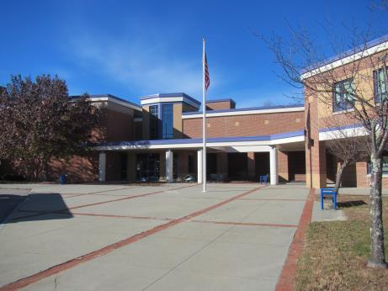

Prepared by:
Massachusetts Department of Public Health
Bureau of Environmental Health
Indoor Air Quality Program
December 2017

Background

Building: | Robert Adams Middle School (RAMS)
Address: | 323 Woodland Street, Holliston, MA
Assessment Requested by: | Keith Buday, Business Manager,  Holliston Public Schools
Reason for Request: | General indoor air quality (IAQ) concerns
Date of Assessment: | November 28, 2017
Massachusetts Department of Public Health/Bureau of Environmental Health (MDPH/BEH) Staff Conducting Assessment: | Jason Dustin, Environmental Analyst, IAQ Program and Ruth Alfasso, Environmental Engineer, IAQ Program
Date of Building Construction: | Built in 2000
Building Description: | Two-story, brick façade building on slab
Building Population: | Approximately 640 students in grades 6 through 8 with about 68 staff members
Windows: | Some openable

IAQ Testing Results
Please refer to the IAQ Manual for methods, sampling procedures, and interpretation of results (MDPH, 2015). The following is a summary of indoor air testing results (Table 1).
- Carbon dioxide levels were above 800 parts per million (ppm) in most occupied classrooms, indicating a lack of adequate air exchange in those areas of the building. Some areas were empty, which can reduce carbon dioxide levels.
- Temperature was within or close to the lower end of the recommended range of 70°F to 78°F in all areas on the day of assessment.
- Relative humidity was below the recommended range of 40 to 60% in all areas the day of assessment as is typical during the heating season.
- Carbon monoxide levels were non-detectable in all areas tested.
- Fine particulate matter (PM2.5) concentrations measured were below the National Ambient Air Quality (NAAQS) limit of 35 μg/m³ in all areas tested.

Ventilation
A heating, ventilating and air conditioning (HVAC) system has several functions. First it provides heating and, if equipped, cooling. Second, it is a source of fresh air. Finally, an HVAC system will dilute and remove normally occurring indoor environmental pollutants by not only introducing fresh air, but by filtering the airstream and ejecting stale air to the outdoors via exhaust ventilation. Even if an HVAC system is operating as designed, point sources of respiratory irritation may exist and cause symptoms in sensitive individuals.
Fresh air is provided to many areas by air handling units (AHUs) which are mounted on the roof (Picture 1). Air from the AHUs is filtered, heated or cooled as needed, and delivered to rooms via ducted supply vents (Picture 2). Most classrooms are equipped with fan coil units (FCUs) mounted against the exterior wall or in the ceiling (Pictures 3 and 4).
It was reported that the FCUs operate under an automated/energy efficiency management system and cycle off/on according to the set point of the thermostat. Many FCUs were obstructed by items placed on top or in front (Picture 5) of the units. Both the supply vent at the top and the return vent at the bottom need to be kept clear of obstructions for the FCUs to operate as designed.
Air is exhausted from ceiling-mounted exhaust vents (Picture 6). Some of these vents were reported to use the same diffuser style as the supply vents which made it difficult to determine which vent was used for removing stale air/pollutants from the room. Several exhaust motors were reported to need repair.
As mentioned above, most classrooms with normal occupancy appeared to have inadequate air exchange. In order to have proper ventilation with a mechanical supply and exhaust system, these systems must be balanced to provide an adequate amount of fresh air while removing stale air from a room. The AHUs should be inspected to ensure that the fresh air intake louvres are opened properly to increase fresh air to the classrooms. It is recommended that existing ventilation systems be re-balanced every five years to ensure adequate air systems function (SMACNA, 1994). It is unknown the last time these systems were balanced.

Microbial/Moisture Concerns
The US EPA and the American Conference of Governmental Industrial Hygienists (ACGIH) recommend that porous materials be dried with fans and heating within 24 to 48 hours of becoming wet (US EPA, 2008; ACGIH, 1989). If these porous materials (e.g., gypsum wallboard, ceiling tiles, and carpeting) are not properly dried they should be discarded to avoid microbial colonization. Water-damaged ceiling tiles were observed in some areas (Picture 7; Table 1), which indicate leaks from the building envelope or plumbing system. These tiles should be replaced after the leak is found and repaired.
Some areas where active or historic water leaks were noted had carpeting (e.g., auditorium). Any carpeting not dried properly within 24 to 48 hours of water exposure should also be replaced to avoid microbial colonization.
Water-damaged gypsum wallboard was observed in a hallway (Picture 8). It was reported that work to properly remove these porous building materials is already scheduled. This work should be performed according to guidelines found in “Mold Remediation in Schools and Commercial Buildings” (US EPA, 2008).
During an inspection of the exterior of the building, IAQ staff noted some trees/vegetation growing against the building (Pictures 9 and 10). These may hold moisture against the building exterior, preventing drying, and may allow water intrusion.
Indoor plants were observed in a few areas (Picture 11; Table 1). Plants can be a source of pollen and mold, which can be respiratory irritants to some individuals. Plants should be properly maintained and equipped with drip pans and should be located away from air diffusers to prevent the aerosolization of dirt, pollen and mold.

Other IAQ Evaluations
Exposure to low levels of total VOCs (TVOCs) may produce eye, nose, throat, and/or respiratory irritation in some sensitive individuals. To determine if VOCs were present, BEH/IAQ staff examined rooms for products containing VOCs. BEH/IAQ staff noted hand sanitizers, cleaners/spray bottles, air fresheners, and dry erase materials in use within the building (Picture 12; Table 1). All of these products have the potential to be irritants to the eyes, nose, throat, and respiratory system of sensitive individuals.
In a few areas, tennis balls had been sliced open and placed on table/chair footings to reduce noise (Picture 13; Table 1). Tennis balls are made of a number of materials that are a source of respiratory irritants. Constant wearing of tennis balls can produce fibers and lead to off-gassing of VOCs. Tennis balls are made with a natural rubber latex bladder, which becomes abraded when used as a chair leg pad. Use of tennis balls in this manner may introduce latex dust into the school environment. Some individuals are highly allergic to latex (e.g., spina bifida patients) (SBAA, 2001). It is recommended that the use of materials containing latex be limited in buildings to reduce the likelihood of symptoms in sensitive individuals (NIOSH, 1997; NIOSH, 1998).
Some classrooms contained ductless or portable air conditioners (ACs). Most ACs are equipped with filters that should be cleaned or changed regularly in accordance with manufacturer’s instructions to prevent the build-up of dust and debris.
Some classrooms had personal fans or fans mounted on walls near windows. Some of these had dusty blades/housing (Table 1). Some supply diffusers and exhaust/return vents were also observed to be dusty. This dust can be reaerosolized when the equipment is activated.
In many areas, items, including books, papers, and decorative items were observed on floors, windowsills, tabletops, counters, bookcases, and desks, which can make it more difficult for custodial staff to clean.
Carpeting should be cleaned annually or semi-annually in soiled high traffic areas as per the recommendations of the Institute of Inspection, Cleaning and Restoration Certification (IICRC, 2012). Many classrooms had area rugs, which should also be cleaned regularly and discarded when too worn out or soiled to be cleaned.
Some carpeted areas were noted to be soiled, worn, or wrinkled (Picture 14). The average lifespan of carpeting is approximately eleven years (Bishop, 2002). Most carpet was reported to be original to the date of building construction 17 years ago. Consideration should be given to planning for the installation of new flooring.
IAQ staff noted kitchen appliances in need of cleaning. Some refrigerators were observed to have spills and food residue inside which may increase the likelihood of microbial colonization and strong odors. Toaster ovens were noted to have accumulated food debris and residue which will increase particulates and odors in the air when heated (Picture 15). These may also be attractive to pests.
Note that the Environmental Protection Agency (EPA) conducted a National School Radon Survey in which it discovered nearly one in five schools had “…at least one frequently occupied ground contact room with short-term radon levels above 4 [picocuries per liter] pCi/L” (US EPA 1993). The BEH/IAQ Program therefore recommends that every school be tested for radon, and that this testing be conducted during the heating season while school is in session in a manner consistent with USEPA radon testing guidelines. Radon measurement specialists and other information can be found at www.nrsb.org and http://aarst-nrpp.com/wp, with additional information at: http://www.mass.gov/eohhs/gov/departments/dph/programs/environmental-health/exposure-topics/iaq/radon.

Conclusions/Recommendations
The following recommendations are made to assist in improving IAQ:
- Inspect the HVAC system to ensure that all fresh air intake louvres are opened properly and that no obstructions are interfering with the introduction of fresh air to the system.
- Operate all supply and exhaust ventilation equipment continuously during occupied hours to provide for continuous fresh air and filtration.
- Check exhaust vents (in classrooms and restrooms) for draw periodically and repair any non-operating motors/vents. If exhaust vents are found to be located close to doorways, classroom doors should be closed to facilitate proper exhaust function from the room.
- Use openable windows to supplement fresh air during temperate weather. Ensure all windows are tightly closed at the end of the day.
- Ensure roof and plumbing leaks are repaired and replace water-damaged ceiling tiles and other porous building materials (e.g., gypsum wallboard, carpeting) in a manner consistent with “Mold Remediation in Schools and Commercial Buildings” (US EPA, 2008).
- Remove items and furniture blocking FCUs both on top and along the front.
- Consider adopting a balancing schedule of every 5 years for all mechanical ventilation systems, as recommended by ventilation industrial standards (SMACNA, 1994).
- For buildings in New England, periods of low relative humidity during the winter are often unavoidable. Therefore, scrupulous cleaning practices should be adopted to minimize common indoor air contaminants whose irritant effects can be enhanced when the relative humidity is low. To control dusts, a high efficiency particulate arrestance (HEPA) filter equipped vacuum cleaner in conjunction with wet wiping of all surfaces is recommended. Avoid the use of feather dusters. Drinking water during the day can help ease some symptoms associated with a dry environment (throat and sinus irritations).
- Properly maintain plants, including drip pans, to prevent water damage to porous materials. Plants should also be located away from air diffusers to prevent the aerosolization of dirt, pollen, and mold.
- Eliminate or reduce use of products that create VOCs (e.g., air fresheners, scented cleaners). Remove air fresheners from FCU units.
- Replace tennis balls on chair/table footings with latex-free glides.
- Continue to change filters for HVAC equipment 2-4 times a year. The MDPH recommends using pleated filters of Minimum Efficiency Reporting Value (MERV) of 8, which are adequate in filtering out pollen and mold spores (ASHRAE, 2012), if these can be used with current equipment.
- Regularly clean/vacuum FCU cabinets, supply/return/exhaust vents and fans to avoid aerosolizing accumulated particulate matter. To clean ceiling grills, remove and wash.
- Clean ductless/portable AC filters/units prior to the start of the cooling season and according to the manufacturer’s instructions.
- Consider reducing the amount of items stored in classrooms to make cleaning easier. Periodically move items to clean flat surfaces.
- Clean carpeting annually (or semi-annually in soiled high traffic areas) as per the recommendations of the Institute of Inspection, Cleaning and Restoration Certification (IICRC). Clean area rugs similarly.
- Consider replacing worn carpeting that is past its useful life.
- The school should be tested for radon by a certified radon measurement specialist during the heating season when school is in session. Radon measurement specialists and other information can be found at: www.nrsb.org, and http://aarst-nrpp.com/wp.
- Consider adopting the US EPA (2000) document, “Tools for Schools”, as an instrument for maintaining a good IAQ environment in the building available at: http://www.epa.gov/iaq/schools/index.html.
- Refer to resource manual and other related IAQ documents located on the MDPH’s website for further building-wide evaluations and advice on maintaining public buildings. These documents are available at: http://mass.gov/dph/iaq.

References
ACGIH. 1989. Guidelines for the Assessment of Bioaerosols in the Indoor Environment. American Conference of Governmental Industrial Hygienists, Cincinnati, OH.
ASHRAE. 2012. American Society of Heating, Refrigeration and Air Conditioning Engineers (ASHRAE) Standard 52.2-2012 -- Method of Testing General Ventilation Air-Cleaning Devices for Removal Efficiency by Particle Size (ANSI Approved).
Bishop. 2002. Bishop, J. & Institute of Inspection, Cleaning and Restoration Certification. A Life Cycle Cost Analysis for Floor Coverings in School Facilities.
IICRC. 2012. Institute of Inspection, Cleaning and Restoration Certification. Carpet Cleaning: FAQ. Retrieved from http://www.iicrc.org/consumers/care/carpet-cleaning.
MDPH. 2015. Massachusetts Department of Public Health. “Indoor Air Quality Manual: Chapters I-III”. Available at: http://www.mass.gov/eohhs/gov/departments/dph/programs/environmental-health/exposure-topics/iaq/iaq-manual/.
NIOSH. 1997. National Institute for Occupational Safety and Health. Alert Preventing Allergic Reactions to Natural Rubber latex in the Workplace. National Institute for Occupational Safety and Health, Atlanta, GA.
NIOSH. 1998. National Institute for Occupational Safety and Health. Latex Allergy A Prevention. National Institute for Occupational Safety and Health, Atlanta, GA.
SBAA. 2001. Latex In the Home And Community Updated Spring 2001. Spina Bifida Association of America, Washington, DC.
SMACNA. 1994. HVAC Systems Commissioning Manual. 1st ed. Sheet Metal and Air Conditioning Contractors’ National Association, Inc., Chantilly, VA.
US EPA. 1993. Radon Measurement in Schools, Revised Edition. Office of Air and Radiation, Office of Radiation and Indoor Air, Indoor Environments Division (6609J). EPA 402-R-92-014. https://www.epa.gov/sites/production/files/2014-08/documents/radon_measurement_in_schools.pdf
US EPA. 2000. Tools for Schools. Office of Air and Radiation, Office of Radiation and Indoor Air, Indoor Environments Division (6609J). EPA 402-K-95-001, Second Edition. http://www.epa.gov/iaq/schools/index.html.
US EPA. 2008. “Mold Remediation in Schools and Commercial Buildings”. Office of Air and Radiation, Indoor Environments Division, Washington, DC. EPA 402-K-01-001. September 2008. Available at: http://www.epa.gov/mold/mold-remediation-schools-and-commercial-buildings-guide.
Picture 1
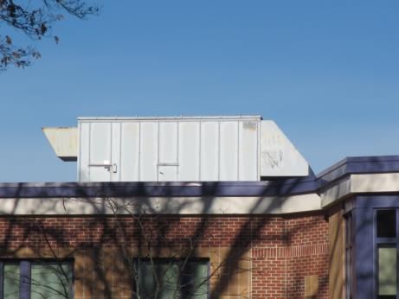
Rooftop air handling unit (AHU)
Picture 2
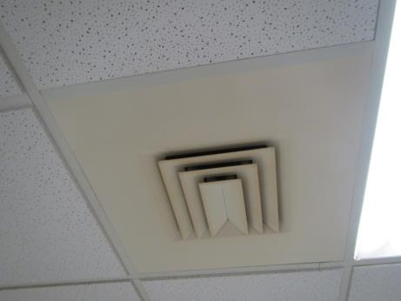
Ceiling-mounted supply diffuser
Picture 3
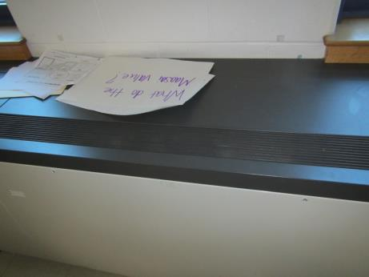
Fan coil unit (FCU) in classroom
Picture 4
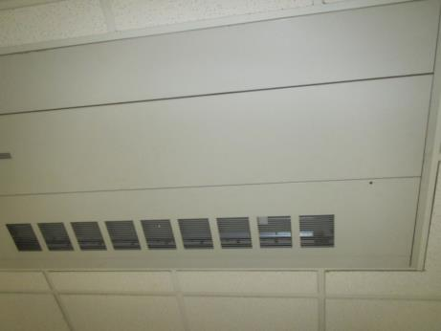
Ceiling-mounted FCU
Picture 5
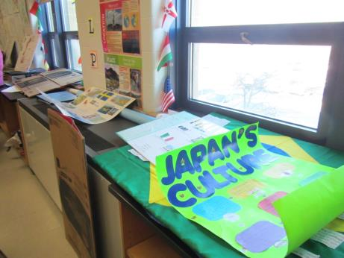
Items on and in front of classroom FCU
Picture 6
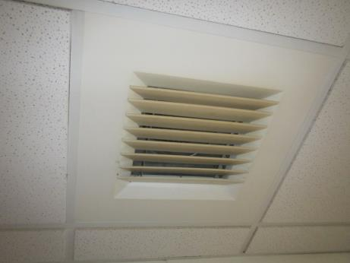
Classroom exhaust vent
Picture 7
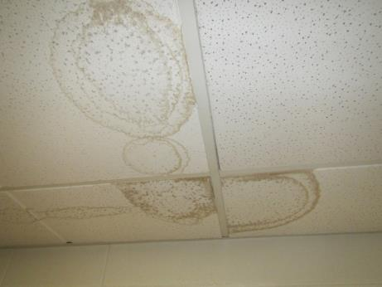
Water-damaged ceiling tiles in classroom
Picture 8
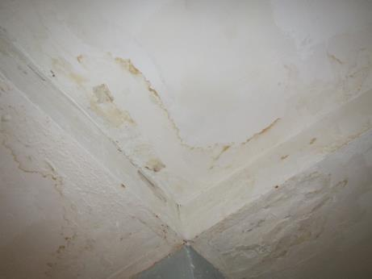
Water-damaged gypsum wallboard ceiling in hallway
Picture 9
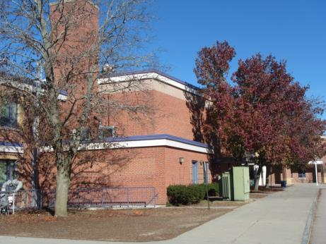
Trees/shrubs in close proximity to building exterior
Picture 10
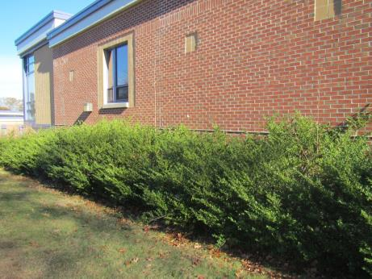
Shrubs against building exterior
Picture 11
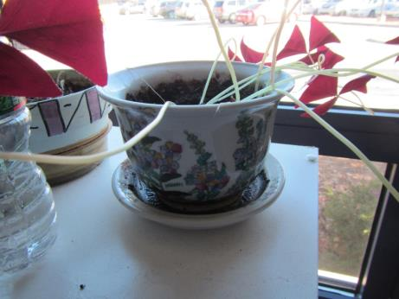
Plant in poor condition with debris/residue in drip plate
Picture 12
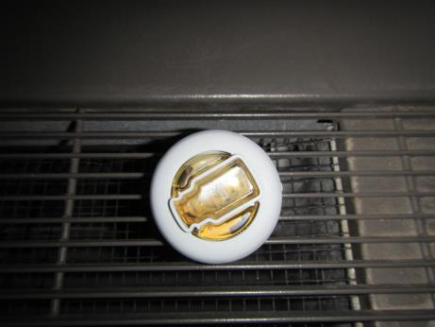
Air freshener placed on top of FCU in classroom
Picture 13
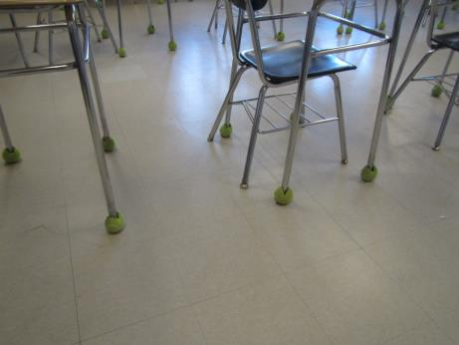
Tennis balls used as chair glides
Picture 14
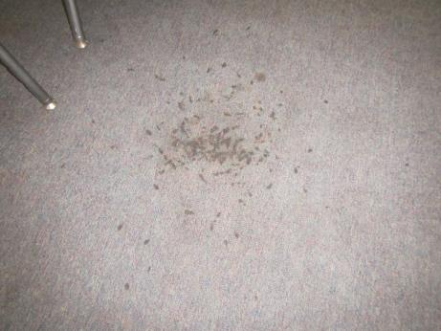
Worn/soiled carpeting in classroom #114
Picture 15
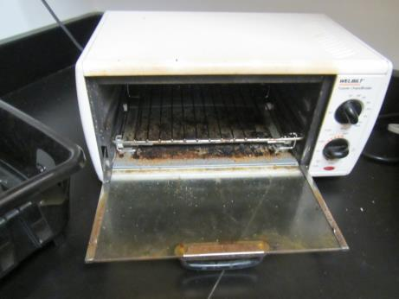
Toaster oven with food debris/residue

Location | Carbon  Dioxide  (ppm) | Carbon Monoxide  (ppm) | Temp  (°F) | Relative  Humidity  (%) | PM2.5  (µg/m³) | Occupants  in Room | Windows  Openable | Ventilation |  | Remarks
 |  |  |  |  |  |  |  | Supply | Exhaust
Background | 509 | ND | 38 | 23 | 4 |  |  |  |  | Sunny
First Floor
101 | 838 | ND | 72 | 19 | 9 | 4 | N | Y | Y | WD CTs x 5 (active leaks), plant
103 | 1270 | ND | 73 | 22 | 10 | 14 | Y | Y | Y | DEM, FCU
105 | 1328 | ND | 74 | 22 | 11 | 17 | Y | Y | Y | PF
Assistant Principal | 590 | ND | 74 | 14 | 3 | 0 | N | Y | Y | HS, carpet
Student Service Admin | 501 | ND | 74 | 14 | 2 | 0 | N | Y | Y | AI, carpet
Guidance area | 524 | ND | 72 | 15 | 3 | 2 | N | Y | Y | Wrinkled/worn carpet
Extended day | 505 | ND | 72 | 15 | 2 | 1 | Door open | Y | N | Slight musty odor, stored items/books brought from other locations
110 | 567 | ND | 73 | 15 | 3 | 9 | N | Y | Y | Art supplies
Library | 412 | ND | 73 | 12 | 4 | 3 | Y | Y | Y | Carpet, WD CT, DEM
112 | 411 | ND | 72 | 17 | 3 | 0 | N | Y | Y | DEM, CPs
114 | 422 | ND | 71 | 12 | 4 | 5 | Y open | Y | Y | DEM, soiled/worn carpet
114-A | 411 | ND | 70 | 12 | 4 | 1 | N | Y | N | Screens missing on windows, sensors broken/exposed
Cafeteria | 381 | ND | 67 | 13 | 5 | 5 | Y | Y | Y | AHU on roof, missing tiles
116 | 507 | ND | 68 | 17 | 3 | 0 | Y | Y | Y | Ductless AC unit
130 | 1135 | ND | 69 | 22 | 3 | 2 | Y | Y | Y | DEM
118 | 1446 | ND | 70 | 26 | 4 | 3 | Y | Y | Y
119 | 2270 | ND | 71 | 33 | 4 | 21 | Y | Yon | Y
120 | 1511 | ND | 72 | 26 | 2 | 18 | Y | Y | Y | Mini fridge, cinnamon fragrance, plants
121 | 1468 | ND | 72 | 24 | 3 | 20 | Y | Y | Y | AI, DO
122 | 1590 | ND | 73 | 25 | 2 | 14 | Y | Yon | Y | DEM
124 | 1849 | ND | 73 | 26 | 3 | 17 | Y | Yon | Y | Intermittent fan on FCU, plants
123 | 3189 | ND | 73 | 34 | 9 | 23 | Y | Y | Y | CP odor, Lysol wipes
102 | 1469 | ND | 72 | 25 | 5 | 7 | Y | Y | Y | DEM, body odor, sink
104 | 1760 | ND | 73 | 26 | 6 | 5+ | Y | Y | Y | PFs, dusty
106 | 1341 | ND | 74 | 19 | 12 | 1 | Y | Y | Y | DEM, PF – dusty
107 | 1200 | ND | 75 | 17 | 12 | 20 | Y | Y | Y | Area rugs, books, DEM
Main office reception | 715 | ND | 74 | 13 | 3 | 2 | N | Y | Y | Carpet, plant, DEM
Copy | 689 | ND | 74 | 13 | 3 | 2 | Y 1 open | Y | Y | NC, photocopier, toaster oven with crumbs
Guidance office | 707 | ND | 73 | 12 | 3 | 0 | Y | Y | Y | Carpet, HS
Guidance storage | 750 | ND | 73 | 13 | 3 | 0 | N | Y | N | DO, NC
Nurse | 740 | ND | 74 | 14 | 3 | 1 | N | Y | Y | Plants, toilet room
109 multi-function | 577 | ND | 74 | 10 | 3 | 0 | Y | Y | Y | NC, 3 WD CT, wall-mounted heaters (also may be AC)
111 art | 630 | ND | 70 | 11 | 5 | 16 | Y | Y | Y | NC, art supplies, plant
Art storage | 598 | ND | 67 | 11 | 4 | 0 | N | Y | Y
Storage | 697 | ND | 67 | 12 | 4 | 0 | Y | N | N | Small fridge, PF
Therapy area | 656 | ND | 69 | 15 | 5 | 0 | N | Y | Y | Mats, NC, 3 WD CT
Teacher’s dining | 528 | ND | 70 | 10 | 4 | 0 | Y and door | Y | Y | NC, dirty fridge, PF, sink and microwave
Teacher’s planning | 776 | ND | 71 | 17 | 225 | 5 | N | Y | Y | Student food prep, cooking during measurement and cooking odors, no exhaust vent
Office next to 113 music | 692 | ND | 70 | 13 | 4 | 2 | N | Y | Y | Carpet and area rug, scented product
113 music | 505 | ND | 71 | 15 | 3 | 8 | Y and door | Y | Y | Carpeted, instruments, WD CT in hallway outside
Gym | 714 | ND | 69 | 15 | 6 | 40 | N and door | Y | Y | DEM
Cafeteria | 733 | ND | 66 | 19 | 4 | ~100 | Y and doors | Y | Y
115 | 908 | ND | 70 | 19 | 6 | 18 | Y | Y | Y | DEM, area rug
Teacher’s planning | 825 | ND | 70 | 17 | 4 | 0 | Y | Y | Y | Toaster, PC, laminator, boxes on floor, stored items
117 | 1191 | ND | 71 | 18 | 5 | 21 | Y | Y | Y | DEM, items on vent
Teacher’s prep | 1131 | ND | 71 | 18 | 4 | 0 | N | Y | Y | 2 fridges (one very old and not used), eyewash/safety shower
125 | 1078 | ND | 71 | 16 | 3 | 21 | Y | Y | Y | Plants, DEM, items on vent
127 | 1065 | ND | 72 | 16 | 3 | 18 | Y | Y | Y | Vent partially blocked, PF, DEM
129 | 1056 | ND | 72 | 15 | 4 | 21 | Y | Y | Y | DEM, PF
128 | 808 | ND | 73 | 12 | 3 | 0 | Y | Y | Y | AF odor (plug-in), PF, DEM, HS
126 SPED | 899 | ND | 73 | 13 | 3 | 10 | Y | Y | Y | DEM, vent partially obstructed, mats, microwave and refrigerator, HS
Storage | 911 | ND | 73 | 13 | 4 | 0 | y | y | Y
Stage | 561 | ND | 67 | 15 | 4 | 0 | N | Y | Y | Items including curtains and set pieces, needs door sweep
Auditorium | 538 | ND | 63 | 24 | 5 | 0 | N | Y | Y | Old carpet, slight paint odor from sets
Auditorium- center | 554 | ND | 64 | 21 | 3 | 3 | N | Y | Y | WD CT, worn carpet, concrete floor under, concrete block walls
Auditorium-dressing room | 564 | ND | 70 | 22 | 5 | 0 | N | Y | Y | Area rug, WD CT, some clothing
Second floor
209 | 1368 | ND | 71 | 24 | 7 | 18 | Y | Y | Y | PF, tile floor, items on FCU
201 | 1332 | ND | 72 | 24 | 4 | 3 | N | Y | N | Exhaust vents may have supply diffuser grills, DEM, heat complaints
202 | 2197 | ND | 74 | 31 | 9 | 20 | Y | Y | Y | Blocked FCUs
204 | 2418 | ND | 74 | 31 | 5 | 16 | Y | Y | Y
218 | 1106 | ND | 73 | 18 | 5 | 1 | Y | Y | Y | DEM
214 | 1031 | ND | 73 | 17 | 4 | 0 | Y | Y | Y | DEM, tennis balls on chair legs
Teacher’s planning | 780 | ND | 72 | 14 | 7 | 0 | Y | Y | Y | Plants, microwave, PC
213 | 930 | ND | 72 | 15 | 4 | 2 | Y | Y | Y | DEM, plants, PF and stand fan (dusty)
211 computer music | 710 | ND | 71 | 10 | 5 | 0 | Y | Y | Y | Computers
Maintenance office | 1130 | ND | 66 | 26 | 3 | 2 | Y | Y | Y
Teachers room | 703 | ND | 72 | 16 | 2 | 0 | Y | Y | Y | Sink
Mrs. Torres | 1005 | ND | 72 | 17 | 3 | 1 | N | N | Y
Storage | 1553 | ND | 72 | 24 | 6 | 1 | Y | Y | Y | PF dusty
203 | 1942 | ND | 73 | 28 | 5 | 21 | Y | Y | Y | Items on vent, eyewash/safety shower, PF, sinks – unused
205 | 2123 | ND | 74 | 29 | 3 | 18 | Y | Y | Y | DEM, science sinks, eyewash/safety shower, PF
207 | 1647 | ND | 74 | 21 | 3 | 22 | Y 1 open | Y | Y | Plants on vent, DEM
206 | 1694 | ND | 74 | 26 | 3 | 21 | Y | Y | Y | DEM, HS, PF, fridge
Girls restroom |  |  |  |  |  | 0 | N | Y | Y | WD ceiling plaster
229 | 790 | ND | 72 | 13 | 4 | 17 | Y | Y | Y | DEM, PF, chalk
228 | 751 | ND | 73 | 12 | 3 | 16 | Y | Y | Y | DEM, chalk, plants, HS
227 | 814 | ND | 74 | 14 | 4 | 21 | Y | Y | Y | DEM
225 | 838 | ND | 73 | 14 | 3 | 20 | Y | Y | Y | PF, DEM, sinks
226 | 851 | ND | 73 | 13 | 3 | 24 | Y | Y | Y | PF, DEM, WD CT in hallway
216 | 846 | ND | 73 | 14 | 4 | 0 | Y | Y | Y | PF (dirty), DEM
Teacher’s prep near 226 | 834 | ND | 74 | 13 | 4 | 0 | Y | Y | Y | Eyewash/safety sink, fridge, sink
224 | 1138 | ND | 75 | 23 | 3 | 18 | Y | Y | Y | FCU, HS, PF, supply diffuser for exhaust vent
223 | 1141 | ND | 75 | 21 | 1 | 11 | Y | Y | Y | HS, PF
221 | 1167 | ND | 73 | 21 | 4 | 20 | Y | Y | Y | CPs
222 | 1246 | ND | 74 | 22 | 2 | 23 | Y | Y | Y | DEM
219 | 1136 | ND | 74 | 22 | 4 | 17 | Y | Yon | Y | DEM
220 | 1159 | ND | 74 | 20 | 4 | 19 | Y | Y | Y | DEM
212 | 824 | ND | 72 | 15 | 3 | 2 | Y | Y | Y | MTs x 5, WD pipe insulation, DEM
217 | 1315 | ND | 73 | 21 | 3 | 1 class just left | Y | Y | Y | PF, body odor, items hanging from ceiling
Teacher’s prep near 217 | 1181 | ND | 73 | 18 | 4 | 0 | N | Y | Y | Very old fridge (still used), eyewash and safety shower
215 | 1076 | ND | 73 | 18 | 4 | 5 | y | Y | Y | Plants, fridge, HS

