INDOOR AIR QUALITY ASSESSMENT

Rodman Early Childhood Center
960 Washington Street
Canton, Massachusetts

Prepared by:
Massachusetts Department of Public Health
Bureau of Environmental Health
Indoor Air Quality Program
December 2019

BACKGROUND
Building: | Rodman Early Childhood Center
Address: | 960 Washington Street, Canton, MA
Assessment Requested by: | Brian Lynch, Facilities Director, Canton Public Schools
Reason for Request: | Odor complaints, general indoor air quality (IAQ) concerns in basement classroom 1.
Date of Assessment: | December 16, 2019
Massachusetts Department of Public Health/Bureau of Environmental Health (MDPH/BEH) Staff Conducting Assessment: | Cory Holmes, Environmental Analyst/Inspector IAQ Program
Date of Building Construction: | Early 1900s
Building Description: | The school is a three-story brick building with the lowest level partially underground; classroom 1 is in the lowest level.
Building Population: | The building houses pre-K students and administrative offices.
Windows: | Openable

METHODS
Please refer to the IAQ Manual and appendices for methods, sampling procedures, and interpretation of results (MDPH, 2015).

RESULTS and DISCUSSION
The following is a summary of indoor air testing results (Table 1).
- Carbon dioxide levels were above the MDPH recommended level of 800 parts per million (ppm) in classroom 1, likely due to limited fresh air intake by the mechanical ventilation system under cold weather conditions (<32°F).
- Temperature was close to the lower end of the MDPH recommended range of 70°F to 78°F.
- Relative humidity was below the MDPH recommended range of 40 to 60% and reflective of outdoor (dry) conditions, which are typical of New England in the winter.
- Carbon monoxide levels were non-detectable (ND) in classroom 1.
- Particulate matter (PM2.5) concentrations measured were below the National Ambient Air Quality (NAAQS) level of 35 μg/m³.

Ventilation
A heating, ventilating and air conditioning (HVAC) system has several functions. First it provides heating and, if equipped, cooling. Second, it is a source of fresh air. Finally, an HVAC system will dilute and remove normally occurring indoor environmental pollutants by not only introducing fresh air, but by filtering the airstream and ejecting stale air to the outdoors via exhaust ventilation. Even if an HVAC system is operating as designed, point sources of respiratory irritation may exist and cause symptoms in sensitive individuals.
Mechanical ventilation for classroom 1 consists of a ceiling-mounted univent located above the suspended ceiling tile system (called a plenum). Fresh air is distributed via multi-directional supply diffusers (Picture 1). Exhaust is provided by a grated vent that opens into the ceiling plenum (Picture 2). Note, ceiling plenum exhausts typically do not have as much draw as ducted-motorized exhaust vents. The restroom attached to the classroom also contained a ceiling-mounted exhaust vent (Picture 3); however this vent was not drawing air at the time of assessment. To maximize air exchange, the MDPH recommends that both supply and exhaust ventilation operate continuously during periods of occupancy.

Microbial/Moisture Concerns

In order for building materials to support mold growth, a source of water exposure is necessary. The US Environmental Protection Agency (US EPA) and the American Conference of Governmental Industrial Hygienists (ACGIH) recommends that porous materials (e.g., wallboard, carpeting) be dried with fans and heating within 24 to 48 hours of becoming wet (US EPA, 2008; ACGIH, 1989). If porous materials are not dried within this time frame, mold growth may occur. It is important to note that the majority of building materials observed were non-porous surfaces (i.e., cinder block, tile floors, wood), which are not conducive to mold growth. However, also note that the room is partially beneath ground level, which can cool surfaces (e.g., floors and walls) and lead to condensation during periods of elevated relative humidity (> 70%). According to the American Society of Heating Refrigeration and Air-Conditioning Engineers (ASHARE), sustained relative humidity indoors of 70 percent or greater, even in the absence of liquid water, can moisten building materials, resulting in fungal growth (ASHRAE, 1989).
At the time of assessment, no musty odors were present. Therefore, it is likely that musty odors are associated with periods of elevated relative humidity. Although the room contains an air conditioning (AC) unit (Picture 4) which will serve to reduce moisture when operating, this may not be sufficient to remove excess water vapor during elevated humidity conditions.
The room also contained significant amounts of clutter such as paper/porous items that can become moistened due to elevated humidity. Materials should be stored neatly, off of floors, and away from walls to prevent moistening. If these materials are not to be used, they should be limited/discarded to prevent mold growth during summer months.
Several water-damaged ceiling tiles were also observed (Pictures 4 and 5). This likely is the result of former leaks and/or condensation from the AC unit. The area above the stained tiles should be examined for the source of the leak and for any additional water-damaged materials. Once the leak(s) are repaired, the ceiling tiles should be replaced.

CONCLUSIONS and RECOMMENDATIONS
In view of the findings at the time of the visit, the following recommendations are made:
- Adjust the system to increase fresh air intake as needed/weather permitting.
- Operate all supply and exhaust ventilation equipment continuously during occupied periods. Ensure both general exhaust vents (plenum) and restroom exhaust vents are operational.
- Ensure that condensation from AC equipment is draining properly. Check collector pans, piping and any associated pumps for clogs and leaks and clean periodically to prevent stagnant water build-up and remove debris that may provide a medium for microbial growth.
- Consider the use of dehumidifiers to supplement AC during extended periods of excess relative humidity (>70%).
- The MDPH recommends pleated filters with a Minimum Efficiency Reporting Value (MERV) of 8, which are adequate in filtering out pollen and mold spores (ASHRAE, 2012). Filters should also be changed two to four times a year, or per the manufacturer’s recommendations.
- Consider reduction/removal of porous materials such as paper and cardboard, as much as practicable, to prevent moistening/mold growth during summer months. Keep porous items off floors and away from walls.
- For buildings in New England, periods of low relative humidity during the winter are often unavoidable. Therefore, scrupulous cleaning practices should be adopted to minimize common indoor air contaminants whose irritant effects can be enhanced when the relative humidity is low. To control for dusts, a high efficiency particulate arrestance (HEPA) filter equipped vacuum cleaner in conjunction with wet wiping of all surfaces is recommended. Avoid the use of feather dusters. Drinking water during the day can help ease some symptoms associated with a dry environment (throat and sinus irritation).
- Clean carpeting (and area rugs) annually or semi-annually in soiled high traffic areas as per the recommendations of the Institute of Inspection, Cleaning and Restoration Certification (IICRC, 2012).
- Consider adopting the US EPA (2000) document, “Tools for Schools,” as an instrument for maintaining a good IAQ environment in the building available at: http://www.epa.gov/iaq/schools/index.html.
- For more information on mold refer to “Mold Remediation in Schools and Commercial Buildings” published by the US Environmental Protection Agency (US EPA, 2008). http://www.epa.gov/mold/mold-remediation-schools-and-commercial-buildings-guide. As well as the MDPH’s https://www.mass.gov/info-details/guidance-regarding-testing-for-mold-in-water-damaged-public-buildings.
- Refer to resource manual and other related indoor air quality documents located on the MDPH’s website for further building-wide evaluations and advice on maintaining public buildings. These documents are available at http://mass.gov/dph/iaq.

REFERENCES
ACGIH. 1989. Guidelines for the Assessment of Bioaerosols in the Indoor Environment. American Conference of Governmental Industrial Hygienists, Cincinnati, OH.
ASHRAE. 1989. ASHRAE Standard: Ventilation for Acceptable Indoor Air Quality. Sections 5.11, 5.12. American Society of Heating, Refrigerating and Air-Conditioning Engineers, Inc. Atlanta, GA.
IICRC. 2012. Institute of Inspection, Cleaning and Restoration Certification. Carpet Cleaning: FAQ.
MDPH. 2015. Massachusetts Department of Public Health. Indoor Air Quality Manual: Chapters I-III. Available at: http://www.mass.gov/eohhs/gov/departments/dph/programs/environmental-health/exposure-topics/iaq/iaq-manual/.
US EPA. 2000. Tools for Schools. Office of Air and Radiation, Office of Radiation and Indoor Air, Indoor Environments Division (6609J). EPA 402-K-95-001, Second Edition. http://www.epa.gov/iaq/schools/index.html.
US EPA. 2008. Mold Remediation in Schools and Commercial Buildings. US Environmental Protection Agency, Office of Air and Radiation, Indoor Environments Division, Washington, D.C. EPA 402-K-01-001. http://www.epa.gov/mold/mold-remediation-schools-and-commercial-buildings-guide.
Picture 1
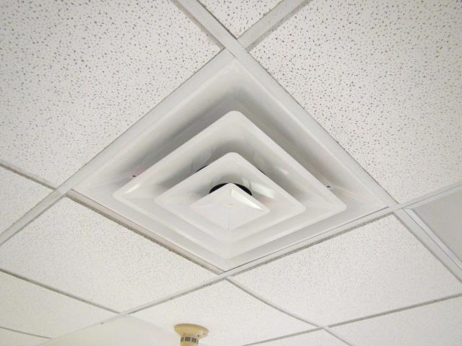
Multi-directional supply diffuser
Picture 2
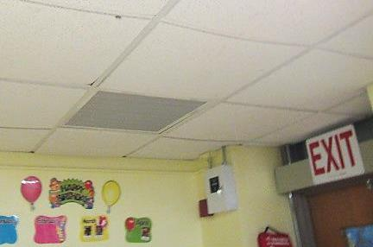
Grated exhaust vent into ceiling plenum
Picture 3
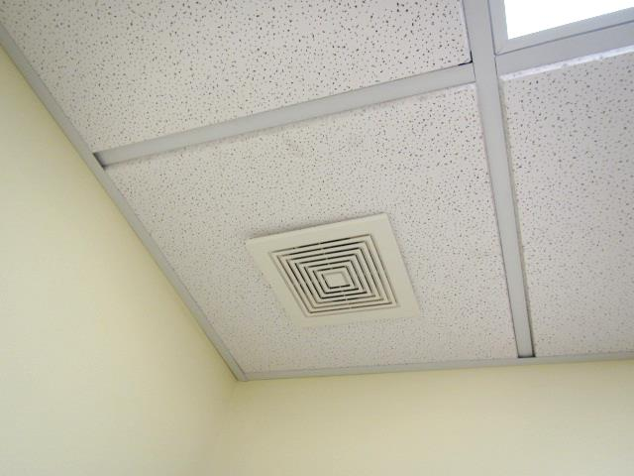
Restroom exhaust vent
Picture 4
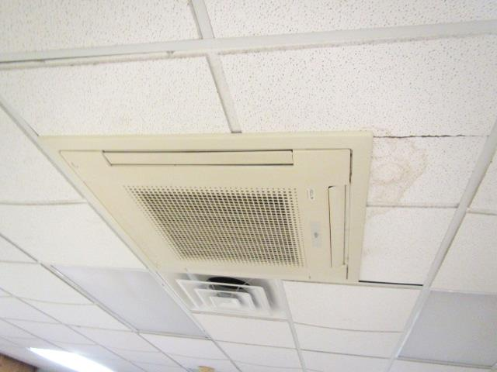
Air conditioning unit, note water-damaged ceiling tiles
Picture 5
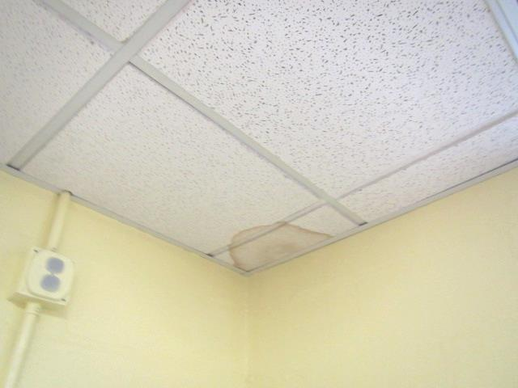
Water-damaged ceiling tiles in corner

Location/ Room |  | Carbon Dioxide (ppm) | Carbon Monoxide (ppm) | Temp (°F) | Relative Humidity (%) | PM2.5  (µg/m³) | Occupants  in Room | Windows Openable | Ventilation |  | Remarks
 |  |  |  |  |  |  |  |  | Supply | Exhaust
 | Background | 395 | ND-1.4 | <32 | 17 | 4 |  |  |  |  | Cold, overcast, moderate traffic
 | Classroom 1 | 1524 | ND | 68 | 31 | 1 | 18 | Y | Y | Y | Ceiling-mounted air conditioner, area carpet, plenum exhaust, restroom exhaust-no draw, 2 WD CTs (near AC and in corner of room)

