Roommate Success Guide

Practical tips for living together,

keeping your housing & moving forward

MA EOHHS Homeless Youth Services

September 2025

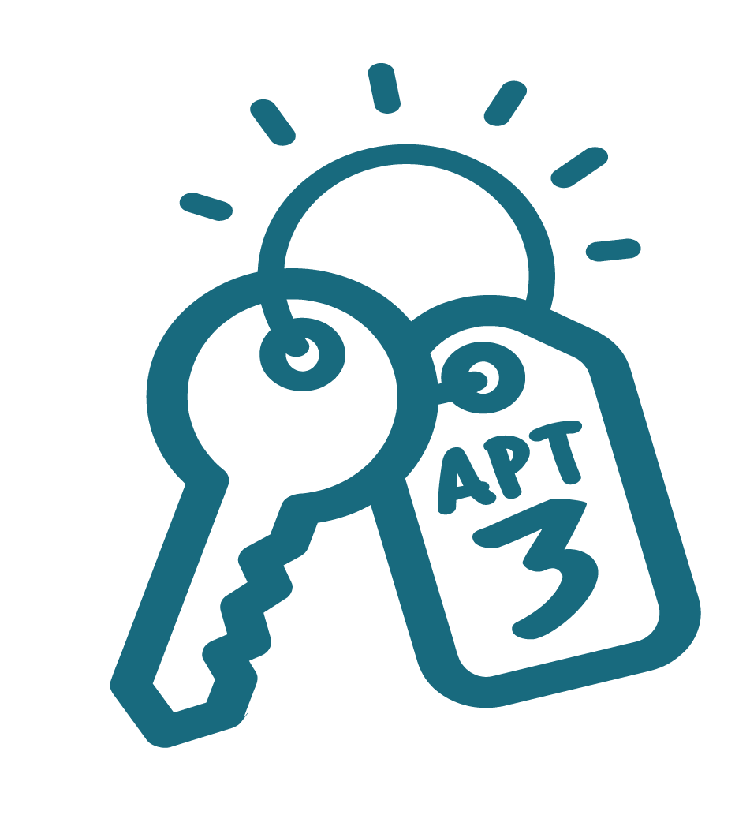
Introduction
Living with roommates can be a great way to make housing more affordable, especially in market-rate apartments where rent and utilities can be expensive on your own. Sharing a home also creates opportunities for connection: having roommates means you’re not alone, and you may find new friendships or a support system.
At the same time, living with others isn’t always easy. Everyone brings different habits, personalities, and experiences into a shared space. Small things like leaving dishes in the sink, playing music late at night, or having guests over can turn into big conflicts if there aren’t clear expectations. That’s why it’s important to set ground rules, communicate openly, and respect one another’s boundaries.
MA Homeless Youth Services created this packet to support you in making your housing experience positive and stable. Our goal is to help you and your roommates start off on the right foot and stay housed long-term. We don’t ever want you to experience homelessness again once you’ve secured a place to live.
Inside this packet, you’ll find three sections:
- Advice for Young Adults Living with Roommates: Practical tips on how to share a space, pay bills, and build healthy roommate relationships.
- Roommate Agreement (Quick Summary): A short, easy-to-read overview of house rules, perfect for posting in a shared space.
- Roommate Agreement (Full Version): A detailed contract for you and your roommates to sign, making sure everyone understands and agrees to the expectations.
We encourage you to read through each section, talk with your roommates about what makes sense for your home, and sign the agreement together. A little planning and respect go a long way in making sure your housing feels safe, supportive, and permanent.

And most of all–– Welcome home! Let this be the first of many good chapters ahead.

Advice for Living with a Roommate
Living with roommates can be a big adjustment, especially if this is your first stable housing in a while. A good roommate relationship can make your home feel safe, supportive, and even fun. A bad one can make things stressful. Here are some tips to help you succeed:

Respect Shared Spaces
- Clean up after yourself in the kitchen, bathroom, and living room.
- Wash your dishes the same day you use them.
- Don’t take food, toiletries, or belongings that aren’t yours. Always ask first.

Communicate Early and Often
- Talk about household rules together: quiet times, guests, chores, and bills.
- If something bothers you, address it calmly and respectfully. (“Hey, I noticed the trash is full — can you take it out today?” works better than yelling.)
- Use monthly house meetings to check in and solve problems before they grow.

Be Responsible
- Pay your share of rent and utilities on time. If you know you’ll be short, communicate early.
- Respect agreements about guests. Remember, your guest is your responsibility.
- Follow house rules to keep your housing safe and stable.

Respect Boundaries
- Everyone needs privacy sometimes. Knock before entering a roommate’s room.
- Don’t assume partners or friends can stay overnight without checking with housemates first.
- Remember: being roommates doesn’t mean being best friends — but you do need to be good neighbors.

Practice Self-Awareness
- Notice how your actions affect the people you live with.
- If you make a mistake, own it, apologize, and do better next time.
- Ask for help if you’re struggling — with cleaning, with bills, or with personal challenges. Case managers and support staff are there for you.

Roommate Agreement: Summary (Post on Fridge)
Room Walkthroughs (if applicable)
- 24-hour notice.
- No searching of personal items.
- Fix issues by next walkthrough or risk housing.
Pets
- No pets or pet-sitting.
Guests
- No keys/codes for non-tenants.
- Guests must be approved by housemates.
- Limit: 1 guest per tenant (2 max at once).
- Guests = your responsibility.
- Partners/friends cannot move in.
Cleaning
- Everyone cleans up after themselves daily.
- Assigned chores done monthly.
- Label food, store safely, no open containers.
- Bathrooms and kitchens must be left clean.
Community Areas
- Don’t hog kitchen/bathroom (10–15 mins during busy times).
- Respect other people’s belongings and food.
Quiet Hours
- House agrees on quiet times (example: 10pm–8am).
Respect & Conflict
- Talk calmly, not aggressively.
- No yelling, threats, or violence.
- Apologize and problem-solve together.
House Meetings
- Once a month.
- If you miss it, you still follow decisions made.
Bills
- Pay on time; Late fees are the responsibility of the late payer.
- Use apps (Cash App, Venmo, etc.).
- Pay in advance if traveling.

Roommate Agreement: Full Version (For Signing)
Pets
- Pets are not allowed.
- Pet-sitting for others is also not allowed.
Guests and Non-Tenants
- Non-tenants may not have keys or door codes. Sharing them is grounds for removal.
- All guests must be approved by housemates. If at least half the house says no, respect that.
- Guest limit: 1 guest per tenant, or 2 total in the house at one time.
- Guests must be respectful. If they are loud, messy, or unsafe, they may be asked to leave.
- Your guest is your responsibility: you clean up after them and cover any damages or added costs.
- Partners, friends, or others cannot move in unless officially added to the lease.
Cleaning
- Each roommate will have a monthly cleaning assignment (bathrooms, kitchen, living room).
- Everyone must clean up after themselves daily: dishes, spills, trash, etc.
- All food must be labeled and dated. Unlabeled food may be thrown out monthly by the kitchen cleaner.
- Food must be stored properly in containers. No open bags or boxes.
- Bathrooms must be left free of hair, products, and personal mess.
- Kitchen users must wash dishes, pots, pans, and appliances immediately after use.
Shared Spaces
- The kitchen, bathroom, and living room must be kept tidy for everyone.
- Don’t hog shared spaces. Limit bathroom/kitchen time to 10–15 minutes during busy hours.
- Respect other people’s belongings and food. Always ask before borrowing.
Quiet Hours
- The house will agree on daily quiet hours. During those times, keep noise to a minimum (music, TV, conversations).
Respect and Conflict
- Problems should be brought up calmly and respectfully.
- No yelling, chasing, threats, or physical violence. Violence may result in removal.
- Take time to cool off before discussing conflict.
- Apologize when needed, and ask for help if you’re struggling.
House Meetings
- Housemates will meet at least once a month.
- Meetings are for discussing cleaning, bills, guests, and any issues.
- If you miss a meeting, you are still responsible for decisions made.
Bills
- All roommates share responsibility for utilities.
- A clear system will be set for payments (Cash App, Venmo, etc.).
- Deadlines must be agreed on (e.g., internet due on the 1st = pay by the week before).
- Late fees caused by one roommate must be paid by that roommate.
- Pay in advance if traveling.
- If your guest increases bills, you are responsible for the extra costs.
Roommate signature ________________________ Date ____________

Roommate signature ________________________ Date ____________

Roommate signature ________________________ Date ____________

Roommate signature ________________________ Date ____________

