INDOOR AIR QUALITY ASSESSMENT

Rowlandson Elementary School
103 Hollywood Drive
Lancaster, MA
Prepared by:
Massachusetts Department of Public Health
Bureau of Environmental Health
Indoor Air Quality Program
July 2017

Background

Building: | Rowlandson Elementary School
Address: | 103 Hollywood Drive, Lancaster, MA
Assessment Requested by: | Orlando Pacheco, Town Administrator
Reason for Request: | Odor and general indoor air quality (IAQ) concerns.  This report focuses on room B116 and the Library.
Date of Assessment: | May 26, 2017
Massachusetts Department of Public Health/Bureau of Environmental Health (MDPH/BEH) Staff Conducting Assessment: | Michael Feeney, Director, IAQ Program  Jason Dustin, Environmental Analyst/Inspector
Date of Building Construction: | 2002
Building Description: | Two-story, brick construction, with pitched asphalt and flat membrane roof sections.
Building Population: | Approximately 460 students in grades K through 4 with a staff of approximately 50
Windows: | Openable

IAQ Testing Results
Please refer to the IAQ Manual for methods, sampling procedures, and interpretation of results (MDPH, 2015). The following is a summary of indoor air testing results (Table 1).
- Carbon dioxide levels were below 800 parts per million (ppm) in locations assessed.
- Temperature was within the recommended range of 70°F to 78°F the day of assessment.
- Relative humidity was within the recommended range of 40 to 60% in most areas the day of the assessment.
- Carbon monoxide levels were non-detectable in all areas tested.
- Fine particulate matter (PM2.5) concentrations measured were below the NAAQS limit of 35 μg/m³ in all areas tested.

Ventilation
A heating, ventilating and air conditioning (HVAC) system has several functions. First it provides heating and, if equipped, cooling. Second, it is a source of fresh air. Finally, an HVAC system will dilute and remove normally occurring indoor environmental pollutants by not only introducing fresh air, but by filtering the airstream and ejecting stale air to the outdoors via exhaust ventilation. Even if an HVAC system is operating as designed, point sources of respiratory irritation may exist and cause symptoms in sensitive individuals.
Fresh air is provided by unit ventilators (univents) located in classrooms and the Library space (Picture 1). The unit ventilators draw fresh air through a vent on the exterior wall (Picture 2). Air is mixed with return air from the room, filtered, heated or cooled (if needed) and delivered back to the room (Figure 1). Exhaust vents are located on the ceilings of rooms (Picture 3) and are ducted to fans on the roof. The exhaust vent in classroom B116 was noted to be off during the assessment.
In order to have proper ventilation with a mechanical supply and exhaust system, these systems must be balanced to provide an adequate amount of fresh air while removing stale air from a room. It is recommended that existing ventilation systems be re-balanced every five years to ensure adequate air systems function (SMACNA, 1994). It is unknown the last time these systems were balanced.

Microbial/Moisture Concerns
RES personnel have complained of a strong musty/wood/mulch-like odor coming from classroom B116. It was reported by RES staff that after a period of vacancy, items in the room were colonized with mold. Contractors were hired to remediate the mold and perform microbial testing in the classroom. A contractor also fitted the univent in this room with two UV sterilization bulbs (Picture 4) but the strong odor has remained and was easily detected by BEH personnel. This room is not currently being used for classes and remains vacant until the odor issue is resolved.
Without performing a more invasive inspection (e.g., removing univent and shelving) it is impossible to definitively state one particular source or cause of the odors in room B116. Instead, the following observations are stated to offer guidance as to the most likely source(s) of moisture/microbial growth potential and associated odors.
In order for building materials to support mold growth, a source of water exposure is necessary. Although no evidence of active water leaks was immediately apparent in B116, BEH staff did observe several sources of possible moisture. The exterior fresh air intake for the univent appeared to be ajar and protruded past the brick-framed opening (Picture 5). This condition allows the vent to “catch” rain/storm water and direct it towards the interior. There were several weep-holes in the brickwork immediately above this protruded intake vent. This flow from the weep-holes may add additional water onto the protruded vent frame and toward the interior of the univent. BEH staff also noted the lack of caulking and several gaps along the intake vent frame for water to infiltrate (Pictures 6 and 7).
The univent in room B116 was opened and examined. BEH staff noted pathways within the univent for this moisture to travel. It was noted that the univent cabinet had multiple gaps/holes in the cabinet facing the exterior wall and within the univent itself. The bottom of the univent did not have adequate separation between the return vent and the unconditioned univent controls compartment which leads to the large hole at the back of the unit facing the exterior wall (Pictures 8 and 9). This condition allows the return vent to draw unconditioned air from the control side of the cabinet as well as from the behind the unit (through the large hole) and behind the shelving (Picture 10). Together these conditions may allow water or condensation to accumulate within debris in the cabinet (Picture 11) or in materials behind or next to the cabinet (e.g., wood/particle board shelving). These materials would then be subject to microbial colonization. Sometimes the wood/varnishes used in furniture/shelving will give off odors when moistened adding to the complexity of the odor.
Since the univent cabinet appears to be the source for water vapor in classroom B116, any materials in or near the univent should be closely examined during the remediation effort. This would include examining any items or building materials in the univent cabinet as well as adjacent to/behind the unit. A thorough and professional cleaning of all nonporous univent surfaces is recommended inside and outside of the unit. The discarding of any porous materials (e.g., foam insulation, paper, and filter) within the unit is further recommended to reduce the likelihood of continued colonization. All holes and gaps leading to unconditioned areas should be sealed and the unit should be reinsulated fully to separate the conditioned compartments from unconditioned compartments/areas. Manufacturer recommendations should be followed for the specific unit being serviced.
The vegetation, soil, or materials in close proximity of the exterior fresh air intake vent should be examined. Decomposing mulch can give off a very strong odor when oxygen is restricted. Although the area outside of the intake vent for B116 appeared to be grassy, several areas around different univent intakes were noted to have mulch around the perimeter. If old mulch is compacted and covered with soil, oxygen thriving (aerobic) bacteria cannot adequately decompose the mulch. Instead the anaerobic bacteria begin to slowly decompose the mulch but an odorous gas is a byproduct of this process. Any odors in close proximity of the intake vent may be easily entrained into the univent and distributed throughout the classroom.
Using a moisture meter, BEH staff observed elevated moisture in floors in room B116 at the time of assessment. It was also reported by RES staff that the adjacent building wing has a problem with floors tiles popping up due to moisture. B116 is a slab on grade with floor tiles which is generally not conducive to microbial growth. However, there were numerous boxes, books, and containers stored directly on the slab floor (Picture 12). Porous items such as papers, cardboard, clothing, etc. may become colonized with mold if subjected to chronic moisture such as condensation from warm air coming in contact with the cooler slab. Condensation will form on surfaces that are cooled below the dew point temperature. This underlines the importance of sealing gaps/holes to unconditioned areas and within the univent cabinet itself. Moisture within the slab can also be increased by poor drainage around the slab perimeter and roof drainage issues.
BEH staff observed dehumidifier units in both room B116 and the Library (Picture 13). These units are helpful in removing excess moisture in the air but must be maintained according to manufacturer recommendations to avoid microbial colonization within the units.
A few water-damaged ceiling tiles were observed in the Library (Picture 14), which indicate leaks from the building envelope or plumbing system. These ceiling tiles should be replaced after the leak is found and repaired.
Plants were observed in a few areas (Picture 15). Plants can be a source of pollen and mold, which can be respiratory irritants to some individuals. Plants should be properly maintained and equipped with drip pans and should be located away from air diffusers to prevent the aerosolization of dirt, pollen and mold.

Other IAQ Evaluations
Exposure to low levels of total VOCs (TVOCs) may produce eye, nose, throat, and/or respiratory irritation in some sensitive individuals. To determine if VOCs were present, BEH/IAQ staff examined rooms for products containing VOCs. BEH/IAQ staff noted hand sanitizers, cleaners, and dry erase materials in use within the building. All of these products have the potential to be irritants to the eyes, nose, throat, and respiratory system of sensitive individuals.
It has been the experience of BEH staff that during mold remediation projects, contractors typically add deodorizing agents to the affected space to mask unpleasant odors or reinforce the perception of the space being clean and fresh. Unfortunately many air deodorizers or air fresheners can have irritating effects to the eyes, nose, and respiratory system. RES staff reported that a solid air deodorizer was previously found on top of a cabinet. BEH staff have found solid, liquid, plug in, and reed diffuser style air deodorizers at other schools/projects throughout the state. In addition to possible irritant effects, these items only mask odors and do not remove the actual source of odors therefore are not recommended. Room B116 should be thoroughly examined for any air deodorizing agents within the classroom and the univent itself.
As mentioned, UV sterilization bulbs were installed in the B116 univent cabinet. They may be effective in killing certain types of bacteria. However, even if mold spores are killed they can still cause allergenic effects to occupants. Depending upon the wavelength of the UV bulbs, they may also produce ozone, a known lung irritant. Further, these bulbs do not address the root source of any odor or microbial colonization.
Classroom B116 was noted to have a large amount of stored items in boxes and plastic containers (Picture 16). Many of these boxes had a large accumulation of dust/debris. If aerosolized, this dust may have irritant effects.
The Library had carpeting that appeared to be dated. The usable life of carpeting in schools is approximately 10-11 years (IICRC, 2002). Exterior doors leading to the Library lacked a weather proof entrance matt or carpet. As a result, dirt/debris and moisture have been allowed to periodically collect in these entrances (Picture 17). This will lead to accelerated carpet degradation and possible aerosolization of the dust/debris. Carpeting should be cleaned annually or semi-annually in soiled high traffic areas as per the recommendations of the Institute of Inspection, Cleaning and Restoration Certification (IICRC, 2012).
Tennis balls had been sliced open and placed on chair footings to reduce noise (Picture 18). Tennis balls are made of a number of materials that are a source of respiratory irritants. Constant wearing of tennis balls can produce fibers and lead to off-gassing of VOCs. Tennis balls are made with a natural rubber latex bladder, which becomes abraded when used as a chair leg pad. Use of tennis balls in this manner may introduce latex dust into the school environment. Some individuals are highly allergic to latex (e.g., spina bifida patients) (SBAA, 2001). It is recommended that the use of materials containing latex be limited in buildings to reduce the likelihood of symptoms in sensitive individuals (NIOSH, 1997; NIOSH, 1998).

Conclusions/Recommendations
The following recommendations are made to assist in improving IAQ:
- When building is unoccupied, remove univent from wall in room B116. Discard all water-damaged porous materials in the univent (e.g., foam insulation, paper, and filter) and water-damaged materials adjacent to the unit (e.g., shelving, books, papers). For more information on mold refer to the US EPA’s “Mold Remediation in Schools and Commercial Buildings”. Available at: http://www.epa.gov/mold/mold-remediation-schools-and-commercial-buildings-guide
- Thoroughly clean all nonporous surfaces within the univent and surrounding area of any dust/debris.
- Inspect the fresh air intake vent for room B116 leading to the exterior and clean this vent thoroughly. Also, properly seat the vent cover so that it does not protrude and collect rain water. Any gaps around this vent should be tightly sealed with waterproof caulking.
- Once remediation activities are concluded, clean all items and surfaces with a HEPA filtered vacuum combined with wet wiping prior to reoccupation.
- Inspect the soil/vegetation beneath the fresh air vent for B116. Ensure there is no buried mulch which may give off odors due to anaerobic decomposition. If found, it is advisable to dig out and replace with crushed stone which will also increase drainage.
- Ensure roof gutters/downspouts are working properly to collect and remove storm water away from the building foundation. Also, ensure proper perimeter grading and drainage to avoid adding excess moisture to the slab foundation.
- Consider discontinuing the use of UV lamps in B116 univent to reduce possible exposure to ozone, a known lung irritant. Proper remediation of the source of odor should render these bulbs unnecessary.
- Ensure exhaust vents are working properly (B116 was off). Operate all supply and exhaust ventilation equipment continuously during occupied periods.
- Thoroughly examine room B116 and univent cabinet for air deodorizers, air fresheners, or masking agents. Some of these are solid, liquid, or plug-in style and most can have irritant effects to occupants so they should be discarded.
- Store boxes/porous items on shelving or pallets and not directly on floors especially slab floors which are at higher risk for condensation.
- Regularly clean bins/stored items and flat surfaces by wet wiping them to avoid irritant effects of dust/debris. Refrain from bringing in porous items that were stored in unconditioned areas (e.g., basements, attics, garages).
- Maintain dehumidifiers according to manufacturer recommendations to avoid microbial colonization with the unit or filter.
- Consider adopting a balancing schedule of every 5 years for all mechanical ventilation systems, as recommended by ventilation industrial standards (SMACNA, 1994).
- Ensure roof and plumbing leaks are repaired and replace water-damaged ceiling tiles in Library.
- Properly maintain plants, including drip pans, to prevent water damage to porous materials. Plants should also be located away from air diffusers to prevent the aerosolization of dirt, pollen, and mold.
- Install weatherproof entry carpets or mats to protect carpeting in the Library from being chronically moistened and rapidly worn.
- Reduce use of products containing VOCs; only use in well-ventilated areas.
- Regularly clean/vacuum univent cabinets, supply/return vents and fans to avoid aerosolizing accumulated particulate matter.
- Replace tennis balls with non-latex chair glides to avoid possible irritation or allergic reactions.
- Clean carpeting annually or semiannually in high traffic areas.
- Consider replacing any outdated carpeting past its useful life.
- Continue to adopt the US EPA (2000) document, “Tools for Schools”, as an instrument for maintaining a good IAQ environment in the building available at: http://www.epa.gov/iaq/schools/index.html.
- Refer to resource manual and other related IAQ documents located on the MDPH’s website for further building-wide evaluations and advice on maintaining public buildings. These documents are available at: http://mass.gov/dph/iaq.

References
IICRC. 2002. Institute of Inspection, Cleaning and Restoration Certification. A Life-Cycle Cost Analysis for Floor Coverings in School Facilities.
IICRC. 2012. Institute of Inspection, Cleaning and Restoration Certification. Carpet Cleaning: FAQ. Retrieved from http://www.iicrc.org/consumers/care/carpet-cleaning.
MDPH. 2015. Massachusetts Department of Public Health. “Indoor Air Quality Manual: Chapters I-III”. Available at: http://www.mass.gov/eohhs/gov/departments/dph/programs/environmental-health/exposure-topics/iaq/iaq-manual/.
National Institute for Occupational Safety and Health (NIOSH). 1997. NIOSH Alert Preventing Allergic Reactions to Natural Rubber latex in the Workplace. National Institute for Occupational Safety and Health, Atlanta, GA.
National Institute for Occupational Safety and Health (NIOSH). 1998. Latex Allergy A Prevention. National Institute for Occupational Safety and Health, Atlanta, GA.
SBAA. 2001. Latex In the Home And Community Updated Spring 2001. Spina Bifida Association of America, Washington, DC.
SMACNA. 1994. HVAC Systems Commissioning Manual. 1st ed. Sheet Metal and Air Conditioning Contractors’ National Association, Inc., Chantilly, VA.
US EPA. 2000. Tools for Schools. Office of Air and Radiation, Office of Radiation and Indoor Air, Indoor Environments Division (6609J). EPA 402-K-95-001, Second Edition. http://www.epa.gov/iaq/schools/index.html.
Picture 1
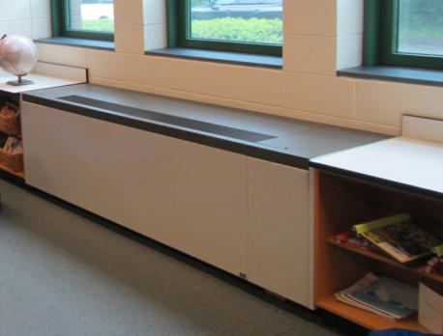
Unit ventilator (uninvent)
Picture 2
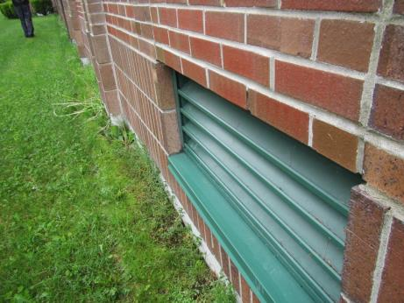
Univent fresh air intake vent (note vent is properly recessed in brick frame)
Picture 3
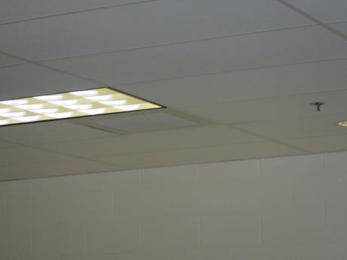
Ceiling-mounted exhaust vent (arrow)
Picture 4
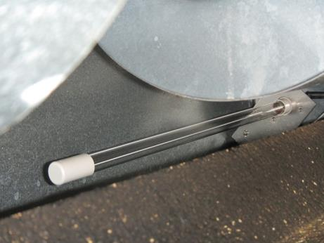
UV sterilization bulb in univent cabinet of room B116
Picture 5
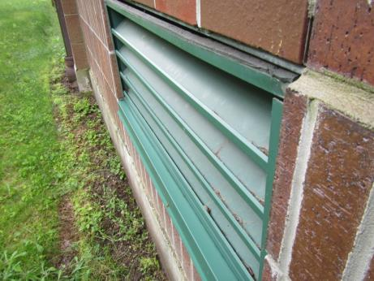
Room B116 fresh air intake vent protruding out past brick frame
Picture 6
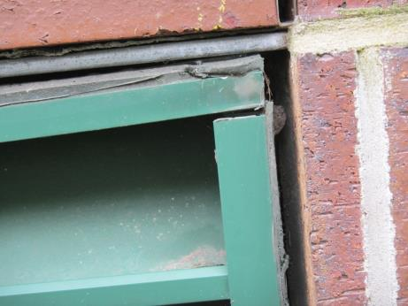
Univent intake vent showing weep hole above and lack of caulking on side
Picture 7
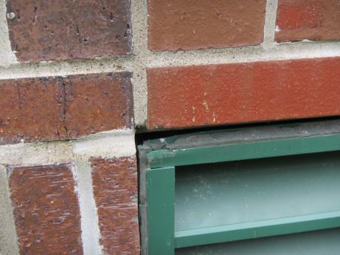
Ajar fresh air intake vent showing large gaps and missing caulking
Picture 8
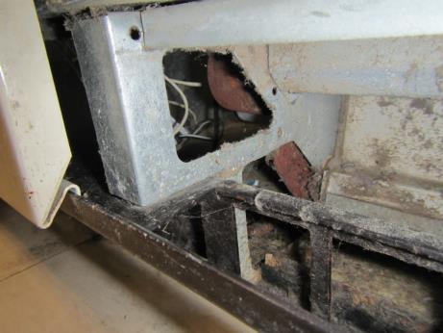
Large gaps in univent wall separating unit return vent from unconditioned controls cabinet
Picture 9
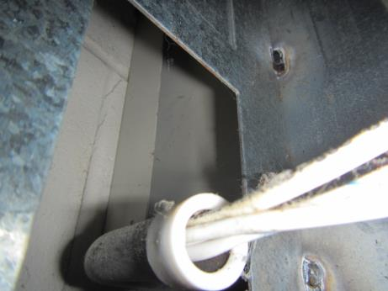
Large gap in univent cabinet facing exterior wall
Picture 10
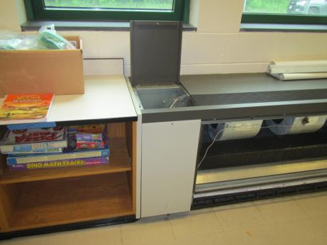
Shelving and items adjacent to univent in room B116
Picture 11
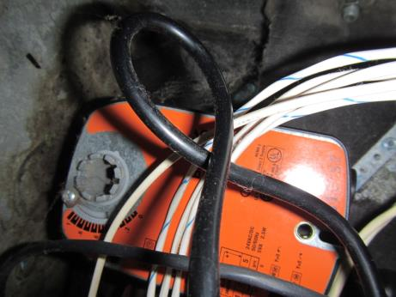
Accumulated dust/debris in cabinet of univent is subject to microbial colonization
Picture 12
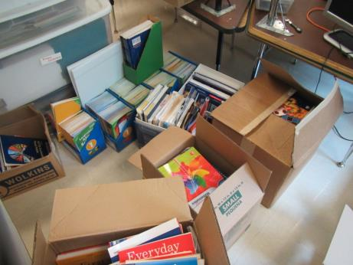
Large amount of porous items stored directly on slab floor
Picture 13
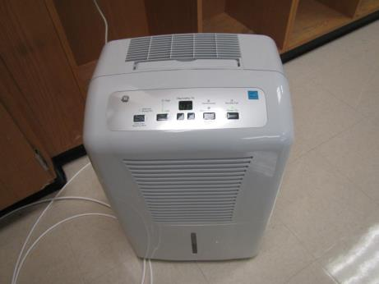
Dehumidifier in room B116
Picture 14
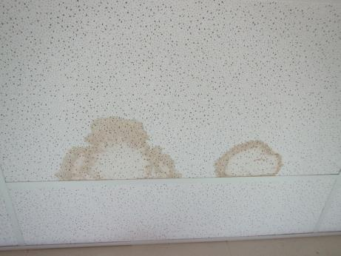
Water-damaged ceiling tiles in Library
Picture 15
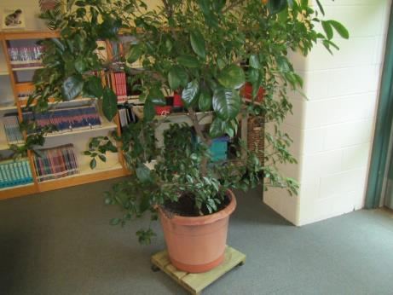
Plant located in Library
Picture 16
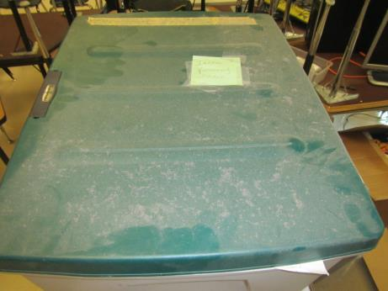
Accumulated dust on stored items in B116
Picture 17
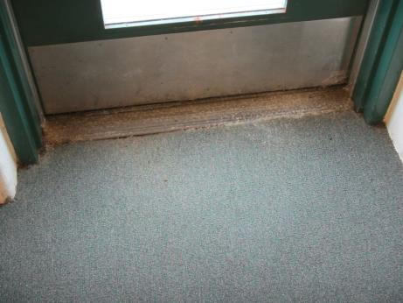
Library exit lacking entrance mat (note accumulated debris at threshold)
Picture 18
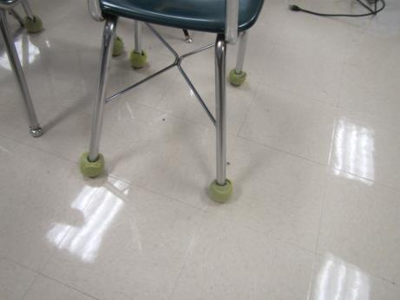
Tennis balls used as chair glides in room B116
Location | Carbon  Dioxide  (ppm) | Carbon Monoxide  (ppm) | Temp  (°F) | Relative  Humidity  (%) | PM2.5  (µg/m³) | TVOCs  (ppm) | Occupants  in Room | Windows  Openable | Ventilation |  |  | Remarks
 |  |  |  |  |  |  |  |  | Intake | Exhaust
Background | 311 | ND | 61 | 56 | 8 | ND | - | - | - |  | - | Light rain
Main office-waiting area | 597 | ND | 67 | 53 | 8 | ND | 6 | Y | Y |  | Y | Carpeted, upholstered furniture, plants
B116 | 512 | ND | 68 | 43 | 5 | ND | 1 | Y | Y on |  | Y off | Odor complaints, strong mulch/cedar/fragrance odor detected. Dehumidifier, elevated moisture in slab, holes/gaps in univent cabinet, large gaps on exterior intake vent-no caulking. Intake vent protrudes beyond brick frame
Library- right side | 539 | ND | 67 | 51 | 6 | ND | 1 | Y | Y |  | Y | Carpeting, no weather proof mat at doors, worn carpeting and debris.
Library- mid | 546 | ND | 68 | 48 | 5 | ND | 1 | Y | Y |  | Y | Dehumidifier, computers

