WATER DAMAGE ASSESSMENT

Mary Rowlandson Elementary School
103 Hollywood Drive
Lancaster, MA

Prepared by:
Massachusetts Department of Public Health
Bureau of Climate and Environmental Health
Indoor Air Quality Program
September 2023

BACKGROUND
Building: | Mary Rowlandson Elementary School (MRES)
Address: | 103 Hollywood Drive, Lancaster, MA
Requestor: | Facilities Department, Nashoba Regional School District
Reason for Request: | Concerns about mold in a classroom
Date of Assessment: | September 12, 2023
Massachusetts Department of Public Health/Bureau of Environmental Health (MDPH/BEH) Staff Conducting Assessment: | Ruth Alfasso, Environmental  Engineer/Inspector, Indoor Air Quality (IAQ)  Program
Building Description: | The MRES is a brick-faced elementary school with a flat roof. It is connected to the Luther Burbank Middle School. Both buildings were constructed in 2002. Only one area of the school was assessed during this visit.
Windows: | Openable

METHODS
Please refer to the IAQ Manual for methods, sampling procedures, and interpretation of results (MDPH, 2015). Note that this school was visited in 2017; a report from that visit can be found at: https://www.mass.gov/info-details/indoor-air-quality-reports-cities-and-towns-l#lancaster-

RESULTS AND DISCUSSION
The following is a summary of indoor air testing results (Table 1):
- Carbon Dioxide was above the MDPH recommended guideline of 800 parts per million (ppm) in both rooms assessed indicating a lack of fresh air to these rooms. This is discussed further under “Ventilation” below.
- Temperature was within the MDPH recommended range of 70°F to 78°F in both areas tested.
- Relative Humidity was above the MDPH recommended range of 40 to 60% in the areas tested. This is reflective of outdoor conditions.
- Carbon Monoxide was not detected (ND) in any areas assessed.
- Particulate matter (PM2.5) concentrations measured were below the National Ambient Air Quality (NAAQS) level of 35 μg/m³ in all areas tested.

Ventilation
The classroom and library visited during this assessment are equipped with unit ventilators (univents) for heating, cooling, and fresh air ventilation (Picture 1). Univents draw air from the outdoors through a fresh air intake located on the exterior wall of the building (Picture 2) and return air through an air intake located at the base of the unit. Fresh and return air are mixed, filtered, heated, and provided to rooms through an air diffuser located in the top of the unit (Figure 1). Thus, for proper operation, the top and front of the equipment should not be blocked. Mechanical exhaust ventilation is provided by ceiling-mounted exhaust vents connected to exhaust fans. Ventilation systems are controlled by a building management system.
Measurements of carbon dioxide in both classroom B122 and the library were above the MDPH guideline of 800 ppm. This indicates that there is not enough fresh air being brought in for the occupancy of the room. This is reportedly due to dampers being in the minimum position to prevent drawing in large amounts of hot, humid outdoor air.

Microbial/Moisture Concerns
It is important to note that Massachusetts experienced extended periods of high relative humidity during the summers of 2018, 2021, and 2023. July of 2021 was the wettest ever recorded in Massachusetts, and the three-month period from June through August, known as the meteorological summer, was the fourth wettest on record, according to the National Oceanic and Atmospheric Administration’s (NOAA) Centers for Environmental Information. The three-month period also was the third warmest ever in the state and was tied for the warmest on record across the United States (HG, 2021, NOAA, 2021). Data for 2023 may show similar if not more extreme conditions.

Under these weather conditions, public buildings experienced extended periods of water vapor exposure from high relative humidity. When exposed to these conditions, porous materials such as gypsum wallboard, cardboard, and other materials may become moistened and colonized with mold, particularly if located in areas that are prone to developing condensation, such as floors and walls in contact with the ground (e.g., below grade space). According to the American Society of Heating, Refrigerating and Air-Conditioning Engineers (ASHRAE); if relative humidity exceeds 70%, mold growth may occur due to wetting of building materials (ASHRAE, 2022) even in the absence of liquid water.

On the day of the visit, the humidity in room B122 was above 70% due to outside conditions. The guideline “Preventing Mold Growth In Schools During Hot, Humid Weather” https://www.mass.gov/info-details/preventing-mold-growth-in-massachusetts-schools-during-hot-humid-weather should be used to minimize the impact of such weather on classroom materials. This includes use of air conditioning and dehumidifiers, ensuring exhaust vents are on and operable, keeping windows closed, and ensuring air can circulate around porous materials.

A dehumidifier was in use in the room. These units need to be emptied frequently, and kept clean, so they do not become a source of mold and odors.

No water-damaged materials, water stains, or moldy or musty odors were detected in classroom B122, including ceiling tiles and items. Note that following the MDPH/IAQ visit in 2017, built-in shelving along the exterior wall of a classroom on the same wing was found to be mold-colonized along the back. While that shelving has been removed and replaced with free-standing shelving, similar shelving is still present in room B122 (Pictures 1 and 3). Checking behind the shelving may be useful to ensure there is no mold growing on/behind it. Large pinboards are also attached to the exterior wall in classrooms (Picture 3). If these boards have any porous materials along the back (e.g. paper backing), it may have become moistened through contact with the exterior wall, and may be mold colonized.

Another potential source of water-damaged porous materials is under the sink. Cabinets under sinks can be moist environments, subject to leaks, or condensation along cold-water pipes. Storing large amounts of material can prevent the cabinet from drying, and if the material is porous, it may become mold-colonized. Large amounts of paper were found under the classroom sink (Picture 4).
The exterior of the building was examined for potential sources of moisture, mold, and odors. Large bushes were noted against the building, including in front of univent fresh air intakes (Picture 1). Bushes and plants can be a source of pollen, water vapor, and odors to the univent intake or windows, prevent the exterior wall from drying, and can be attractive to pests. Bushes and plants should be trimmed away from the building at least 5 feet, particularly in the vicinity of air intakes or windows.

Other conditions

Classroom B122 contains a large number of items (Pictures 1 and 3). If items in classrooms are not stored properly or are brought in from outside the classroom, they may have become mold-colonized or musty. Items in classrooms should be stored neatly and in water resistant containers when possible. Items should be inspected before being brought into school to ensure they are not colonized with mold.

Classroom B122 has area rugs (Picture 5). These rugs are reportedly deep cleaned yearly and stored rolled-up in a clean, dry location over summer break. These are good practices to reduce the potential for rugs to become dusty or mold-colonized. Area rugs should also be vacuumed daily to remove dust and debris.

Univents have filters (Picture 6), which should be changed 2-4 times a year or per the manufacturer’s recommendations. Filters should be at least a Minimum Efficiency Rating Value (MERV) of 8 or higher, if they fit and the equipment can handle the pressure reductions caused by more restrictive filters. Univent filters at the MRES are reportedly a MERV 10 and are changed twice a year. Univent cabinets should also be vacuumed/cleaned whenever the filters are changed.

An air purifier was located in the classroom (Picture 7). This unit appears to have a high-efficiency particulate air (HEPA) filter, and also has the capacity to perform ionization (Picture 8). Ionizing air purifiers have the potential to produce ozone, which is a respiratory irritant (USEPA, 2003). This unit should be properly maintained, including cleaning and filter changes in accordance with manufacturer’s instructions, and should only be used with the ionizing feature turned off. For best results, air purifiers should also be placed where the outlet flow from the units is in or near the breathing zone for occupants.

BCEH/IAQ staff noted hand sanitizers, disinfectants, and dry erase materials (e.g., Picture 4) in classroom B112. All of these and similar products have the potential to be irritants to the eyes, nose, throat, and respiratory system of sensitive individuals.

CONCLUSIONS/RECOMMENDATIONS
While no signs of water intrusion, water damage, or mold was found in classroom B112, there are a number of areas that could be further assessed and other recommendations to improve and maintain IAQ:

Ventilation Recommendations
- Ensure univent air intake dampers are opened during temperate weather to bring more fresh air into classrooms and that univents and exhaust vents are on and operating during all occupied periods. Check exhaust vents for draw periodically and repair when needed.
- Avoid placing items on top of or in front of univents.

Water Damage Recommendations
- Continue using the dehumidifier. Dehumidifiers should be used to reduce indoor relative humidity below 70% if possible. If humidity drops below 40%, discontinue use of the dehumidifier until the next period of humid weather.
- Ensure dehumidifiers are emptied daily and cleaned regularly to prevent stagnant water, leaks, and odors.
- Ensure that all windows are closed when the HVAC system is operating in chilling mode, particularly during periods of hot, humid weather.
- Ensure condensation drainage for univents is not clogged or stagnant.
- Management of buildings in extreme relative humidity and rain can be challenging. The following documents can provide guidance that can be used to reduce the impact of hot, humid weather in buildings; Mold Growth Prevention During Hot, Humid Weather https://www.mass.gov/service-details/preventing-mold-growth-in-massachusetts-schools-during-hot-humid-weather and Remediation and Prevention of Mold Growth and Water Damage in Public Schools https://www.mass.gov/service-details/remediation-and-prevention-of-mold-growth-and-water-damage-in-public-schools-and.
- Check behind built-in shelves for hidden water damage and mold, and remediate as needed. Use the information in US EPA’s “Mold Remediation in Schools and Commercial Buildings” (http://www.epa.gov/mold/mold-remediation-schools-and-commercial-buildings-guide) for guidance on mold removal..
- Avoid storing porous materials in contact with the floors, particularly during periods of high humidity.
- Avoid storing porous material or large amounts of materials under sinks.
- Trim bushes and plants at least five feet away from the building, particularly near univent air intakes.

Other Recommendations
- Regularly sort through items and discard those that are no longer needed, or that may be water-damaged. Store remaining items neatly.
- Clean area rugs and other fabric items regularly, and store in a clean, dry area off the floor over summer breaks. Discard any area rugs that are too worn to be effectively cleaned.
- Continue to change univent filters regularly using a minimum of a MERV 8 rated filter, or higher if the equipment can function. Vacuum/clean out univent cabinets whenever filters are changed to remove dust and debris. This should include inspection of univent condensation drainage systems.
- Maintain the air purifier in accordance with manufacturer's instructions and keep the ionization setting turned off. Consider locating air purifiers so the outlet of the units is in the breathing zone of occupants.
- Use only school-supplied or compatible cleaning and sanitizing products, keep tightly closed when not in use, and keep away from children. Avoid using any scented products such as air fresheners.
- Refer to resource manual and other related IAQ documents located on the MDPH’s website for further building-wide evaluations and advice on maintaining public buildings. These documents are available at: http://mass.gov/dph/iaq.

REFERENCES
ASHRAE, 2022. American Society of Heating, Refrigeration and Air Conditioning Engineers (ASHRAE) Ventilation for Acceptable Indoor Air Quality. ANSI/ASHRAE Standard 62.1-2022. Atlanta, GA.
HG. 2021. Mold keeps South Hadley High School shuttered. Hampshire Gazette. https://www.gazettenet.com/South-Hadley-High-School-still-closed-amid-mold-remediation-42413519.
MDPH. 2015. Massachusetts Department of Public Health. Indoor Air Quality Manual: Chapters I-III. Available at: https://www.mass.gov/lists/indoor-air-quality-manual-and-appendices#indoor-air-quality-manual-.
NOAA. 2021. Summer 2021 neck and neck with Dust Bowl summer for hottest on record. National Oceanic and Atmospheric Administration, 1401 Constitution Avenue NW, Room 5128, Washington, DC 20230 https://www.noaa.gov/news/summer-2021-neck-and-neck-with-dust-bowl-summer-for-hottest-on-record.

US EPA. 2003. “Ozone Generators that are Sold as Air Cleaners: An Assessment of Effectiveness and Health Consequences”. United States Environmental Protection Agency, Office of Air and Radiation, Indoor Environments Division, Washington, DC. Last updated September, 2018. https://www.epa.gov/indoor-air-quality-iaq/ozone-generators-are-sold-air-cleaners
US EPA. 2008. “Mold Remediation in Schools and Commercial Buildings”. Office of Air and Radiation, Indoor Environments Division, Washington, DC. EPA 402-K-01-001. September 2008. Available at: http://www.epa.gov/mold/mold-remediation-schools-and-commercial-buildings-guide.
Figure 1

Unit Ventilator (Univent)

Mixed Air

Air Diffuser

Outdoors Indoors

Fan

Heating/Cooling Coil

Air Mixing Plenum

Filter

Outdoor Return
Air Air

Air
Flow
Control
Louvers

Air Flow

= Fresh Air/Return Air

= Mixed Air

Picture 1
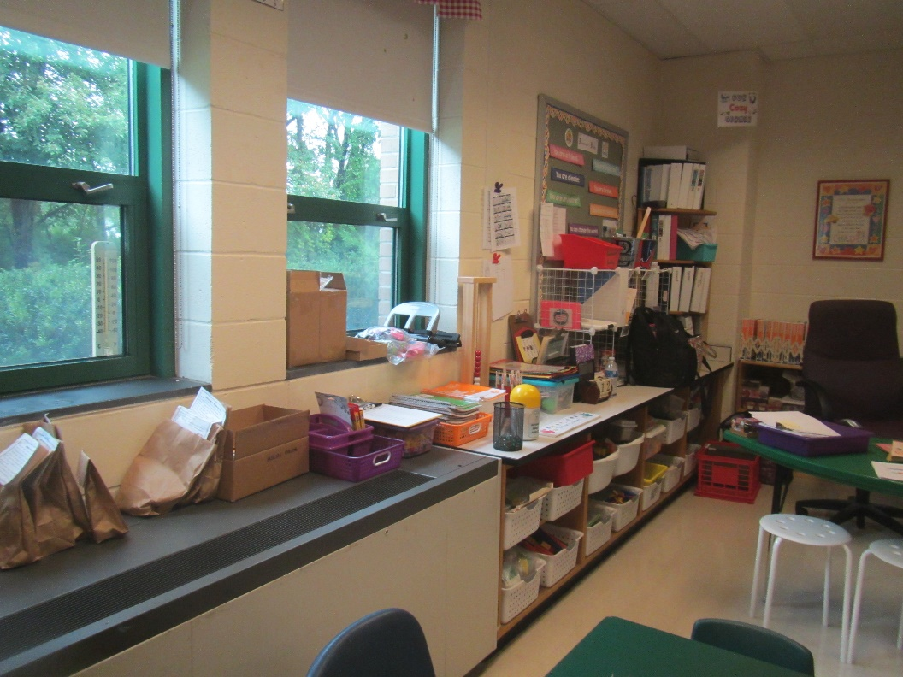
Classroom univent and built-in shelving
Picture 2
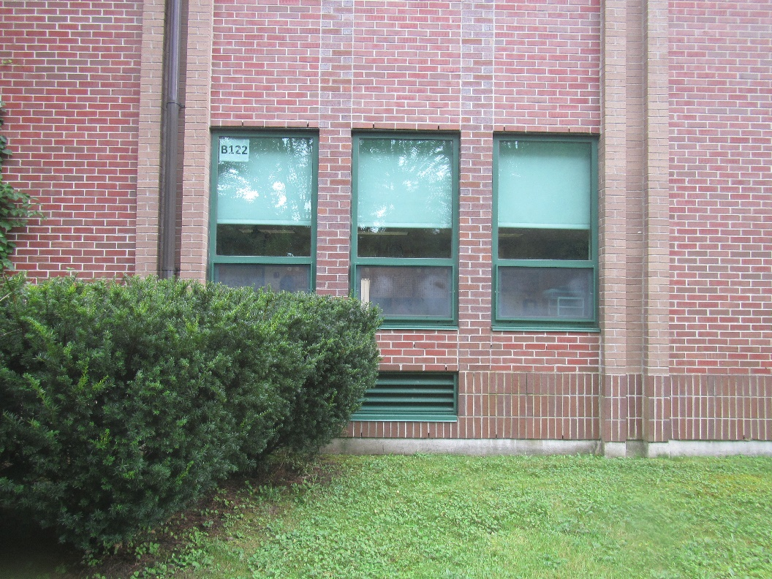
Univent air intake, note bushes in front of vent

Picture 3
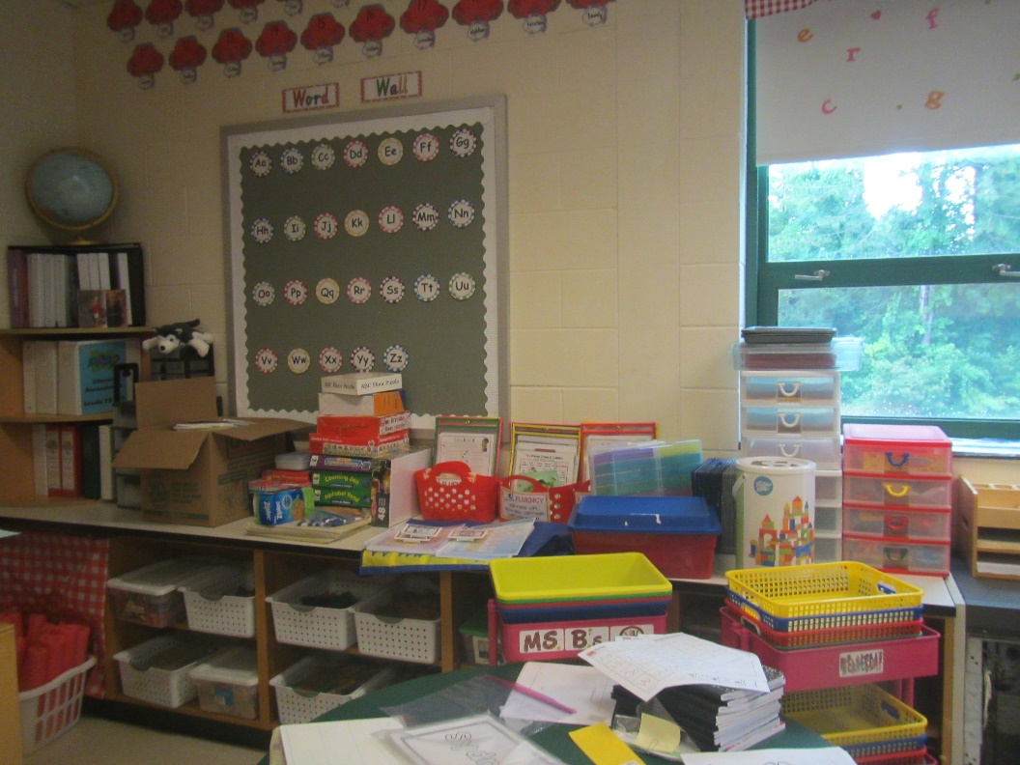
Large pinboard on exterior wall, also note shelving and items
Picture 4
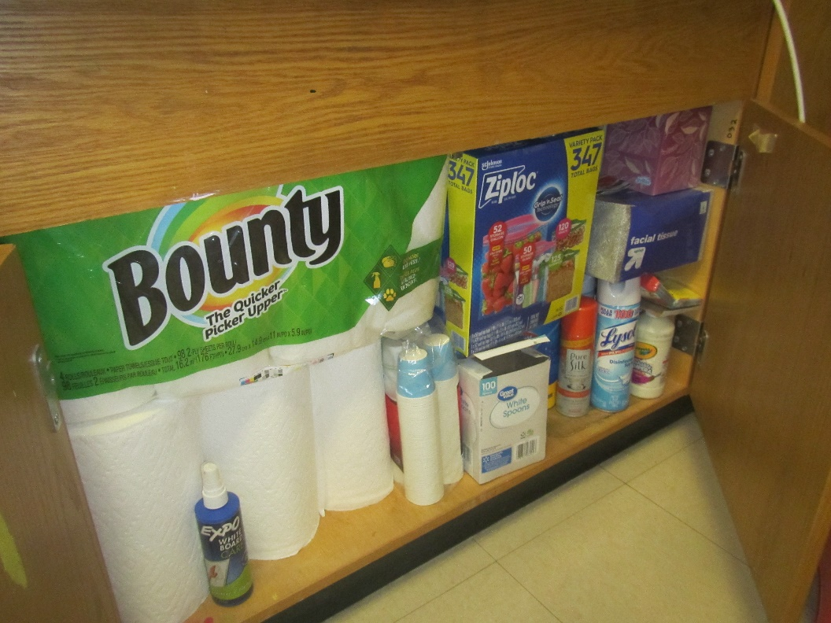
Cabinet under sink full of paper, also note dry erase remover, sanitizers and other products

Picture 5
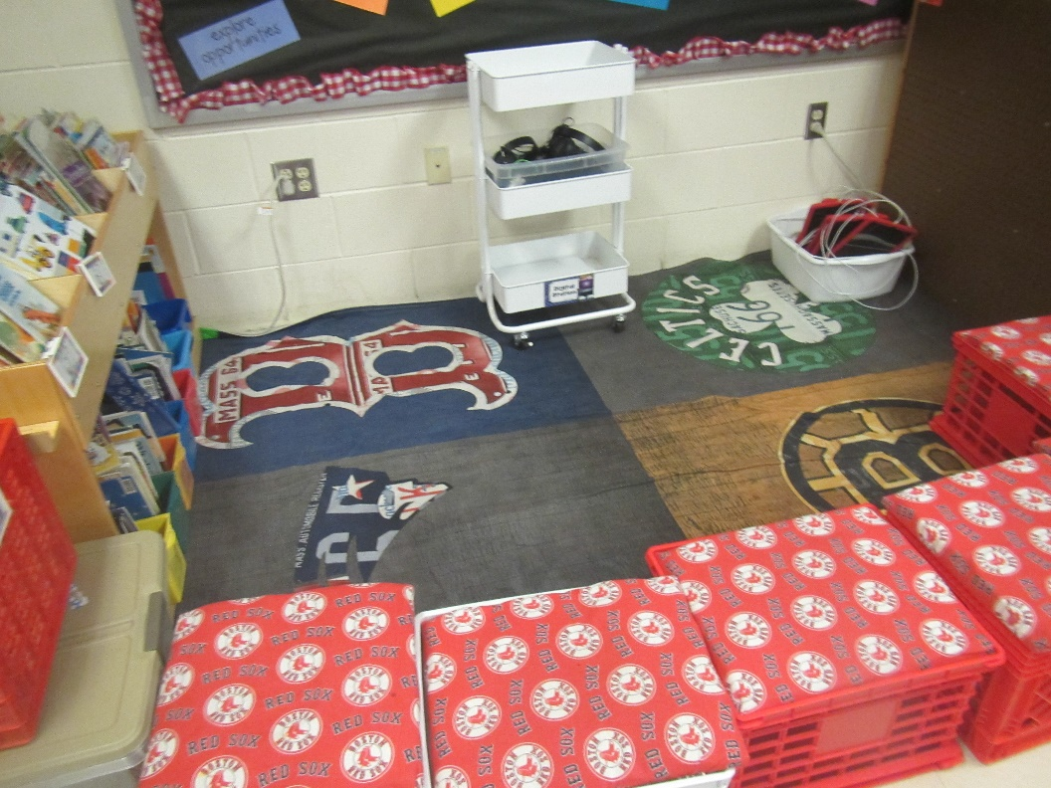
Area rug and fabric-covered items
Picture 6
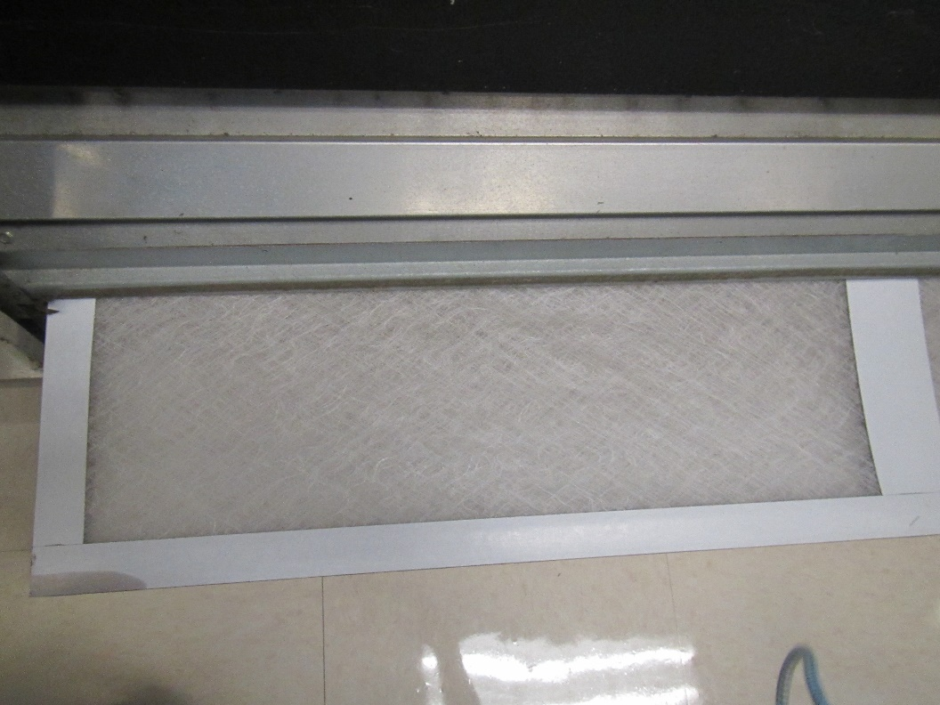
Univent filter

Picture 7
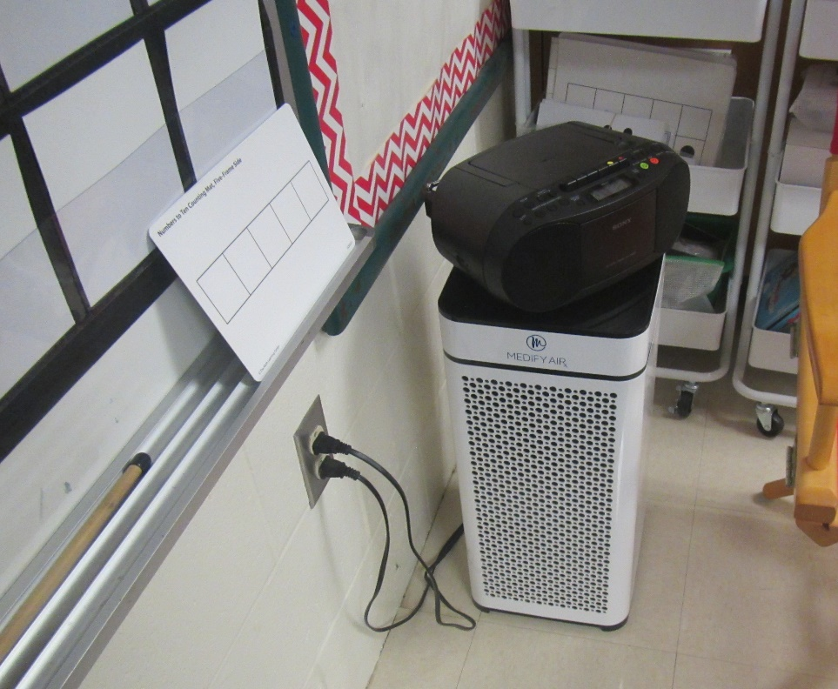
Air purifier
Picture 8
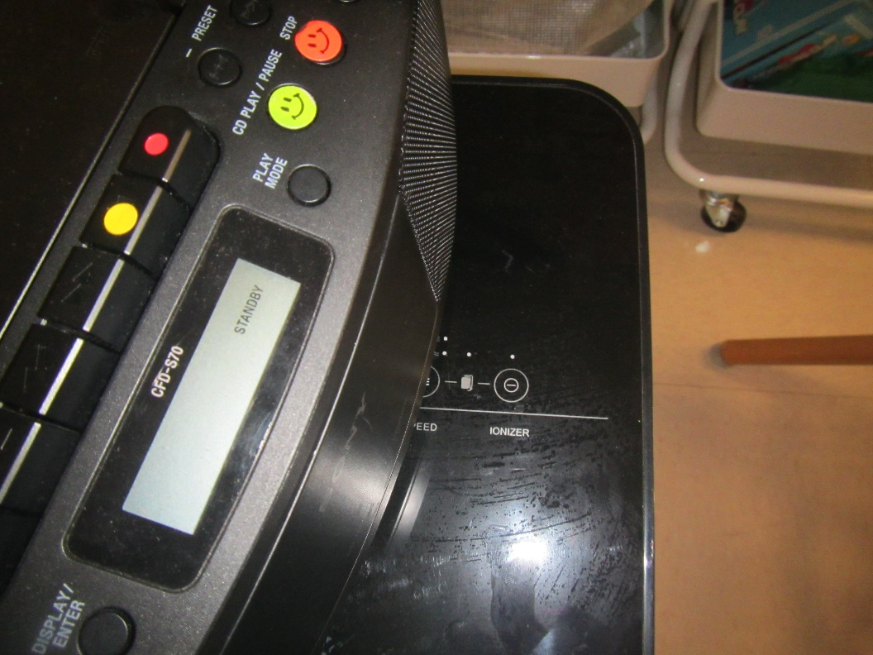
Ionizer setting on air purifier (off at the time of the visit)
Location | Carbon  Dioxide  (ppm) | Carbon Monoxide  (ppm) | Temp  (°F) | Relative  Humidity  (%) | PM2.5  (µg/m3) | Occupants | Windows  Openable | Ventilation |  | Remarks
 |  |  |  |  |  |  |  | Supply | Exhaust
Background | 379 | ND | 77 | 74 | 6 |  |  |  |  | Rain showers
B122 | 1597 | ND | 72 | 74 | ND | Full class just left | Y | Y | Y | Univent on, area rugs, air purifier and dehumidifier, large amount of paper under sink
Library | 968 | ND | 71 | 69 | 1 | 0 | Y | Y | Y | Univent on

