INDOOR AIR QUALITY ASSESSMENT

Massachusetts Department of Transitional Assistance
Roxbury Office
2201 Washington Street
Roxbury, Boston, MA

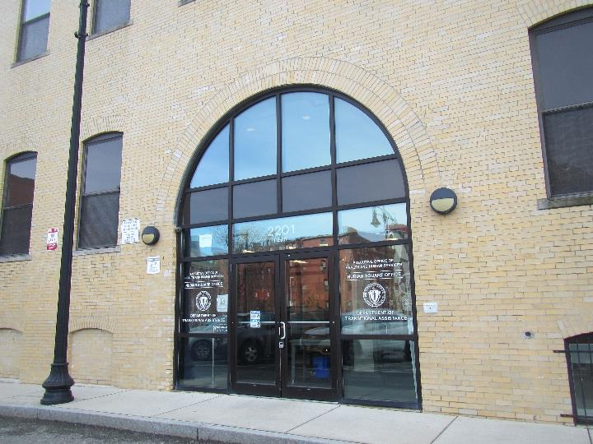

Prepared by:
Massachusetts Department of Public Health
Bureau of Environmental Health
Indoor Air Quality Program
April 2022

BACKGROUND
Building: | Massachusetts Department of Transitional Assistance (DTA)
Address: | 2201 Washington Street, Roxbury, Boston
Assessment Requested by: | Pedro Batista, Project Coordinator,  Executive Office of Health and Human Services (EOHHS)
Reason for Request: | Concerns about respiratory irritation and general indoor air quality (IAQ) issues
Date of Assessment: | March 25, 2022
Massachusetts Department of Public Health/Bureau of Environmental Health (MDPH/BEH) Staff Conducting Assessment: | Ruth Alfasso Environmental  Engineer/Inspector, and Jennifer  Lajoie, Environmental  Analyst/Inspector, IAQ Program
Building Description: | The DTA offices are located in a three-story yellow brick building with a basement and a flat roof located in the Nubian Square area of Roxbury. Only the second floor was assessed during this visit. The areas assessed included offices, workstations, conference rooms and other accessory spaces. The rest of the building contains additional DTA and other offices. Part of the ground level contains a convenience store.
Windows: | None of the windows in the areas assessed are openable. Some windows are of an openable type, but they have been sealed.

METHODS
Please refer to the IAQ Manual for methods, sampling procedures, and interpretation of results (MDPH, 2015).

RESULTS AND DISCUSSION
The following is a summary of indoor air testing results (Table 1):
- Carbon Dioxide was below the MDPH recommended guideline of 800 parts per million (ppm) in all areas assessed. Note that many areas have low occupancy, as employees are on a hybrid work schedule. Carbon dioxide levels may be higher with increased occupancy.
- Temperature was within the MDPH recommended range of 70°F to 78°F in all areas tested.
- Relative Humidity was below the MDPH recommended range of 40 to 60% in the areas tested.
- Carbon Monoxide was not detected (ND) in the areas assessed.
- Particulate matter (PM2.5) concentrations measured were below the National Ambient Air Quality (NAAQS) level of 35 μg/m³ in all areas tested.
- Total Volatile Organic Compounds (TVOC) were ND in the areas assessed.

Ventilation
A heating, ventilating and air conditioning (HVAC) system has several functions. First it provides heating and, if equipped, cooling. Second, it is a source of fresh air. Finally, an HVAC system will dilute and remove normally occurring indoor environmental pollutants by not only introducing fresh air, but by filtering the airstream and ejecting stale air to the outdoors via exhaust ventilation. Even if an HVAC system is operating as designed, point sources of respiratory irritation may exist and cause symptoms in sensitive individuals.
Fresh air in the areas assessed is provided by air-handling units (AHUs) located on the roof. These areas were not accessible during the visit. Fresh air is drawn into the AHUs from outside, heated or cooled, and delivered to occupied space via supply diffusers (Picture 1). Return air is drawn into ceiling grates and ducted back to AHUs (Picture 2). To maximize air exchange, the IAQ program recommends that both supply and exhaust ventilation operate continuously during periods of occupancy. To have proper ventilation with a mechanical ventilation system, the systems must be balanced after installation to provide an adequate amount of fresh air to the interior of a room while removing stale air from the room. It is recommended that HVAC systems be re-balanced every five years to ensure adequate air systems function (SMACNA, 1994).
Note that several of the supply vents were found to be completely or partially blocked during the assessment (Picture 3, Table 1). Blocking supply vents reduces the ability of the HVAC system to supply fresh air and may cause an imbalance in the system leading to airflow/comfort complaints in other areas.
Extra heating is provided by radiators located along the outside edge of the building (Picture 4), which appeared to be operating on the day of the assessment. In addition, office spaces adjacent to windows along the sunny side of the building were found to be warmer than other areas due to solar heating (Table 1). Blinds should be used during sunny periods to reduce solar heating and glare.
The exhaust vent in the women’s restroom was drawing weakly or not at all at the time of the visit. It is important that restroom vents operate at all times the building is in use to remove odors and moisture from the restroom area.

Moisture/Microbial Issues
Some water-damaged ceiling plaster was observed along the top edges and corners of some windows (Picture 5). This may indicate that brickwork needs repointing, or that windows or flashing needs to be repaired. The water-damaged material is likely to be made of mostly inorganic materials which do not support mold growth, and no mold staining was observed. Water-damaged suspended ceiling tiles were noted in the women’s restroom and near cubicle 280/281. These are likely due to water leaks from the floor above. Water-damaged paint and plaster should be repaired once the source of water is removed. Water-damaged ceiling tiles should be replaced. The area above any water-damaged tiles should be inspected for additional water damage and cleaned as necessary.
Although some occupants had reported musty odors in the office, no odors were detected during the visit. No other signs of mold were noted.
In several areas, water coolers, small refrigerators, and drinking fountains were on carpet (Pictures 6 and 7). These can spill or leak, which can damage carpeting and lead to musty odors. Appliances like these should be placed on a waterproof mat or moved to a non-carpeted area. Some windowsills also had signs of water damage, possibly from plants or cooking equipment that had been placed there in the past. Plants should be well maintained and not overwatered to prevent water damage and pests.

Other issues
Exposure to low levels of total volatile organic compounds (TVOCs) may produce eye, nose, throat, and/or respiratory irritation in some sensitive individuals. In addition to testing, BEH/IAQ staff examined spaces for products containing VOCs. BEH/IAQ staff noted air fresheners, hand sanitizers, cleaning products, and scented candles in the office space (Table 1). All of these products have the potential to be irritants to the eyes, nose, throat, and respiratory system of sensitive individuals.
Several photocopiers were noted in the office, including near cubicle areas. Photocopiers can be a source of odors, particulates, and VOCs, particularly if older or heavily used. Photocopiers should be placed in well-ventilated areas away from occupants and near an exhaust vent whenever possible.
Items were observed on a number of flat surfaces, such as floors, windowsills, tabletops, counters, bookcases, and desks (Picture 8). Items stored in offices provide a source for dusts to accumulate and make it difficult for custodial staff to clean. Items should be relocated and/or be cleaned periodically to avoid excessive dust build up. In addition, some of the items were located in areas heated by the sun; this not only potentially damages the items, but heated items may produce odors and release VOCs.
Dust/debris was noted in some areas, including between cubicle dividers and building walls (Picture 9) and in and on radiators (Picture 4). Debris in areas such as behind cubicle walls can be hard to clean, and may provide food or harborage for pests, or emit odors. Dust or debris on heated surfaces such as radiators may become reaerosolized or give off odors. Cleaning of these areas and radiators should be performed on a regular schedule. Items were also found hanging from the ceiling, which can collect dust and are difficult to clean. Hanging items from the ceiling tile system can also allow dust and debris from the ceiling plenum into occupied areas.
Food and food preparation equipment was found in several areas of the floor. Food can be attractive to pests. Some of the toasters were full of crumbs. Debris inside food preparation equipment can give off smoke and odors when the equipment is used.
The offices were mostly carpeted. Carpets should be cleaned annually (or semi-annually in soiled/high traffic areas) in accordance with Institute of Inspection, Cleaning and Restoration Certification (IICRC) recommendations, (IICRC, 2012). DCAMM staff reported that the building manager is required to deep clean the office periodically; if this activity has not been performed as required, it should be scheduled as soon as possible.

CONCLUSIONS AND RECOMMENDATIONS
In view of the findings at the time of the visit, the following recommendations are made:

Ventilation Recommendations
- Operate supply and exhaust ventilation continuously when the building is occupied.
- Unblock supply vents. If occupants are concerned about drafts, occupants or supply vents may be relocated/reconfigured.
- Continue with regular filter changes for AHUs using the best quality/highest Minimum Efficiency Reporting Value (MERV) rated filters that can be used with current equipment.
- Check the functioning of the restroom exhaust vents and repair as needed.
- Use blinds to reduce solar heating on sunny days.
- Consider adopting a balancing schedule of every 5 years for all mechanical ventilation systems, as recommended by ventilation industrial standards (SMACNA, 1994).

Water Damage Recommendations
- Have the building envelope/window systems assessed in the area of the water-damaged plaster and repair. Scrape and repaint water-damaged plaster as needed.
- Replace water-damaged ceiling tiles in the restroom (and any other areas in the building). Inspect the area above the stained tiles for other signs of water damage and clean/repair as needed. Use methods from US EPA’s “Mold Remediation in Schools and Commercial Buildings” during any mold removal activities (US EPA, 2008).
- Consider moving water coolers and refrigerators to areas without carpeting or use a waterproof mat to protect the carpet from spills and condensation.
- Ensure plants are well-maintained and not overwatered.

Other recommendations
- Avoid bringing in cleaners, deodorizers, scented products or candles into the office.
- Keep items away from windows to avoid solar heating, odors, and VOC emissions.
- Consider moving heavily used photocopiers away from occupants and to areas with exhaust ventilation.
- Store items neatly and off the floor to assist with cleaning.
- Consider periodic cleaning of hidden areas and radiators to remove accumulated dust and debris.
- Avoid hanging items from the ceiling.
- Keep food stored in tightly closed pest-proof containers.
- Keep food preparation equipment clean.
- Clean carpets in accordance with IIRC recommendations and the terms of the lease.
- Refer to the resource manual and other related indoor air quality documents located on the MDPH’s website for further building-wide evaluations and advice on maintaining public buildings. These documents are available at http://mass.gov/dph/iaq.

REFERENCES
IICRC. 2012. Institute of Inspection, Cleaning and Restoration Certification. Carpet Cleaning: FAQ.
MDPH. 2015. Massachusetts Department of Public Health. Indoor Air Quality Manual: Chapters I-III. Available at: https://www.mass.gov/lists/indoor-air-quality-manual-and-appendices#indoor-air-quality-manual-
SMACNA. 1994. HVAC Systems Commissioning Manual. 1st ed. Sheet Metal and Air Conditioning Contractors’ National Association, Inc., Chantilly, VA.
US EPA. 2008. “Mold Remediation in Schools and Commercial Buildings”. Office of Air and Radiation, Indoor Environments Division, Washington, DC. EPA 402-K-01-001. September 2008. Available at: http://www.epa.gov/mold/mold-remediation-schools-and-commercial-buildings-guide.

Picture 1
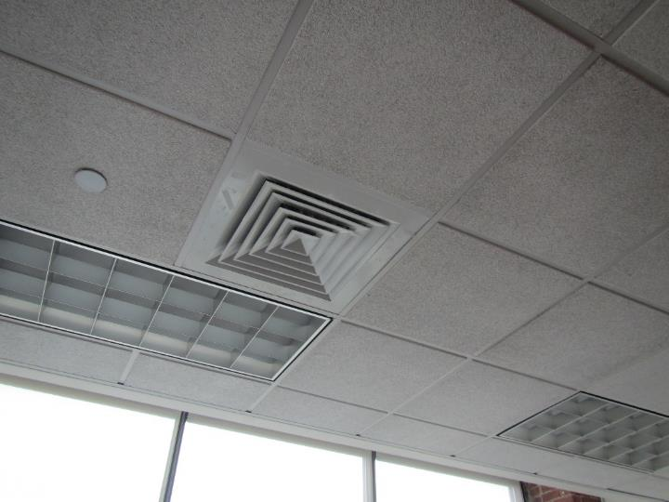
Typical supply vent in an office
Picture 2
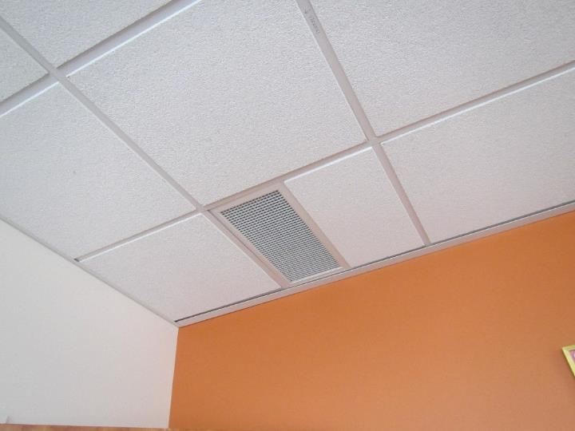
Typical return vent
Picture 3
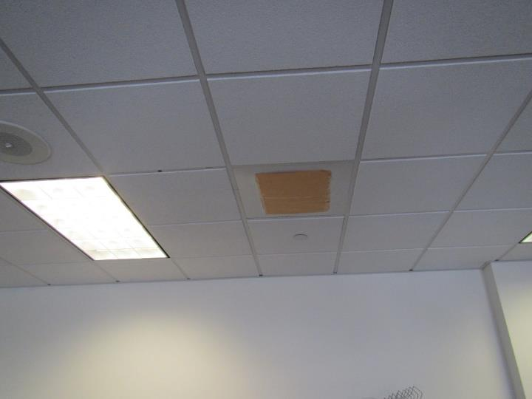
Blocked supply vent
Picture 4
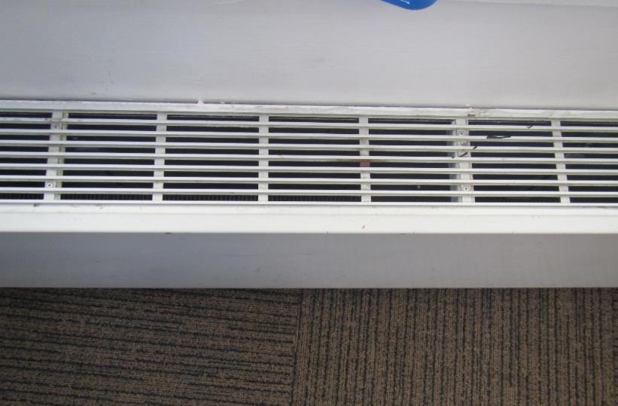
Typical radiator, note dust and debris
Picture 5
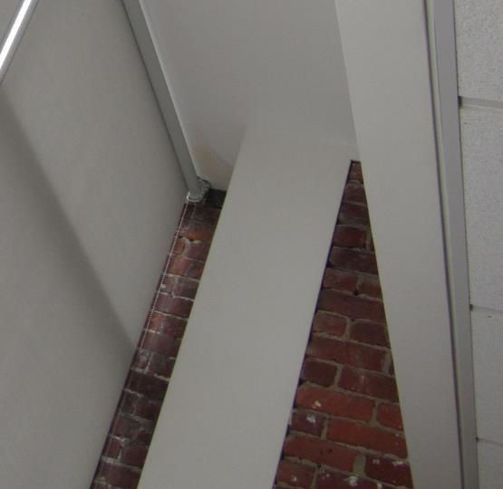
Water-damaged ceiling plaster in upper corner of window
Picture 6
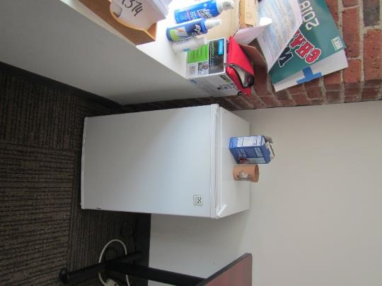
Refrigerator on carpet
Picture 7
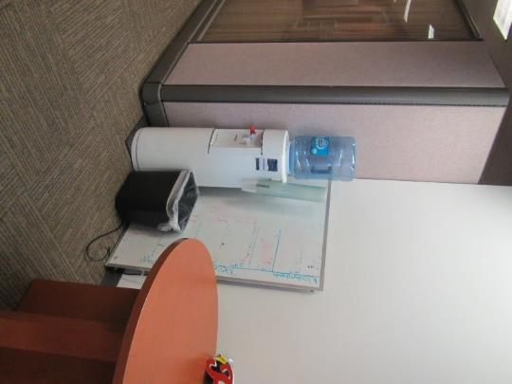
Water cooler on carpet
Picture 8
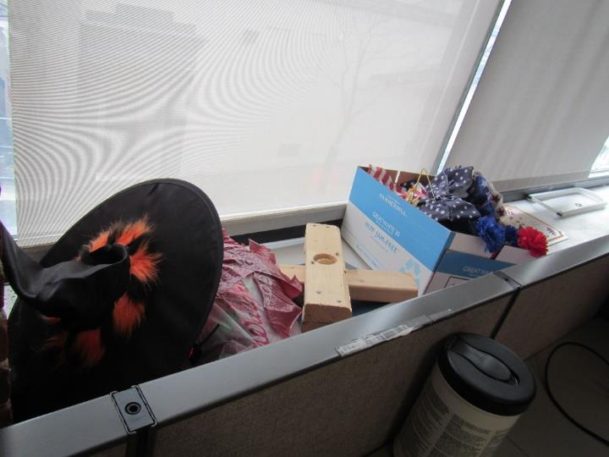
Items stored in the office

Picture 9
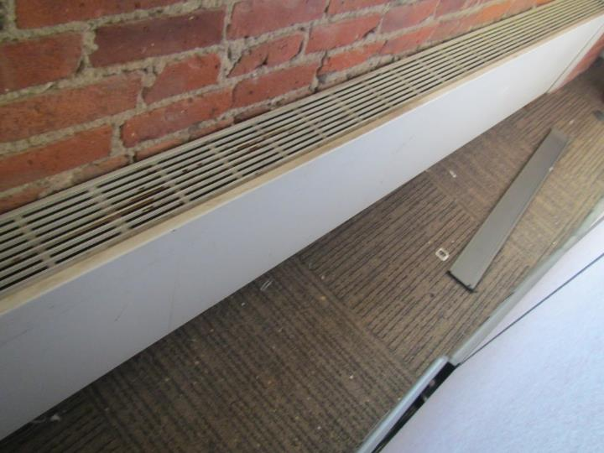
Dust and debris on radiator and carpet behind cubicle wall
Location/ Room | Carbon  Dioxide  (ppm) | Carbon Monoxide  (ppm) | Temp  (°F) | Relative  Humidity  (%) | PM2.5  (µg/m³) | Occupants  in Room | Windows  Openable | Ventilation |  | Remarks
 |  |  |  |  |  |  |  | Supply | Exhaust
Background | 391 | ND | 57 | 48 | ND |  |  |  |  | Partly cloudy
Cubicle 284 | 535 | ND | 73 | 32 | ND | 0 | No | Yes | Yes | Hand sanitizers, mini fridge on carpet, food in office
Cubicle 266 | 562 | ND | 73 | 32 | ND | 0 | No | Yes | Yes | Mini fridge on carpet
Office 264 | 549 | ND | 73 | 31 | ND | 0 | No | Yes | Yes
Half wall office 269 | 530 | ND | 73 | 32 | ND | 0 | No | Yes | Yes | Debris between cube wall and windows
Cubicle 261 | 581 | ND | 73 | 32 | ND | 0 | No | Yes | Yes
Half wall office 271 | 516 | ND | 73 | 33 | ND | 1 | No | Yes | Yes | Water-damaged windowsill
Half wall office 272 | 519 | ND | 73 | 32 | ND | 0 | No | Yes | Yes
Cubicle 274 | 520 | ND | 73 | 32 | ND | 1 | No | Yes | Yes
Cubicle 276 | 520 | ND | 73 | 32 | ND | 0 | No | Yes | Yes
Cubicle 279 | 524 | ND | 73 | 32 | ND | 1 | No | Yes | Yes
Cubicle 250 | 572 | ND | 75 | 31 | ND | 0 | No | Yes | Yes | Solar glare from large windows in this area, water-damaged plaster on ceiling
Half wall office 247 | 518 | ND | 76 | 29 | ND | 0 | No | Yes | Yes
Half wall office 249 | 549 | ND | 77 | 29 | ND | 1 | No | Yes | Yes | Solar glare from large windows in this area
Cubicle 242 | 545 | ND | 78 | 28 | ND | 1 | No | Yes | Yes
Half wall office 238 | 526 | ND | 76 | 29 | ND | 0 | No | Yes | Yes
Half wall office 237 | 518 | ND | 76 | 30 | ND | 0 | No | Yes | Yes
Cubicle 236 | 537 | ND | 75 | 31 | ND | 1 | No | Yes | Yes
Cubicle 233 | 552 | ND | 75 | 31 | ND | 0 | No | Yes | Yes | Photocopier outside cubicle
Cubicle 231 | 531 | ND | 74 | 30 | ND | 1 | No | Yes | Yes
Cubicle 227 | 547 | ND | 75 | 30 | ND | 1 | No | Yes | Yes
Cubicle 224 | 571 | ND | 73 | 32 | ND | 0 | No | Yes | Yes
Cubicle 222 | 555 | ND | 73 | 32 | ND | 0 | No | Yes | Yes
Half wall office 221 | 560 | ND | 73 | 32 | ND | 0 | No | Yes | Yes
Office 220 | 551 | ND | 73 | 32 | ND | 1 | No | Yes | Yes | Mini fridge on carpet, air fresheners, food on floor and desk
Cubicle 218 | 536 | ND | 73 | 32 | ND | 0 | No | Yes | Yes
Cubicle 216 | 508 | ND | 72 | 32 | ND | 0 | No | Yes | Yes
Half wall office 217 | 551 | ND | 72 | 32 | ND | 0 | No | Yes | Yes
Office 215 | 529 | ND | 72 | 33 | ND | 1 | No | Yes | Yes
Hot desks near elevators | 545 | ND | 73 | 32 | ND | 0 | No | Yes | Yes
Half wall office | 518 | ND | 72 | 32 | ND | 0 | No | Yes | Yes | Debris behind cubicle wall, radiator behind cubicle wall with debris in it
Hamilton cube | 573 | ND | 72 | 33 | ND | 1 | No | Yes | Yes | Photocopier outside cubicle
Half wall office 204 | 569 | ND | 72 | 33 | ND | 1 | No | Yes | Yes
Cubicle 209 | 608 | ND | 72 | 33 | ND | 1 | No | Yes | Yes | Blocked vent outside cubes 208/209. Vent blocked with a file folder
Office 205 | 575 | ND | 72 | 33 | ND | 0 | No | Yes | Yes | Candle (unused)
Women’s Restroom |  |  |  |  |  | 1 | No | Yes | Yes (weak) | 6 water-damaged ceiling tiles, deodorizers
Kitchen |  |  |  |  |  | 0 | No | Yes | Yes | Appliances, toaster has crumbs
Conference room 206 | 512 | ND | 73 | 32 | ND | 0 | No | Yes | Yes | Debris in radiators

