**INDOOR AIR QUALITY**

**POST-OCCUPANCY ASSESSMENT**

**Massachusetts Department of Transitional Assistance**

**1785 Columbus Avenue**

**Roxbury, MA**

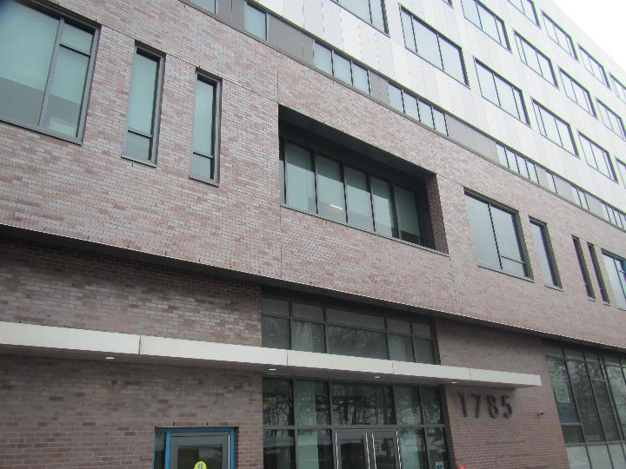

Prepared by:

Massachusetts Department of Public Health

Bureau of Climate and Environmental Health

Division of Environmental Health Regulations and Standards

February 2025

# BACKGROUND

|  |  |
| --- | --- |
| Building: | Department of Transitional Assistance (DTA) offices |
| Address: | 1785 Columbus Avenue  Roxbury, MA 02119  7th floor |
| Assessment Requested by: | Kendra Howes, Senior Project Manager, Division of Capital Asset Management & Maintenance (DCAMM) |
| Reason for Request: | Post-occupancy indoor air quality (IAQ) assessment. The DTA office has recently moved into this space from a different location in Roxbury |
| Date of Assessment: | February 12, 2025 |
| Massachusetts Department of Public Health/Bureau of Climate and Environmental Health (MDPH/BCEH) Staff Conducting Assessment: | Ruth Alfasso, Environmental Inspector, Division of Environmental Health Regulations and Standards (EHRS) |
| Building Description: | The DTA occupies a portion of the 7th floor of a 7-story office building built in 2020. The DTA offices include private offices, cubicle workstations, conference and interview rooms, a waiting room, and a small kitchen. |
| Windows: | Windows are not openable. |

# METHODS

Please refer to the IAQ Manual for methods, sampling procedures, and interpretation of results (MDPH, 2015).

# RESULTS AND DISCUSSION

The following is a summary of indoor air testing results (Table 1).

* ***Carbon dioxide*** measurements were below the MDPH guideline of 800 parts per million (ppm) in all areas tested, indicating adequate air exchange at the time of assessment.
* ***Temperature*** was within or close to the recommended range of 70°F to 78°F in all areas.
* ***Relative humidity*** was below the recommended range of 40% to 60% in all areas examined. Low relative humidity is a common issue during the heating season.
* ***Carbon monoxide*** levels were non-detectable (ND) in all indoor areas tested.
* ***Fine particulate matter (PM2.5)*** concentrations were below the National Ambient Air Quality Standard (NAAQS) level of 35 μg/m3 in all areas tested.
* ***Total Volatile Organic Compounds***were ND in all areas tested.

## Ventilation

A heating, ventilating, and air conditioning (HVAC) system has several functions. First, it provides heating and, if equipped, cooling. Second, it is a source of fresh air. Finally, an HVAC system will dilute and remove normally occurring indoor environmental pollutants by not only introducing fresh air but also filtering the airstream and ejecting stale air outdoors via exhaust ventilation. Even if an HVAC system is operating as designed, point sources of respiratory irritation may exist and affect symptoms in sensitive individuals.

Fresh air is supplied to the DTA offices and common areas through supply vents in the ceiling (Pictures 1 and 2). Air is drawn back to the air handling units (AHUs) through ceiling-mounted return vents (Picture 3).

Temperature sensors are located in offices and common areas (Pictures 4 and 5). This type of sensor feeds information to a central control system. Some of the sensors (e.g., Picture 5) have a slider that appears to allow for occupant adjustment of the setpoint over a short range. The sensors do not show any indication of the temperature setpoints, or whether the fan is set to be on all the time, or only when temperatures need adjustment. The MDPH EHRS recommends that the fan be on continuously during occupied periods to provide fresh air regardless of temperature demands. Temperature and fan setbacks can be used for nights and weekends when the space will not be occupied.

Note that this brand of sensor can include additional measurements such as humidity and carbon dioxide. If additional measurements are available from these sensors, they should be calibrated or replaced in accordance with the manufacturer’s instructions.

The MDPH EHRS program recommends that AHU filters be changed 2-4 times a year (or in accordance with the manufacturers’ recommendations) and be at least minimum efficiency reporting value (MERV) 8, as these are adequate to filter out pollen, mold, and similar particulates (ASHRAE, 2012). The AHU or AHUs for this office were not accessed during this visit.

It is recommended that HVAC systems be re-balanced every five years to ensure adequate air systems function (SMACNA, 1994). While it is likely these systems were balanced prior to occupancy, that information was not available at the time of the assessment.

## Microbial/Moisture Concerns

No water-damaged materials were found during this assessment. A water fountain was noted in a carpeted area (Picture 6). A waterproof mat was underneath this unit, but did not appear large enough to capture spills or condensation from both fountains. There was also a small refrigerator on carpet in the Wellness Room (Picture 7). The refrigerator in the breakroom had small spots that might be from a spill or the beginning of mold growth (Picture 8). This should be cleaned. Refrigerators and other food storage and preparation equipment should be kept clean to reduce the chance of smoke or odors, and to avoid attracting pests.

## Other IAQ Concerns

Testing was conducted for total volatile organic compounds (TVOCs). All measurements were non-detect (ND). An examination was conducted for products that may be a source of VOCs in indoor air. Products such as hand sanitizers and cleaners were noted (Table 1). VOCs from these products can build up and lead to irritation of the mucous membranes.

Boxes were noted on floors in the storage area and a few other places (Picture 9; Table 1). Large amounts of items in offices and common areas, particularly on floors, can prevent effective cleaning and may become attractive to pests as harborage.

The exhaust vent in the staff-side women’s restroom was dusty (Picture 10). This dust can be aerosolized and can also become a mold growth medium if the vent becomes moistened by condensation. Vents should be cleaned of dust periodically. Note that dust on an exhaust vent is also a sign the vent is working.

Finally, most areas of the office are carpeted. Carpets should be cleaned regularly in accordance with Institute of Inspection, Cleaning and Restoration Certification (IICRC) recommendations (IICRC, 2012).

# CONCLUSIONS/RECOMMENDATIONS

In view of the findings at the time of the visit, the following recommendations are made:

## Ventilation recommendations

1. Ensure the AHU and other HVAC system filters are at least a MERV rating of 8 and are changed at least twice a year.
2. Ensure the control system is configured to have the fan on during occupied periods regardless of the need for heating or cooling.
3. If sensors shown in Pictures 4 and 5 are used for additional measurements such as humidity or carbon dioxide, ensure these sensors are calibrated or replaced in accordance with manufacturer’s instructions.
4. It is recommended that HVAC systems be re-balanced every five years to ensure adequate air systems function (SMACNA, 1994).

## Water damage recommendations

1. Clean the refrigerator in the breakroom to remove spotting. Keep refrigerators in the office clean and free of spoiled food.
2. Consider using a waterproof mat under the entire water fountain shown in Picture 6 and under the refrigerator in the breakroom.

## Other recommendations

1. Use VOC-containing products in areas with good ventilation and keep tightly closed when not in use. Avoid products with strong scents and avoid mixing incompatible products.
2. Clean supply and return vents periodically to remove dust.
3. Ensure paper and boxes are stored in appropriate locations as soon as possible to make thorough cleaning easier.
4. Clean carpeting in accordance with IICRC recommendations (IICRC, 2012); annually (or semi-annually in soiled/high traffic areas).
5. Refer to resource manual and other related IAQ documents located on the MDPH’s website for further building-wide evaluations and advice on maintaining public buildings. These documents are available at: <http://mass.gov/dph/iaq>.

# REFERENCES

ASHRAE. 2012. American Society of Heating, Refrigeration and Air Conditioning Engineers (ASHRAE) Standard 52.2-2012 -- Method of Testing General Ventilation Air-Cleaning Devices for Removal Efficiency by Particle Size (ANSI Approved).

IICRC. 2012. Institute of Inspection, Cleaning and Restoration Certification. Carpet Cleaning: FAQ.

MDPH. 2015. Massachusetts Department of Public Health. Indoor Air Quality Manual: Chapters I-III. Available at: <https://www.mass.gov/lists/indoor-air-quality-manual-and-appendices>.

SMACNA. 1994. HVAC Systems Commissioning Manual. 1st ed. Sheet Metal and Air Conditioning Contractors’ National Association, Inc., Chantilly, VA.

**Picture 1**

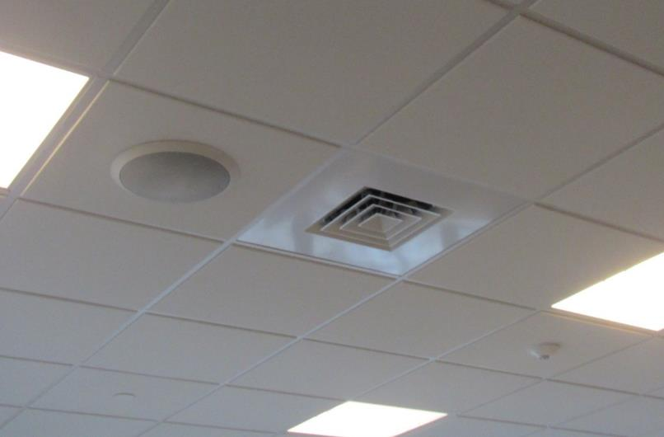

**Ceiling-mounted supply vent**

**Picture 2**

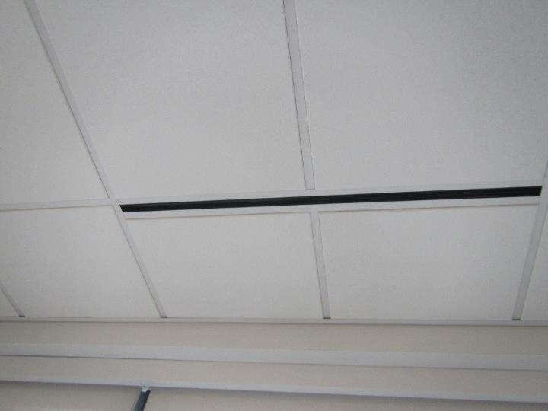

**Slot-style supply vent near windows**

**Picture 3**

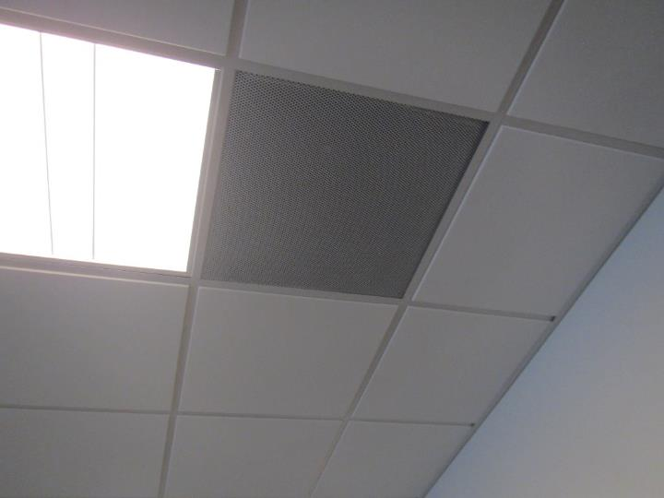

**Typical return vent**

**Picture 4**

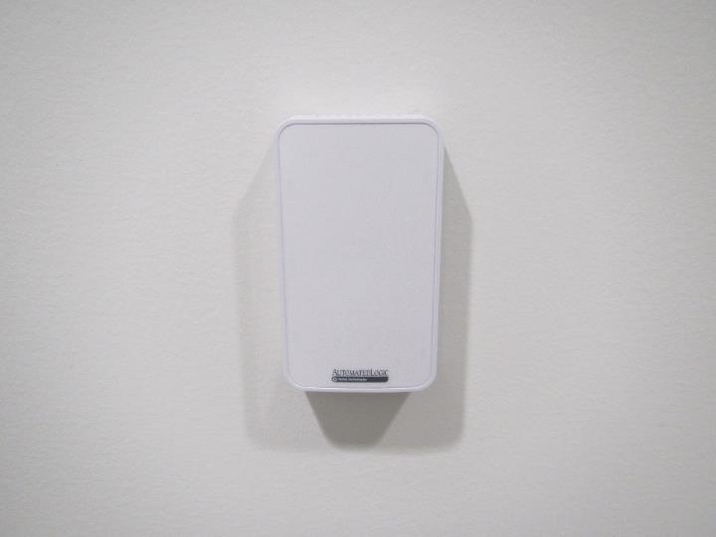

**Temperature sensor without slider**

**Picture 5**

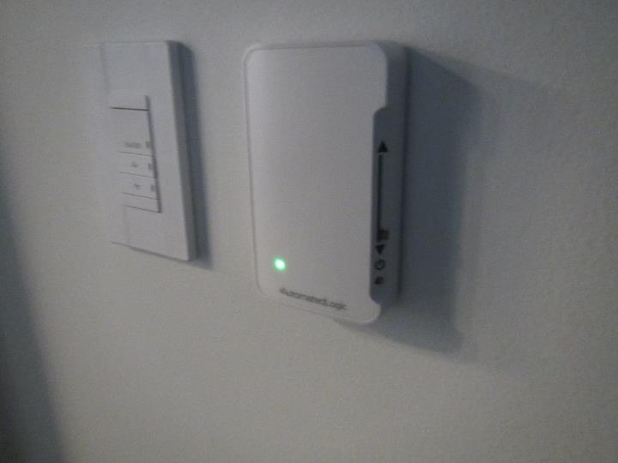

**Temperature sensor with adjustment slider (item on right)**

**Picture 6**

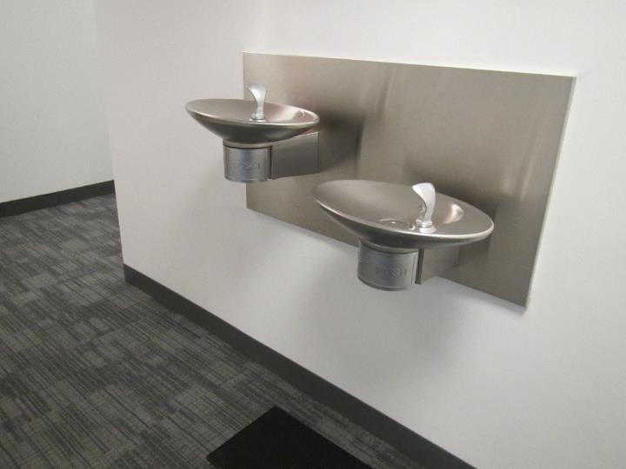

**Water fountain in carpeted area, note mat under part of fountain**

**Picture 7**

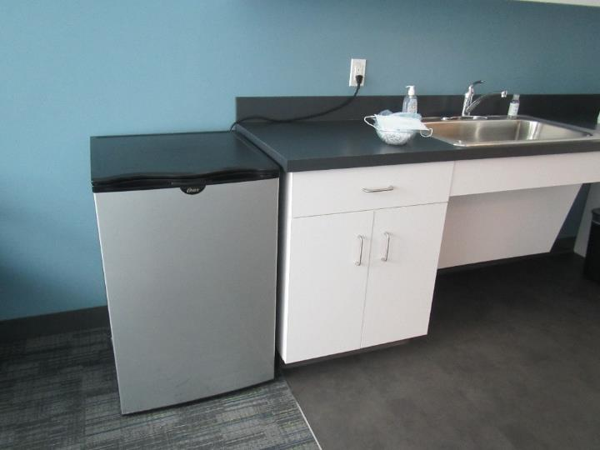

**Small refrigerator on carpet in the Wellness Room**

**Picture 8**

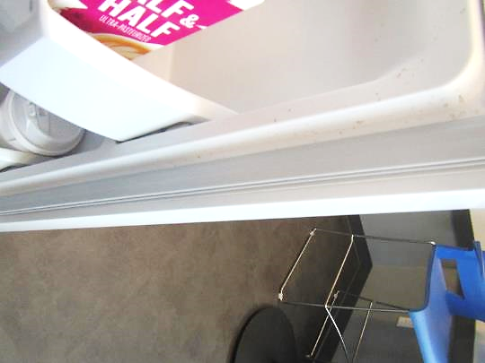

**Spots in refrigerator from a spill or the beginning of mold growth**

**Picture 9**

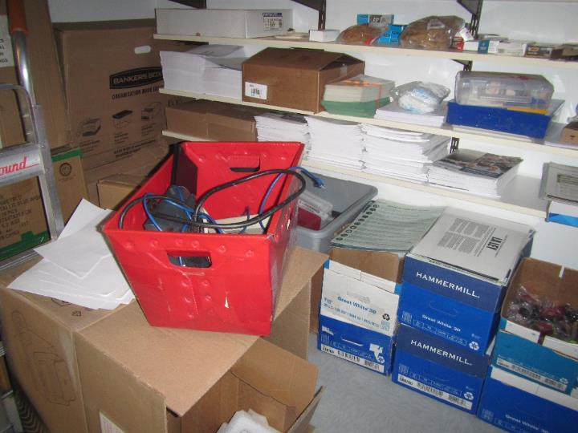

**Boxes on the floor in the storage room**

**Picture 10**

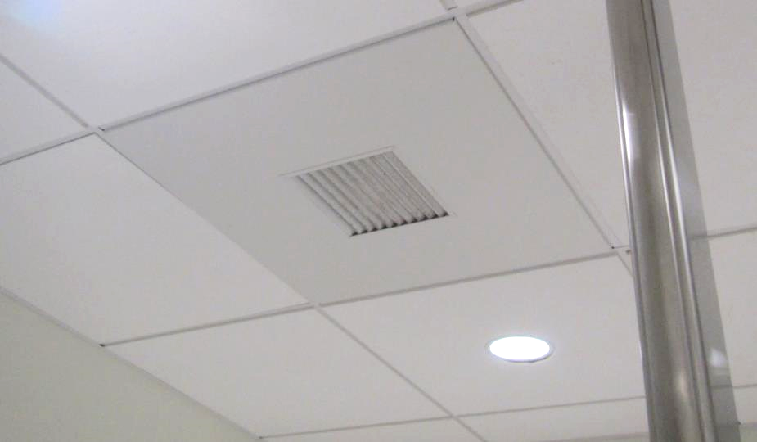

**Dusty exhaust in the staff-side women’s restroom**

| **Location** | **Carbon**  **Dioxide**  **(ppm)** | **Carbon Monoxide**  **(ppm)** | **Temp**  **(°F)** | **Relative**  **Humidity**  **(%)** | **PM2.5**  **(µg/m3)** | **TVOC**  **(ppm)** | **Occupants**  **in Room** | **Windows**  **Openable** | **Ventilation** | | **Remarks** |
| --- | --- | --- | --- | --- | --- | --- | --- | --- | --- | --- | --- |
| **Supply** | **Exhaust** |
| Background | 538 | 1 | 38 | 44 | 9 | ND |  |  |  |  | Flurries, measurement taken at street level on busy side street |
| 7181 cubes | 696 | ND | 68 | 21 | 1 | ND | 1 | N | Y | Y | PC |
| 7177 hotel cubes | 680 | ND | 69 | 20 | ND | ND | 1 | N | Y | Y |  |
| 7176 cubes | 685 | ND | 70 | 19 | ND | ND | 1 | N | Y | Y | HS |
| 7172 cubes | 681 | ND | 72 | 18 | 1 | ND | 0 | N | Y | Y |  |
| 7141 break room | 698 | ND | 72 | 18 | ND | ND | 1 | N | Y | Y | NC, fridge, microwave, toaster, sink, coffee maker |
| 7140 office | 703 | ND | 72 | 17 | 1 | ND | 1 | N | Y | Y | Occupant reports cold temperature |
| 7133 office | 798 | ND | 72 | 17 | 1 | ND | 1 | N | Y | Y |  |
| 7139 office | 693 | ND | 73 | 17 | 2 | ND | 0 | N | Y | Y |  |
| 7138 office | 684 | ND | 73 | 17 | 1 | ND | 0 | N | Y | Y |  |
| 7137 office | 681 | ND | 73 | 17 | 1 | ND | 0 | N | Y | Y |  |
| 7157 | 675 | ND | 73 | 17 | 1 | ND | 0 | N | Y | Y |  |
| 7119 wellness | 669 | ND | 74 | 16 | 1 | ND | 0 | N | Y | Y | Sink with non-porous flooring underneath, fridge on carpet |
| Conference | 753 | ND | 74 | 17 | ND | ND | 0 | N | Y | Y |  |
| 7136 office | 702 | ND | 74 | 16 | ND | ND | 0 | N | Y | Y |  |
| 7159 hotel cubes | 714 | ND | 74 | 16 | ND | ND | 1 | N | Y | Y |  |
| 7135 office | 716 | ND | 74 | 16 | 1 | ND | 0 | N | Y | Y |  |
| 7134 storage | 701 | ND | 74 | 16 | ND | ND | 0 | N | Y | Y | NC, boxes on floor |
| 7163 cubes | 714 | ND | 74 | 16 | ND | ND | 1 | N | Y | Y |  |
| 7170 cubes | 734 | ND | 74 | 16 | 1 | ND | 1 | N | Y | Y |  |
| Reception (secure side) | 700 | ND | 75 | 17 | ND | ND | 3 | N | Y | Y | PC |
| Single occupancy restroom secure side | 678 | ND | 74 | 17 | ND | ND | 0 | N | Y | Y |  |
| Women’s restroom secure side |  |  |  |  |  |  |  | N | Y | Y | Dusty exhaust vent, dirty ceiling tile |
| Waiting | 667 | ND | 74 | 17 | ND | ND | 6-8 | N | Y | Y | NC |
| 7103 interview | 452 | ND | 73 | 18 | ND | ND | 0 | N | Y | Y | NC |
| 7104 interview | 455 | ND | 73 | 17 | ND | ND | 0 | N | Y | Y | NC |
| 7105 hybrid hearing | 651 | ND | 73 | 17 | ND | ND | 0 | N | Y | Y | NC |
| 7106 interview | 656 | ND | 73 | 17 | ND | ND | 0 | N | Y | Y | NC |
| 7109 interview | 693 | ND | 73 | 17 | ND | ND | 1 | N | Y | Y | NC |
| 7110 interview | 769 | ND | 74 | 17 | ND | ND | 0 | N | Y | Y | NC |
| 7111 interview | 663 | ND | 74 | 17 | ND | ND | 0 | N | Y | Y | NC |