INDOOR AIR QUALITY ASSESSMENT

Department of Mental Health
Youth Center
76 Amory St
Roxbury, MA 02119

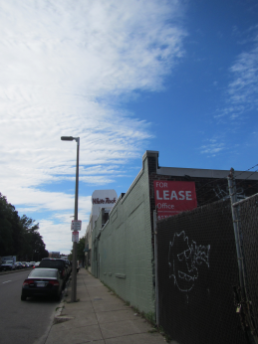

Prepared by:
Massachusetts Department of Public Health
Bureau of Environmental Health
Indoor Air Quality Program
October 2018

Background
Building: | Department of Mental Health (DMH) Youth Center
Address: | 76 Amory St, Roxbury, MA
Assessment Requested by: | Jamie Merrill Blood, Project Manager, DCAMM
Reason for Request: | General indoor air quality (IAQ)
Date of Assessment: | September 21, 2018
Massachusetts Department of Public Health/Bureau of Environmental Health (MDPH/BEH) Staff Conducting Assessment: | Sharon Lee, Environmental Analyst, IAQ Program
Building Description: | The office is located on a single floor of an old bottling company
Windows: | Not openable

Methods
Please refer to the IAQ Manual for methods, sampling procedures, and interpretation of results (MDPH, 2015).

IAQ Testing Results
The following is a summary of indoor air testing results (Table 1).
- Carbon dioxide levels were above the MDPH guideline of 800 parts per million (ppm) in about a third of areas tested.
- Temperature was within the MDPH recommended range of 70°F to 78°F in all occupied areas tested.
- Relative humidity was within the MDPH recommended range of 40 to 60% in all occupied areas tested.
- Carbon monoxide levels were non-detect (ND) throughout the occupied areas surveyed.
- Fine particulate matter (PM2.5) concentrations measured were below the National Ambient Air Quality Standard (NAAQS) level of 35 μg/m³ in all areas assessed.

Ventilation
A heating, ventilating, and air conditioning (HVAC) system has several functions. First, it provides heating and, if equipped, cooling. Second, it is a source of fresh air. Finally, an HVAC system will dilute and remove normally-occurring indoor environmental pollutants by not only introducing fresh air, but also filtering the airstream and ejecting stale air to the outdoors via exhaust ventilation. Even if an HVAC system is operating as designed, point sources of respiratory irritation may exist and affect symptoms in sensitive individuals.
Fresh air is provided by an air-handling unit (AHU) located on the roof. Air from the AHU is filtered, heated/cooled, and delivered to rooms via ducted supply diffusers (Picture 1). Air is returned back to the AHU via ceiling-mounted grates (Picture 2). It is recommended that HVAC systems be re-balanced every five years to ensure adequate air systems function (SMACNA, 1994). It is not known when the last time these systems were balanced.
At the time of the assessment, BEH/IAQ staff observed one supply vent sealed with plastic wrap. This can prevent fresh air supply to the space (Picture 3).
Two thermostats control ventilation at the Youth Center. At the time of the assessment, these thermostats were set to fan “auto” rather than “on” (Picture 4). When the fan is set to auto, air is circulated only when the AHU calls for the delivery of tempered air. In contrast, fan on allows for continued air movement. The thermostats should be set to fan on during work hours. This is especially important during temperate weather (e.g., spring and fall) where heating or cooling may not be called for frequently. Intermittent fresh air supply will likely increase occupant complaints regarding IAQ. Additionally, one thermostat was not programmed with the correct time/day, which can lead to lack of fresh air ventilation during setback periods. Operating the system with fan in on setting and ensuring the thermostat is set correctly will help increase comfort.
Filters appear to be installed directly at return vents. These are reportedly changed twice a year. It is recommended that AHUs be outfitted with pleated filters of a Minimum Efficiency Reporting Value (MERV) of 8 or higher, which are adequate in filtering out pollen and mold spores (ASHRAE, 2012). In addition, filters should be changed 2-4 times a year or in accordance with the manufacture’s recommendations.
Note that the Youth Center has a kitchen that is used for cooking demonstrations on Thursdays and Fridays. BEH/IAQ staff noted that the kitchen exhaust hood is not ducted to outdoors (Picture 5). Instead, the hood filters and recirculates air, which can result in the distribution of odors and particulates generated while cooking. Without dedicated exhaust ventilation and adequate air exchange, cooking odors and particulates will persist indoors.

Microbial/Moisture Concerns
Water-damaged ceiling tiles and plaster were observed in a number of areas (Table 1). This was particularly evident around skylights (Picture 6). Each of these areas should be monitored following rain events to determine whether leaks are active so they can be sealed/repaired. Water-damaged ceiling tiles were also observed in other areas (Picture 1), indicating roof or pipe leaks. Water-damaged ceiling tiles should be replaced once the leaks have been fixed. During ceiling tile replacement, the area above the ceiling tile system should be checked for any additional water damage/odors and cleaned/repaired as needed.
A gap was observed between the sink backsplash and countertop (Picture 7). Water can run between the gap and behind the laminate backsplash and counter, which can cause damage. Over time, continued water damage can lead to mold growth.
A fan unit that appeared to be an evaporative cooler was observed in the large conference room (Picture 8). This type of equipment draws warm air into the unit, and as air passes over water-moistened pads, it is cooled. The unit then circulates cooled, humid air into the room. These types of units are designed to be used in warm climates with low humidity (DOE, 2018), and may be ineffective in cooling the conference room when it is fully occupied. Operation of these units may also be a source of additional humidity during hot, humid weather.
Indoor plants were observed in a few areas (Table 1). Plants can be a source of pollen and mold, which can be respiratory irritants to some individuals. Plants should be properly maintained and equipped with drip pans and should be located away from air diffusers to prevent the aerosolization of dirt, pollen, and mold.

Other IAQ Evaluations
Exposure to low levels of total volatile organic compounds (TVOCs) may produce eye, nose, throat, and/or respiratory irritation in some sensitive individuals. Although no measurable levels of TVOCs were detected in the air, BEH/IAQ staff noted cleaners, hand sanitizers, air fresheners/scented candles, and other products in use within the building. All of these products have the potential to be irritants to the eyes, nose, throat, and respiratory system of sensitive individuals.
A utility cover had pulled away from the wall (Picture 9). Openings in the wall can allow dust/debris to circulate from the wall space into the occupant space, and allow pests into the office. Wall surfaces should be contiguous and openings should be covered.
An active construction site was observed adjacent/behind the building occupied by the DMH (Picture 10). Construction sites can increase pest populations in the surrounding areas. Measures should be taken to prevent and control pests in the building. In addition to regular pest maintenance, staff should be mindful of food storage in office and in the kitchen area. Additionally, food waste, including crumbs and packaging, should be cleaned and discarded daily.

Conclusions/Recommendations
Based on observations at the time of assessment, the following is recommended:
- Operate supply and exhaust ventilation in all areas during occupied periods. This includes using the “fan-on” setting for mechanical ventilation to supply fresh air circulation and filtration even when the temperature is within comfort limits.
- Ensure that all exhaust vents are functional and turned on when the building is occupied.
- Consider installing a kitchen exhaust hood that is ducted to the outside, ensuring cooking odors and particulates are removed.
- Have the HVAC system balanced every 5 years in accordance with SMACNA recommendations (SMACNA, 1994).
- Use pleated MERV 8 filters in AHUs, which are adequate in filtering out pollen and mold spores (ASHRAE, 2012). Change 2-4 times a year or in accordance with the manufacture’s recommendations.
- For buildings in New England, periods of low relative humidity during the winter are often unavoidable. Therefore, scrupulous cleaning practices should be adopted to minimize common indoor air contaminants whose irritant effects can be enhanced when the relative humidity is low. To control for dusts, a high efficiency particulate arrestance (HEPA) filter equipped vacuum cleaner in conjunction with wet wiping of all surfaces is recommended. Avoid the use of feather dusters. Drinking water during the day can help ease some symptoms associated with a dry environment (throat and sinus irritations).
- Monitor skylights for leaks during and after a rain event and repair as needed.
- Remove any water-damaged ceiling tiles and replace. Monitor the area for any new leaks and make any necessary repairs.
- Seal gap between sink countertop and backsplash with caulking to prevent water damage.
- Consider discontinuing use of the evaporative cooler, since adding moisture to the air may not aid in cooling during hot, humid weather. In addition to operating thermostats in the “fan on” mode, standing fans or a ductless air conditioning unit may help to improve comfort in the room.
- Reduce use of products containing VOCs including eliminating air freshening products and scented candles.
- Use the principles of IPM to reduce pest issues in the building, including the sealing of pathways and reduction in sources of food and harborage. Consult “Integrated Pest Management Kit For Building Managers” (MDFA, 1996), http://www.mass.gov/eea/docs/agr/pesticides/publications/ipm-kit-for-bldg-mgrs.pdf.
- Take measures to seal breaches/install door sweeps to the exterior of the building. Spaces as small as 1/4 inch are large enough for rodents to enter a building.
- Refer to resource manual and other related IAQ documents located on the MDPH’s website for further building-wide evaluations and advice on maintaining public buildings. These documents are available at: http://mass.gov/dph/iaq.

References
ASHRAE. 2012. American Society of Heating, Refrigeration and Air Conditioning Engineers (ASHRAE) Standard 52.2-2012 -- Method of Testing General Ventilation Air-Cleaning Devices for Removal Efficiency by Particle Size (ANSI Approved).
MDFA. 1996. Integrated Pest Management Kit for Building Managers. Massachusetts Department of Food and Agriculture, Pesticide Bureau, Boston, MA.
MDPH. 2015. Massachusetts Department of Public Health. Indoor Air Quality Manual: Chapters I-III. Available at: http://www.mass.gov/eohhs/gov/departments/dph/programs/environmental-health/exposure-topics/iaq/iaq-manual/.
SMACNA. 1994. HVAC Systems Commissioning Manual. 1st ed. Sheet Metal and Air Conditioning Contractors’ National Association, Inc., Chantilly, VA.
US DOE. 2018. Evaporative Coolers. Available at: https://www.energy.gov/energysaver/home-cooling-systems/evaporative-coolers
Picture 1
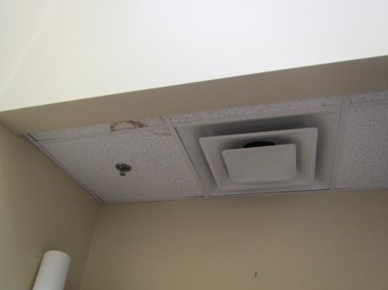
Fresh air supply vent. Note water-damaged ceiling tiles
Picture 2
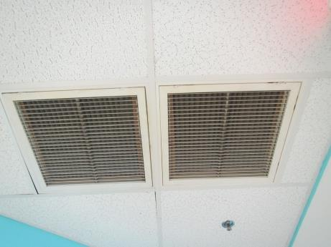
Return vent
Picture 3
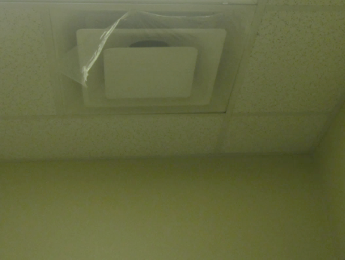
Supply vent sealed with plastic
Picture 4
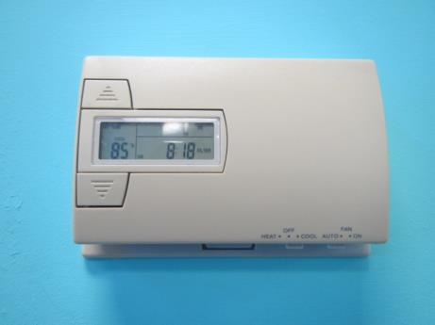
Thermostat, note set temperature for turning on air conditioning
Picture 5
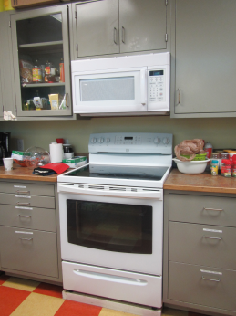
Kitchen hood vent, not ducted outside
Picture 6
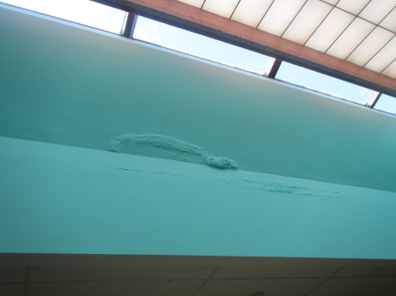
Water damaged ceiling plaster
Picture 7
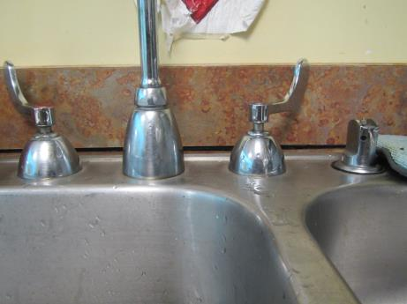
Breach between sink backsplash and countertop
Picture 8
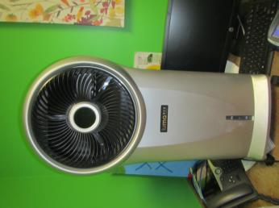
Evaporative cooler in large conference room
Picture 9
Utility cover pulled from wall
Picture 10
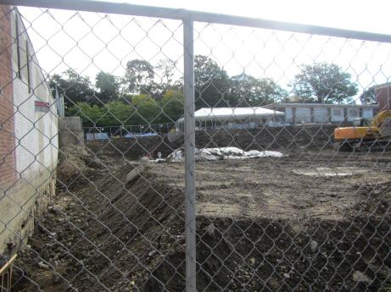
Active construction site
Location | Carbon  Dioxide  (ppm) | Carbon Monoxide  (ppm) | Temp  (°F) | Relative  Humidity  (%) | PM2.5  (µg/m3) | Occupants  in Room | Windows  Openable | Ventilation |  | Remarks
 |  |  |  |  |  |  |  | Supply | Exhaust
Background | 367 | ND | 67 | 53 | 11 |  |  |  |  | Mix of sun and clouds
12 (unoccupied) | 681 | ND | 70 | 46 | 7 |  |  |  |  | 3 computers, DO, DEM, portable evaporative cooler
12 (occupied) | 1063 | ND | 74 | 47 | 12 | 8
10 | 655 | ND | 71 | 43 | 7 | 1 | N | Y | N | PF CPs, HS, 5 computers, DO
9 | 721 | ND | 71 | 43 | 8 | 1 | N | Y | N | PF, outlet missing covering, DO
4 | 838 | ND | 71 | 43 | 4 | 1 | N | Y | N | DO, CPs
7 | 871 | ND | 71 | 43 | 9 | 1 | N | Y  Plastic cover | N | DO
8 | 753 | ND | 71 | 44 | 8 | 1 | N | Y | N | DO
6 | 671 | ND | 71 | 42 | 7 | 0 | N | Y | N | WD-ceiling around skylight, WD-CT, food storage, CPs, PF
5 | 679 | ND | 71 | 43 | 7 | 0 | N | Y | N | Plants, PF
3 | 567 | ND | 71 | 43 | 6 | 0 | N | Y | N
2 | 716 | ND | 72 | 42 | 8 | 1 | N | Y | N | CPs, HS, scented candle
1 | 699 | ND | 72 | 43 | 11 | 0 | N | Y | N | HS
Main room (upper) | 700 | ND | 72 | 45 | 9 | 0 | N | Y | Y | WD-CT, WD-ceiling around skylight, plants, CP
Main room (lower) | 871 | ND | 73 | 45 | 7 | 3 | N | Y | Y | 6 computers
Kitchen | 708 | ND | 73 | 45 | 17 | 0 | N | Y | Y | WD-CT, CPs, kitchen hood exhaust not directly vented out
Women’s room |  | ND | 73 | 47 | 7 |  | N | Y | Y | Fruit flies, DO
Men’s room |  | ND | 74 | 48 | 17 |  | N | Y | Y | WD-CT, DO

