INDOOR AIR QUALITY ASSESSMENT

Mass Rehabilitation Commission
40 Dimock Street
3rd floor
Boston (Roxbury)

Prepared by:
Massachusetts Department of Public Health
Bureau of Environmental Health
Indoor Air Quality Program
September 2019

Background
Building: | Mass Rehabilitation Commission (MRC)
Address: | 40 Dimock Street, 3rd floor, Boston (Roxbury), MA
Assessment Requested by: | Pedro Batista, Facilities Resource Coordinator, Executive Office of Health and Human Services (EOHHS)
Reason for Request: | Indoor air quality (IAQ) concerns during renovations on other floors
Date of Assessment: | September 3, 2019
Massachusetts Department of Public Health/Bureau of Environmental Health (MDPH/BEH) Staff Conducting Assessment: | Ruth Alfasso, Environmental Engineer/Inspector IAQ Program
Building Description: | The MRC is located on the third floor of a three-story brick building constructed in the mid-1800s as the New England Hospital for Women and Children. The building was renovated several times since construction. The lower two floors are currently occupied by Metropolitan Council for Educational Opportunity (METCO). The MRC space consists of small offices and common work area.
Windows: | Openable

Note that this building has been visited several times in the past, most recently in November of 2016. At that time the recommendations made included: removal of a dead bird and other debris from the attic, sealing breaches between the attic/other non-occupied areas and occupied areas, repairing damage from past water leaks, and keeping offices and storage areas clean and organized.
Previously, the IAQ Program visited the building in 2011. Recommendations at that time included:
- identifying if materials seen in the attic have asbestos-containing materials (ACM) and, if so, remediating per applicable regulations;
- sealing breaches in ductwork in the attic;
- maintaining the heating, ventilation and air conditioning (HVAC) system;
- repairing any water-damaged materials; and
- other typical office recommendations were made such as keeping items organized and clean and keeping plants in good condition.
During the current visit, repairs were being made to the windows on the lower two floors of the building to remove ACM. Windows on the lower two floors were boarded up and had plastic on the inside (Pictures 1 and 2). It was reported that applicable regulatory monitoring and testing for asbestos was being conducted in both the work area and adjacent areas including the MRC office. Performance of this project also includes the use of motorized lifts and other power equipment which can create fumes and noise (Picture 3).

Methods
Please refer to the IAQ Manual for methods, sampling procedures, and interpretation of results (MDPH, 2015).

IAQ Testing Results
The following is a summary of indoor air testing results (Table 1):
- Carbon dioxide levels were all below the MDPH guideline of 800 parts per million (ppm) indicating adequate fresh air.
- Temperature was within the recommended range of 70°F to 78°F.
- Relative humidity was within or close to the recommended range of 40 to 60%.
- Carbon monoxide levels were non-detectable (ND) in the areas tested.
- Fine particulate matter (PM2.5) concentrations measured were all below the National Ambient Air Quality (NAAQS) limit of 35 μg/m³.

Ventilation
A heating, ventilating and air conditioning (HVAC) system has several functions. First it provides heating and, if equipped, cooling. Second, it is a source of fresh air. Finally, an HVAC system will dilute and remove normally-occurring indoor environmental pollutants by not only introducing fresh air, but by filtering the airstream and ejecting stale air to the outdoors via exhaust ventilation. Even if an HVAC system is operating as designed, point sources of respiratory irritation may exist and cause symptoms in sensitive individuals.
This building does not have a mechanical source of fresh air, relying on openable windows. An air handling unit (AHU), located in the attic, only cools and recirculates air. Recirculated air is supplied to ceiling-mounted vents in offices (Picture 4). A large return vent is located in a central area to draw air back to the AHU (Picture 5). This vent is equipped with a filter to remove dust as air is circulated. Heating for the building is supplied by radiators located along the outside walls. One office, located off the elevator lobby, had a window-installed air conditioner (WAC) in the only window (Picture 6). WACs can be used in the fan-only mode to introduce fresh air even when cooling is not needed.
There are exhaust vents in the two restrooms (Picture 7). IAQ staff could not determine if these were drawing air at the time of the assessment. Exhaust vents are necessary in restrooms to remove odors and water vapor. This is especially necessary in the men’s restroom since it has no window.
The MDPH typically recommends that HVAC systems be re-balanced every five years to ensure adequate air systems function (SMACNA, 1994). It is not known when the last time these systems were balanced.

Microbial/Moisture Concerns
A few areas of water-damaged ceiling plaster were noted in the office (Picture 8). This damage appeared to be from past water leaks and did not show signs of microbial growth. Water-damaged plaster should be repaired. Water damage was also observed in a light fixture (Picture 9). This light fixture should be investigated to ensure that the electric components have not been compromised. Signs of water damage were observed on carpet in several areas including stains and wrinkles (Picture 10). The US Environmental Protection Agency (US EPA) and the American Conference of Governmental Industrial Hygienists (ACGIH) recommends that porous materials (e.g., wallboard, carpeting) be dried with fans and heating within 24 to 48 hours of becoming wet (US EPA, 2008; ACGIH, 1989). If porous materials are not dried within this time frame, mold growth may occur.
Water coolers were located on carpet in several areas (Picture 11). These appliances can spill or leak and lead to water damage to carpeting. Plants were found in many offices including on windowsills, the floor and attached to walls (Pictures 12 and 13). Plants, especially those that are not well maintained, or that are overwatered can become a source of pollen, debris, odors and mold spores.
The refrigerator had evidence of spills (Picture 14). Refrigerators should be kept clean to prevent odors and microbial growth.

Construction-related Concerns
This assessment was prompted by occupant concerns regarding the construction occurring on the lower two floors of the building, particularly related to the asbestos abatement. Asbestos abatement is conducted under the jurisdiction and regulations of the Department of Labor Standards (DLS) including requirements for containment and sampling.
Occupants had additional concerns regarding the renovation, mostly related to the lack of communication regarding the activities to be conducted. When buildings are renovated while occupied, it is important to have a plan for communication, and a forum for occupants to ask questions regarding the activities. When possible, significantly disruptive activities, such as those creating high levels of noise or odors, should be scheduled for unoccupied times.

Other Concerns
Exposure to low levels of total volatile organic compounds (TVOCs) may produce eye, nose, throat, and/or respiratory irritation in some sensitive individuals. BEH/IAQ examined spaces for products containing VOCs. BEH/IAQ staff noted hand sanitizers, cleaners, and air fresheners in the office space (Picture 13; Table 1). All of these products have the potential to be irritants to the eyes, nose, throat, and respiratory system of sensitive individuals. One office had an essential oil scent diffuser operating. Scented products such as oil diffusers or air fresheners are not recommended, as fragrances may cause allergic reactions or exacerbate other health conditions such as migraines or asthma.
The attic space was examined. As noted in previous visits, a large amount of debris and dust was present (Pictures 15 through 17). This dust may infiltrate any gaps in the HVAC system, or gaps in the attic floor/ceiling below and be distributed to occupied areas. Dust can also be a mold growth medium if leaks or condensation moistens surfaces in the attic. In addition, items stored in this area, such as the window screens shown in Picture 17, may become coated in dust and need significant cleaning before being put into use. Handling the items can also expose occupants to dust.
Gaps/pathways between occupied and unoccupied areas were noted in several areas. Where the radiator pipe in the women’s bathroom enters the wall/floor, there is a large hole (Picture 18) which should be sealed to prevent dust and odors from being carried into the space from unoccupied areas. Gaps may also be present around the disused fireplaces (Picture 19) in many offices, between bricks in the center of each fireplace, or in the old flues. Note that gaps around fireplaces were identified as an issue in a previous report.
Since open windows are the only source of fresh air to this office, window screens need to be intact to provide protection against insects, however many screens were found damaged (Picture 20). Windows should also be closed during hot, humid weather to prevent condensation. Windows should also be closed (as needed) when construction is occurring adjacent to the window.
Items were observed on flat surfaces, such as windowsills, tabletops, counters, bookcases, and desks (Table 1). Items stored in offices provide a source for dusts to accumulate. These items also make it difficult for custodial staff to clean. Items should be relocated and/or be cleaned periodically to avoid excessive dust build up.
Most of the offices are carpeted. Carpets should be cleaned annually (or semi-annually in soiled/high traffic areas) in accordance with Institute of Inspection, Cleaning and Restoration Certification (IICRC) recommendations, (IICRC, 2012). Carpeting that has become significantly water-damaged, wrinkled, or torn may need to be replaced. Protective mats for chairs and other areas may be useful to protect carpet as well.

Conclusions/Recommendations
Based on observations at the time of assessment, the following is recommended:
- Develop a method to communicate about renovations and other projects in the building to occupants including a schedule for activities.
- Ensure that containment for construction/asbestos abatement is checked for integrity daily and maintained as needed.
- When possible schedule highly disruptive construction activities to unoccupied periods.
- Use operable windows for fresh air during temperate weather. Ensure windows are tightly closed at the end of the day and during hot, humid weather. While construction is going on, keep windows closed (as needed) along the side of the building adjacent to the construction to keep out dust, fumes and noise.
- Operate ACs in the fan-only mode to introduce fresh air when cooling is not needed.
- Ensure all windows that are opened have intact screens.
- Operate supply and exhaust ventilation continuously in all areas during occupied periods. Ensure all HVAC equipment is cleaned/maintained in accordance with manufacturer’s instructions.
- Periodically check bathroom exhaust vents to ensure they are functioning and repair as needed.
- Change filters for HVAC equipment 2-4 times a year. If possible in current equipment, use pleated filters of a Minimum Efficiency Rating Value (MERV) 8 (or higher), which are adequate in filtering out pollen and mold spores (ASHRAE, 2012).
- Balance the HVAC system every 5 years in accordance with Sheet Metal and Air Conditioning Contractors’ National Association (SMACNA) recommendations (SMACNA, 1994).
- Clean supply, return and exhaust vents to prevent reaerosolization of dust. Clean the filters of any window air conditioners and air purifiers as well.
- For buildings in New England, periods of low relative humidity during the winter are often unavoidable. Therefore, scrupulous cleaning practices should be adopted to minimize common indoor air contaminants whose irritant effects can be enhanced when the relative humidity is low. To control for dusts, a high efficiency particulate arrestance (HEPA) filter equipped vacuum cleaner in conjunction with wet wiping of all surfaces is recommended. Avoid the use of feather dusters. Drinking water during the day can help ease some symptoms associated with a dry environment (throat and sinus irritations).
- Repair water-damaged plaster and clean water-damaged light fixture. Ensure that water has not caused an electrical fault.
- Consider placing water dispensers in areas without carpeting or on a waterproof mat.
- Keep plants in good condition, and do not overwater. Place plants on waterproof drip pans and clean periodically to remove debris. Avoid attaching plants to walls or other materials.
- Keep refrigerators clean and remove spoiled food to prevent microbial growth and odors.
- Reduce the use of products containing VOCs, especially scented products and air fresheners.
- Keep the attic space clean and organized to assist those performing HVAC maintenance and prevent dust, debris and odors from infiltrating into occupied areas. Cover or enclose items stored in the attic to prevent a buildup of dust that would be transferred when the items are next used, or avoid storing items in the attic.
- Seal gaps/pathways between occupied and unoccupied areas including the hole around the radiator pipe in the women’s restroom and gaps around/in fireplaces. Monitor for light and drafts.
- Keep items in offices organized to allow for effective cleaning. Remove items from floors and other surfaces periodically so that surface cleaning and dusting can be performed.
- Clean carpeting in accordance with IICRC recommendations (IICRC 2012).
- Refer to resource manual and other related IAQ documents located on the MDPH’s website for further building-wide evaluations and advice on maintaining public buildings. These documents are available at: http://mass.gov/dph/iaq.

References
ACGIH. 1989. Guidelines for the Assessment of Bioaerosols in the Indoor Environment. American Conference of Governmental Industrial Hygienists, Cincinnati, OH.
ASHRAE. 2012. American Society of Heating, Refrigeration and Air Conditioning Engineers (ASHRAE) Standard 52.2-2012 -- Method of Testing General Ventilation Air-Cleaning Devices for Removal Efficiency by Particle Size (ANSI Approved). 2012.
IICRC. 2012. Institute of Inspection, Cleaning and Restoration Certification. Carpet Cleaning: FAQ.
MDPH. 2015. Massachusetts Department of Public Health. Indoor Air Quality Manual: Chapters I-III. Available at: http://www.mass.gov/eohhs/gov/departments/dph/programs/environmental-health/exposure-topics/iaq/iaq-manual/.
SMACNA. 1994. HVAC Systems Commissioning Manual. 1st ed. Sheet Metal and Air Conditioning Contractors’ National Association, Inc., Chantilly, VA.
US EPA. 2008. “Mold Remediation in Schools and Commercial Buildings”. Office of Air and Radiation, Indoor Environments Division, Washington, DC. EPA 402-K-01-001. September 2008. Available at: http://www.epa.gov/mold/mold-remediation-schools-and-commercial-buildings-guide.
Picture 1
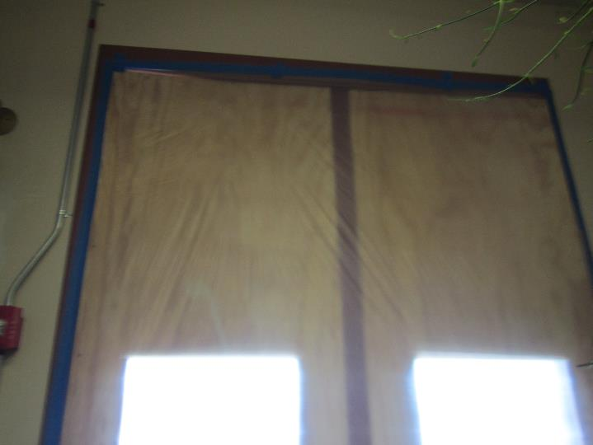
Wood and plastic around window in stairwell below MRC office
Picture 2
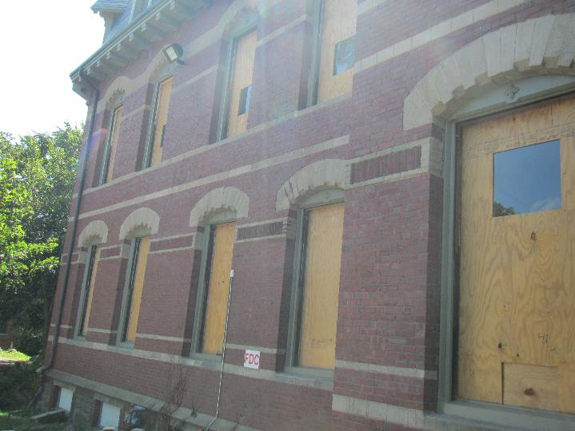
Exterior view of boarded up windows on floors 1 and 2
Picture 3
Use of motorized lifts on site
Picture 4
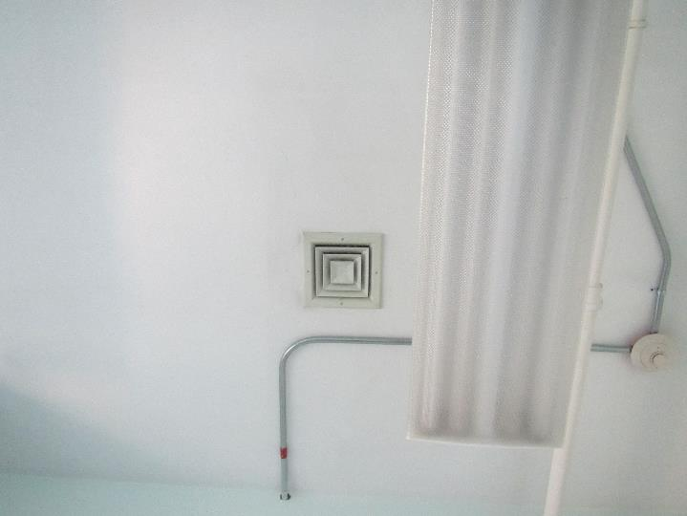
Typical supply vent for recirculated air
Picture 5
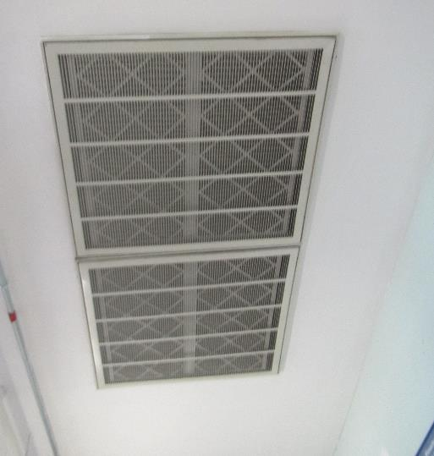
Return vent with filter located above open office area
Picture 6
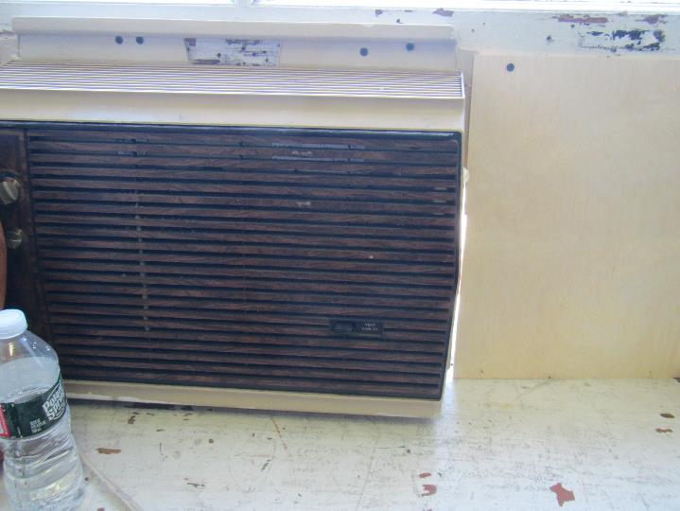
Window-mounted air conditioner
Picture 7
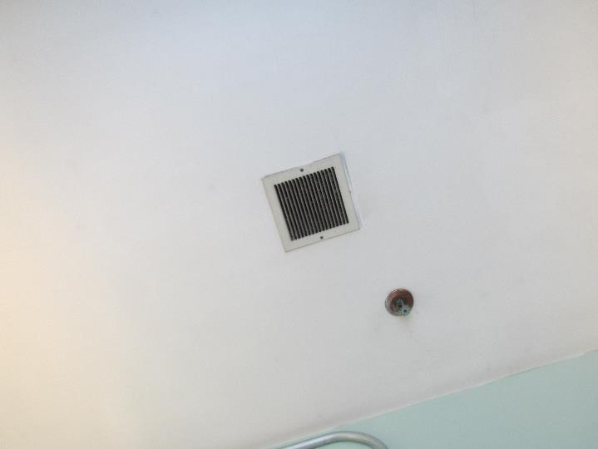
Restroom exhaust vent, note dust
Picture 8
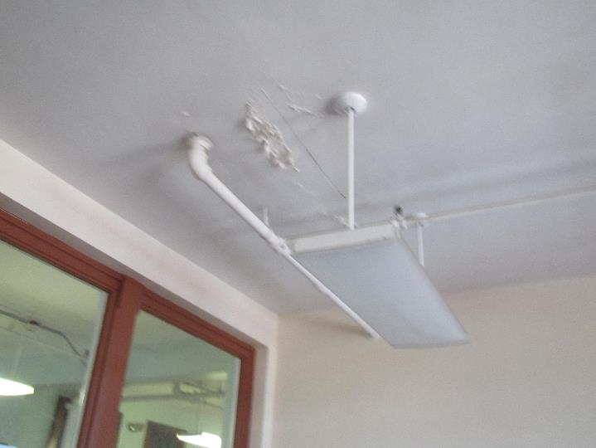
Water-damaged plaster
Picture 9
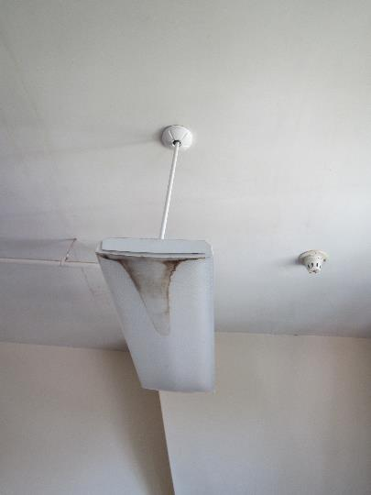
Water damage/stain inside light fixture
Picture 10
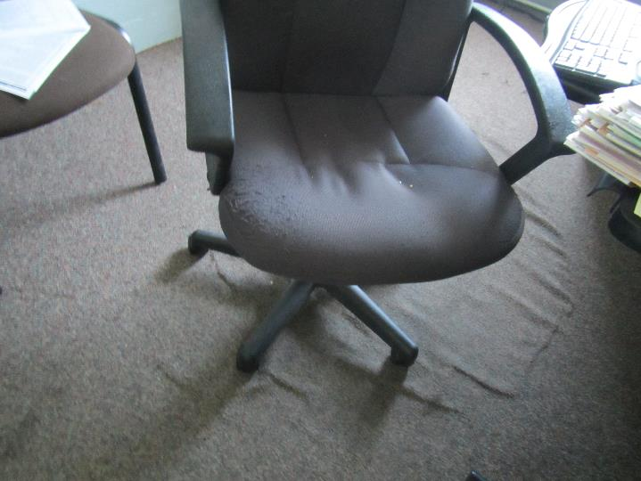
Wrinkles indicating possible water damage to carpeting
Picture 11
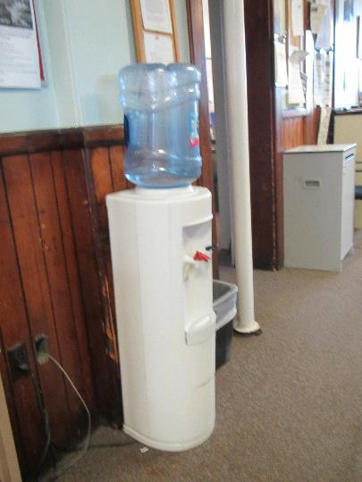
Water cooler in carpeted area
Picture 12
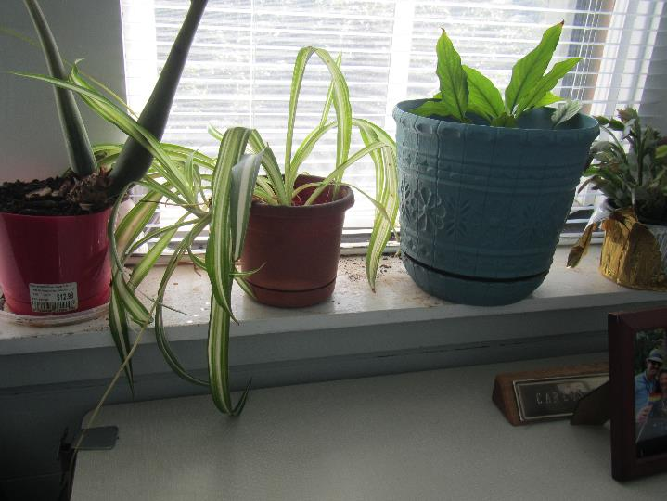
Plants and plant debris on windowsill
Picture 13
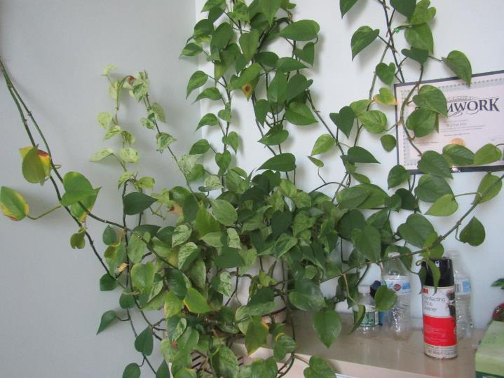
Plant climbing wall, also note cleaning product
Picture 14
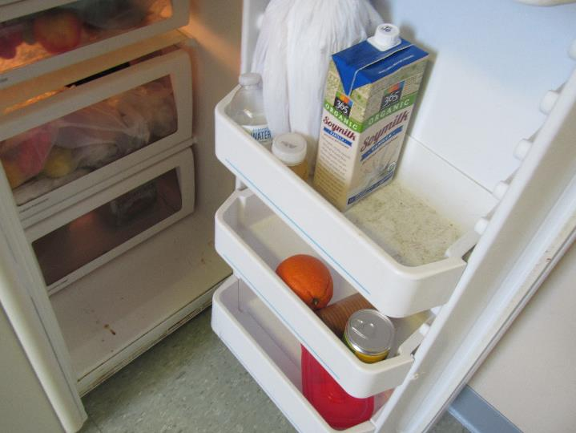
Evidence of spills in refrigerator
Picture 15
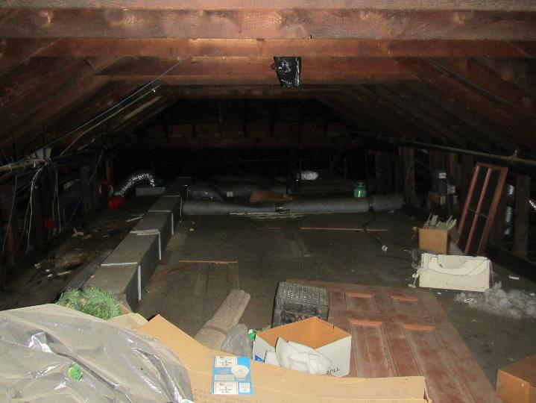
Items, debris and dust in the attic
Picture 16
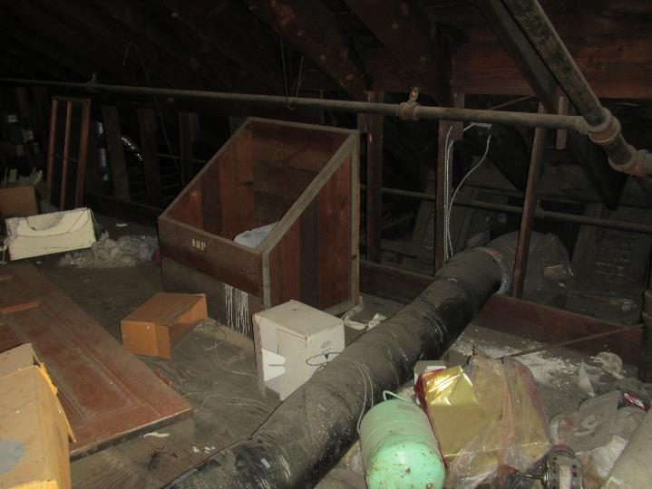
Items, debris, and dust in the attic, note ductwork for AHU
Picture 17
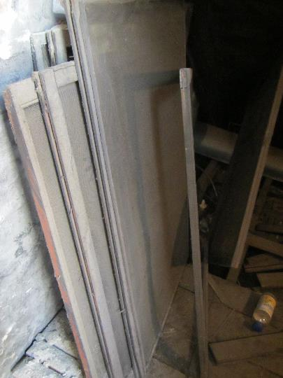
Items, including window screens, debris, and dust in the attic
Picture 18
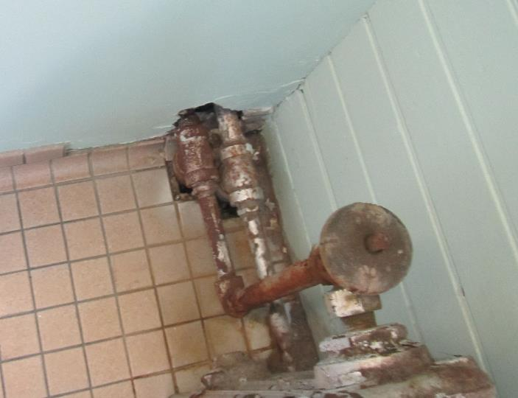
Hole around radiator pipe
Picture 19
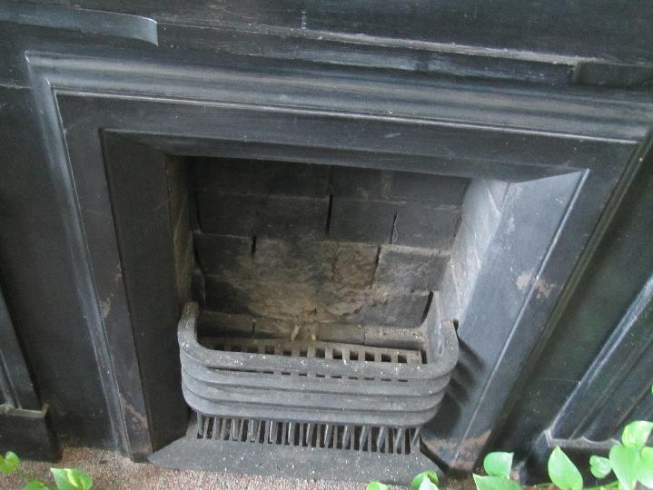
Fireplace with gaps around bricks, dust, possible efflorescence
Picture 20
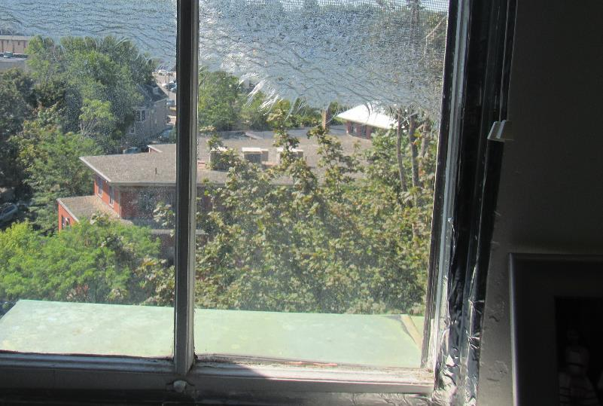
Damaged window screen
Location | Carbon  Dioxide  (ppm) | Carbon Monoxide  (ppm) | Temp  (°F) | Relative  Humidity  (%) | PM2.5  (µg/m³) | Occupants  in Room | Windows  Openable | Ventilation |  | Remarks
 |  |  |  |  |  |  |  | Supply | Exhaust
Background | 421 | ND | 75 | 60 | 9 |  |  |  |  | Sunny and pleasant
304 | 564 | ND | 71 | 57 | 8 | 2 | Y | Y |  | Plant, fireplace, tall closet with items
305 | 553 | ND | 71 | 55 | 7 | 0 | Y | Y |  | Radiator, plant, WD/wrinkled carpet
307 | 580 | ND | 72 | 56 | 10 | 1 | Y | Y |  | PF, plant
308 | 582 | ND | 71 | 55 | 8 | 0 | Y | Y |  | Ceiling hatchway, plant
310 | 565 | ND | 72 | 54 | 12 | 0 | Y | Y dusty |  | Plants on floor, PF, WD carpet
311 | 526 | ND | 73 | 55 | 18 | 2 | Y | Y |  | Scent oil diffuser
313 | 605 | ND | 73 | 54 | 9 | 0 | M | Y
314 | 652 | ND | 73 | 54 | 9 | 0 | Y | Y |  | Plant including on wall, pipes, CP
315 files | 707 | ND | 72 | 54 | 10 | 0 | M | Y dusty
316 | 628 | ND | 72 | 54 | 8 | 0 | Y | Y |  | Window screen torn
316 inner | 623 | ND | 73 | 54 | 8 | 0 | Y | Y |  | Items on floor and surfaces, CP
318 | 579 | ND | 73 | 53 | 8 | 0 | Y | Y |  | Plants (many)
Women’s restroom | 781 | ND | 74 | 62 | 15 | 0 | Y open | N | Y dusty | Window screen broken, gap around pipes from below/wall, can’t tell if exhaust is working
Men’s restroom | 587 | ND | 74 | 57 | 12 | 0 | N | N | Y | Can’t tell if exhaust is working
325 | 634 | ND | 75 | 51 | 9 | 0 | Y | Y |  | Plants with debris
Kitchen | 630 | ND | 75 | 51 | 9 | 0 | Y | Y |  | Sink, stove, oven, microwave, toaster. Fridge has spills/debris
326 | 566 | ND | 75 | 50 | 8 | 0 | Y | Y |  | Dusty stand fan, plants
328 | 607 | ND | 75 | 51 | 8 | 2 | Y | Y |  | Large plant, WD carpet
329 | 585 | ND | 74 | 57 | 9 | 0 | Y | Y
Main open area | 605 | ND | 74 | 52 | 10 | 5 | N | Y | Y | Return vent has attached filter
Elevator/ stairwell area on 3rd floor | 566 | ND | 74 | 60 | 13 | 0 | Y |  |  | WD ceiling plaster, WD in light fixture, plants
301 (off elevator area) | 625 | ND | 74 | 64 | 15 | 2 | Y has window AC |  |  | Window AC is older
Entry area on 1st floor | 543 | ND | 74 | 62 | 14 | 0 | Door | N

