INDOOR AIR QUALITY ASSESSMENT

Massachusetts Rehabilitation Commission
40 Dimock Street, 3rd Floor
Roxbury, Massachusetts

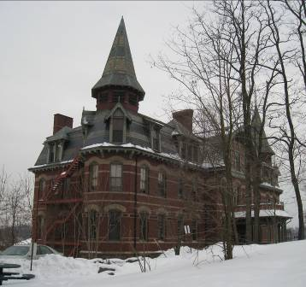

Prepared by:
Massachusetts Department of Public Health
Bureau of Environmental Health
Indoor Air Quality Program
May 2011

Background/Introduction
At the request of Roger Tremblay, Human Resources Director for the Executive Office of Health and Human Resources’ (EOHHS) Office of Disabilities and Community Services, the Massachusetts Department of Public Health (MDPH), Bureau of Environmental Health (BEH) provided assistance and consultation regarding indoor air quality (IAQ) concerns at the Massachusetts Rehabilitation Commission’s (MRC) located at 40 Dimock Street, Roxbury, Massachusetts. The request was prompted by employee concerns related to indoor air quality conditions in the building. A visit was made to this office on January 26, 2011, by Sharon Lee and Cory Holmes, Environmental Analysts
/IAQ Inspectors within BEH’s IAQ Program.
The MRC is located on the third floor of a three-story brick building that was constructed in the mid-1800s as the New England Hospital for Women and Children. The building has undergone many interior renovations over the years and is currently occupied by various agencies, including the office for the Metropolitan Council for Educational Opportunity. The MRC space, which consists of small offices and common work areas, has wall-to-wall carpeting, plaster walls, and dropped ceilings. Windows are openable throughout the MRC space.

Methods
Air tests for carbon monoxide, carbon dioxide, temperature and relative humidity were conducted with the TSI, Q-Trak, IAQ Monitor, Model 7565. Air tests for airborne particle matter with a diameter less than 2.5 micrometers were taken with the TSI, DUSTTRAK™ Aerosol Monitor Model 8520. BEH staff also performed visual inspection of building materials for water damage and/or microbial growth.

Results
The MRC has an employee population of approximately 16 and can be visited by up to 20 members of the public daily. The tests were taken during normal operations and results appear in Table 1.

Discussion

Ventilation
It can be seen from Table 1 that carbon dioxide levels were above 800 parts per million (ppm) in four of nineteen areas surveyed, indicating a lack of air exchange in these areas of the building at the time of the assessment. It is important to note that the building is not equipped with a mechanical ventilation system capable of supplying fresh air or exhaust ventilation. Radiators provide heated air to the space in cold weather. A centralized air-conditioning (AC) system provides chilled (recycled) air in the summer months. The sole source of fresh air is via openable windows.
Chilled air is provided to occupied spaces via ceiling-mounted supply vents (Picture 1). This system is designed to create positive pressure in the office space to force air out of offices through undercut doors and into the hallway, where ceiling-mounted vents return air to the system. Filters are installed directly above return vents (Picture 2). The air handling units (AHUs) for the AC system are located in the attic.
BEH staff observed two different AC systems in the attic (Pictures 3 and 4). It is unclear which system services the MRC. A number of small breaches were observed in the ductwork of one system (Picture 3). These breaches should be permanently sealed to prevent draw of air from the attic into the system and/or leakage of chilled air into the attic. The AHU for the other system had a missing filter access panel (Picture 4). Filters should be installed in a manner to prevent unfiltered air from being drawn into the system. Furthermore, condensate pipes did not appear to be appropriately fitted with drainage lines, and spaces were observed around them (Picture 4). These conditions can result in discharge of moisture into the environment, as well as entrainment of air (post-filtration) through breaches around pipes.
The Massachusetts Building Code requires that each area have a minimum ventilation rate of 20 cubic feet per minute (cfm) per occupant of fresh outside air or openable windows (SBBRS, 1997; BOCA, 1993). The ventilation must be on at all times that the room is occupied. Providing adequate fresh air ventilation with open windows and maintaining the temperature in the comfort range during the cold weather season is impractical. Mechanical ventilation is usually required to provide adequate fresh air ventilation.
Carbon dioxide is not a problem in and of itself. It is used as an indicator of the adequacy of the fresh air ventilation. As carbon dioxide levels rise, it indicates that the ventilating system is malfunctioning or the design occupancy of the room is being exceeded. When this happens a buildup of common indoor air pollutants can occur, leading to discomfort or health complaints. The Occupational Safety and Health Administration (OSHA) standard for carbon dioxide is 5,000 parts per million parts of air (ppm). Workers may be exposed to this level for 40 hours/week, based on a time-weighted average (OSHA, 1997).
The Department of Public Health uses a guideline of 800 ppm for publicly occupied buildings. A guideline of 600 ppm or less is preferred in schools due to the fact that the majority of occupants are young and considered to be a more sensitive population in the evaluation of environmental health status. Inadequate ventilation and/or elevated temperatures are major causes of complaints such as respiratory, eye, nose and throat irritation, lethargy and headaches. For more information concerning carbon dioxide, please see Appendix A.
Temperatures ranged from 68º F to 83º F. Several areas had temperatures outside of the MDPH recommended comfort range. The MDPH recommends that indoor air temperatures be maintained in a range of 70º F to 78º F in order to provide for the comfort of building occupants. In many cases concerning indoor air quality, fluctuations of temperature in occupied spaces are typically experienced, even in a building with an adequate fresh air supply. MRC staff expressed concerns regarding uneven temperature control, which would be expected in a building that has been retro-fitted for uses different from the original design.
Relative humidity ranged from 13 to 26 percent, which was below the MDPH recommended comfort guidelines. The MDPH recommends that indoor air relative humidity is comfortable in a range of 40 to 60 percent. Relative humidity levels in the building would be expected to drop during the winter months due to heating. The sensation of dryness and irritation is common in a low relative humidity environment. Low relative humidity is a very common problem during the heating season in the northeast part of the United States.

Microbial/Moisture Concerns
Plants were observed in several areas, some placed on porous materials (i.e., paper products). Plants, soil and drip pans can serve as sources of mold/bacterial growth. Plants should be properly maintained, over-watering of plants should be avoided and drip pans should be inspected periodically for mold growth (Pictures 5 and 6). Plants in one area were located on top of carpeting (Table 1). Carpeting is a porous material that can provide a medium for mold growth, especially if wetted repeatedly.
Although no current leaks were reported by building staff, evidence of historic water damage has resulted in peeling paint, efflorescence and water-damaged wall/ceiling plaster in a few areas (Pictures 7 and 8/Table 1). Efflorescence is a characteristic sign of water-damage to brick and mortar, but it is not mold growth. As moisture penetrates and works its way through mortar, brick or plaster, water-soluble compounds dissolve, creating a solution. As the solution moves to the surface of the material, the water evaporates, leaving behind white, powdery mineral deposits.

Other IAQ Evaluations
Indoor air quality can be negatively influenced by the presence of respiratory irritants, such as products of combustion. The process of combustion produces a number of pollutants. Common combustion emissions include carbon monoxide, carbon dioxide, water vapor, and smoke (fine airborne particle material). Of these materials, exposure to carbon monoxide and particulate matter with a diameter of 2.5 micrometers (μm) or less (PM2.5) can produce immediate, acute health effects upon exposure. To determine whether combustion products were present in the indoor environment, BEH staff obtained measurements for carbon monoxide and PM2.5.

Carbon Monoxide
Carbon monoxide is a by-product of incomplete combustion of organic matter (e.g., gasoline, wood and tobacco). Exposure to carbon monoxide can produce immediate and acute health effects. Several air quality standards have been established to address carbon monoxide and prevent symptoms from exposure to these substances. The MDPH established a corrective action level concerning carbon monoxide in ice skating rinks that use fossil-fueled ice resurfacing equipment. If an operator of an indoor ice rink measures a carbon monoxide level over 30 ppm, taken 20 minutes after resurfacing within a rink, that operator must take actions to reduce carbon monoxide levels (MDPH, 1997).
The American Society of Heating Refrigeration and Air-Conditioning Engineers (ASHRAE) has adopted the National Ambient Air Quality Standards (NAAQS) as one set of criteria for assessing indoor air quality and monitoring of fresh air introduced by HVAC systems (ASHRAE, 1989). The NAAQS are standards established by the US EPA to protect the public health from six criteria pollutants, including carbon monoxide and particulate matter (US EPA, 2006). As recommended by ASHRAE, pollutant levels of fresh air introduced to a building should not exceed the NAAQS levels (ASHRAE, 1989). The NAAQS were adopted by reference in the Building Officials & Code Administrators (BOCA) National Mechanical Code of 1993 (BOCA, 1993), which is now an HVAC standard included in the Massachusetts State Building Code (SBBRS, 1997). According to the NAAQS, carbon monoxide levels in outdoor air should not exceed 9 ppm in an eight-hour average (US EPA, 2006).
Carbon monoxide should not be present in a typical, indoor environment. If it is present, indoor carbon monoxide levels should be less than or equal to outdoor levels. Outdoor carbon monoxide concentrations ranged from non-detect (ND) to 2 ppm at the time of the assessment (Table 1). Indoor carbon monoxide measurements ranged from ND to 2 ppm, which were reflective of outdoor conditions at the time of the assessment, most likely due to idling vehicles and parking near the building (Table 1).

Particulate Matter
The US EPA has established NAAQS limits for exposure to particulate matter. Particulate matter is airborne solids that can be irritating to the eyes, nose and throat. The NAAQS originally established exposure limits to particulate matter with a diameter of 10 μm or less (PM10). According to the NAAQS, PM10 levels should not exceed 150 micrograms per cubic meter (μg/m³) in a 24-hour average (US EPA, 2006). These standards were adopted by both ASHRAE and BOCA. Since the issuance of the ASHRAE standard and BOCA Code, US EPA established a more protective standard for fine airborne particles. This more stringent PM2.5 standard requires outdoor air particle levels be maintained below 35 μg/m³ over a 24-hour average (US EPA, 2006). Although both the ASHRAE standard and BOCA Code adopted the PM10 standard for evaluating air quality, MDPH uses the more protective PM2.5 standard for evaluating airborne particulate matter concentrations in the indoor environment.
Outdoor PM2.5 concentrations were measured at 96 μg/m³ (Table 1), which were above the NAAQS PM2.5 level of 35 μg/m³. PM2.5 levels measured indoors ranged from 46 to 63 μg/m³ (Table 1), which were reflective of outside ambient conditions. Outdoor particulates were forecasted to be at or above health standards due to poor atmospheric mixing (MDEP, 2011). In addition, vehicle exhaust emissions from numerous vehicles and delivery trucks that were in the vicinity during the assessment likely contributed to elevated particulate levels. Frequently, indoor air levels of particulates (including PM2.5) can be at higher levels than those measured outdoors. A number of activities that occur indoors and/or mechanical devices can generate particulate during normal operations. Sources of indoor airborne particulates may include but are not limited to particles generated during the operation of fan belts in the HVAC system, use of stoves and/or microwave ovens in kitchen areas; use of photocopiers, fax machines and computer printing devices; operation of an ordinary vacuum cleaner and heavy foot traffic indoors.

Other Conditions
Other conditions that can affect indoor air quality were observed during the assessment. Damaged insulation material was observed in the attic on pipes and covering the chimney (Pictures 9 through 11). This material may contain asbestos. Intact asbestos-containing materials (ACM) do not pose a health hazard. If damaged, however, ACM can be rendered friable and become aerosolized. Friable asbestos is a chronic (long-term) health hazard, but will not produce acute (short-term) health effects (e.g., headaches) typically associated with buildings believed to have indoor air quality problems. If ACM are damaged, the materials should be removed or remediated in a manner consistent with Massachusetts asbestos remediation laws (MDLI, 1993). AHUs in the attic should be thoroughly inspected to ensure these materials have not been entrained into the systems. In addition, consideration should be given to thoroughly cleaning the ductwork for these systems.
Also noted was a hole in the chimney, (Picture 11). It was not clear whether this chimney is actively being used to remove boiler exhaust from the building. Breaches compromise the ability of the system to properly remove exhaust/boiler emissions and may allow carbon monoxide and other combustion products to infiltrate occupied spaces. The function of the chimney should be confirmed, and if active, the hole should be repaired and the remainder of the chimney should be inspected for structural integrity.
A number of AC supply diffusers and return vents and ceiling tiles adjacent to supply diffusers were observed to have accumulated dust/debris (Pictures 3 and 4). Dust can be irritating to the eyes, nose and respiratory tract.
In several areas, items were observed on windowsills, tabletops, counters, bookcases and desks. The large number of items stored in classrooms provides a source for dusts to accumulate. These items (e.g., papers, folders, boxes) make it difficult for custodial staff to clean. Items should be relocated and/or be cleaned periodically to avoid excessive dust build up. In addition, dust can accumulate on flat surfaces (e.g., desktops, shelving and carpets) in occupied areas and subsequently be re-aerosolized causing further irritation.
As previously mentioned, the majority of floor surfaces are covered by wall-to-wall carpeting. It was not clear if the MRC had a carpet cleaning program in place. The Institute of Inspection, Cleaning and Restoration Certification (IICRC), recommends that carpeting be cleaned annually (or semi-annually in soiled high traffic areas) (IICRC, 2005).

Conclusions/Recommendations
In view of the findings at the time of the assessment, the following recommendations are made to improve indoor air quality in the building:
- Contact a licensed asbestos remediation firm to determine if damaged insulation and chimney covering in attic contains ACM. Remediate damaged ACMs in conformance with Massachusetts asbestos remediation and hazardous waste disposal laws and regulations.
- If the presence of ACM is confirmed, AHUs in the attic and associated ductwork should be thoroughly inspected by a licensed asbestos remediation firm and/or HVAC engineering firm to ensure these materials have not been entrained into the systems.
- Contact licensed plumber or HVAC engineer and/or masonry firm to conduct a thorough inspection of the structural integrity of the chimneys to ensure proper removal of exhaust emissions (if active). Make repairs as needed.
- Clean/change filters for ACs as per the manufacturer’s instructions or more frequently if needed. Ensure filters fit properly and AHUs have filter access covers installed.
- Ensure leaks are repaired; clean efflorescence, loose paint and plaster debris using a vacuum with a brush attachment. Once repairs are completed, water-damaged plaster ceilings and walls should be prepped and refinished.
- Open windows (weather permitting) to temper rooms and provide fresh outside air. Care should be taken to ensure windows are properly closed at night and weekends to avoid the freezing of pipes and potential flooding. Supplement fresh air by operating window-mounted air conditioners in the "fan only" “fresh air” mode, which introduces outside air by mechanical means.
- Clean AC diffusers and return vents periodically of accumulated dust/debris.
- For buildings in New England, periods of low relative humidity during the winter are often unavoidable. Therefore, scrupulous cleaning practices should be adopted to minimize common indoor air contaminants whose irritant effects can be enhanced when the relative humidity is low. To control for dusts, a HEPA filter equipped vacuum cleaner in conjunction with wet wiping of all surfaces is recommended. Drinking water during the day can help ease some symptoms associated with a dry environment (throat and sinus irritations).
- Avoid overwatering of plants. Ensure flat surfaces around plants are free of potting soil and other plant debris. Examine drip pans periodically for mold growth and disinfect with an appropriate antimicrobial where necessary. Do not place plants on porous materials (e.g., paper/cardboard, carpeting). Consider reducing number of plants in some areas.
- Clean carpeting annually or semi-annually in soiled high traffic areas as per the recommendations of the Institute of Inspection, Cleaning and Restoration Certification (IICRC). Copies of the IICRC fact sheet can be downloaded at: http://www.cleancareseminars.com/carpet_cleaning_faq4.htm (IICRC, 2005).
- Refer to resource manuals and other related indoor air quality documents for further building-wide evaluations and advice on maintaining public buildings. Copies of these materials are located on the MDPH’s website: http://www.mass.gov/dph/iaq.

References
ACGIH. 1989. Guidelines for the Assessment of Bioaerosols in the Indoor Environment. American Conference of Governmental Industrial Hygienists, Cincinnati, OH.
ASHRAE. 1989. Ventilation for Acceptable Indoor Air Quality. American Society of Heating, Refrigeration and Air Conditioning Engineers. ANSI/ASHRAE 62-1989
BOCA. 1993. The BOCA National Mechanical Code/1993. 8th ed. Building Officials and Code Administrators International, Inc., Country Club Hill, IL.
IICRC. 2005. Carpet Cleaning FAQ 4 Institute of Inspection, Cleaning and Restoration Certification. Institute of Inspection Cleaning and Restoration, Vancouver, WA.
January 26, 2011.
MDEP. 2011. Massachusetts Department of Environmental Protection. Air Quality Forecast. http://public.dep.state.ma.us/MassAir/Pages/MapForecast.aspx?ht=1&hi=108
MDLI. 1993. Regulation of the Removal, Containment or Encapsulation of Asbestos, Appendix 2. 453 CMR 6,92(I)(i).
MDPH. 1997. Requirements to Maintain Air Quality in Indoor Skating Rinks (State Sanitary Code, Chapter XI). 105 CMR 675.000. Massachusetts Department of Public Health, Boston, MA.
OSHA. 1997. Limits for Air Contaminants. Occupational Safety and Health Administration. Code of Federal Regulations. 29 C.F.R 1910.1000 Table Z-1-A.
SBBRS. 1997. Mechanical Ventilation. State Board of Building Regulations and Standards. Code of Massachusetts Regulations. 780 CMR 1209.0
US EPA. 2006. National Ambient Air Quality Standards (NAAQS). US Environmental Protection Agency, Office of Air Quality Planning and Standards, Washington, DC. http://www.epa.gov/air/criteria.html.
Picture 1

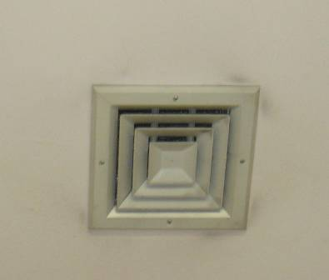

Ceiling-mounted AC diffuser, note dust/debris accumulation on/around vent

Picture 2

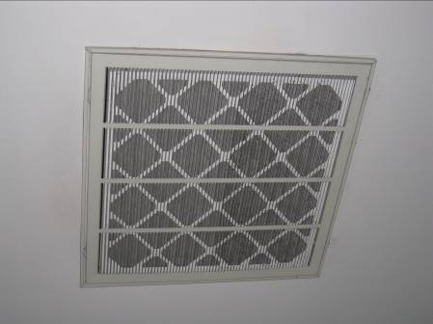

Ceiling-mounted return vent

Picture 3

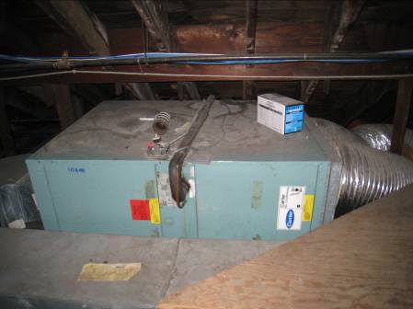

AHU in attic

Picture 4

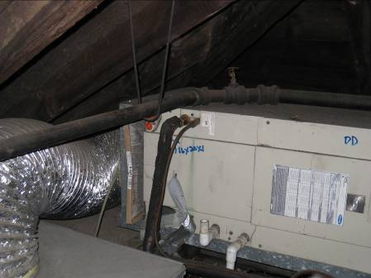

AHU in attic, note missing filter access panel and condensation pipes

Picture 5

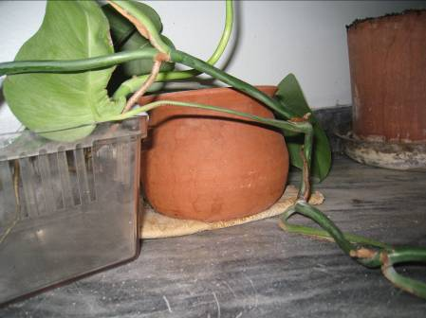

Plant on water-stained paper towel

Picture 6

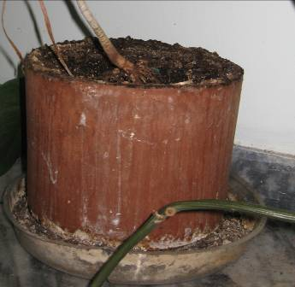

Plant with mold growth in drip pan

Picture 7

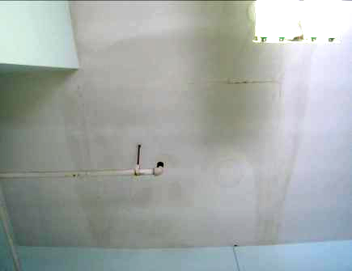

Water-stained ceiling plaster in room 22

Picture 8

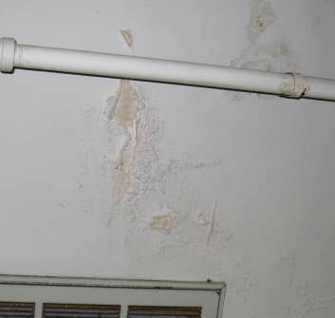

Peeling paint/efflorescence on wall plaster

Picture 9

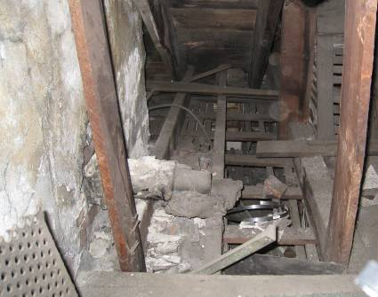

Damaged insulation material around pipe near chimney in attic

Picture 10

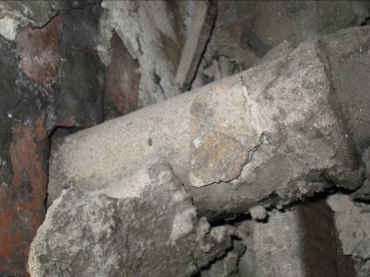

Close-up of damaged insulation material around pipe near chimney in attic

Picture 11

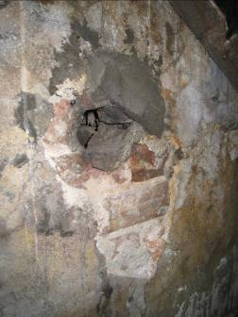

Hole and damaged material covering chimney in attic
Location | Carbon  Dioxide  (*ppm) | Carbon Monoxide  (*ppm) | Temp  (°F) | Relative  Humidity  (%) | TVOCs  (*ppm) | PM2.5  (ug/m3) | Occupants  in Room | Windows  Openable | Ventilation |  | Remarks
 |  |  |  |  |  |  |  |  | Intake | Exhaust | Remarks
Background | 500 | ND-2 | 29 | 51 | ND | 96
Attic/mechanical room | 923 | 2 | 71 | 20 | ND | 62 |  |  |  |  | Filter held in place by heating coil, possible ACM in attic (damaged pipe insulation, chimney wall), hole in chimney (active?), breaches/penetrations to exterior-light penetration
Reception | 882 | ND | 68 | 26 | ND | 61 | 2 | N | Y | Y
3 | 762 | ND | 78 | 17 | ND | 58 | 1 | Y | Y | N | Items
4 | 734 | ND | 76 | 19 | ND | 59 | 1 | Y | Y | N
6 Conference room | 733 | ND | 75 | 19 | ND | 58 | 0 | Y | Y | N | Fireplace, PF, plants, DEM
7 | 706 | ND | 77 | 18 | ND | 53 | 1 | Y | Y | N
8 Kitchen | 899 | ND | 73 | 20 | ND | 56 | 0 | Y | Y | N | Breach around pipes
10 | 684 | ND | 78 | 17 | ND | 58 | 0 | Y | Y | N | Fireplace
11 | 646 | ND | 78 | 16 | ND | 57 | 2 | Y | Y | N | CPs
12 | 742 | ND | 79 | 16 | ND | 57 | 0 | Y | Y | N | Plants, fireplace
13 | 761 | ND | 78 | 16 | ND | 57 | 1 | Y | Y | N | DO
14 | 768 | ND | 78 | 17 | ND | 53 | 1 | N | Y | N | DO
15 | 790 | ND | 78 | 18 | ND | 54 | 0 | N | Y | N | DO, plants
16 | 857 | ND | 79 | 20 | ND | 49 | 1 | Y | Y | N | Plants on carpet
18 | 723 | ND | 81 | 15 | ND | 46 | 1 | Y | Y | N | Plants
19 | 690 | ND | 79 | 13 | ND | 63 | 1 | Y  Open | Y | N | PF, stuffed animals, CPs
20 | 724 | ND | 83 | 14 | ND | 47 | 0 | Y | Y | N | Plants
21 | 776 | ND | 80 | 15 | ND | 50 | 0 | Y | Y | N | DO, fireplace
22 | 741 | ND | 77 | 15 | ND | 61 | 1 | Y | N | N | WD-ceiling, plants, items

