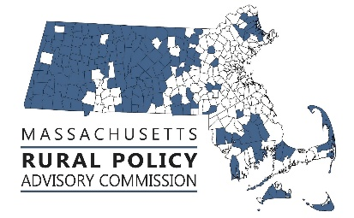 | RPAC Meeting  Friday, February 11, 2022  11:00 am to 1:00
Zoom link:
https://us02web.zoom.us/j/83954868236?pwd=dEtuSGw5elVTbWlpWTZid0Zmck9mdz09

AGENDA:
Welcome and Introductions. – Linda Dunlavy | 11:00
Adopt Minutes from December 10, 2021 - Trish Settles | 11:05
RPP Priority Focus  - Broadband  - Status of Last Mile with Peter Larkin EOHED  - Update on status of federal broadband funding with Michael Baldino MBI  - Land Use  - Rural municipalities impacted by new MBTA community requirements presented by Helen Zincavage SRPEDD | 11:06  11:40
Discuss Legislation, Policies & Priorities  - Review and discuss ARPA Advocacy power point and prepare for presentation to legislative Rural Caucus and others  - Discuss development of a rural platform and scheduling of forums with candidates for Governor and Lt. Governor | 12:00
Discuss RPAC Future Topics and Actions Steps – Linda Dunlavy  - Farmland Action Plan with Winton Pitcoff at April meeting | 12:40

FY22 Meetings (all scheduled from 11:00 to 1:00 and via Zoom for now):
- Friday, April 8
- Friday, June 10

FRCOG1 is inviting you to a scheduled Zoom meeting.

Topic: RPAC
Time: Feb 11, 2022 11:00 AM Eastern Time (US and Canada)

Join Zoom Meeting
https://us02web.zoom.us/j/83954868236?pwd=dEtuSGw5elVTbWlpWTZid0Zmck9mdz09

Meeting ID: 839 5486 8236
Passcode: 711408
One tap mobile
+13126266799,,83954868236#,,,,*711408# US (Chicago)
+19292056099,,83954868236#,,,,*711408# US (New York)

Dial by your location
+1 312 626 6799 US (Chicago)
+1 929 205 6099 US (New York)
+1 301 715 8592 US (Washington DC)
+1 346 248 7799 US (Houston)
+1 669 900 6833 US (San Jose)
+1 253 215 8782 US (Tacoma)
Meeting ID: 839 5486 8236
Passcode: 711408
Find your local number: https://us02web.zoom.us/u/kdLV8uEsn6

