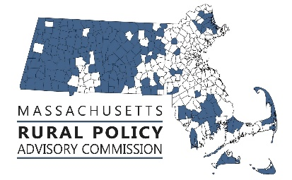 | RPAC Meeting  Friday, January 12, 2023  10:00 to 12:00  Zoom link:  https://us02web.zoom.us/j/89105793445
AGENDA:
Welcome and Introductions – Linda Dunlavy | 10:00
Adopt Minutes of meetings of 11/9/23 – Trish Settles | 10:05
Introduction of Mallory Sullivan, Rural Programs Manager, Massachusetts Executive Office of Economic Development – Mallory Sullivan | 10:10
RTP Focus Area - Housing  - Housing Bond Bill Testimony | 10:20
RPP Focus Area - Governance  - MMA Western MA/Rural Conference update and discussion of priority focus – with Andy Hogeland | 10:40
Discuss Legislation, Policies & Priorities  - Senate Updates – Paul Mark unable to join us  - House Updates – Natalie Blais (10 minutes)  - Review Status of priority bills and id any new priorities | 11:00
Future Activities, Priorities and Other Items  - Future meeting topics and meeting types – Agriculture next meeting?  - Other | 11:45

FY24 Meeting Dates: 9/8, 11/9, 1/12, 3/8, 5/10, 7/12 and the zoom link is https://us02web.zoom.us/j/89105793445

