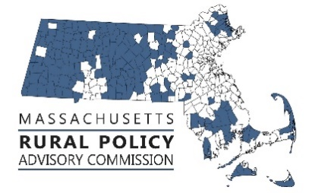**Rural Policy Advisory Commission**

**Zoom meeting minutes**

**Thursday January 14, 2021 11am-1:30pm**

**Members Present:** Linda Dunlavy, Jay Coburn, Dave Christopolis, Bill Veno, Trish Settles, Tom Matuszko, Helen Zincavage, Wendy Hudson, Representative Paul Mark, Shaun Suhoski, Brian Bullock, Corinne Fitzgerald

**Guests:** Andy Hodgeland (MMA), Kim Robinson, (PVPC), James Fuccione (MCOA), Pat Beaudry (PVPC), Robert Milann (EOHED), Connor Robichaud (CMRPC)

**Absent:** Sara Smiarowski, Judy Terry

Call meeting to order 11am – Linda Dunlavy, Chair

RPAC members reviewed meeting minutes from 12/11/2020. Trish made a motion to approve minutes, Jay second the motion. Minutes were approved unanimously.

RPAC members reviewed legislative priorities. A sub-committee consisting of members Linda, Tom, Jay, Shaun, Connor and Helen presented a list of RPAC priorities and began a dialogue with members to prioritize and organize RPAC’s legislative priorities.

Initial priorities focus on COVID relief and recovery. Post COVID priorities will focus on education and climate. RPAC will send priorities to Rural Caucus members for support.

RPAC member agreed to write and send letters based on priorities and what is likely to be successful in the current session and those to be advocated for in the next session. Priorities will be categorized in each letter. Letter one will focus on filed legislation and co-sponsorship. Letter 2 will focus on FY 22 budget priorities. Letter 3 will focus policy changes and legislation yet to be filed.

Letter one will include Office of Rural Policy, statewide Digital Literacy Program, Dirt Roads program, HERO campaign and Transfer Tax, an Act to Encourage Rural Regionalization, and SAPHE legislation.

Rep Mark will research the legislation related to a rural TDI proposal.

Letter two will include funding for Office of Rural Policy, funding for DEP and Umass Extension, and continued funding of $10m for local public health.

Letter three will include PILOT payments, rural water and sewer capital funding, full promise for rural school funding.

RPAC will follow up with Special Commission for Student Opportunity Act to ensure RPAC membership on this commission.

RPAC member s discussed sending a letter to Governor Baker regarding RPAC membership on the TCI board.

Members also discussed sending a letter to EOEEA regarding cash match requirements to the state MVP program being a barrier for rural towns.

Members agreed to hold off on climate advocacy until Governor finalizes budget and House responds.

Rep. Mark reported Rep. Blais and Sen. Hinds plan to refile the Office of Rural Policy legislation.

RPAC will meet again February 12, 2021 at 11:00.

Adjourn - 1:27pm

Submitted,

Dave Christopolis