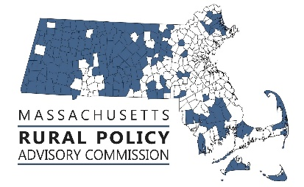 | RPAC Meeting  September 18, 2024  12:30 to 2:30  Zoom link:  https://us02web.zoom.us/j/86762394479?pwd=DffWKdAbdxBKR8TsSiwu6NiOFzk3vj.1
AGENDA:
Welcome and Introductions – Linda Dunlavy | 12:30
Adopt Minutes of meetings of 5/31/24 – Trish Settles | 12:32
RPP Focus Area – Housing  - Discussion about the Affordable Homes Act and specifically ADUs by right in rural municipalities with Housing and Livable Communities staff (Chris Kluchman, Ben Bryant, Filipe Zamborlini) | 12:35
Director of Rural Affairs update with Anne Gobi and Mallory Sullivan | 1:10
Discuss Legislation, Policies & Priorities  - End of session update – Rep. Natalie Blais and Sen. Paul Mark  - Plan for next legislative session  - Process to set priorities  - E&R grant application to develop a communication system for rural munis and redo of Rural Policy Plan? | 1:30
Future Activities, Priorities and Other Items  - FY25 meeting schedule  - Other | 1:50
RTP Focus Area – Land Use and Working Lands, Climate Change & Resiliency  - MDAR Farmland Action Plan with Katharine Otto, MDAR | 2:00

Topic: RPAC
Time: Sep 18, 2024 12:30 PM Eastern Time (US and Canada)

Join Zoom Meeting
https://us02web.zoom.us/j/86762394479?pwd=DffWKdAbdxBKR8TsSiwu6NiOFzk3vj.1

Meeting ID: 867 6239 4479
Passcode: 269629

---

One tap mobile
+13052241968,,86762394479#,,,,*269629# US
+13092053325,,86762394479#,,,,*269629# US

---

Dial by your location
• +1 305 224 1968 US
• +1 309 205 3325 US
• +1 312 626 6799 US (Chicago)
• +1 646 931 3860 US
• +1 929 436 2866 US (New York)
• +1 301 715 8592 US (Washington DC)
• +1 689 278 1000 US
• +1 719 359 4580 US
• +1 253 205 0468 US
• +1 253 215 8782 US (Tacoma)
• +1 346 248 7799 US (Houston)
• +1 360 209 5623 US
• +1 386 347 5053 US
• +1 507 473 4847 US
• +1 564 217 2000 US
• +1 669 444 9171 US
• +1 669 900 6833 US (San Jose)

Meeting ID: 867 6239 4479
Passcode: 269629

Find your local number: https://us02web.zoom.us/u/kcXRTQkbDF

