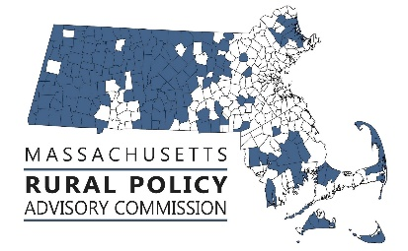 | RPAC Meeting  Friday, May 31, 2024  1:00 to 3:00  Zoom link:  https://us02web.zoom.us/j/89105793445
AGENDA:
Welcome and Introductions – Linda Dunlavy | 1:00
Adopt Minutes of meetings of 3/8/24 – Trish Settles | 1:02
Discuss Legislation, Policies & Priorities  - FY25 Budget update – Rep. Natalie Blais and Sen. Paul Mark  - Review Status of other priority bills and next steps; id any new priorities | 1:05
RTP Focus Area – Land Use and Working Lands, Climate Change & Resiliency  - Review and Discussion of final report of the Commission on Energy Siting and Permitting – Rep. Natalie Blais and Sen. Jo Comerford | 1:15
RTP Focus Area – Transportation  - Presentation and Discussion of Beyond Mobility – Derek Krevat, MassDOT | 1:45
Director of Rural Affairs update  - Updates and Rural Policy Plan refresh discussion | 2:15
Future Activities, Priorities and Other Items  - FY25 meeting schedule  - Other | 2:45

Next Meeting Dates: 7/12 and the zoom link is https://us02web.zoom.us/j/89105793445

