Regional Transit Authorities (RTA) in Massachusetts
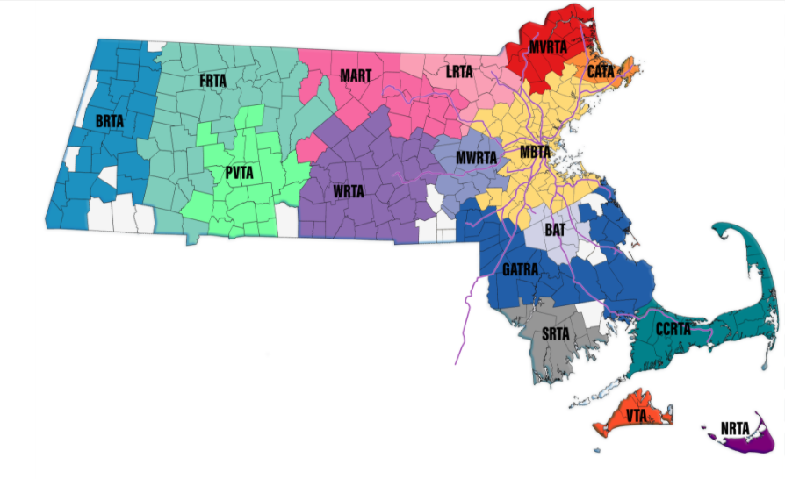
Many RTAs offer travel instruction programs for individuals and/or groups
RTA | Web | Phone | Travel Training
BRTA | www.berkshirerta.com | 413-499-2782 | Yes
CCRTA | www.capecodrta.org | 800-352-7155 | Yes
GATRA | www.gatra.org | 800-483-2500 | Yes
VTA | www.vineyardtransit.com | 508-693-9440 | Yes
MBTA | www.mbta.com | 617-222-3200 | Yes
MVRTA | www.mvrta.com | 978-469-6878 | Yes
MART | www.mrta.us | 978-345-7711 | Yes
MWRTA | www.mwrta.com | 508-935-2222 | Yes
PVTA | www.pvta.com | 413-781-7882 | Yes
WRTA | www.therta.com | 508-791-9782 | Yes
FRTA | www.frta.org | 413-773-8090 | N/A
LRTA | www.lrta.com | 978-452-6161 | N/A
CATA | www.canntran.com | 978- 83-7916 | N/A
BAT | www.ridebat.com | 508-588-1000 | N/A
SRTA | www.srtabus.com | 508-999-5211 | N/A
NRTA | www.nrtawave.com | 508-228-7025 | N/A

More information about public transportation by Regional Transit Authority (RTA) region is available at https://www.mass.gov/info-details/public-transportation-in-massachusetts#regional-transit-authorities-
More information about RTA travel instruction program is available at https://www.mass.gov/service-details/learn-to-ride-transit-with-travel-instruction

Find your ride in Massachusetts!

RideMatch – www.massridematch.org – is a one-stop searchable directory of public, private and accessible transportation providers in Massachusetts.
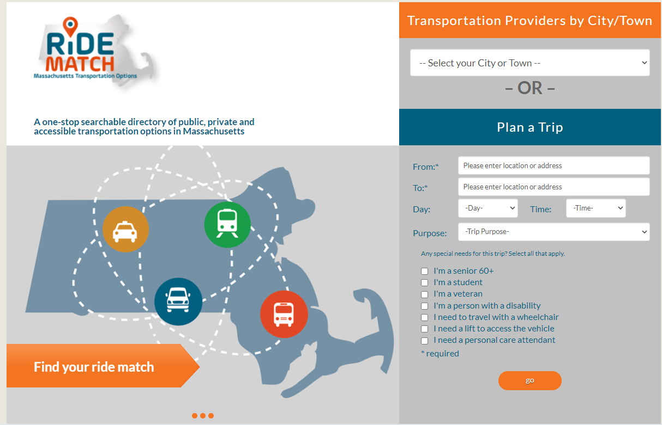

9/29/2021

