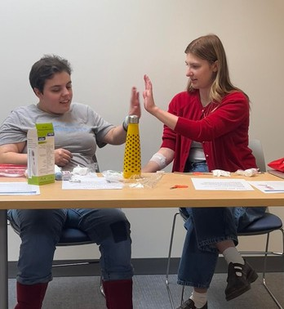
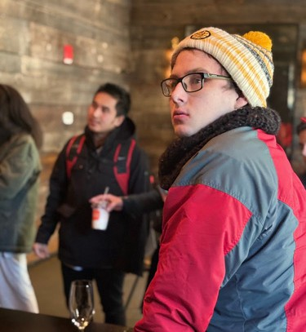

February 2026 Issue No. 5
SAVE THE DATE: RTG Open House on February 26th
RTG is hosting an Open House for
community members and prospective families to learn more about our program, our space, and our team.
Our February Open House will include:
Light refreshments
A tour of our space and an admissions information session
A guest speaker
This month’s guest speaker is Jeff Gentry,
Senior Director of Disability Services and Jewish Career Services at JVS Boston and he will be answering all your questions about the resources available to you!
RSVP for our February 26th
Open House here!
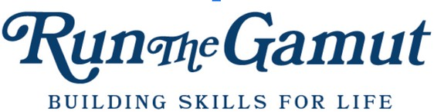

MONTHLY NEWSLETTER
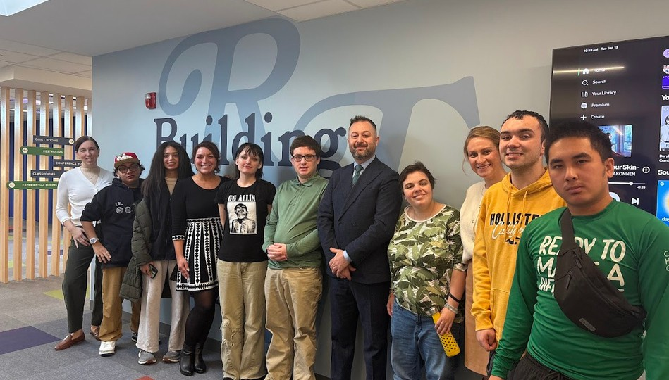

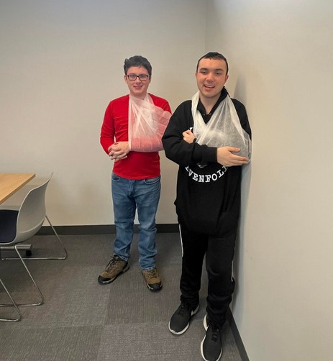
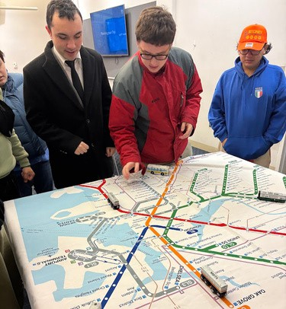
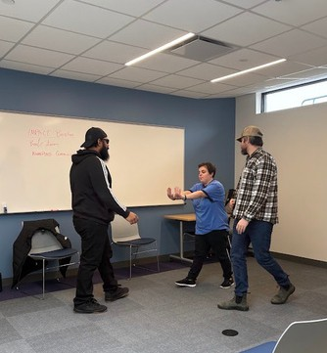
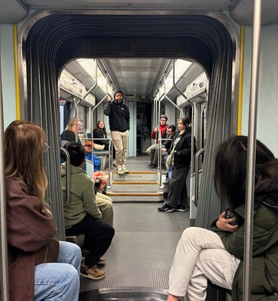

February 2026 Issue No. 5

New Year, New Skills

The new year often brings a desire to learn new skills. As the first cohort of RTG students enter their second semester, they are preparing for jobs, college, and independent living, and with those responsibilities come the need for new skill sets.

One needs to learn how to travel to reach their new opportunities. RTG students visited the MBTA Mobility Center for a travel training class. This training covered all of the accessibility features the MBTA offers and how to plan trips using public transit through simulated activities. After learning the basics, MBTA staff took RTG students to two decommissioned train cars (one Red Line and one Green Line) to learn how to safely board the T and to properly respond to emergencies on board.

RTG students can help in emergency situations in more ways than just dialing the conductor on the T – they are first aid certified! Joanne Hamer, a retired nurse, taught RTG students and staff the basics of first aid, from wrapping a sling to treating a burn. Joanne brought each student a first aid kit to practice with and take home after their certification exam so they can be prepared wherever they go.

First aid is not the only way one can take care of themselves. RTG students were joined by staff from IMPACT Boston to learn how to set boundaries. In multiple interactive lessons, students learned how to properly communicate their boundaries with friends, teachers, and colleagues. Students took to these lessons immediately and began implementing them in their everyday life (as you will see on page four of this newsletter).

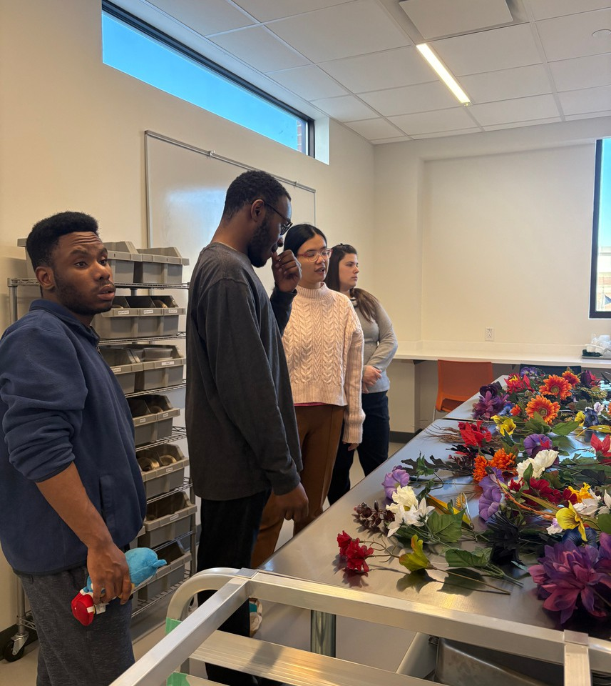
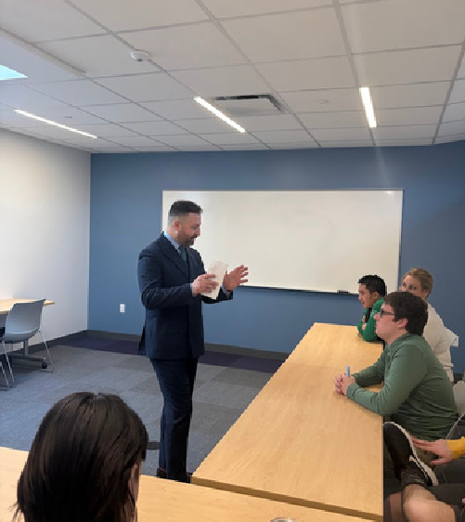
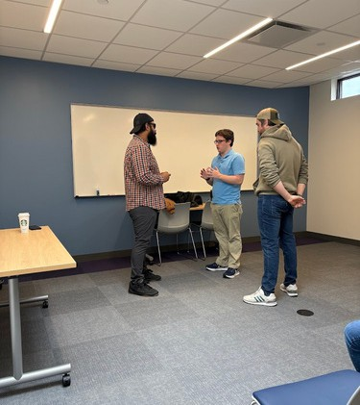

Collaboration and Community

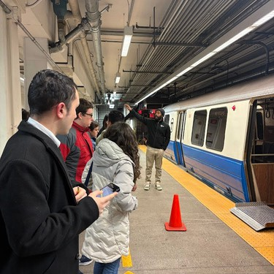
We are so grateful for the individuals and organizations that support our mission by partnering with us to provide engagement opportunities and hands-on learning within RTG and out in the community. These partners allow us to provide a holistic curriculum that is flexible enough to offer customized experiences based on our students individual interests and needs.

Big thank you to our guests and partners for January:
- Amanda Cahill and students from the Randolph High School Transition Program
- Ben and Javon, IMPACT Boston
- Joanne Hamer, retired nurse
- Massi Ouyahia, Director of Operations at Committee
- Brenda Dater, Executive Director of AANE
- Dr. Jennifer Lillis, research scientist at Boston University Wheelock College of Education & Human Development
- Amy Benjamin, Amy Benjamin Consulting
- Stephanie Mattuchio, Massachusetts Commission for the Blind
- Kristie Raymond, Founder of HumanKind

My Hardware Store Essay

Student’s Perspective on His Recent Job Shadow Experience

My experience at the Benjamin Moore Hardware Store was really spectacular because I had a really great mentor named Ethan, who works there along with my other co-workers, Jordy, Mike and Ralph.

When I go to work at the Hardware Store, I go to Ethan’s office to clock in like all the other employees do every day. Ethan has me put away all of the different products according to the SKU numbers and UPC (Universal Product Code). Next, he gives me all the new green-colored price tags to replace the old gray-colored price tags that had been used for months as well as last year and the year before. Then, he has me take notes on all of the empty SKU numbers on the paper for only the hooks that don’t have any products. I also sweep up the floors by the door where the dirt comes in from the customers and take out the full trash bags and replace them with new clean trash bags.

Best of all, I got to work at the cash register for the very first time. While I’m at the cash register, a customer comes up to me and hands the items they’re buying for me to scan, I enter the code and look at the price for the items on how much they cost.

I’ve learned three important skills at Benjamin Moore Hardware Store:
- I learned not get distracted by my surroundings while I’m working or putting away different products.
- I try to listen to the customers properly just in case if there’s anything wrong going on in the store or when they need help to find the product they need.
- I try not to stay in someone else’s bubble because it makes them feel very uncomfortable, just like what happened when Ben and Javon [instructors from IMPACT Boston] are doing some acting on a boss and employee’s feelings.
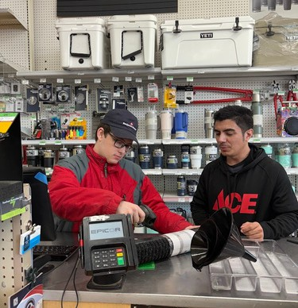
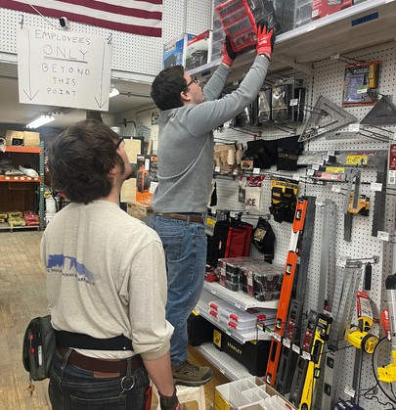
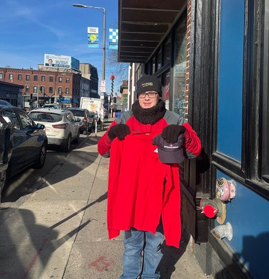

February 2026 Issue No. 5

From Our Kitchen to Yours

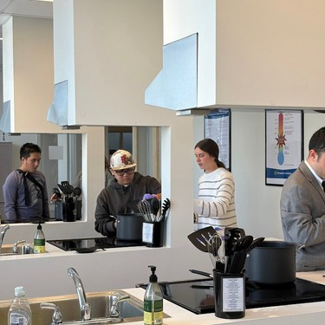
From Our Kitchen...
RTG students make a lot of recipes throughout the month, but a favorite in January was lemon chicken orzo soup. Students smashed garlic, created their mirepoix, and seasoned to taste as they layered ingredients to make a hearty soup. Students were excited to take containers of this soup home for their families to enjoy during the wintry weather, especially during the weekend of the snow storm.

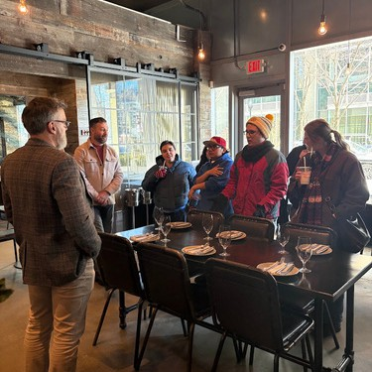
... To Yours!
As much as students enjoy cooking their own lunches in the RTG kitchen, going out to restaurants together is one of their favorite activities. In January, RTG students went to three restaurants!

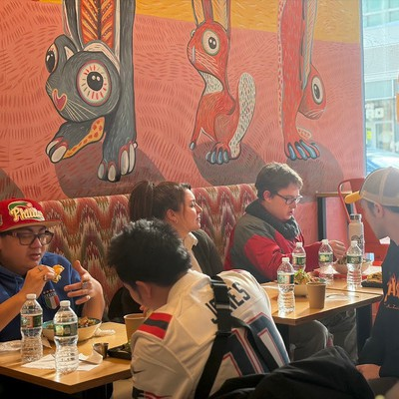
After the MBTA accessibility training, students and staff walked over to Layla’s American Tavern to have lunch. Students enjoyed the time to socialize with each other and practice ordering at restaurants.

RTG students and staff were invited to the Seaport to enjoy a lunch at Tacos El Chikis and tour Committee next tour. We are grateful for the generosity from Massi Ouyahia, Director of Operations at Committee, Dominick Mintos, Chief Operating Officer at Committee, and Executive Chef Sebastian Zuluaga for hosting us and teaching us about career opportunities in the food industry.

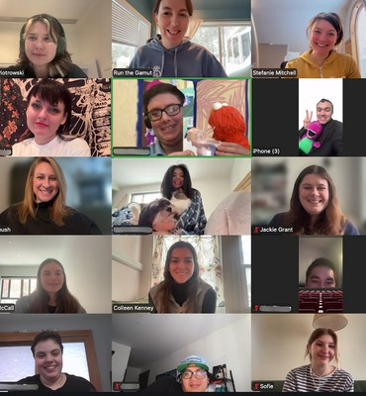
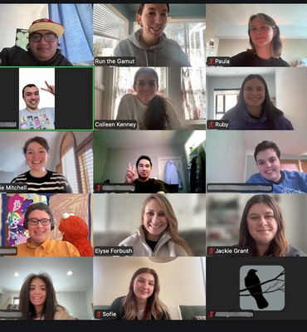
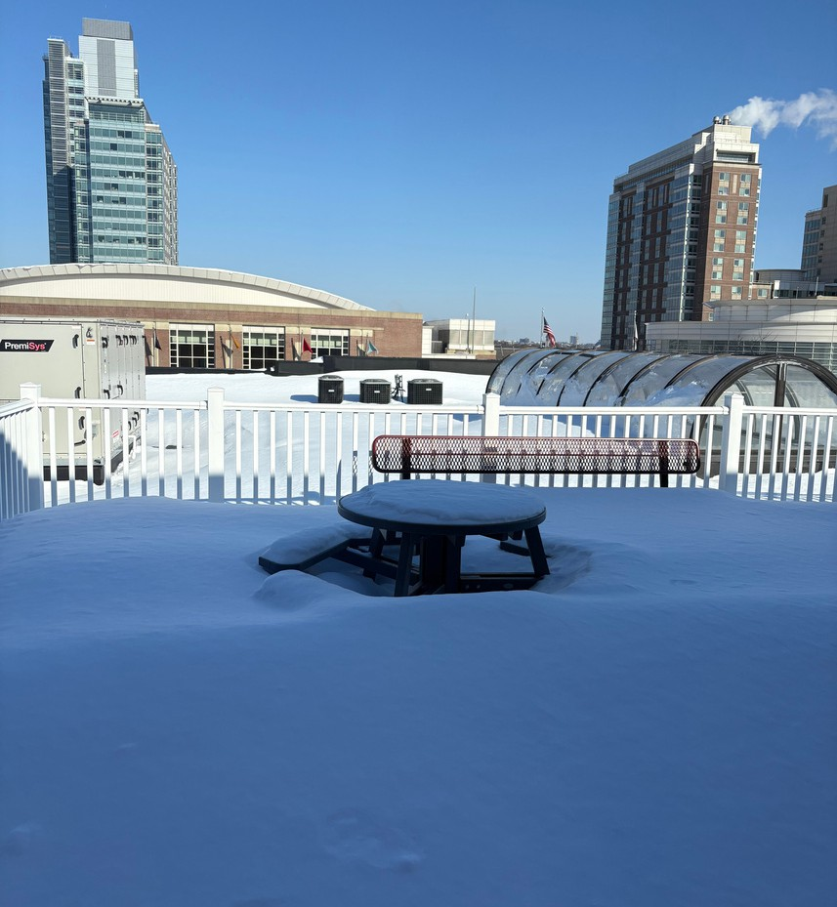
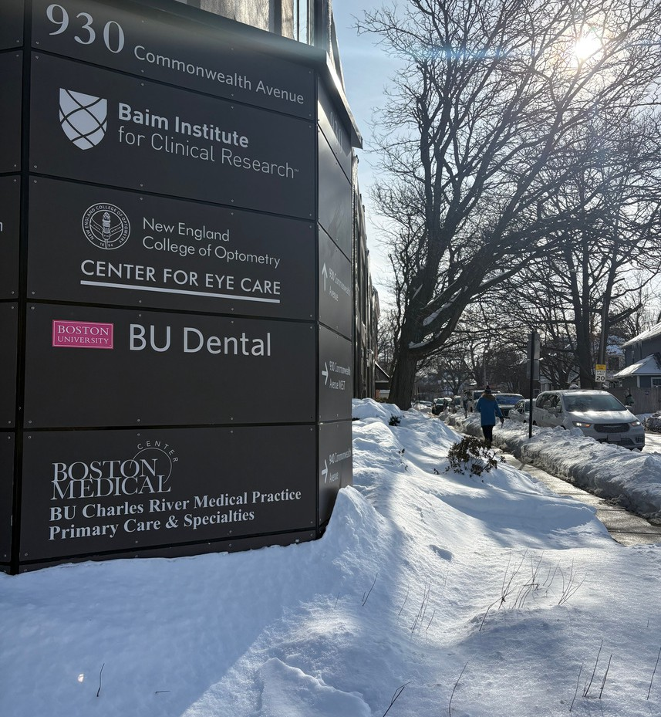
Cooked recipes learned at RTG, including the popular lemon chicken orzo soup
Watched favorite television shows and movies between chores to recharge Participated in immersive virtual workouts
Joined virtual lunch sessions to socialize with each other
Practiced appropriate Zoom skills and video boundaries
Played online games together, like Gartic Phone

February 2026 Issue No. 5

Snow Days at RTG

The winter storm did not hold RTG back! As Boston received nearly two feet of snow, RTG students and staff held two remote snow days.

RTG’s snow days were full of virtual socializing and online skill building. They were a perfect opportunity to practice video call etiquette – a skill set that is increasingly more important as more interviews are held over Zoom and colleges offer remote class options.
Though these days were a great opportunity for learning, students still enjoyed the opportunity to use silly background and see their RTG friends.

Here are some activities RTG students participated in during their snow days:
Practiced money management skills through Financial Football and FAME: Claim Your Future
Caught up on laundry, including bedding Shoveled snow

Independent Living

Hobbies


Social Skills

February 2026 Issue No. 5

Coming up!

The season ahead is filled with new opportunities, career exploration, and social experiences for
the RTG community!

This month, RTG students will:
- Tour the Langham Hotel
- Learn about dating safety and situational awareness from retired police captain, Bob Gorgone
- Host a Valentine’s Day Party on February 13th from 1pm to 3pm. You can RSVP to attend here.

HumanKind Photo Clinics at RTG

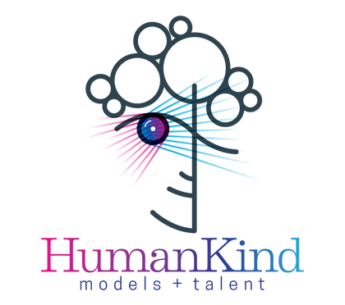


Run The Gamut and Beauty Has No Limits, in collaboration with HumanKind Originals, are partnering to create a fully inclusive modeling and acting education experience for individuals with disabilities.

Mark your calendars and stay tuned for next month’s newsletter for more details!

Upcoming Dates

March 8th April 12th May 10th

NNooww
EEnnrroolllliinngg
ffoorr
22002266

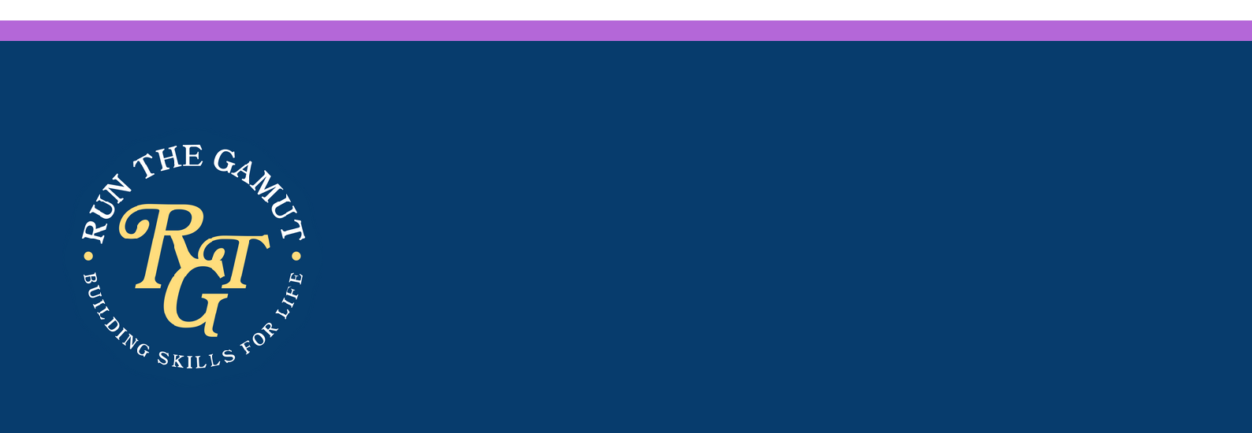

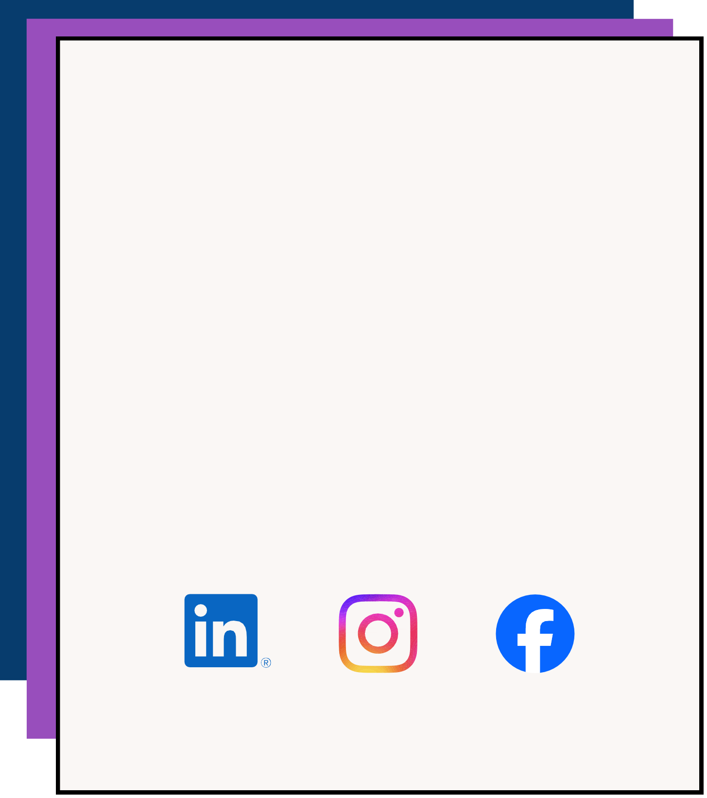
Run the Gamut, Inc. empowers motivated young adults on the autism spectrum to successfully transition into adulthood through hands-on learning, workplace experiences, and a supportive educational community, fostering independence and enhancing quality of life. Our two year transition program, which runs Mon-Fri year round, provides individualized instruction around life skills that have real world application.

At Run the Gamut, we don’t just teach skills, we help individuals build lives filled with meaning, autonomy, and purpose.

We are now enrolling for our next cohort starting in September 2026. Do you know someone who would be a great fit? Follow this link to inquire about admissions or write us at outreach@runthegamut.org for more information.

Make sure to follow us on social media and like & share!

