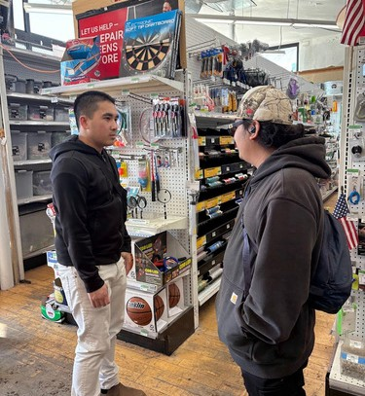
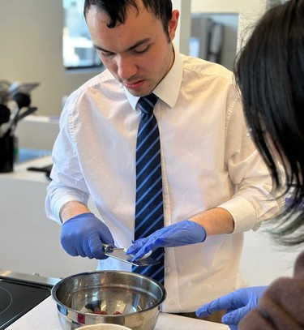

March 2026 Issue No. 6
SAVE THE DATE: RTG Open House on March 20th
RTG is hosting an Open House from 5:30pm to 7:30pm on March 20th for community members and prospective families to learn more about our program, our space, and our team.
Our March Open House will include:
Light refreshments
A tour of our experiential learning spaces An admissions information session
A guest speaker
This month’s guest speaker is Colleen
Flanagan, Outreach and Engagement Specialist for the City of Boston.
She’ll be available for individual Q&A’s
about transition and accessibility services!
RSVP for our March 20th
Open House here!
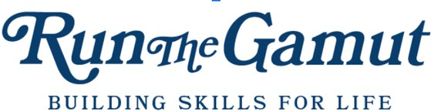

MONTHLY NEWSLETTER
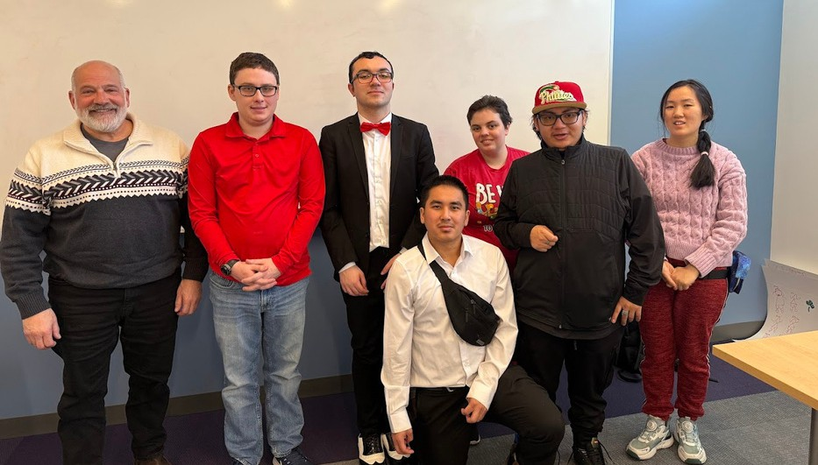

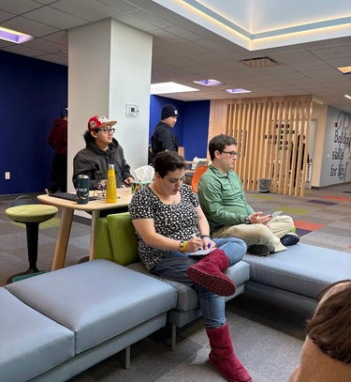
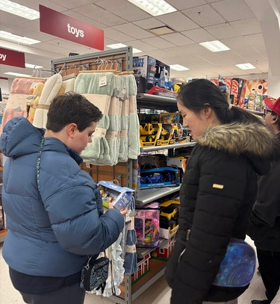
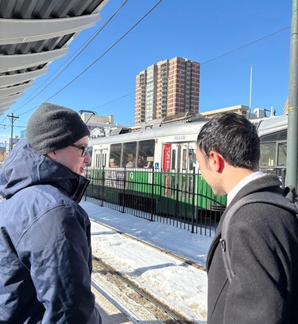
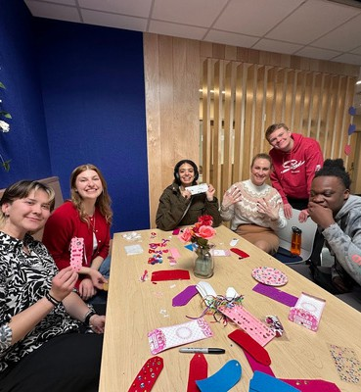
Valentine’s Day Party with invited guests Tour of CCAP’s downtown Boston space and meeting with their community members Safe dating class with Bob Gorgone Professional networking event with fitness industry instructors
Trip to Downtown Crossing to shop for interview attire
Photography Q&A session with professional photographer, Marcus Howard
Boundary-setting workshop with IMPACT Boston
March 2026 Issue No. 6

Building Community
Social Activities Inside and Out
Social connection and community engagement are central to RTG, 38% of our program time is intentionally dedicated to social learning and relationship-building. With Valentine’s Day as a reminder to appreciate the relationships in our lives, we took time this month to celebrate the strong community our students are building.

That community extends beyond our program walls. Alongside the friendships formed at RTG, we are actively building connections across the Greater Boston Area community through partnerships with local businesses, volunteer sites, peer groups, and community resources.
Current events group with BU Occupational Therapy faculty and graduate students.
Workplace visit to one student’s retail job site during their shift for a visit
Birthday celebration for an RTG instructor Social afternoons with games (UNO and Hues and Cues are group favorites)
Trips to local cafes during travel training Weekly “Fika”: a time to reflect and relax and connect with each other.

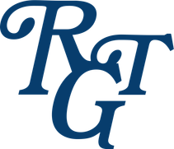
Student Community


Greater Community

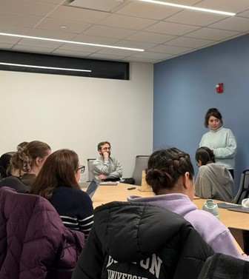
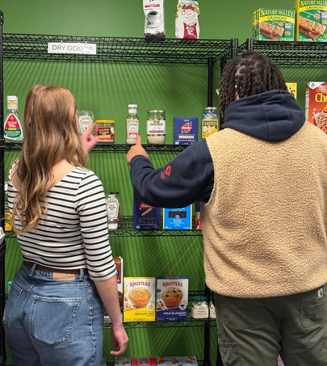
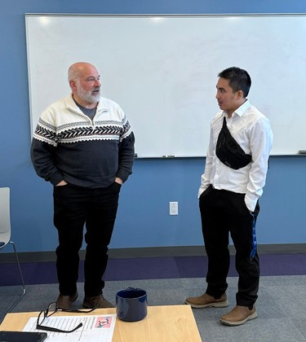
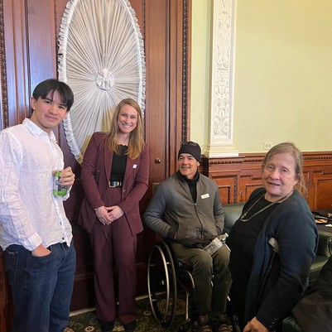

Collaboration and Community

Big thank you to our guests and partners for February:
- Bob Gorgone, retired police captain
- Ben and Javon, IMPACT Boston
- Dr. Jennifer Lillis, research scientist at Boston University Wheelock College of Education & Human Development, and her students
- Brooke Iglar, Kelly Anderson, and Marianne Gilmore from the Carroll Center for the Blind
- Dr. Joseph Moldover, Dr. Moldover & Associates Developmental Neuropsychology
- Marcus Howard, Marcus Earl Photography

Elyse Forbush Joins the Massachusetts Permanent Commission on the Status of Persons with Disabilities
Elyse Forbush has joined the Advisory Council of the Massachusetts Permanent Commission on the Status of Persons with Disabilities. The Advisory Council is a 37 member, cross-sector body created to expand the Commission’s efforts to learn from and engage with communities across the Commonwealth. Members offer perspectives on barriers, gaps, and opportunities related to disability inclusion.

RTG Valentine’s Day Party

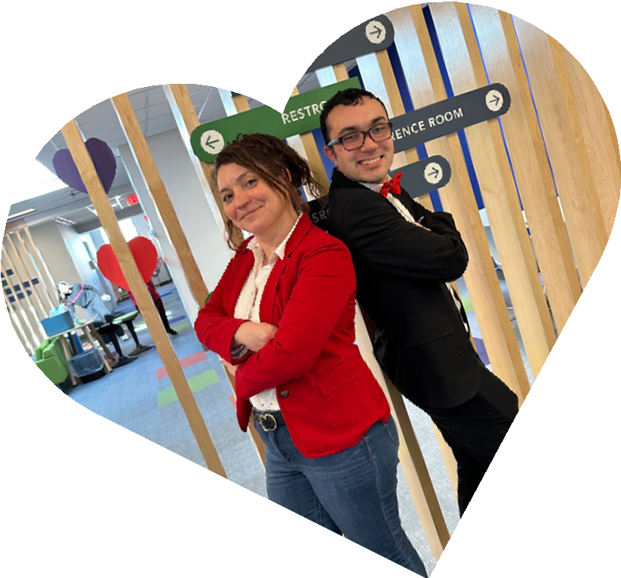
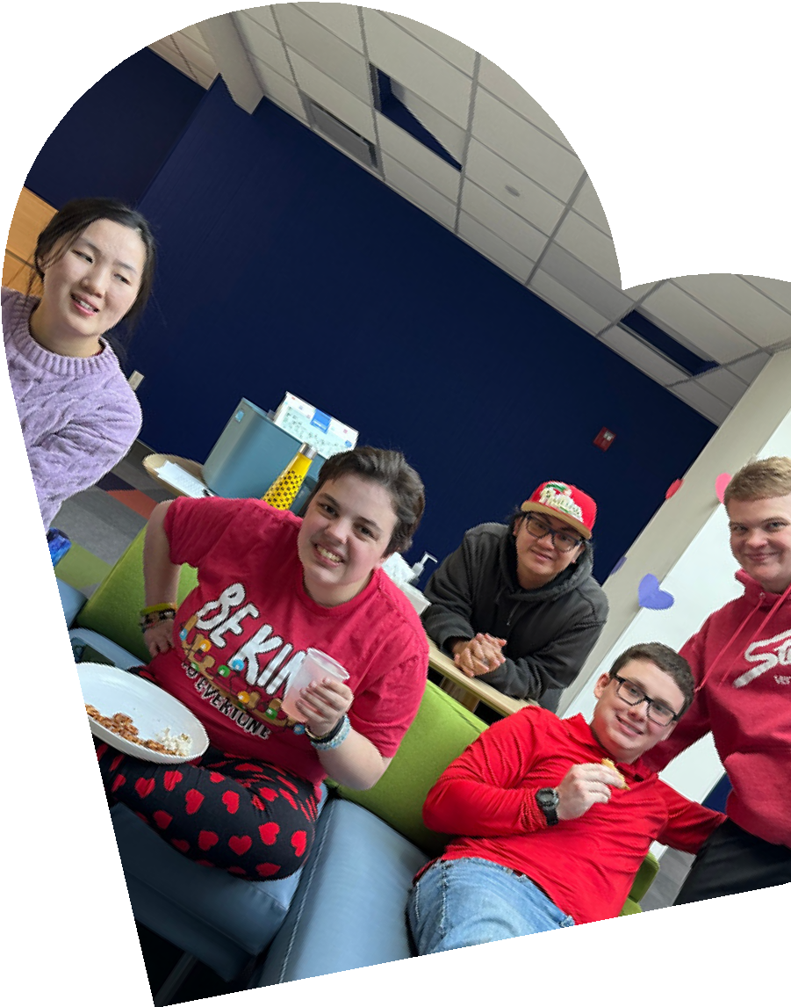
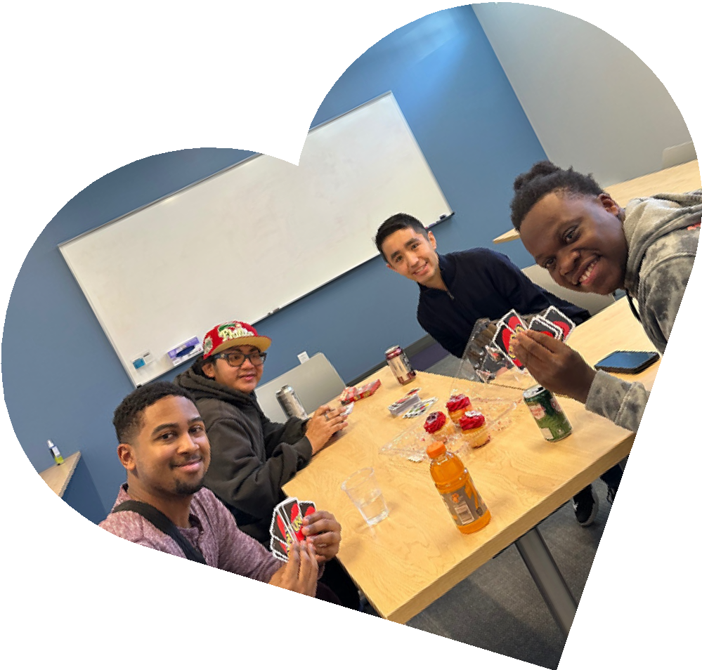
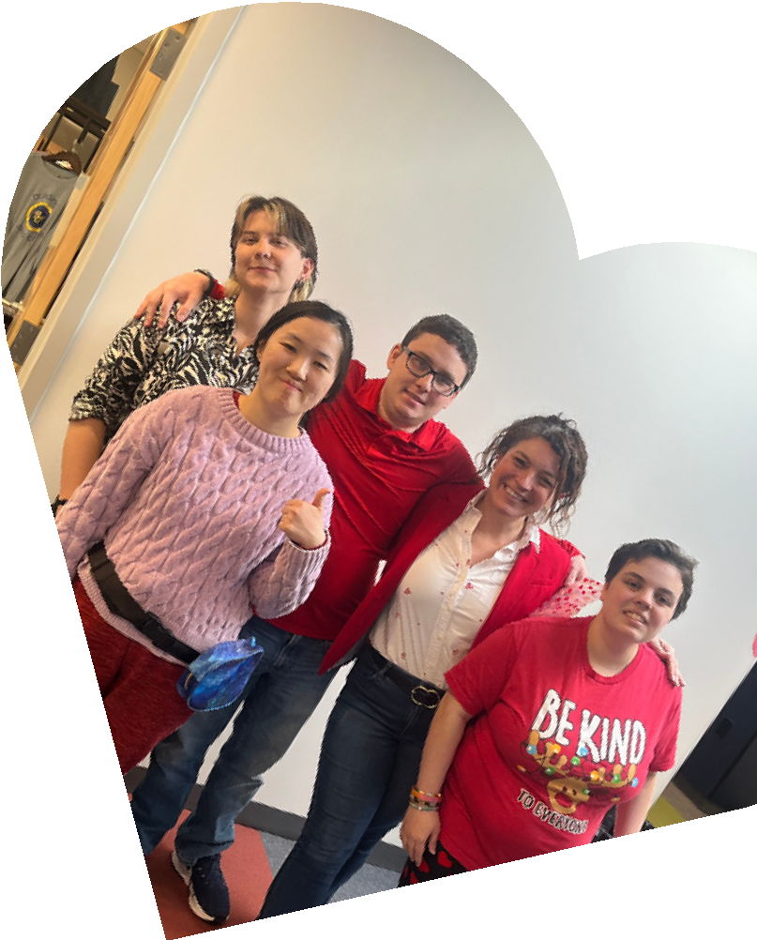
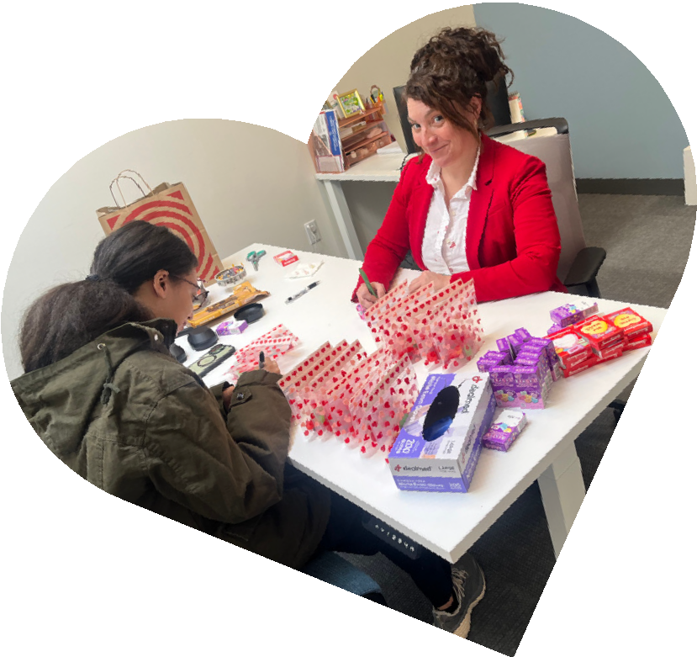
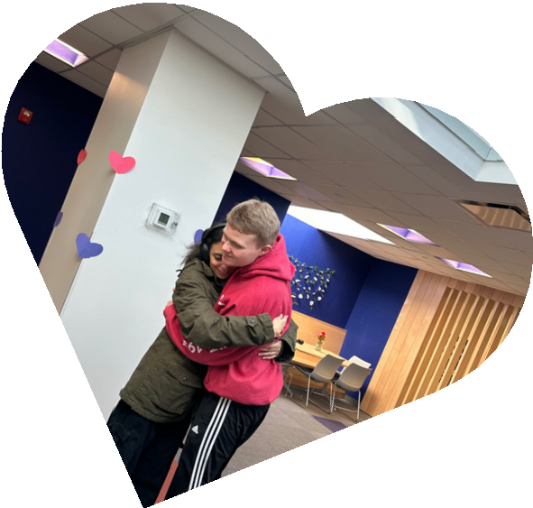
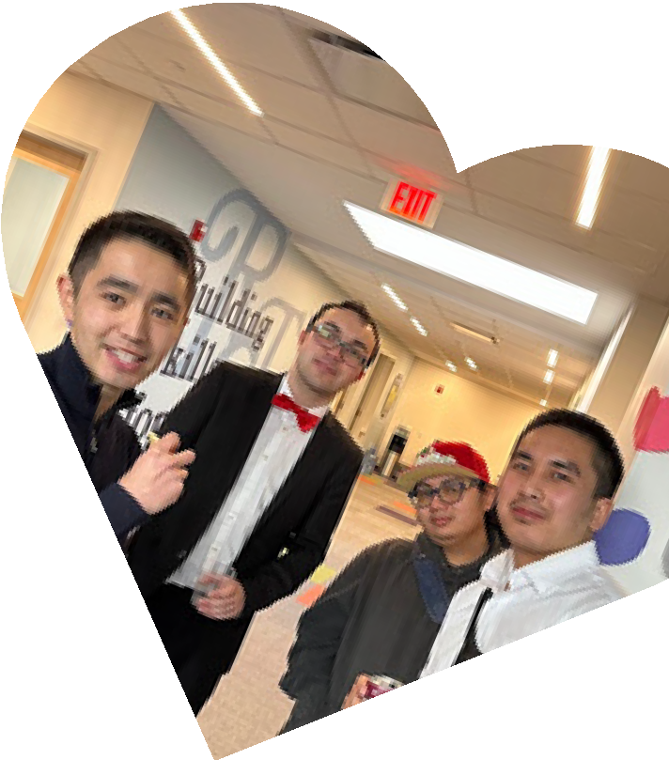
Valentine’s Day is most associated with romantic relationships, but RTG students and staff wanted to spend the holiday and their last day before school vacation week by celebrating with their friends and showing their appreciation for the RTG community. The best way to do that is with a Valentine’s Day Party!

The RTG space was bursting with excitement. RTG students, staff, and community friends were engaged in every activity. Some played games and watched live Winter Olympic coverage together.
Others created love bugs and valentines to take home to family and friends. No matter their chosen activity, everyone was happy to be together.

Amongst the guests at the Valentine’s Day Party were two important members of the RTG community: Bob Gorgone, a retired police captain, and IMPACT Boston. Bob Gorgone taught the students about safe dating online and in-person, creating an atmosphere for students to openly ask questions. IMPACT Boston followed with discussing how to set proper boundaries and respect others’ spaces.

Thank you to everyone who joined us for Valentine’s Day, and we can’t wait for the next holiday party!
www.runthegamut.org

My Experience with IMPACT Boston

Student’s Perspective on the IMPACT Boston Program

What I have learned from IMPACT Boston is that giving other people space and trying not to touch someone and respecting their personal space or boundaries is very important. Another thing I learned is what you do when you feel uncomfortable in a work setting because during the lessons I could name one of the characters after my boss. One last thing I learned is where to get help if something goes wrong in the workplace as well as at school.

My favorite experience is doing a role-play, like acting out different types of scenarios of what is going on around me. Ben asked me if I was ready and I said yes. After I was ready, I decide to tell my boss [in the scenario] not to touch me. In a role-play where there’s an emergency going on, I mimic everything that Ben and Javon do. I liked the role-plays because I get to be a famous actor and singer too.

What I mostly like about Ben and Javon is that they are like construction workers because their outfits that look similar to them.

What I like about Ben is that he was my mentor when I was about to start acting and role-playing. As for Javon, I like naming him after my boss, Ethan, because Ethan is one of the names of my co-workers at the hardware store. Together with Ben and Javon, I can use the acting as well as the role-plays to learn how to be safe in a workplace.

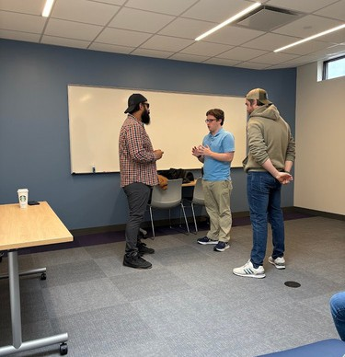
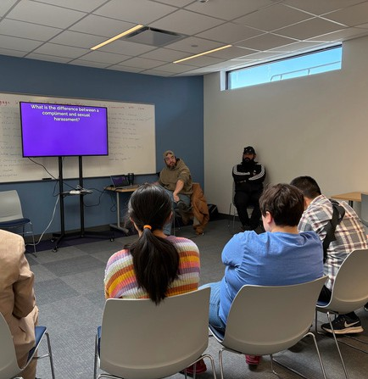
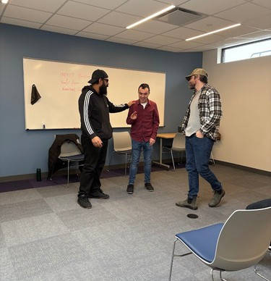

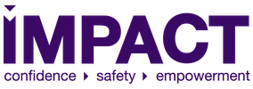
Interested in IMPACT Boston? You can learn more about them here!

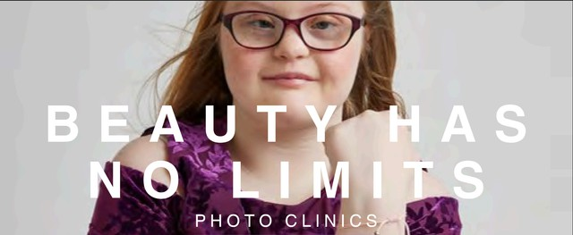
HumanKind x RTG: Beauty Has No Limits Photo Clinics

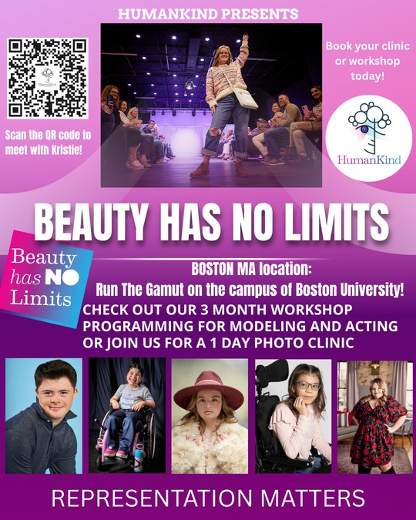

For three weekends this spring, HumanKind will be hosting its Beauty Has No Limits Photo Clinics, modeling classes, and acting classes at RTG’s space.
Upcoming Dates
Sunday, March 8
Sunday, April 12
Sunday, May 10

Beauty Has No Limits is a low-cost modeling portfolio session that includes professional hair and makeup, wardrobe styling, modeling poses and art direction to create portfolio-worthy images. Sessions will last between an hour and a half to two hours.

Modeling 101 and Acting 101 classes are held each month in-person with two additional virtual sessions. Classes end with an in-person showcase.
Schedule a Call
with Kristie Here!
RSVP for a Boston
Session Here!

www.runthegamut.org

Coming up!

The season ahead is filled with new opportunities, career exploration, and social experiences for
the RTG community!

This month, RTG students will:
- Tour the Langham Hotel for a behind-the-scenes look at employment in the hospitality industry
- Attend the MA-APSE All In for Employment First Conference at the Old Colony YMCA
- Join the The Arc of Massachusetts (The Arc) and the Massachusetts Developmental Disabilities Council (MDDC) at the 48th Annual Legislative Reception at the Massachusetts State House
Event Recap: February Open House

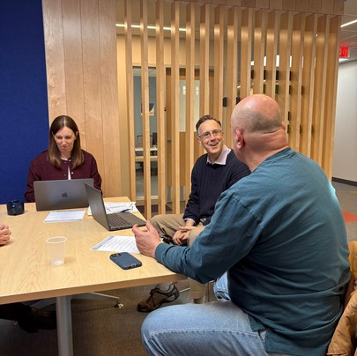
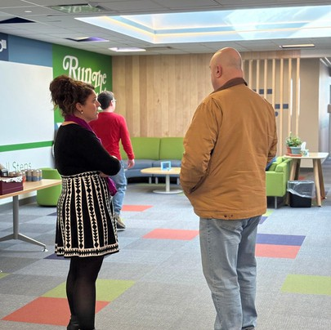
During our first open house this spring, we welcomed community members and prospective families to view our space!

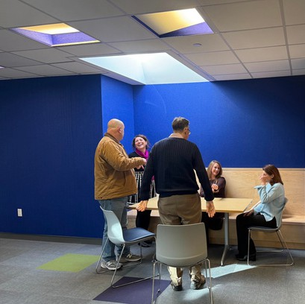
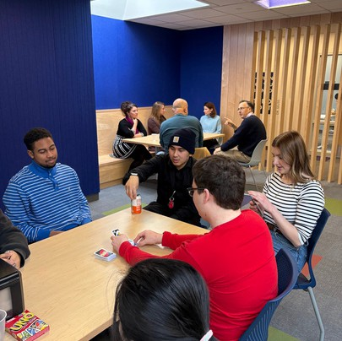
RTG students welcomed prospective families to play UNO with them while parents chatted with RTG staff and Jeff Gentry, Senior Director of Disability and Jewish Career Services.

We’re excited to welcome more community members, families, and friends to our March 20th open house featuring our guest speaker, Colleen Flanagan!

INQUIRE NOW

SCHOLARSHIP

All families are able to apply for scholarships.
OOPPPPOORRTTUUNNIITTYY

Scholarships are awarded on a need basis.

Scholarships applications are reviewed holistically.

AVAILABLE

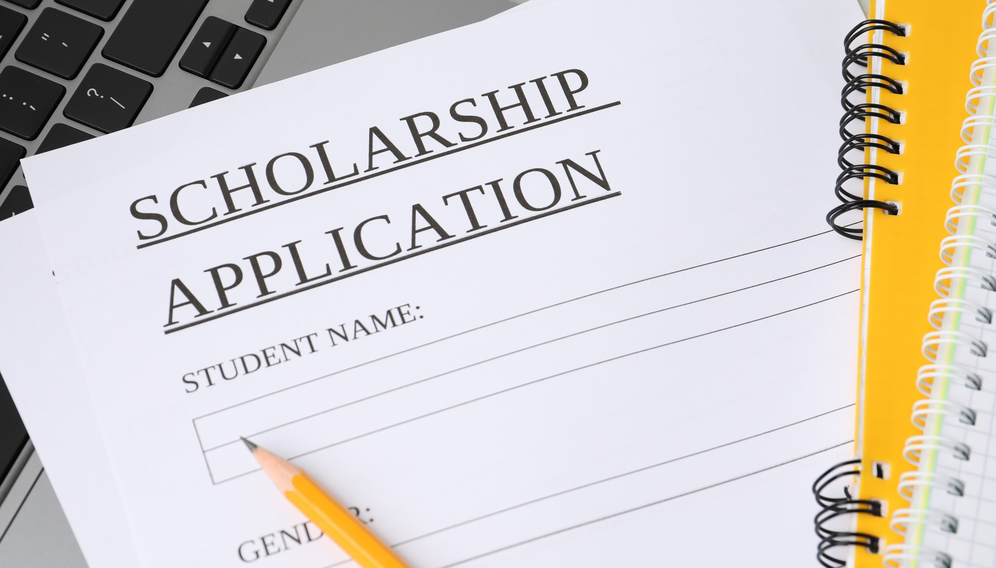
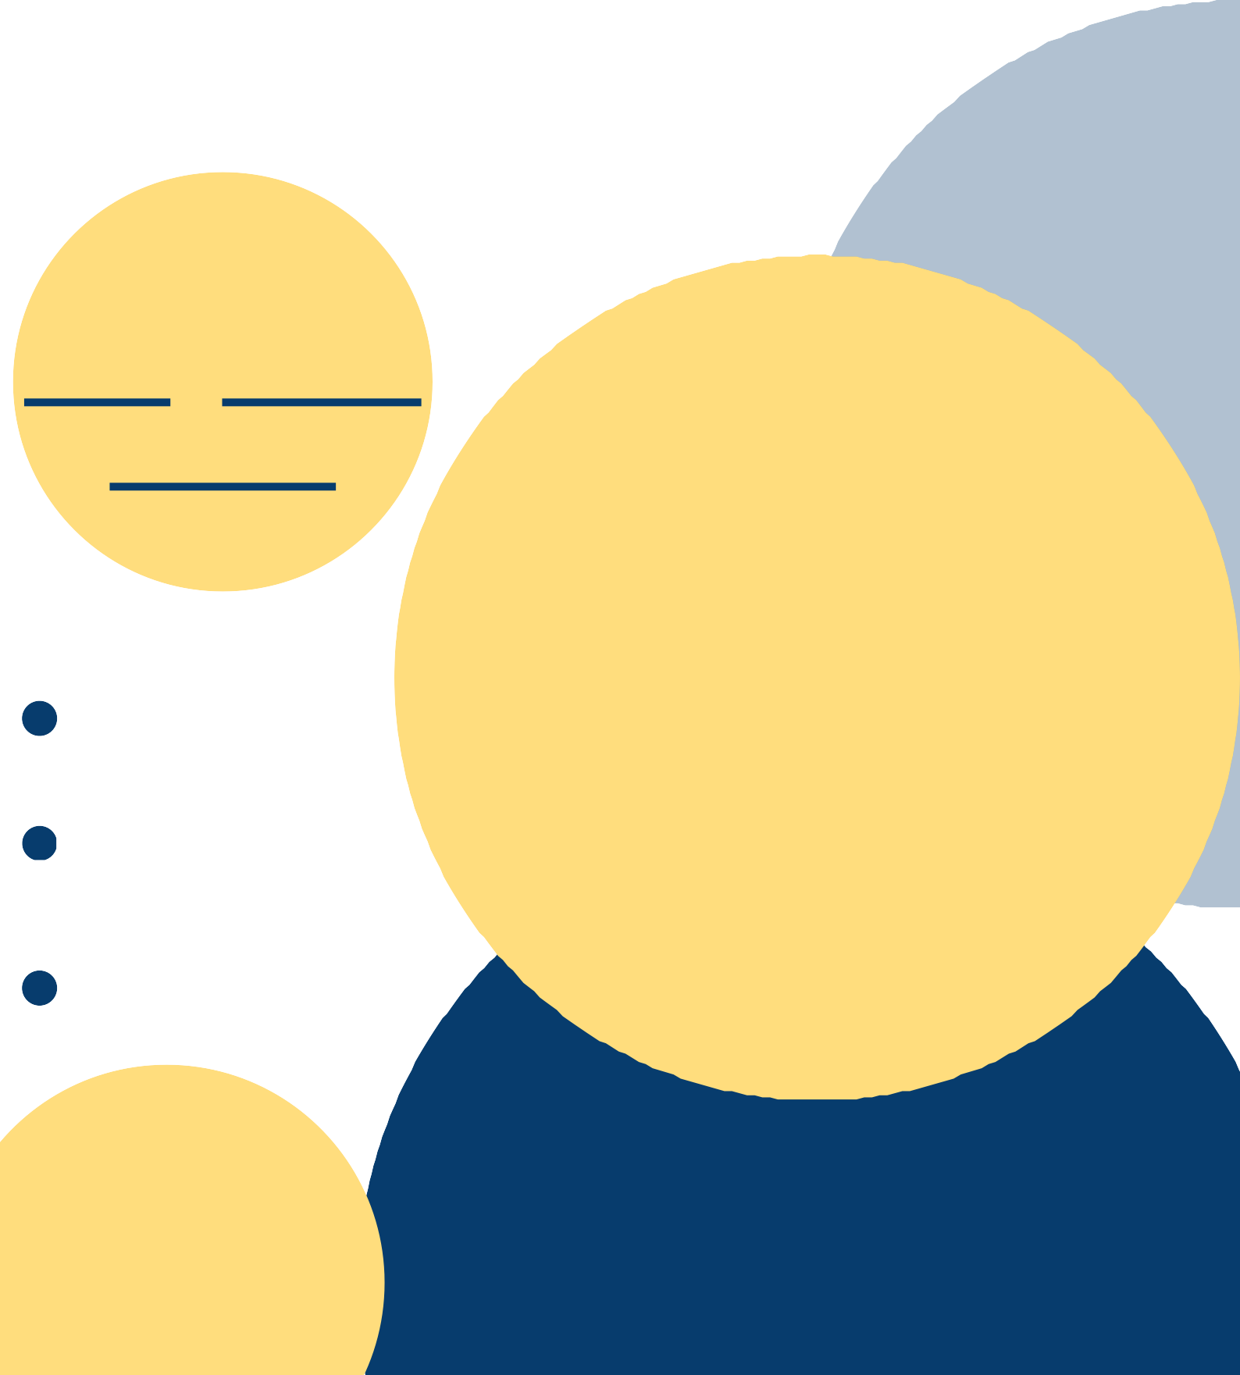
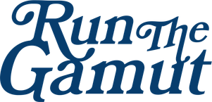

Notice of Non-Discrimination
RTG shall admit students of any race, color, national and ethnic origin, religion, gender, disability, or sexual orientation to all the rights, privileges, programs, and activities generally accorded or made available to students at the corporation’s school. RTG will not discriminate on the basis of race, color, national and ethnic origin, religion, gender, disability, or sexual orientation in the administration of any of its educational policies, admissions policies, scholarship and loan programs, and athletic and other school-administered programs.

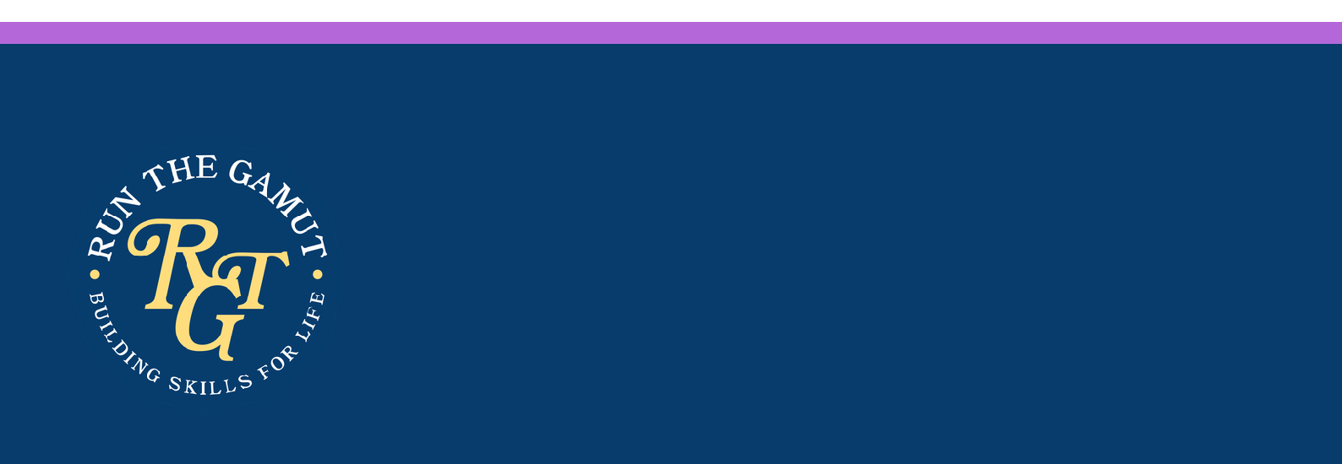
NNooww
EEnnrroolllliinngg
ffoorr
22002266

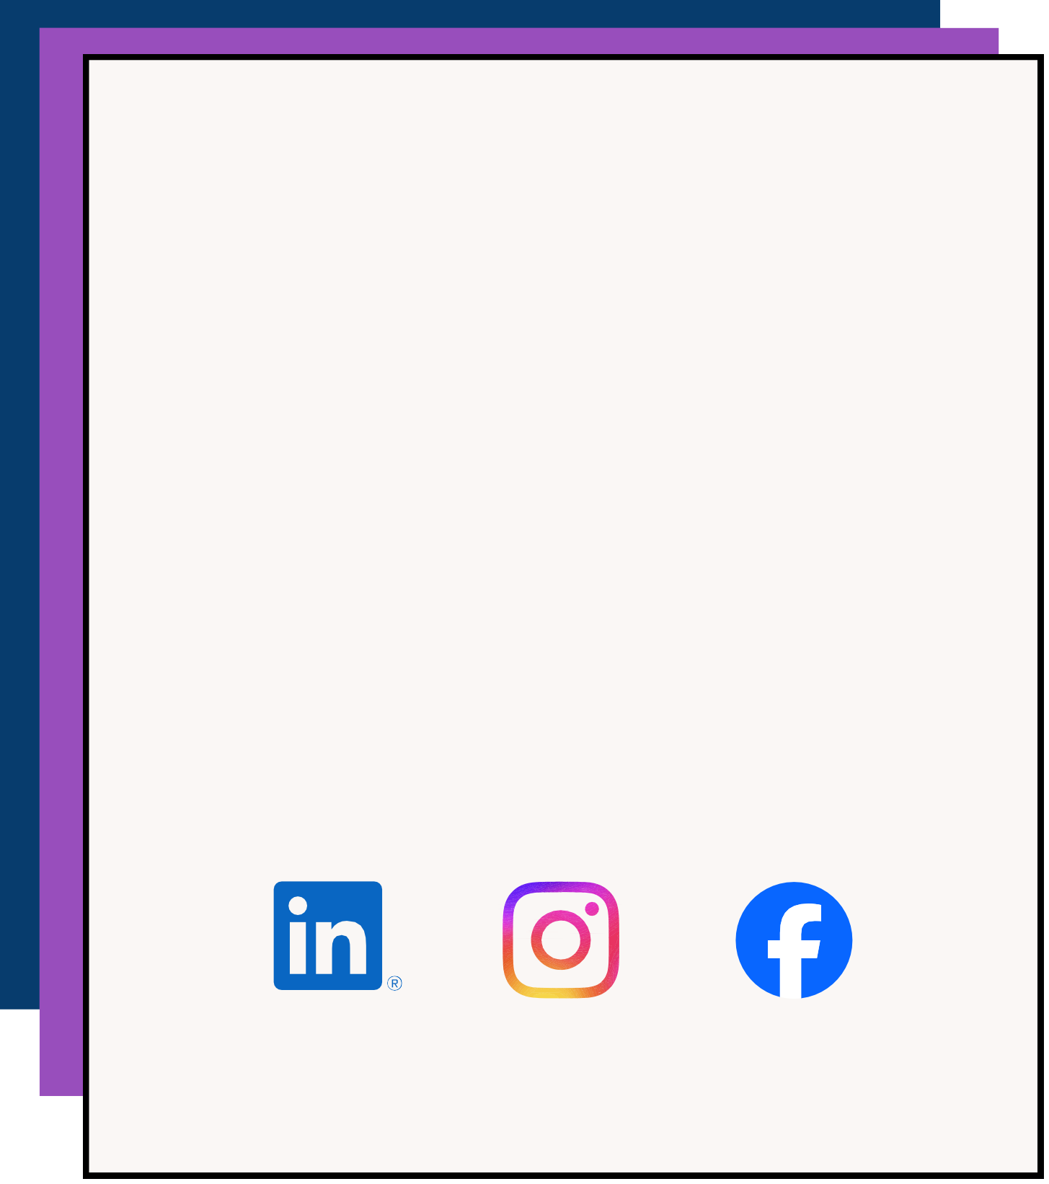
Run the Gamut, Inc. empowers motivated young adults on the autism spectrum to successfully transition into adulthood through hands-on learning, workplace experiences, and a supportive educational community, fostering independence and enhancing quality of life. Our two year transition program, which runs Mon-Fri year round, provides individualized instruction around life skills that have real world application.

At Run the Gamut, we don’t just teach skills, we help individuals build lives filled with meaning, autonomy, and purpose.

We are now enrolling for our next cohort starting in September 2026. Do you know someone who would be a great fit? Follow this link to inquire about admissions or write us at outreach@runthegamut.org for more information.

Make sure to follow us on social media and like & share!

