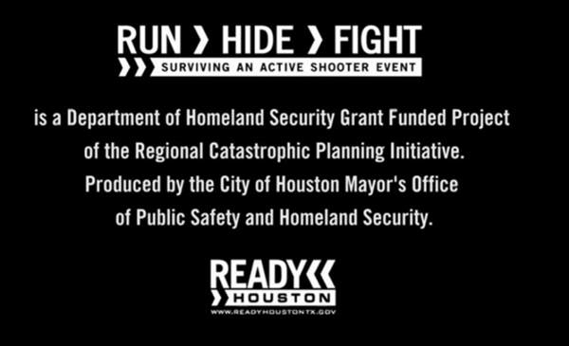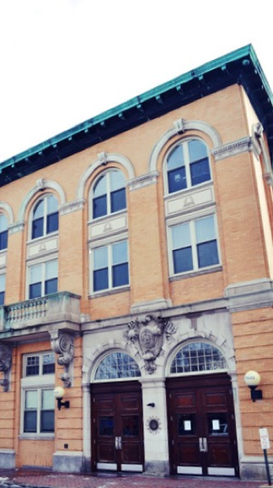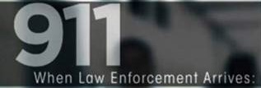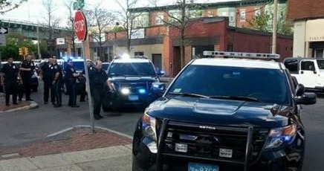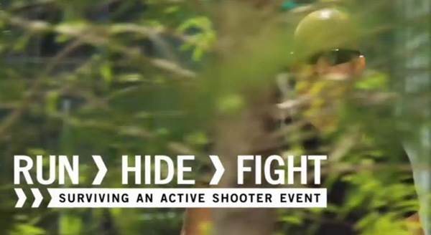

* + 160 Active Shooter incidents occurred between 2000 and 2013.
  + An average 0f 11.4 incidents occurred annually: an average of 6.4 annually in the first seven years of the study and an average of 16.4 annually in the last seven years.
  + Shootings occurred in 40 of 50 states and the District of Columbia.
  + The 160 incidents resulted in 1.043 casualties: 486 killed and 557 wounded, not including the shooter.
  + In incidents, the median number of people killed was two, the median wounded was two.
  + Approximately 60 percent of the incidents ended before police arrived.
  + 64 (40 percent) of the incidents ended with the shooter committing suicide.
  + In 21 Incidents (13.1 percent), the incident ended after unarmed citizens safely and successfully restrained the shooter. Of note, 11 of the incidents involved unarmed principals, teachers, other school staff, and students who confronted shooters to end the threat.
  + In 45 of the 160 (28.1 percent) incidents, law enforcement had to engage the shooter to end the threat. In 21 of those 45 (46.7 percent) instances, law enforcement suffered casualties with nine killed and 28 wounded.
  + In 64 cases where the duration could be ascertained, 44 (69 percent) ended in less than five minutes with 23 ending in two minutes or less.
  + In five incidents (3.8 percent) the shooting ended after armed individuals who were not law enforcement personnel exchanged gunfire with the shooters.
  + Active shooter incidents occurred most frequently in areas of commerce (46 percent), followed by educational environments (24 percent), and government properties (ten percent).
* Remain calm and follow instructions.
* Keep your hands visible at all times.
* Avoid pointing or yelling.
* Know that help for the injured is on its way.

**Watch the six minute video at:**

**www.youtube.com/watch?v=5VcSwejU2D0&feature=player_detailpage**

CHELSEA

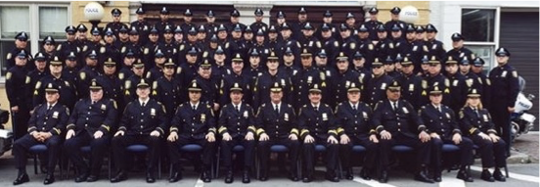

A Public Safety Message From

Chief Brian Kyes 617 466-4810

Emergencies Call 911

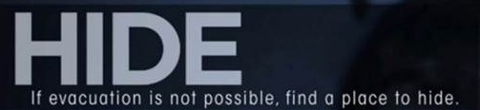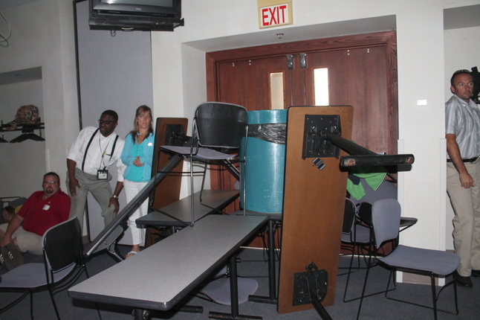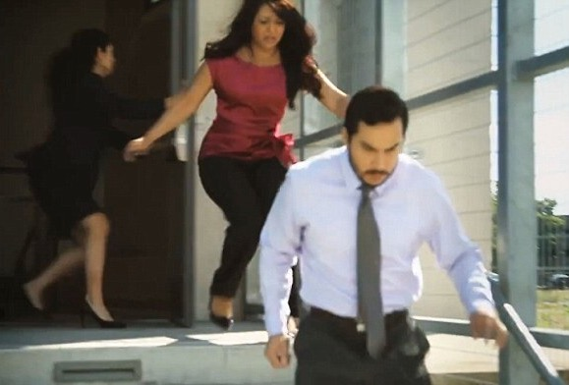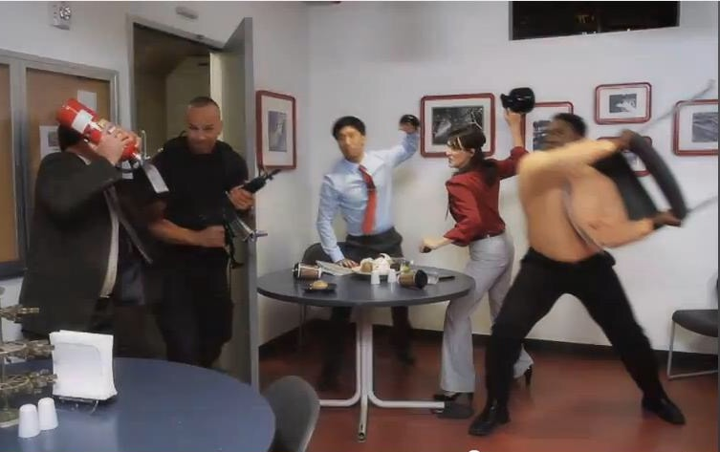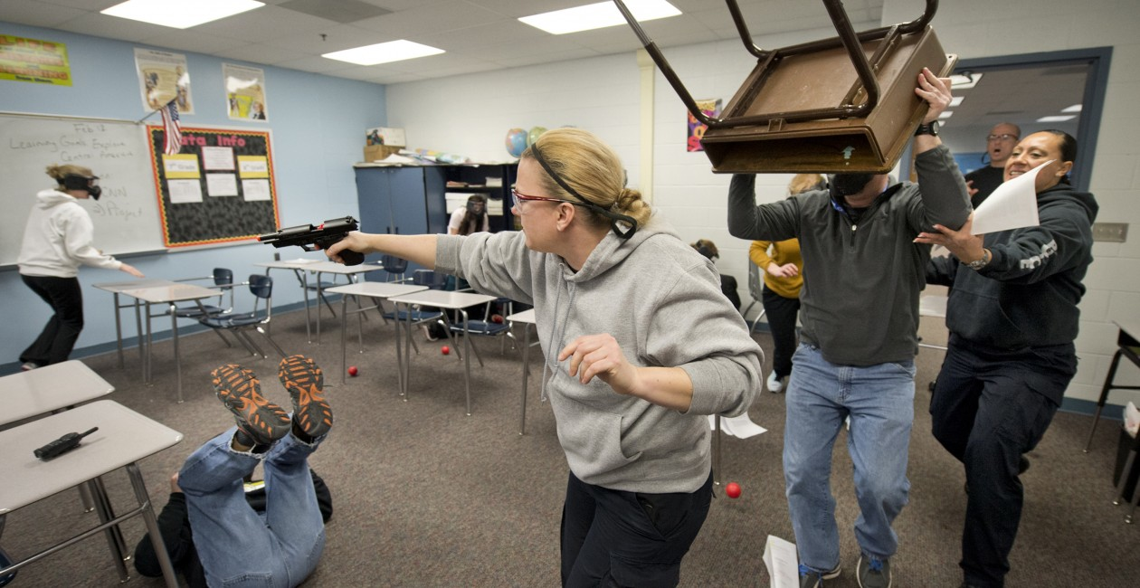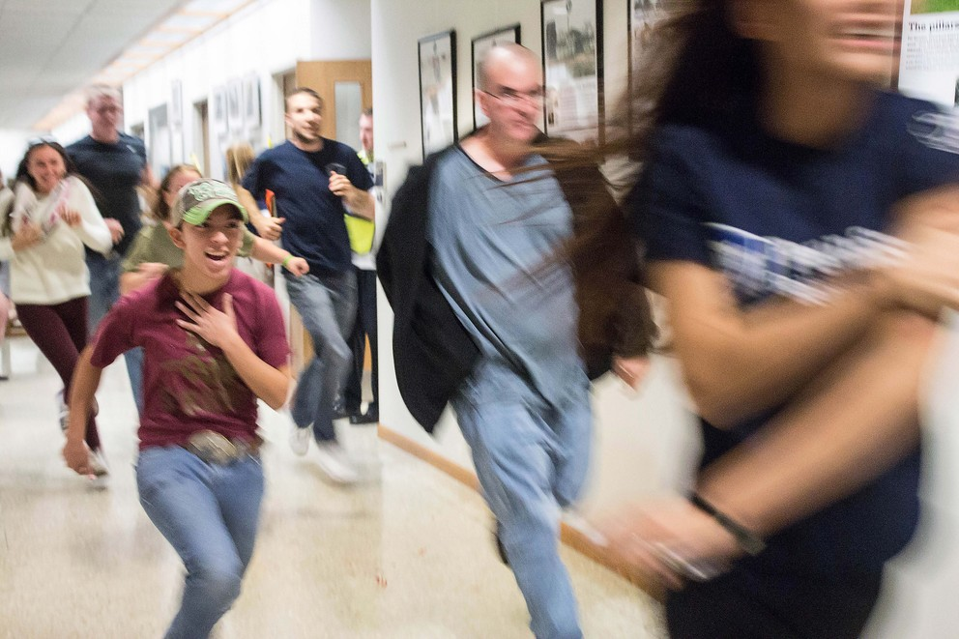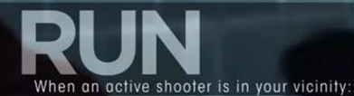

* If there is an escape path, attempt to evacuate
* Evacuate whether others agree or not.
* Leave your belongings behind
* Help others escape if possible.
* Prevent others from entering the area.
* Call 911 when you are safe
* Lock and/or blockade the door
* Silence your cell phone.
* Hide behind large objects.
* Remain very quiet.
* Attempt to incapacitate the shooter.
* Act with physical aggression.
* Improvise weapons.
* Commit to your actions.

Your hiding place should:

* Be out of the shooter’s view.
* Provide protection if shots are fired in your direction.
* Not trap or restrict your options for movement