MA State Office of Rural Health
Rural Definition

Background

What is rural?
There is no single definition of Rural. In fact there are many rural definitions recognized within federal, state and regional organizations. No single definition can fulfill all programmatic and policy needs. This is why different definitions are used based on the individual needs of a program or policy.
The Rural Health Information Hub States:
Rural is an inexact term that can mean different things to different people, organizations and governments. Trying to define what "rural" is, in a nation of diverse geography, can be a daunting task. However, for those concerned with rural healthcare and human services, that which constitutes rural must be precisely defined. Federal and state policymakers, as well as service providers and researchers, need a clearly stated definition that is current in its interpretation.
Typically, methods for defining rural are based on geographic units that are sometimes combined with population or provider characteristics. For the purposes of the State Office of Rural Health, the following three federal agency rural definitions are the most commonly used.
- the U.S. Census Bureau
  - Urbanized Areas (UAs) are geographic areas of 50,000 or more people. Urban Clusters (UCs) are geographic areas of 2,500 to 50,000 people. Any area not categorized as a UA or UC is considered rural.
- the Office of Management and Budget
  - Categorizes Metropolitan, Micropolitan, & Nonmetropolitan statistical areas. Metropolitan areas contain a core urban area population of 50,000 or more. Nonmetropolitan areas contain a population of less than 50,000. Micropolitan areas are urban clusters with populations 10,000 to 50,000.
- the Economic Research Service of the U.S. Department of Agriculture (USDA)
  - Utilizes the U.S. Census Bureau’s UAs and UCs definitions with information on work commuting. Classification delineates metropolitan, micropolitan, small town and rural commuting areas with whole numbers 1-10 and further subdivides into 21 secondary codes based on commuting flows - local or to another census tract.
It is nationally recognized that there is no single rural definition to serve all purposes. Definitions are used by their prospective agencies to target policy and program eligibility.

Creation of a state definition

The framework for a state definition was created in 2002. The Massachusetts Department of Public Health - State Office of Rural Health worked with its advisory council, the Massachusetts Rural Council on Health to develop this definition. This framework is updated with the release of new census data every ten years. Every update is reviewed to make sure it still meets the needs of our office and advisory council. The Massachusetts State Office of Rural Health’s rural definition is used for assessment and planning purposes.
Definition of Rural Massachusetts Towns
A municipality in Massachusetts is considered rural if it meets one of the following criteria:
    - Meets at least one of three federal rural definitions at the sub-county level (Census Bureau, OMB, or RUCAs), and/or
    - Has a population less than 10,000 people and a population density below 500 people per square mile, and/or
    - Has an acute care hospital in the town that meets the state hospital licensure definition of a small rural hospital (SRH), or is a certified Critical Access Hospital (CAH).
Two Levels of Rurality
Rural towns are also classified into two categories of rurality. Towns classified as rural level one meet fewer rural criteria than towns considered rural at level two.
- Towns in level two are less densely populated and more remote and isolated from urban core areas.
- Towns in level one and level two are both rural.
- Towns not in level one or two are considered urban.

To determine the level of rurality, the MA SORH rural definition uses a composite scoring system with points assigned for meeting particular definitions of rural.

Definitions of Rural | Standard | Points if Met
Census Bureau | >50% Rural | 5 points
OMB | town level | 10 points
RUCAs | Codes 4 - 10 | 10 points
Population & Density | Pop< 10,000 & Den<500 PPSM | 5 points
SRH/CAH in town | MA law & Hospital Regs | 5 point

Points for each definition were then added together and categorized as follows:

Rural Level 1: Communities with combined rurality scores of 5-15
Rural Level 2: Communities with combined rurality scores of 20-35

Running Data on Massachusetts Rural Towns

The definition of Massachusetts Rural Towns can be used for analysis is in different ways. These analysis levels are available in excel format from the State Office of Rural Health. The descriptions below introduce you to the levels and examples of appropriate uses. For access to the rural definition spread sheet please contact the state office of rural health.
    - All Rural Towns
    - All Rural Counties
    - Rural Clusters
All Rural Towns
We have provided a list of all towns classified as rural, including their level of rurality and zip code. Using this level for analyzing data will provide a high level view in rural communities across the commonwealth. This larger list is favorable when using a data set that may be suppressed due to smaller sample sizes. It is also effective when doing a data comparison of rural and urban communities at the state level.

This analysis level can be found in the’ ALL RURAL’ tab
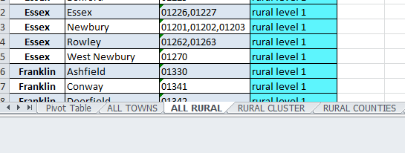
Each table also contains filter arrows for easier navigation.
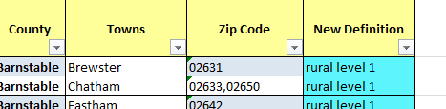
All Rural Counties
This analysis level provides all rural counties. If you are analyzing data at the county level, this can provide a high level overview. This analysis level should be used if the data set contains county level data. Included in this analysis level are the three completely rural counties. We also include one nearly rural county in this analysis level as it has only one urban town included.
This analysis level can be found in the ‘RURAL COUNTIES’ tab
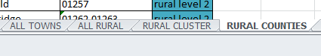
Rural Clusters
For more in depth analysis, there are rural clusters. These groupings of rural towns allow for a more specific analysis to be done. Clustering towns can create a data sample size that meets quality standards. Rural populations are often too small to have data analyzed at the town or zip code level and meet data quality standards. These rural clusters were identified by our rural partners. They represent geographic areas that have been historically classified together in those regions. Clusters may represent areas of shared services, cultural commonality, or geographic cohesion. This analysis level can be helpful for hot spotting data and identifying trends specific to certain regions. It provides a representative analysis of Massachusetts rural regions. This analysis level also tends to be more helpful to rural communities using data.

This analysis level can be found under the ‘RURAL CLUSTER’ tab.

