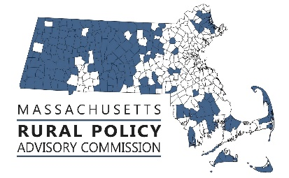 | RPAC Meeting  November 8, 2024  10:00 to 12:30  Zoom link:  https://us02web.zoom.us/j/83556960872?pwd=JFpyGOrk6UiNFgZ3buLqxlgokemZfk.1
AGENDA:
Welcome and Introductions – Linda Dunlavy | 10:00
Adopt Minutes of meetings of 9/18/24 – Trish Settles | 10:05
Director of Rural Affairs update with Anne Gobi and Mallory Sullivan | 10:10
Discuss Legislation, Policies & Priorities  - End of session update – Rep. Natalie Blais and Sen. Paul Mark  - Plan and priorities for next legislative session | 10:30
RPP Focus Areas – Housing, Transportation and Land Use  - Holistic Land Use Study soon underway by EEA – Kurt Gaertner, EEA invited  - Discussion about the Affordable Homes Act rural advocacy next steps  - Chapter 90 Reform Working Committee | 11:00  11:30  11:45
Future Activities, Priorities and Other Items  - FY25 meeting schedule  - Future agenda items  - Other | 12:00

FRCOG1 is inviting you to a scheduled Zoom meeting.

Join Zoom Meeting
https://us02web.zoom.us/j/83556960872?pwd=JFpyGOrk6UiNFgZ3buLqxlgokemZfk.1

Meeting ID: 835 5696 0872
Passcode: 521799

---

One tap mobile
+16469313860,,83556960872#,,,,*521799# US
+19292056099,,83556960872#,,,,*521799# US (New York)

---

Dial by your location
• +1 646 931 3860 US
• +1 929 205 6099 US (New York)
• +1 301 715 8592 US (Washington DC)
• +1 305 224 1968 US
• +1 309 205 3325 US
• +1 312 626 6799 US (Chicago)
• +1 253 205 0468 US
• +1 253 215 8782 US (Tacoma)
• +1 346 248 7799 US (Houston)
• +1 360 209 5623 US
• +1 386 347 5053 US
• +1 507 473 4847 US
• +1 564 217 2000 US
• +1 669 444 9171 US
• +1 669 900 6833 US (San Jose)
• +1 689 278 1000 US
• +1 719 359 4580 US

Meeting ID: 835 5696 0872
Passcode: 521799

Find your local number: https://us02web.zoom.us/u/kdvEi6lZmZ

