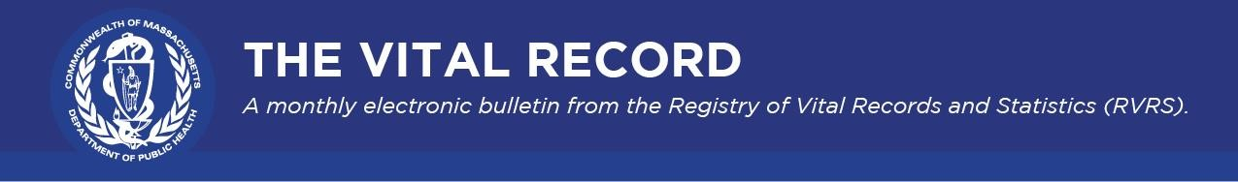
The Vital Record highlights updates from the Massachusetts Registry of Vital Records and Statistics (RVRS) on modernization efforts and other timely information of interest to our registration and data partners.

November 2022

RVRS Happenings

What Massachusetts Birth Records Tell Us

As part of its ongoing data collection responsibilities, RVRS collects and disseminates information that tells us a lot about babies born in Massachusetts.
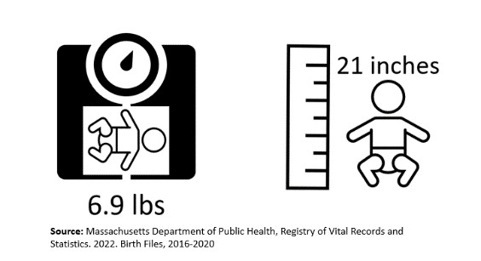
For instance, RVRS’s birth data shows that
Massachusetts babies born between 2016 and 2020 on average weighed 6.9 pounds and were 21 inches long.

The data also shows how naming trends have evolved over time and across generations. As displayed in the graphic below, "Michael" and "John" remained in the top 10 baby boy names for each generation spanning from Gen X to Gen Alpha, and no single baby girl name remained in the top 10 across all generations. See if your name is on any of the lists below.

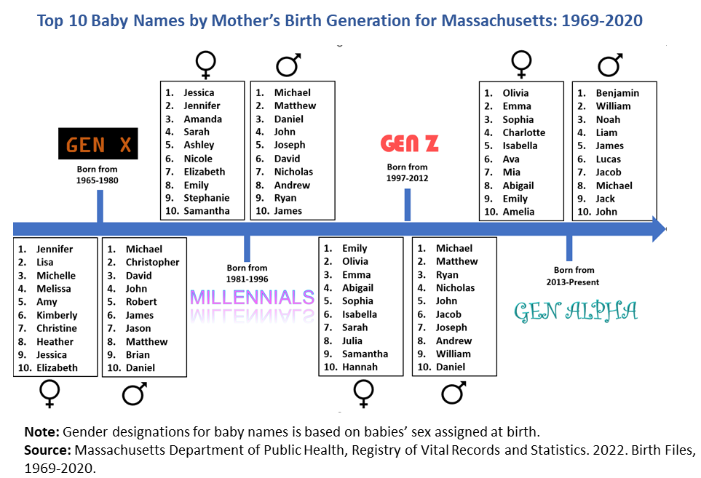

Policy and Procedure

Additional Options for Veteran Information Worksheet
The Veteran Information Worksheet for Certificate of Death has been updated to include additional uniformed branches of the military as options to select when indicating the most recent branches of the military a veteran was engaged with at the time of completing the worksheet. These new uniformed branches include the National Oceanic and Atmospheric Administration (NOAA) Corps, the Public Health Service, and the Space Force.

Marriage Age Changes

A memo was recently sent to city and town clerks regarding updates to the marriage certificate process, indicating that legislation enacted October 26, 2022, prohibits marriages to individuals under the age of 18. This legislation was included as part of the Governor’s Fiscal Year 2023 budget (sections 81-88).

Access to Pre-Adoption Birth Records

Effective November 3, 2022, Chapter 158 of the Acts of 2022 expands access to records of births prior to adoption to all years of birth. Previously, such records were restricted to births occurring on or before July 14, 1974, and on or after January 1, 2008. You can find specifics in the memo that was issued to city and town clerks on November 2. Non-certified pre-adoption records may be requested through the Registry of Vital Records and Statistics by visiting our web page.

National Observances

National Adoption Day

As we celebrate National Adoption Day on November 19, did you know that RVRS plays an important role in adoption? RVRS receives information about every adoption to a Massachusetts-born child for the purpose of amending a child's birth certificate. RVRS completes about 1,300 birth certificate amendments for adoptions annually.

American Diabetes Month

November is American Diabetes Month. RVRS collects Massachusetts diabetes death data according to various demographic information, such as age group, gender, and race/ethnicity. The statistics based on these data are published at Death Reports. In addition, DPH provides a variety of resources and information on how to manage diabetes once it has been diagnosed.
The data shows that there were 51.3% more deaths where diabetes was a contributing cause in
2020 when compared to 2016. It is important for medical certifiers, when completing a death certificate, to consistently include detailed information about contributing factors as these data are used by public health programs and medical research both statewide and nationally.
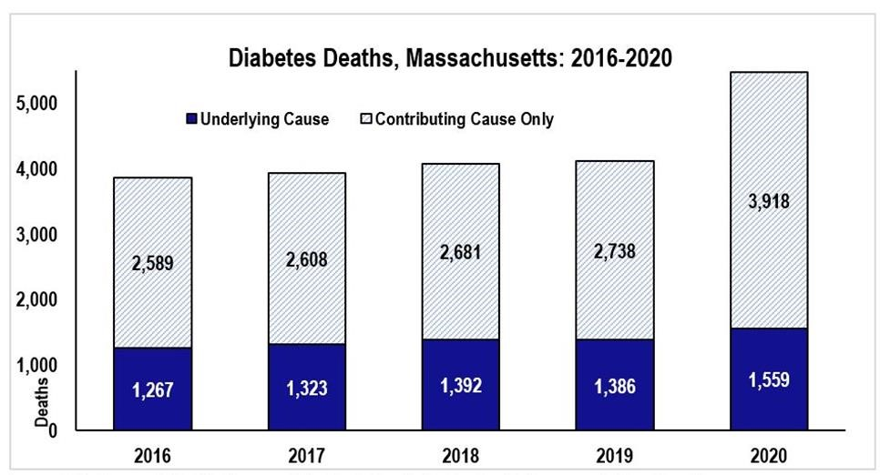

Immediate Cause of Death: The condition that directly led to death. An example is respiratory failure. Underlying Cause of Death: The condition that led to the immediate cause of death. An example would be lung cancer as the underlying cause that led to respiratory failure
Contributing Cause of Death: Related conditions that were not part of the sequence of events leading to the immediate cause of death. An example would be that the patient who died from lung cancer also had emphysema as a contributing factor.
Source: Massachusetts Department of Health, Registry of Vital Records and Statistics. 2022. Death Files, 20162020.

How to Contact RVRS

For the topics below, please contact the given email address. Your inquiry will be responded to by a member of the RVRS team.

Topic | Contact
Amendments | vip-amend@state.ma.us
Data and Publications | vital.datarequest@state.ma.us
Delayed Records | vital.regulation@state.ma.us
General Inquiries | RVRSCommunications@mass.gov
RVRS Customer Service | vital.recordsrequest@state.ma.us
Vitals Information Partnership (VIP) Accounts | vip-accounts@state.ma.us
Vitals Information Partnership (VIP) Registration | vip@state.ma.us

Key Resources

- RVRS administers and issues copies of vital records that occurred in Massachusetts from 1931 to the present. RVRS also provides statistics on births, deaths, fetal deaths, divorces, and marriages.
- Population Health Information Tool (PHIT) is a core website to explore Massachusetts public health data. PHIT is free to use, open to the public, and provides dynamic, easyto-download data so users can make data-informed decisions.
- The Federal Emergency Management Administration’s (FEMA) COVID-19 Funeral Assistance Program may be able to offer financial assistance to your constituents who have already paid for funeral expenditures linked to COVID-19.

Registry of Vital Records and Statistics | 150 Mt Vernon Street, Dorchester, MA 02125
Unsubscribe RVRSCommunications@mass.gov
Sent by RVRSCommunications@mass.gov

