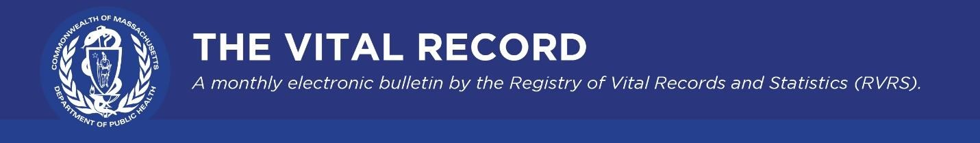
The Vital Record highlights updates from the Massachusetts Registry of Vital Records and Statistics (RVRS) on modernization efforts and other timely information of interest to our registration and data partners.
October 2022

RVRS Happenings

21st Century Project Launched
RVRS has launched its 21st Century Project to be more efficient, reduce paper use, and improve data quality. The project aims to better serve you, whether you are a state, municipal, federal, academic, or private sector customer. RVRS’s modernization efforts will span the next five years and include several major transformation projects:
- Replacing the Vitals Information Partnership (VIP) system with a modernized, userfriendly, and secure cloud-based vital records and statistics system, Massachusetts Vital Records Information Collaborative (MAVRIC), for the preparation of birth, marriage, death, divorce, fetal death, and other vital events. MAVRIC will feature mobile device compatibility to support our providers in the field and for telework. The new system will explore automated information exchanges between RVRS internal and external partners to reduce redundancy and improve quality of data. The initial focus of MAVRIC is to replace the current Vitals Information Partnership (VIP) death certificate module, for release in January 2024, followed by birth and other modules in 2025.
- Launching a Learning Center that will provide access to personalized online training modules on relevant topics. Stay tuned for updates in future editions of this e-bulletin.
- Producing this monthly e-bulletin to ensure you are kept up to date on all activities and policy news.
- Refreshing our website, so it will be easier for you to find the latest content and popular topics. As we embark on this project, you’ll have opportunities to collaborate with RVRS through webinars, focus groups, surveys, user testing, and other activities.

Feel free to email RVRSCommunications@mass.gov with any ideas, comments, or suggestions you may have about MAVRIC implementation, communication plans, or other modernization topics. Many of your colleagues have already participated in some early design sessions, but RVRS is always interested in engaging more of our partners.

1926-1930 Birth, Death, and Marriage Records

Every five years, birth, death, and marriage records are transferred to the Mass. State Archives. As of late September, approximately 450,000 records from 1926 to 1930 will no longer be available for issuance or amendment at the State Registry offices. While copies of these records may still, in most cases, be obtained or amended at local city and town vital records offices, individuals seeking to research or obtain vital records from the Mass Archives may visit their website for more information.

Evolving from Paper to Digital

RVRS is nearing completion of a more than two-year effort to scan over 15 million birth, death, and marriage records and related indexes dating from 1936 to present. This project will help RVRS enhance the customer experience and improve data availability.

Race and Ethnicity on the Death Certificate

In collaboration with the Massachusetts Funeral Directors Association, RVRS State Registrar Karin Barrett recently presented to funeral directors about standards to record race and ethnicity on the deceased’s death certificate. Accurate and complete population statistics help to assess and improve health equity across the Commonwealth by targeting public health interventions, ensuring access to care, and providing culturally appropriate education materials where they are most needed. If you are involved in collecting race and ethnicity data on vital records, we appreciate your efforts to encourage accurate reporting of these important data elements. Please contact RVRS if you need worksheets or other forms in different languages.

Policy Changes

Ending Child Marriage

Effective October 26, 2022, legislation will prohibit marriages to individuals under the age of 18. RVRS will provide you with more detailed information and update our guidance prior to this date. This legislation was included as part of the Governor’s Fiscal Year 2023 budget (see sections 81-88).

Access to Adoption Birth Records

Effective November 3, 2022, Chapter 158 of the Acts of 2022 expands access to records of birth prior to adoption to all years of birth. Currently, such records are restricted to births occurring on or before July 14, 1974, and on or after January 1, 2008. Non-certified pre-adoption records may be requested through the Registry of Vital Records and Statistics. Visit our web page closer to the implementation date for more information.

National Health Observance

October: Breast Cancer Awareness Month

Every year in October, people participate in events and campaigns to bring attention to the devastating effects of breast cancer. Researchers and epidemiologists can examine the mortality statistics for breast cancer that RVRS gathers and publishes in their Death Reports.
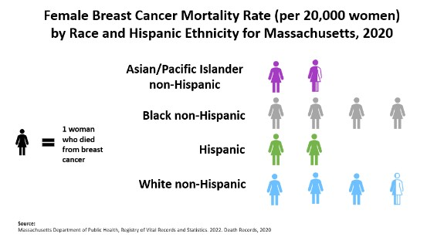
According to “Health and Racial Disparity in Breast Cancer,” breast cancer is the most common type of cancer affecting women of every ethnic group in the United States. And Black women in the United States are 42% more likely to die from breast cancer than white women.
The rates of breast cancer occurrence and breast cancer-related deaths have increased over the last three decades, as reported in a recent article in the Cancers journal.
For additional information on trends in cancer mortality by race and Hispanic ethnicity see: 2022 Update - Health Outcomes among Massachusetts Residents by Race and Hispanic Ethnicity - Cancer Mortality (2014-2018) (phitinfohubma.org)
For more information on racial inequities in breast cancer mortality and other outcomes, please see Health Outcomes among Massachusetts Residents by Race and Hispanic Ethnicity | Health Equity (phitinfohubma.org)
Read additional information regarding breast cancer screening from the Massachusetts Department of Public Health.

Key Resources

- RVRS administers and issues copies of vital records that occurred in Massachusetts from 1931 to the present. RVRS also provides statistics on births, deaths, fetal deaths, divorces, and marriages.
- The National Association for Public Health Statistics and Information Systems (NAPHSIS) is the national nonprofit organization representing the state vital records and public health statistics offices in the United States.
- The Federal Emergency Management Administration’s (FEMA) COVID-19 Funeral Assistance Program may be able to offer financial assistance to your constituents who have already paid for funeral expenditures linked to COVID-19.

Registry of Vital Records and Statistics | 150 Mt Vernon Street, Dorchester, MA 02125
Unsubscribe RVRSCommunications@mass.gov Sent by RVRSCommunications@mass.gov

