**RY2023 EOHHS Hospital Clinical Quality Incentive**

**Program Technical Specifications Manual (v1.0)**

Publication Date: May 19, 2023

**RY2023 EOHHS Hospital Clinical Quality Incentive (CQI) Program Technical Specifications Manual (v1.0)**

**RY2023 (CY2023 Performance Period)**

Contents

Table of Contents……………………………………………………………………………………………………………………………………………………1

Section 1. Clinical Quality Incentive Program (CQI) 3

A. Overview 3

B. Purpose of Manual 3

C. Using this Manual 4

D. CQI Program Measures and Performance Periods 6

E. Quality Reporting Timelines 9

F. Program Participant Forms 9

Section 2. Data Collection Standards & Guidelines 10

A. MassHealth Measure Specifications 10

B. MassHealth Specific Data Elements 10

C. Data Collection & Reporting Tools 12

Section 3. Portal Guidelines 15

A. Portal System Requirements 15

B. Data File Contents and ICD Entry Form 16

C. Portal Reports Repository 19

D. Data-Entry Measures Data Collection 22

E. User Accounts Registration 24

F. Customer Support 26

G. Extraordinary Circumstance Exception 26

Section 4. Chart-Abstracted Measures Specifications 29

A. Care Coordination and Integration of Care Domain 29

1. Reconciled Medication List Received by Discharge Patient (CCM-1) 29

2.Transition Record with Specified Elements Received by Discharge Patient (CCM-2) 34

3. Timely Transmittal of Transition Record (CCM-3) 41

B. Care for Acute and Chronic Conditions Domain 46

1. Alcohol Use Brief Intervention Provided or Offered (SUB-2) 46

2. Alcohol & Other Drug Use Disorder Treatment Provided or Offered at Discharge (SUB-3) 51

1. Cesarean Birth, NTSV (MAT-4) 58

2. Unexpected Complications in Term Newborns (NEWB-3) 63

Section 5. MassHealth Population Sampling Specifications 74

A. Medicaid Population Sampling Specifications 74

B. Measure Population Definitions 74

Section 6. MassHealth Data Validation Methods 75

A. Chart Sampling 75

B. Data Validation Scoring Methods 75

Section 7. Data-Entry Measures 77

A. Care for Acute and Chronic Conditions Data-Entry Measure 77

B. Behavioral Health Care Domain Data-Entry Measure 78

C. Perinatal Care Domain Data-Entry Measure 80

1. Measure Description 80

2. Data Collection Method 80

3. Completing the Attestation Form 81

3. Data Accuracy and Completeness 81

4. Measure Evaluation Method 81

8. Claims-Based Measures Specifications 82

A. MassHealth Claims Data File 82

B. NCQA HEDIS Claims-Based Measures Specifications 82

1. Care Coordination and Integration of Care Domain 83

2. Care for Acute and Chronic Conditions Domain 85

3. Behavioral Health Care Domain Claims-Based Measures 86

C. Other Claims-Based Measures 87

9. Patient Safety Domain Measures 88

A. Patient Safety Adverse Events Composite (PSI-90) 88

B. National Healthcare-Associated Infection (HAI) Measures 88

Section 10. Patient Experience Domain Measures 89

# Section 1. Clinical Quality Incentive Program (CQI)

## Overview

The EOHHS Acute Hospital RFA2023 Section 7.B.3 introduced a new MassHealth Clinical Quality Incentive (CQI) Program that expands on Section 7 measure reporting requirements. This Technical Specifications Manual provides specifications for the RY2023 CQI program measures, specifications, and timeframes, which are outlined in Amendment 2 of the Rate Year 2023 Acute Hospital RFA, re-issued on December 27, 2022.

The MassHealth Hospital Clinical Quality Incentive (CQI) program will be effective with Q1-2023 discharges. CQI program measures are grouped into four core quality measure domains and two specialty quality domains:

* ***Core Quality Domains****: Care Coordination/Integration of Care; Care for Acute and Chronic Conditions*; *Patient Safety*; and *Patient Experience*
* ***Specialty Domains***: *Perinatal Care* and *Behavioral Health Care*

**Participation Requirement:** All Hospitals must participate in the four Core Quality Measure Domains. Birthing Hospitals with deliveries are required to participate in the Perinatal Domain.

Hospitals that have an inpatient psychiatric unit and participate in the current CMS IPFQR program are required to participate in the Behavioral Health Care Domain

Hospitals are required to report data for individual quality measures that are chart-abstracted, survey-based or data-entry based. EOHHS will calculate claims-based measures. This approach requires no additional data collection or reporting by hospitals for claims-based measures.

## Purpose of Manual

This EOHHS Technical Specifications Manual for Acute Hospital Quality Measures(EOHHS Manual) contains comprehensive instruction to assist hospitals with implementation of CQI reporting requirements, including the standards expected of the nationally reported measures that are also required by MassHealth. To minimize burden, every effort is made to align the program measurement and reporting standards with guidelines maintained by the Center for Medicare and Medicaid Services (CMS) and other stakeholder groups developing hospital inpatient quality measures. For chart-abstracted measures, hospital and vendor users of the Specifications Manual are responsible for updating their software and associated documentation based on the Joint Commissions and Center for Medicare and Medicaid Services (CMS) published manual production timelines.

This CQI Manual should be used in conjunction with previously published Rate Year 2023 Technical Specifications Manual for MassHealth Acute Hospital Quality Measures (Version 16.0), which can be located here: <https://www.mass.gov/lists/eohhs-technical-specifications-manuals>. Any differential guidance within this CQI manual supersedes Rate Year 2023 Technical Specifications Manual for MassHealth Acute Hospital Quality Measures (Version 16.0) and Release Notes v16.1. *Updates to existing and/or new information presented in CQI Manual v1.0 are shown in emphasis font.*

EOHHS reserves the right to make changes to measure specifications and reporting instructions contained in this manual, during the Acute Hospital RFA contract rate year, as necessary to improve reliability and accuracy of measurement. Changes made during the rate year are provided using EOHHS Release Notes. The following resources are available to all participating hospitals and their data vendors:

1. **EOHHS Medicaid Acute Hospital Request for Application (RFA):** Contains detail on terms and conditions of quality performance requirements. To download a copy use the following Instructions:

* Go to [www.commbuys.com](http://www.commbuys.com) and press Enter. The COMMBUYS introductory screen appears.
* At top left of screen, type Document # in Search box: 23LCEHSACUTEHOSPITAL.
* Choose “Bid Solicitations” and Click “Perform Quick Search” button.
* In Results section (at bottom of page), click the link to RFA under “Bid #”.
* The “Bid Solicitation” screen for the Acute RFA appears.
* In the “File Attachments” section, click the link to the document you want to access.
* From ‘File Download’ pop-up menu, click “Open” to view the document
* Save (or Save as) to download copy on your desktop.

**Special Notices to Hospitals**: other information on Acute RFA contract reimbursement methods are in posted on Mass.Gov at: <https://www.mass.gov/service-details/special-notices-for-acute-hospitals>

1. **MassHealth Quality Exchange (MassQEX) Website**: a centralized hub of all technical resources for hospitals and data vendors participating in quality reporting requirements are posted on Mass.Gov website at: <https://www.mass.gov/masshealth-quality-exchange-massqex>
2. **MassQEX Portal Homepage:** The Telligen QIO-QIN is the EOHHS contractor who manages the secure portal that collects and analyzes all inpatient quality measures data on EOHHS behalf. The portal homepage is located on: <https://www.mass.gov/service-details/massqex-portal>. See Section 3 of this manual for details.
3. **MassQEX Help Desk:** The EOHHS contractor also provides customer support via live helpdesk (844-546-1343) and email at [massqexhelp@telligen.com](mailto:massqexhelp@telligen.com). See Section 3.F of this manual for details.
4. **CQI Program Contact**

***Nicole Brault***

EOHHS MassHealth Office or Providers and Pharmacy Programs

100 Hancock Street 6th floor Quincy, MA. 02171

Email: [Masshealthhospitalquality@mass.gov](mailto:Masshealthhospitalquality@mass.gov)

## Using this Manual

This CQI Manual v1.0 should be used in conjunction with the RY2023 Technical Specifications Manual for MassHealth Acute Hospital Quality Measures (Version 16.0) published here: <https://www.mass.gov/lists/eohhs-technical-specifications-manuals>.

The following tables outline where to locate guidance for specific areas of the CQI Program across both manuals. Notable changes, updates, or clarifications from the RY2023 Technical Specifications Manual for MassHealth Acute Hospital Quality Measures (Version 16.0) that impact hospitals or vendors are listed in Table 1.1 and are described throughout this RY23 CQI Manual.

Tables 1-1. CQI Program Manual References

Table 1-1.1. Core Manual

| **Content** | **Reference in RY2023 Technical Specifications Manual for MassHealth Acute Hospital Quality Measures (Version 16.0)** | **Reference in EOHHS RY2023 CQI Technical Specifications (v1.0)** | **Applicable Updates Outlined in RY23 CQI Manual v1.0** |
| --- | --- | --- | --- |
| Data Collection Standards and Guidelines | Section 2 | *Revised Section 2* | * Update to Table 2.1 (previously 2.2) * Update to Table 2.2 (previously 2.4) * Update to Table 2.3 (previously 2.6) |
| MassQEX Portal Transmittal Guidelines | Section 5 | *Relocated to Section 3* | * Update Portal Repository to reflect new measures |
| Chart-abstracted Measures Specifications | Section 3 | *Relocated to Section 4* | * Add new measures (SUB-2, SUB-3, NEWB-3) * Remove discontinued measure (NEWB-1) |
| Medicaid Population Sampling Specifications | Section 4 | *Relocated to Section 5* | * Clarify sampling for new measures |
| Data Validation Methods | Section 6 | *Revised Section 6* | * Update quarterly chart request volume for Chart-abstracted Measure validation * Add data elements for new SUB-2 and 3 and NEWB-3 measures * Remove data elements for discontinued measure (NEWB-1) |
| Data-Entry Measures | N/A | *NEW Section 7* | * Add new section for web-based data-entry measures (OP-1e, BHC-3) * Relocate PMSM-1 to Data-Entry Measure Section |
| Claims-Based Measures | N/A | *NEW Section 8* | * Add new section for NCQA HEDIS claims-based measures * Add new section for other claims-based measures * Add section on Medicaid Claims Data File |
| MassHealth PSI-90 Measure Specifications | Section 7 | *Relocated to Section 9* | * Update reporting period (Table 1.2) |
| National Healthcare- Associated Infection Measures | Section 8 | *Relocated to Section 9* | * Update reporting period (Table 1.2) |
| National Hospital Patient Experience Measure | Section 9 | *Relocated to Section 10* | * Update data collection period (Table 1.2) |
| MassHealth Perinatal Morbidity Structural Measure | Section 10 | *Relocated to Section 7* | * Update data collection period (Table 1.2) * Remove language related to response verification * Update to bundle “Maternal Equity” |

Table 1-1.2. Appendix Tools

| **Content** | **Reference in RY2023 Technical Specifications Manual for MassHealth Acute Hospital Quality Measures (Version 16.0)** | **Reference in EOHHS RY2023 CQI Technical Specifications (v1.0)** | **Applicable Updates Outlined in RY23 CQI Manual v1.0** |
| --- | --- | --- | --- |
| Data Abstraction Tool for CCM-1,2,3 | A-3 | *Renamed A-1* | Change to “Sex” data element |
| Data Abstraction Tool for SUB-2 | N/A | *Added A-2* | Add SUB-2 (new measure) |
| Data Abstraction Tool for SUB-3 | N/A | *Added A-3* | Add SUB-3 (new measure) |
| Data Abstraction Tool for MAT-4 | A-2 | *Renamed A-4* | * Add “Previous Births” data element * Remove “Previous Live Births” data element   Change to “Sex” data element |
| Data Abstraction Tool for NEWB-1 | A-1 | *Removed* | Remove NEWB-1 (discontinued measure) |
| Data Abstraction Tool for NEWB-3 | N/A | *Added A-5* | Add NEWB-3 (new measure) |
| XML Schema Chart-abstracted Measures | A-4 | *Renamed A-6* | * Add SUB-2,3, NEWB-3 * Remove NEWB-1 * Update to “Sex” data element * Add “Previous Births” data element (MAT-4) * Remove “Previous Live Births” data element (MAT-4)   Update to “Payer Source” Acceptable Values |
| XML Schema Data Deletion Request | A-5 | *Renamed A-7* | * Add SUB-2, 3, NEWB-3   Remove NEWB-1 |
| MassHealth Data Dictionary | A-6 | *Renamed A-8* | * Update to “Sex” data element * Add “Previous Births” data element (MAT-4) * Remove “Previous Live Births” data element for (MAT-4) * Add elements for SUB-2, 3, NEWB-3 * Remove elements for NEWB-1   Change to birthdate allowable values (1880-Current Year) changed to (1907-Current Year) |
| MassHealth Measure Calculation Rules | A-7 | *Renamed A-9* | * Add SUB-2, 3, NEWB-3 * Remove NEWB-1 * Add “Previous Births” data element (MAT-4)   Remove “Previous Live Births” data element (MAT-4) |
| MassHealth PSI-90 Claims Extract Rules | A-8 | *Renamed A-10* | Clarify program reference in footer |

## CQI Program Measures and Performance Periods

The tables below clarify measure names, measure domains, timelines and measure types for the CQI Program measures that will be effective in the RY2023 CQI program (CY2023 performance period).

**Tables 1-2. CY2023 Performance Period CQI Program Measures**

**Table 1-2.1. Chart-Abstracted Measures**

| **Quality Measure** | **CQI Program Domain** | **Collection Method** | **Payment** | **Comparison Year Period** | **CQI 2023 Performance Period** |
| --- | --- | --- | --- | --- | --- |
| Reconciled Medication List Received by Discharge Patient (CCM-1) | Care Coordination / Integration | Chart-Abstracted | P4P | Jan 1 – Dec 31, 2022 | Jan 1 – Dec 31, 2023 |
| Transition Record with Specified Elements Received by Discharge Patient (CCM-2) | Care Coordination / Integration | Chart-Abstracted | P4P | Jan 1 – Dec 31, 2022 | Jan 1 – Dec 31, 2023 |
| Timely Transmittal of Transition Record (CCM-3) | Care Coordination / Integration | Chart-Abstracted | P4P | Jan 1 – Dec 31, 2022 | Jan 1 – Dec 31, 2023 |
| Alcohol Use Brief Intervention Provided or Offered (SUB-2) | Care for Acute and Chronic Conditions | Chart-Abstracted | P4R | N/A | July 1, 2023 – Dec 31, 2023* |
| Alcohol & Other Drug Use Disorder Treatment Provided or Offered at Discharge (SUB-3) | Care for Acute and Chronic Conditions | Chart-Abstracted | P4R | N/A | July 1, 2023 – Dec 31, 2023* |
| Cesarean Birth, NTSV  (MAT-4) | Perinatal Care | Chart-Abstracted | P4P | Jan 1 – Dec 31, 2022 | Jan 1 – Dec 31, 2023 |
| Unexpected Newborn Complications in Term Infants  (NEWB-3) | Perinatal Care | Chart-Abstracted | P4R | N/A | Jan 1 – Dec 31, 2023 |

**Table 1-2.2. Data-Entry Measures**

| **Quality Measure** | **CQI Program Domain** | **Collection Method** | **Payment** | **Comparison Year Period** | **CQI 2023 Performance Period** |
| --- | --- | --- | --- | --- | --- |
| CMS: Safe Use of Opioids – Concurrent Prescribing  (OP-1e) | Care for Acute and Chronic Conditions | EHR  e-measure  Entered as Num/Den/Exclusion (all payer) | P4R | N/A | Jan 1, 2023 – Dec 31, 2023 |
| Perinatal Morbidity Structural Measure (PMSM-1) | Perinatal Care | Survey | P4R | N/A | Jan 1 – Dec 31, 2023 |
| Screening for Metabolic Disorders (BHC-3) | Behavioral Health Care | Chart-abstracted measure/ Entered as Num/Den/Exclusion (all-payer) | P4R | N/A | Jan 1, 2023 – Dec 31, 2023 |

**Table 1-2.3. NCQA HEDIS Claims-Based Measures**

| **Quality Measure** | **CQI Program Domain** | **Collection Method** | **Payment** | **Comparison Year Period** | **CQI 2023 Performance Period** |
| --- | --- | --- | --- | --- | --- |
| Readmission Measure to Be Determined (CCI-1) | N/A | N/A | N/A | N/A | N/A |
| Follow-up After ED Visit for Mental Illness (CCI-2) | Care Coordination / Integration | Claims-based | R | N/A | Jan 1, 2023 – Dec 31, 2023 |
| Follow-up after ED Visit for Alcohol or Drug Abuse Dependence  (CCI-3) | Care Coordination / Integration | Claims-based | R | N/A | Jan 1, 2023 – Dec 31, 2023 |
| Avoidance of Antibiotic Treatment for Acute Bronchitis/Bronchiolitis (PED-2) | Care for Acute and Chronic Conditions | Claims-based | R | N/A | Jan 1, 2023 – Dec 31, 2023 |
| Behavioral health follow-up  (BHC-1) | Behavioral Health Care | Claims-based | R | N/A | Jan 1, 2023 – Dec 31, 2023 |

**Table 1-2.4. Other Claims-Based Measures**

| **Quality Measure** | **CQI Program Domain** | **Collection Method** | **Payment** | **Comparison Year Period** | **CQI 2023 Performance Period** |
| --- | --- | --- | --- | --- | --- |
| Pediatric Readmission Measure to be Determined  (PED-1) | N/A | N/A | N/A | N/A | N/A |
| Medication Continuation Following Inpatient Psychiatric Discharge  (BHC-2) | Behavioral Health Care | Claims-based | R | N/A | Jan 1, 2023 – Dec 31, 2023 |

**Table 1-2.5. Patient Safety Measures**

| **Quality Measure** | **CQI Program Domain** | **Collection Method** | **Payment** | **Comparison Year Period** | **CQI 2023 Performance Period** |
| --- | --- | --- | --- | --- | --- |
| Patient Safety & Adverse Events (PSI-90) | Patient Safety | Claims-Based | P4P | N/A | Jan 1, 2022 – Dec 31, 2023 (24-months) |
| Healthcare-Associated Infections (CLABSI, CAUTI, MRSA, CDI, SSI) | Patient Safety | National Registry-Based | P4P | N/A | Jan 1, 2022 – Dec 31, 2022 (12-months) |

**Table 1-2.6. Patient Experience Measure**

| **Quality Measure** | **CQI Program Domain** | **Collection Method** | **Payment** | **Comparison Year Period** | **CQI 2023 Performance Period** |
| --- | --- | --- | --- | --- | --- |
| Patient Experience and Engagement (HCAHPS) | Patient Experience | National Survey-Based | P4P | Jan 1 - Dec 31, 2021 | Jan 1- Dec 31, 2022 |

LEGEND:

* P4P = Pay-for-Performance
* P4R = Pay-for-Reporting
* R = Reporting Only

Contact the MassQEX Help Desk massqexhelp@telligen.com or (844) 546-1343 for questions regarding collection and reporting on new measures described in this document.

## Quality Reporting Timelines

**1. Data Submission Timelines.** CQI reporting submission discharge data periods, timelines, and core manual versions that apply to each reporting cycle are summarized in the table that follows.

**Table 1-3. Hospital Chart-Abstracted Measure Reporting Due Dates**

| **Submission Due Date** | **Quarter Period** | **Calendar Year**  **Discharge Data Period** | **EOHHS Manual Version\*** |
| --- | --- | --- | --- |
| Aug 11, 2023 | Q1-2023 | Jan 1, 2023 – Mar 31, 2023 | RY23 Hospital CQI Manual v1.0 & EOHHS Release Notes 16.1 |
| Nov 10, 2023 | Q2-2023 | April 1, 2023 - June 30, 2023 | RY23 Hospital CQI Manual v1.0 & EOHHS Release Notes 16.1 |
| Feb 9, 2024 | Q3-2023 | July 1, 2023 – Sept 30, 2023 | RY23 CQI Manual v1.0 |
| May 10, 2024 | Q4-2023 | Oct 1, 2023 – Dec 31, 2023 | RY23 CQI Manual v1.0 |
| Aug 9, 2024 | Q1-2024 | Jan 1, 2024 – Mar 31, 2024 | RY24 CQI Manual TBD |

*Release Notes may be published during performance year in order to provide important program and/or measure updates. List serv communication will notify hospitals of Release Note publication if applicable.

**Table 1-4. Hospital Aggregate Data-Entry measure Reporting Due Dates**

| **Measure** | **Submission Due Date** | **Calendar Year**  **Discharge Data Period** |
| --- | --- | --- |
| OP-1e | Feb 29, 2024 | Jan 1, 2023 – Dec 31, 2023 |
| BHC-3 | Aug 15, 2024 | Jan 1, 2023 – Dec 31, 2023 |
| PMSM-1 | Feb 09, 2024 | Jan 1, 2023 – Dec 31, 2023 |

## Program Participant Forms

Pursuant to RY2023 Acute RFA (Section 7.B.5), all hospitals participating in the MassHealth Clinical Quality Incentive Program must complete and submit required participant forms. Please refer to RY2023 Technical Specifications Manual for MassHealth Acute Hospital Quality Measures (Version 16.0), Section 1.E for additional detail on MassHealth Program Participant Forms. Please note, hospitals should send any changes to the MassHealth Hospital Quality Contact Form to EOHHS CQI Program Contact listed in Section 1.B. of this manual throughout the rate year.

# Section 2. Data Collection Standards & Guidelines

This section outlines the general data collection standards and guidelines that apply to the process and outcome measures based on the inpatient patient population mix and service line. For additional detail, please refer to RY2023 Technical Specifications Manual for MassHealth Acute Hospital Quality Measures (Version 16.0), Section 2.

The following changes are applicable to this CQI v1.0 Manual.

## MassHealth Measure Specifications

Please see updated Table 1.2 in Section 1.D in this CQI Manual.

**General Data Elements.** Hospital quality measures must contain all clinical and administrative data elements required to calculate measure assignments. Regardless of which measures are reported, certain data elements that are considered general to each patients care episode must be collected and submitted for every case that falls into the measure’s initial patient population. Technical instructions for data collection standards that apply to measures on Table 2.1 are contained in the following manuals:

1. **EOHHS Technical Specifications Manual for Acute Hospital Quality Measures:** This manual is the primary source of instruction for all MassHealth measures data collection and reporting guidelines that apply to each Acute RFA rate year. Hospitals must adhere to instructions in the appropriate versions of this manual that apply to reporting periods in Table 1.1:
   * + P4P Version 16.0 & Release Notes 16.1 - use this version for Q1-2023 & Q2-2023 discharge data file reporting
     + CQI Version 1.0 – use this version as of Q3-2023 discharge data file reporting
2. **Specifications Manual for Joint Commission National Quality Measures**, plus related Release Notes and Appendix A: ICD-10-CM Code Tables for substance use, maternity and newborn measures are posted on: <https://manual.jointcommission.org/Home/>. Please note that hospitals should use the applicable version of the Joint Commissions Specifications that aligns with the discharge period being submitted. For example, when submitting Q3-2023 discharges, hospitals can reference Joint Commissions specifications for the Q3-2023 discharge period (v2023B).

**Acknowledgment:** Specifications Manual for Joint Commission National Quality Measure version are periodically updated by The Joint Commission. Users of the Specifications Manual are responsible for updating their software and associated documentation based on the Joint Commissions published manual production timelines.

1. **Other Manual Instruction**: Refer to Sections 9 and 10 in this EOHHS manual for website links that contain technical specification manual versions applicable to PSI-90, HAI and HCAHPS measures.

## MassHealth Specific Data Elements

The Massachusetts state regulation *957 CMR 8.00* requires that hospitals report case mix and charge data to the Center for Health Information and Analysis (CHIA) Agency which includes Medicaid payer and race data elements. To minimize burden MassHealth adopts the CHIA Medicaid payer and race code standards for hospital quality reporting requirements as described in this section.

* + - 1. **Medicaid Payer Source.** The following payer codes apply to quality reporting:

1. **Included Codes**: Medicaid fee-for-service and managed care plans where MassHealth is the primary or only payment source listed in Table 2.1.

*Table 2-1: Massachusetts CHIA Medicaid Payer Codes*

| **Payer Source Code** | **Medicaid Plan Description** |
| --- | --- |
| 103 | MassHealth FFS Network, MassHealth Limited Plans |
| 103 | Primary Care Clinician Management (PCCM) Plan |
| 118 | Medicaid Managed Care: Massachusetts Behavioral Health Partnership |
| *103* | *Medicaid Managed Care: Other (not listed elsewhere)* |
| *288* | *Medicaid Managed Care: WellSense Health Plan* |
| 7 | Medicaid Managed Care: Tufts Health Plan |
| 311 | Medicaid Other ACO |
| *4* | *Fallon Health-Atrius Health Care Collaborative* |
| 4 | Berkshire Fallon Health Collaborative |
| 4 | Fallon 365 Care |
| 24 | Be Healthy Partnership with Health New England |
| *288* | *East Boston Neighborhood Health WellSense Alliance* |
| *288* | *WellSense Beth Israel Lahey Health (BILH) Performance Network ACO* |
| *288* | *WellSense Boston Children’s ACO* |
| *288* | *WellSense Care Alliance* |
| *288* | *WellSense Community Alliance* |
| 288 | WellSense Mercy Alliance |
| 288 | WellSense Signature Alliance |
| 288 | WellSense Southcoast Alliance |
| 320 | Community Care Cooperative |
| *322* | *Mass General Brigham Health Plan with Mass General Brigham ACO with Mass General Brigham (ACO)* |
| 323 | Steward Health Choice (ACO) |
| *7* | *Tufts Health Together with UMass Memorial Health* |
| 7 | Tufts Health Together with Cambridge Health Alliance |
| 328 | Tufts Medicine (ACO) |

b) **Excluded Codes**: are insurance plans where MassHealth is ***not*** the primary payment source, and/or is the secondary payer (i.e.: covered by Medicare and Medicaid, Commercial Plan/HMO and Medicaid). These include:

* + Children’s Medical Security Plan
  + Health Safety Net
  + MassHealth Senior Care Option Plan
  + MassHealth One Care Plans
  + All Health Connector and Commonwealth Care Plans
  + Out-of-state Medicaid plan or
  + Other Government Plan

For more detail refer to the FY22 CHIA Hospital Specification payer source code excel file posted on: [https://www.chiamass.gov/information-for-data-submitters-acute-hospital-case-mix-data/](https://urldefense.com/v3/__https:/nam12.safelinks.protection.outlook.com/?url=https*3A*2F*2Furldefense.com*2Fv3*2F__https*3A*2Fwww.chiamass.gov*2Finformation-for-data-submitters-acute-hospital-case-mix-data*2F__*3B!!CUhgQOZqV7M!wt10ZY59pbodkQbt7EokiqUgiIVoJOJGmUdmkzlYqf4Y1T65jZzxAyYiw1b7EoY8vzM*24&data=05*7C01*7CPaul.Smith*40chiamass.gov*7Ce789224902d441e1397d08da5a8d4ac0*7C33ef9c555a2841fe9345401870bee8ea*7C0*7C0*7C637921860490697136*7CUnknown*7CTWFpbGZsb3d8eyJWIjoiMC4wLjAwMDAiLCJQIjoiV2luMzIiLCJBTiI6Ik1haWwiLCJXVCI6Mn0*3D*7C3000*7C*7C*7C&sdata=0x0fVR*2FRfiT6aQugOd*2B*2Beuh3kV*2FLkkHtK*2B2Xy*2FRw58I*3D&reserved=0__;JSUlJSUlJSUlJSUlJSUlJSUlJSUlJSUlJSUlJSUlJSUl!!CUhgQOZqV7M!3Bhg8exgU7wfX2xdsyJ0c5i4MFXsjU7oRUsiCxrC3g3_uHxTX1rRpDVml7ejKbQxK-w$).

2) **Race/Ethnicity Data Elements.** The Massachusetts state regulation 957 CMR 8.00 also requires hospitals to collect and report case mix data to Center for Health Information and Analysis (CHIA) Agency that includes race/ethnicity data elements. As of RY2019, MassHealth hospital quality measures reporting must include the minimum Race and Hispanic indicator data elements shown in Table 2.2.

1. **CHIA Data Element Codes.** Thecodes and allowable values required for MassHealth chart-based reported measures data are summarized in the following table.

Table 2-2: Massachusetts CHIA Race/Hispanic Indicator Codes

| **Race Category Code** | **Allowable Value** |
| --- | --- |
| **R1** | American Indian or Alaska Native |
| **R2** | Asian |
| **R3** | Black or African American |
| **R4** | Native Hawaiian or Pacific islander |
| **R5** | White |
| **R9** | Other Race |
| **UNKNOW** | Unknown/Not Specified |
| **Hispanic Indicator Code** | **Allowable Value** |
| **YES** | Patient is Hispanic/Latino/Spanish |
| **NO** | Patient is not Hispanic/Latino/Spanish |

1. **CHIA Data Element Coding Standard**. At least one race and the Hispanic indicator must be reported per patient as part of the measure data files as follows:
2. Race Categories- allow up to three fields (Race1; Race2; Other Race as free text).
3. Hispanic Indicator- allows one field for reporting (Yes or No).

Refer to the data dictionary in this EOHHS Manual for specific data element definitions. Detail on the CHIA race and Hispanic indicator codes are contained in the Hospital Case Mix Data Specifications at: <http://www.chiamass.gov/hospital-data-specification-manuals>.

1. **EOHHS Data Accuracy Standard.** The federal OMB Directive standard for collection requires race and ethnicity data be patient self-reported or reported by a repre­sentative who is authorized to speak for the patient (i.e.: patient proxy-reported). As outlined in Section 6 of this EOHHS Manual, the Race and Hispanic indicator data codes are validated during the chart review process to verify that codes are correctly reported in submitted data files. Hospitals must ensure that medical records selected for validation include the proper race and Hispanic indicator documentation for each medical record submitted.
2. **EOHHS Data Completeness Standard.** Collection and reporting of race/Hispanic indicator data must meet data completeness standards described in RY2023 Technical Specifications Manual for MassHealth Acute Hospital Quality Measures (Version 16.0) Section 2.D. Minimizing the use of “Unknown" race code in reported files will improve the reliability of reported measure data and maximize subgroup analysis.

**Unknown Race Reporting**: The “Unknown code” affects data completeness of patient population sampled data by further decreasing numerator or denominator volume which are invalid for measure analysis. Invalid data is removed and treated as missing data for hospital quality comparison purposes. Unknown race codes are largely observed in newborn inpatient quality measures data which can be improved by developing practices to systematically document race prior to newborn discharge.

## Data Collection & Reporting Tools

This EOHHS Manual provides the following standardized tools to assist hospitals in collecting and reporting MassHealth patient-level information for the chart-abstracted measures listed in Table 1.2.

* + - 1. **Data Abstraction Tools***.*This manualincludes severalpaper data abstraction tools to facilitate standardized collection and reporting of MassHealth specific measures not published in national manuals. These data abstraction tools should beused in conjunction with Section 4 measure specifications and data dictionary provided in this EOHHS manual.
      2. **XML Schema Layout***.* The MassHealth specific chart-abstracted measures data files must be collected using the Extensible Markup Language (XML) file format in accordance with standards and guidelines provided in this EOHHS Manual. This manualincludes several XML schema file layouts in excel worksheets to assist hospitals in standardized formatting of electronic files for all MassHealth quality measures data reporting. These XML file layouts should be used in conjunction with Section 4 measure specifications and data dictionary of this EOHHS manual. Adherence to XML file format is important to decreasing variation in data collection and critical to meeting compliance with portal specifications. Failure to comply with the technical requirements in this manual will result in data files not being accepted by the portal.
      3. **Data Dictionary***.* This manual includes a data dictionary which provides detailed definitions on the required clinical and administrative data elements, format, allowable values, and data abstraction sources to assist in preparing all patient-level data files. The dictionary contains the data elements pertaining to the MassHealth chart-abstracted measures in Table 1.2. The data dictionary should be used in conjunction with Section 4 in this EOHHS manual.
      4. **Measure Calculation Rules***.* This manual also includes calculation rules for MassHealth chart-abstracted measures in Table 1.2 of this EOHHS manual.
      5. **Appendix Tool Versions**. The following table lists the data tool versions that apply to quarter reporting cycles listed in Table 1.1 of this EOHHS Manual.

| Table 2-2: Data Collection Tool Versions**Tool**  **ID** |  | **Data Tool Name** | **Q3-Q4 2022**  **discharges** | **Q1-2023 –**  **Q2-2023**  **discharges** | **Q3-2023 – Q4-2023**  **discharges** | **Q1-2024** |
| --- | --- | --- | --- | --- | --- | --- |
| A-1 |  | Data Abstraction Tool (CCM-1,2,3) | EOHHS Manual v16.0 | EOHHS Manual v16.0 | CQI v1.0 | CQI *TBD* |
| A-2 |  | Data Abstraction Tool (SUB-2) | N/A | N/A | CQI v1.0 | CQI *TBD* |
| A-3 |  | Data Abstraction Tool (SUB-3) | N/A | N/A | CQI v1.0 | CQI *TBD* |
| A-4 |  | Data Abstraction Tool (MAT-4) | EOHHS Manual v16.0 | EOHHS Manual v16.0 | CQI v1.0 | CQI *TBD* |
| A-5 |  | Data Abstraction Tool (NEWB-3) | N/A | Release Notes 16.1 | CQI v1.0 | CQI *TBD* |
| A-6 |  | XML Schema MassHealth Specific Files | EOHHS Manual v16.0 | EOHHS Manual v16.0 & Release Notes 16.1 | CQI v1.0 | CQI *TBD* |
| A-7 |  | XML Schema Data Deletion Request File | EOHHS Manual v16.0 | EOHHS Manual v16.0 & Release Notes 16.1 | CQI v1.0 | CQI *TBD* |
| A-8 |  | MassHealth Data Dictionary | EOHHS Manual v16.0 | EOHHS Manual v16.0 & Release Notes 16.1 | CQI v1.0 | CQI *TBD* |
| A-9 |  | Measure Calculation Rules | EOHHS Manual v16.0 | EOHHS Manual v16.0 & Release Notes 16.1 | CQI v1.0 | CQI *TBD* |

**Data Accuracy and Completeness Requirements**

Please refer to RY2023 Technical Specifications Manual for MassHealth Acute Hospital Quality Measures (Version 16.0) Section 2.D for detail that apply.Manual Version Tracker

EOHHS periodically updates technical specifications during the rate year to improve accuracy of measure reporting. A summary of updates that apply to MassHealth measures that are listed in in Table 1.2. New changes are noted in italic underline font in Table 2.3 below.

Table 2-3: Rate Year EOHHS Manual Version Tracker

| **EOHHS Manual**  **(Publish Date)** | **Manual**  **Version** | **Calendar Year (CY)**  **Quarter Period** | **Measure Description** | **Abstraction Tools** | **XML Schema Files** | **Data Dictionary** | **Measure Calc. Rules** | **Report**  **User Guides** |
| --- | --- | --- | --- | --- | --- | --- | --- | --- |
| **RY2023**  **EOHHS Manual**  **(Sept 21, 2022)** | **P4P v16.0** | Continue CY22 specs   * Q3 and Q4-2022   Introduce CY23 specs as of Q1-2023 | NEWB1: Description/Flowchart  MAT4: Description/Flowchart  CCM: Description/Flowchart  PSI-90: Description edits  HAI: Description edits  HCAHPS: Description edits  PMSM1: Description (NEW) | A-1: NEWB1  A-2: MAT4  A-3: CCM | A-4: MH Specific Measures  A-5: Data Deletion | A-6: Data Elements   * NEWB * MAT * CCM * All MH records | * A-7: MassHealth Metrics (NEWB, MAT, CCM) * A-8: PSI-90 rules | * A-9: MassQEX Report User Guide * A-10: Payment User Guide |
| **RY23 Release Notes**  **(Sept 26, 2022)** | **P4P v16.1** | Introduce CY23 specs as of Q1-2023 | NEWB-3: Description/flowchart  SUB-2: Description/Flowchart  SUB-3: Description/Flowchart | Insert as text in Release Notes | A-4: MH Specific Measures | Insert as text in Release Notes | Not applicable | Not applicable |
| ***RY2023 CQI Manual (CY2023)*** | ***CQI v1.0*** | *Announce new CQI measure reporting specs as of Q3-2023* | CCM:Description/flowchart  *SUB-2: Description/flowchart*  *SUB-3: Description/flowchart*  *NEWB-3: Description/flowchart*  MAT-4: Description/flowchart  *OP-1e: Description (NEW)*  *BHC-3: Description (NEW)*  *PMSM-1: Description*  PSI-90: Description  HAI: Description  HCAHPS: Description  *CCI-2: Description (NEW)*  *CCI-3: Description (NEW)*  *BHC-1: Description (NEW)*  *BHC-2: Description (NEW)*  *PED-2: Description (NEW)* | *A-1: CCM*  *A-2: SUB-2*  *A-3: SUB-3*  *A-4: MAT-4*  *A-5: NEWB-3* | *A-6: MH Specific Measures*  *A-7: Data Deletion* | *A-8: Data Elements:*   * CCM * SUB-2 * SUB-3 * MAT-4 * NEWB-3 | * *A-9: MassHealth Metrics (CCM, SUB, MAT-4, NEWB-3)* * *A-10: PSI-90 rules* | *TBD* |

**Column Headers**

* **EOHHS Manual** - Refers to rate year (RY) reporting relevant to Acute RFA contract period. Publish date is when posted on Mass.gov website
* **Manual Version -** Indicates substantive update to specification instructions that apply to RY data cycles.
* **CY Quarter Period** – Refers to quarter discharge period that new changes in technical specifications apply.
* **Measure Description** – Refers to chart process measure descriptions/flowcharts and other outcome measure specifications that apply.
* **Abstraction Tools** – Refers to data abstraction tools that apply effective when CY quarter reporting changes begin.
* **XML Schema File** – Refers to XML file layout listed that applies effective when CY quarter reporting changes begin.
* **Data Dictionary** - Refers to data element descriptions that apply effective when CY quarter reporting changes begin.
* **Measure Calc. Rule** – Refers to MassHealth specific process and claims measure calculation rules that apply to the data period.
* **User Guide -**  Refers to explanation of year-end report and performance score results posted in the MassQEX portal.
* **None –** Indicates that content of technical specifications have not changed.

# Section 3. Portal Guidelines

This section outlines the technical guidelines for transmittal of the chart-abstracted measure data files described in Section 4 of this manual. Hospitals and vendors must comply with instructions provided in this section.

EOHHS has designated the MassHealth Quality Exchange (MassQEX) as the secure web portal for submitting all required electronic data files and information outlined in this section. This portal is the only approved method to securely exchange data files between hospitals and the EOHHS contractor (Telligen).

The MassQEX Portal address is: <https://massqex-portal.telligen.com/massqex/>. The MassQEX portal is divided into three sections: portal system requirements for submission, reports repository and user accounts that are described throughout this section. All aspects of the MassQEX web portal, including set up and configuration of system requirements are managed by the EOHHS contractor.

## Portal System Requirements

The web portal’s data submission tool allows users to securely transmit data files to the web portal. The following technical portal system specifications are required to transmit data. Any deviation from the portal system requirements may result in data submissions not being processed.

1) **System Requirements***:*The portal system requirements are as follows*:*

* Minimum of 1 GHz processor or better with a minimum of 125MB free disk space
* Windows 10 or higher
* 1 GB of RAM or higher
* High speed internet connect of 384 Kbps or higher
* MassQEX Portal supports the following Browsers:
  + Microsoft Edge v 90 or higher
  + Chrome v 88 or higher
  + Firefox v 90 or higher
* Browser security level of medium
* Browser Transport Layer Security (TLS) version 1.2
* Must have adequate operating system rights to allow provider sites to properly install programs and modify/edit registry entries
* Pop-ups allowed for URL<https://massqex-portal.telligen.com/massqex/><https://massqex.masspro.org/massqex/upload/systest>

1. **Test Data Files.** All usersare required to successfully complete a test submission for each of the MassHealth chart-abstracted reporting measures before uploading final production data. Certification of successful transmission is required prior to the permission being granted for final production level submissions. This certification will serve as proof that a provider’s system is capable of generating properly formatted XML files based on CMS, TJC and MassHealth XML schemas. The following is additional information about using this data submission tool to run test submissions.

* Test files will be processed in a near real time environment.
* The user will be able to access reports that show summary success or failure information as well as reports that provide detailed descriptions of errors detected in a test submission.
* All errors must be addressed before certification of a measure can be given.
* There is no limit to the number of test files that can be submitted.
* Test files will not be permanently stored on EOHHS contactor servers.
* The test environment remains open throughout the entire Acute Hospital RFA rate year to allow registered users to perform ongoing tests in preparation for subsequent submission cycles.

1. **Production Data Files.** Providers are required to use the EOHHS Contractor provided upload software for the transmission of data to the web portal. The upload application provides:

* Single and multiple file data submission
* Data compression to reduce transmission sizes
* Data encryption utilizing asymmetric key pairs
* Filename
  + Name cannot exceed 45 characters
  + Filenames are limited to the following character ranges
    - a – z
    - A – Z
    - 0 – 9
  + Underscores will replace spaces in all filenames
  + Filenames containing illegal characters will not be uploaded or processed

Upon completion of data transmissions, users will be able to run reports that show the success or failure of processing. The production environment does not remain open throughout the entire Acute Hospital RFA rate year period.

The production environment is activated approximately 60 days before submission deadlines and then closed after each submission due date. Notices are sent via the MassQEX list-serve to announce when the portal environment is open for data production before each submission deadline.

1. **Portal Environment Maintenance**. The portal environment is periodically programmed in between submission cycles, to prepare for and support the changes in the transmittal of revised technical specifications for chart-abstracted measures described in Section 4 of this EOHHS manual.

Portal status updates are periodically posted on the MassQEX portal homepage to notify users of scheduled maintenance periods.

## Data File Contents and ICD Entry Form

Hospitals must adhere to the instructions for preparing data file content and on-line ICD population data entry associated with quarter data file uploads. The data file upload and data entry procedures that apply are noted as follows.

* + - 1. **Technical File Upload.** Each XML file may contain data for only one admission per each provider hospital on each of the measures a hospital is eligible to report on. Each measure must be submitted in separate electronic data files using instructions that follow. The secure file transfer application allows measure files to be submitted separately or collectively as a zipped file.
      2. **Data Transmittal Process.** Hospitals must submit all required data files via the secure web portal described in this manual. Data files are not accepted in file formats other than those previously described. A summary of the required data submission contents follows.

Table 3-1: MassQEX Electronic Data File Contents

| **Quality Measures** | **XML MassHealth**  **Specific Measures File** | **Online**  **ICD Data Entry Form** |
| --- | --- | --- |
| CCM-1, 2, 3 | Yes | Yes |
| SUB-2, 3 | yes | yes |
| MAT-4 | YES | YES |
| NEWB-3 | YES | YES |

* + - 1. **XML File Types.** The two types of XML file layouts that apply to MassHealth quality measures quarterly reporting follows.

1. XML Schema Chart-Abstracted Measures **-** this XML file is required for the chart-abstracted care coordination, substance use treatment, and perinatal care measures. The file must include all measures data the hospital is eligible to report on for the required discharge data period in Section 1.D. This file should contain all required clinical and administrative data elements for the MassHealth records sampled on each measure, as defined in Section 4 of this manual.
2. XML Schema MassHealth Data Deletion Request - to remove data files you must use the XML Schema Deletion Request File provided in Appendix-7 of this EOHHS manual.

All reported measures data must be submitted using the appropriate XML Schema file layout versions that apply to the RY2023 CQI Technical Specifications v1.0, available on the MassHealth website: <https://www.mass.gov/masshealth-quality-exchange-massqex>

* + - 1. **Data File Deletion Procedures.** The portal allows hospitals and/or data vendors to delete data files that have been uploaded during an active data production cycle as follows:

1. To remove data files you must use the XML Schema MassHealth Deletion Request File. A successfully processed delete request will remove any measure level submission that corresponds to the unique patient identifier information submitted with the delete request. This will delete all matching submissions for the period at that time not just the last submission.
2. Note that a delete request will only remove the measure data and not the historical submission information. Future data uploads are not affected by previous delete requests.
3. Electronic file delete requests can only be made for the current submission cycle period. Once a submission cycle has closed file delete requests can no longer be made.
   * + 1. **ICD Population Entry Form**

Hospitals are required to submit aggregate ICD population data that accompanies the measures data files. All ICD data must be reported via the portal using the on-line data entry form which is visible only after you have logged into the secure web portal.

1. **Updated ICD Data Entry Form** *-* The ICD entry form provides fields to enter the total counts related to each measure category assignment for the aggregate Medicaid payer data. Please see RY2023 Technical Specifications Manual for MassHealth Acute Hospital Quality Measures (Version 16.0), Section 4 for additional information on ICD patient population definitions.The ICD population data must include total counts related to each quarterly submission cycle due for the measures being reported in the electronic data file contents. Please note, the NEWB-3 measure does not allow sampling.
2. **ICD Data Entry Form Compliance** *-* If the hospital has no cases to report during a given quarter then zero’s (0) must be entered in all the fields provided on the data entry form. Failure to enter zeros will render the hospital entry having missing data resulting in non-compliance reporting status.
3. **ICD Data Entry Form Options** *-* The MassQEX portal will provide the option to enter ICD data for quarterly or monthly samples as illustrated in Figures 1 and 2 that follow.

Figure 1 illustrates the MassQEX ICD Quarterly Population entry form on the left hand side of the portal screen that has been properly completed in order to be in compliance with reporting requirements. The screenshot shows that for each measure listed (CCM, SUB, MAT-4, NEWB-3), quarterly data is entered under the ICD column and under the Sample column. Please note for NEWB-3, sampling will not be allowed. Therefore, only ICD will be entered. For NEWB-3, the sample will be automatically populated as zero, and hospitals will not be able to edit.

Figure 1. MassQEX Portal Quarterly ICD Data Entry Form

This image is a screenshot, figure 1, described above. The image contains several rows of information:
MassQEX: MassHealth Quality Exchange Portal
ICD Quarterly Populations for MassQEX
Quarter Including July 2023-September 2023
Measure / ICD / Sample
CCM / 50 / 48
SUB / 60 / 55
MAT-4 / 60 / 55
NEWB-3 / 85 / 0

Figure 2 illustrates the ICD Monthly Population on the left hand side of the portal screen that has been properly completed for quarter 3 in order to be in compliance with reporting requirements. The screenshot shows each measure listed (CCM, SUB, MAT-4, NEWB-3) by each monthly period data entered under the ICD column and under the Sample column. For NEWB-3, the sample will be automatically populated as zero, and hospitals will not be able to edit.

Figure 2. MassQEX Portal Monthly ICD Data Entry Form

This image is a screenshot, figure 2, described above. The image contains several rows of information:
MassQEX: MassHealth Quality Exchange Portal
ICD Quarterly Populations for MassQEX
Quarter Including July 2023-September 2023
Measure / ICD / Sample
CCM / 65 / 60
SUB / 85 / 82
MAT-4 / 85 / 82
NEWB-3 / 85 / 0
Measure / ICD / Sample
CCM / 75 / 72
SUB / 88 / 83
MAT-4 / 88 / 83
NEWB-3 / 88 / 0
Measure / ICD / Sample
CCM / 77 / 72
SUB / 80 / 78
MAT-4 / 80 / 78
NEWB-3 / 85 / 0

* + - 1. **Data Transmittal Schedule.** All data file uploads plus on-line ICD data entry must be completed by the close of business day (5 pm Eastern time) of published submission deadlines. The ICD data entry information should be submitted within fifteen (15) days of the close date of the data cycle and can be revised up until the final submission due dates noted in Section 1.E of this manual.

IMPORTANT NOTE: Hospitals may not request an extension of submission deadlines or request to resubmit corrections to data files or ICD data entry after the portal has closed. See Section 3.G of this manual for extraordinary circumstances that apply to data extension requests.

## Portal Reports Repository

The web portal is equipped with a self-serve feature that provides users with summary information on data files uploaded to the MassQEX data warehouse. On-line self-serve reports are generated for processing of test and production level data that can be viewed and printed in a PDF format.

MassQEX portal generates reports that provide feedback on content of submissions files uploaded into the portal environment. The report repository includes Input file reports plus two types of hospital summary reports that are described as follows.

* 1. **Input Files Report**. This report provides detailed information on specifications met for all test and production level data files submitted via the web portal to the MassQEX clinical data warehouse. These reports are available to both the hospital and data vendorfor previously submitted data files and for both test and production submissions.

1. To view the ‘Input Files Report’ the hospital or data vendor user will click on the “View Uploaded Files” link from the MassQEX portal home page. Clicking on this link will bring up the View Uploaded Files web page, which shows the last five file submissions to the MassQEX clinical data warehouse, including whether the data transmittal was a test or production data submission. Clicking on one of these submissions will bring up a list of the XML input files for that submission. From the “Input Files” screen, the user can click the “Print Report” link to generate the ‘Input Files Report’ for that submission.
2. The ‘Input Files Report’ is available for all submissions, regardless of whether they are test or production submissions. Submitters of test data will find the reports useful because they will indicate where the submitted data is either incomplete or incorrect and will thus enable the user to correct their data files before submitting them as “production” data to the MassQEX clinical data warehouse. What follows is an example of an ‘Input Files Report’ generated from the portal and details on how to read the report.

Figure 3. Example of a MassQEX Portal Input Files Report

This image is a screenshot, Figure 3. Further description below image. Several rows of information in image:
MassHealth Quality Exchange (MassQEX)
Input Files Report
File: 2023-01-13-11-42-31-534 / Exampleemail@telligen.com_108195426_1506320_test.zip
Processed: 01/13/2023 11:45AM (Example, User)
Provider: Example Hospital
File Name / Provider / Measure / Date / Processed / Status
[Random File Name] / Example Hospital / CCM (07/01/2022-09/03/2022) / 01/13/2023 11:45AM / YES / Error
Errors/Warnings: Error Transmission Date (TRDATE) is invalid. Going to Bucket CCM-3X
[Random File Name] / Example Hospital / MAT-4 (07/01/2022-09/03/2022) / 01/13/2023 11:45AM / Yes / Warnings
[Random File Name] / Example Hospital / MAT-4 (07/01/2022-09/03/2022) / 01/13/2023 11:45AM / Yes / Ok

As shown in Figure 3, the MassQEX ‘Input Files Report’ contains the following information:

* File Name – the name of the XML file that was submitted
* Provider – the name of the submitting provider
* Measure – the appropriate MassQEX measure name (and the data submission quarter)
* Date – the date that the XML file was submitted
* Processed – indicates whether the file was processed
* Status – indicates if the file processing ended with an error, warning or an OK status.

In addition to this information, any warning or error messages resulting from data file submission will be displayed. The following messages will be generated, under the status column, when the data files contain either incorrect or incomplete information:

* + 1. *Error Message –* is a “hard edit” – receiving such a message indicates that the file was incorrect or incomplete such that the submission was fatal, and the file was not accepted into the MassQEX clinical data warehouse. An error message identifies a problem with the file which needs to be corrected before resubmission by the hospital and/or vendor.
    2. *Warning Message –*  If the message was a warning (i.e. without the word “error” preceding it), then the message was a “soft edit” in which the file submission was not fatal, and the file was accepted into the MassQEX clinical data warehouse. Even though the file submission was accepted, the warning message is still provided to the submitter for educational purposes. These soft edits do not need to be corrected unless the submitter chooses to do so. In contrast, an error message informs the submitter that an error has occurred that has prevented the data file from being uploaded into the MassQEX clinical data warehouse.
    3. *OK Message* ***-*** If message has OK status, then the data file was processed with no errors or warnings as previously described.

Hospitals and data vendors are responsible for reviewing all details on the “Input Files Report” to ensure specifications and data completeness are met as part of the submission cycle process.

**2) Hospital Summary Reports.** The MassQEX portal functionality allows hospitals to run data summary profile reports on demand. The portal generates two types of self-serve reports described as follows.

* + - 1. **Measure Counts Report.** This report summarizes aggregate information on the individual files uploaded to display overall counts of cases that met the numerator and denominator specifications for each measure as well as cases excluded from the denominator. The following is an example of the report generated from the portal and on how to read this report.

Figure 4. MassQEX Portal Measure Counts Report (Example)

This image is a screenshot, Figure 4. Further description below image. Several rows of information in image:
MassHealth Quality Exchange (MassQEX)
Measure Counts
Medicaid Provider 1234ZYXWV MassQEX
Calendar Year and Quarter / Measure Name / Population / Numerator / Denominator / Excluded
CY2023, Q3 / CCM 1 / 50 / 47 / 49 / 1
CY2023, Q3 / CCM 2 / 50 / 47 / 49 / 1
CY2023, Q3 / CCM 3 / 50 / 46 / 49 / 1
CY2023, Q3 / SUB 2 / 25 / 17 / 23 / 2
CY2023, Q3 / SUB 3 / 25 / 15 / 23 / 2
CY2023, Q3 / MAT 4 / 55 / 15 / 55 / 0
CY2023, Q3 / NEWB-3 / 50 / 10 / 50 / 0

As shown in Figure 4, the ‘Measure Counts Report’ contains the following information:

Calendar Year - the full (Jan-Dec) measurement period that apply to discharge data

* Quarter – the discharge data period that apply to quarters of a calendar year
* Measure – the measure ID as defined in the MassQEX portal
* Overall Population – the sum of the denominator and the excluded counts
* Numerator - the counts that met the criteria for inclusion in the measure numerator
* Denominator - the counts that met the criteria for inclusion in the measure denominator
* Excluded – the number of cases that did not meet the criteria for denominator

To view the ‘Measure Counts Report’, the user will click on the ‘*Reports*’ link from the menu on the right side of the MassQEX portal home page. Clicking on this link leads to a web page that displays links to the ‘Input Files Report” and the new user-initiated reports. The hospital user can specify report criteria such as calendar year and/or quarter, which allows reports to be generated for the calendar year reporting period being requested. From the screen, the user can click the “Print Report” link to generate the report. This report is not designed to display measure counts by the Medicaid payer population.

The ‘Measure Counts Report’ is available for all data transmittals completed as part of the production level submissions***.*** Hospitals will find this report useful because it provides an interim summary on cases that met the measure numerator and denominator specifications as files are submitted. This report is intended for MassQEX portal data management purposes only and does not represent the EOHHS hospital measure rate results used to calculate performance scores**.**

* + - 1. **The ICD Population vs. Collapsed Upload Counts Report.** This report aggregates and summarizes information on the ICD population data entered by the hospital with the actual uploaded cases that have been processed at the time of the submission cycle. The following is an example of the report and instructions on how to read this report.

Figure 5. MassQEX ICD Population Counts vs. Collapsed Upload Counts Report (Example)

This image is a screenshot, Figure 5. Further description below image. Several rows of information in image:
MassHealth Quality Exchange (MassQEX)
Measure Counts
Medicaid Provider 1234ZYXWV MassQEX
Q3 CY2023
Measure / ICD / Sample / Cases Uploaded / Difference
CCM / 177 / 145 / 145 / 0
SUB / 28 / 28 / 28 / 0
NEWB-3 / 29 / N/A / 29 / N/A
MAT-4 / 28 / 28 / 0

As shown in Figure 5, the ‘ICD Population vs. Collapsed Upload Counts Report’ displays the following information:

* Calendar Year - the full (Jan-Dec) measurement period that apply to discharge data
* Quarter – the discharge data period that apply to quarters of a calendar year
* Measure – the measure ID as defined in the MassQEX portal
* ICD – the hospital reported count case.
* Sample – the hospital reported count of cases sampled as defined in Section 5.
* Cases Uploaded - actual cases received and processed for production level data.
* Difference - the difference between sample counts entered compared to actual cases uploaded and processed for production level data. **Note: For NEWB-3 “Difference” equals difference between ICD counts entered and cases uploaded.**

To view the ‘ICD Population vs. Collapsed Upload Counts Report’ the user will click on the ‘*Reports’* link from the menu on the right side of the MassQEX portal home page. Clicking on this link leads to a web page that displays links to the ‘Input Files Report’ and the new user-initiated reports. The hospital user can specify criteria, such as calendar year and/or quarter, which allow reports to be generated for the calendar year reporting period being requested. From the screen, the user can click the “Print Report” link to generate a PDF of the report.

The ‘ICD Population vs. Collapsed Uploaded Counts Report’ is available for all data transmittals completed as part of the production level submissions***.*** Hospitals will find this information to be useful because this report displays the difference between the two counts (sample and cases uploaded) and thus enables providers to identify when they have met their submission level obligations. This report is intended for MassQEX portal data management purposes only and does not represent the EOHHS hospital discharge data used to calculate payments.

* + - 1. **Access to Portal Reports Repository**. Hospitals are responsible for downloading and reviewing all details in the portal self-serve generated reports with their MassQEX registered users to ensure that data completeness requirements are met as part of each submission cycle process. Input File Reports are available to both hospitals and/or data vendors and the hospital user-initiated reports are available to the hospital user only and not data vendors**.**

## Data-Entry Measures Data Collection

There are three measures that require hospitals to use a web-based data-entry tool to report data annually:

* Aggregate Data-Entry Measures:
  + Safe Use of Opioids (OP-1e)
  + Screening for Metabolic Disorders (BHC-3)
* Survey Data-Entry Measure:
  + Perinatal Structural Morbidity Measure (PMSM-1)

For both the aggregate measures (OP-1e and BHC-3), all hospitals must complete and submit the same initial patient population, numerator, denominator, and exclusions that the hospital reports to CMS for the same data discharge period using the instructions that follow. No patient level data is submitted. Information on populations included for each measure is outlined in Section 7 of this manual.

**1) Web-Based Data-Entry Aggregate Measures (OP-1e and BHC-3):**

**A. Data-Entry Form**

1. **Web-Based Data Entry Tool:** Each hospital must enter the OP-1e and BHC-3 data-entry measures using the EOHHS approved web-based data entry tool located in the MassQEX secure portal.The OP-1e and BHC-3 measure results will be calculated using Hospital submissions of aggregated initial population, numerator, denominator, and exclusion values based on all-payer data submissions to CMS.Measures required to be reported using the web-based data entry format cannot be submitted via paper format, an XML file or other electronic format. Hospitals must attest that the data submitted for these elements yield is the same data they submit to CMS during the applicable discharge period.
2. **MassQEX Portal Users**: Only MassQEX hospital staff users can access the OP-1e and BHC-3 web-based entry tool to submit the completed attestation form.
3. **Hospital Entry Preview:** The MassQEX portal allows authorized users to store and print a draft of their item responses for review with their hospital quality team. Hospitals cannot change their responses after the MassQEX portal deadline closes. Hospitals may print a copy of their responses after submission.
4. **Annual Submission Due Date:** The OP-1e data-entry is due on February 29, 2024. The BHC-3data-entry is due August 15, 2024. EOHHS intends to align submission deadlines with CMS. List serv communications will notify hospitals of submission deadlines.

Figure 6 demonstrates how to navigate to the data-entry tool. To navigate to the tool, hospitals will use the “Web-Based Entry Tool” link on the “Getting Started Menu” on the right side of the portal homepage. Figures 6 and 7 below demonstrate how to access the tool and an example of the data-entry tool and response formats.

Figure 6. Navigating to the Web-Based Entry Tools

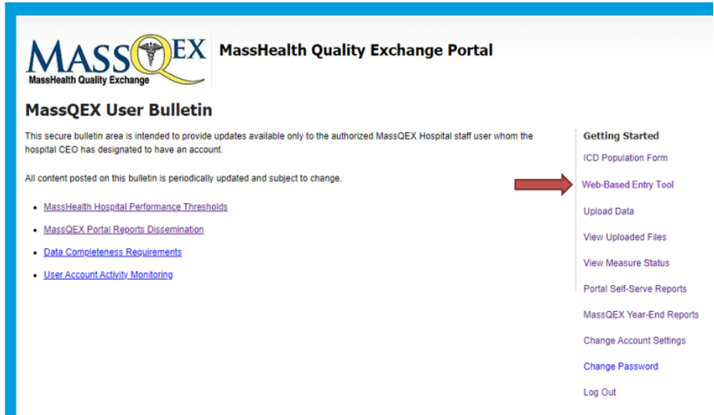

Figure 7. Web-Based Data Entry Tool – Aggregate Measures

This image is a screenshot, Figure 7. Several rows of information in image:
Aggregate Measures Data-Entry
Reporting Period: January 1, 2023-December 31, 2023
Measure / Initial Population / Num / Exclusions
OP-1e / 70 / 50 / 70 / 0
BHC-3 / 187 / 146 / 187 / 0
Below there are buttons titled "Print Report", "Save", and "Submit".

**D1-B. Aggregate Measure Data-Entry Measure Accuracy and Completeness**

Hospitals will report the same initial population, numerator, denominator and exclusions data that they report to CMS IQR for the OP-1e measure, and the same initial population, numerator, denominator and exclusion data they report to CMS IPFQR for the BHC-3 measure (if applicable). Hospitals must attest that the data submitted for these measures is the same data they have submitted to CMS. There will be an attestation box following aggregate data-entry. Hospitals must enter a response to the attestation box to complete submission.

Authorized MassQEX hospital user staff who will submit responses via the portal must coordinate with their hospital staff to complete the aggregate data-entry. Hospitals are responsible for confirming the accuracy and completeness of responses prior to submitting the form.

For more information on the aggregate web-based data-entry measure specifications, see Section 7.A and 7.B of this manual.

**2) Perinatal Morbidity Structural Measure Web-Based Data-Entry (PMSM-1)**

All hospitals must complete and submit the PMSM-1 survey using the instructions that follow.

1. **Web-Based Data Entry Tool:** Each hospital must enter the PMSM-1 survey item responses using the EOHHS approved web-based data entry tool located in the MassQEX secure portal.Hospitals that do not provide inpatient labor and delivery care must enter the “N/A” response to items 1 to 4 only to comply with Acute RFA required reporting. Measures required to be reported using the web-based data entry format cannot be submitted via paper format, an XML file or other electronic format.
2. **MassQEX Portal Users**: The authorized MassQEX hospital staff users are the individuals that shall access the PMSM-1 web-based entry tool to submit the completed attestation form.
3. **Hospital Entry Preview:** The MassQEX portal allows authorized users to store and print a draft of their item responses for review with their hospital Labor and Delivery Unit staff. Hospitals should allow ample time to review and correct their responses in the web-based entry tool prior to and until the annual PMSM-1 submission deadline. Hospitals cannot change their responses after the MassQEX portal deadline closes.
4. **Annual Submission Due Date:** The PMSM-1 measure survey is due annually on the third quarter of each calendar year reporting cycle date noted on Table 1.2 (Section 1) in this EOHHS manual. The open period for the CY2023 performance period PMSM-1 web-based data entry will be December 11, 2023 to February 09, 2024.

For more information on the PMSM-1 web-based data-entry survey measure specifications, see Section 7.C of this manual.

## User Accounts Registration

The EOHHS Contractor (Telligen) will establish and manage all aspects of MassQEX portal user accounts system for hospitals participating in the MassHealth CQI Program in accordance with EOHHS Medicaid Acute Hospital RFA contract requirements. This includes validating each user registration form and monitoring MassQEX user activity. Steps to register a new user are as follows.

1. **Opening an Account:** All hospitals must set up user accounts to access the secure web portal using the on-line registration form.Each hospital must identify the individual users that will be authorized to submit and conduct all data transactions on the hospital’s behalf. The users can be individuals from hospital staff and/or hospital third-party vendors.
2. **Account Limits:** EOHHS sets a maximum limit of user accounts that the hospital can identify as the registered user.

* The hospital can identify a maximum of five (5) accounts for hospital staff users and a maximum of three accounts for hospital third-party data vendors.
* All designated individuals must be identified on the MassHealth Hospital Quality Contact Form submitted to EOHHS each rate year.
* Newly identified users must complete user registration requirements described in this section to gain access to the secure web portal.

3) **Completing User Registration Forms**: The new user must complete a registration form, then sign and date it in the presence of a notary public, who will issue the notary’s stamp and seal on page 1 of the form. The hospital chief executive officer (CEO)must sign the notarized form to authorize the individual designated to be the registered user for that hospital site.

**Note to Vendors:** A vendor user registers only once and receives one account that allows access to all hospitals represented by the vendor. A copy of each vendor user registration form (notarized page 1 and page 2) must be submitted to the hospital CEO for signature for each hospital represented.

Email and Mailing User Registration Form. Originals of the completed notarized registration forms must be mailed and emailed to the following EOHHS Contractor address listed for the account to be activated.

**Email**: [massqexhelp@telligen.com](mailto:massqexhelp@telligen.com)

**Mail:**

Telligen, Inc.

Attention: MassHealth Quality Exchange (MassQEX)

800 South Street (Suite 170)

Waltham, MA, 02453

**4) Logging into the System**. the portal provides instructions for setting up a password and is equipped with a ‘forgot my password’ option that will have the following functionality:

* A temporary password, valid for one time use, will be transmitted to the user’s registered email account after successfully answering three randomly selected security questions.
* The temporary password will expire if it is not used within four hours.
* Upon logging into the system, the user will be required to choose a new password.

**5)** Maintaining User Accounts: Hospitals designate authorized Users to transmit data, which contains protected health information, in accordance with HIPAA standards. All hospitals are required to actively monitor and maintain their secure portal User accounts during each Acute RFA contract rate year, including when any changes to hospital staff or vendors occur. The EOHHS Contractor (MassQEX) monitors all user account activity as follows:

1. **Inactive Accounts-** defined as a user account that has not been logged into by the hospital or data vendor registered user over an extended period of time (90 days). The MassQEX portal sends weekly email the month before the 90 day expiration date stating that no user activity has been detected for 60 days and that the account must be logged into within 30 days or it will be closed. Upon the 90 day deadline, if no activity is detected account will be closed. The user must restart a new MassQEX registration using the preceding instructions.
2. **Disabled Accounts-** defined as a user account that is locked during attempted log-in with an incorrect password. An email is generated from the MassQEX Portal to the user alerting them the account has been disabled, the registered user must contact the MassQEX Help Desk to reset the account.
3. **Unusual Account Activity-** defined as an account where the hospital CEO authorized users have gained access of their user ID and password to any individuals other than the one authorized by the hospital CEO in their registration form. This type of activity is immediately reported to EOHHS and the account is automatically disabled and suspended.

## Customer Support

**1)** EOHHS MassHealth provides technical support for all registered portal users. The MassQEX Contractor is available to work with hospital staff and third-party data vendors to assist in the implementation of technical data collection and transmittal procedures outlined in this manual.

**MassQEX Helpdesk** *–* the customer support contact information follows.

* **Phone**: The toll free number is (844) 546-1343. This line is answered by a live person who will request a description of inquiry and initiate a help desk ticket. The inquiry is triaged to a clinical or technical staff. A response is sent via email or a call is returned
* **Helpdesk Email:** [massqexhelp@telligen.com](mailto:massqexhelp@telligen.com) All inquiries will initiate a help desk ticket.
* **Business Hours**: 8:00 a.m. – 5:00 p.m. (Eastern Time). Business hours are Monday to Friday. Inquiries are addressed within one business day.

**2) MassQEX List-Serve.** MassQEX operates an auto-notification feature for individuals that have created users-accounts and are authorized to conduct data transactions on behalf of the hospital. The list-serve provides information updates on portal system functionality enhancements, updates to measure specifications, status of portal production timelines, posting of updated content in secure bulletins and other program related activities. Individuals not authorized as portal users may also register for the list-serve by sending a request to the MassQEX Help Desk at: [massqexhelp@telligen.com](mailto:massqexhelp@telligen.com)

**3) Hospital Third-party Data Vendors.** Hospitals can identify and authorize third-party vendors to conduct electronic data transactions via the MassQEX secure portal, on the hospital’s behalf.

The Medicaid Acute RFA contract stipulates that hospitals are responsible for communicating directly with their data vendors on all aspects of MassHealth hospital data collection and reporting requirements, including adherence to the appropriate versions of the EOHHS Technical Specifications Manual. This is to ensure data completeness and accuracy of electronic data files are submitted on the hospital’s behalf. Section 3 of this EOHHS manual contains instruction that requires collaboration among the hospital and their data vendors to successfully meet data submission requirements and verifying data completeness status during each submission cycle.

Hospitals should note that data vendors who submit electronic data files on their behalf can ***only*** access certain types of portal repository reports (Input file reports) but not the “Measure Counts” and “ICD population vs. Collapsed Upload Counts” reports which are hospital user-initiated ***only*** via the portal. For this reason, it is recommended that hospitals review all portal repository reports with their data vendors toidentify errors, warnings or inconsistencies that can be corrected before the close of each submission cycle. The MassQEX Helpdesk is available to assist hospitals and data vendors in interpreting the self-serve reports generated by the portal.

## Extraordinary Circumstance Exception

Each rate year the Acute Hospital RFA contract outlines quality data reporting requirements all hospitals must meet to be eligible for incentive payments under the MassHealth Hospital Quality Program. EOHHS acknowledges that extraordinary circumstances can arise during the rate year which may impede the hospitals’ ability to meet quality reporting deadlines in Section 7.6 of Acute RFA. The conditions and procedures that apply to submitting quality reporting data exceptions follow.

1. **Provision for Data Exceptions.** A hospital can request an exception to Acute RFA quality reporting deadlines when it has experienced circumstances that are beyond the control of the hospital facility, which may include but are not limited to, the following definitions:
2. Extraordinary Circumstance**:** a natural disaster, catastrophic event or act of nature (hurricane, tornado, floods, fires*,* etc.) that results in shut down of the hospital and/or data vendor facility operations thereby affecting the hospital’s ability to complete the work required to meet a quality reporting deadline. This type of circumstance does not preclude EOHHS from granting exceptions for other hospitals that may be affected across a specific state region or locale.
3. Unusual Circumstance**:** in the event that EOHHS agency and/or its Contractor (MassQEX) experience a problem with data collection systems (e.g.: building power outages, internet provider interruptions, phone service provider interruptions, etc.) that directly affects the hospital’s ability to submit data via the MassQEX portal or access customer helpdesk during an active quarter reporting submission cycle. Other unusual circumstances where meeting the quarterly reporting deadlines is beyond the control of the hospital may be considered (e.g.: newly enrolled Medicaid hospitals in current rate year, national public health emergency, etc.).
4. Non-Applicable Circumstances**:** quality reporting exceptionsdo not apply to a request for resubmission to correct data files that were incomplete or incorrectly submitted during a quarter reporting cycle after the portal has closed. Data exceptions do not apply to a request for resubmitting chart record data that were incomplete, after the quarter specific timelines noted in Section 6.A of the RY2023 Technical Specifications Manual for MassHealth Acute Hospital Quality Measures (Version 16.0). Data exceptions are not granted for issues related to aforementioned unusual circumstances definition or events such as burst water pipes, temporary electrical outages, hospital or data vendor staff turnover as these circumstances are manageable and within the control of the hospital. Lastly, data exceptions do not apply to calendar year quarter data cycles associated with prior Acute RFA contract rate year payment requirements.
5. **Provision for Data Extension.**  A hospital request for data extension to a specific quarter reporting deadline must meet the aforementioned extraordinary circumstances definition and timelines specified above and in 5.F4.b in the RY2023 Technical Specifications Manual for MassHealth Acute Hospital Quality Measures (Version 16.0). EOHHS considers various factors prior to granting a data extension that include, but are not limited to, the impact on current active open submission cycle and timely re-programming of portal technology specifications for prospective quarter reporting cycles.

Should EOHHS make a determination to change a published Acute RFA quality reporting deadline that affect all hospitals, then such decision will be communicated to hospital key quality contacts using standard methods (e.g.: EOHHS business email, memos, MassQEX list-serve, Mass.Gov website posting, etc.) including an Amendment to the Acute RFA rate year contract as applicable.

1. **Provision for Approved Exception**. Hospitals that are granted data exceptions for specific quarter reporting cycles must comply with the ICD population entry requirements outlined in Section 3.B of this EOHHS Manual. The hospital must enter zeros (0) to confirm that no data was reported using the online ICD entry form. Failure to enter zeros will result in non-compliant status. In addition, hospitals that are granted data exceptions should be aware that such exemptions can and likely will impact the criteria to be eligible for comparison year performance scoring and incentive payment incentives that apply to each Acute RFA rate year contract.
2. **EOHHS Request Procedure.** Hospitals must adhere to following procedures to request a data exception for EOHHS agency consideration specific to the Acute RFA contract period:
3. **MassHealth Extraordinary Circumstance Request (MHECR) Form:** The hospital must submit a written request using the “MHECR Form” with all the following required information:
4. *Type of Request -* specify the type of data exception (exemption vs. extension), the affected measures and quarter data periods indicated, reporting deadline, applicable chart records;
5. *Describe Circumstance –* explain the extraordinary circumstance and date of occurrence*;*
6. *Reason for Request –* why the quarter period data exception is needed, explain how the extraordinary event impeded the hospital not being able to meet reporting requirement*.*
7. *Supporting Documents* – include evidence of the event occurrence (e.g.: media articles, photos, relevant web links, etc.) that is required for EOHHS MassHealth agency review. Failure to attach supporting documents will delay the review process.

The updated “MHECR Form” must be downloaded from the Mass.Gov website at: <https://www.mass.gov/service-details/masshealth-acute-hospital-p4p-program-documents>.

1. **Timeline to Submit Request:** The hospital must notify EOHHS directly of intent to submit a request for a data exception within ten (10) calendar days of the date that the extraordinary circumstance event occurred. At the latest, the MHECR form packet must be received no later than 60 days from the last date of the quarter data period exception requested (e.g.: if last date of Q3 period is 9/30 then the request should be submitted no later than November 30).

Table 3-2: RY2023 Extraordinary Circumstance Request Timelines

| **Quarter Reporting Period** | **Acute RFA2023**  **Submission Deadlines** | **Hospital ECE Request Form Due Date** |
| --- | --- | --- |
| Q1-2023 (Jan 1, 2023 – Mar 31, 2023) | Aug 11, 2023 | *May 29, 2023* |
| Q2-2023 (April 1, 2023 - June 30, 2023) | Nov 10, 2023 | *Aug 25, 2023* |
| Q3-2023 (July 1, 2023 – Sept 30, 2023) | Feb 9, 2024 | *Nov 28, 2023* |
| Q4-2023 (Oct 1, 2023 – Dec 31, 2023) | May 10, 2024 | *Feb 28, 2024* |
| Q1-2024 (Jan 1. 2024 – Mar 31, 2024) | Aug. 09, 2024 (Est.) | *May 2024 (Est.)* |

1. **Submitting Your Request Packet:**  The original packet must include a typed cover letter on hospital stationery summarizing enclosures, the completed “MHECR Form” with hospital CEO signature plus supporting documentation submitted using the following methods:

* Postal Mail: Nicole Brault, EOHHS MassHealth Acute Hospital CQI Program 100 Hancock Street (6th floor) Quincy, MA 02171.
* Email: Hospitals can expedite their request by scanning a copy via the EOHHS business mailbox at: [Masshealthhospitalquality@mass.gov](mailto:Masshealthhospitalquality@mass.gov).

1. **EOHHS Notification Process:** EOHHS will confirm receipt of the hospitals request via email sent to the hospital key quality representative. The EOHHS final written decision on the request for data reporting exception will be mailed to the hospital CEO and key quality representative designee. *Non-adherence to terms of acceptance will NULLIFY the initial granted request*. Please contact EOHHS MassHealth at [Masshealthhospitalquality@mass.gov](mailto:Masshealthhospitalquality@mass.gov) if you have questions on how to submit the extraordinary circumstance exception request.

# Section 4. Chart-Abstracted Measures Specifications

Please refer to RY2023 Technical Specifications Manual for MassHealth Acute Hospital Quality Measures (Version 16.0), Section 5 for information on population sampling for MassHealth chart abstracted measures. For the RY2023 CQI Program (CY2023 performance period), the CCM, SUB-2, SUB-3, and MAT-4 measures will allow for sampling. **Note: the NEWB-3 measure will not allow for sampling.**

## Care Coordination and Integration of Care Domain

Care coordination is the deliberate organization of care delivery activities between providers, patients, and health system components designed to improve quality and efficiency of healthcare. Care coordination measures are intended to capture a broad cross-section of diagnoses and reasons for admissions that must include patients discharged from any hospital inpatient facility unit. Refer to the initial patient population algorithm for identification of the included population.

### 1. Reconciled Medication List Received by Discharge Patient (CCM-1)

**Description:** Percentage of patients discharged from an acute hospital inpatient facility to home or any other site of care, or their caregiver(s), who received a reconciled medication list at the time of discharge including, at a minimum, medications in the specified categories (continued, new, discontinued).

**Numerator statement:** Patients or their caregiver(s) who received a reconciled medication list at the time of discharge.

**Data Elements**:

* Reconciled Medication List

**Denominator statement**: Patients discharged from any unit of the acute hospital inpatient facility (e.g.: medical, surgical, rehab, psychiatric, obstetrics, etc.) to home/ self-care or any other site of care.

**Excluded population**:

* Patients less than 2 years
* Patients greater than or equal to 65 years of age
* Patients who died
* Patients who left against medical advice (AMA) or discontinued care

**Risk adjustment**: No

**Data Collection Approach**: Retrospective data sources for required data elements include administrative and medical records. See data abstraction tool (Appendix A-1)and data dictionary (Appendix A-8)of this manual for detailed instructions.

**Measure Type:** Process Measure

**Data Accuracy**: Variation may exist in documentation provided at the time of transition and documentation of transmission time; therefore, medical record documentation processes may require evaluation.

**Measure analysis suggestion**: Data could be analyzed further to determine specific patterns or trends.

**Sampling:** Yes. Refer to Section 4 in the RY2023 Technical Specifications Manual for MassHealth Acute Hospital Quality Measures (Version 16.0) for details on sample size requirements.

**Data reported as**: Aggregate rate generated from count data.

**Improvement noted as:** An increase in the rate

Please contact the MassQEX Help Desk at massqexhelp@telligen.com if you require assistance to interpret the content of the measure flowcharts in this section of the manual.

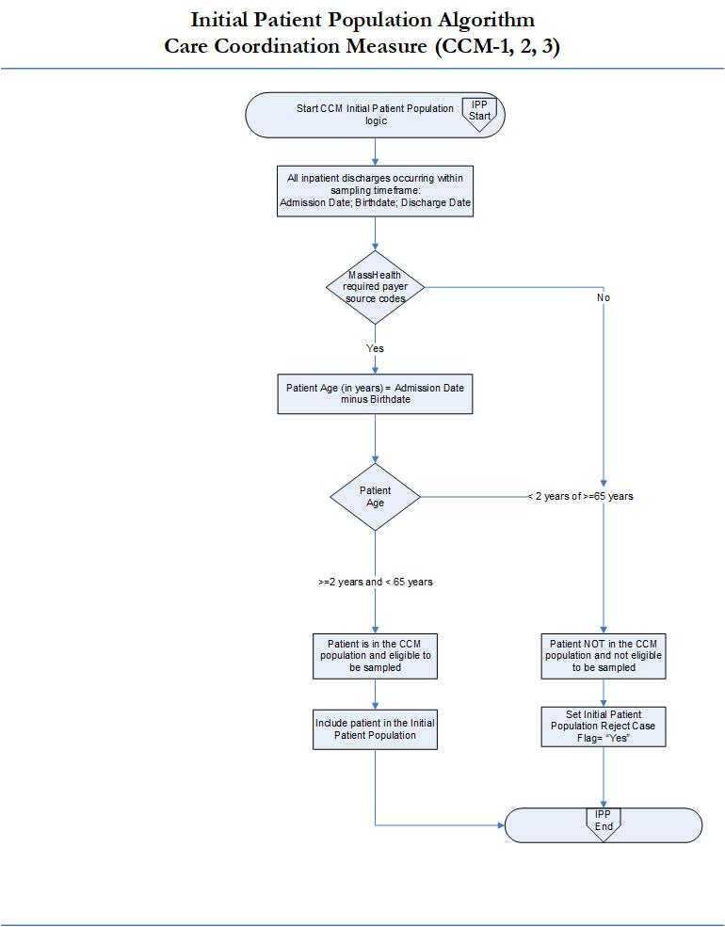

Please contact the MassQEX Help Desk at massqexhelp@telligen.com if you require assistance to interpret the content of the measure flowcharts in this section of the manual.

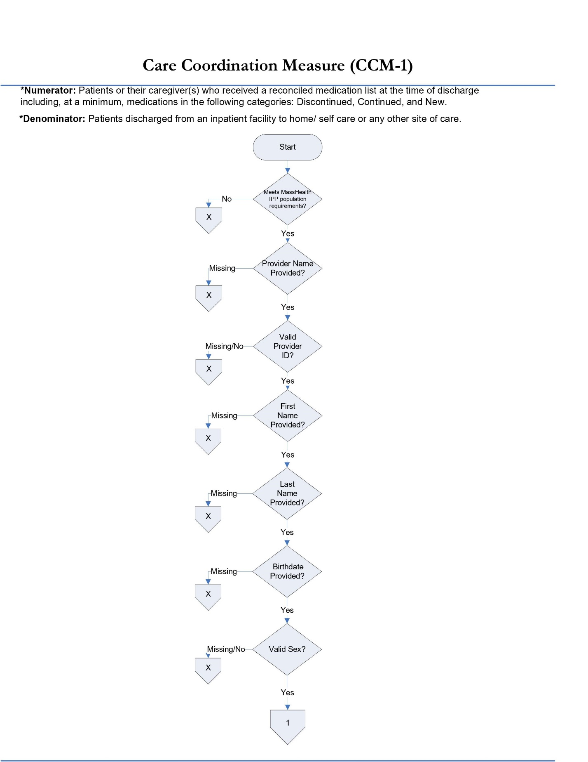

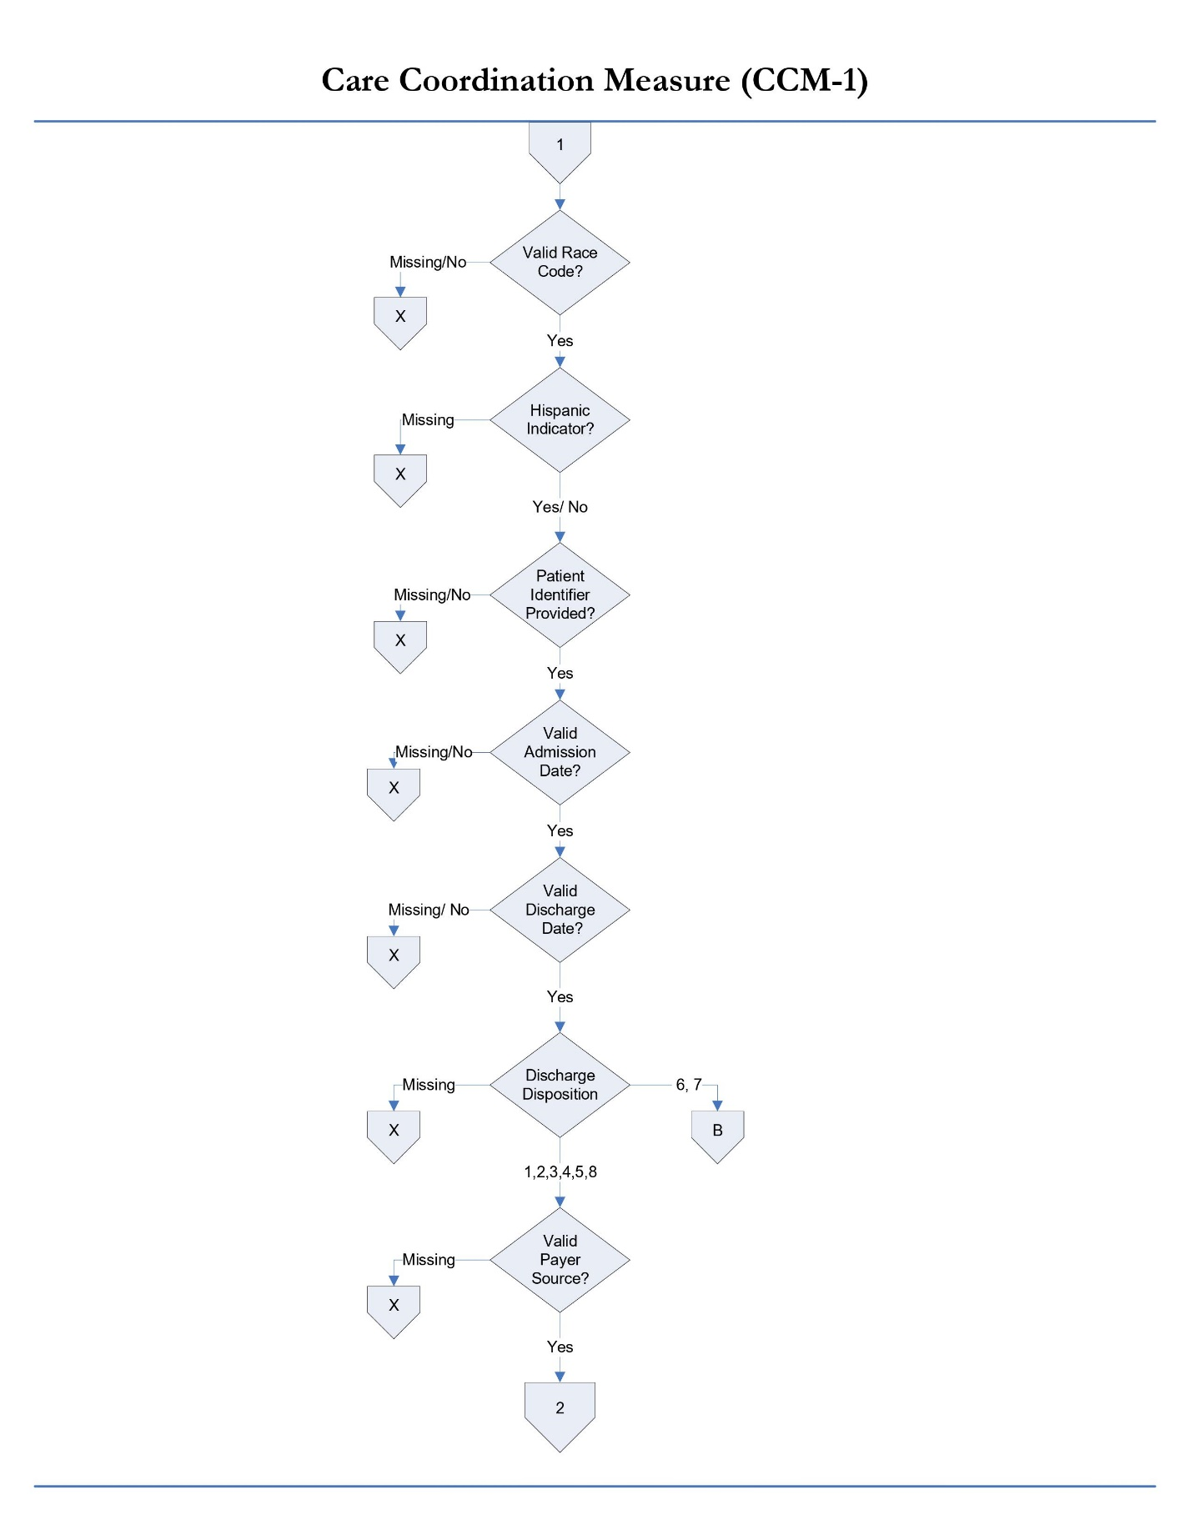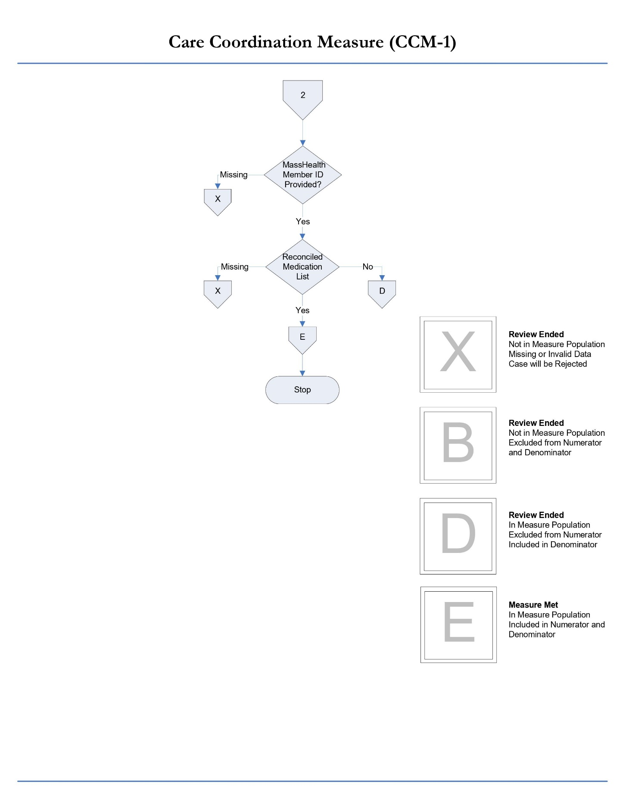

### 

### 2.Transition Record with Specified Elements Received by Discharge Patient (CCM-2)

**Description:** Percentage of patients discharged from an acute inpatient facility to home or any other site of care, or their caregiver(s), who received a transition record (and with whom a review of all included information was documented) at the time of discharge including all of the specified elements.

**Numerator statement:** Patients or their caregiver(s) who received a transition record (and with whom a review of all included information was documented) at the time of discharge including, at a minimum, *all* of the specified data elements.

**Data Elements**:

* Transition Record
* Reason for Inpatient Admission
* Medical Procedures and Tests Performed During Inpatient Stay and Summary of Results
* Discharge Diagnosis
* Current Medication List
* Studies Pending at Discharge
* Patient Instructions
* Advance Care Plan
* Contact Information 24 hrs./ 7 days
* Contact Information for Studies Pending
* Plan for Follow up care
* Primary Physician or Other Health Care Professional Designated for Follow up care

**Denominator statement**: Patients discharged from any unit of the acute hospital inpatient facility (e.g.: medical, surgical, rehab, psychiatric, obstetrics, etc.) to home/ self-care or any other site of care.

**Excluded population**:

* Patients less than 2 years
* Patients greater than or equal to 65 years of age
* Patients who died
* Patients who left against medical advice (AMA) or discontinued care

**Risk adjustment**: No

**Data Collection Approach**: See data abstraction tool (Appendix A-1)and data dictionary (Appendix A-8)of this manual for detailed instruction.

**Measure Type:** Process Measure

**Data accuracy**: Variation may exist in documentation provided at the time of transition and transmission time; therefore, medical record documentation processes may require evaluation.

**Measure analysis suggestion**: Review specific patterns or trends for missing data elements.

**Sampling:** Yes. Refer to Section 4 in the RY2023 Technical Specifications Manual for MassHealth Acute Hospital Quality Measures (Version 16.0) for details on sample size requirements.

**Data reported as**: Refer to the measure calculation rules Appendix-7 in this manual that apply to this measure.

**Improvement noted as:** An increase in the rate.

Please contact the MassQEX Help Desk at massqexhelp@telligen.com if you require assistance to interpret the content of the measure flowcharts in this section of the manual.

This image is of a flow chart, the same one as above on page 31. As reminder:
The title of this flow chart is "Initial patient Population Algorithm: Care Coordination Measure (CCM-1, 2, 3)". Below this title, there is a box stating "Start CCM Initial Patient Population Logic (IPP Start)". This box then leads directly to a box which reads "All inpatient discharges occurring within sampling timeframe: Admission; Birthdate; Discharge Date". This box then leads directly to a box which reads "MassHealth required payer source codes". From here, there is a branch. If Yes, one is directed through a box reading "Patient Age (in years) = Admission Date minus Birthdate" to a box reading "Patient Age". Now there is a second branch, one path reading "Greater than or equal to 2 years and less than 65 years" and the other reading "Less than 2 years or greater than or equal to 65 years". If greater than or equal to 2 years and less than 65 years, one is directed through three boxes, reading: "Patient is in the CCM population and eligible to be sampled", then "Include patient in the Initial Patient Population", and finishing with "IPP End". Going back up the flow chart, if one were to answer "No" to the box stating "MassHealth required payer source codes", then they would be directed straight to "Less than 2 years or greater than or equal to 65 years", then to three final boxes: "Patient NOT in the CCM population and not eligible to be sampled", then "Set Initial Patient Population Reject Case Flag='Yes'", then finishing with "IPP End". These final three boxes would be the same if one were to answer "Yes" to "MassHealth required payer source code" and "Less than 2 years or greater than or equal to 65 years" to "Patient Age".

Please contact the MassQEX Help Desk at massqexhelp@telligen.com if you require assistance to interpret the content of the measure flowcharts in this section of the manual.

This image is the first page of a five-page flow chart. The title of this flow chart is: "Care Coordination Measure (CCM-2)".
Note: Numerator is patients or their caregiver(s) who received a written transition record at the time of discharge.
Denominator is patients discharged from an inpatient facility to home/self care or any other site of care.
The flow chart begins with "Meets MassHealth IPP population requirements?" If no, then to "Review Ended: Not in Measure Population; Missing or Invalid Data; Case will be Rejected". If yes, then to "Provider Name Provided?" If Missing, then to "Review Ended: Not in Measure Population; Missing or Invalid Data; Case will be Rejected". If Yes, then to "Valid Provider ID?" If Missing or Not, then to "Review Ended: Not in Measure Population; Missing or Invalid Data; Case will be Rejected". If Yes, then to "First Name provided?" If Missing, then to "Review Ended: Not in Measure Population; Missing or Invalid Data; Case will be Rejected". If Yes, then to "Last Name Provided?" If Missing, then to "Review Ended: Not in Measure Population; Missing or Invalid Data; Case will be Rejected". If Yes, then to "Birthdate Provided?" If Missing, then to "Review Ended: Not in Measure Population; Missing or Invalid Data; Case will be Rejected". If Yes, then to "Valid Sex?" If Missing or No, then to "Review Ended: Not in Measure Population; Missing or Invalid Data; Case will be Rejected". If Yes, then to a box solely containing the number "1". This is the end of the first page of this five-page flow chart.

This image is the second page of a five-page flow chart. The title of this flow chart is: "Care Coordination Measure (CCM-2)".
Beginning with a box simply stating the number "1", then move down to a box reading "Valid Race Code?" If Missing or No, then to "Review Ended: Not in Measure Population; Missing or Invalid Data; Case will be Rejected". If Yes, then to "Hispanic Indicator?" If Missing, then to "Review Ended: Not in Measure Population; Missing or Invalid Data; Case will be Rejected". If Yes or No, then to "Patient Identifier Provided?" If Missing or No, then to "Review Ended: Not in Measure Population; Missing or Invalid Data; Case will be Rejected". If Yes, then to "Valid Admission Date. If No, then to "Review Ended: Not in Measure Population; Missing or Invalid Data; Case will be Rejected". If Yes, then to "Valid Discharge Date?" If Missing or No, then to "Review Ended: Not in Measure Population; Missing or Invalid Data; Case will be Rejected". If Discharge Disposition". If Missing, then to "Review Ended: Not in Measure Population; Missing or Invalid Data; Case will be Rejected". If 6 or 7, then to "Review Ended: Not in Measure Population; Excluded from Numerator and Denominator". If 1, 2, 3, 4, 5, or 8, then to "Valid Payer Source?" If Missing or No, then to "Review Ended: Not in Measure Population; Missing or Invalid Data; Case will be Rejected". If Yes, then to "Member ID Provided?" If Missing, then to "Review Ended: Not in Measure Population; Missing or Invalid Data; Case will be Rejected". If Yes, then to a box solely reading the number "2". This is the end of the second page of this five-page flow chart.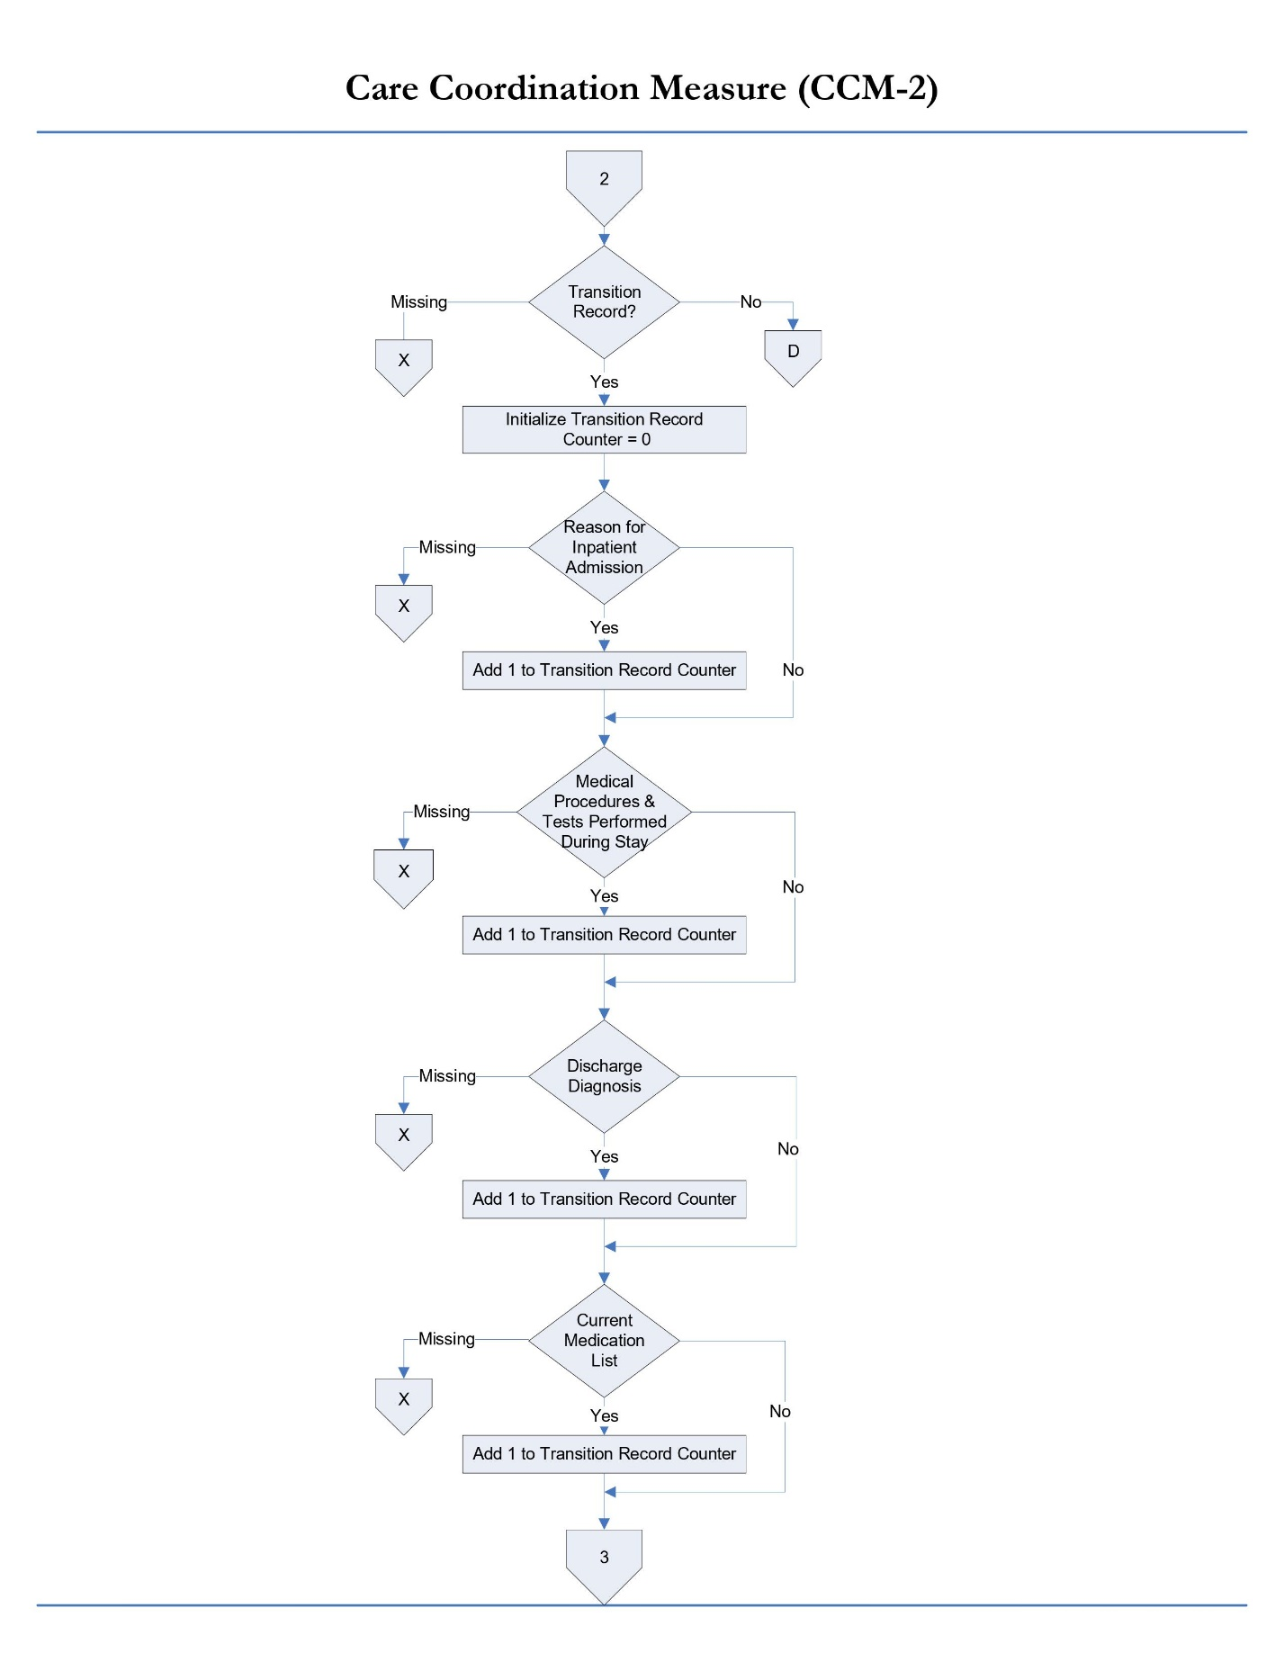

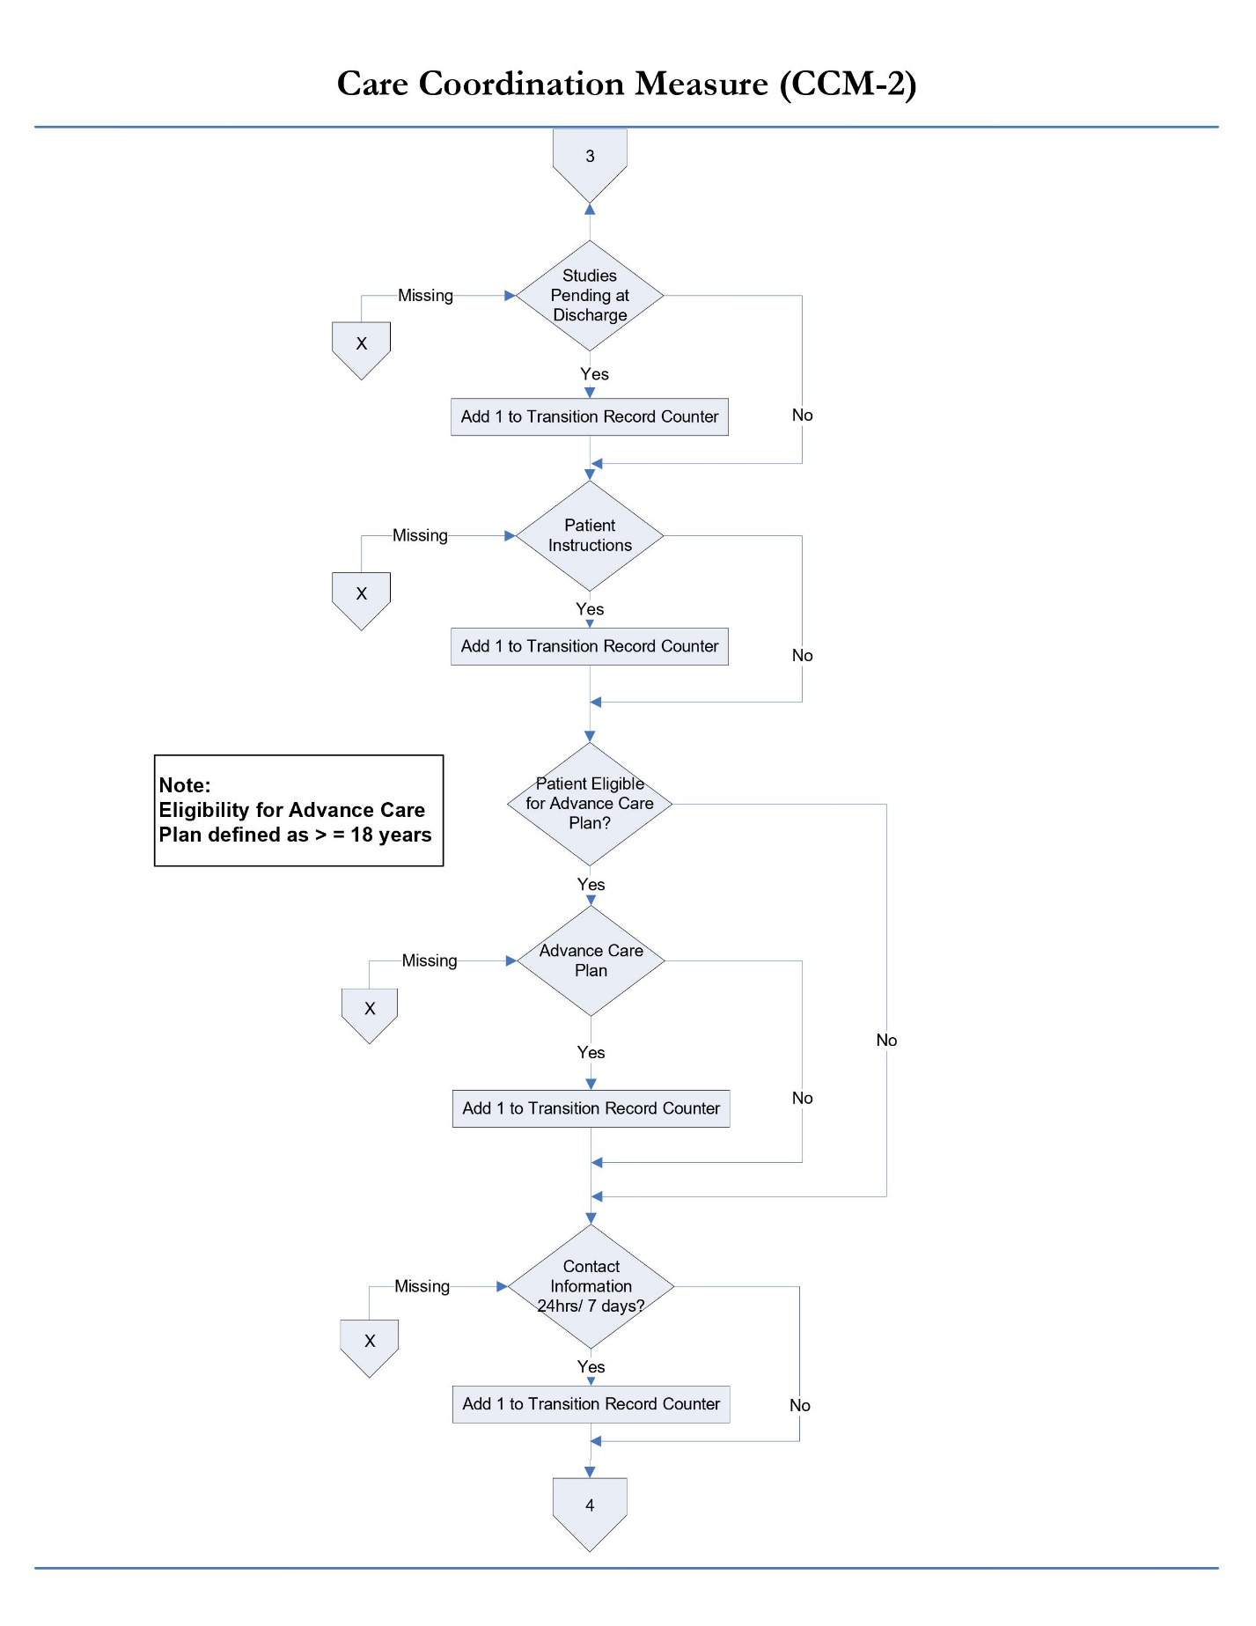

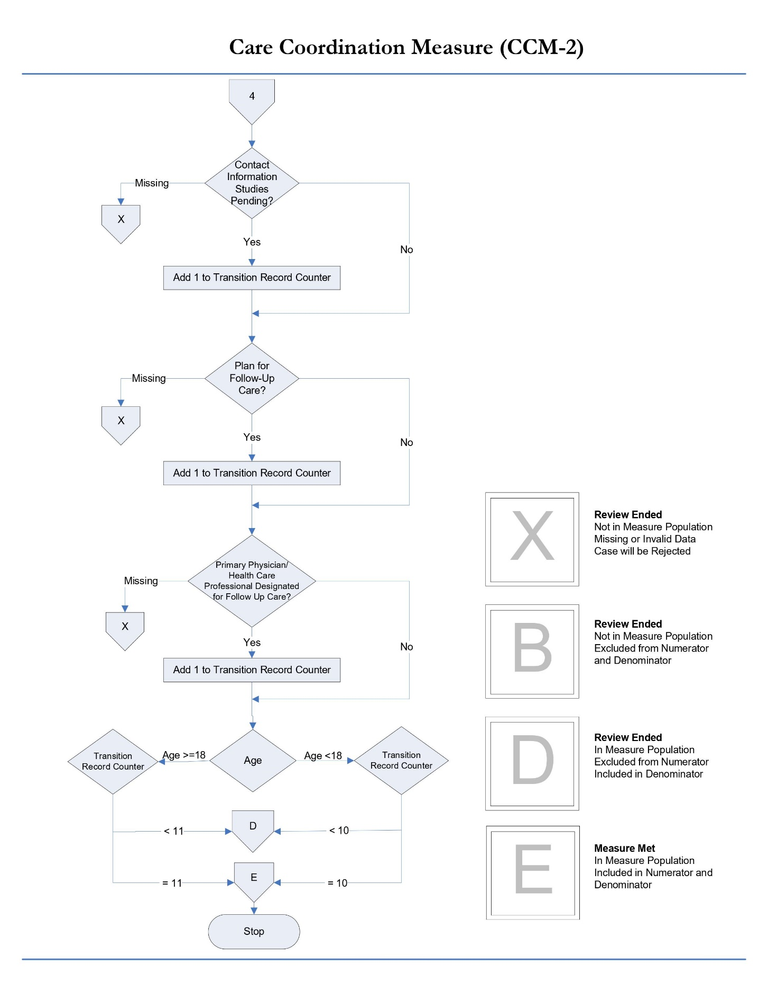

### 

### 3. Timely Transmittal of Transition Record (CCM-3)

**Description:** Percentage of patients discharged from an acute hospital inpatient facility to home or any other site of care for whom a transition record was transmitted to the facility or primary physician or other health care professional designated for follow-up care within 2 days of discharge.

**Numerator statement:** Patients for whom a transition record was transmitted to the facility or primary physician or other health care professional designated for follow-up within 2 days of discharge.

**Data Elements**:

* Discharge Date
* Transmission Date
* Patient Refusal of Transmission

**Denominator statement**: Patients discharged from any unit of the acute hospital inpatient facility (e.g.: medical, surgical, rehab, psychiatric, obstetrics, etc.) to home/ self-care or any other site of care.

**Excluded population**:

* Patients less than 2 years
* Patients greater than or equal to 65 years of age
* Patients who died
* Patients who left against medical advice (AMA) or discontinued care
* Patients who refused transmission of transition record

**Risk adjustment**: No

**Data Collection Approach**: Retrospective data sources for required data elements include administrative and medical records. Refer to data abstraction tool in Appendix A-1 and data dictionary in Appendix A-8 of this manual for detailed instructions.

**Measure Type:** Process Measure

**Data accuracy**: Variation may exist in documentation provided at the time of transition; therefore, medical record documentation processes may require evaluation.

**Measure analysis suggestion**: Data could be analyzed further to determine specific patterns or trends.

**Sampling:** Yes. Refer to Section 4 in the RY2023 Technical Specifications Manual for MassHealth Acute Hospital Quality Measures (Version 16.0) for details on sample size requirements.

**Data reported as**: Aggregate rate generated from count data.

**Improvement noted as:** An increase in the rate.

Please contact the MassQEX Help Desk at massqexhelp@telligen.com if you require assistance to interpret the content of the measure flowcharts in this section of the manual.

This image is of a flow chart, the same one as above on page 31. As reminder:
The title of this flow chart is "Initial patient Population Algorithm: Care Coordination Measure (CCM-1, 2, 3)". Below this title, there is a box stating "Start CCM Initial Patient Population Logic (IPP Start)". This box then leads directly to a box which reads "All inpatient discharges occurring within sampling timeframe: Admission; Birthdate; Discharge Date". This box then leads directly to a box which reads "MassHealth required payer source codes". From here, there is a branch. If Yes, one is directed through a box reading "Patient Age (in years) = Admission Date minus Birthdate" to a box reading "Patient Age". Now there is a second branch, one path reading "Greater than or equal to 2 years and less than 65 years" and the other reading "Less than 2 years or greater than or equal to 65 years". If greater than or equal to 2 years and less than 65 years, one is directed through three boxes, reading: "Patient is in the CCM population and eligible to be sampled", then "Include patient in the Initial Patient Population", and finishing with "IPP End". Going back up the flow chart, if one were to answer "No" to the box stating "MassHealth required payer source codes", then they would be directed straight to "Less than 2 years or greater than or equal to 65 years", then to three final boxes: "Patient NOT in the CCM population and not eligible to be sampled", then "Set Initial Patient Population Reject Case Flag='Yes'", then finishing with "IPP End". These final three boxes would be the same if one were to answer "Yes" to "MassHealth required payer source code" and "Less than 2 years or greater than or equal to 65 years" to "Patient Age".

Please contact the MassQEX Help Desk at massqexhelp@telligen.com if you require assistance to interpret the content of the measure flowcharts in this section of the manual.

This image is the first page of a three-page flow chart. The title of this flow chart is: "Care Coordination Measure (CCM-3)".
Note: Numerator is patients for whom a written transition record was transmitted to the facility or primary physician or other health care professional designated for follow up care within 2 days of discharge.
Denominator is patients discharged from an inpatient facility to home/ self care or any other site of care.
The flow chart begins with "Meets MassHealth IPP Population Requirements?" If No, then to "Review Ended: Not in Measure Population; Missing or Invalid Data; Case will be Rejected". If Yes, then to "Provider Name Provided?" If Missing, then to "Review Ended: Not in Measure Population; Missing or Invalid Data; Case will be Rejected". If Yes, then to "Valid Provider ID?" If Missing or No, then to "Review Ended: Not in Measure Population; Missing or Invalid Data; Case will be Rejected". If Yes, then to "First Name Provided?" If Missing, then to "Review Ended: Not in Measure Population; Missing or Invalid Data; Case will be Rejected". If Yes, then to "Last Name Provided?" If Missing, then to "Review Ended: Not in Measure Population; Missing or Invalid Data; Case will be Rejected". If Yes, then to "Birthdate Provided?" If Missing, then to "Review Ended: Not in Measure Population; Missing or Invalid Data; Case will be Rejected". If Yes, then to "Valid Sex?" If Missing or No, then to "Review Ended: Not in Measure Population; Missing or Invalid Data; Case will be Rejected". If Yes, then move to the next page of this flow chart.

This image is the second page of a three-page flow chart. The title of this flow chart is: "Care Coordination Measure (CCM-3)".
From previous page of this flow chart: If Yes for "Valid Sex?", then to "Valid Race Code?" If Missing or No, then to "Review Ended: Not in Measure Population; Missing or Invalid Data; Case will be Rejected". If Yes, then to "Hispanic Indicator?" If Missing, then to "Review Ended: Not in Measure Population; Missing or Invalid Data; Case will be Rejected". If Yes or No, then to "Patient Identifier Provided?" If Missing or No, then to "Review Ended: Not in Measure Population; Missing or Invalid Data; Case will be Rejected". If Yes, then to "Valid Admission Date?" If Missing or No, then to "Review Ended: Not in Measure Population; Missing or Invalid Data; Case will be Rejected". If Yes, then to 'Valid Discharge Date?" If Missing or No, then to "Review Ended: Not in Measure Population; Missing or Invalid Data; Case will be Rejected". If Yes, then to "Discharge Disposition". If Missing, then to "Review Ended: Not in Measure Population; Missing or Invalid Data; Case will be Rejected". If 6 or 7, then to "Review Ended: Not in Measure Population; Excluded from Numerator and Denominator". If Discharge Disposition is 1, 2, 3, 4, 5, or 8, then to "Valid Payer Source?" If Missing or No, then to "Review Ended: Not in Measure Population; Missing or Invalid Data; Case will be Rejected". If Yes, then move to third and final page of this flow chart.This image is the second page of a three-page flow chart. The title of this flow chart is: "Care Coordination Measure (CCM-3)".
From previous page of this flow chart: If there is a "Valid Payer Source", then on to "MassHealth Member ID Provided?"  If Missing, then on to "Review Ended: Not in Measure Population; Missing or Invalid Data; Case will be Rejected". If Yes, then on to "Patient Refusal". If Missing, then on to  "Review Ended: Not in Measure Population; Missing or Invalid Data; Case will be Rejected". If Yes, then on to "Review Ended: Not in Measure Population; Excluded from Numerator and Denominator". If No, then on to "Valid Transmission Date?" If Missing or No, then on to  "Review Ended: Not in Measure Population; Missing or Invalid Data; Case will be Rejected". If UTD, then on to "Review Ended: In Measure Population; Excluded from Numerator; Included in Denominator". If Yes, then on to "Transmission was within specified timeframe?" If No, then to "Review Ended: In Measure Population; Excluded from Numerator; Included in Denominator". If Yes, then on to "Measure Met: In Measure Population; Included in Numerator and Denominator". 
Final Note for this flow chart: If the Transition Record was transmitted within 2 days of the discharge date, the case will be assigned to "Measure Met: In Measure Population; Included in Numerator and Denominator".
With this, third and final page of this flow chart is finished.

## Care for Acute and Chronic Conditions Domain

For MassHealth reporting purposes, the “Initial Patient Population” (also termed ICD population) for the Alcohol Use treatment measures shall include all Medicaid patients discharged from any acute inpatient care setting (medical, surgical, obstetrical, rehab, psychiatric, etc.) that received care for a given condition. Measure collection is required for all acute care hospitals with or without a behavioral health unit.

### 1. Alcohol Use Brief Intervention Provided or Offered (SUB-2)

**Measure Name:** Alcohol Use Brief Intervention Provided or Offered

**Description:** This measure is reported as an overall rate which includes all patients to whom a brief intervention was provided or offered and refused. The SUB-2 rate describes the patients who screened positive for unhealthy alcohol use who received or refused a brief intervention during the hospital stay.

**Numerator Statement:** Patients who received or refused a brief intervention.

**Included in Population**: Patients who refuse/decline the offered brief intervention

**Excluded Population**: None

**Data Elements**:

* *Brief Intervention*

**Denominator Statement:** The number of hospitalized inpatients 18 years of age and older who screened positive for unhealthy alcohol use or an alcohol use disorder (alcohol abuse or alcohol dependence).

**Included Population:** Not applicable

**Excluded Population**

* Patients less than 18 years of age
* Patients who are cognitively impaired
* Patients who refused screening for Alcohol Use status during the hospital stay
* Patients who have a duration of stay less than or equal to one day or greater than 120 days
* Patients receiving *Comfort Measures Only* documented

**Data Elements**:

* *Admission Date*
* *Alcohol Use Status*
* *Birthdate*
* *Comfort Measures Only*
* *Discharge Date*

**Risk Adjustment**: No.

**Data Collection Approach**: See data abstraction tool (Appendix A-2) and data dictionary (Appendix A-8) of this manual for detailed instruction.

**Type of Measure:** Process

**Data Accuracy**: See TJC Core Specifications Manual for applicable discharge period for detail that apply.

**Measure Analysis Suggestions**: None

**Sampling:** Yes. Refer to Section 4 in the RY2023 Technical Specifications Manual for MassHealth Acute Hospital Quality Measures (Version 16.0) for details on sample size requirements.

**Data Reported As**: Aggregate rate generated from count data reported.

**Improvement Noted as:** Increase in rate.

Please contact the MassQEX Help Desk at massqexhelp@telligen.com if you require assistance to interpret the content of the measure flowcharts in this section of the manual.

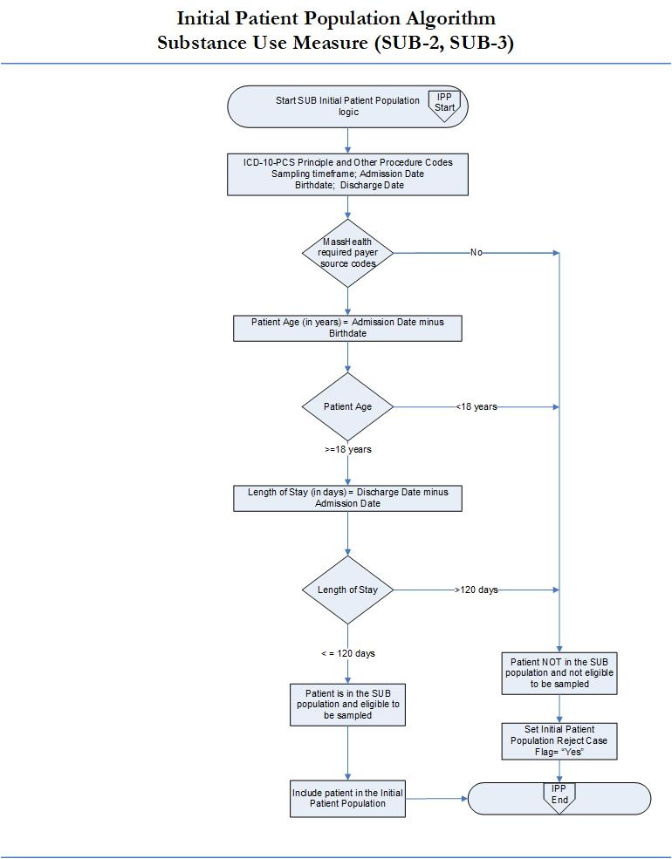

Please contact the MassQEX Help Desk at massqexhelp@telligen.com if you require assistance to interpret the content of the measure flowcharts in this section of the manual.

This image is the first page of a three-page flow chart titled "Alcohol Use-Brief Intervention Provided or Offered (SUB-2)". Note: Numerator is the number of patients who received or refused a brief intervention. And Denominator is the number of hospitalized patients 18 years of age or older who screen positive for unhealthy alcohol use or an alcohol use disorder (alcohol abuse or alcohol dependence).
The flow chart begins with "Meets MassHealth IPP Population Requirements?" If No, then to "Review Ended: Not in Measure Population; Missing or Invalid Data; Case will be Rejected". If Yes, then to "Provider Name Provided?" If Missing, then to "Review Ended: Not in Measure Population; Missing or Invalid Data; Case will be Rejected". If Yes, then to "Valid Provider ID?" If Missing or No, then to "Review Ended: Not in Measure Population; Missing or Invalid Data; Case will be Rejected". If Yes, then to "First Name Provided?" If Missing, then to "Review Ended: Not in Measure Population; Missing or Invalid Data; Case will be Rejected". If Yes, then to "Last Name Provided?" If Missing, then to "Review Ended: Not in Measure Population; Missing or Invalid Data; Case will be Rejected". If Yes, then to "Birthdate Provided?" If Missing, then to "Review Ended: Not in Measure Population; Missing or Invalid Data; Case will be Rejected". If Yes, then to "Valid Sex?" If Missing or No, then to "Review Ended: Not in Measure Population; Missing or Invalid Data; Case will be Rejected". If Yes, then move to the next page of this flow chart.

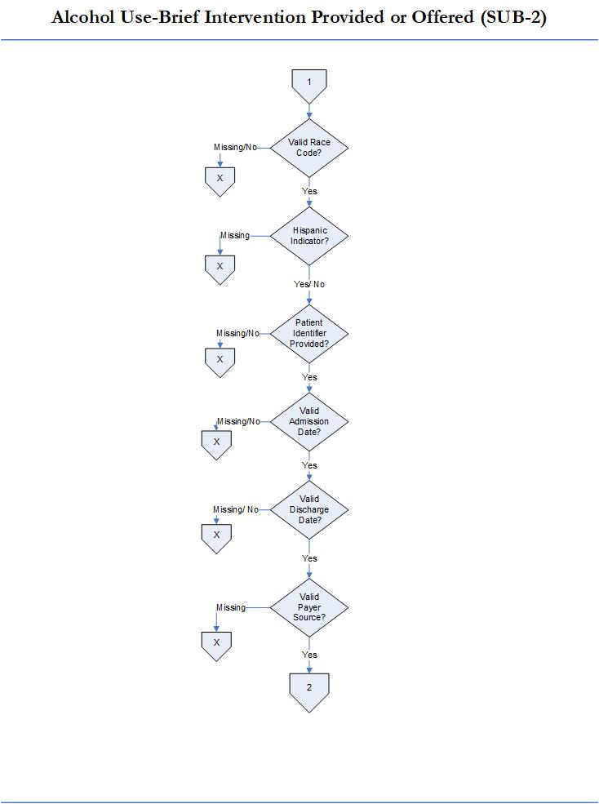

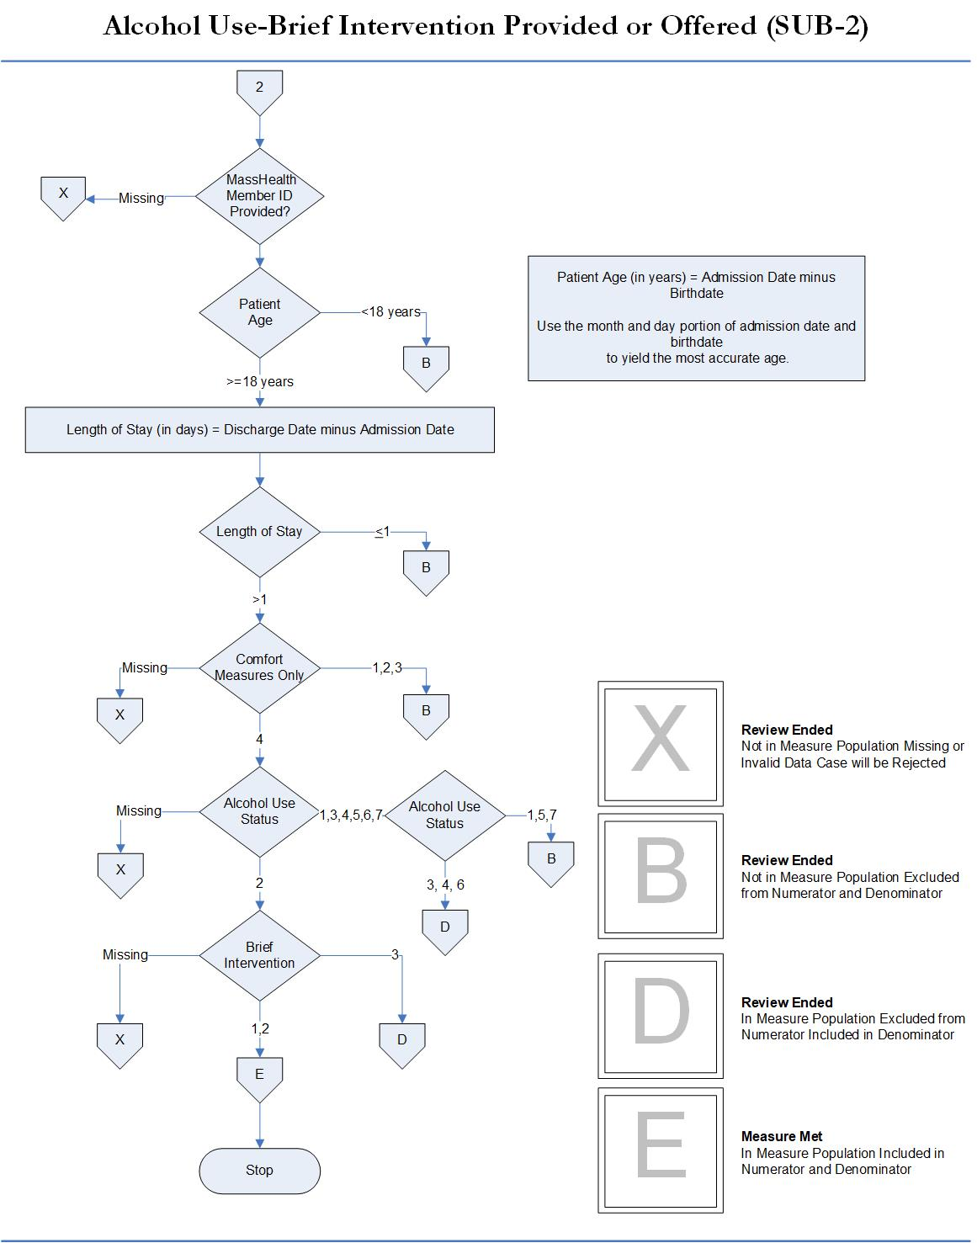

### 2. Alcohol & Other Drug Use Disorder Treatment Provided or Offered at Discharge (SUB-3)

**Measure Name:** Alcohol & Other Drug Use Disorder Treatment Provided or Offered at Discharge

**Description:** The measure is reported as an overall rate which includes all patients to whom alcohol or drug use disorder treatment was provided, or offered and refused, at the time of hospital discharge.

**Numerator Statement** - The number of patients who received or refused at discharge a prescription for medication for treatment of alcohol or drug use disorder OR received or refused a referral for addictions treatment.

**Included Populations:** Patients who refused a prescription for FDA-approved medication for treatment of an alcohol or drug dependence. Patients who refused a referral for addictions treatment.

**Excluded Populations:** None

**Data Elements**:

* *Prescription for Alcohol or Drug Disorder Medication*
* *Referral for Addictions Treatment*

**Denominator Statement** - The number of hospitalized inpatients 18 years of age and older identified with an alcohol or drug use disorder.

**Included Population**

* Patients with ICD-10-CM Principal or Other Diagnosis Code for alcohol or drug use disorder listed on Table 13.1 and 13.2 of the Specifications Manual for Joint Commission National Core Measures
* Patients with a Principal or Other ICD-10-PCS Procedure Code listed on Table 13.3 of the Specifications Manual for Joint Commission National Core Measures

**Excluded Population**

* Patients less than 18 years of age
* Patient drinking at unhealthy levels who do not meet criteria for an alcohol use disorder
* Patients who are cognitively impaired
* Patients who expire
* Patients discharged to another hospital
* Patients who left against medical advice
* Patients discharged to another healthcare facility
* Patients discharged to home or another healthcare facility for hospice care
* Patients who have a duration of stay less than or equal to one day or greater than 120 days
* Patients who do not reside in the United States
* Patients receiving *Comfort Measures Only* documented

**Data Elements**:

* *Admission Date*
* *Alcohol Use Status*
* *Birthdate*
* *Comfort Measures Only*
* *Discharge Date*
* *Discharge Disposition*
* *ICD-10-CM Other Diagnosis Codes*
* *ICD-10-CM Principal Diagnosis Code*
* *ICD-10-PCS Other Procedure Codes*
* *ICD-10-PCS Principal Procedure Code*

**Risk Adjustment**: No.

**Data Collection Approach**: See data abstraction tool (Appendix A-3) and data dictionary (Appendix A-8) of this manual for detailed instruction.

**Type of Measure:** Process Measure

**Data Accuracy**: See TJC Core Specifications Manual for applicable discharge period for detail that apply.

**Measure Analysis Suggestions**: See TJC Core Specifications Manual for applicable discharge period for detail that apply.

**Sampling**: Yes. Refer to Section 4 in the Rate Year 2023 Technical Specifications Manual for MassHealth Acute Hospital Quality Measures (Version 16.0) for details on sample size requirements.

**Data Reported As**: Aggregate rate generated from count data reported as a proportion.

**Improvement Noted as:** Increase in rate.

Please contact the MassQEX Help Desk at massqexhelp@telligen.com if you require assistance to interpret the content of the measure flowcharts in this section of the manual.



Please contact the MassQEX Help Desk at massqexhelp@telligen.com if you require assistance to interpret the content of the measure flowcharts in this section of the manual.

This image is the first page of a four-page flow chart titled "Alcohol & Other Drug Use Disorder Treatment Provided or Offered at Discharge (SUB-3)". Note: Numerator is the number of patients who received or refused at discharge a prescription for medication for treatment of alcohol or drug use disorder OR received or refused a referral for addictions treatment. And Denominator is the number of hospitalized patients 18 years of age or older identified with an alcohol or drug disorder.
The flow chart begins with "Meets MassHealth IPP Population Requirements?" If No, then to "Review Ended: Not in Measure Population; Missing or Invalid Data; Case will be Rejected". If Yes, then to "Provider Name Provided?" If Missing, then to "Review Ended: Not in Measure Population; Missing or Invalid Data; Case will be Rejected". If Yes, then to "Valid Provider ID?" If Missing or No, then to "Review Ended: Not in Measure Population; Missing or Invalid Data; Case will be Rejected". If Yes, then to "First Name Provided?" If Missing, then to "Review Ended: Not in Measure Population; Missing or Invalid Data; Case will be Rejected". If Yes, then to "Last Name Provided?" If Missing, then to "Review Ended: Not in Measure Population; Missing or Invalid Data; Case will be Rejected". If Yes, then to "Birthdate Provided?" If Missing, then to "Review Ended: Not in Measure Population; Missing or Invalid Data; Case will be Rejected". If Yes, then to "Valid Sex?" If Missing or No, then to "Review Ended: Not in Measure Population; Missing or Invalid Data; Case will be Rejected". If Yes, then move to the next page of this flow chart.

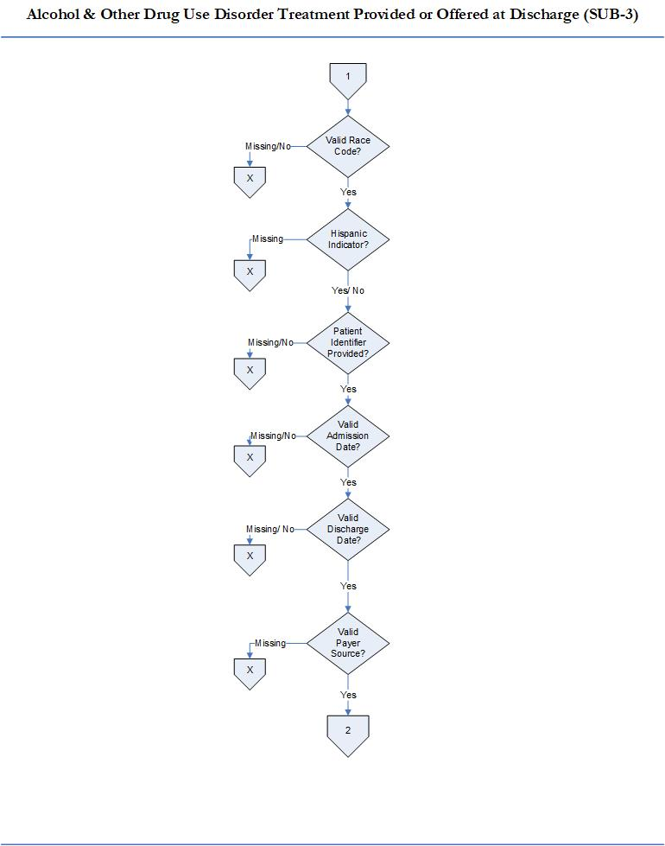

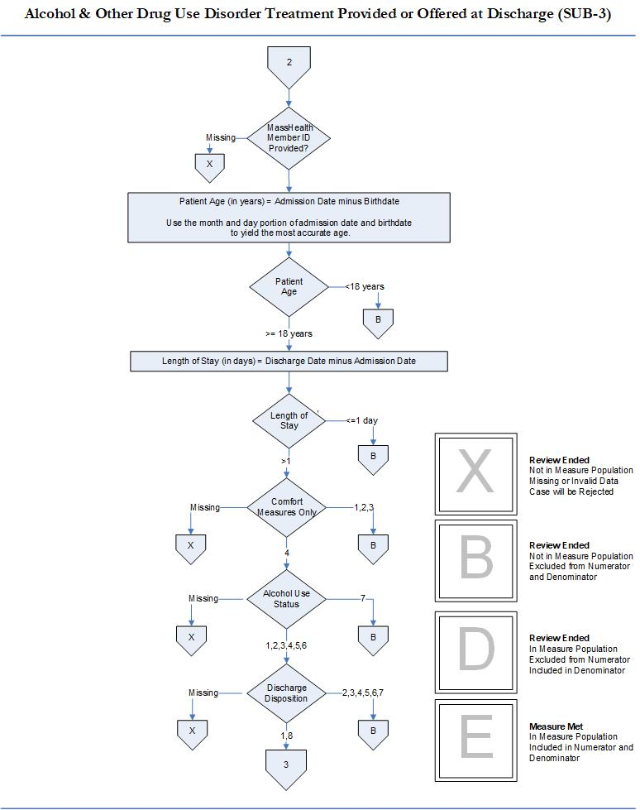

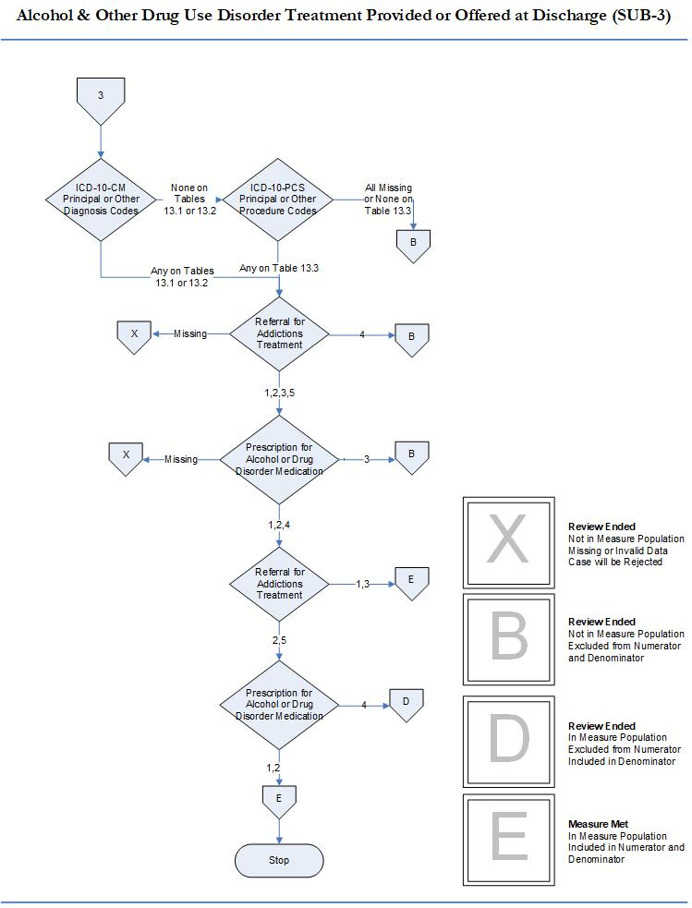

Perinatal Care Domain

### 1. Cesarean Birth, NTSV (MAT-4)

**Description**: Nulliparous women with a term, singleton baby in vertex position delivered by cesarean birth.

**Numerator statement**: Patients with cesarean births.

**Included population**: ICD-10-PCS Principal Procedure Code or ICD-10-PCS Other Procedure Codes for cesarean birth as defined in Appendix A, Table 11.06 of the Specifications Manual for Joint Commission National Core Measures applicableversion*.*

**Excluded population**: None

**Data Elements:**

* ICD-10-PCS Other Procedure Codes
* ICD-10-PCS Principal Procedure Code

**Denominator statement**: Nulliparous patients delivered of a live term singleton newborn in vertex presentation.

**Included population**:

* ICD-10-PCS Principal Procedure Code or ICD-10-PCS Other Procedure Codes for delivery (as defined in Appendix A: ICD-10-PCS Code Tables 11.01.1 of the Specifications Manual for Joint Commission National Core Measures applicable version)
* Nulliparous patientswith ICD-10-CM Principal Diagnosis Code or ICD-10-CM Other DiagnosisCodes for outcome of delivery as defined in Appendix A, Table 11.08 (of the Specifications Manual for Joint Commission National Core Measures applicable version)and with a delivery of a newborn with 37 weeks or more of gestation completed

**Excluded populations:**

* ICD-10-CM Principal Diagnosis Code or ICD-10-CM Other Diagnosis Codes for multiple gestations and other presentations as defined in Appendix A, Table 11.09 (of the Specifications Manual for Joint Commission National Core Measures applicable version)
* Less than 8 years of age
* Greater than or equal to 65 years of age
* Length of stay > 120 days
* Gestational age < 37 weeks or UTD

**Data Elements:**

* Admission Date
* Birthdate
* Discharge Date
* Gestational Age
* ICD-10-CM Other Diagnosis Codes
* ICD-10-CM Principal Diagnosis Code
* *Previous Births*

**Risk adjustment**: No

**Data Collection:** Sources include administrative data and medical records. Refer to MAT-4 data abstraction tool and data dictionary of this EOHHS manual for detailed instruction.

**Measure Type:** Outcome Measure

**Data Accuracy**: See TJC Core Specifications Manual for applicable discharge period for detail that apply.

**Sampling:** Yes. Refer to Section 4 in the RY2023 Technical Specifications Manual for MassHealth Acute Hospital Quality Measures (Version 16.0) for details on sample size requirements.

**Data reported as**: Aggregate rate reported from count data.

**Improvement noted as:** Decrease in rate.

Please contact the MassQEX Help Desk at massqexhelp@telligen.com if you require assistance to interpret the content of the measure flowcharts in this section of the manual.

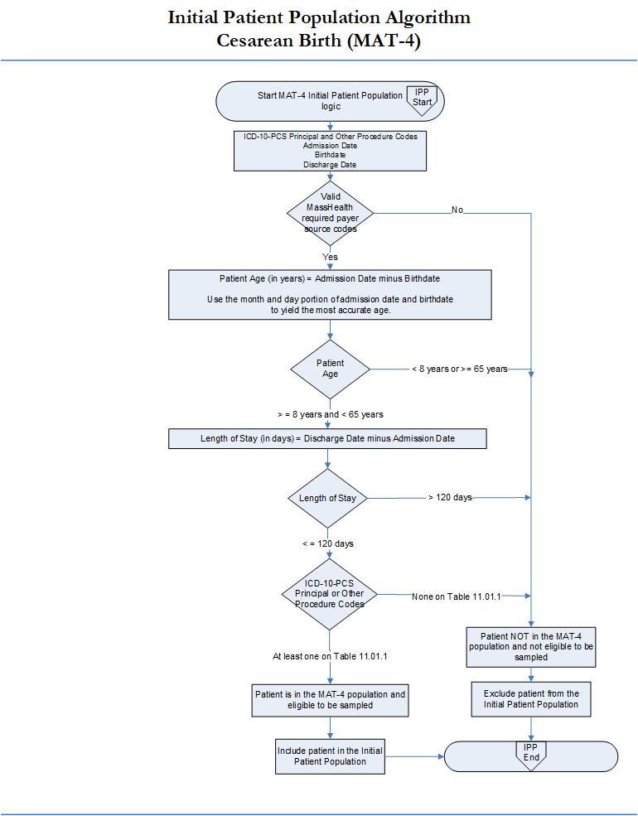

Please contact the MassQEX Help Desk at massqexhelp@telligen.com if you require assistance to interpret the content of the measure flowcharts in this section of the manual.

This image is the first page of a three-page flow chart titled "Cesarean Birth (MAT-4)". Note: Numerator is the number of patients with cesarean births and the Denominator is Nulliparous patients delivered of a live term newborn in vertex presentation.
The flow chart begins with "Meets MassHealth IPP Population Requirements?" If No, then to "Review Ended: Not in Measure Population; Missing or Invalid Data; Case will be Rejected". If Yes, then to "Provider Name Provided?" If Missing, then to "Review Ended: Not in Measure Population; Missing or Invalid Data; Case will be Rejected". If Yes, then to "Valid Provider ID?" If Missing or No, then to "Review Ended: Not in Measure Population; Missing or Invalid Data; Case will be Rejected". If Yes, then to "First Name Provided?" If Missing, then to "Review Ended: Not in Measure Population; Missing or Invalid Data; Case will be Rejected". If Yes, then to "Last Name Provided?" If Missing, then to "Review Ended: Not in Measure Population; Missing or Invalid Data; Case will be Rejected". If Yes, then to "Birthdate Provided?" If Missing, then to "Review Ended: Not in Measure Population; Missing or Invalid Data; Case will be Rejected". If Yes, then to "Valid Sex?" If Missing or No, then to "Review Ended: Not in Measure Population; Missing or Invalid Data; Case will be Rejected". If Yes, then move to the next page of this flow chart.

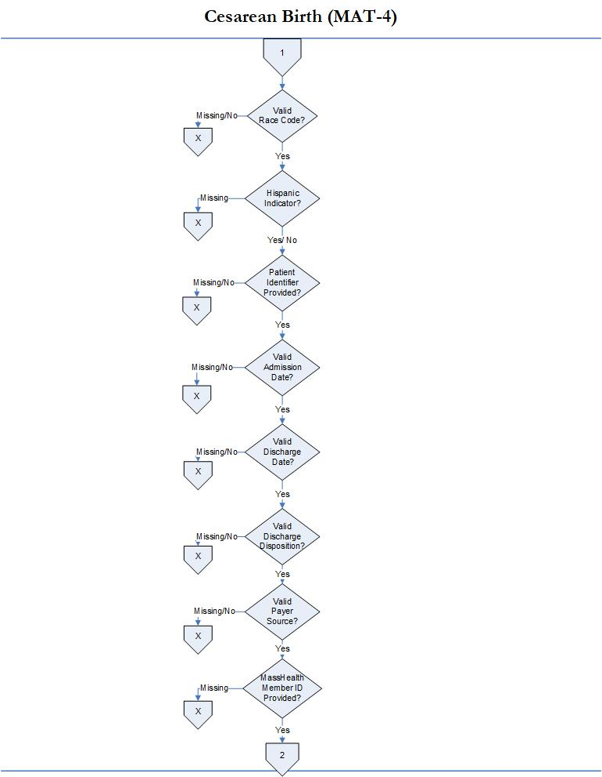

This image is the third and final page of a three-page flow chart titled "Cesarean Birth (MAT-4). Continuing from the previous image, if the MassHealth Member ID is provided, then on to "ICD-10-CM: Principal or Other Diagnosis Code". If Missing, then on to "Review Ended: Not in Measure Population; Missing or Invalid Data; Case will be Rejected". If At least one on table 11.09, then on to "Review Ended: Not in Measure Population; Excluded from Numerator and Denominator". And if None on Table 11.09 or Table 11.08, then on to "Review Ended: Not in Measure Population; Excluded from Numerator and Denominator". But if there is None on Table 11.09 and at least one on Table 11.08, then on to "Gestational Age". If Gestational Age is Missing, then on to "Review Ended: Not in Measure Population; Missing or Invalid Data; Case will be Rejected". If Gestational Age is less than 37 or UTD, then on to "Review Ended: Not in Measure Population; Excluded from Numerator and Denominator". And if Gestational Age is greater than or equal to 37, then on to "Previous Births". If Missing, then on to  "Review Ended: Not in Measure Population; Missing or Invalid Data; Case will be Rejected". Or if Y then on to "Review Ended: Not in Measure Population; Excluded from Numerator and Denominator". Or if N, then on to "ICD-10-PCS: Principal or Other Procedure Codes". And if None on Table 11.06, then to "Review Ended: In Measure Population; Excluded from Numerator; Excluded from Denominator". And if At least one on Table 11.06, then on to "Review Ended: In Numerator Population; Excluded in Numerator and Denominator". This is the end of the third and final page of this flow chart.

### 

### 2. Unexpected Complications in Term Newborns (NEWB-3)

**Measure Name: Unexpected Complications in Term Newborns**

**Description**: Unexpected complications among full term newborns with no preexisting conditions. Severe complications include neonatal death, transfer to another hospital for higher level of care, severe birth injuries such as intracranial hemorrhage or nerve injury, neurologic damage, severe respiratory and infectious complications such as sepsis. Moderate complications include diagnoses or procedures that raise concern but at a lower level than the list for severe e.g. use of CPAP or bone fracture. Examples include less severe respiratory complications e.g. Transient Tachypnea of the Newborn, or infections with a longer length of stay not including sepsis, infants who have a prolonged length of stay of over 5 days. *EOHHS will report only the aggregate rate of newborns with severe complications and moderate complications.*

**Numerator Statement:** Newborns with severe complications and moderate complications.

**Included Populations**:

**Severe Complications**:

* Death
* Transfer to another acute care facility for higher level of care
* ICD-10-CM Principal Diagnosis Code, ICD-10-CM Other Diagnosis Codes, ICD-10-PCS Principal

Procedure Code or ICD-10-PCS Other Procedure Codes for Severe Morbidities as defined in

Appendix A, Tables of the Specifications Manual for Joint Commission National Core Measures applicable version:

* + 11.36 Severe Birth Trauma
  + 11.37 Severe Hypoxia/Asphyxia
  + 11.38 Severe Shock and Resuscitation
  + 11.39 Neonatal Severe Respiratory Complications
  + 11.40 Neonatal Severe Infection
  + 11.41 Neonatal Severe Neurological Complications
  + 11.42 Severe Shock and Resuscitation Procedures
  + 11.43 Neonatal Severe Respiratory Procedures
  + 11.44 Neonatal Severe Neurological Procedures
* Patients with Length of Stay greater than 4 days AND an ICD-10-CM Principal Diagnosis Code or ICD-10-CM Other Diagnosis Codes for Sepsis as defined in Appendix A, Table 11.45 Neonatal Severe Septicemia of the Specifications Manual for Joint Commission National Core Measures applicable version

**Moderate Complications**:

* ICD-10-CM Principal Diagnosis Code, ICD-10-CM Other Diagnosis Codes, ICD-10-PCS Principal

Procedure Code or ICD-10-PCS Other Procedure Codes for moderate complications as defined in Appendix A, Tables of the Specifications Manual for Joint Commission National Core Measures:

* + 11.46 Moderate Birth Trauma
  + 11.47 Moderate Respiratory Complications
  + 11.48 Moderate Respiratory Complications Procedures
* *ICD-10-CM Principal Diagnosis Code* for single liveborn newborn as defined in the Specifications Manual for Joint Commission National Core Measures Appendix A, Table 11.20.2 Single Liveborn Newborn-Vaginal AND Length of Stay greater than 2 days  
  OR  
  *ICD-10-CM Principal Diagnosis Code* for single liveborn newborn as defined in the Specifications Manual for Joint Commission National Core Measures Appendix A, Table 11.20.3 Single Liveborn Newborn-Cesarean AND Length of Stay greater than 4 days  
  AND ANY  
  *ICD-10-CM Principal Diagnosis Code*, *ICD-10-CM Other Diagnosis Codes*, *ICD-10-PCS Principal Procedure Code* or *ICD-10-PCS Other Procedure Codes* for moderate complications as defined in the Specifications Manual for Joint Commission National Core Measures Appendix A, Tables:
  + 11.49 Moderate Birth Trauma with LOS
  + 11.50 Moderate Respiratory Complications with LOS
  + 11.51 Moderate Neurological Complications with LOS Procedures
  + 11.52 Moderate Respiratory Complications with LOS Procedures
  + 11.53 Moderate Infection with LOS
* Patients with Length of Stay greater than 5 days and NO *ICD-10-CM Principal Diagnosis Code*, *ICD-10-CM Other Diagnosis Codes*, *ICD-10-PCS Principal Procedure Code* or *ICD-10-PCS Other Procedure Codes* for jaundice or social indications as defined in the Specifications Manual for Joint Commission National Core Measures Appendix A, Tables:
  + 11.33 Neonatal Jaundice
  + 11.34 Phototherapy
  + 11.35 Social Indications

**Excluded Populations**: None

**Data Elements:**

* *Admission Date*
* *Discharge Date*
* *Discharge Disposition*
* *ICD-10-CM Other Diagnosis Codes*
* *ICD-10-CM Principal Diagnosis Code*
* *ICD-10-PCS Other Procedure Codes*
* *ICD-10-PCS Principal Procedure Code*

**Denominator Statement**: Liveborn single term newborns 2500 gm or over in birth weight.

**Included Populations:** Single liveborn newborns with ICD-10-CM Principal Diagnosis Code for single liveborn newborn as defined in the Specifications Manual for Joint Commission National Core Measures Appendix A, Table Number 11.20.1: Single Liveborn Newborn

**Excluded Populations**:

* Patients who are not born in the hospital or are part of multiple gestation pregnancies, with no

ICD-10-CM Principal Diagnosis Code for single liveborn newborn as defined in the Specifications Manual for Joint Commission National Core Measures Appendix A, Table Number 11.20.1: Single Liveborn Newborn

* *Birth Weight* < 2500 gm
* Patients who are not term or with < 37 weeks gestation completed
* Patients whose term status or gestational age is missing and birthweight < 3000 gm
* ICD-10-CM Principal Diagnosis Code or ICD-10-CM Other Diagnosis Codes for congenital malformations and genetic diseases as defined in the Specifications Manual for Joint Commission National Core Measures Appendix A, Table 11.30 Congenital Malformations
* ICD-10-CM Principal Diagnosis Code or ICD-10-CM Other Diagnosis Codes for pre-existing fetal

conditions as defined in the Specifications Manual for Joint Commission National Core Measures Appendix A, Table 11.31 Fetal Conditions

* ICD-10-CM Principal Diagnosis Code or ICD-10-CM Other Diagnosis Codes for maternal drug use exposure in-utero as defined in the Specifications Manual for Joint Commission National Core Measures Appendix A, Table 11.32 Maternal Drug Use

**Data Elements:**

* *Birth Weight*
* *Birthdate*
* *ICD-10-CM Other Diagnosis Codes*
* *ICD-10-CM Principal Diagnosis Code*
* *ICD-10-PCS Other Procedure Codes*
* *ICD-10-PCS Principal Procedure Code*
* *Term Newborn*

**Risk Adjustment**: No.

**Data Collection Approach**: See data abstraction tool (Appendix A-5)and data dictionary (Appendix A-8)of this manual for detailed instruction.

**Measure Type:** Outcome Measure

**Data Accuracy**: See TJC Core Specifications Manual for applicable discharge period discharge period for detail that apply.

**Sampling**: No. Include all discharged infants where MassHealth is the primary and only payment source that meet ICD population requirements.

**Data Reported As**: Aggregate rate generated from count data reported as a rate per 1000 livebirths.

**Improvement Noted As**: Decrease in the rate

Please contact the MassQEX Help Desk at massqexhelp@telligen.com if you require assistance to interpret the content of the measure flowcharts in this section of the manual.

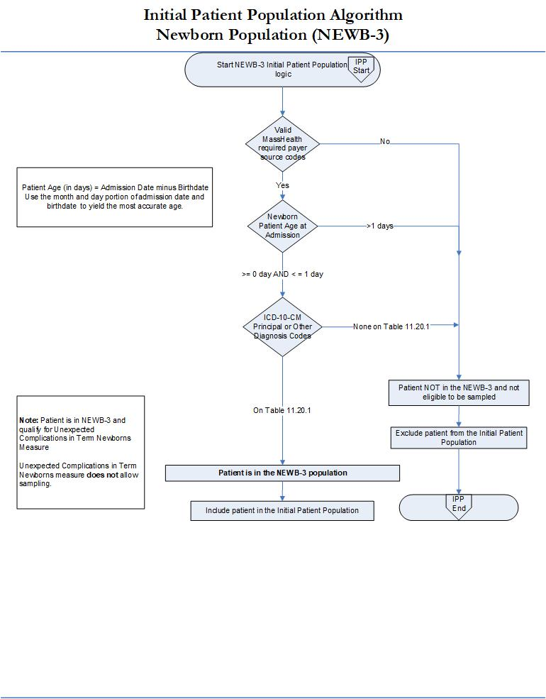

Please contact the MassQEX Help Desk at massqexhelp@telligen.com if you require assistance to interpret the content of the measure flowcharts in this section of the manual.

This image is the first page of a seven-page flow chart titled "Unexpected Complications in Term Newborns (NEWB-3)". Note: Numerator is the number of newborns with severe complications and moderate complications and the Denominator is live single term newborns 2500 grams or over in birth weight.
The flow chart begins with "Meets MassHealth IPP Population Requirements?" If No, then to "Review Ended: Not in Measure Population; Missing or Invalid Data; Case will be Rejected". If Yes, then to "Provider Name Provided?" If Missing, then to "Review Ended: Not in Measure Population; Missing or Invalid Data; Case will be Rejected". If Yes, then to "Valid Provider ID?" If Missing or No, then to "Review Ended: Not in Measure Population; Missing or Invalid Data; Case will be Rejected". If Yes, then to "First Name Provided?" If Missing, then to "Review Ended: Not in Measure Population; Missing or Invalid Data; Case will be Rejected". If Yes, then to "Last Name Provided?" If Missing, then to "Review Ended: Not in Measure Population; Missing or Invalid Data; Case will be Rejected". If Yes, then to "Birthdate Provided?" If Missing, then to "Review Ended: Not in Measure Population; Missing or Invalid Data; Case will be Rejected". If Yes, then to "Valid Sex?" If Missing or No, then to "Review Ended: Not in Measure Population; Missing or Invalid Data; Case will be Rejected". If Yes, then move to the next page of this flow chart.



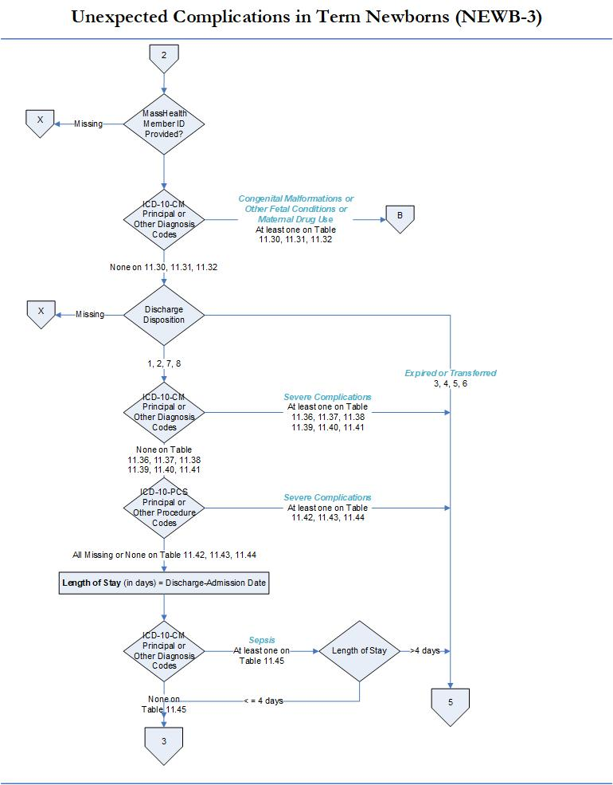

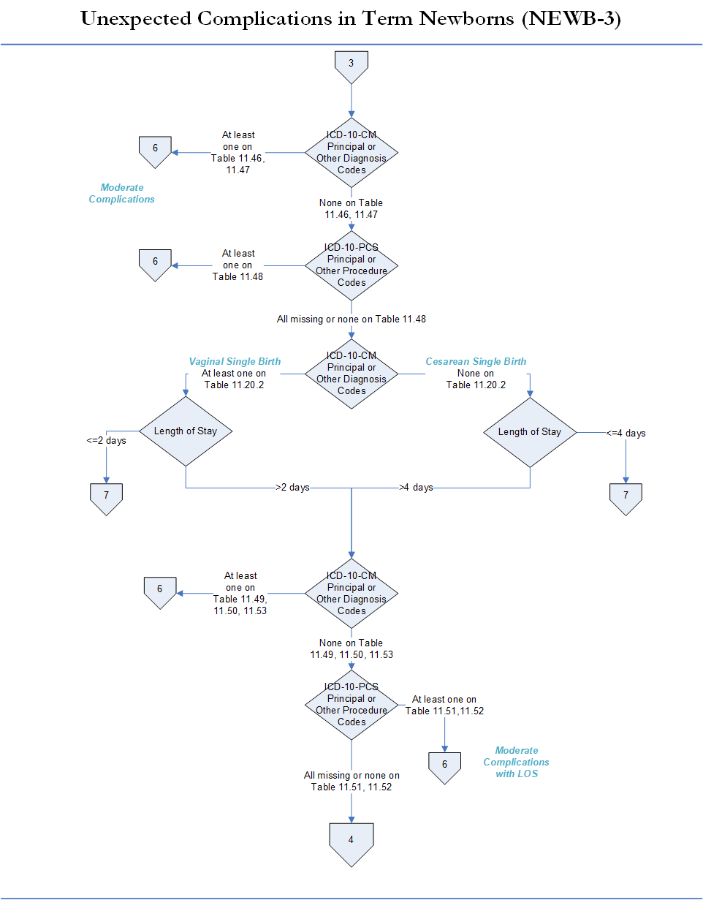

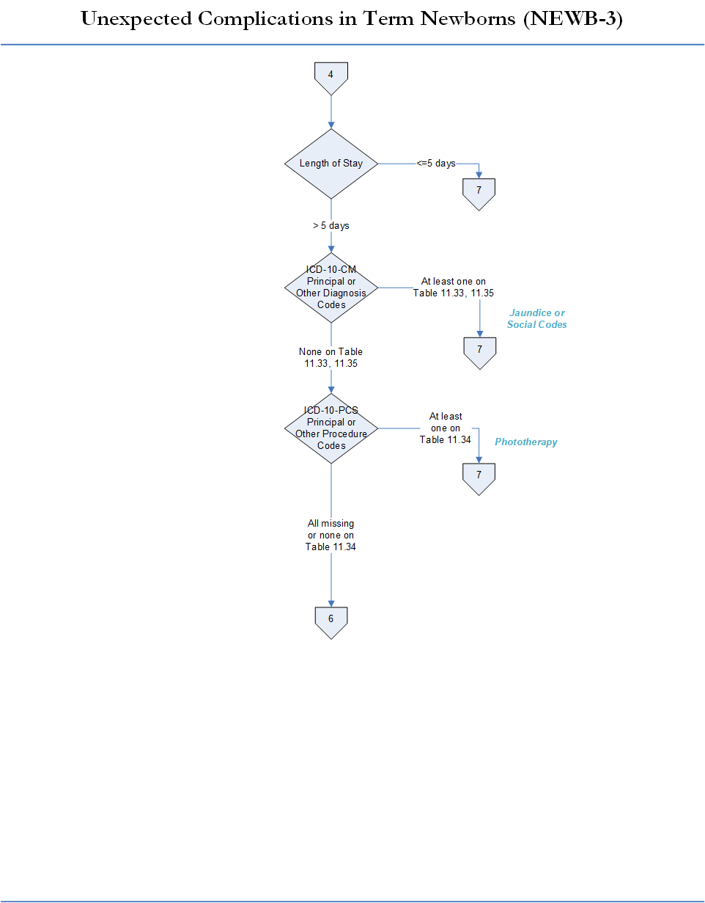

This image is the sixth page of a seven-page flow chart titled "Unexpected Complications in Term Newborns (NEWB-3)". PART ONE: If previously directed to the first part of page 6 of this flow chart (Severe Complications), then on to "Birth Weight". If Birth Weight is missing, then on to "Review Ended: Not in Measure Population; Missing or Invalid Data; Case will be Rejected". If Birth Weight is less than 2500g or UTD, then to "Review Ended: Not in Measure Population; Excluded from Numerator and Denominator". Or if Birth Weight is greater than or equal to 2500g, then on to "Term Newborn". If Missing, then on to "Review Ended: Not in Measure Population; Missing or Invalid Data; Case will be Rejected". If Term Newborn reads the number 2, then on to "Review Ended: Not in Measure Population; Excluded from Numerator and Denominator". If Term Newborn reads the number 1, then on to "Measure Met: In Measure Population; Included in Numerator and Denominator". Or if Term Newborn reads the number 3, then back to Birth Weight. If from here Birth Weight is greater than or equal to 3000g, then on to "Measure Met: In Measure Population; Included in Numerator and Denominator". Or if Birth Weight is less than 3000g (and greater than or equal to 2500g), then on to "Review Ended: Not in Measure Population; Excluded from Numerator and Denominator". This is the end of the FIRST PART of the this page, page 6, of this flow chart.
Page 6, SECOND PART (Moderate Complications): If directed to the second part of page 6 of this flow chart, then on to "Birth Weight". If Birth Weight is Missing, then on to "Review Ended: Not in Measure Population; Missing or Invalid Data; Case will be Rejected". If Birth Weight is less than 2500g or UTD, then on to "Review Ended: Not in Measure Population; Excluded from Numerator and Denominator".  Or if Birth Weight is greater than or equal to 2500g, then on to "Term Newborn". If "Term Newborn is Missing, then on to "Review Ended: Not in Measure Population; Missing or Invalid Data; Case will be Rejected". If Term Newborn reads the number 2, then on too "Review Ended: Not in Measure Population; Excluded from Numerator and Denominator". If 1, then on to "Measure Met: In Measure Population; Included in Numerator and Denominator". Or if 3, then back to "Birth Weight". If Birth Weight is greater than or equal to 3000g, then on to "Measure Met: In Measure Population; Included in Numerator and Denominator". Or if Birth Weight is less than 3000g (and greater than or equal to 2500g), then on to "Review Ended: Not in Measure Population; Excluded from Numerator and Denominator". This is the end of the second part of the sixth page of this flow chart, thereby ending this page, page 6, of this flow chart.

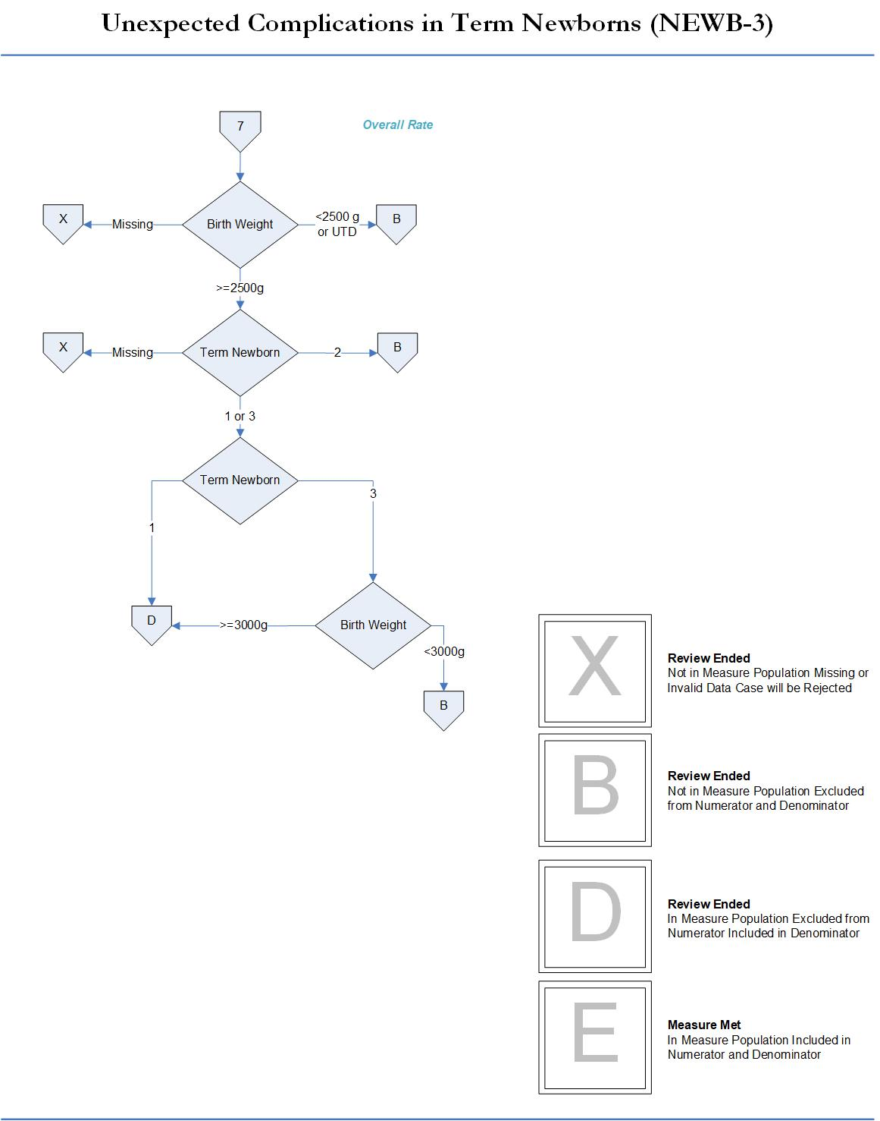

# Section 5. MassHealth Population Sampling Specifications

This section is designed to provide guidance on population sampling specifications for each of the measures included in the CQI program.

## Medicaid Population Sampling Specifications

Please refer to the RY2023 Technical Specifications Manual for MassHealth Acute Hospital Quality Measures v16.0, Section 4 (<https://www.mass.gov/doc/ry2023-eohhs-technical-specifications-manual-for-masshealth-hospital-quality-measures-160-0/download>) for guidance on the patient population and sampling specifications that apply to MassHealth chart-abstracted measures. There are no changes/adjustments to the Medicaid Population Sampling from this prior version.

Each hospital is responsible to ensure that sampling techniques applied for their hospital adhere to the sampling requirements outlined in the RY2023 Technical Specifications Manual for MassHealth Acute Hospital Quality Measures (Version 16.0). Hospitals with large enough volume of discharges to allow for sampling in their MassHealth initial patient populations for chart-abstracted measures may choose to sample for the following measures: Care Coordination (CCM), Substance Use (SUB), and Cesarean Birth (MAT-4) measures. Hospitals are required to include the entire MassHealth initial patient population for the Unexpected Complications in Term Newborns (NEWB-3) measure; Sampling is not allowed for the NEWB-3 measure.

## Measure Population Definitions

The RY2023 CQI program includes measures collected using varied methods, including chart-abstraction, data-entry, survey, and claims. Table 5.1 is designed to assist hospitals and vendors in referencing which patient populations are included in each measure category and data or method used to identify the population.

Table 5-1: Measure Populations

|  |  |  |
| --- | --- | --- |
| **Measure Category** | **Payer Population Included** | **Method Used to Identify Population** |
| **Chart-Abstracted Measures**  (CCM, SUB, MAT-4, NEWB-3) | MassHealth Medicaid | Medical records with a MassHealth Payer Code on Table 2.1 |
| **Aggregate Data-Entry Measures**  (OP-1, BHC-3) | All-Payer | Hospital reported all-payer population that hospital reports to CMS for respective measures |
| **Survey Data Entry Measure** (PMSM-1) | N/A | N/A |
| **Claims Based Patient Safety** (PSI-90) | MassHealth Medicaid | Claims from EOHHS Medicaid Hospital Stay File |
| **Registry Based Patient Safety** (HAI 1-5) | All-Payer | Data pulled from National Healthcare Safety Network (NHSN) |
| **Patient Experience** (HCAHPS) | All-Payer | Data pulled from CMS Provider Data Catalog |
| **HEDIS Claims-Based Measure** (CCI-2, CCI-3, BHC-1, PED-2) | MassHealth Medicaid | Claims from EOHHS MassHealth Claims Data File |
| **Other Claims-Based Measure** (BHC-2) | MassHealth Medicaid | Claims from EOHHS MassHealth Claims Data File |

# Section 6. MassHealth Data Validation Methods

The EOHHS Medicaid Acute RFA contract requires that hospitals meet data validation standards on reported measures as part of MassHealth CQI program participation. The EOHHS contractor will perform all aspects of chart validation process for quality measures data reported under the MassHealth Acute Hospital RFA. All measures data are subject to the validation methods described in this section. For more detail on Data Validation Methods, including overview, chart request schedule, chart submission content, and secure file transfer method, see Section 6 of the RY2023 Technical Specifications Manual for MassHealth Acute Hospital Quality Measures (Version 16.0).

RY2023 CQI (CY2023 performance period) will follow validation methods outlined in the RY2023 Technical Specifications Manual for MassHealth Acute Hospital Quality Measures (Version 16.0), with the following important updates for the RY2023 CQI Program:

* Update to volume of medical records requested for validation
* Update to Scored Data Elements (see Table 6.1)

## Chart Sampling

For RY2023 CQI (performance period CY2023), EOHHS will request additional medical records to allow for appropriate sampling on newly introduced chart-abstracted measures. Data validation is performed on a random sampling of charts selected from the hospitals chart-abstracted measures in Table 1.2 (Section 1.D) of this EOHHS manual as follows:

* 1. *Chart sampling requirements will collect a total of eighteen (18) records/year on the reported data.*
  2. *A random sample of six (6) charts are identified for the first three quarters (Q1, Q2, Q3) only.*
  3. No charts are required for the fourth quarter data (Q4) files submitted to the portal.

## Data Validation Scoring Methods

1. **Validation Standard*.*** Hospitals will be evaluated against the ‘EOHHS Standard’ for chart abstraction by measuring agreement on the specific clinical and non-clinical (demographic and administrative) data elements for the measure sets described in Section 4. Information from the ‘Hospital original’ and ‘EOHHS Standard’ abstraction will be compared to identify matches and variances across the data elements.
2. **Data Element Scoring.** All data elements are categorized as scored or non-scored. Scored elements are included in the calculation of the overall validation rate. Non-scored elements are not included in the calculation of validation rates but must pass portal completeness checks and will also be used to verify that the correct medical chart was received. A list of the scored and non-scored data elements is summarized in the following table.

Table 6-1: Summary of Data Element Scoring Categories

| **Scored Data Elements** | **Non-Scored Data Elements** |
| --- | --- |
| **CCM Measures**: Discharge Disposition, Reconciled Medication List, Transition Record, Advance Care Plan, Contact Information 24 hours/ 7 days, Contract Information for Studies Pending, Current Medication List, Discharge Diagnosis, Medical Procedures and Tests, Patient Instructions, Patient Refusal of Transmission, Plan for Follow-up Care, Primary Physician/ Healthcare Professional for Follow-up Care, Reason for Admission, Studies Pending at Discharge, Transmission Date, Discharge Date, Race, Hispanic Indicator  **SUB-2 Measure:** *Alcohol Use Status, Brief Intervention, Comfort Measures Only*, Race, Hispanic indicator  **SUB-3 Measure:** *Alcohol Use Status, Comfort Measures Only,* Discharge Disposition, *Prescription for Alcohol or Drug Disorder Medication, Referral for Additions Treatment*, Race, Hispanic indicator  **MAT-4 Measure**: Gestational Age, *Previous Births*, Race, Hispanic Indicator  **NEWB-3 Measure**: *Birth Weight,* Discharge Disposition,Term Newborn, Race, Hispanic indicator | * Admission Date * Admission Time * Birth Date * Discharge Date (scored for CCM-3 only) * Discharge Disposition (scored for CCM, *SUB-3*, & *NEWB-3*) * Episode of Care * First Name * Hospital Patient ID # * ICD-CM Diagnosis Codes * ICD-PCS Procedure Codes * Last Name * Member ID Number * Payer Source * Provider ID * Provider Name * *Sex* |

As noted in Table 6.1, scored data elements include administrative and clinical as follows:

1. Administrative Data Elements:
2. Race and Hispanic Indicatordata elements will be scored across all measures data being reported on. The aim of validation is to determine how consistently hospitals document all required data elements in medical record and electronic clinical data files.
3. All race/Hispanic indicator data elements documented in the medical record must indicate that the patient has self-reported. Clinician notes that make reference to a patient’s Race and Hispanic Indicator are considered invalid for data validation purposes.
4. Copies of all medical records must include information on two data elements of Race and Hispanic Indicator for validation purposes. The data elements must be clearly documented in the copy of the medical record submitted (i.e.: copy of the face sheet, nursing admission assessment, initial patient assessment) or include a copy of the administrative record (i.e.: registration system screen shot) for that patient.
5. Failure to include the documentation of Race and Hispanic Indicator data in any medical record submitted will result in failing data validation for these data elements.
6. Clinical Data Elements: A full list of the clinical data elements that are eligible to be scored for each of the measure categories are contained in the measures specifications for each chart-abstracted measure outlined in Section 4 of this manual. The list of clinical data elements that apply to validation scoring for MassHealth process measures are listed onthe Table 6.1 and further defined in the Data Dictionary (Appendix A-8) in this EOHHS manual.

Please contact the MassQEX Help Desk at [massqexhelp@telligen.com](mailto:massqexhelp@telligen.com) for questions on medical record request and validation.

# Section 7. Data-Entry Measures

## Care for Acute and Chronic Conditions Data-Entry Measure

This section includes measure specifications for the data-entry measure the Care for Acute and Chronic Conditions core domain: the electronic clinical quality measure (eCQM), Safe Use of Opioids Concurrent Prescribing (OP-1e). For RY2023, hospitals will only be required to submit initial population, numerator, denominator, and exclusions for OP-1e via the web-based data-entry tool in the MassQEX Portal. Hospitals will report the same data in aggregate they report to CSM on their all-payer population. For complete information on this measure, please refer to the measure steward specifications outlined in the Hospital Inpatient Quality Report (IQR) Program: <https://qualitynet.cms.gov/inpatient/measures/ecqm>

**Measure Name:** Safe Use of Opioids Concurrent Prescribing (OP-1e)

**Description:** Proportion of inpatient hospitalizations for patients 18 years of age and older prescribed, or continued on, two or more opioids or an opioid and benzodiazepine concurrently at discharge.

**Measure Steward:** Centers for Medicare & Medicaid Services (CMS)

**Type of Measure:** Electronic health record clinical quality measure

**Measure Collection Method:** Web-based data entry tool via the secure MassQEX Portal (see Section 3.D for additional detail).

**Payer Population:** All-payer population that hospital reports to CMS for CY2023 data

**Data Collection Approach:** Web-based data entry tool via the secure MassQEX Portal. For the CY2023 reporting period, hospitals will submit initial population, numerator, denominator, and exclusions for all-payer population to EOHHS via a web-based data entry tool located on the MassQEX portal. Details on data-entry tool and process are further outlined in section 3.D. This will be the same four-quarter data period the hospital reports to CMS for the CY2023 reporting period, estimated for reporting to CMS in February, 2024.

**Data Accuracy**: See CMS IQR Electronic clinical quality measures (eCQM) specifications for applicable discharge period for detail that apply.

**Measure Analysis Suggestions**: None

**Sampling:** Not applicable.

**Data Reported As**: Aggregate rate generated from claims data.

## Behavioral Health Care Domain Data-Entry Measure

This section includes new measure specifications and flowcharts for the BHC-3 chart-abstracted measure that will be required for the CQI program as part of the Behavioral Health Care Domain. Hospitals will only be required to submit initial population, numerator, denominator, and exclusions for BHC-3 via the web-based data-entry tool in the MassQEX Portal, described in Section 3.D.1. Hospitals must attest that the aggregate data submitted for this measure is the same as what they submit to CMS for the applicable data period. Only hospitals that have an inpatient psychiatric unit and participate in the current CMS IPFQR program are required to participate in the Behavioral Health Care Domain.

Although the Screening for Metabolic Disorders Measures is collected as patient-level abstracted data for CMS (as defined in the applicable IPFQR Program specification’s manual), for CY23 discharge data EOHHS will only require collection of hospital annual aggregate initial population, numerator, denominator, and exclusions for the BHC-3 measure. For complete information on this measure, please refer to the measure steward specifications outlined in the applicable version of the IPFQR Program: <https://qualitynet.cms.gov/ipf/ipfqr/measures>

**Measure Name:** Screening for Metabolic Disorders Measure(BHC-3)

**Description**: Percentage of patients discharged from an Inpatient Psychiatric Facility (IPF) with a prescription for one or more routinely scheduled antipsychotic medications for which a structured metabolic screening for four elements was completed in the 12 months prior to discharge – either prior to or during the index IPF stay.

**Measure Steward:** CMS Inpatient Psychiatric Facility Quality Reporting (IPFQR)

**Numerator Statement:** The total number of patients who received a metabolic screening in the 12 months prior to discharge, either prior to or during the index IPF stay.

**Data Elements:**

* *Body Mass Index (BMI)*
* *Blood Pressure*
* *Blood Glucose*
* *Discharge Disposition*
* *Lipid Panel*
* *Reason for Incomplete Metabolic Screening*

**Denominator Statement**: Discharges from an IPF during the measurement period with a prescription for one or more routinely scheduled antipsychotic medications.

**Included Populations:** All patients discharged from IPFs with one or more routinely scheduled antipsychotic medications during the measurement period.

**Excluded Populations**:

* + Patients for whom a screening could not be completed due to the patient’s enduring unstable medical condition or enduring unstable psychological condition.
  + Patients with a LOS equal to or greater than 365 days, or equal to or less than three days.
  + Patients who expired during the admission (Discharge Disposition = 6)

**Data Elements:**

* *Admission Date*
* *Discharge Date*
* *Number of Antipsychotic Medications Prescribed at Discharge*

**Risk Adjustment**: No.

**Measure Collection Method:** Aggregate data submission viaWeb-based data entry tool via the secure MassQEX Portal.

**Data Collection Approach**: See version applicable to discharge periods Inpatient Psychiatric Facility Quality Reporting (IPFQR) Program manual for detail that apply. <https://qualitynet.cms.gov/ipf/ipfqr/measures>

**Measure Type**: Process measure.

**Data Accuracy**: See FY2023 Inpatient Psychiatric Facility Quality Reporting (IPFQR) Program manual for detail that apply. <https://qualitynet.cms.gov/ipf/ipfqr/measures>

**Sampling**: Optional, per CMS sampling requirements

**Data Reported As**: Aggregate rate

**Improvement Noted As**: Decrease in the rate

## Perinatal Care Domain Data-Entry Measure

### 1. Measure Description

**Measure Name:** Perinatal Morbidity Structural Measure (PMSM-1)

Please refer to the specifications outlined in the RY2023 Technical Specifications Manual for MassHealth Acute Hospital Quality Measures (Version 16.0), Section 10 for guidance on submitting the PMSM-1 measure. Below, we outline important updates and/or clarifications for the applicable RY2023 CQI Program.

**Performance Period**: Hospital responses reflect activity taken during CY2023 (01/01/23 – 12/31/2023), as noted in Table 1.2 (Section 1.D).

### 2. Data Collection Method

**Attestation Survey Content:** The PMSM-1 measure includes five items framed as attestation statements that collect information on perinatal quality collaborative participation and in-hospital implementation activity. An example of the survey items and response formats follow.

Table 7-1: MassHealth PMSM-1 Survey Items

| **Item Number** | **Response Format** |
| --- | --- |
| **Item 1-** The hospital participated in the following Perinatal Quality Collaborative (PQC) aimed at improving maternal morbidity outcomes during intrapartum care: | Check one response:   * Massachusetts Perinatal Quality Collaborative (PQC) * Other State or National PQC (enter name): _________ * Both of above * None of above * N/A (hospital does not provide inpatient labor/delivery care) |
| **Item 2 -** The hospital implemented the following maternity bundles while partaking in PQC: | Check all that apply:   * Obstetric Hemorrhage * Severe Hypertension/Preeclampsia * Safe Reduction of Primary Cesarean Birth * Care for Pregnant and Postpartum People with Substance Use Disorder (previously referred to as Obstetric Care for Opioid Use Disorder) * **Maternal Equity** * Other Bundle not listed (enter name): ____________ * None of above * N/A (hospital does not provide inpatient labor/delivery care) |
| **Item 3-** The hospital was involved in the following PQC activities listed | Check all that apply:   * Formal data user agreement * Actively submit and exchange data * Attend educational events (webinars, annual meetings) * Attend ongoing team meetings * None of above * N/A (hospital does not provide inpatient labor/delivery care) |
| **Item 4 -** The hospital participated in the PQC during the following periods: | Check all that apply:   * Q1-2023 (Jan to March 2023) * Q2-2023 (Apr to June 2023) * Q3-2023 (July to Sept 2023) * Q4-2023 (Oct to Dec 2023) * None of above * N/A (hospital does not provide inpatient labor/delivery care) |
| **Item 5 -** The hospital has implemented the specific practices listed to manage one or more of the maternal morbidity areas listed.  NOTE: This item does not apply if hospital does not provide labor/delivery care. | Enter X to indicate Yes for all that apply:   1. **Unit Policy and Procedure** – The hospital has an obstetrical complication policy and procedure (updated in last 2 years) that provides a Unit-standard approach using a stage-based management plan. 2. **Multidisciplinary Case Reviews** – The hospital has procedures to perform multi-disciplinary systems-level reviews on all cases of severe maternal morbidity. 3. **Debriefs** – The hospital has established an internal process to perform regular formal post-event debriefs on cases with major complications. 4. **Birth Unit Supplies** – The hospital has the necessary supplies readily available on birthing unit (e.g.: in a cart or mobile box) to manage specific complications. 5. **Patient, Family & Staff Support Protocols-** The hospital has developed OB specific resources and protocols to support patients, family and staff through major OB complications. 6. **Electronic Health Record Integration** – Most of the recommended safety practices are integrated into the hospitals electronic medical record system (i.e.: order sets, tracking tools, medications, clinical metrics, etc.) |

Detailed definition of terms and instructions on how to complete each PMSM-1 survey item are provided in the sections that follow.

### 3. Completing the Attestation Form

The PMSM-1 survey collects information along two distinct components of participation and practice implementation. Hospital responses should reflect actions taken throughout the CY23 period as follows:

1. **Participation in Perinatal Quality Collaborative (PQC):**

* **Item 1 (PQC entity) -**Theresponse selected represents the state or national PQC entity the hospital participated in throughout the CY23 period. If selected only “Other PQC” then enter name of the entity.
* **Item 2 (Bundle projects) -** The responses selected represent the listed safety bundle project(s) the hospital actively engaged in while partaking in the PQC checked under Item 1 throughout the CY23 measurement period. If selected “Other Bundle” then enter the bundle name.
* **Item 3 (Participation level) -** The responses selected represent involvement in activities listed, while the hospital was testing any safety bundle project(s) checked under Item 2 throughout the CY23 measurement period.
* **Item 4 (Participation period)-** The responses selected represent the estimated period of time the hospital was involved in bundle project(s) checked under Item 2 throughout the CY23 period. *Participation activity that occurred prior to CY23 period cannot be selected and does not apply.*

1. **In-Hospital Implementation:** Item 5 content is *mutually exclusive* of item 2 content, which is focused on PQC participation only. Item 5 asks what hospital practices has been put in place regardless of whether or not you were partaking in quality projects with a PQC.

* **Item 5 (Component practices) -** The “X” entryresponserepresents that the component practice has been implemented (applied, executed) in the Labor and Delivery Unit to manage one or more of the maternal morbidity areas listed ***as of and/or*** *throughout the CY2023 period*.
* The hospital can check off all component practices applicable to each maternal morbidity area per AIM Program guidelines. For example, AIM Program guidelines recommend the “multidisciplinary case review” component practice for managing hemorrhage, hypertension, primary cesarean complications but not for OB opioid. Refer to AIM Program guidelines for structure component practices recommended for managing each maternal morbidity area listed.

Please see Section 3.D for additional information on PMSM-1 submission in the portal.

Hospitals must enter a response for all data entry fields including the attestation box at the end of the survey. Please contact the MassQEX helpdesk via phone 844-546-1343 or email at [massqexhelp@telligen.com](mailto:massqexhelp@telligen.com) if you have questions on how to complete PMSM-1 item responses.

### 3. Data Accuracy and Completeness

Please see RY2023 Technical Specifications Manual for MassHealth Acute Hospital Quality Measures (Version 16.0) for information on data accuracy and completeness.

### 4. Measure Evaluation Method

Please note, **language related to data verification has been removed from the RY2023 CQI Technical Specifications Manual v1.0**. EOHHS will not verify hospital responses aside from attestation statement.

# 8. Claims-Based Measures Specifications

## MassHealth Claims Data File

EOHHS will use NCQA certified software to calculate HEDIS claims-based measures per the applicable version of the NCQA specifications for those measures. Other claims-based measures are computed using the applicable version of the technical specifications indicated for the measure, as outlined in Sections 8.C.1 and 8.C.2. Both NCQA HEDIS and other claims-based measures will be calculated using the MassHealth Claims Data File described below.

The MassHealth Claims Data Files includes MassHealth administrative data, including: regular claims (paid and denied), encounter claims (paid and denied), and enrollment files for a three-year period. EOHHS will calculate HEDIS measure rates using the Claims Data File pulled a minimum of six months after the last day of discharges that are applicable to the measurement period to ensure final claims have been processed (e.g., if the measurement period ends on 12/31/2023 then run-out claims date is pulled on or after 06/01/2024). Prior to calculating HEDIS rates for the performance period, EOHHS will review the HEDIS Data File for data completeness, duplications, outliers and unexpected values. EOHHS will consider claims final after the run-out claims date for the measure period. *Hospitals must ensure claims submitted to both MMIS and Encounter data warehouse contain the correct clinical codes and are submitted in a timely manner.*

## NCQA HEDIS Claims-Based Measures Specifications

Section 8.B provides information on the HEDIS measures selected for inclusion in the MassHealth CQI Program. Hospitals may choose to purchase the full HEDIS specifications through the NCQA website: <https://www.ncqa.org/hedis/measures/>.

Please visit the NCQA website for additional information on HEDIS measure specifications <https://www.ncqa.org/hedis/measures/>. NCQA has published a summary of MY2023 measure changes here: <https://www.ncqa.org/wp-content/uploads/2022/08/MY-2023-Summary-Table-of-Measures-Product-Lines-Changes.pdf>

### 1. Care Coordination and Integration of Care Domain

This section provides measure specifications for the new NCQA HEDIS claims-based measures added to the CY2023 CQI Care Coordination and Integration core domain.

#### I) Follow-Up After Emergency Department Visit for Mental Illness (CCI-2)

**Measure Name:** Follow-Up After Emergency Department Visit for Mental Illness

**Description**:

The percentage of emergency department (ED) visits for members 6 years of age and older with a principal diagnosis of mental illness or intentional self-harm, who had a follow-up visit for mental illness. Two rates are reported:

1. The percentage of ED visits for which the member received follow-up within 30 days of the ED visit (31 total days).
2. The percentage of ED visits for which the member received follow-up within 7 days of the ED visit (8 total days).

**Measure Steward:** NCQA HEDIS

**Eligible Population:**

**Age:** Medicaid members 6-64 years of age as of the date of the ED visit.

**Denominator:** The eligible population

**Numerator Statement:**

**30-Day Follow-Up**: A follow-up visit with any practitioner, with a principal diagnosis of a mental health disorder or with a principal diagnosis of intentional self-harm and any diagnosis of a mental health disorder within 30 days after the ED visit (31 total days). Include visits that occur on the date of the ED visit.

**7-Day Follow-Up**: A follow-up visit with any practitioner, with a principal diagnosis of a mental health disorder or with a principal diagnosis of intentional self-harm and any diagnosis of a mental health disorder within 7 days after the ED visit (8 total days). Include visits that occur on the date of the ED visit.

**Risk Adjustment**: No.

**Improvement Noted As**: Increase in the rate

**Payer-Population:** All Medicaid population

**Data Calculation Approach:** EOHHS will use NCQA certified software to calculate measure results

**Data Accuracy**: See MY2023 HEDIS Specification Manual for applicable discharge period for detail that apply.

**Measure Analysis Suggestions**: None

**Sampling:** Not applicable.

**Data Reported As**: Aggregate rate generated from claims data.

#### II. Follow-Up After Emergency Department Visit for Substance Use (CCI-3)

**Measure Name:** Follow-Up After Emergency Department Visit for Substance Use

**Description:**

The percentage of emergency department (ED) visits among members age 13 years and older with a principal diagnosis of substance use disorder (SUD), or any diagnosis of drug overdose, for which there was follow-up. Two rates are reported:

1. The percentage of ED visits for which the member received follow-up within 30 days of the ED visit (31 total days).
2. The percentage of ED visits for which the member received follow-up within 7 days of the ED visit (8 total days).

**Measure Steward:** NCQA

**Eligible Population:**

**Age:** 13-64 years of age as of the date of the ED visit.

**Denominator:** Eligible population

**Numerator Statement:**

**30-day Follow-up:** A follow-up visit or a pharmacotherapy dispensing event within 30 days after the ED visit (31 total days). Include visits and pharmacotherapy events that occur on the date of the ED visit.

**7-Day Follow-up:** A follow-up visit or a pharmacotherapy dispensing event within 7 days after the ED visit (8 total days). Include visits and pharmacotherapy events that occur on the date of the ED visit.

**Risk Adjustment**: No.

**Improvement Noted as:** Increase in rate

**Payer-Population:** All Medicaid population

**Data Calculation Approach:** EOHHS will use NCQA certified software to calculate measure results

**Data Accuracy**: See MY23 HEDIS Specification Manual for applicable discharge period for detail that apply.

**Measure Analysis Suggestions**: None

**Sampling:** Not applicable.

**Data Reported As**: Aggregate rate generated from claims data.

### 2. Care for Acute and Chronic Conditions Domain

This section provides measure specifications for the new NCQA HEDIS claims-based measures added to the CQI Care for Acute and Chronic Conditions core domain.

#### I) Avoidance of Antibiotic Treatment for Acute Bronchitis/Bronchiolitis (PED-2)

**Measure Name**: Avoidance of Antibiotic Treatment for Acute Bronchitis/Bronchiolitis

**Description:** The percentage of episodes for members ages 3 months through 17 years of age with a diagnosis of acute bronchitis/ bronchiolitis that did not result in an antibiotic dispensing event.

**Measure Steward**: NCQA HEDIS

**Eligible Population:** Members who were 3 months through 17 years of age as of the Episode Date.

|  |  |
| --- | --- |
| Ages | Members who were 3 months through 17 years of age as of the Episode Date.  **Note:** EOHHS will only report on the pediatric population stratification for this measure (ages 3 months through 17 years of age). |

**Denominator Statement:** The eligible population

**Numerator Statement:** Dispensed prescription for an antibiotic medication on or three days after the Episode Date.

**Risk Adjustment**: No.

**Improvement Noted as:** Decrease in the rate. The measure is reported as an inverted rate [1–(numerator/eligible population)]. A higher rate indicates appropriate acute bronchitis/bronchiolitis treatment (i.e., the proportion for episodes that did not result in an antibiotic dispensing event).

**Data Calculation Approach**: EOHHS will use NCQA certified software to calculate measure results

**Data Accuracy**: See MY23 HEDIS Specification Manual for applicable discharge period for detail that apply.

**Measure Analysis Suggestions**: None

**Sampling:** Not applicable.

**Data Reported As**: Aggregate rate generated from claims data.

### 3. Behavioral Health Care Domain Claims-Based Measures

This section provides measure specifications for the new NCQA HEDIS claims-based measures added to the CQI Behavioral Health specialty domain. Only hospitals that have an inpatient psychiatric unit and participate in the current CMS IPFQR program are required to participate in the Behavioral Health Care Domain.

#### I) Follow-Up After Hospitalization for Mental Illness (BHC-1)

**Measure Name:** Follow-Up After Hospitalization for Mental Illness

**Description:** The percentage of discharges for members 6 years of age and older who were hospitalized for treatment of selected mental illness or intentional self-harm diagnoses and who had a follow-up visit with a mental health provider. Two rates are reported:

1. The percentage of discharges for which the member received follow-up within 30 days after discharge.
2. The percentage of discharges for which the member received follow-up within 7 days after discharge.

**Eligible Population**

**Age:** 6-64 years of age as of the date of discharge.

**Numerator Statement:**

**30-Day Follow-Up:** A follow-up visit with a mental health provider within 30 days after discharge. Do not include visits that occur on the date of discharge.

**7-Day Follow-Up:** A follow-up visit with a mental health provider within 7 days after discharge. Do not include visits that occur on the date of discharge.

**Risk Adjustment**: No.

**Type of Measure:** Process measure

**Measure Calculation Approach:** EOHHS will calculate using NCQA certified software

**Improvement Noted as:** Increase in rate

**Data Collection Approach**: See MY23 HEDIS Specification Manual for applicable discharge period for detail that apply.

**Data Accuracy**: See MY23 HEDIS Specification Manual for applicable discharge period for detail that apply.

**Measure Analysis Suggestions**: None

**Sampling:** Not applicable.

**Data Reported As**: Aggregate rate generated from count data reported.

### C. Other Claims-Based Measures

#### I) Medication Continuation Following Inpatient Psychiatric Discharge (BHC-2)

EOHHS will use measure specifications from IPFQR to calculate the Medication Continuation Following Inpatient Psychiatric Discharge (BHC-2) measure. For detailed description of the applicable measure specifications for BHC-2, please see published specifications from the IPFQR program manual, located here: <https://qualitynet.cms.gov/ipf/measures>

**Measure Name:** Medication Continuation Following Inpatient Psychiatric Discharge

**Description:** This measure assesses whether psychiatric patients admitted to an inpatient psychiatric facility (IPF) for major depressive disorder (MDD), schizophrenia, or bipolar disorder filled a prescription for evidence-based medication within 2 days prior to discharge and 30 days post-discharge.

**Note:** CMS allows data from the start of the measurement period through 30 days after the close of the measurement period to be used to identify medications 30 days post-discharge.

**Numerator Statement:** The numerator for this measure includes:

1. Discharges with a principal diagnosis of MDD in the denominator population for which patients were dispensed evidence-based outpatient medication within 2 days prior to discharge through 30 days post-discharge
2. Discharges with a principal diagnosis of schizophrenia in the denominator population for which patients were dispensed evidence-based outpatient medication within 2 days prior to discharge through 30 days post-discharge
3. Discharges with a principal diagnosis of bipolar disorder in the denominator population for which patients were dispensed evidence-based outpatient medication within 2 days prior to discharge through 30 days post-discharge

**Denominator Statement:** The target population for this measure are patients aged 18 years and older discharged from an IPF with a principal diagnosis of MDD, schizophrenia, or bipolar disorder.

**Denominator Exclusions**

The denominator for this measure excludes discharged patients who:

* Received electroconvulsive therapy (ECT) during the inpatient stay or follow-up period.
* Received transcranial magnetic stimulation (TMS) during the inpatient stay or follow-up period.
* Were pregnant at discharge.
* Had a secondary diagnosis of delirium at discharge.
* Had a principal diagnosis of schizophrenia with a secondary diagnosis of dementia at discharge.

**Risk Adjustment**: No.

**Type of Measure:** Claims-based process measure

**Improvement Noted as:** Increase in rate

**Data Collection Approach**: EOHHS will calculaxte using Medicaid Claims Data File. Please section 8.A for information.

**Data Accuracy**: See CMS Inpatient Psychiatric Facility Quality Reporting (IPFQR) Program Claims-Based Measure Specifications for applicable discharge period for detail that apply.

**Measure Analysis Suggestions**: None

**Sampling:** Not applicable.

**Data Reported As**: Aggregate rate generated from claims data.

# 9. Patient Safety Domain Measures

This section outlines the EOHHS data collection and calculations methods that apply to the PSI-90 composite measure and the Healthcare-Associated Infections (HAI) measures required by the MassHealth Clinical Quality Incentive (CQI) Program. This manual is not intended to repeat information that is contained within the previously published RY2023 EOHHS P4P Technical Specifications Manual v16.0 located here: <https://www.mass.gov/lists/eohhs-technical-specifications-manuals>. All methodology for PSI-90 and HAI will be consistent with previously published materials in Sections 7 and 8 of the EOHHS manual with the following notes.

## Patient Safety Adverse Events Composite (PSI-90)

EOHHS will use the most recently published AHRQ Patient Safety Indicators Technical Specifications for the applicable data period at time of calculation. For the RY2023 CQI program, EOHHS anticipates using AHRQ Patient Safety Indicators Technical Specifications v2023 and AHRQ Software v2023 when available. EOHHS will publish updated versions of the AHRQ Technical resources in subsequent manual versions when they become available.

## National Healthcare-Associated Infection (HAI) Measures

**Ward Description:** All applicable Pediatric and neonatal intensive care units (ICUs); and

Adult & Pediatric Medical, Surgical, and Medical/Surgical ward locations.

**HAI Measure Names:**

The Healthcare-Associated Infection (HAI) measures are as follows:

* Central Line-Associated Blood Stream Infections (CLABSI)
* Catheter-Associated Urinary Tract Infection (CAUTI)
* Methicillin Resistant Staph Aureus bacteremia (MRSA)
* Clostridium Difficile Infection (CDI)
* Surgical Site Infections for colon and abdominal hysterectomy (SSI’s)

Contact the MassQEX Helpdesk at: [massqexhelp@telligen.com](mailto:massqexhelp@telligen.com) for questions on PSI-90 or HAI results*.*

# Section 10. Patient Experience Domain Measures

This section outlines the EOHHS data collection and calculation guidelines that apply to the nationally reported Hospital Consumer Assessment Health Provider Systems (HCAHPS) Survey Composite (HCHAPS) required by the MassHealth Clinical Quality Incentive (CQI) Program. This manual is not intended to repeat information that is contained within the previously published RY2023 EOHHS P4P Technical Specifications Manual v16.0 located here: <https://www.mass.gov/lists/eohhs-technical-specifications-manuals>. All methodology for HCAHPS will be consistent with previously published materials.

Contact the MassQEX Helpdesk at [massqexhelp@telligen.com](mailto:massqexhelp@telligen.com) if you have questions about HCAHPS measure calculation and report results.