RY2024 EOHHS Hospital Clinical Quality Incentive
Program Technical Specifications Manual (v2.0)
Publication Date: April 1, 2024
RY2024 EOHHS Hospital Clinical Quality Incentive (CQI) Program Technical Specifications Manual (v2.0)
RY2024 (CY2024 Performance Period)
Table of Contents
Section 1. Clinical Quality Incentive Program (CQI) 4
A. Overview 4
B. Purpose of Manual 4
C. Enhancements to Manual Version 5
D. CQI Program Measures and Performance Periods 6
E. Quality Reporting Timelines 7
F. Program Participant Forms 8
Section 2. Data Collection Standards & Guidelines 9
A. MassHealth Measure Specifications 9
B. MassHealth Specific Data Elements 9
C. Data Collection & Reporting Tools 11
D. Data Accuracy and Completeness Requirements 12
Section 3. Portal Guidelines 14
A. Portal System Requirements 14
B. Data File Contents and ICD Entry Form 15
C. Portal Reports Repository 18
D. Data-Entry Measures Data Collection 21
E. User Accounts Registration 24
F. Customer Support 25
G. Extraordinary Circumstance Exception 26
Section 4. Chart-Abstracted Measures Specifications 29
A. Care Coordination and Integration of Care Domain 29
1. Reconciled Medication List Received by Discharge Patient (CCM-1) 29
2. Transition Record with Specified Elements Received by Discharge Patient (CCM-2) 34
3. Timely Transmittal of Transition Record (CCM-3) 41
B. Care for Acute and Chronic Conditions Domain 46
1. Alcohol Use Brief Intervention Provided or Offered (SUB-2) 46
2. Alcohol & Other Drug Use Disorder Treatment Provided or Offered at Discharge (SUB-3) 51
C. Perinatal Care Domain 58
1. Cesarean Birth, NTSV (MAT-4) 58
2. Unexpected Complications in Term Newborns (NEWB-3) 64
Section 5. MassHealth Population Sampling Specifications 75
A. Medicaid Population Sampling Specifications 75
B. Sampling Methods Overview 75
C. Medicaid Sampling Requirements 76
D. Medicaid Sampling Options 77
E. ICD Patient Population Data Definitions 78
F. Measure Population Definitions 79
Section 6. MassHealth Data Validation Methods 80
A. Chart-Abstracted Measure Validation Process 80
B. Chart Submission Content 80
C. Secure File Transfer Portal (SFTP) Method 81
D. Data Validation Scoring Methods 83
E. Requesting Re-evaluation of Chart-Abstracted Data Validation Results 85
Section 7. Data-Entry Measures 87
A. Care for Acute and Chronic Conditions Domain 87
1. Safe Use of Opioids Concurrent Prescribing (OP-1e) 87
B. Behavioral Health Care Domain Data-Entry Measure 89
1. Screening for Metabolic Disorders Measure (BHC-3) 89
C. Perinatal Care Domain Data-Entry Measures 91
1. Severe Obstetric Complications (SOC) 91
2. Perinatal Morbidity Structural Measure (PMSM-1) 92
Section 8. Claims-Based Measures Specifications 99
A. MassHealth Claims Data File 99
B. NCQA HEDIS Claims-Based Measures Specifications 99
1. Care Coordination and Integration of Care Domain 100
I) Follow-Up After Emergency Department Visit for Mental Illness (CCI-2) 100
II) Follow-Up After Emergency Department Visit for Alcohol and Other Drug Abuse or Dependence (CCI-3) 101
III) Follow-Up After Hospitalization for Mental Illness (CCI-4) 102
2. Care for Acute and Chronic Conditions Domain 103
I) Avoidance of Antibiotic Treatment for Acute Bronchitis/Bronchiolitis (PED-2) 103
C. Other Claims-Based and Readmission Measures 104
1. Care Coordination and Integration of Care Domain 104
I) CHIA Readmission Measure (CCI-1) 104
II) Pediatric All-Condition Readmission (PED-1) 105
2. Behavioral Health Care Domain Other Claims-Based Measure 106
I) Medication Continuation Following Inpatient Psychiatric Discharge (BHC-2) 106
Section 9. Patient Safety Domain Measures 108
A. Patient Safety Adverse Events Composite (PSI-90) 108
1. Measure Description 108
2. MassHealth Claims Extract Procedure 108
3. Data Accuracy and Completeness 109
4. Measure Calculation Method 110
B. National Healthcare-Associated Infection (HAI) Measures 113
1. Measure Description 113
2. MassHealth Data Extract Procedure 113
3. Data Accuracy and Completeness 114
4. Measure Calculation Method 115
Section 10. Patient Experience Domain Measures 117
A. Measure Description 117
B. MassHealth Data Extract Procedures 117
C. Data Accuracy and Completeness 118
D. Measure Calculation Methods 119

Section 1. Clinical Quality Incentive Program (CQI)

Overview
This Technical Specifications Manual provides specifications for the RY2024 CQI program measures, specifications, and timeframes, which are outlined in Rate Year 2024 Acute Hospital RFA, re-issued on September 30, 2023.
CQI program measures are grouped into four core quality measure domains and two specialty quality domains:
- Core Quality Domains: Care Coordination/Integration of Care; Care for Acute and Chronic Conditions; Patient Safety; and Patient Experience
- Specialty Domains: Perinatal Care and Behavioral Health Care
Participation Requirement: All hospitals must participate in the four Core Quality Measure Domains. Core Quality Domain measures are applicable to all hospitals unless otherwise noted and discussed with the hospital. All birthing hospitals with deliveries are required to participate in the Perinatal Care Specialty Domain unless otherwise noted and discussed with the hospital. All hospitals that have an inpatient psychiatric unit and participate in the current CMS IPFQR program are required to participate in the Behavioral Health Care Domain.
Hospitals are required to report data for individual quality measures that are chart-abstracted, survey-based or data-entry based. EOHHS will calculate claims-based measures. This approach requires no additional data collection or reporting by hospitals for claims-based measures.

Purpose of Manual
This EOHHS Hospital Clinical Quality Incentive (CQI) Program Technical Specifications Manual contains comprehensive instruction to assist hospitals with the implementation of CQI reporting requirements, including the standards expected of the nationally reported measures that are also required by MassHealth. To minimize burden, every effort is made to align the program measurement and reporting standards with guidelines maintained by the Center for Medicare and Medicaid Services (CMS) and other stakeholder groups developing hospital inpatient quality measures. For chart-abstracted measures, hospital and vendor users of the Specifications Manual are responsible for updating their software and associated documentation based on The Joint Commission (TJC) and Center for Medicare and Medicaid Services (CMS) published manual production timelines.
EOHHS reserves the right to make changes to measure specifications and reporting instructions contained in this manual during the Acute Hospital RFA contract rate year as necessary to improve reliability and accuracy of measurement. Changes made during the rate year are provided using EOHHS Release Notes. The following resources are available to all participating hospitals and their data vendors:
- EOHHS Medicaid Acute Hospital Request for Application (RFA): Contains detail on terms and conditions of quality performance requirements. To download a copy, use the following Instructions:
- Go to www.commbuys.com and press Enter. The COMMBUYS introductory screen appears.
- At top left of screen, type Document # in Search box: 24PMEHSACUTEHOSPITAL.
- Choose “Bid Solicitations” and Click “Perform Quick Search” button.
- In Results section (at bottom of page), click the link to RFA under “Bid #”.
- The “Bid Solicitation” screen for the Acute RFA appears.
- In the “File Attachments” section, click the link to the document you want to access.
- From ‘File Download’ pop-up menu, click “Open” to view the document
- Save (or Save as) to download copy on your desktop.
Special Notices to Hospitals: other information on Acute RFA contract reimbursement methods are posted on Mass.Gov at: https://www.mass.gov/service-details/special-notices-for-acute-hospitals
- MassHealth Quality Exchange (MassQEX) Website: a centralized hub of all technical resources for hospitals and data vendors participating in quality reporting requirements are posted on Mass.Gov website at: https://www.mass.gov/masshealth-quality-exchange-massqex
- MassQEX Portal Homepage: The Telligen QIO-QIN is the EOHHS contractor who manages the secure portal that collects and analyzes all inpatient quality measures data on EOHHS behalf. The portal homepage is located on: https://www.mass.gov/service-details/massqex-portal. See Section 3 of this manual for details.
- MassQEX Help Desk: The EOHHS contractor also provides customer support via live helpdesk (844-546-1343) and email at massqexhelp@telligen.com.
- CQI Program Contact
Nicole Brault
EOHHS MassHealth Quality Office
100 Hancock Street 6th floor Quincy, MA. 02171
Email: Masshealthhospitalquality@mass.gov

Enhancements to Manual Version
This EOHHS Manual version contains substantive changes throughout core sections and related appendices that are summarized in the following Table 1.1.
Table 1-1. Changes in Version 2.0
Content Topic | Section | Applicable Updates Outlined in RY24 CQI Manual v2.0
Data Collection Standards and Guidelines | Section 2 | - Removed “Measure Calculation Rules” from Table 2.3  - Update to Table 2.5
MassQEX Portal Transmittal Guidelines | Section 3 | - Update portal reports to allow vendor viewing  - Add SOC as a data-entry measure; update to data-entry instruction  - Update hospital requirement for PMSM-1 data-entry to include only hospitals with labor and delivery services  - Update registration process to remove notary requirement and physical mailing of forms  - Update inactive accounts management to annual review
Chart-abstracted Measures Specifications | Section 4 | - Update MAT-4 “Excluded Populations” to remove LOS >120 days  - Update MAT-4 “Initial Patient Population” flowchart to remove exclusion for LOS >120 days
Medicaid Population Sampling Specifications | Section 5 | - N/A
Data Validation Methods | Section 6 | - N/A
Data-Entry Measures (BHC-3, OP-1e, SOC, PMSM-1) | Section 7 | - Modify PMSM-1 tool  - Add SOC measure
Claims-Based and Readmission Measures | Section 8 | - Add CHIA Readmission Measure (CCI-1)  - Add Pediatric All-Condition Readmission Measure (PED-1)  - Add Follow-up After Hospitalization for Mental Illness (CCI-4)  - Remove Follow-up After Psychiatric Hospitalization (BHC-1)
MassHealth PSI-90 Measure Specifications | Section 9 | - Update to AHRQ software and technical manual version web links
National Healthcare- Associated Infection Measures | Section 9 | - N/A
Hospital Patient Experience Measure | Section 10 | - N/A
Data Abstraction Tool for CCM-1,2,3 | A-1 | - Modify abstraction tool to remove reference to “Skip to Question 28” if Data Element, “Transition Record” is “No”
Data Abstraction Tool for SUB-2 | A-2 | - N/A
Data Abstraction Tool for SUB-3 | A-3 | - N/A
Data Abstraction Tool for MAT-4 | A-4 | - N/A
Data Abstraction Tool for NEWB-3 | A-5 | - N/A
XML Schema Chart-abstracted Measures | A-6 | - N/A
XML Schema Data Deletion Request | A-7 | - N/A
MassHealth Data Dictionary | A-8 | - Update to exclusion list for Discharge Diagnosis  - Update to Discharge Disposition re: NEWB 3  - Update to Reconciled Medication List  - Update to Term Newborn
MassHealth Measure Calculation Rules | N/A | - Remove Appendix tool for all chart-abstracted measures
MassHealth PSI-90 Claims Extract Rules | A-9 | - Update AHRQ software version
Report Users Guide | A-10 | - To be determined

CQI Program Measures and Performance Periods
The table below clarifies measure names, measure domains, timelines, and measure types for the CQI Program measures that will be effective in the RY2024 CQI program (CY2024 performance period).
Table 1-2. CY2024 Performance Period CQI Program Measures
Quality Measure | CQI Program Domain | Collection Method | Payment for RY2024 | Comparison Period | CQI 2024 Performance Period
Reconciled Medication List Received by Discharge Patient (CCM-1) | Care Coordination / Integration | Chart-Abstracted | P4P | Jan 1 – Dec 31, 2023 | Jan 1 – Dec 31, 2024
Transition Record with Specified Elements Received by Discharge Patient (CCM-2) | Care Coordination / Integration | Chart-Abstracted | P4P | Jan 1 – Dec 31, 2023 | Jan 1 – Dec 31, 2024
Timely Transmittal of Transition Record (CCM-3) | Care Coordination / Integration | Chart-Abstracted | P4P | Jan 1 – Dec 31, 2023 | Jan 1 – Dec 31, 2024
Alcohol Use Brief Intervention Provided or Offered (SUB-2) | Care for Acute and Chronic Conditions | Chart-Abstracted | P4R | N/A | Jan 1 – Dec 31, 2024
Alcohol & Other Drug Use Disorder Treatment Provided/ Offered at Discharge (SUB-3) | Care for Acute and Chronic Conditions | Chart-Abstracted | P4R | N/A | Jan 1 – Dec 31, 2024
Cesarean Birth (MAT-4) | Perinatal Care | Chart-Abstracted | P4P | Jan 1 – Dec 31, 2023 | Jan 1 – Dec 31, 2024
Unexpected Newborn Complications in Term Infants (NEWB-3) | Perinatal Care | Chart-Abstracted | P4R | N/A | Jan 1 – Dec 31, 2024
Safe Use of Opioids- Concurrent Prescribing (OP-1e) (eCQM) | Care for Acute and Chronic Conditions | Data Entry | P4R | N/A | Jan 1 – Dec 31, 2024
Screening for Metabolic Disorders (BHC-3) | Behavioral Health Care | Data Entry | P4P | Jan 1 – Dec 31, 2023 | Jan 1 – Dec 31, 2024
Severe Obstetric Complications (SOC) (eCQM) | Perinatal Care | Data Entry | P4R | N/A | Jan 1 – Dec 31, 2024
Perinatal Morbidity Structural Measure (PMSM-1) | Perinatal Care | Survey | P4R | N/A | Jan 1 – Dec 31, 2024
Follow-up After ED Visit for Mental Illness (CCI-2) | Care Coordination / Integration | Claims-based | P4P | Jan 1 – Dec 31, 2023 | Jan 1 – Dec 31, 2024
Follow-up after ED Visit for Alcohol or Drug Abuse Dependence (CCI-3) | Care Coordination / Integration | Claims-based | P4P | Jan 1 – Dec 31, 2023 | Jan 1 – Dec 31, 2024
Avoidance of Antibiotic Treatment for Acute Bronchitis/Bronchiolitis (PED-2) | Care for Acute and Chronic Conditions | Claims-based | R | N/A | Jul 1 2023 – June 30, 2024
Follow-Up After Hospitalization for Mental Illness (CCI-4) | Care Coordination / Integration | Claims-based | R | N/A | Jan 1 – Dec 31, 2024
CHIA Readmission Measure (CCI-1) | Care Coordination / Integration | CHIA’s Hospital Inpatient Discharge Database | R | N/A | Jul 1 2022 – Jun 30 2023
Pediatric All-Condition Readmission (PED-1) | Care Coordination / Integration | Claims-based | R | N/A | Jan 1 – Dec 31, 2024
Medication Continuation Following Inpatient Psychiatric Discharge (BHC-2) | Behavioral Health Care | Claims-based | P4P | Jan 1, 2022 – Dec 31, 2023 | Jan 1– Dec 31, 2024
Patient Safety & Adverse Events (PSI-90) | Patient Safety | Claims-Based | P4P | N/A | Jan 1, 2023 – June 30, 2024 (18-mths)
Healthcare-Associated Infections (CLABSI, CAUTI, MRSA, CDI, SSI) | Patient Safety | National Registry-Based | P4P | N/A | Jan 1 – Dec 31, 2023 (12-months)
Patient Experience and Engagement (HCAHPS) | Patient Experience | National Survey-Based | P4P | Jan 1 - Dec 31, 2022 | Jan 1- Dec 31, 2023
LEGEND:
- P4P = Pay-for-Performance
- P4R = Pay-for-Reporting
- R = Reporting Only
Contact the MassQEX Help Desk massqexhelp@telligen.com or (844) 546-1343 for questions regarding collection and reporting on new measures described in this document.

Quality Reporting Timelines
1. Data Submission Timelines. CQI reporting submission discharge data periods, timelines, and core manual versions that apply to each reporting cycle are summarized in the table that follows.
Table 1-3. Hospital Chart-Abstracted Measure Reporting Due Dates
Submission Due Date | Quarter Period | Calendar Year  Discharge Data Period | EOHHS Manual Version*
Feb 9, 2024 | Q3-2023 | July 1, 2023 – Sept 30, 2023 | RY23 CQI Manual v1.0 & Release Notes v1.1
May 10, 2024 | Q4-2023 | Oct 1, 2023 – Dec 31, 2023 | RY23 CQI Manual v1.0 & Release Notes v1.1
Aug 9, 2024 | Q1-2024 | Jan 1, 2024 – Mar 31, 2024 | RY24 CQI Manual v2.0
Nov 1, 2024 | Q2-2024 | Apr 1, 2024 – Jun 30, 2024 | RY24 CQI Manual v2.0
Feb 7, 2025 | Q3-2024 | Jul 1, 2024 – Sept 30, 2024 | RY24 CQI Manual v2.0 & Release Notes TBD
May 9, 2025 | Q4-2024 | Oct 1, 2024 – Dec 31, 2024 | RY24 CQI Manual v2.0 & Release Notes TBD
*Release Notes may be published during performance year in order to provide important program and/or measure updates. List serv communication will notify hospitals of Release Note publication if applicable.
Table 1-4. Hospital Aggregate Data-Entry Measure Reporting Due Dates
Measure | Submission Due Date | Calendar Year  Discharge Data Period
PMSM-1 | Feb 07, 2025 | Jan 1, 2024 – Dec 31, 2024
OP-1e | Feb 28, 2025 | Jan 1, 2024 – Dec 31, 2024
SOC | Feb 28, 2025 | Jan 1, 2024 – Dec 31, 2024
BHC-3 | Aug 15, 2025 | Jan 1, 2024 – Dec 31, 2024

Program Participant Forms
Pursuant to Rate Year 2024 Acute Hospital RFA, all hospitals participating in the MassHealth Clinical Quality Incentive Program must complete and submit required participant forms. Please note, hospitals should send any changes to the MassHealth Hospital Quality Contact Form to EOHHS using the online form posted at https://www.mass.gov/info-details/masshealth-cqi-program-participant-documents throughout the rate year.
Accessing Program Forms:
- MassHealth Forms: All hospitals must use the versions of the forms posted on the Mass.Gov website at https://www.mass.gov/info-details/masshealth-cqi-program-participant-documents
- MassQEX Portal User Forms: All on-line entry portal user registration forms are located on the MassQEX portal homepage at: https://massqex-portal.telligen.com/massqex/
- Submission Form Timelines: Each form has a specific submission deadline requirement and submission instruction as outlined in the MassHealth Hospital Clinical Quality Incentive Program
RY2024 Instructions for Program Forms document located on the Mass.gov website at https://www.mass.gov/info-details/masshealth-cqi-program-participant-documents.
MassHealth CQI Program Participant Documents:
- RY2024 Hospital Quality Contacts Form
- RY2024 Hospital Data Accuracy and Completeness Attestation Form
- MassHealth Data Validation Reevaluation Form
- MassHealth Extraordinary Circumstance Request Form

Section 2. Data Collection Standards & Guidelines
This section outlines the general data collection standards and guidelines that apply to the process and outcome measures based on the inpatient patient population mix and service line.

MassHealth Measure Specifications
Please see updated Table 1.2 in Section 1.D in this CQI Manual for full measure list.
General Data Elements. Hospital quality measures must contain all clinical and administrative data elements required to calculate measure assignments. Regardless of which measures are reported, certain data elements that are considered general to each patient’s care episode must be collected and submitted for every case that falls into the measure’s initial patient population. Technical instructions for data collection standards that apply to measures on Table 1.2 are contained in the following manuals:
- EOHHS Hospital Clinical Quality Incentive (CQI) Program Technical Specifications Manual: This manual is the primary source of instruction for all MassHealth measures data collection and reporting guidelines that apply to each Acute RFA rate year. Hospitals must adhere to instructions in the appropriate versions of this manual that apply to reporting periods in Table 1.1:
    - CQI Version 1.0 and Release Notes Version 1.1– use this version as of Q3-2023 discharge data file reporting
    - CQI Version 2.0 – use this version as of Q1-2024 discharge data file reporting
- Specifications Manual for Joint Commission National Quality Measures, plus related Release Notes and Appendix A: ICD-10-CM Code Tables for substance use, maternity and newborn measures are posted on: https://manual.jointcommission.org/Home/. Please note that hospitals should use the applicable version of the Joint Commission Specifications that aligns with the discharge period being submitted. For example, when submitting Q1-2024 discharges, hospitals should reference Joint Commission specifications for the Q1-2024 discharge period (v2024A1).
Acknowledgment: Specifications Manual for Joint Commission National Quality Measure version is periodically updated by The Joint Commission. Users of the Specifications Manual are responsible for updating their software and associated documentation based on the Joint Commissions published manual production timelines.
- Specifications Manual for Electronic Clinical Quality Measures (eCQMs) for Data-Entry: Hospitals can refer to eCQM measure specifications for OP-1e and SOC here: https://ecqi.healthit.gov/. Hospitals should use the applicable version of the specifications that align with the discharge period being submitted. Hospitals can search for the measure by eCQM title and period. Please note that hospitals will enter aggregate data only for these two measures as outlined in Section 7.
- Other Manual Instruction: Refer to Section 7 for information on Data-Entry Measures and Section 8 for information on Claims-Based and Readmissions Measures. Refer to Sections 9 and 10 in this EOHHS manual for website links that contain references applicable to PSI-90, HAI and HCAHPS measures.

MassHealth Specific Data Elements
The Massachusetts state regulation 957 CMR 8.00 requires that hospitals report case mix and discharge data to the Center for Health Information and Analysis (CHIA) Agency which includes Medicaid payer and race data elements. To minimize burden MassHealth adopts the CHIA Medicaid payer and race code standards for hospital quality reporting requirements as described in this section.
      - Medicaid Payer Source. The following payer codes apply to quality reporting:

- Included Codes: Medicaid fee-for-service and managed care plans where MassHealth is the primary or only payment source listed in Table 2.1.
Table 2-1: Massachusetts CHIA Medicaid Payer Codes
Payer Source Code | Medicaid Plan Description
103 | MassHealth FFS Network, MassHealth Limited Plans
103 | Primary Care Clinician Management (PCCM) Plan
118 | Medicaid Managed Care: Massachusetts Behavioral Health Partnership
103 | Medicaid Managed Care: Other (not listed elsewhere)
288 | Medicaid Managed Care: WellSense Health Plan
7 | Medicaid Managed Care: Tufts Health Plan
311 | Medicaid Other ACO
4 | Fallon Health-Atrius Health Care Collaborative
4 | Berkshire Fallon Health Collaborative
4 | Fallon 365 Care
24 | Be Healthy Partnership with Health New England
288 | East Boston Neighborhood Health WellSense Alliance
288 | WellSense Beth Israel Lahey Health (BILH) Performance Network ACO
288 | WellSense Boston Children’s ACO
288 | WellSense Care Alliance
288 | WellSense Community Alliance
288 | WellSense Mercy Alliance
288 | WellSense Signature Alliance
288 | WellSense Southcoast Alliance
320 | Community Care Cooperative
322 | Mass General Brigham Health Plan with Mass General Brigham (ACO)
323 | Steward Health Choice (ACO)
7 | Tufts Health Together with UMass Memorial Health
7 | Tufts Health Together with Cambridge Health Alliance
328 | Tufts Medicine (ACO)
b) Excluded Codes: are insurance plans where MassHealth is not the primary payment source, and/or is the secondary payer (i.e.: covered by Medicare and Medicaid, Commercial Plan/HMO and Medicaid). These include:
  - Children’s Medical Security Plan
  - Health Safety Net
  - MassHealth Senior Care Option Plan
  - MassHealth One Care Plans
  - All Health Connector and Commonwealth Care Plans
  - Out-of-state Medicaid plan or
  - Other Government Plan
For more detail refer to the FY23 CHIA Hospital Specification payer source code excel file posted on: https://www.chiamass.gov/information-for-data-submitters-acute-hospital-case-mix-data/.
2) Race/Ethnicity Data Elements. The Massachusetts state regulation 957 CMR 8.00 also requires hospitals to collect and report case mix data to Center for Health Information and Analysis (CHIA) Agency that includes race/ethnicity data elements. As of RY2019, MassHealth hospital quality measures reporting must include the minimum Race and Hispanic indicator data elements shown in Table 2.2.
- CHIA Data Element Codes. The codes and allowable values required for MassHealth chart-based reported measures data are summarized in the following table.
Table 2-2: Massachusetts CHIA Race/Hispanic Indicator Codes
Race Category Code | Allowable Value
R1 | American Indian or Alaska Native
R2 | Asian
R3 | Black or African American
R4 | Native Hawaiian or Pacific islander
R5 | White
R9 | Other Race
UNKNOW | Unknown/Not Specified
Hispanic Indicator Code | Allowable Value
YES | Patient is Hispanic/Latino/Spanish
NO | Patient is not Hispanic/Latino/Spanish
- CHIA Data Element Coding Standard. At least one race and the Hispanic indicator must be reported per patient as part of the measure data files as follows:
- Race Categories- allow up to three fields (Race1; Race2; Other Race as free text).
- Hispanic Indicator- allows one field for reporting (Yes or No).
Refer to the data dictionary in this EOHHS Manual for specific data element definitions. Detail on the CHIA race and Hispanic indicator codes are contained in the Hospital Case Mix Data Specifications at: http://www.chiamass.gov/hospital-data-specification-manuals.
- EOHHS Data Accuracy Standard. The federal OMB Directive standard for collection requires race and ethnicity data be patient self-reported or reported by a representative who is authorized to speak for the patient (i.e.: patient proxy-reported). As outlined in Section 6 of this EOHHS Manual, the Race and Hispanic indicator data codes are validated during the chart review process to verify that codes are correctly reported in submitted data files. Hospitals must ensure that medical records selected for validation include the proper race and Hispanic indicator documentation for each medical record submitted.
- EOHHS Data Completeness Standard. Collection and reporting of race/Hispanic indicator data must meet data completeness standards described above.

Data Collection & Reporting Tools
This EOHHS Manual provides the following standardized tools to assist hospitals in collecting and reporting MassHealth patient-level information for the chart-abstracted measures listed in Table 1.2.
      - Data Abstraction Tools. This manual includes several paper data abstraction tools to facilitate standardized collection and reporting of MassHealth specific measures not published in national manuals. These data abstraction tools should be used in conjunction with Section 4 measure specifications and data dictionary provided in this EOHHS manual.
      - XML Schema Layout. The MassHealth specific chart-abstracted measures data files must be collected using the Extensible Markup Language (XML) file format in accordance with standards and guidelines provided in this EOHHS Manual. This manual includes several XML schema file layouts in excel worksheets to assist hospitals in standardized formatting of electronic files for all MassHealth quality measures data reporting. These XML file layouts should be used in conjunction with Section 4 measure specifications and data dictionary of this EOHHS manual. Adherence to XML file format is important to decreasing variation in data collection and critical to meeting compliance with portal specifications. Failure to comply with the technical requirements in this manual will result in data files not being accepted by the portal.
      - Data Dictionary. This manual includes a data dictionary which provides detailed definitions on the required clinical and administrative data elements, format, allowable values, and data abstraction sources to assist in preparing all patient-level data files. The dictionary contains the data elements pertaining to the MassHealth chart-abstracted measures in Table 1.2. The data dictionary should be used in conjunction with Section 4 in this EOHHS manual.
      - Appendix Tool Versions. The following table lists the data tool versions that apply to quarter reporting cycles listed in Table 1.1 of this EOHHS Manual.
Table 2-3: Data Collection Tool Versions
Tool ID | Data Tool Name | Q1-2023 - Q2-2023  discharges | Q3-2023 – Q4-2023  discharges | Q1-2024 – Q4-2024 discharges
A-1 | Data Abstraction Tool (CCM-1,2,3) | EOHHS Manual v16.0 | CQI v1.0 | CQI v2.0
A-2 | Data Abstraction Tool (SUB-2) | N/A | CQI v1.0 | CQI v2.0
A-3 | Data Abstraction Tool (SUB-3) | N/A | CQI v1.0 | CQI v2.0
A-4 | Data Abstraction Tool (MAT-4) | EOHHS Manual v16.0 | CQI v1.0 | CQI v2.0
A-5 | Data Abstraction Tool (NEWB-3) | Release Notes 16.1 | CQI v1.0 | CQI v2.0
A-6 | XML Schema MassHealth Specific Files | EOHHS Manual v16.0 & Release Notes 16.1 | CQI v1.0 & Release Notes v1.1 | CQI v2.0
A-7 | XML Schema Data Deletion Request File | EOHHS Manual v16.0 & Release Notes 16.1 | CQI v1.0 | CQI v2.0
A-8 | MassHealth Data Dictionary | EOHHS Manual v16.0 & Release Notes 16.1 | CQI v1.0 | CQI v2.0

Data Accuracy and Completeness Requirements
Hospitals must meet data accuracy and completeness requirements for all quality measures listed on Table 1.2 in this manual to be eligible for calculating measure category assignments.
      - Chart-Based Measures. The criteria that apply to each reporting period are as follows:
Table 2-4: Chart-Based Data Completeness Criteria
Data Component | Description
Chart Abstracted Data | Collect information from patient medical records and other administrative data that apply to all eligible population for chart abstracted measures listed in Table 1.2
Electronic Data Files | Upload electronic data files that meet inclusion criteria for each measure population, conform to XML format, and includes required MassHealth patient identifier data
On-line ICD Data Entry | Enter aggregate ICD population data that supplements the uploaded electronic data files being reported
Medical Records Data | Submit medical chart records for data validation purposes on the specific quarter reporting periods as requested by EOHHS contractor
Timeliness of Data | All data components previously listed must be received by the submission due dates listed in Section 1.E of this EOHHS manual. Failure to timely submit all data components in formats required by EOHHS will render the hospital not eligible for payments
      - Non-Chart-Based Measures: Refer to Sections 7 and 8 in this manual for criteria that apply to data-entry measures (BHC-3, OP-1e, SOC, and PMSM-1), claims-based, and readmission measures. Refer to Sections 9 and 10 in this manual for data accuracy and completeness criteria that apply to PSI-90, HAI, and HCAHPS measures.
      - Data Accuracy - is defined as data on all cases that must meet the specific inclusion criteria for eligible patients, which includes information collected and abstracted from the patient’s medical record and other administrative data sources. Measure data elements that are not collected accurately will not be reliable for determining hospital performance.
      - Data Completeness - refers to how comprehensive the data is and whether it contains all required information to compute each measure, including complying with all technical data collection format and reporting requirements published in this EOHHS manual. Completeness is assessed as follows:
- Incomplete Data - is defined as data that is selectively collected or because the hospital leaves out eligible cases in submitted data files. If the hospital submits accurate data but leaves out eligible cases in data files, and vice versa, then those data are not reliable. Incomplete data also raises concerns about reliability of information to compare hospital performance.
- Missing or Invalid Data – missing refers to measure data elements that have no values present (or blank) from chart or non-chart based data sources. Invalid data refers to data element values that fall outside the range of allowable values defined by the measure specifications manuals. Reducing missing and invalid data is critical to minimizing the bias for measure results because this data cannot be included in the measure rate calculation, and therefore, may not accurately reflect the observed measure rate for the patient population. For chart-abstracted measures, missing and invalid data may result in mismatches between data elements that can affect the overall validation score and result in measure failure. All abstraction of data must provide an answer to every required data element that applies to each measure in a measure category.
      - Measures Reporting Exception. At the start of an Acute RFA contract, hospitals must attest to pertinent quality data reporting exceptions using the “MassHealth Hospital Data Accuracy and Completeness Attestation (DACA) Form”. A valid exception is accepted when no service line exists to collect on a measure and/or CMS IPPS has granted exclusion for inpatient quality reporting programs on specific metrics (i.e.: HCAHPS). Failure to submit a correct DACA Form will affect meeting data completeness requirements.

Section 3. Portal Guidelines
This section outlines the technical guidelines for measures that are entered via the MassHealth Quality Exchange (MassQEX) Portal:
      - Transmittal of the chart-abstracted measure data files are described in Section 4 of this manual.
      - Web-based Data-Entry Measures are described in Section 7 of this manual.
Hospitals and vendors must comply with instructions provided in this section.
EOHHS has designated MassQEX as the secure web portal for submitting all required electronic data files and information outlined in this section. This portal is the only approved method to securely exchange data files between hospitals and the EOHHS contractor (Telligen).
The MassQEX Portal address is: https://massqex-portal.telligen.com/massqex/. The MassQEX portal is divided into three sections: portal system requirements for submission, reports repository and user accounts that are described throughout this section. All aspects of the MassQEX web portal, including set up and configuration of system requirements are managed by the EOHHS contractor.

Portal System Requirements
The web portal’s data submission tool allows users to securely transmit data files to the web portal. The following technical portal system specifications are required to transmit data. Any deviation from the portal system requirements may result in data submissions not being processed.
1) System Requirements: The portal system requirements are as follows:
- Minimum of 1 GHz processor or better with a minimum of 125MB free disk space
- Windows 10 or higher
- 1 GB of RAM or higher
- High speed internet connection of 384 Kbps or higher
- MassQEX Portal supports the following Browsers:
  - Microsoft Edge v 90 or higher
  - Chrome v 88 or higher
  - Firefox v 90 or higher
- Browser security level of medium
- Browser Transport Layer Security (TLS) version 1.2
- Pop-ups allowed for URL https://massqex-portal.telligen.com/massqex/
- Test Data Files. All users are required to successfully complete a test submission for each of the MassHealth chart-abstracted reporting measures before uploading final production data. Certification of successful transmission is required prior to the permission being granted for final production level submissions. This certification will serve as proof that a provider’s system is capable of generating properly formatted XML files based on CMS, TJC and MassHealth XML schemas. The following is additional information about using this data submission tool to run test submissions.
- Test files will be processed in a near real time environment.
- The user will be able to access reports that show summary success or failure information as well as reports that provide detailed descriptions of errors detected in a test submission.
- All errors must be addressed before certification of a measure can be given.
- There is no limit to the number of test files that can be submitted.
- Test files will not be permanently stored on EOHHS contactor servers.
- The test environment remains open throughout the entire Acute Hospital RFA rate year to allow registered users to perform ongoing tests in preparation for subsequent submission cycles.
- Production Data Files. Providers are required to use the EOHHS Contractor provided upload software for the transmission of data to the web portal. The upload application provides:
- Single and multiple file data submission
- Data compression to reduce transmission sizes
- Data encryption utilizing asymmetric key pairs
- Filename
  - Name cannot exceed 45 characters
  - Filenames are limited to the following character ranges
    - a – z
    - A – Z
    - 0 – 9
  - Underscores will replace spaces in all filenames
  - Filenames containing illegal characters will not be uploaded or processed
Upon completion of data transmissions, users will be able to run reports that show the success or failure of processing. The production environment does not remain open throughout the entire Acute Hospital RFA rate year period.
The production environment is activated approximately 60 days before submission deadlines and then closed after each submission due date. Notices are sent via the MassQEX list-serve to announce when the portal environment is open for data production before each submission deadline.
- Portal Environment Maintenance. The portal environment is periodically programmed in between submission cycles, to prepare for and support the changes in the transmittal of revised technical specifications for chart-abstracted measures described in Section 4 of this EOHHS manual.
Portal status updates are periodically posted on the MassQEX portal homepage to notify users of scheduled maintenance periods.

Data File Contents and ICD Entry Form
Hospitals must adhere to the instructions for preparing data file content and on-line ICD population data entry associated with quarter data file uploads. The data file upload and ICD data entry procedures that apply are noted as follows.
      - Technical File Upload. Each XML file may contain data for only one admission per each hospital on each of the measures a hospital is eligible to report on. Each measure must be submitted in separate electronic data files using the instructions that follow. The secure file transfer application allows measure files to be submitted separately or collectively as a zipped file.
      - Data Transmittal Process. Hospitals must submit all required data files via the secure web portal described in this manual. Data files are not accepted in file formats other than those previously described. All chart abstracted measures require XML MassHealth Specific Measures File and Online ICD Data Entry Form.
Note: If an XML file is submitted more than once, the last file submitted is utilized for measure evaluation.
      - XML File Types. The XML file layout that applies to MassHealth quality measures quarterly reporting follows:
- XML Schema Chart-Abstracted Measures - this XML file is required for the chart-abstracted measures. The file must include all measures data the hospital is eligible to report on for the required discharge data period in Section 1.D. This file should contain all required clinical and administrative data elements for the MassHealth records sampled on each measure, as defined in Section 4 of this manual.
All reported measures data must be submitted using the appropriate XML Schema file layout versions that apply to the RY2024 CQI Technical Specifications v2.0, available on the MassHealth website: https://www.mass.gov/info-details/masshealth-hospital-clinical-quality-incentive-program
      - Data File Deletion Procedures. The portal allows hospitals and/or data vendors to delete data files that have been uploaded during an active data production cycle as follows:
- To remove data files, you must use the XML Schema MassHealth Deletion Request File. A successfully processed delete request will remove any measure level submission that corresponds to the unique patient identifier information submitted with the delete request. This will delete all matching submissions for the period at that time, not just the last submission.
- Note that a delete request will only remove the measure data and not the historical submission information. Future data uploads are not affected by previous delete requests.
- Electronic file delete requests can only be made for the current submission cycle period. Once a submission cycle has closed, file delete requests can no longer be made.
      - ICD Population Entry Form
Hospitals are required to submit aggregate ICD population data that accompanies the measures data files. All ICD data must be reported via the portal using the on-line data entry form which is visible only after you have logged into the secure web portal.
- ICD Data Entry Form - The ICD entry form provides fields to enter the total counts related to each measure category assignment for the aggregate Medicaid payer data. Please see Section 5 of this manual for additional information on ICD patient population definitions. The ICD population data must include total counts related to each quarterly submission cycle due for the measures being reported in the electronic data file contents. Please note, the NEWB-3 measure does not allow sampling.
- ICD Data Entry Form Compliance - If the hospital has no cases to report during a given quarter for a particular measure, then the hospital must enter zero’s (0) in all the fields provided on the data entry form. Failure to enter zeros will render the hospital entry having missing data resulting in non-compliance reporting status.
- ICD Data Entry Form Options - The MassQEX portal will provide the option to enter ICD data for quarterly or monthly samples as illustrated in Figures 1 and 2 that follow.
Figure 1 illustrates the MassQEX ICD Quarterly Population entry form on the left-hand side of the portal screen that has been properly completed in order to be in compliance with reporting requirements. The screenshot shows that for each measure listed (CCM, SUB, MAT-4, NEWB-3) quarterly data is entered under the ICD column and under the Sample column. Please note for NEWB-3, sampling will not be allowed. Therefore, only ICD will be entered. For NEWB-3, the sample will be automatically populated as “N/A” and hospitals will not be able to edit.
Figure 1. MassQEX Portal Quarterly ICD Data Entry Form
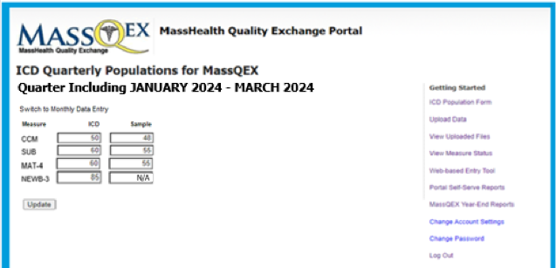

Figure 2 illustrates the ICD Monthly Population on the left-hand side of the portal screen that has been properly completed for quarter 3 in order to be in compliance with reporting requirements. The screenshot shows each measure listed (CCM, SUB, MAT-4, NEWB-3) by each monthly period data entered under the ICD column and under the Sample column. For NEWB-3, the sample will be automatically populated as not applicable (“N/A”), and hospitals will not be able to edit as there is not sampling allowed for this measure.
Figure 2. MassQEX Portal Monthly ICD Data Entry Form
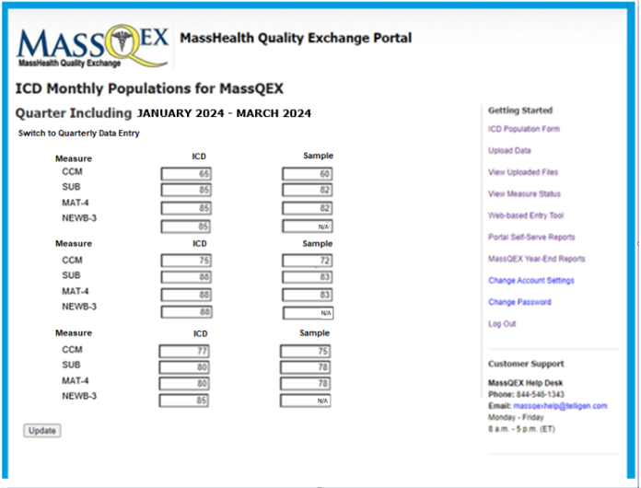

      - Data Transmittal Schedule. All data file uploads plus on-line ICD data entry must be completed by the close of business day (5 pm Eastern time) of published submission deadlines. The ICD data entry information should be submitted within fifteen (15) days of the close date of the data cycle and can be revised up until the final submission due dates noted in Section 1.E of this manual.
IMPORTANT NOTE: Hospitals may not request an extension of submission deadlines or request to resubmit corrections to data files or ICD data entry after the portal has closed. See Section 3.G of this manual for extraordinary circumstances that apply to data extension requests.

Portal Reports Repository
The web portal is equipped with a self-serve feature that provides users with summary information on XML data files uploaded to the MassQEX data warehouse for chart-abstracted measures. Online self-serve reports are generated for processing of test and production level data that can be viewed and printed in a PDF format.
MassQEX portal generates reports that provide feedback on content of submissions files uploaded into the portal environment. The report repository includes Input file reports plus two types of hospital summary reports that are described as follows.
Input Files Report. This report provides detailed information on specifications met for all test and production level data files submitted via the web portal to the MassQEX clinical data warehouse. These reports are available to both the hospital and data vendor for previously submitted data files and for both test and production submissions.
- To view the ‘Input Files Report’ the hospital or data vendor user will click on the “View Uploaded Files” link from the MassQEX portal home page. Clicking on this link will bring up the View Uploaded Files web page, which shows the last five file submissions to the MassQEX clinical data warehouse, including whether the data transmittal was a test or production data submission. Clicking on one of these submissions will bring up a list of the XML input files for that submission. From the “Input Files” screen, the user can click the “Print Report” link to generate the ‘Input Files Report’ for that submission.
- The ‘Input Files Report’ is available for all submissions, regardless of whether they are test or production submissions. Submitters of test data will find the reports useful because they will indicate where the submitted data is either incomplete or incorrect and will thus enable the user to correct their data files before submitting them as “production” data to the MassQEX clinical data warehouse. What follows is an example of an ‘Input Files Report’ generated from the portal and details on how to read the report.
Figure 3. Example of a MassQEX Portal Input Files Report
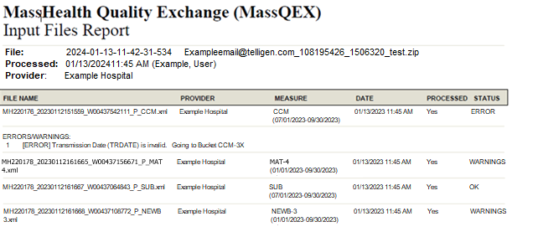
As shown in Figure 3, the MassQEX ‘Input Files Report’ contains the following information:
- File Name – the name of the XML file that was submitted
- Provider – the name of the submitting provider
- Measure – the appropriate MassQEX measure name (and the data submission quarter)
- Date – the date that the XML file was submitted
- Processed – indicates whether the file was processed
- Status – indicates if the file processing ended with an error, warning or an OK status.
In addition to this information, any warning or error messages resulting from data file submission will be displayed. The following messages will be generated, under the status column, when the data files contain either incorrect or incomplete information:
    - Error Message – is a “hard edit” – receiving such a message indicates that the file was incorrect or incomplete such that the submission was fatal, and the file was not accepted into the MassQEX clinical data warehouse. An error message identifies a problem with the file which needs to be corrected before resubmission by the hospital and/or vendor.
    - Warning Message – If the message was a warning (i.e. without the word “error” preceding it), then the message was a “soft edit” in which the file submission was not fatal, and the file was accepted into the MassQEX clinical data warehouse. Even though the file submission was accepted, the warning message is still provided to the submitter for educational purposes. These soft edits do not need to be corrected unless the submitter chooses to do so. In contrast, an error message informs the submitter that an error has occurred that has prevented the data file from being uploaded into the MassQEX clinical data warehouse.
    - OK Message - If message has OK status, then the data file was processed with no errors or warnings as previously described.
Hospitals and data vendors are responsible for reviewing all details on the “Input Files Report” to ensure specifications and data completeness are met as part of the submission cycle process.
2) Input Files Summary Reports. The MassQEX portal functionality allows hospitals and vendors to run data summary profile reports on demand. The portal generates two types of self-serve reports described as follows.
      - Measure Counts Report. This report summarizes aggregate information on the individual files uploaded to display overall counts of cases that met the numerator and denominator specifications for each measure as well as cases excluded from the denominator. The following is an example of the report generated from the portal and on how to read this report.
Figure 4. MassQEX Portal Measure Counts Report (Example)
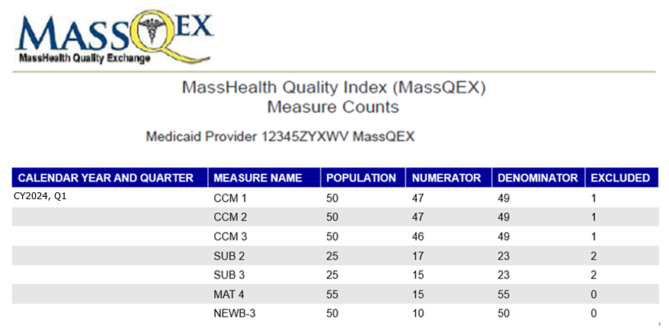

As shown in Figure 4, the ‘Measure Counts Report’ contains the following information:
- Calendar Year - the full (Jan-Dec) measurement period that apply to discharge data
- Quarter – the discharge data period that apply to quarters of a calendar year
- Measure – the measure ID as defined in the MassQEX portal
- Overall Population – the sum of the denominator and the excluded counts
- Numerator - the counts that met the criteria for inclusion in the measure numerator
- Denominator - the counts that met the criteria for inclusion in the measure denominator
- Excluded – the number of cases that did not meet the criteria for denominator
To view the ‘Measure Counts Report’, the user will click on the ‘Portal Self-Serve Reports’ link from the menu on the right side of the MassQEX portal home page. Clicking on this link leads to a web page that displays links to the ‘Input Files Report” and the new user-initiated reports. The user can specify report criteria such as calendar year and/or quarter, which allows reports to be generated for the calendar year reporting period being requested. From the screen, the user can click the “Print Report” link to generate the report.
The ‘Measure Counts Report’ is available for all data transmittals completed as part of the production level submissions. Hospitals will find this report useful because it provides an interim summary for cases that met the measure numerator and denominator specifications as files are submitted. This report is intended for MassQEX portal data management purposes only and does not represent the EOHHS hospital measure rate results used to calculate performance scores.
      - The ICD Population vs. Collapsed Upload Counts Report. This report aggregates and summarizes information on the ICD population data entered by the hospital with the actual uploaded cases that have been processed at the time of the submission cycle. The following is an example of the report and instructions on how to read this report.
Figure 5. MassQEX ICD Population Counts vs. Collapsed Upload Counts Report (Example)
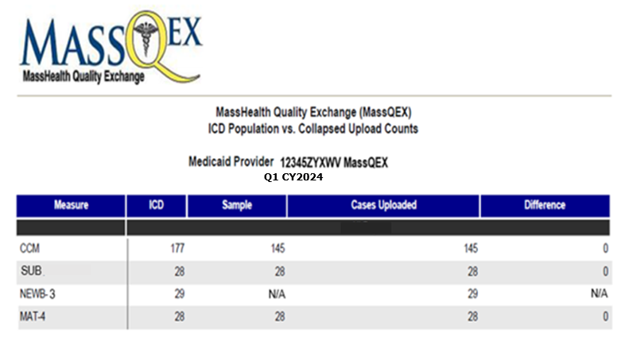

As shown in Figure 5, the ‘ICD Population vs. Collapsed Upload Counts Report’ displays the following information:
- Calendar Year - the full (Jan-Dec) measurement period that apply to discharge data
- Quarter – the discharge data period that apply to quarters of a calendar year
- Measure – the measure ID as defined in the MassQEX portal
- ICD – the hospital reported count case.
- Sample – the hospital reported count of cases sampled as defined in Section 5.
- Cases Uploaded - actual cases received and processed for production level data.
- Difference - the difference between sample counts entered compared to actual cases uploaded and processed for production level data. Note: For NEWB-3 “Difference” equals difference between ICD counts entered and cases uploaded.
To view the ‘ICD Population vs. Collapsed Upload Counts Report’ the user will click on the ‘Portal Self-Serve Reports’ link from the menu on the right side of the MassQEX portal home page. Clicking on this link leads to a web page that displays links to the ‘Input Files Report’ and the user-initiated reports. The user can specify criteria, such as calendar year and/or quarter, which allow reports to be generated for the calendar year reporting period being requested. From the screen, the user can click the “Print Report” link to generate a PDF of the report.
The ‘ICD Population vs. Collapsed Uploaded Counts Report’ is available for all data transmittals completed as part of the production level submissions. Hospitals and vendors will find this information to be useful because this report displays the difference between the two counts (sample and cases uploaded) and thus enables providers to identify when they have met their submission level obligations. This report is intended for MassQEX portal data management purposes only and does not represent the EOHHS hospital discharge data used to calculate payments.
      - Access to Portal Reports Repository. Hospitals are responsible for downloading and reviewing all details in the portal self-serve generated reports with their MassQEX registered users to ensure that data completeness requirements are met as part of each submission cycle process.

Data-Entry Measures Data Collection
There are four measures that require hospitals to use a web-based data-entry tool to report data annually:
- Aggregate Data-Entry Measures:
  - Safe Use of Opioids (OP-1e)
  - Screening for Metabolic Disorders (BHC-3)
  - Severe Obstetric Complications (SOC)
- Survey Data-Entry Measure:
  - Perinatal Structural Morbidity Measure (PMSM-1)
For the OP-1e, BHC-3, and SOC aggregate measures, eligible hospitals must complete and submit the same initial patient population, numerator, denominator, and exclusions that the hospital reports to CMS for the same data discharge period using the instructions that follow. No patient level data is submitted.
1) Web-Based Data-Entry Aggregate Measure (OP-1e, BHC-3, SOC):
        - Data-Entry Form
- Web-Based Data Entry Tool: All hospitals, except those with approved exemptions, must enter data for the OP-1e measure. Each hospital that is required to participate in the Perinatal Care Specialty Domain must enter data for the SOC data-entry measure. Each hospital that is required to participate in the Behavioral Health Specialty Domain must enter data for the BHC-3 data-entry measure. Hospitals must use the EOHHS approved web-based data entry tool located in the MassQEX secure portal. All hospitals will be prompted with an attestation of services or approved exemption prior to initiating data entry for each of the OP-1e, BHC-3 or SOC measures. Hospitals that attest to no services specific to the data entry measure will have met data entry requirements and the measure data entry screen will not be displayed. Hospitals that attest to an approved exemption will have met data entry requirements and the measure data entry screen will not be displayed. Hospitals that attest to relevant services with no exemption will proceed to the measure entry screen.
Data-entry measure results will be calculated using hospital submissions of aggregated initial population, numerator, denominator, and exclusion values based on all-payer data submissions to CMS for the IQR, IPFQR and TJC programs. Measures required to be reported using the web-based data entry format cannot be submitted via paper format, an XML file or other electronic format. Hospitals must attest that the data submitted for these elements is the same data they submit to CMS during the applicable discharge period.
- MassQEX Portal Users: Only MassQEX hospital staff users can access the web-based entry tool to submit data and complete the attestation form.
- Hospital Entry Preview: The MassQEX portal allows authorized users to store and print a draft of their item responses for review with their hospital quality team. Hospitals cannot change their responses after the MassQEX portal deadline closes. Hospitals may print a copy of their responses after submission.
- Annual Submission Due Date: Refer to Section 1E for submission deadlines.
Figure 6 demonstrates how to navigate to the data-entry tool. To navigate to the tool, hospitals will use the “Web-Based Entry Tool” link on the “Getting Started Menu” on the right side of the portal homepage. Figures 6 and 7 below demonstrate how to access the tool and an example of the data-entry tool and response formats.

Figure 6. Navigating to the Web-Based Entry Tools
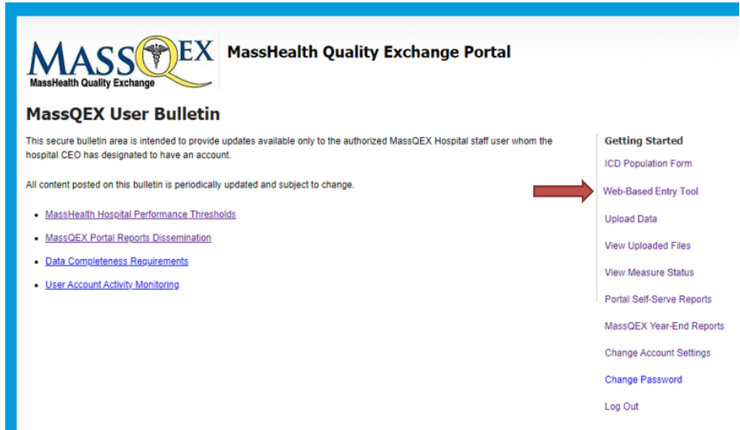
Figure 7. Web-Based Data Entry Tool – Aggregate Measures
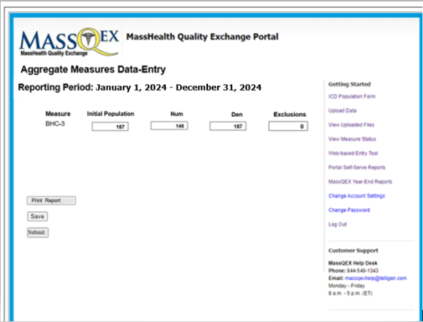
        - Aggregate Measure Data-Entry Measure Accuracy and Completeness
Hospitals must attest that the data submitted for the OP-1e, SOC, and BHC-3 measure is the same data they have submitted to CMS. There will be an attestation box following aggregate data-entry. Hospitals must enter a response to the attestation box to complete submission.
Authorized MassQEX hospital user staff who will submit responses via the portal must coordinate with their hospital staff to complete the aggregate data-entry. Hospitals are responsible for confirming the accuracy and completeness of responses prior to submitting the form.
For more information on the aggregate web-based data-entry measure specifications, see Section 7 of this manual.
2) Perinatal Morbidity Structural Measure Web-Based Data-Entry (PMSM-1)
All hospitals must complete and submit the PMSM-1 survey using the instructions that follow:
- Web-Based Data Entry Tool: Each hospital that is required to participate in the Perinatal Care specialty domain must enter the PMSM-1 survey item responses using the EOHHS approved web-based data entry tool located in the MassQEX secure portal.
- MassQEX Portal Users: The authorized MassQEX hospital staff users are the individuals that shall access the PMSM-1 web-based entry tool to submit the completed attestation form.
- Hospital Entry Preview: The MassQEX portal allows authorized users to store and print a draft of their item responses for review with their hospital Labor and Delivery Unit staff. Hospitals should allow ample time to review and correct their responses in the web-based entry tool prior to and until the annual PMSM-1 submission deadline. Hospitals cannot change their responses after the MassQEX portal deadline closes.
- Annual Submission Due Date: Refer to Section 1E for submission deadlines.
For more information on the PMSM-1 web-based data-entry survey measure specifications, see Section 7.C of this manual.

User Accounts Registration
The EOHHS Contractor (Telligen) will establish and manage all aspects of MassQEX portal user accounts system for hospitals participating in the MassHealth CQI Program in accordance with EOHHS Medicaid Acute Hospital RFA contract requirements. This includes validating each user registration form and monitoring MassQEX user activity. Steps to register a new user are as follows.
- Opening an Account: All hospitals must set up user accounts to access the secure web portal using the on-line registration form. Each hospital must identify the individual users that will be authorized to submit and conduct all data transactions on the hospital’s behalf. The users can be individuals from hospital staff and/or hospital third-party vendors.
- Account Limits: EOHHS sets a maximum limit of user accounts that the hospital can identify as the registered user.
  - The hospital can identify a maximum of five (5) accounts for hospital staff users and a maximum of three accounts for hospital third-party data vendors.
  - All designated individuals must be identified on the MassHealth Hospital Quality Contact Form submitted to EOHHS each rate year.
  - Newly identified users must complete user registration requirements described in this section to gain access to the secure web portal.
- Completing User Registration Forms: The new user must complete a registration form. The hospital chief executive officer (CEO) must sign the form to authorize the individual designated to be the registered user for that hospital site.
Only the following forms of signature will be accepted:
- (Preferred method) Electronic signature affixed using a digital tool such as Adobe Sign or DocuSign; or
- Electronic signature that is:
- Hand drawn using a mouse or finger if working from a touch screen device; or
- An uploaded picture of the signatory’s hand drawn signature.
- Traditional “wet signature” (ink on paper); print out one original of the signature page, have an authorized signatory sign it, and scan the signed page.
Note to Vendors: A vendor user registers only once and receives one account that allows access to all hospitals represented by the vendor. A copy of each vendor user registration form (page 1) must be submitted to the hospital CEO for signature for each hospital represented.
Email Submission for the User Registration Form. All completed registration forms must be emailed to the following EOHHS Contractor address listed below for the account to be activated.
Email Completed Forms to: massqexhelp@telligen.com
- Logging into the System. The portal provides instructions for setting up a password and is equipped with a ‘forgot my password’ option that will have the following functionality:
- A temporary password, valid for one time use, will be transmitted to the user’s registered email account after successfully answering three randomly selected security questions.
- The temporary password will expire if it is not used within four hours.
- Upon logging into the system, the user will be required to choose a new password.
- Maintaining User Accounts: Hospitals designate authorized Users to transmit data, which contains protected health information, in accordance with HIPAA standards. All hospitals are required to actively monitor and maintain their secure portal User accounts during each Acute RFA contract rate year, including when any changes to hospital staff or vendors occur. The EOHHS Contractor (MassQEX) monitors all user account activity as follows:
- Inactive Accounts- defined as a user account that has not been logged into by the hospital or data vendor registered user over an extended period of time. The MassQEX portal sends notification after the annual review stating that no user activity has been detected and that the account must be logged into within 30 days or it will be closed. Upon the 30-day deadline, if no activity is detected the account will be closed. The user must restart a new MassQEX registration using the preceding instructions.
- Disabled Accounts- defined as a user account that is locked during attempted log-in with an incorrect password. An email is generated from the MassQEX Portal to the user alerting them the account has been disabled, the registered user must contact the MassQEX Help Desk to reset the account.
- Unusual Account Activity- defined as an account where the hospital CEO authorized users have provided access to their user ID and password to any individuals other than the one authorized by the hospital CEO in their registration form. This type of activity is immediately reported to EOHHS and the account is automatically disabled and suspended.

Customer Support
1) EOHHS MassHealth provides technical support for all registered portal users. The MassQEX Contractor is available to work with hospital staff and third-party data vendors to assist in the implementation of technical data collection and transmittal procedures outlined in this manual.
MassQEX Helpdesk – the customer support contact information follows.
- Phone: The toll free number is (844) 546-1343. This line is answered by a live person who will request a description of inquiry and initiate a help desk ticket. The inquiry is triaged to a clinical or technical staff. A response is sent via email or a call is returned.
- Helpdesk Email: massqexhelp@telligen.com All inquiries will initiate a help desk ticket.
- Business Hours: 8:00 a.m. – 5:00 p.m. (Eastern Time). Business hours are Monday to Friday. Inquiries are addressed within one business day.
2) MassQEX List-Serve. MassQEX will share list-serve updates to all registered MassQEX authorized users and SFTP users (when content is applicable to medical record requests). List servs provide updates on portal system functionality enhancements, updates to measure specifications, status of portal production timelines, posting of updated content in secure bulletins and other program related activities. Individuals not authorized as portal users may also register for the list-serve by sending a request to the MassQEX Help Desk at: massqexhelp@telligen.com
3) Hospital Third-party Data Vendors. Hospitals can identify and authorize third-party vendors to conduct electronic data transactions via the MassQEX secure portal, on the hospital’s behalf.
The Medicaid Acute RFA contract stipulates that hospitals are responsible for communicating directly with their data vendors on all aspects of MassHealth hospital data collection and reporting requirements, including adherence to the appropriate versions of the EOHHS Technical Specifications Manual. This is to ensure data completeness and accuracy of electronic data files are submitted on the hospital’s behalf.
It is recommended that hospitals review all portal repository reports with their data vendors to identify errors, warnings or inconsistencies that can be corrected before the close of each submission cycle. The MassQEX Helpdesk is available to assist hospitals and data vendors in interpreting the self-serve reports generated by the portal.

Extraordinary Circumstance Exception
Each rate year the Acute Hospital RFA contract outlines quality data reporting requirements all hospitals must meet to be eligible for incentive payments under the MassHealth Hospital Quality Program. EOHHS acknowledges that extraordinary circumstances can arise during the rate year which may impede the hospitals’ ability to meet quality reporting deadlines outlined in the Rate Year 2024 Acute Hospital RFA. The conditions and procedures that apply to submitting quality reporting data exceptions follow.
- Provision for Data Exceptions. A hospital can request an exception to Acute RFA quality reporting deadlines when it has experienced circumstances that are beyond the control of the hospital facility, which may include but are not limited to, the following definitions:
- Extraordinary Circumstance: a natural disaster, catastrophic event or act of nature (hurricane, tornado, floods, fires, etc.) that results in shut down of the hospital and/or data vendor facility operations thereby affecting the hospital’s ability to complete the work required to meet a quality reporting deadline. This type of circumstance does not preclude EOHHS from granting exceptions for other hospitals that may be affected across a specific state region or locale.
- Unusual Circumstance: in the event that EOHHS agency and/or its Contractor (MassQEX) experience a problem with data collection systems (e.g.: building power outages, internet provider interruptions, phone service provider interruptions, etc.) that directly affects the hospital’s ability to submit data via the MassQEX portal or access customer helpdesk during an active quarter reporting submission cycle. Other unusual circumstances where meeting the quarterly reporting deadlines is beyond the control of the hospital may be considered (e.g.: newly enrolled Medicaid hospitals in current rate year, national public health emergency, etc.).
- Non-Applicable Circumstances: quality reporting exceptions do not apply to a request for resubmission to correct data files that were incomplete or incorrectly submitted during a quarter reporting cycle after the portal has closed. Data exceptions do not apply to a request for resubmitting chart record data that were incomplete after the quarter specific timelines. Data exceptions are not granted for issues related to aforementioned unusual circumstances definition or events such as burst water pipes, temporary electrical outages, hospital or data vendor staff turnover as these circumstances are manageable and within the control of the hospital. Lastly, data exceptions do not apply to calendar year quarter data cycles associated with prior Acute RFA contract rate year payment requirements.
- Provision for Data Extension. A hospital request for data extension to a specific quarter reporting deadline must meet the aforementioned extraordinary circumstances definition and timelines specified above and in the RY2024 CQI Forms Reporting Instruction document located on the Mass.gov website here: https://www.mass.gov/info-details/masshealth-cqi-program-participant-documents. EOHHS considers various factors prior to granting a data extension that include, but are not limited to, the impact on current active open submission cycle and timely re-programming of portal technology specifications for prospective quarter reporting cycles.
Should EOHHS make a determination to change a published Acute RFA quality reporting deadline that impacts all hospitals, then such decision will be communicated to hospital key quality contacts using standard methods (e.g.: EOHHS business email, memos, MassQEX list-serve, Mass.Gov website posting, etc.) including an Amendment to the Acute RFA rate year contract as applicable.
- Provision for Approved Exception. Hospitals that are granted data exceptions for specific quarter reporting cycles must comply with the ICD population entry requirements outlined in Section 3.B of this EOHHS Manual. The hospital must enter zeros (0) to confirm that no data was reported using the online ICD entry form. Failure to enter zeros will result in non-compliant status. In addition, hospitals that are granted data exceptions should be aware that such exemptions can and likely will impact the criteria to be eligible for comparison year performance scoring and incentive payment that apply to each Acute RFA rate year contract.
- EOHHS Request Procedure. Hospitals must adhere to following procedures to request a data exception for EOHHS agency consideration specific to the Acute RFA contract period:
- MassHealth Extraordinary Circumstance Request (MHECR) Form: The hospital must submit a written request using the “MHECR Form” with all the following required information:
- Type of Request - specify the type of data exception (exemption vs. extension), the affected measures and quarter data periods indicated, reporting deadline, applicable chart records;
- Describe Circumstance – explain the extraordinary circumstance and date of occurrence;
- Reason for Request – why the quarter period data exception is needed, explain how the extraordinary event impeded the hospital from being able to meet reporting requirement;
- Supporting Documents – include evidence of the event occurrence (e.g.: media articles, photos, relevant web links, etc.) that is required for EOHHS MassHealth agency review. Failure to attach supporting documents will delay the review process.
The updated “MHECR Form” must be downloaded from the Mass.Gov website at: https://www.mass.gov/info-details/masshealth-cqi-program-participant-documents?auHash=eELTiKB70xGlOqqeSwf6a-LMqYU3-jh__z0gp-0BCFI

- Timeline to Submit Request: The hospital must notify EOHHS directly of intent to submit a request for a data exception within ten (10) calendar days of the date that the extraordinary circumstance event occurred. At the latest, the MHECR form packet must be received no later than 60 days from the last date of the quarter data period exception requested (e.g.: if last date of Q3 period is September 30 then the request should be submitted no later than November 30).
Table 3-1: RY2024 Extraordinary Circumstance Request Timelines
Quarter Reporting Period | Acute RFA2024  Submission Deadlines | Hospital ECE Request Form Due Date
Q4-2023 (Oct 1, 2023 – Dec 31, 2023) | May 10, 2024 | Feb 29, 2024
Q1-2024 (Jan 1. 2024 – Mar 31, 2024) | Aug. 09, 2024 | May 31, 2024
Q2-2024 (Apr 1, 2024 – June 30, 2024) | Nov 1, 2024 | Aug 30, 2024
Q3-2024 (July 1, 2024 – Sept 30, 2024) | Feb 7, 2025 | Nov 29, 2024
Q4-2024 (Oct 1, 2024 – Dec 31, 2024) | May 9, 2025 | Feb 28, 2025
- Submitting Your Request Packet: The original packet must include a typed cover letter on hospital stationery summarizing enclosures, the completed “MHECR Form” with hospital CEO signature plus supporting documentation submitted to the EOHHS business mailbox at Masshealthhospitalquality@mass.gov.
- EOHHS Notification Process: EOHHS will confirm receipt of the hospital’s request via email sent to the hospital key quality representative. The EOHHS final written decision on the request for data reporting exception will be sent to the hospital CEO and key quality representative designee. Non-adherence to terms of acceptance will NULLIFY the initial granted request.

Section 4. Chart-Abstracted Measures Specifications

Care Coordination and Integration of Care Domain
Care coordination is the deliberate organization of care delivery activities between providers, patients, and health system components designed to improve quality and efficiency of healthcare. Care coordination measures are intended to capture a broad cross-section of diagnoses and reasons for admissions that must include patients discharged from any hospital inpatient facility unit. Refer to the initial patient population algorithm for identification of the included population.

1. Reconciled Medication List Received by Discharge Patient (CCM-1)
Measure Name: Reconciled Medication List Received by Discharge Patient (CCM-1)
Description: Percentage of patients discharged from an acute hospital inpatient facility to home or any other site of care, or their caregiver(s), who received a reconciled medication list at the time of discharge including, at a minimum, medications in the specified categories (continued, new, discontinued).
Numerator statement: Patients or their caregiver(s) who received a reconciled medication list at the time of discharge.
Data Elements:
- Reconciled Medication List
Denominator statement: Patients discharged from any unit of the acute hospital inpatient facility (e.g.: medical, surgical, rehab, psychiatric, obstetrics, etc.) to home/ self-care or any other site of care.
Excluded population:
- Patients less than 2 years
- Patients greater than or equal to 65 years of age
- Patients who died
- Patients who left against medical advice (AMA) or discontinued care
Risk adjustment: No
Data Collection Approach: Retrospective data sources for required data elements include administrative and medical records. See data abstraction tool (Appendix A-1) and data dictionary (Appendix A-8) of this manual for detailed instructions.
Measure Type: Process Measure
Data Accuracy: Variation may exist in documentation provided at the time of transition and documentation of transmission time; therefore, medical record documentation processes may require evaluation.
Measure analysis suggestion: Data could be analyzed further to determine specific patterns or trends.
Sampling: Yes. Refer to Section 5 for details on sample size requirements.
Data reported as: Aggregate rate generated from count data.
Improvement noted as: An increase in the rate
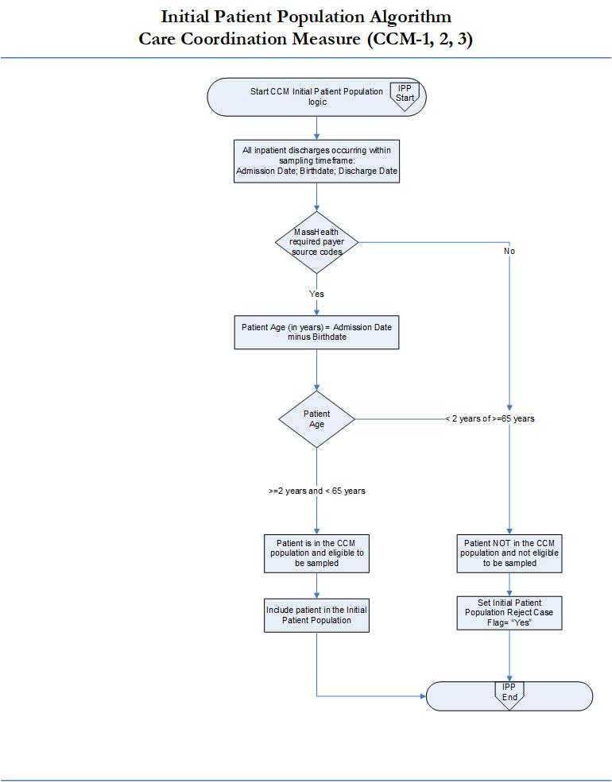
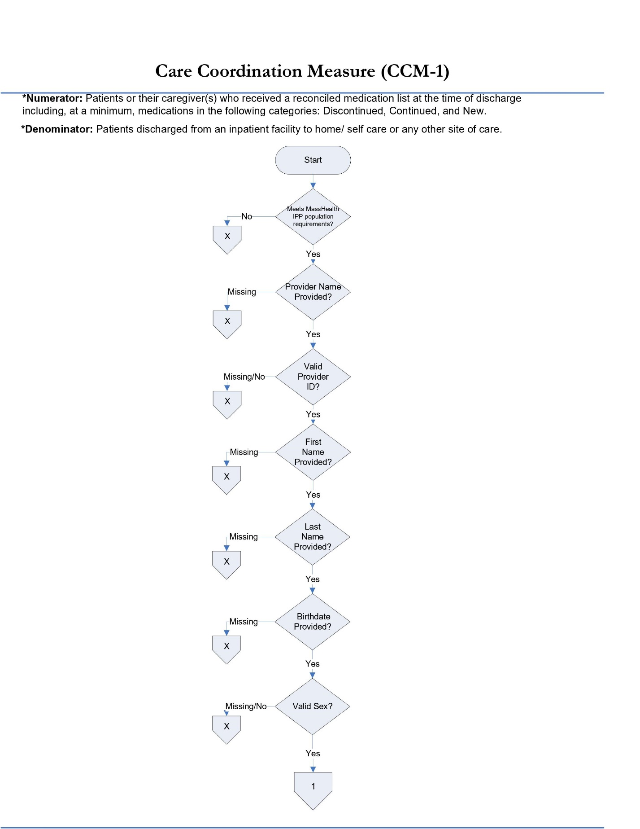
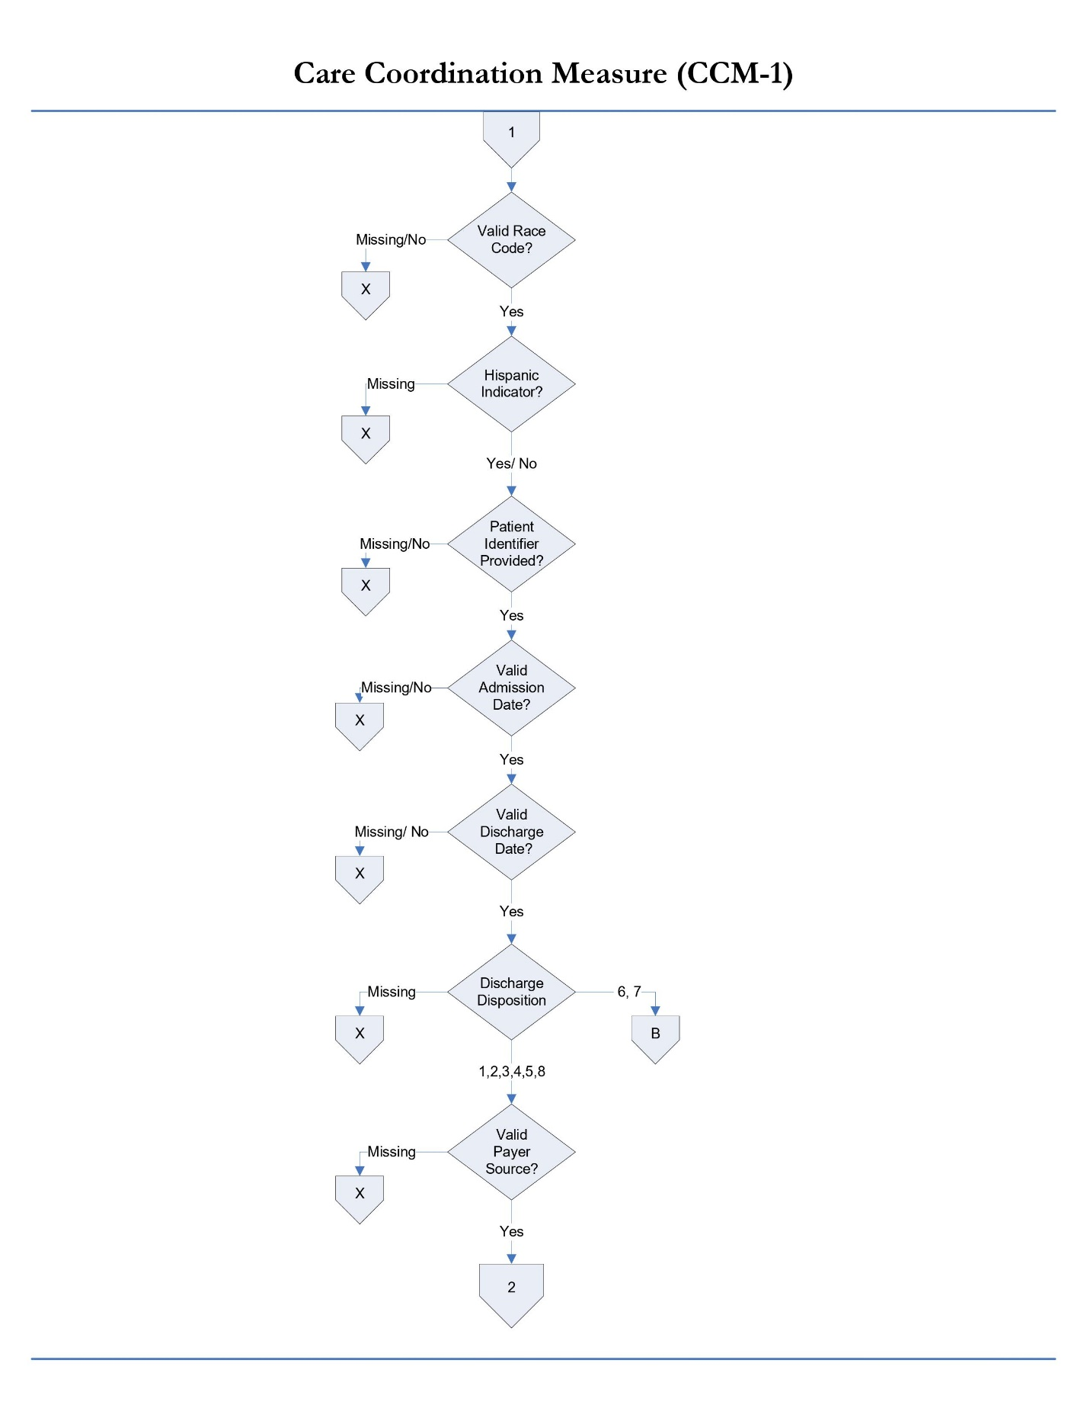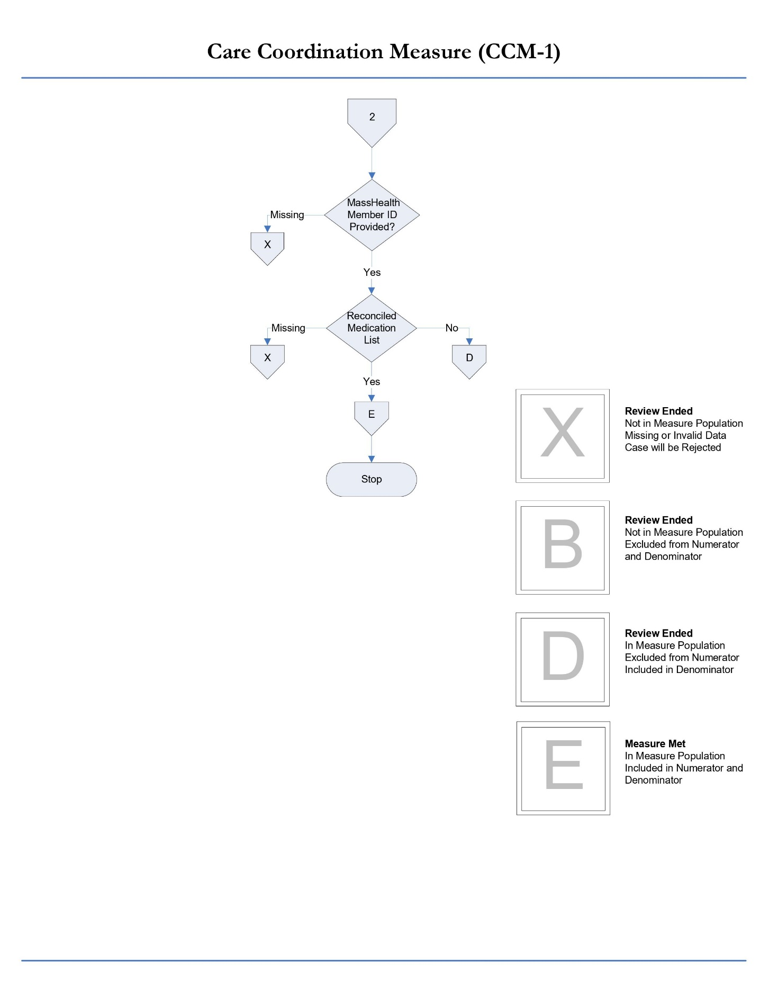
Contact the MassQEX Help Desk at massqexhelp@telligen.com if you require assistance to interpret the content of the measure flowcharts in this section of the manual.

2. Transition Record with Specified Elements Received by Discharge Patient (CCM-2)
Measure Name: Transition Record with Specified Elements Received by Discharge Patient (CCM-2)
Description: Percentage of patients discharged from an acute inpatient facility to home or any other site of care, or their caregiver(s), who received a transition record (and with whom a review of all included information was documented) at the time of discharge including all of the specified elements.
Numerator statement: Patients or their caregiver(s) who received a transition record (and with whom a review of all included information was documented) at the time of discharge including, at a minimum, all of the specified data elements.
Data Elements:
- Transition Record
- Reason for Inpatient Admission
- Medical Procedures and Tests Performed During Inpatient Stay and Summary of Results
- Discharge Diagnosis
- Current Medication List
- Studies Pending at Discharge
- Patient Instructions
- Advance Care Plan
- Contact Information 24 hrs./ 7 days
- Contact Information for Studies Pending
- Plan for Follow up care
- Primary Physician or Other Health Care Professional Designated for Follow up care
Denominator statement: Patients discharged from any unit of the acute hospital inpatient facility (e.g.: medical, surgical, rehab, psychiatric, obstetrics, etc.) to home/ self-care or any other site of care.
Excluded population:
- Patients less than 2 years
- Patients greater than or equal to 65 years of age
- Patients who died
- Patients who left against medical advice (AMA) or discontinued care
Risk adjustment: No
Data Collection Approach: See data abstraction tool (Appendix A-1) and data dictionary (Appendix A-8) of this manual for detailed instruction.
Measure Type: Process Measure
Data accuracy: Variation may exist in documentation provided at the time of transition and transmission time; therefore, medical record documentation processes may require evaluation.
Measure analysis suggestion: Review specific patterns or trends for missing data elements.
Sampling: Yes. Refer to Section 5 for details on sample size requirements.
Data reported as: Aggregate rate generated from count data.
Improvement noted as: An increase in the rate.
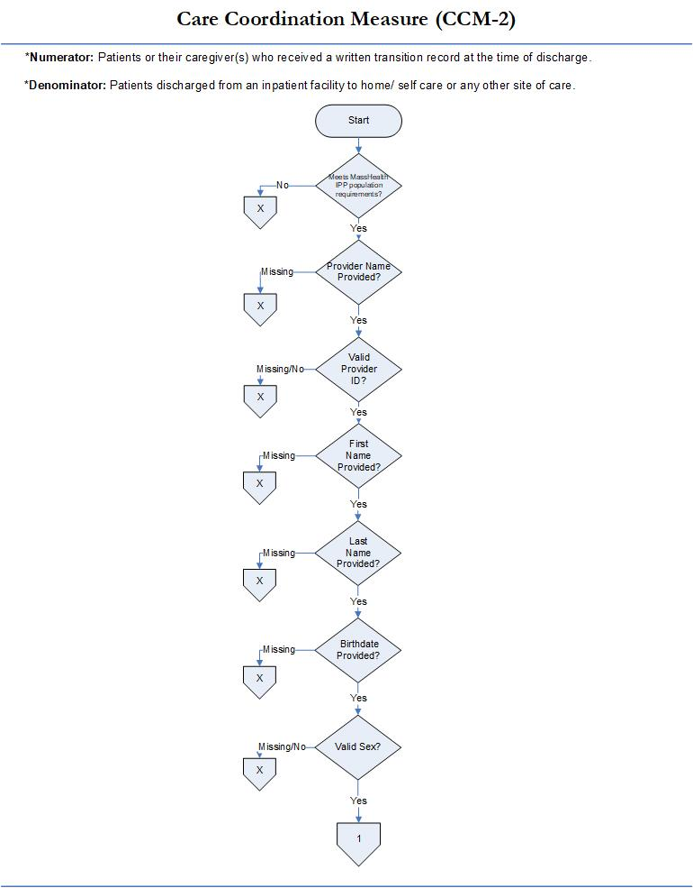

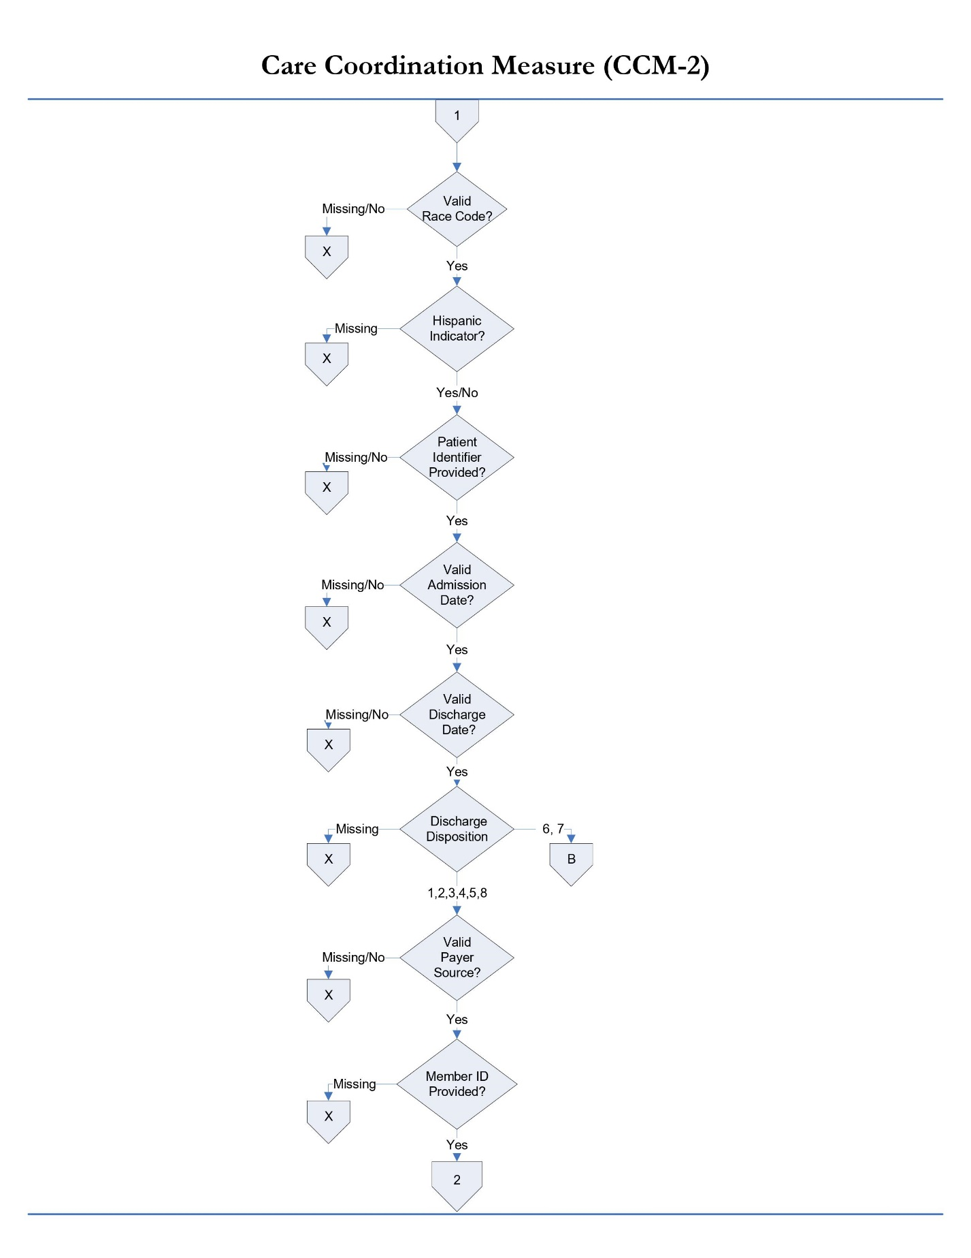
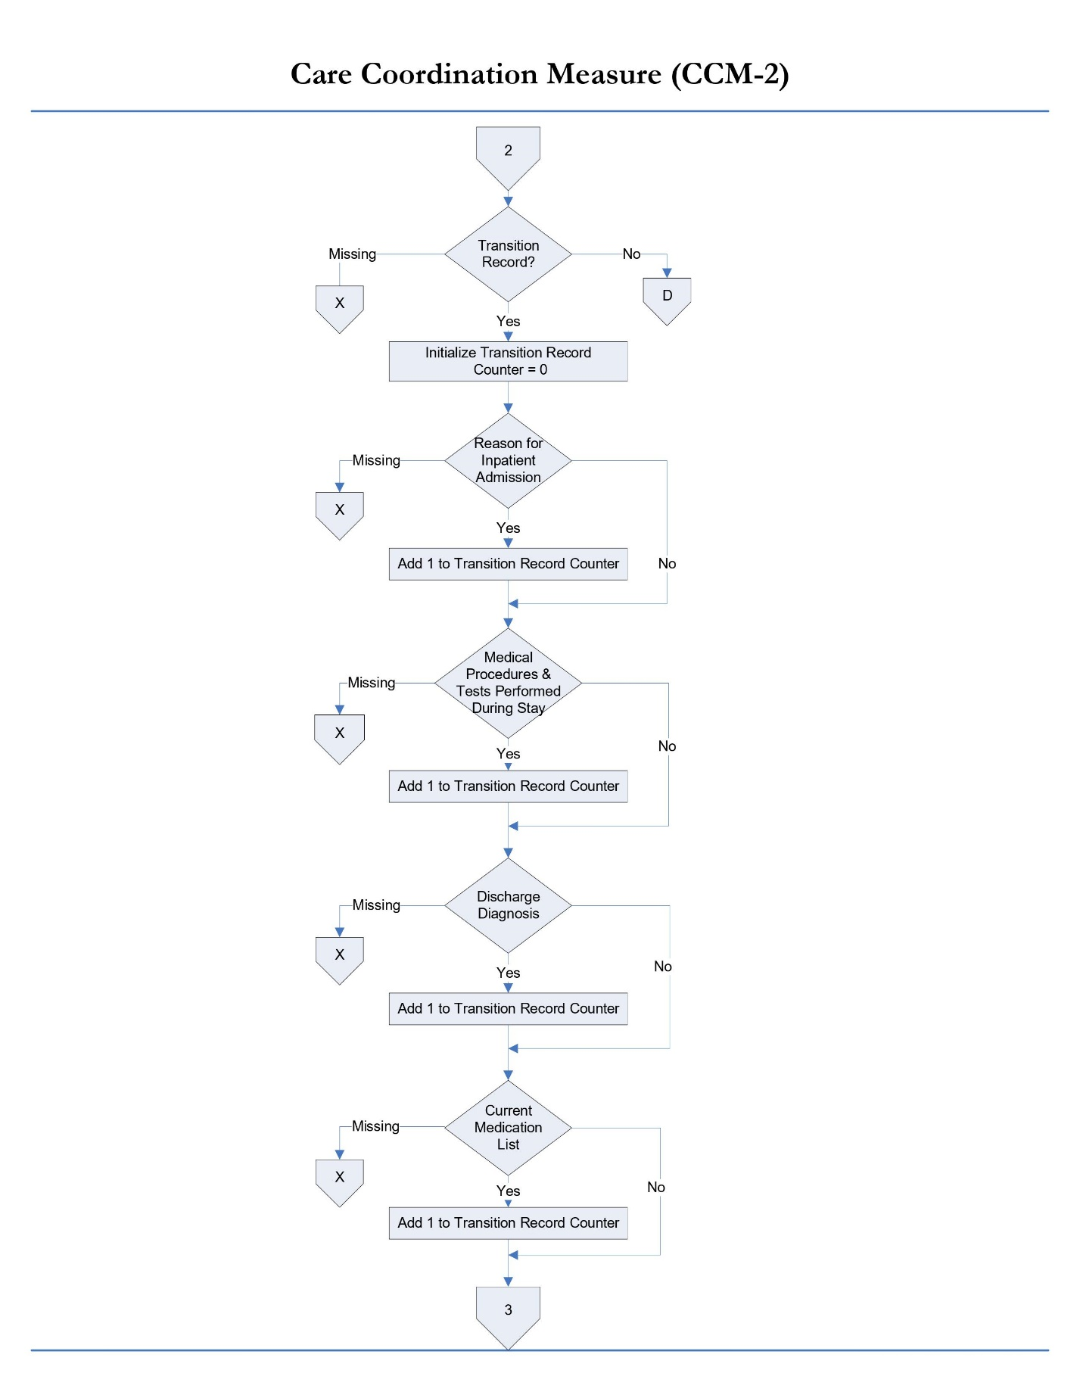
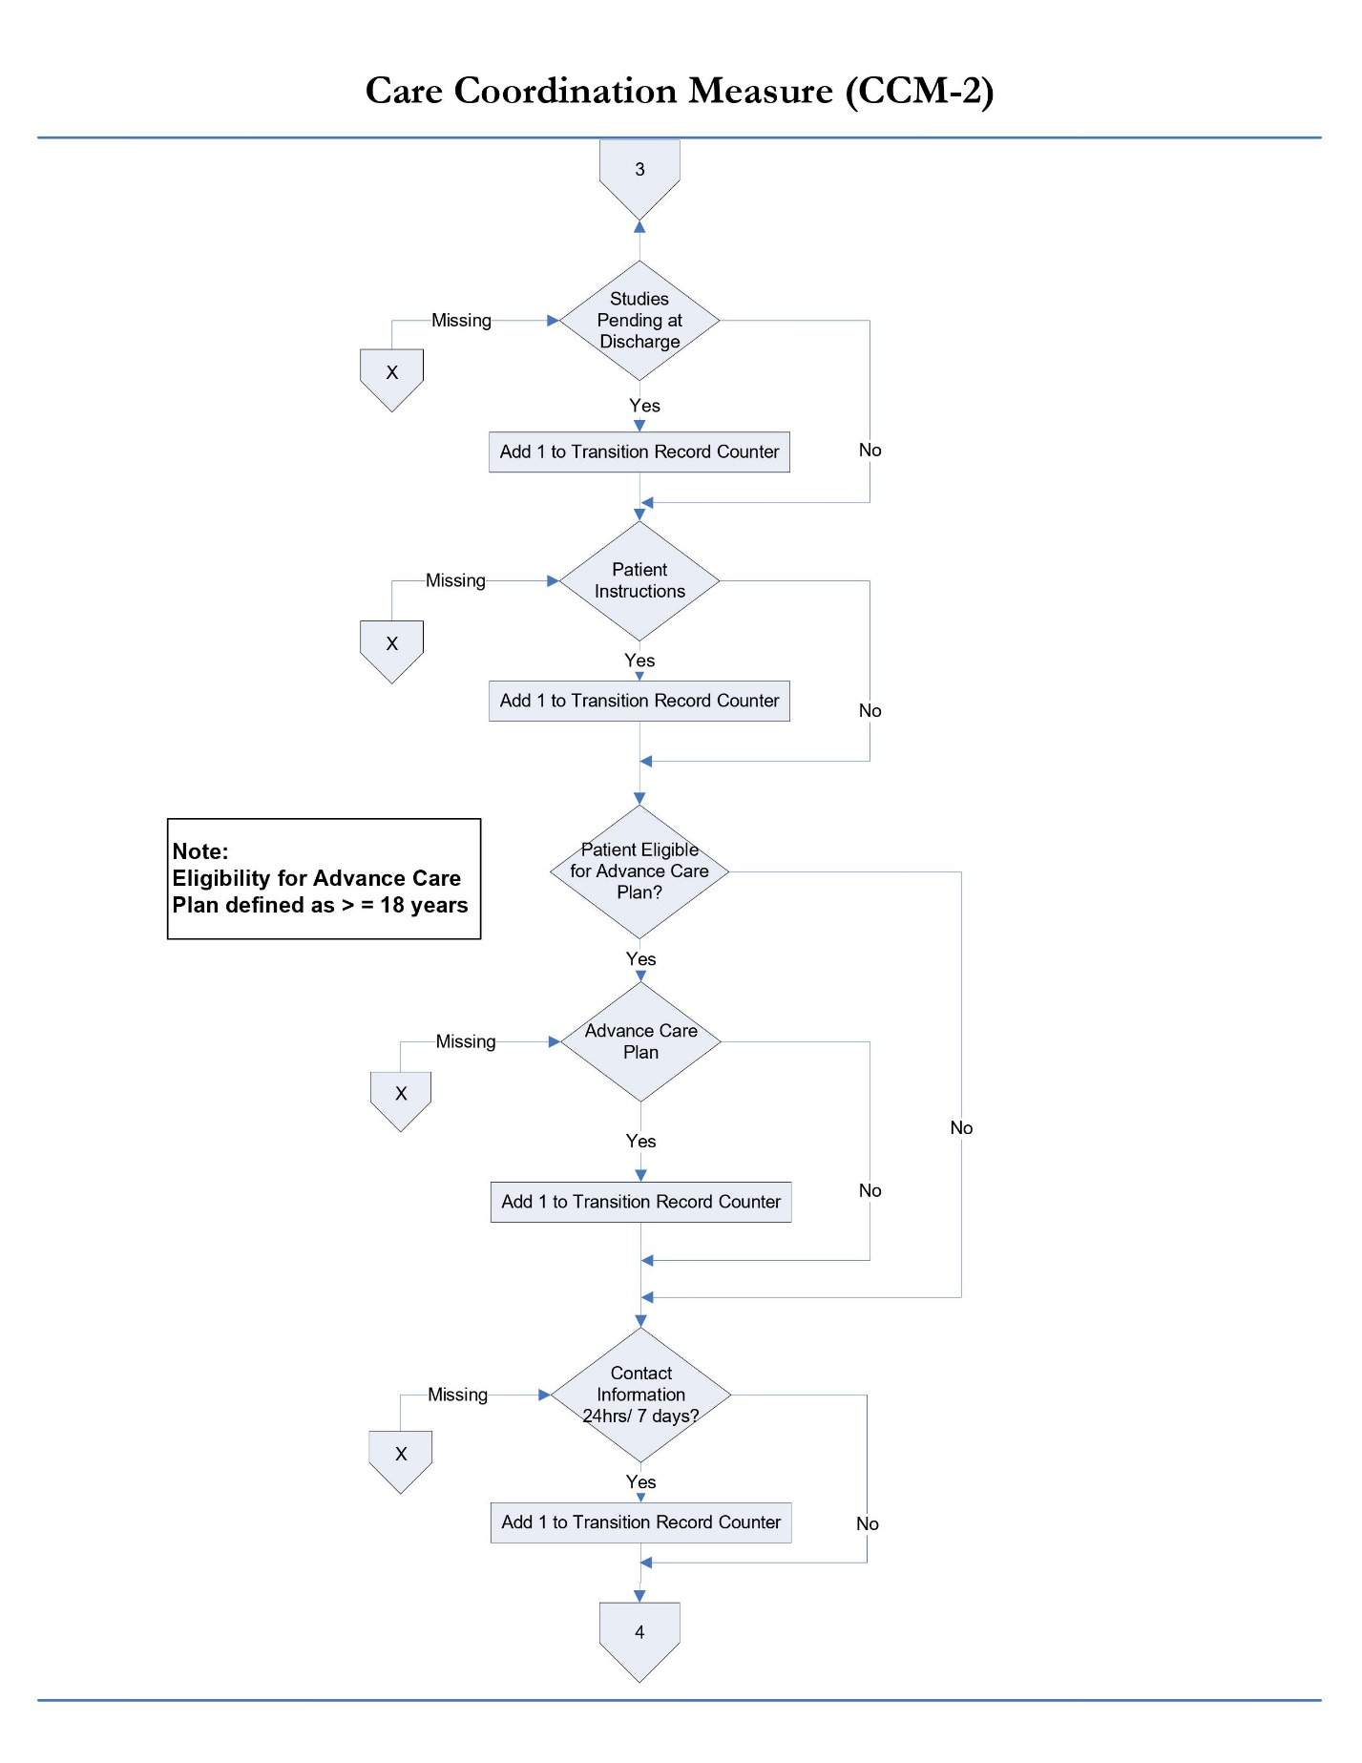
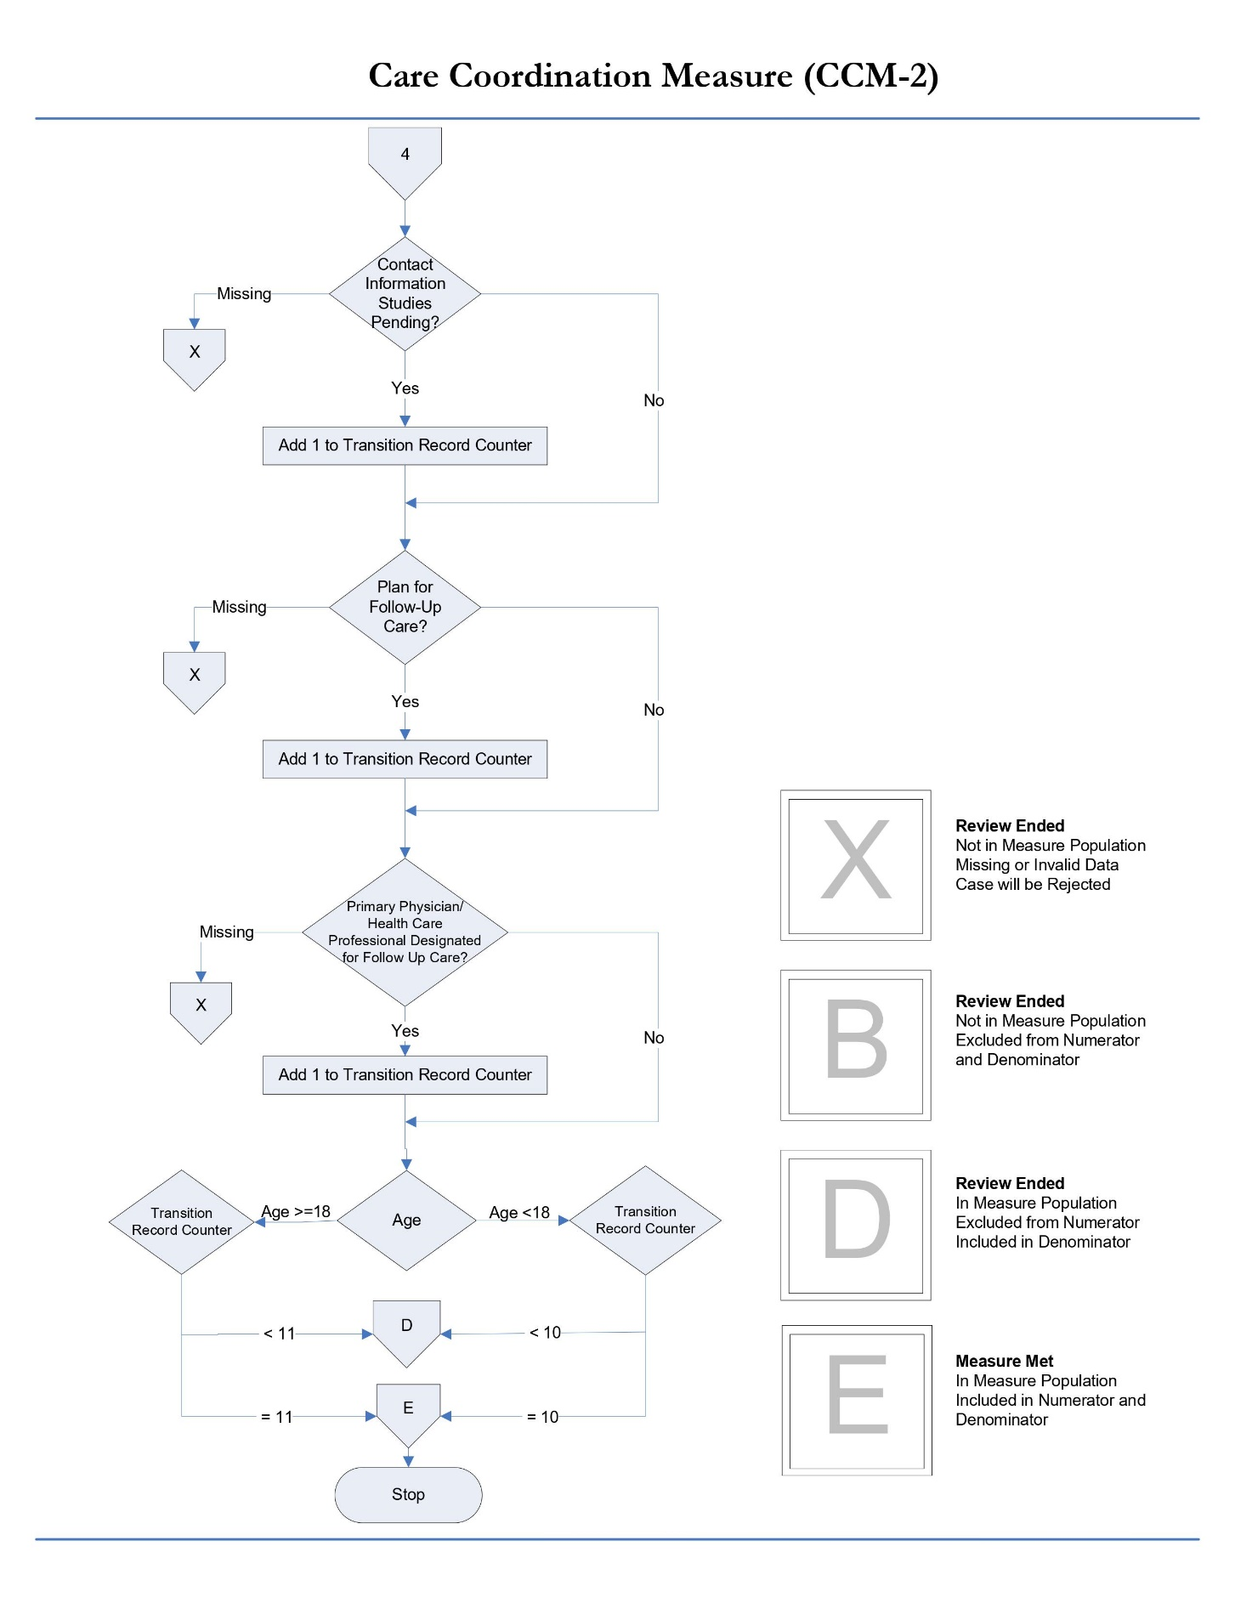
Please contact the MassQEX Help Desk at massqexhelp@telligen.com if you require assistance to interpret the content of the measure flowcharts in this section of the manual.

3. Timely Transmittal of Transition Record (CCM-3)
Measure Name: Timely Transmittal of Transition Record (CCM-3)
Description: Percentage of patients discharged from an acute hospital inpatient facility to home or any other site of care for whom a transition record was transmitted to the facility or primary physician, or other health care professional designated for follow-up care within 2 days of discharge.
Numerator statement: Patients for whom a transition record was transmitted to the facility or primary physician, or other health care professional designated for follow-up within 2 days of discharge.
Data Elements:
- Discharge Date
- Transmission Date
- Patient Refusal of Transmission
Denominator statement: Patients discharged from any unit of the acute hospital inpatient facility (e.g.: medical, surgical, rehab, psychiatric, obstetrics, etc.) to home/ self-care or any other site of care.
Excluded population:
- Patients less than 2 years
- Patients greater than or equal to 65 years of age
- Patients who died
- Patients who left against medical advice (AMA) or discontinued care
- Patients who refused transmission of transition record
Risk adjustment: No
Data Collection Approach: Retrospective data sources for required data elements include administrative and medical records. Refer to data abstraction tool in Appendix A-1 and data dictionary in Appendix A-8 of this manual for detailed instructions.
Measure Type: Process Measure
Data accuracy: Variation may exist in documentation provided at the time of transition; therefore, medical record documentation processes may require evaluation.
Measure analysis suggestion: Data could be analyzed further to determine specific patterns or trends.
Sampling: Yes. Refer to Section 5 for details on sample size requirements.
Data reported as: Aggregate rate generated from count data.
Improvement noted as: An increase in the rate.

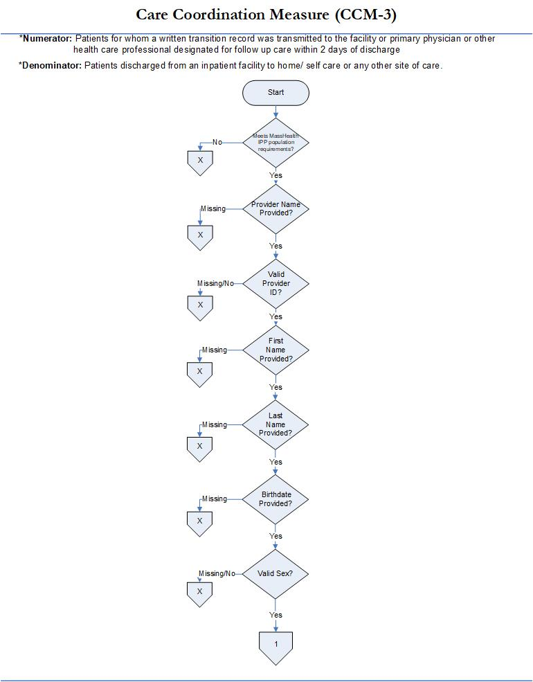

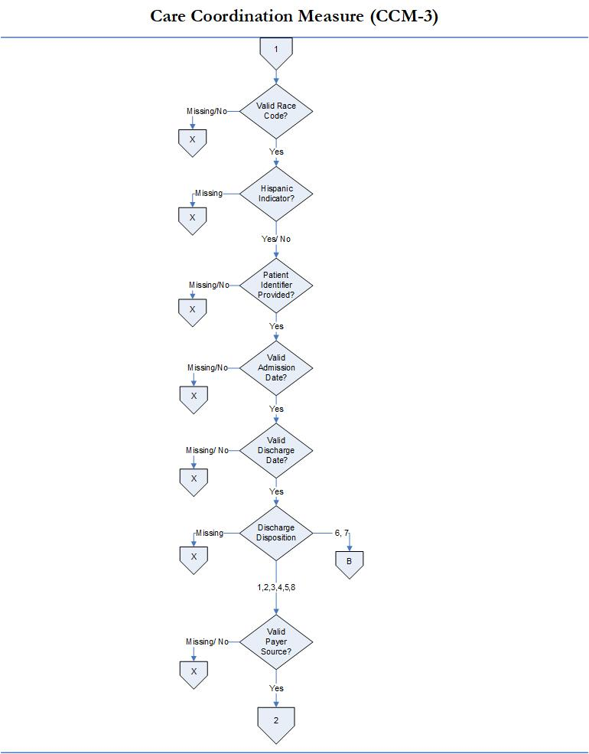

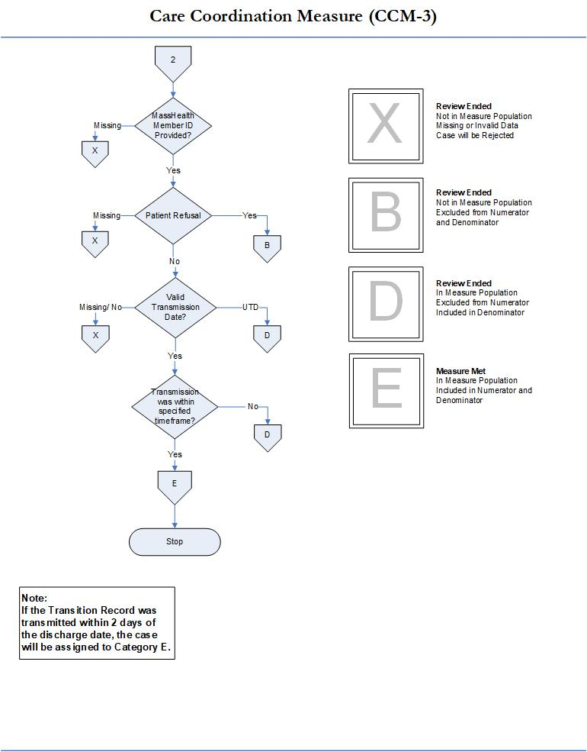

Care for Acute and Chronic Conditions Domain
For MassHealth reporting purposes, the “Initial Patient Population” (also termed ICD population) for the Alcohol Use treatment measures shall include all Medicaid patients 18 years of age or older with less than or equal to 120 days length of stay who were discharged from any acute inpatient care setting (medical, surgical, obstetrical, rehab, psychiatric, etc.) that received care for a given condition. Measure collection is required for all acute care hospitals with or without a behavioral health unit.

1. Alcohol Use Brief Intervention Provided or Offered (SUB-2)
Measure Name: Alcohol Use Brief Intervention Provided or Offered
Description: This measure is reported as an overall rate which includes all patients to whom a brief intervention was provided or offered and refused. The SUB-2 rate describes the patients who screened positive for unhealthy alcohol use who received or refused a brief intervention during the hospital stay.
Numerator Statement: The number of patients who received or refused a brief intervention.
Included in Population: Patients who refuse/decline the offered brief intervention
Excluded Population: None
Data Elements:
- Brief Intervention
Denominator Statement: The number of hospitalized inpatients 18 years of age and older who screened positive for unhealthy alcohol use or an alcohol use disorder (alcohol abuse or alcohol dependence).
Included Population: Not applicable
Excluded Population
- Patients less than 18 years of age
- Patients who are cognitively impaired
- Patients who refused screening for Alcohol Use status during the hospital stay
- Patients who have a duration of stay less than or equal to one day or greater than 120 days
- Patients receiving Comfort Measures Only documented
Data Elements:
- Admission Date
- Alcohol Use Status
- Birthdate
- Comfort Measures Only
- Discharge Date
Risk Adjustment: No.
Data Collection Approach: See data abstraction tool (Appendix A-2) and data dictionary (Appendix A-8) of this manual for detailed instruction.
Type of Measure: Process
Data Accuracy: See TJC Core Specifications Manual for applicable discharge period for detail that apply.
Sampling: Yes. Refer to Section 5 for details on sample size requirements.
Data Reported As: Aggregate rate generated from count data reported.
Improvement Noted as: Increase in rate
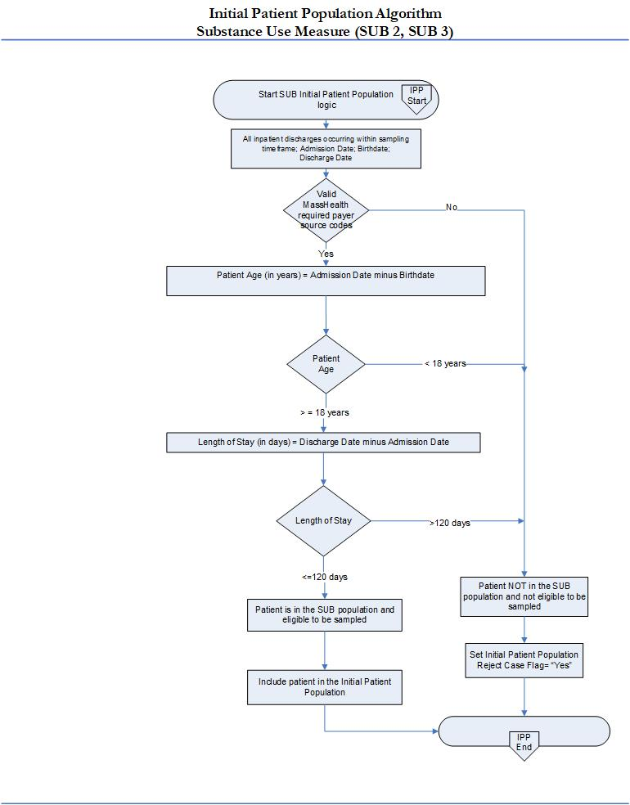
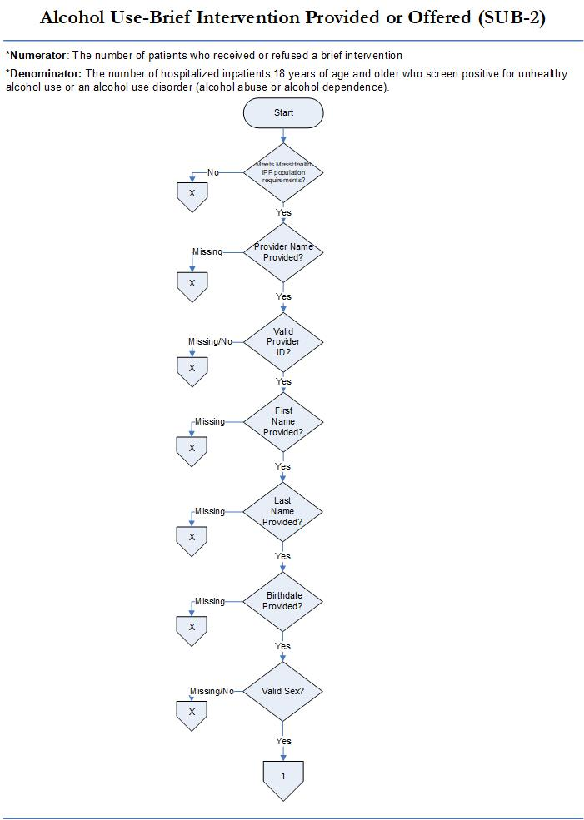
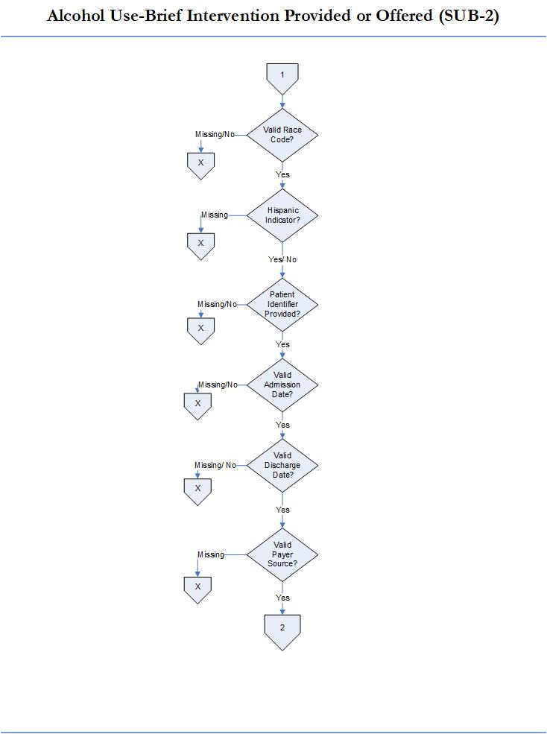

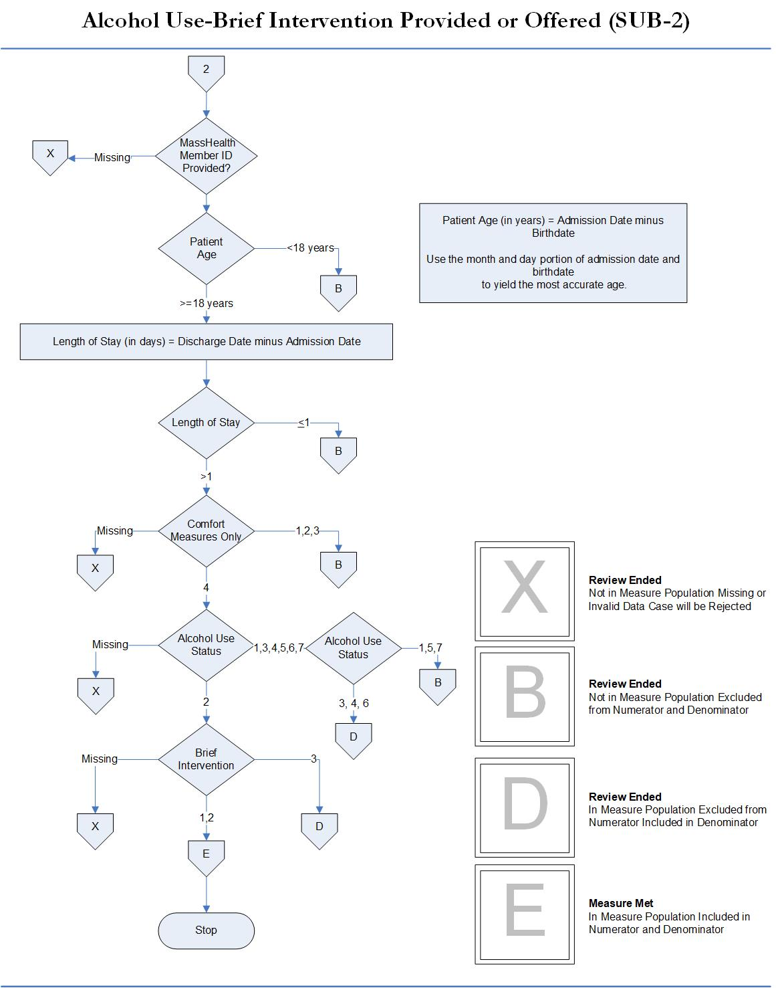

2. Alcohol & Other Drug Use Disorder Treatment Provided or Offered at Discharge (SUB-3)
Measure Name: Alcohol & Other Drug Use Disorder Treatment Provided or Offered at Discharge
Description: Patients who are identified with alcohol or drug use disorder who receive or refuse at discharge a prescription for FDA-approved medications for alcohol or drug use disorder, OR who receive or refuse a referral for addictions treatment.
Numerator Statement - The number of patients who received or refused at discharge a prescription for medication for treatment of alcohol or drug use disorder OR received or refused a referral for addictions treatment.
Included Populations: Patients who refused a prescription for FDA-approved medication for treatment of an alcohol or drug dependence. Patients who refused a referral for addictions treatment.
Excluded Populations: None
Data Elements:
- Prescription for Alcohol or Drug Disorder Medication
- Referral for Addictions Treatment
Denominator Statement - The number of hospitalized inpatients 18 years of age and older identified with an alcohol or drug use disorder.
Included Population
- Patients with ICD-10-CM Principal or Other Diagnosis Code for alcohol or drug use disorder listed on Table 13.1 and 13.2 of the Specifications Manual for Joint Commission National Core Measures
- Patients with a Principal or Other ICD-10-PCS Procedure Code listed on Table 13.3 of the Specifications Manual for Joint Commission National Core Measures
Excluded Population
- Patients less than 18 years of age
- Patient drinking at unhealthy levels who do not meet criteria for an alcohol use disorder
- Patients who are cognitively impaired
- Patients who expire
- Patients discharged to another hospital
- Patients who left against medical advice
- Patients discharged to another healthcare facility
- Patients discharged to home or another healthcare facility for hospice care
- Patients who have a duration of stay less than or equal to one day or greater than 120 days
- Patients who do not reside in the United States
- Patients receiving Comfort Measures Only documented
Data Elements:
- Admission Date
- Alcohol Use Status
- Birthdate
- Comfort Measures Only
- Discharge Date
- Discharge Disposition
- ICD-10-CM Other Diagnosis Codes
- ICD-10-CM Principal Diagnosis Code
- ICD-10-PCS Other Procedure Codes
- ICD-10-PCS Principal Procedure Code
Risk Adjustment: No.
Data Collection Approach: See data abstraction tool (Appendix A-3) and data dictionary (Appendix A-8) of this manual for detailed instruction.
Type of Measure: Process Measure
Data Accuracy: See TJC Core Specifications Manual for applicable discharge period for detail that apply.
Sampling: Yes. Refer to Section 5 for details on sample size requirements.
Data Reported As: Aggregate rate generated from count data reported as a proportion.
Improvement Noted as: Increase in rate.

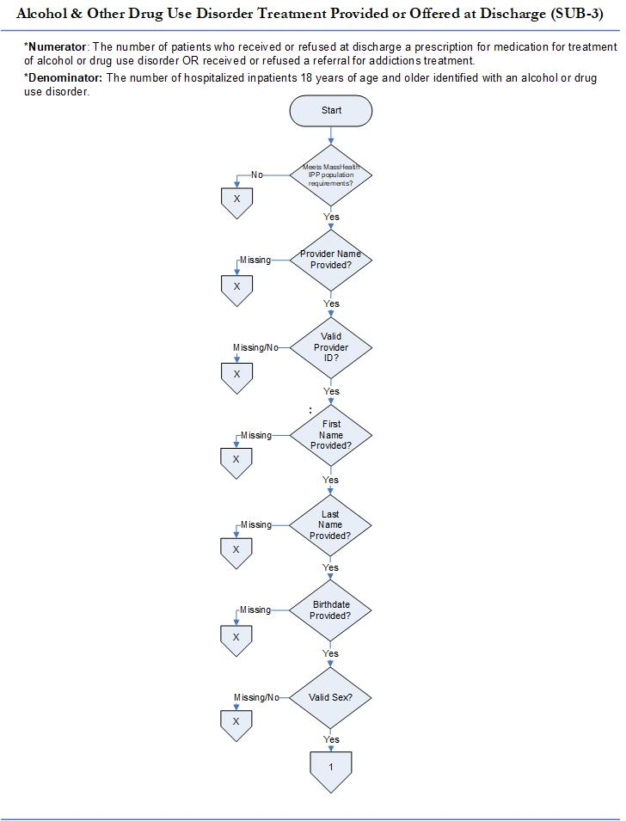

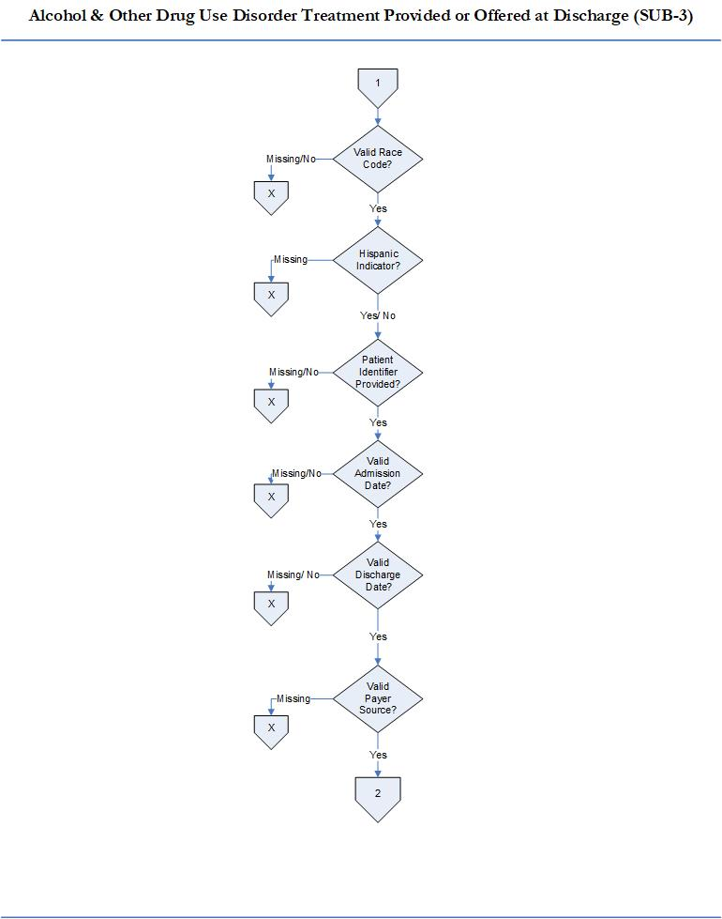

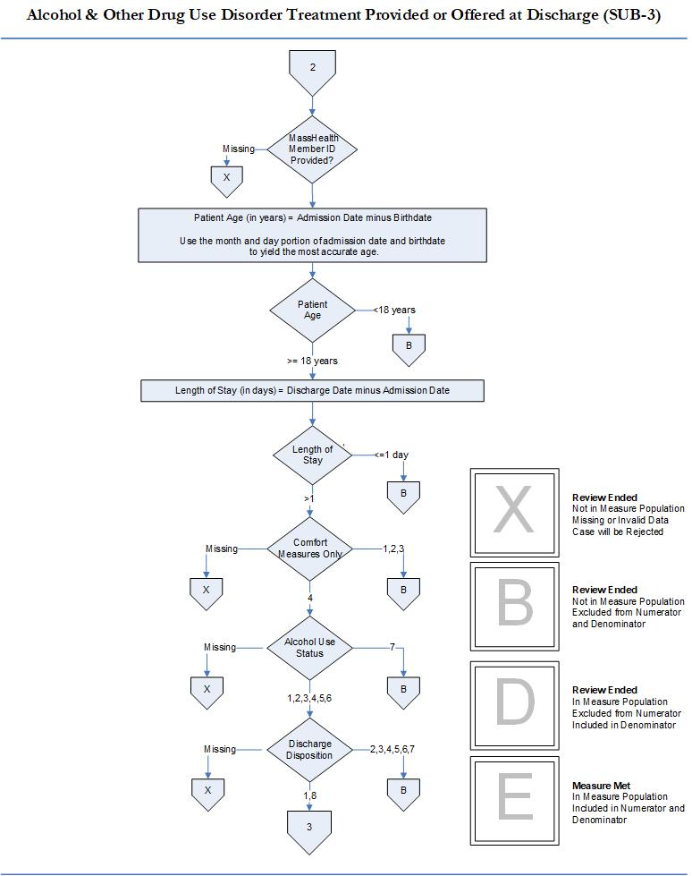

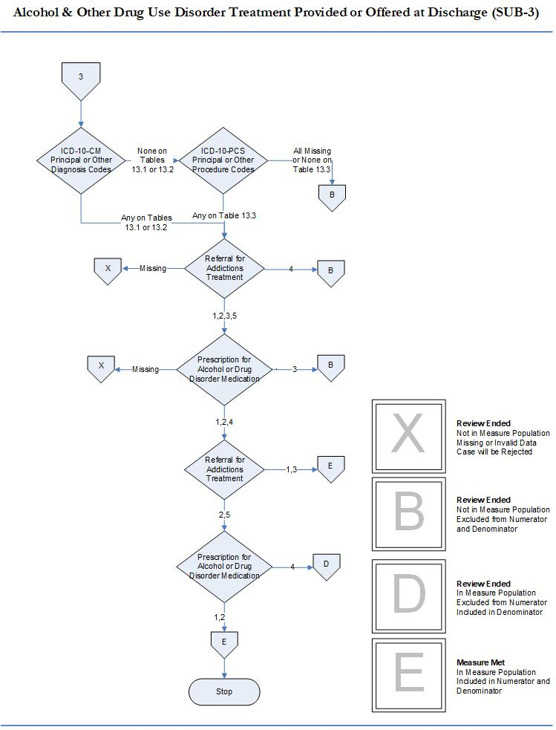

Perinatal Care Domain

1. Cesarean Birth, NTSV (MAT-4)
Measure Name: Cesarean Birth
Description: Nulliparous women with a term, singleton baby in vertex position delivered by cesarean birth.
Numerator statement: Patients with cesarean births.
Included population: ICD-10-PCS Principal Procedure Code or ICD-10-PCS Other Procedure Codes for cesarean birth as defined in Appendix A, Table 11.06 of the Specifications Manual for Joint Commission National Core Measures applicable version.
Excluded population: None
Data Elements:
- ICD-10-PCS Other Procedure Codes
- ICD-10-PCS Principal Procedure Code
Denominator statement: Nulliparous patients delivered of a live term singleton newborn in vertex presentation.
Included population:
- ICD-10-PCS Principal Procedure Code or ICD-10-PCS Other Procedure Codes for delivery (as defined in Appendix A: ICD-10-PCS Code Tables 11.01.1 of the Specifications Manual for Joint Commission National Core Measures applicable version)
- Nulliparous patients with ICD-10-CM Principal Diagnosis Code or ICD-10-CM Other Diagnosis Codes for outcome of delivery as defined in Appendix A, Table 11.08 (of the Specifications Manual for Joint Commission National Core Measures applicable version) and with a delivery of a newborn with 37 weeks or more of gestation completed
Excluded populations:
- ICD-10-CM Principal Diagnosis Code or ICD-10-CM Other Diagnosis Codes for multiple gestations and other presentations as defined in Appendix A, Table 11.09 (of the Specifications Manual for Joint Commission National Core Measures applicable version)
- Less than 8 years of age
- Greater than or equal to 65 years of age
- Gestational age < 37 weeks or UTD
Data Elements:
- Admission Date
- Birthdate
- Discharge Date
- Gestational Age
- ICD-10-CM Other Diagnosis Codes
- ICD-10-CM Principal Diagnosis Code
- Previous Births
Risk adjustment: No
Data Collection: See data abstraction tool (Appendix A-4) and data dictionary (Appendix A-8) of this manual for detailed instruction.
Measure Type: Outcome Measure
Data Accuracy: See TJC Core Specifications Manual for applicable discharge period for detail that apply.
Measure Analysis Suggestions: See TJC Core Specifications Manual for applicable discharge period for detail that apply.
Sampling: Yes. Refer to Section 5 for details on sample size requirements.
Data reported as: Aggregate rate reported from count data.
Improvement noted as: Decrease in rate.

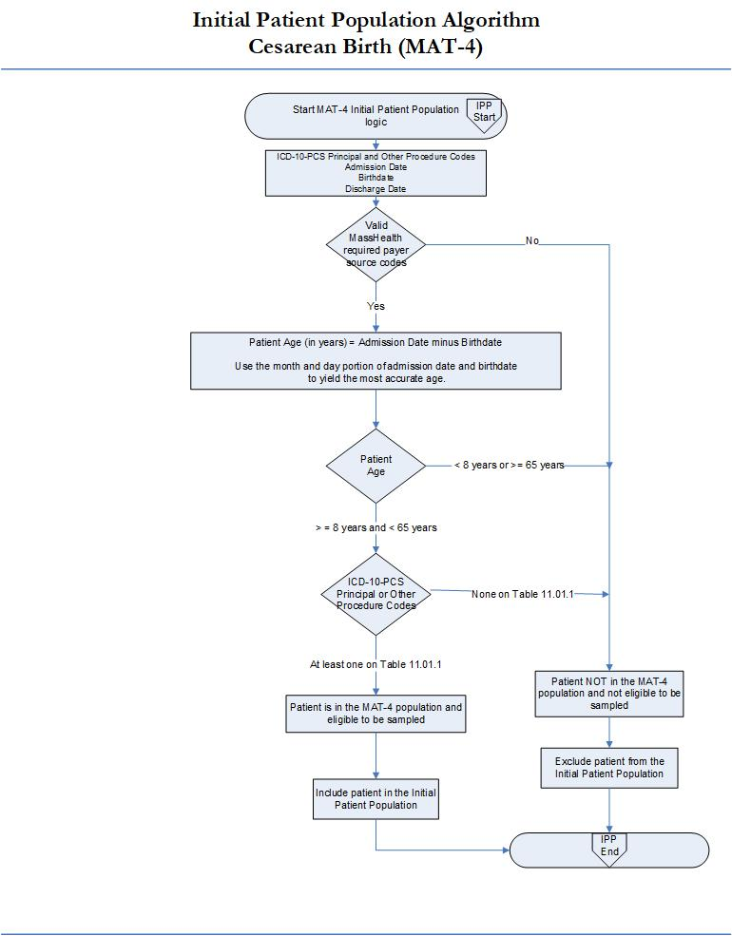

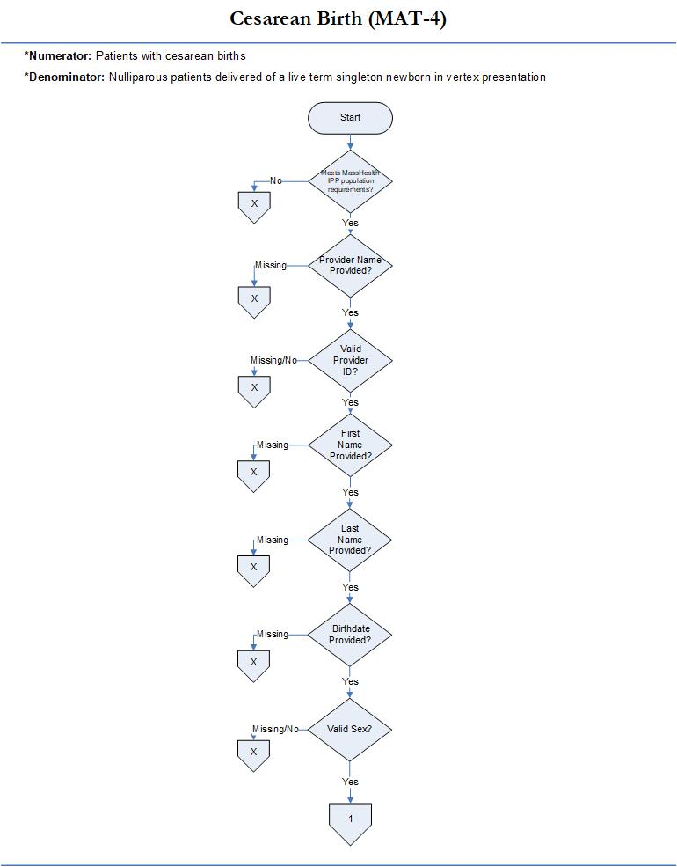

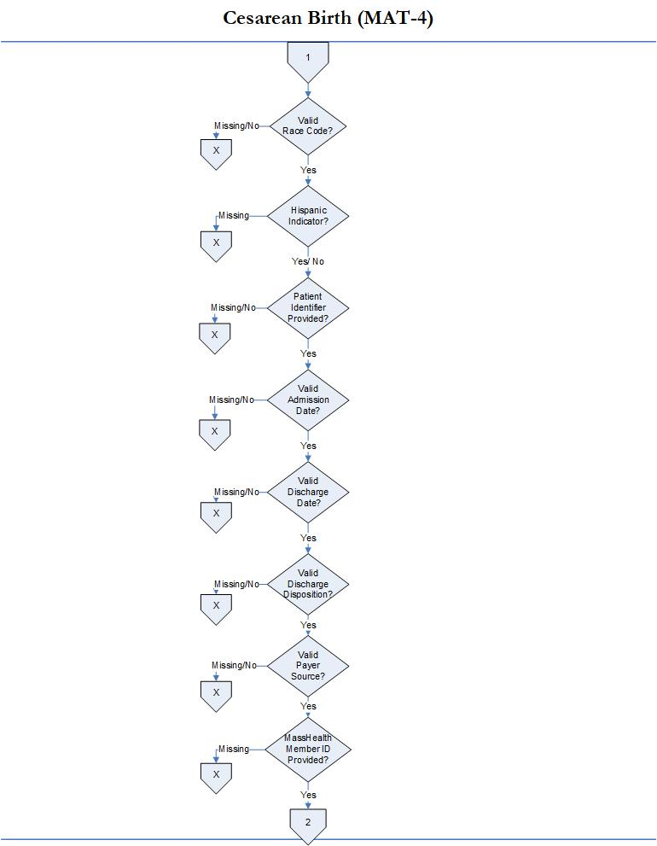

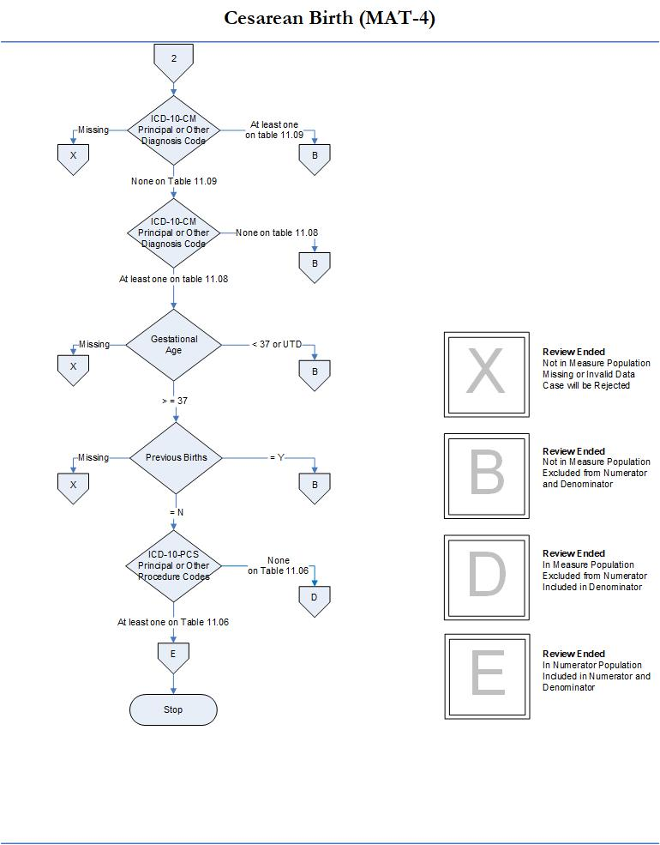

2. Unexpected Complications in Term Newborns (NEWB-3)
Measure Name: Unexpected Complications in Term Newborns
Description: Unexpected complications among full term newborns with no preexisting conditions. Severe complications include neonatal death, transfer to another hospital for higher level of care, severe birth injuries such as intracranial hemorrhage or nerve injury, neurologic damage, severe respiratory and infectious complications such as sepsis. Moderate complications include diagnoses or procedures that raise concern but at a lower level than the list for severe e.g. use of CPAP or bone fracture. Examples include less severe respiratory complications e.g. Transient Tachypnea of the Newborn, or infections with a longer length of stay not including sepsis, infants who have a prolonged length of stay of over 5 days. EOHHS will report only the aggregate rate of newborns with severe complications and moderate complications.
Numerator Statement: Newborns with severe complications and moderate complications.
Included Populations:
Severe Complications:
- Death
- Transfer to another acute care facility for higher level of care
- ICD-10-CM Principal Diagnosis Code, ICD-10-CM Other Diagnosis Codes, ICD-10-PCS Principal
Procedure Code or ICD-10-PCS Other Procedure Codes for Severe Morbidities as defined in
Appendix A, Tables of the Specifications Manual for Joint Commission National Core Measures applicable version:
  - 11.36 Severe Birth Trauma
  - 11.37 Severe Hypoxia/Asphyxia
  - 11.38 Severe Shock and Resuscitation
  - 11.39 Neonatal Severe Respiratory Complications
  - 11.40 Neonatal Severe Infection
  - 11.41 Neonatal Severe Neurological Complications
  - 11.42 Severe Shock and Resuscitation Procedures
  - 11.43 Neonatal Severe Respiratory Procedures
  - 11.44 Neonatal Severe Neurological Procedures
- Patients with Length of Stay greater than 4 days AND an ICD-10-CM Principal Diagnosis Code or ICD-10-CM Other Diagnosis Codes for Sepsis as defined in Appendix A, Table 11.45 Neonatal Severe Septicemia of the Specifications Manual for Joint Commission National Core Measures applicable version
Moderate Complications:
- ICD-10-CM Principal Diagnosis Code, ICD-10-CM Other Diagnosis Codes, ICD-10-PCS Principal
Procedure Code or ICD-10-PCS Other Procedure Codes for moderate complications as defined in Appendix A, Tables of the Specifications Manual for Joint Commission National Core Measures:
  - 11.46 Moderate Birth Trauma
  - 11.47 Moderate Respiratory Complications
  - 11.48 Moderate Respiratory Complications Procedures
- ICD-10-CM Principal Diagnosis Code for single liveborn newborn as defined in the Specifications Manual for Joint Commission National Core Measures Appendix A, Table 11.20.2 Single Liveborn Newborn-Vaginal AND Length of Stay greater than 2 days
OR
ICD-10-CM Principal Diagnosis Code for single liveborn newborn as defined in the Specifications Manual for Joint Commission National Core Measures Appendix A, Table 11.20.3 Single Liveborn Newborn-Cesarean AND Length of Stay greater than 4 days
AND ANY
ICD-10-CM Principal Diagnosis Code, ICD-10-CM Other Diagnosis Codes, ICD-10-PCS Principal Procedure Code or ICD-10-PCS Other Procedure Codes for moderate complications as defined in the Specifications Manual for Joint Commission National Core Measures Appendix A, Tables:
  - 11.49 Moderate Birth Trauma with LOS
  - 11.50 Moderate Respiratory Complications with LOS
  - 11.51 Moderate Neurological Complications with LOS Procedures
  - 11.52 Moderate Respiratory Complications with LOS Procedures
  - 11.53 Moderate Infection with LOS
- Patients with Length of Stay greater than 5 days and NO ICD-10-CM Principal Diagnosis Code, ICD-10-CM Other Diagnosis Codes, ICD-10-PCS Principal Procedure Code or ICD-10-PCS Other Procedure Codes for jaundice or social indications as defined in the Specifications Manual for Joint Commission National Core Measures Appendix A, Tables:
  - 11.33 Neonatal Jaundice
  - 11.34 Phototherapy
  - 11.35 Social Indications
Excluded Populations: None
Data Elements:
- Admission Date
- Discharge Date
- Discharge Disposition
- ICD-10-CM Other Diagnosis Codes
- ICD-10-CM Principal Diagnosis Code
- ICD-10-PCS Other Procedure Codes
- ICD-10-PCS Principal Procedure Code
Denominator Statement: Liveborn single term newborns 2500 gm or over in birth weight.
Included Populations: Single liveborn newborns with ICD-10-CM Principal Diagnosis Code for single liveborn newborn as defined in the Specifications Manual for Joint Commission National Core Measures Appendix A, Table Number 11.20.1: Single Liveborn Newborn
Excluded Populations:
- Patients who are not born in the hospital or are part of multiple gestation pregnancies, with no
ICD-10-CM Principal Diagnosis Code for single liveborn newborn as defined in the Specifications Manual for Joint Commission National Core Measures Appendix A, Table Number 11.20.1: Single Liveborn Newborn
- Birth Weight < 2500 gm
- Patients who are not term or with < 37 weeks gestation completed
- Patients whose term status or gestational age is missing and birthweight < 3000 gm
- ICD-10-CM Principal Diagnosis Code or ICD-10-CM Other Diagnosis Codes for congenital malformations and genetic diseases as defined in the Specifications Manual for Joint Commission National Core Measures Appendix A, Table 11.30 Congenital Malformations
- ICD-10-CM Principal Diagnosis Code or ICD-10-CM Other Diagnosis Codes for pre-existing fetal
conditions as defined in the Specifications Manual for Joint Commission National Core Measures Appendix A, Table 11.31 Fetal Conditions
- ICD-10-CM Principal Diagnosis Code or ICD-10-CM Other Diagnosis Codes for maternal drug use exposure in-utero as defined in the Specifications Manual for Joint Commission National Core Measures Appendix A, Table 11.32 Maternal Drug Use
Data Elements:
- Birth Weight
- Birthdate
- ICD-10-CM Other Diagnosis Codes
- ICD-10-CM Principal Diagnosis Code
- ICD-10-PCS Other Procedure Codes
- ICD-10-PCS Principal Procedure Code
- Term Newborn
Risk Adjustment: No.
Data Collection Approach: See data abstraction tool (Appendix A-5) and data dictionary (Appendix A-8) of this manual for detailed instruction.
Measure Type: Outcome Measure
Data Accuracy: See TJC Core Specifications Manual for applicable discharge period discharge period for detail that apply.
Sampling: No. Include all discharged infants where MassHealth is the primary and only payment source that meet ICD population requirements.
Data Reported As: Aggregate rate of newborns with severe complications and moderate complications generated from count data reported as a rate per 1000 livebirths.
Improvement Noted As: Decrease in the rate
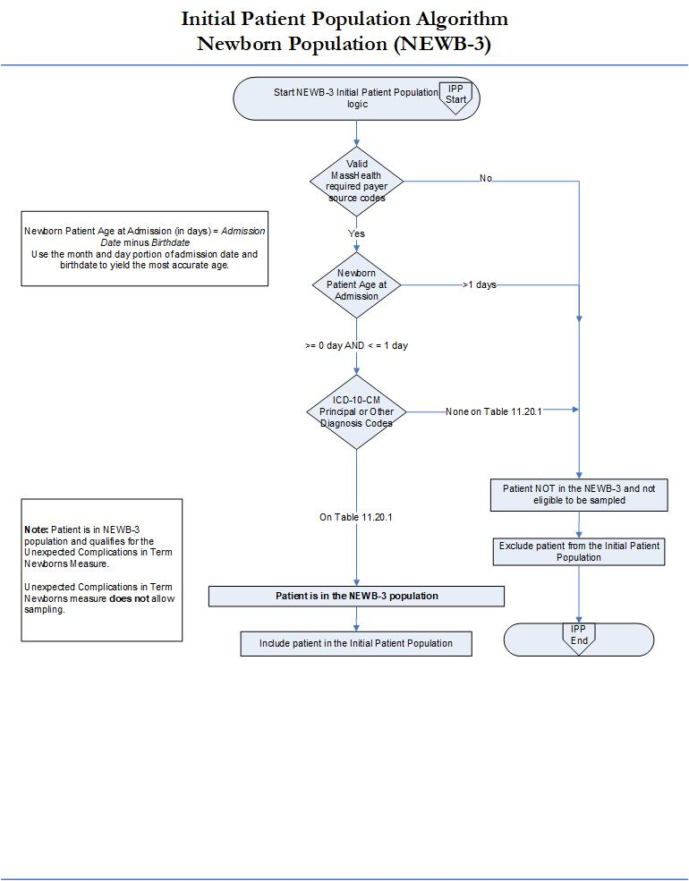

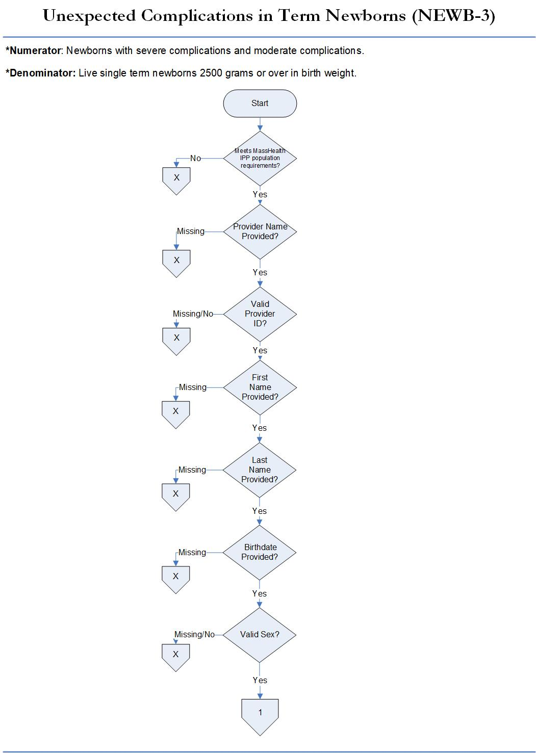

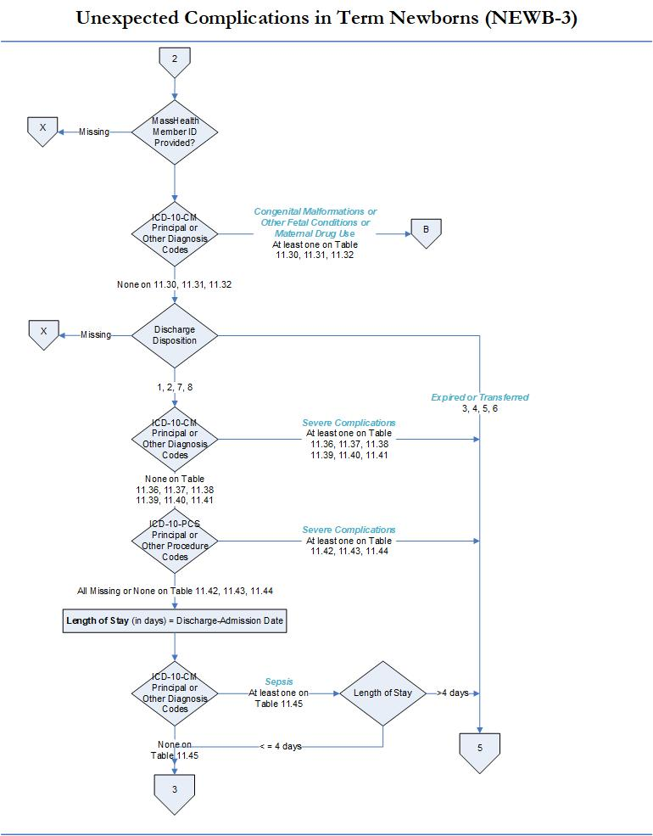
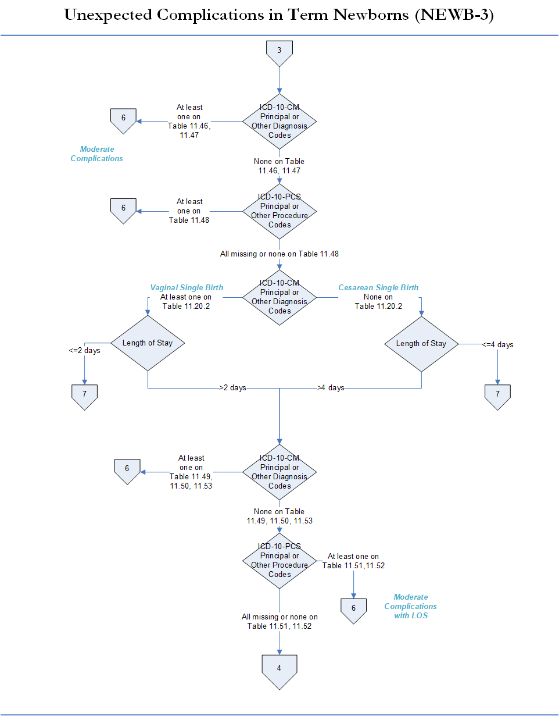

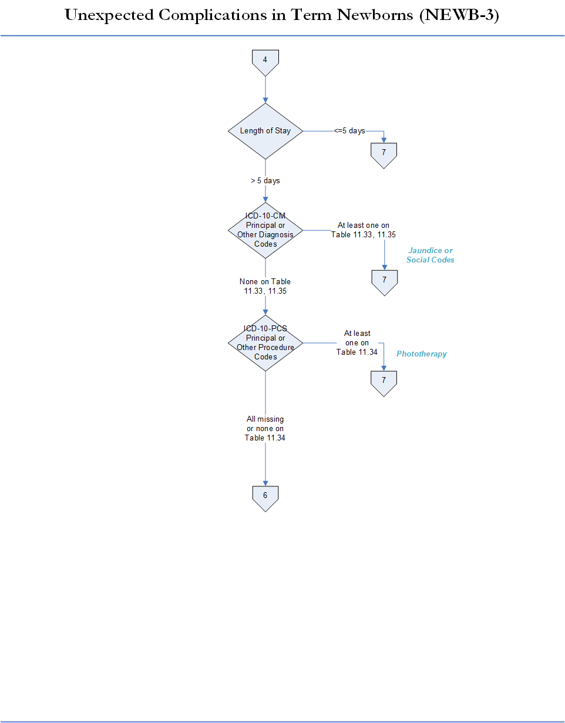

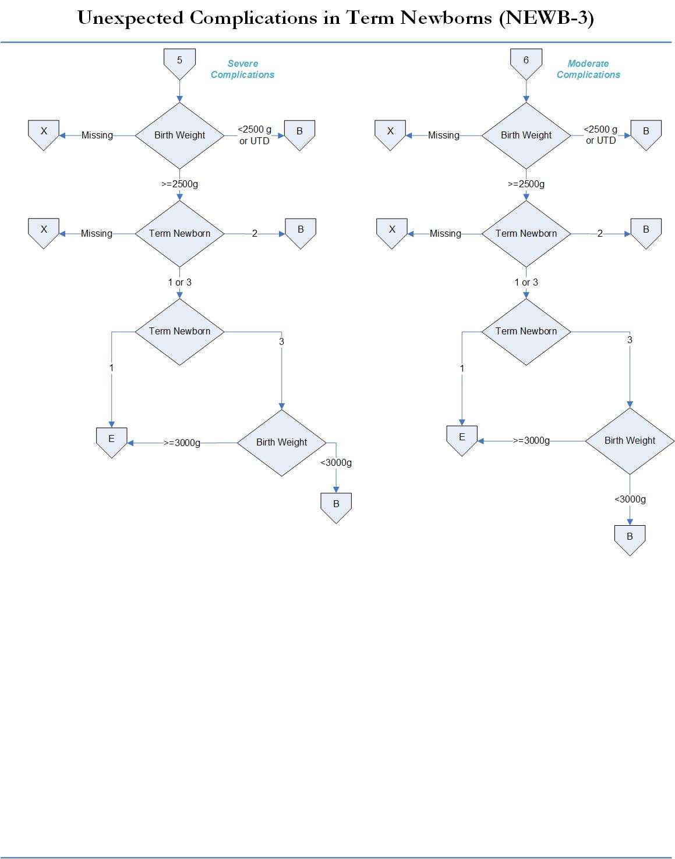
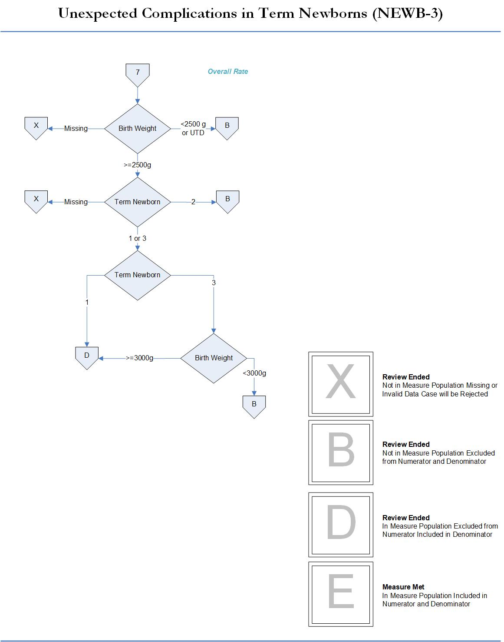

Section 5. MassHealth Population Sampling Specifications
This section defines the patient population and sampling specifications that apply to MassHealth chart-abstracted measures reporting requirements. Definitions contained in this section align with guidelines set forth in national manuals wherever possible to minimize data collection burden. Sampling is allowed for some but not all of the MassHealth chart-abstracted measures. Please refer to the chart-abstracted measure definitions in Section 4 for additional guidance.

Medicaid Population Sampling Specifications
Hospitals with large enough volume of discharges to allow for sampling in their MassHealth initial patient populations for chart-abstracted measures may choose to sample for the following measures: Care Coordination (CCM), Substance Use (SUB), and Cesarean Birth (MAT-4).
Note: Sampling is not allowed for the Unexpected Complications in Term Newborns (NEWB-3). Hospitals are required to include the entire MassHealth initial patient population for the NEWB-3 measure.
The CMS Specifications Manual for National Hospital Inpatient Quality Chart Abstracted Measures defines the “Initial Patient Population” (also termed ICD population) as all patients who share a common set of clinical and administrative characteristics (admission date, ICD-10-CM principle diagnosis or ICD-10-PCS procedure code, length of stay less than or equal to 120 days, payer source, age, etc.) for a given condition from which the sample must be drawn and represent. All ICD-10 codes relevant to the initial patient population must be identified before applying data integrity filters, measure exclusions and the sampling method. The term ‘MassHealth Initial Patient Population’ will be used in this section to refer to all patients who share the common set of clinical and administrative data elements (payer, race elements, other identifier codes, etc.) that are eligible to be sampled for the measure discharge data periods.
Cases identified as being in the Initial Patient Population for the measure are eligible to be sampled. For the definition of the Initial Patient Population(s) for each measure, refer to the appropriate Initial Patient Population for each chart-abstracted measure in Section 4 of this manual.

Sampling Methods Overview
Sampling is the process of selecting cases from a broader patient population without collecting data for the entire population. A well-designed sample is based on a selection of cases that provide sufficient information for calculating measure rates. Sample size must be carefully determined, and cases randomly selected to ensure meaningful and valid sample-based performance measures data.
- Sampling Approaches. Hospitals can use either the simple random sampling or systematic random sampling methods to ensure their data is representative of the measure initial patient population. Random sampling allows you to control the likelihood of specific cases being selected. Hospitals can achieve this by using one of the following approaches:
- Simple random sampling: selecting a sample size (n) from the population of size (N) so that every case has the same chance of being selected into the sample; or
- Systematic random sampling: selecting every k^{th} record from a population of size N so that a sample n is obtained, where k ≤ N/n. The first sample record (i.e.: the starting point) must be randomly selected before taking every k^{th} record. This requires a two-step process:
    - Randomly select the starting point by choosing a number between one and k using a table of random numbers or a computer-generated random number; and then
    - Select every k^{th} record until the selection of the sample size is completed.
- Hospitals must ensure that the sampling approach selected is consistently applied for each quarter. While over-sampling is not required, it may improve precision of measure rates. Hospitals should work with their vendors to ensure that sampling techniques are applied consistently across hospitals.
- Order of Data Flow. The order of data flow for selecting cases involves the following steps:
  - Identify the Initial Patient Population of the measure set previously described in Section 5.A.
  - Follow either simple random or systematic random sampling approach previously described.
  - Pull the sample of medical records for each measure set based on sample size requirements.
  - Abstract specific data elements needed for each measure.
Hospitals may sample their population (for all chart-abstracted measures except for NEWB-3) or may report their entire population. Sampling should not be used unless the hospital has a large number of cases for a given measure. Hospitals whose ‘MassHealth ICD Patient Population’ size is less than the minimum number of cases cannot sample. To determine the minimum number of cases that need to be sampled for each population, please refer to sample size requirement tables provided further in this section.

Medicaid Sampling Requirements
The sampling methods selected to establish sample size requirements for all MassHealth acute hospital quality reporting on each measure set is based on statistical power analysis. This method enables the calculation of the minimum number of discharges necessary to detect changes in the measure rates and hospital performance data and ensure that a statistically valid sample is drawn. The following guidelines apply to MassHealth sampling specifications.
        - MassHealth Sampling Instruction. Hospitals must sample cases from all MassHealth inpatient paid claims using instructions provided in this section and perform medical chart abstraction for the sampled claims. The number sampled by hospitals will vary by the volume of the patients that meets the criteria for ‘MassHealth Initial Patient Population’ for each measure as defined in this manual. The minimum required sample size is based on the estimated volume of MassHealth discharges required for each measure.
        - Dates of Service. Hospitals must identify the MassHealth Initial Patient Population measures data using available databases that contain all discharges for the quarter reporting periods specified in the Acute RFA and Section 1.E of this manual using the sample size requirements tables that follow.
        - Aggregate Medicaid Payer Sampling. The MassHealth Initial Patient Population is identified as an aggregate of all the Medicaid payer source codes. Please refer to Table 2.1 of this EOHHS manual for a list of Medicaid payer code inclusions that apply to quality measures data sampling and reporting.
        - Aggregate Medicaid Payer Sampling Steps. The order of data flow must be modified when selecting cases for the aggregate Medicaid payer source groups as follows:
- Step 1- Identify Initial patient population based on measure specifications and dates of service.
- Step 2- Identify and include cases with all the Medicaid payer inclusion codes previously listed.
- Step 3- Identify MassHealth sample size requirements for each measure using Tables 6.1 and 6.2 to follow.
- Step 4- Select and apply the random sampling approach to identify charts.
- Step 5- Begin medical chart abstraction of specified measure on cases selected.
The previously outlined steps begin with the initial patient population and then extract all Medicaid payer cases. These steps can be followed to identify cases for all the measures being submitted.

Medicaid Sampling Options
Hospitals that choose to sample have the option of sampling either quarterly (option A) or monthly (option B) for each measure. Hospitals must select and utilize only one option consistently (either quarterly or monthly), during a calendar year submission period.
Regardless of the option used, hospitals must ensure that sampling procedures consistently produce statistically valid and useful data. Due to measure exclusions, hospitals selecting sample cases must submit at least the minimum required sample size. The tables that follow for each sampling option automatically build the number of cases needed to obtain the required sample sizes.
- Quarterly Sampling (Option A). Hospitals that choose the quarterly sampling option method must use the minimum sample sizes specified in Table 5.1 that follows.
Table 5.1 – Quarterly Sample Size Requirement
Number of MassHealth Discharges  Per QUARTER  (Initial Patient Population Size “N”) | Aggregate of All Medicaid Payer  Minimum Required Sample Size “n”
1 - 59 | No sampling; 100% of ICD Population is required
60 – 119 | 60
120 – 199 | 92
> = 200 | 103
As noted in the Table 5.1, the quarterly sampling option Initial patient population size (N) and the minimum required sample size (n) column numbers have been adjusted for the aggregation of all Medicaid payer population inclusions defined in Section 2.B of this EOHHS manual.
The quarterly sampling option displays the MassHealth initial patient population (N) category numbers and required minimum sample sizes (n) that apply to each clinical chart measure listed in Section 1.D of this manual.
Hospitals must ensure that the quarterly sample sizes selected for each measure are representative of the aggregate of all Medicaid payer population inclusions listed in Section 2.B of this EOHHS manual. The following is an example of how the quarterly sampling option would be used for calendar year reporting.
Example #1: Options A - MassHealth Quarterly Sampling of Each Measure
- During the first quarter, the hospitals MassHealth initial patient population is N=30 cases. Using Table 5.1, no sampling is allowed and 100% of the Medicaid population is required.
- During the second quarter, the hospitals MassHealth initial patient population is N=67 cases. Using Table 5.1, the minimum required sample would be 60 cases for the Medicaid population.
- During the third quarter, the hospitals MassHealth initial patient population is N=75 cases. Using Table 5.1, the required sample would be a minimum of 60 cases for the Medicaid population.
- During the fourth quarter, the hospitals MassHealth initial patient population is N=207 cases. Using Table 5.1, the required sample would be a minimum of 103 cases for the Medicaid population.
- Monthly Sampling (Option B). Hospitals that choose the monthly sampling option must use the minimum sample sizes specified in Table 5.2 that follows.
Table 5.2 – Monthly Sample Size Requirements for Each Measure
Number of MassHealth Discharges  Per MONTH  (Initial Patient Population Size “N”) | Aggregate of All Medicaid Payer  Minimum Required Sample Size “n”
1 - 19 | No sampling; 100% of ICD Population is required
20 – 39 | 20
40 – 66 | 30
> = 67 | 35
As noted in Table 5.2, the monthly sampling option Initial patient population size (N) and the minimum required sample size (n) column numbers have been adjusted for the aggregation of all Medicaid payer population inclusions defined in Section 2.B of this EOHHS manual.
The monthly sampling option displays a revised MassHealth initial patient population (N) category numbers and required minimum sample sizes (n) that apply to each measure listed in Section 1.D of this EOHHS manual.
The following provides an example of how the monthly sampling option would be used for calendar year reporting.
Example #2: Option B - MassHealth Monthly Sampling of Each Measure
- During January the hospital’s MassHealth initial patient population is N=19 cases. Using Table 5.2, no sampling is allowed and 100% of the Medicaid population is required for the month.
- During February the hospitals MassHealth initial patient population is N=65 cases. Using Table 5.2, the required Medicaid sample would be a minimum of 30 cases for this month.
- During March the hospitals MassHealth initial patient population is N=100 cases. Using Table 5.2, the required Medicaid sample size would be 35 cases for this month.

ICD Patient Population Data Definitions
Hospitals are required to submit information on the MassHealth Initial Patient Population and sample count data. ICD population and sample count data are used to evaluate data completeness of all files submitted by the hospital, in accordance with the MassHealth sampling requirements in this section.
1) Definition of ICD Population Data - include the following information as follows:
- ICD-10 Population Size: Refers to count of patient population with all relevant ICD-10-CM diagnosis or ICD-10-PCS codes included in the measure defined in previous Section 5.C.
- Aggregate Medicaid Payer Population Size: Refers to count of patient population with all relevant ICD-10 codes included in the measure that meet all Medicaid payer inclusions.
- Sample Size: Refers to whether or not the hospital has sampled data for the time period being reported. If no sampling was done then enter the total population count.
2) On-line ICD Population Data Entry Form
- The ICD population and sample size count information must be entered as aggregate data using the on-line data entry form located in the secure web portal, described in Section 3 of this manual. Only hospitals, not data vendors, are authorized to enter ICD population data.
- Hospitals with no inpatient population and sample size data for a given measure, during a quarter (or month), must enter zero (0) on the form to meet data reporting requirement.
- Failure to comply with ICD population data entry will result in not meeting data completeness requirements as defined in Section 2.D of this manual.
Refer to Section 3A of this EOHHS manual for other ICD data entry instruction and requirements.

Measure Population Definitions
The RY2024 CQI program includes measures collected using varied methods, including chart-abstraction, data-entry, survey, and claims. Table 5.3 is designed to assist hospitals and vendors in referencing which patient populations are included in each measure category and data or method used to identify the population.
Table 5-3: Measure Populations
Measure Category | Payer Population Included | Method Used to Identify Population
Chart-Abstracted Measures  (CCM, SUB, MAT-4, NEWB-3) | MassHealth Medicaid | Medical records with a MassHealth Payer Code on Table 2.1
Aggregate Data-Entry Measures  (BHC-3, OP-1e, SOC) | All-Payer | Hospital reported all-payer population that hospital reports to CMS for respective measures
Survey Data Entry Measure (PMSM-1) | N/A | N/A
Claims Based Patient Safety (PSI-90) | MassHealth Medicaid | Claims from EOHHS Medicaid Hospital Stay File
Registry Based Patient Safety (HAI 1-5) | All-Payer | Data from National Healthcare Safety Network (NHSN)
Patient Experience (HCAHPS) | All-Payer | Data from CMS Provider Data Catalog
HEDIS Claims-Based Measures (CCI-2, CCI-3, CCI-4, PED-2) | MassHealth Medicaid | Claims from EOHHS MassHealth Claims Data File
Other Claims-Based and Readmissions Measures (CCI-1, PED-1, BHC-2) | MassHealth Medicaid | Claims from EOHHS MassHealth Claims Data File or CHIA’s Hospital Inpatient Discharge Database

Section 6. MassHealth Data Validation Methods

Chart-Abstracted Measure Validation Process
The EOHHS Medicaid Acute RFA contract requires that hospitals meet data validation standards on reported chart-abstracted measures as part of MassHealth CQI program participation. The EOHHS contractor will perform all aspects of the chart validation process for quality measures data reported under the MassHealth Acute Hospital RFA. All chart-abstracted measures are subject to the validation methods described in this section.
- Overview of Chart-Abstracted Data Validation Process
  - Purpose: The purpose of validation is to verify that the patient-level abstracted data submitted by hospitals is accurate and reliable for calculating performance scores and incentive payments. The EOHHS contractor will identify a sample of medical records from hospital reported patient-level measures data files submitted via the MassQEX portal for re-abstraction. Chart re-abstraction will establish the ‘EOHHS Standard’ for data abstraction. The hospital’s original abstraction will be compared to the ‘EOHHS Standard’ for data abstraction based on the methods outlined throughout this section.
  - Chart Sampling: Data validation is performed on a random sampling of charts selected from the hospitals chart-abstracted measures in Table 1.2 (Section 1.D) of this EOHHS manual as follows:
        - Chart sampling requirements will collect a total of eighteen (18) records/year on the reported data.
        - A random sample of six (6) charts are identified for the first three quarters (Q1, Q2, Q3) only.
        - No charts are required for the fourth quarter data (Q4) files submitted to the portal.
- Chart Request Schedule
  - Case List Request: The EOHHS contractor will post the applicable quarter medical records case list requests for chart-abstracted measures in the MassQEX secure portal for hospital users to download. Hospital key representatives and the MassQEX hospital staff users are responsible for communicating and coordinating this chart data submission requirement to their medical records department staff.
  - MassQEX Notice: The EOHHS contractor will notify hospitals, via the MassQEX list-serve, when the hospital case records selected for chart validation have been posted, within fourteen (14) calendar days following the portal close date of the applicable quarter reporting deadline in Table 1.3 of this EOHHS manual.
  - Submission Window: Each hospital’s case list request document includes the submission deadline by which the EOHHS contractor must receive all records. Hospitals must submit copies of all medical records requested within twenty-one (21) calendar days of the request using instructions provided in this manual.
The EOHHS contractor will contact hospitals, by email or telephone, if any requested records have not been received within four (4) calendar days before the submission deadline. Records not received from hospitals within twenty-one (21) calendar days of the EOHHS contractor request will be deemed as failing validation.

Chart Submission Content
All hospitals must adhere to the general chart submission content and format required for data validation purposes listed as follows:
- Submit a copy of the entire medical record for the admission/discharge dates of each member identified in the quarterly case list request.
- Each medical record must include information on MassHealth unique identifiers for “Race and Hispanic Indicator” data elements either within the record or as a screen print from the hospital’s registration system. Hospitals are responsible for communicating this data submission requirement to their medical records department staff.
- For the CCM-2 measure: In addition to the complete medical record submitted, hospitals may submit documentation in the form of a list of document names of what comprises the transition record given to the patient or caregiver(s) or site of care for a transfer for each case selected for validation with their submission of medical records for each quarter.
- All hospitals are required to upload copies of medical records using the MassQEX secure file transfer portal method. Hospitals must designate a staff that will upload medical records on their behalf using the instructions that follow. Paper records will not be accepted.

Secure File Transfer Portal (SFTP) Method
The EOHHS Contractor manages a secure file transfer method for hospitals to submit copies of records via the MassQEX portal. Hospitals must submit copies of medical records using the secure file transfer portal (SFTP) methods and instructions described as follows.
- SFTP System Description. Hospitals will upload medical records electronically via the MassQEX portal using the Go Anywhere secure file transfer application using instructions in this EOHHS Manual. The secure file transfer method conducts transmission of the data using FIPS 140-2 compliant encryption algorithms and verified certificates while meeting Health Insurance Portability and Accountability Act of 1996 (HIPAA) standards.
- SFTP System Specification The system specification includes:
- The preferred browser for the secure file transfer application is Google Chrome.
- File size cannot be larger than 1 GB per upload.
- More than one file may be transferred at a time.
- Each file must be uploaded in Adobe PDF format only.
- Zip files with PDF documents may be uploaded
- Submit PDF files that have not been password protected or encrypted.
- Uploaded files are routed to a secure directory and then deleted from the server.
- MassQEX portal sends a confirmation e-mail to the SFTP sender for each file uploaded.
- The SFTP feature is available 24 hours/7days during the 21 day chart submission window.
- Creating SFTP User Accounts
- Account Type
- Account Limit: Each hospital may designate one (1) SFTP user to upload medical record files via the secure MassQEX portal. The hospital must complete a SFTP user registration form using the instructions that follow.
- Limited User Access: Each authorized SFTP user is limited to medical record uploads only and cannot access other MassQEX portal data reporting or processing functions. All SFTP users must coordinate with their authorized MassQEX registered users to obtain a copy of the quarter case list request that contains the chart submission deadline.
- MassQEX User Note: Active MassQEX registered users already authorized by their hospital CEO can request an SFTP user account by submitting an email to the MassQEX Help Desk at massqexhelp@telligen.com. A separate SFTP user on-line form will not be required. This arrangement can provide a backup option to the one SFTP user account limit to prevent possible interruption of access to MassQEX portal for record uploads.
- Completing SFTP User Account Registration Form
- The MassQEX portal will display a SFTP user registration form under “User Resources”.
- Select “Register for SFTP Account” which will display the on-line fillable form.
- Complete entry of all fields and print the document.
- User must obtain signature of hospital CEO.
- Submit signed SFTP user form to MassQEX via email at top of form.
- MassQEX will contact the user and verify submitted information against EOHHS data.
- MassQEX will create the SFTP account and send the authorized individual two emails, one with the assigned user name and another with a temporary password.
- The authorized individual user will reset the temporary password after which the account is active for file upload
- Preparing Records for SFTP. The MassQEX portal will accept imaged medical record files in Adobe PDF format only. Instructions on how to prepare records for secure file transfer follows:
- Each patient record must be a separate PDF file.
- Each file requires a unique file name that includes hospital name, patient name or validation control number.
- Create a separate PDF file for each patient record. Do not combine multiple patient records into one PDF file.
- Large records must be split into multiple PDF files and add sequential numbering to files for that record (e.g.: 1 of x, 2 of x, etc.).
- If photocopying records, copy them single sided, full size pages on white paper only.
- Do not highlight, tab, or otherwise mark any information in the medical record
- Do not copy double sided pages or use color paper.
- Do not apply a password and do not encrypt the PDF file itself.
- SFTP Upload Procedure
- Only individuals with an authorized SFTP user account can upload medical record files.
- A link to access SFTP will be displayed on MassQEX portal homepage.
- Clicking on the link will bring the user to the log in page.
- Enter your SFTP user-name and password; you will enter a secure folders page.
- SFTP user will open their applicable hospital folder and select “upload” for file transfer.
- The Browse dialogue box displays. After selecting the file(s), click Open.
- The upload is completed for the file(s) selected.
- The SFTP sender of the file(s) receives a confirmation e-mail for each file uploaded.
- MassQEX will review uploaded record files against the quarter specific case list request to assess completeness of records.
- SFTP User Compliance
- All record files will be date/time stamped upon submission through SFTP system. Record files received after the 5:00pm deadline date will be removed from review and kept in portal secure directory storage.
- Any records received that were not requested in the specific quarter case list will not be processed for review. Hospitals should minimize errors in transmittal of sensitive patient information whenever possible.
- Record files that are not in the required PDF format will not be processed for review.
- SFTP users are expected to comply with portal account maintenance procedures outlined in Section 3.E of this EOHHS manual.

Data Validation Scoring Methods
  - Validation Standard. Hospitals will be evaluated against the ‘EOHHS Standard’ for chart abstraction by measuring agreement on the specific clinical and non-clinical (demographic and administrative) data elements for the measure sets described in Section 4. Information from the ‘Hospital original’ and ‘EOHHS Standard’ abstraction will be compared to identify matches and variances across the data elements.
  - Data Element Scoring. All data elements are categorized as scored or non-scored. Scored elements are included in the calculation of the overall validation rate. Non-scored elements are not included in the calculation of validation rates but must pass portal completeness checks and will also be used to verify that the correct medical chart was received. A list of the scored and non-scored data elements is summarized in the following table.
Table 7-1: Summary of Data Element Scoring Categories for Chart-Abstracted Measures
Scored Data Elements | Non-Scored Data Elements
CCM Measures: Discharge Disposition, Reconciled Medication List, Transition Record, Advance Care Plan, Contact Information 24 hours/ 7 days, Contract Information for Studies Pending, Current Medication List, Discharge Diagnosis, Medical Procedures and Tests, Patient Instructions, Patient Refusal of Transmission, Plan for Follow-up Care, Primary Physician/ Healthcare Professional for Follow-up Care, Reason for Admission, Studies Pending at Discharge, Transmission Date, Discharge Date, Race, Hispanic Indicator  SUB-2 Measure: Alcohol Use Status, Brief Intervention, Comfort Measures Only, Race, Hispanic indicator  SUB-3 Measure: Alcohol Use Status, Comfort Measures Only, Discharge Disposition, Prescription for Alcohol or Drug Disorder Medication, Referral for Additions Treatment, Race, Hispanic indicator  MAT-4 Measure: Gestational Age, Previous Births, Race, Hispanic Indicator  NEWB-3 Measure: Birth Weight, Discharge Disposition, Term Newborn, Race, Hispanic Indicator | - Admission Date  - Admission Time  - Birth Date  - Discharge Date (scored for CCM-3 only)  - Discharge Disposition (scored for CCM, SUB-3, & NEWB-3)  - Episode of Care  - First Name  - Hospital Patient ID #  - ICD-CM Diagnosis Codes  - ICD-PCS Procedure Codes  - Last Name  - Member ID Number  - Payer Source  - Provider ID  - Provider Name  - Sex
As noted in Table 7.1, scored data elements include administrative and clinical as follows:
  - Administrative Data Elements:
- Race and Hispanic Indicator data elements will be scored across all measures data being reported on. The aim of validation is to determine how consistently hospitals document all required data elements in medical record and electronic clinical data files.
- All race/Hispanic indicator data elements documented in the medical record must indicate that the patient has self-reported. Clinician notes that refer to a patient’s Race and Hispanic Indicator are considered invalid for data validation purposes.
- Copies of all medical records must include information on two data elements of Race and Hispanic Indicator for validation purposes. The data elements must be clearly documented in the copy of the medical record submitted (i.e.: copy of the face sheet, nursing admission assessment, initial patient assessment) or include a copy of the administrative record (i.e.: registration system screen shot) for that patient.
- Failure to include the documentation of Race and Hispanic Indicator data in any medical record submitted will result in failing data validation for these data elements.
  - Clinical Data Elements: A full list of the clinical data elements that are eligible to be scored for each of the measure categories are contained in the measure specifications for each chart-abstracted measure outlined in Section 4 of this manual. The list of clinical data elements that apply to validation scoring for MassHealth process measures are listed on Table 7.1 and further defined in the Data Dictionary (Appendix A-8) in this EOHHS manual.
  - Data Element Mismatch Reasons. The EOHHS contractor will identify a mismatch reason for each variance observed between the data elements in the ‘Hospital original’ and ‘EOHHS Standard’ abstraction. The mismatch reason categories are provided as follows.
Table 7-2: Mismatch Reason Categories
Mismatch Reason | Description
Abstractor answer not found | EOHHS contractor was unable to locate the hospital’s answer
Abstractor missed information | Selected when the information is present in the medical record, in the approved locations, but was not abstracted
Acceptable match/mismatch | To be used for unique scenario(s) only
Data entry error | Selected when it is clear a data entry error was made
Not following abstraction guidelines | Selected when the data abstraction guidelines published in the appropriate version of the EOHHS Technical Specification Manual have not been followed
Parent element mismatch (child element) | Selected when the parent variables are missed, therefore; the child variables were disabled or not answered
Poor record copy | Selected when the medical record copy received is of poor density (too light or too dark), the copy is distorted, or part of the information is cut off from the page
Unclear element definition | Selected when clarifications are implemented and the EOHHS contractor is not sure if the information was shared with the hospital
Invalid record sent | Selected when the record sent by the hospital is invalid (incorrect)
Record not received | Selected when requested records are not received by the EOHHS contractor within the required timeframe
- Calculating Overall Validation Results. The year-end overall validation result is the aggregate of the rates for the applicable quarters of data validated. The overall validation results are computed as follows:
      - Agreement Rate: The overall rate is the proportion of scored items in agreement divided by the total scored items rated. Hospitals that achieve an overall agreement rate ≥ 80% for chart data submitted, are considered to have “passed” validation and rates that fall below 80% are considered to have “failed” validation. Confidence intervals are calculated to determine the appropriate range for estimating if a reliability threshold has been met.
      - EOHHS will adjust the overall validation results when it has determined that the hospital has not been compliant for calendar year data completeness requirements, per Section 2.D of this Manual. When a hospital does not submit proper chart documentation applicable to calendar year, then the overall agreement rate will not be computed. This determination is based on insufficient information to conclude that the data accuracy standard has been met for the calendar year reporting.
- Validation Results Reports. In RY2024, hospitals will receive validation reports that provide information on the first three quarters (Q1, Q2, Q3) of case detail results at the data element level, and comments to improve reliability of measures reporting as appropriate.

E. Requesting Re-evaluation of Chart-Abstracted Data Validation Results
Hospitals can have their original validation results considered for re-evaluation under the following conditions:
1) Basis for Re-evaluation:
- Only hospitals that have not met an overall agreement rate of ≥ 80% may request a re-evaluation of their results. Hospitals can request a re-evaluation of validation results for any quarter of chart data submitted that falls below 80%.
- The re-evaluation process for any quarter will be based on copies of medical records that were originally submitted, for that quarter.
- Hospitals are not allowed to submit any new or additional documentation as part of the re-evaluation process. Hospitals that failed to submit copies of the medical records requested by the EOHHS Contractor are not eligible to submit a request for re-evaluation.
2) Timelines for Re-evaluation: The hospital has 10 business days from the date of notification on their original overall validation report results to submit a written request for re-evaluation. The re-evaluation process will be completed and mailed to the hospital by the EOHHS contractor within 10 business days from receipt of the hospital’s request.
3) Submission Format:
- MassHealth Hospital Data Validation Re-evaluation Request Form (MHDVRR). The hospital must submit a request using the “MHDVRR Form” that lists the specific data element mismatches and basis for re-evaluation. The form is posted on the Mass.Gov website at: https://www.mass.gov/info-details/masshealth-cqi-program-participant-documents
- Completed forms can be submitted to MassQEX Help Desk at massqexhelp@telligen.com
4) Final Re-Evaluation Results. The hospital will receive a written response indicating whether any of the validation results have been adjusted and whether the overall agreement rate remains below the required threshold (≥ 80%) and will give detail on data element mismatches that remain and comments to improve data reliability as appropriate.
Please contact the MassQEX Help Desk at massqexhelp@telligen.com for questions on chart-abstracted measure medical record request and validation or for questions about secure file transfer procedures and medical record submission requirements.

Section 7. Data-Entry Measures

A. Care for Acute and Chronic Conditions Domain
This section includes measure specifications for the OP-1e data-entry eCQM measure required for the CQI program as part of the Care for Acute and Chronic Conditions Domain. Hospitals will only be required to submit initial population, numerator, denominator, and exclusions for OP-1e via the web-based data-entry tool in the MassQEX Portal, described in Section 3.D. Hospitals must attest that the aggregate data submitted for this measure is the same as what they submit to CMS for the applicable data period. All hospitals are required to participate in measures in the Care for Acute and Chronic Conditions Domain unless the hospital has an approved exemption with EOHHS.
Although the Safe Use of Opioids measure is collected as a patient-level eCQM measure for CMS, for CY24 discharge data, EOHHS will only require collection of hospital annual aggregate initial population, numerator, denominator, and exclusions for the OP-1e measure. For complete information on this measure, please refer to the measure specifications outlined on the CMS eCQM resource center: https://ecqi.healthit.gov/ecqms

1. Safe Use of Opioids Concurrent Prescribing (OP-1e)
Measure Name: Safe Use of Opioids Concurrent Prescribing (OP-1e)
Description: Proportion of inpatient hospitalizations for patients 18 years of age and older who are prescribed, or continued on, two or more opioids or an opioid and benzodiazepine concurrently at discharge.
Measure Steward: Centers for Medicare & Medicaid Services (CMS)
Initial Population: Inpatient hospitalizations (inpatient stay less than or equal to 120 days) that end during the measurement period, where the patient is 18 years of age and older at the start of the encounter and prescribed one or more new or continuing opioid or benzodiazepine at discharge.
Denominator: Initial Population
Denominator Exclusions: Inpatient hospitalizations where patients have cancer that begins prior to or during the encounter or are ordered or are receiving palliative or hospice care (including comfort measures, terminal care, and dying care) during the hospitalization or in an emergency department encounter or observation stay immediately prior to hospitalization, patients discharged to another inpatient care facility, and patients who expire during the inpatient stay.
Numerator: Inpatient hospitalizations where the patient is prescribed or continuing to take two or more opioids or an opioid and benzodiazepine at discharge.
Numerator Exclusions: Not Applicable
Type of Measure: Process Measure
Measure Collection Method: Aggregate data submission via Web-based data entry tool via the secure MassQEX Portal.
Payer Population: All-Payer population for CY2024 data
Data Accuracy: See CMS IQR Electronic clinical quality measures (eCQM) specifications for applicable discharge period for detail that apply.
Measure Analysis Suggestions: None
Sampling: Not applicable.
Data Reported As: Aggregate rate generated from claims data.
Improvement Noted As: Decrease in rate

B. Behavioral Health Care Domain Data-Entry Measure
This section includes the measure specifications for the Screening for Metabolic Disorders Measure (BHC-3) chart-abstracted measure required for the CQI program as part of the Behavioral Health Care Domain. Hospitals will only be required to submit initial population, numerator, denominator, and exclusions for BHC-3 via the web-based data-entry tool in the MassQEX Portal, described in Section 3.D. Hospitals must attest that the aggregate data submitted for this measure is the same as what they submit to CMS for the applicable data period. Only hospitals that have an inpatient psychiatric unit and participate in the current CMS IPFQR program are required to participate in the Behavioral Health Care Domain.
Although the Screening for Metabolic Disorders Measures is collected as patient-level abstracted data for CMS (as defined in the applicable IPFQR Program specification’s manual), for CY24 discharge data EOHHS will only require collection of hospital annual aggregate initial population, numerator, denominator, and exclusions for the BHC-3 measure. For complete information on this measure, please refer to the measure steward specifications outlined in the applicable version of the IPFQR Program: https://qualitynet.cms.gov/ipf/ipfqr/measures

Screening for Metabolic Disorders Measure (BHC-3)
Description: Percentage of patients discharged from an Inpatient Psychiatric Facility (IPF) with a prescription for one or more routinely scheduled antipsychotic medications for which a structured metabolic screening for four elements was completed in the 12 months prior to discharge – either prior to or during the index IPF stay.
Measure Steward: Centers for Medicare & Medicaid Services (CMS)
Numerator Statement: The total number of patients who received a metabolic screening in the 12 months prior to discharge, either prior to or during the index IPF stay.
Data Elements:
- Body Mass Index (BMI)
- Blood Pressure
- Blood Glucose
- Discharge Disposition
- Lipid Panel
- Reason for Incomplete Metabolic Screening
Denominator Statement: Discharges from an IPF during the measurement period with a prescription for one or more routinely scheduled antipsychotic medications.
Included Populations: All patients discharged from IPFs with one or more routinely scheduled antipsychotic medications during the measurement period.
Excluded Populations:
  - Patients for whom a screening could not be completed due to the patient’s enduring unstable medical condition or enduring unstable psychological condition.
  - Patients with a LOS equal to or greater than 365 days, or equal to or less than three days.
  - Patients who expired during the admission (Discharge Disposition = 6)
Data Elements:
- Admission Date
- Discharge Date
- Number of Antipsychotic Medications Prescribed at Discharge
Risk Adjustment: No.
Measure Collection Method: Aggregate data submission via Web-based data entry tool via the secure MassQEX Portal.
Data Collection Approach: See version applicable to discharge periods Inpatient Psychiatric Facility Quality Reporting (IPFQR) Program manual for detail that apply. https://qualitynet.cms.gov/ipf/ipfqr/measures
Payer Population: All-payer that Hospital reports to CMS
Measure Type: Process measure.
Data Accuracy: See FY2024 Inpatient Psychiatric Facility Quality Reporting (IPFQR) Program manual for details that apply. https://qualitynet.cms.gov/ipf/ipfqr/measures
Sampling: Optional, per CMS sampling requirements
Data Reported As: Aggregate rate
Improvement Noted As: Increase in the rate

C. Perinatal Care Domain Data-Entry Measures
This section includes measure specifications for the two data-entry measures required for the CQI program as part of the Perinatal Care Specialty Domain. All birthing hospitals with deliveries are required to participate in measures in the Perinatal Care Specialty Domain.
Although the Severe Obstetric Complications (SOC) measure is collected as a patient-level eCQM measure for CMS, for CY24 discharge data, EOHHS will only require collection of hospital annual aggregate initial population, numerator, denominator, and exclusions for the SOC measure. For complete information on this measure, please refer to the measure specifications outlined on the CMS eCQM resource center: https://ecqi.healthit.gov/ecqms

1. Severe Obstetric Complications (SOC)
Measure Name: Severe Obstetric Complications
Description: Patients with severe obstetric complications which occur during the inpatient delivery hospitalization
Measure Steward: The Joint Commission
Initial Population: Inpatient hospitalizations for patients age >= 8 years and < 65 admitted to the hospital for inpatient acute care who undergo a delivery procedure with a discharge date that ends during the measurement period
Denominator: Inpatient hospitalizations for patients delivering stillborn or live birth with >= 20 weeks, 0 days gestation completed
Denominator Exclusions: Inpatient hospitalizations for patients with confirmed diagnosis of COVID with COVID-related respiratory condition or patients with confirmed diagnosis of COVID with COVID-related respiratory procedure
Numerator: Inpatient hospitalizations for patients with severe obstetric complications (not present on admission that occur during the current delivery encounter) including the following:
- Severe maternal morbidity diagnoses
- Severe maternal morbidity procedures
- Discharge disposition of expired
Numerator Exclusions: Not applicable
Type of Measure: Outcome Measure
Data Collection Approach: Aggregate data submission via Web-based data entry tool via the secure MassQEX Portal.
Payer Population: All-Payer population
Data Accuracy: See CMS IQR Electronic clinical quality measures (eCQM) specifications for applicable discharge period for detail that apply.
Measure Analysis Suggestions: None
Sampling: Not applicable.
Data Reported As: Aggregate rate
Improvement Noted As: Decrease in rate.

2. Perinatal Morbidity Structural Measure (PMSM-1)
Rationale: Over the past decade severe maternal morbidity (SMM) has increased in the U.S. at an alarming rate with evidence showing that 60% of maternal deaths are preventable. Furthermore, racial and geographic disparities intensify the nation’s maternal health crisis. The identification and effective treatment of SMM are essential to prevent conditions that lead to maternal mortality and reduce racial disparities. A key factor contributing to the increase in maternal morbidity and mortality is inconsistent obstetric practice. Hospitals in the U.S. lack standardized protocols to effectively address and manage obstetric emergencies and complications of care associated with SMM. Hospitals are encouraged to develop the infrastructure needed to implement best practices for the management of obstetric emergencies including targeted interventions that reduce disparities to support the delivery of equitable and high-quality care for all patients.
Given many factors contributing to maternal morbidity are preventable, a structural measure is a first step to assess the current landscape of hospital participation in a Perinatal Quality Collaborative (PQC) aimed at improving outcomes. A collaborative employs formal data-driven quality assessment of clinical practices and processes to address gaps in care including implementation of safety practices and/or bundles to prevent and manage SMM. Safety bundles utilize a structured approach and measurable elements that ultimately support implementation of policies and consistency of care practices to prevent maternal deaths.
Type of Measure: A structural measure is designed to assess features of a healthcare organization or clinician practice relevant to its capacity to provide high quality care (i.e.: policy or procedures that govern practice, staff capability, technology). This measure serves as a requisite indicator of hospital infrastructure development.
Data Collection Method: Web-based data entry tool via the secure MassQEX portal.
Measure Analysis: The measure gauges the extent of hospital participation in a Perinatal Quality Improvement Collaborative (PQC) and implementation of in-hospital safety practices and/or bundles to manage obstetrical emergencies, from taking part in the collaborative.
Performance Period: Hospital responses reflect activity taken during CY2024 (01/01/24 – 12/31/2024), as noted in Table 1.2 (Section 1.D).
Updated References:
- Alliance for Innovation on Maternal Health Resources: https://saferbirth.org/aim-data/resources/
- State Perinatal Quality Collaborative https://www.cdc.gov/reproductivehealth/maternalinfanthealth/pqc-states.html
- National Network of Perinatal Quality Collaborative https://cdc.gov/reproductivehealth/maternalinfanthealth/nnPQC.htm
- Bajaj K, de Roche A, Goffman D. The Contribution of Diagnostic Errors to Maternal Morbidity and Mortality During and Immediately After Childbirth: State of the Science. Rationale for Improvement Tools. Content last reviewed September 2021. Agency for Healthcare Research and Quality, Rockville, MD. https://www.ahrq.gov/patient-safety/reports/issue-briefs/maternal-mortality-3.html
- Bernstein P., Martin, J., Barton, R., et al. National Partnership for Maternal Safety Consensus Bundle on Severe Hypertension During Pregnancy and the Postpartum Period. Obstetrics and Gynecology vol. 130, no. 2, :347–57 August 2017. DOI: 10.1097/AOG.0000000000002115.
- Howell, E., Brown, H., Brumley, J., Bryant, A, et al. Consensus Statement Reduction of Peripartum Racial and Ethnic Disparities: A Conceptual Framework and Maternal Safety Consensus Bundle, Jnl Obstetrics and Gynecology; Vol., 131, NO. 5, MAY 2018
- Lagrew, D., Low, LK, Brennan, R., Corry, M. et al. National Partnership for Maternal Safety Consensus Bundle on Safe Reduction of Primary Cesarean Births—Supporting Intended Vaginal Births; Obstetrics and Gynecology vol 131: no. 3, 503–13 March 2018, DOI: 10.1097/AOG.0000000000002471
- Main EK, Goffman D, Scavone BM, Low LK, et al., Consensus Statement National Partnership for Maternal Safety: consensus bundle on obstetric hemorrhage. Anesth Analg. 2015 Vol 126. July 121(1):142-148. doi: 10.1097/AOG.0000000000000869. Erratum in: Anesth Analg. 2019 Dec;129(6):e206. PMID: 26091046
- Morton, C., Hall, MF.’ Saffer, S. et al. National Partnership for Maternal Safety: Consensus Bundle on Support After a Severe Maternal Event. Jnl Obstetrics, Gynecologic and Neonatal Nursing vol. 50, 88–101; 2021. https://doi.org/10.1016/j.jogn.2020.09.160
A. Attestation Survey Content: The PMSM-1 measure includes five items framed as attestation statements that collect information on perinatal quality collaborative participation and in-hospital implementation activity. An example of the survey items and response formats follow.
Table 7-1: MassHealth PMSM-1 Survey Items
Item Number | Response Format
Item 1- During CY2024, the hospital participated in the following Perinatal Quality Collaborative (PQC) aimed at improving maternal morbidity outcomes during intrapartum care: | Check one response:  - Massachusetts Perinatal Quality Collaborative (PQC)  - Other State or National PQC (enter name): _________  - Both of above  - None of above
Item 2 - During CY2024, the hospital implemented the following maternity bundles while partaking in PQC: | Check all that apply:  - Obstetric Hemorrhage  - Severe Hypertension/Preeclampsia  - Safe Reduction of Primary Cesarean Birth  - Opioid/Substance Use Disorder  - Reduce Peripartum Race/Ethnic Disparities  - PNQIN Maternal Equity  - Other Bundle not listed (enter name): ____________  - None of above
Item 3- During CY2024, the hospital was involved in the following PQC activities listed | Check all that apply:  - Formal data user agreement  - Actively submit and exchange data  - Attend educational events (webinars, annual meetings)  - Attend ongoing team meetings  - None of above
Item 4 - During CY2024, the hospital participated in the PQC during the following periods: | Check all that apply:  - Q1-2024 (Jan to March 2024)  - Q2-2024 (Apr to June 2024)  - Q3-2024 (July to Sept 2024)  - Q4-2024 (Oct to Dec 2024)  - None of above
Item 5 - Prior to and through the end of CY2024, the hospital has implemented the specific practices listed to manage one or more of the maternal morbidity areas listed. | Enter X to indicate Yes for all that apply:  - Unit Policy and Procedure – The hospital has an obstetrical complication policy and procedure (updated in last 2 years) that provides a Unit-standard approach using a stage-based management plan.  - Multidisciplinary Case Reviews – The hospital has procedures to perform multi-disciplinary systems-level reviews on all cases of severe maternal morbidity.  - Debriefs – The hospital has established an internal process to perform regular formal post-event debriefs on cases with major complications.  - Birth Unit Supplies – The hospital has the necessary supplies readily available on birthing unit (e.g.: in a cart or mobile box) to manage specific complications.  - Patient, Family & Staff Support Protocols- The hospital has developed OB specific resources and protocols to support patients, family, and staff through major OB complications.  - Electronic Health Record Integration – Most of the recommended safety practices are integrated into the hospital’s electronic medical record system (i.e.: order sets, tracking tools, medications, clinical metrics, etc.)
Detailed definition of terms and instructions on how to complete each PMSM-1 survey item are provided in the sections that follow.
B. Definition of Terms: The following definitions apply to each PMSM-1 item responses.
  - Perinatal Quality Collaborative (Item 1): defined as a state or multi-state network of perinatal quality collaborative (PQC’s) identified by Centers for Disease Control and Prevention (CDC) or Health Resources and Services Administration (HRSA) working to improve maternal and newborn outcomes. PQC’s provide learning forums that support large scale quality improvement initiatives to develop and implement maternal safety practices focused on reducing severe maternal morbidity and mortality. The Massachusetts PQC provides support to implement evidence-based actions on high-risk maternal conditions aimed at improving state specific outcomes. To learn more about the Massachusetts PQC partnership with the Alliance for Innovative Maternal Health (AIM) program visit https://www.pnqinma.org/.
  - Bundle Project (Item 2): is a structured approach to improve care by adopting a small set of evidence-based practices, that when performed collectively, is proven to improve outcomes. A bundle ties together critical intervention procedures that must be followed for every patient every single time. The types of bundles developed by ACOG and HRSA to manage indicators of maternal morbidity include:
    - Primary Bundles – these core bundles identify specific evidence-based clinical measures and quality metrics that address known causes of preventable morbidity and mortality during labor and delivery (i.e.: obstetrical hemorrhage, hypertension, primary cesarean birth, opioid use disorder, etc.).
    - Supporting Bundles –provides a counterpart framework to improve comprehensive care delivery for all women to complement the implementation of a primary bundle (i.e.: racial disparities, mental health, equitable care, postpartum discharge transition, etc.). These bundles identify other specific quality metrics that are not designed to be implemented independent from a primary bundle.
To learn more about the various types of safety bundles visit https://saferbirth.org/aim-data/resources/
  - Implementation (Item 2): defined as putting a plan into effect by formal collection of structural metrics that assess their system capacity (e.g.: medical equipment, EMR, etc.), process metrics known to improve care delivery (e.g.: risk profiles, unit drills, provider education) and outcome metrics (e.g.: evidence-based metrics, etc.) to assess impact of safety bundle interventions.
  - Participation Level (Item 3): defined as actively partaking in a broad set of improvement activities coordinated by the PQC that include, but are not limited to, having a formal data user agreement to guide parameters for submitting and exchanging data on maternal safety bundle projects, team involvement, attend educational events, and/or analysis of measure results.
  - Participation Period (Item 4): defined as approximate timelines the hospital actively engaged in a PQC coordinated maternal safety bundle project during the calendar year measurement period. The length and period may vary depending on the project scope or start/end times.
  - In-Hospital Practice (Item 5): The National Partnership for Maternal Safety provides various consensus bundle frameworks to prevent and manage obstetrical emergencies organized into four domains (i.e.: readiness, recognition and prevention, response; reporting and systems learning). This framework guides in identifying key opportunities and effective strategies to improve hospital infrastructure and processes that promote consistency of practice.
Structural component practices include, but are not limited to, Unit policy/procedure that is regularly updated, multi-disciplinary reviews of serious complications, case debriefs/huddles for high-risk patients, patient and staff support protocols, birthing unit supply readiness, electronic health record integration that documents clinical or evidence-based interventions and quality measures appropriate to each indicator of severe maternal morbidity.
C. Completing the Attestation Form
- Hospital Response: Each hospital must complete the attestation survey items using instructions that follow. Hospitals that do not provide labor and delivery care are no longer required to report or submit the PMSM-1 form. Hospitals must enter a response for all data entry fields including the attestation box at the end of the survey. Responses must reflect actions taken in the measurement period.
- Item 1 (Participation): A valid response must represent the hospital’s participation in a local state or national PQC as defined in “Definition of Terms” previously outlined. The hospital must select “one” response from those listed. If the hospital only selects “Other State/ National PQC” then you must enter exact name of the PQC in the line provided. If check “Both of above” then name of “Other State/National PQC” is required. Select “none of above” as applicable.
- Item 2 (Bundle Project): A valid response must represent the safety bundle project(s) the hospital developed and tested while partaking in the PQC checked under Item 1. The hospital must check all that apply from those listed. If check “Other Bundle not listed” then must enter the bundle name in line provided. Select “none of above” as applicable.
- Item 3 (Participation level): A valid response must represent the extent of hospital involvement while partaking in PQC bundle projects checked under Item 2. The hospital must check all that apply from activities listed. Select “none of above” as applicable.
- Item 4 (Participation period): A valid response should represent the period the hospital actively carried out the PQC bundle project(s) checked under Item 2. The hospital must check all that apply from those listed. Select “none of above” as applicable.
- Item 5 (In-Hospital practice): This item content is separate from the item 2 response.
A valid response should represent the in-hospital practices that were formally implemented, prior to and through the end of CY2024 period, to promote consistency in managing complications of care across the areas of severe maternal morbidity as displayed below.
Table 7-2: MassHealth PMSM-1 Survey Item 5 (Mock Template)
Component Practice | OB Hemorrhage | Severe Hypertension/  Preeclampsia | Reduce Primary Cesarean Birth | Opioid Use/Substance Use Disorder in OB care | Cardiac Conditions in OB Care
Unit Policy and Procedure Updated
Multidisciplinary Case Reviews
Debriefs
Birth Unit Supplies
Patient, Family and Staff Support
Electronic Health Record Integration
Table 7.2 illustrates a truncated example of how Item 5 will be displayed in the MassQEX web-based data entry tool. The first column lists the name of each component practice (described in Table 7.1) and row headers show the maternal morbidity areas.
The hospital must enter an “X” to indicate a “Yes” for each component practice that has been put in place to manage complications in any maternal morbidity area listed.
- MassQEX Portal Submission
All hospitals eligible for the measure must complete and submit the PMSM-1 survey using the instructions that follow. Hospitals that do not provide labor and delivery services are not required to complete or submit the PMSM-1 measure.
- Web-Based Data Entry Tool: Each hospital must enter the PMSM-1 survey item responses using the EOHHS approved web-based data entry tool located in the MassQEX secure portal. Measures required to be reported using the web-based data entry format cannot be submitted via paper format, an XML file or other electronic format.
- MassQEX Portal Users: The authorized MassQEX hospital staff users are the individuals that shall access the PMSM-1 web-based entry tool to submit the completed attestation form.
- Hospital Entry Preview: The MassQEX portal allows authorized users to store and print a draft of their item responses for review with their hospital Labor and Delivery Unit staff. Hospitals should allow ample time to review and correct their responses in the web-based entry tool prior to and until the annual PMSM-1 submission deadline. Hospitals cannot change their responses after the MassQEX portal deadline closes.
- Annual Submission Due Date: The PMSM-1 measure survey is due annually on the third quarter of each calendar year reporting cycle date noted on Table 1.2 (Section 1) in this EOHHS manual. The open period for RY2024 PMSM-1 web-based data entry will be December 09, 2024, to February 07, 2025.
Please see Section 3.D for additional information on PMSM-1 submission in the portal.
3. Data Accuracy and Completeness
Hospital item attestation responses are evaluated for accuracy and completeness as described below.
- Reliability: The accuracy and completeness of item responses are assessed using the following criteria:
- Accurate Response – attestation survey items are worded as past tense statements. The past tense is a declaration that some activity has occurred. The hospital’s response should reflect a truthful representation of actions taken in the calendar year measurement period.
- Incomplete Response – attestation survey items are inter-related and inconsistent or incomplete responses to any item can affect reliability of overall measure result. If the hospital selects a response for an item that is not consistent with a response to another item, then their overall result will not be reliable for year-to-year comparison. For example, for item 2, if hospital checked more than one response but item 3 or item 4 is checked “None of the above” then this is inconsistent and considered an incomplete response. Incomplete responses will impact YES/NO coding of hospital responses described in Section 7.C.4 of this manual.
- Invalid Response – is a response that provides information not relevant to open-ended options listed for item 1 or item 2. For example, for item 1 if the hospital checked they are participating in “Other State/National PQC” and enters the name of a collaborative that does not focus on improving maternal outcomes or is not identified on the national CDC Perinatal Quality Collaborative website then that response is considered “Invalid” for meeting the PMSM-1 measure requirement. If item 2 checked “Other Bundle not listed” and the name entered focuses on infant outcomes, then that response is considered “Invalid”.
- Data Completeness: Hospital staff completing the PMSM-1 item content must coordinate with their authorized MassQEX hospital user staff who will submit responses via the portal. Hospitals are responsible for confirming the accuracy and completeness of item responses with their Obstetrical Labor and Delivery Unit medical lead prior to submitting the form.
4. Measure Evaluation Method
Hospital responses on the perinatal structural measure are evaluated using methods described below.
- Data Verification. Hospital item responses are validated using the modified procedures that follow:
- PQC Participation - EOHHS may request supporting documentation or a conference call with the hospital staff if needed to review inconsistent responses on items 1 to 4. For item 1, if hospital only selects “Other State/National PQC” and enters a name, that information is verified against the CDC national profile list on https://www.cdc.gov/reproductivehealth/maternalinfanthealth/pqc.htm.
- In-Hospital Implementation - EOHHS may request supporting documentation and/or a conference call to validate item 5 responses with the hospital’s birthing unit staff if needed.
- Measure Met Criteria. The PQC participation and in-hospital implementation responses are coded using the criteria that follows.
- Valid Response - is the response checked by the hospital from those listed on each item that has been validated using methods described above. Valid responses are coded as YES or NO to indicate if the measure requirement was met.
- PQC Participation – to meet the participation requirement the hospital must have a valid response for both items 1 and 2 to obtain a YES code. If the hospital checked a valid response for just one of the items, then participation requirement is coded as a NO. If the hospital had “none of above” for items 1 to 4 then requirement is coded as NO. The hospital responses to items 3 and 4 will be used to further verify consistency of response for item 2 only.
- In-Hospital Implementation – to meet the implementation requirement the hospital must have entered at least one valid response for item 5 on any of the component practices listed to obtain a YES code. If all item 5 responses were left blank, then implementation requirement is coded as NO.
- Overall Result – to meet the overall intent of the PMSM-1 structural measure the hospital must meet both the PQC participation and in-hospital practice implementation requirement. To obtain a YES code on the overall requirement the hospital must have YES codes for items 1 and 2 plus item 5 only. Responses to items 3 and 4 are not included in the overall result. If the hospital meets in-hospital implementation but not the PQC participation status, then overall measure requirement is coded as NO.
- MassQEX Year-End Report: The MassHealth PMSM-1 report result will provide a summary of the hospital’s responses related to PQC participation, in-hospital implementation and an overall result that determines if the measure was met.
Please contact the MassQEX helpdesk at 844-546-1343 or massqexhelp@telligen.com if you have questions related to data entry measures.

Section 8. Claims-Based Measures Specifications

MassHealth Claims Data File
EOHHS will use NCQA certified software to calculate HEDIS claims-based measures per the applicable version of the NCQA specifications for those measures. Other claims-based measures are computed using the applicable version of the technical specifications indicated for the measure. Both NCQA HEDIS and other claims-based measures will be calculated using the MassHealth Claims Data File described below.
The MassHealth Claims Data Files include MassHealth administrative data including regular claims (paid and denied), encounter claims (paid and denied), and enrollment files for a three-year period. EOHHS will calculate HEDIS measure rates using the Claims Data File pulled a minimum of six months after the last day of discharges that are applicable to the measurement period to ensure final claims have been processed (e.g., if the measurement period ends on 12/31/2024 then run-out claims date is pulled on or after 06/01/2025). Prior to calculating HEDIS rates for the performance period, EOHHS will review the HEDIS Data File for data completeness, duplications, outliers and unexpected values. EOHHS will consider claims final after the run-out claims date for the measure period. Hospitals must ensure claims submitted to both MMIS and Encounter data warehouse contain the correct clinical codes and are submitted in a timely manner.

NCQA HEDIS Claims-Based Measures Specifications
This section outlines HEDIS measures selected for inclusion in the MassHealth CQI Program. Hospitals may choose to purchase the full HEDIS specifications through the NCQA website: https://www.ncqa.org/hedis/measures/.
Please visit the NCQA website for additional information on HEDIS measure specifications https://www.ncqa.org/hedis/measures/. NCQA has published a summary of MY2023 measure changes here: https://www.ncqa.org/wp-content/uploads/2022/08/MY-2023-Summary-Table-of-Measures-Product-Lines-Changes.pdf

Care Coordination and Integration of Care Domain
This section provides measure specifications for the NCQA HEDIS claims-based measures included in the CQI Care Coordination and Integration of Care domain.

I) Follow-Up After Emergency Department Visit for Mental Illness (CCI-2)
Measure Name: Follow-Up After Emergency Department Visit for Mental Illness (FUM)
Description: The percentage of emergency department (ED) visits for members ages 6 years of age and older with a principal diagnosis of mental illness or intentional self-harm, who had a follow-up visit for mental illness. Two rates are reported:
- The percentage of ED visits for which the member received follow-up within 30 days of the ED visit (31 total days).
- The percentage of ED visits for which the member received follow-up within 7 days of the ED visit (8 total days).
Measure Steward: NCQA HEDIS
Eligible Population:
Age: Medicaid members 6 years and older as of the date of the ED visit.
Event/diagnosis: An ED visit with a principal diagnosis of mental illness or intentional self-harm on or between January 1 and December 1 of the measurement year where the member was 6 years or older on the date of the visit.
Denominator: The eligible population
Numerator Statement:
30-Day Follow-Up: A follow-up visit with any practitioner, with a principal diagnosis of a mental health disorder or with a principal diagnosis of intentional self-harm and any diagnosis of a mental health disorder within 30 days after the ED visit (31 total days). Include visits that occur on the date of the ED visit.
7-Day Follow-Up: A follow-up visit with any practitioner, with a principal diagnosis of a mental health disorder or with a principal diagnosis of intentional self-harm and any diagnosis of a mental health disorder within 7 days after the ED visit (8 total days). Include visits that occur on the date of the ED visit.
Risk Adjustment: No.
Improvement Noted As: Increase in the rate
Payer-Population: All Medicaid population
Data Calculation Approach: EOHHS will use NCQA certified software to calculate measure results
Data Accuracy: See MY2024 HEDIS Specification Manual for applicable discharge period for detail that apply.
Measure Analysis Suggestions: None
Sampling: Not applicable.
Data Reported As: Aggregate rate generated from claims data.

II) Follow-Up After Emergency Department Visit for Alcohol and Other Drug Abuse or Dependence (CCI-3)
Measure Name: Follow-Up After Emergency Department Visit for Alcohol and Other Drug Abuse or Dependence (FUA)
Description: The percentage of emergency department (ED) visits among members aged 13 years and older with a principal diagnosis of substance use disorder (SUD), or any diagnosis of drug overdose, for which there was follow-up. Two rates are reported:
- The percentage of ED visits for which the member received follow-up within 30 days of the ED visit (31 total days).
- The percentage of ED visits for which the member received follow-up within 7 days of the ED visit (8 total days).
Measure Steward: NCQA
Eligible Population:
Age: 13 years and older as of the date of the ED visit.
Event/diagnosis: An ED visit with a principal diagnosis of SUD or any diagnosis of drug overdose on or between January 1 and December 1 of the measurement year, where the member was age 13 years or older on the date of the visit.
Denominator: Eligible population
Numerator Statement:
30-day Follow-up: A follow-up visit or a pharmacotherapy dispensing event within 30 days after the ED visit (31 total days). Include visits and pharmacotherapy events that occur on the date of the ED visit.
7-Day Follow-up: A follow-up visit or a pharmacotherapy dispensing event within 7 days after the ED visit (8 total days). Include visits and pharmacotherapy events that occur on the date of the ED visit.
Risk Adjustment: No.
Improvement Noted as: Increase in rate
Payer-Population: All Medicaid population
Data Calculation Approach: EOHHS will use NCQA certified software to calculate measure results
Data Accuracy: See MY24 HEDIS Specification Manual for applicable discharge period for detail that apply.
Measure Analysis Suggestions: None
Sampling: Not applicable.
Data Reported As: Aggregate rate generated from claims data.

III) Follow-Up After Hospitalization for Mental Illness (CCI-4)
Measure Name: Follow-Up After Hospitalization for Mental Illness (FUH)
Description: The percentage of discharges for members 6 years of age and older who were hospitalized for treatment of selected mental illness or intentional self-harm diagnoses and who had a follow-up visit with a mental health provider. Two rates are reported:
- The percentage of discharges for which the member received follow-up within 30 days after discharge.
- The percentage of discharges for which the member received follow-up within 7 days after discharge.
Eligible Population
Age: 6-64 years of age as of the date of discharge.
Numerator Statement:
30-Day Follow-Up: A follow-up visit with a mental health provider within 30 days after discharge. Do not include visits that occur on the date of discharge.
7-Day Follow-Up: A follow-up visit with a mental health provider within 7 days after discharge. Do not include visits that occur on the date of discharge.
Risk Adjustment: No.
Type of Measure: Process measure
Measure Calculation Approach: EOHHS will use NCQA certified software to calculate measure results
Improvement Noted as: Increase in rate
Data Collection Approach: See MY24 HEDIS Specification Manual for applicable discharge period for detail that apply.
Data Accuracy: See MY24 HEDIS Specification Manual for applicable discharge period for detail that apply.
Measure Analysis Suggestions: None
Sampling: Not applicable.
Data Reported As: Aggregate rate generated from count data reported.

2. Care for Acute and Chronic Conditions Domain
This section provides measure specifications for the NCQA HEDIS claims-based measures included in the CQI Care for Acute and Chronic Conditions core domain.

I) Avoidance of Antibiotic Treatment for Acute Bronchitis/Bronchiolitis (PED-2)
Measure Name: Avoidance of Antibiotic Treatment for Acute Bronchitis/Bronchiolitis (AAB)
Description: The percentage of episodes for members ages 3 months through 17 years of age with a diagnosis of acute bronchitis/ bronchiolitis that did not result in an antibiotic dispensing event.
Measure Steward: NCQA HEDIS
Eligible Population: Members who were 3 months through 17 years of age as of the Episode Date.
Age: Members who were 3 months through 17 years of age as of the Episode Date.
Note: EOHHS will only report on the pediatric population stratification for this measure (ages 3 months through 17 years of age).
Event/diagnosis: Members who had an outpatient visit, a telephone visit, an e-visit or virtual check-in, an observation visit or an ED visit during the intake period, with a diagnosis of acute bronchitis/bronchiolitis. Excludes member visits that results in an inpatient stay, members with a comorbid condition history in prior 12 months, members with an antibiotic medication prescription in the 30 days prior, or members who had a competing diagnosis on or 3 days after the episode start date.
Denominator Statement: The eligible population
Numerator Statement: Dispensed prescription for an antibiotic medication on or three days after the Episode Date.
Risk Adjustment: No.
Improvement Noted as: Decrease in the rate. The measure is reported as an inverted rate [1– (numerator/eligible population)]. A higher rate indicates appropriate acute bronchitis/bronchiolitis treatment (i.e., the proportion for episodes that did not result in an antibiotic dispensing event).
Payer-Population: All Medicaid population
Data Calculation Approach: EOHHS will use NCQA certified software to calculate measure results
Data Accuracy: See MY24 HEDIS Specification Manual for applicable discharge period for detail that apply.
Measure Analysis Suggestions: None
Sampling: Not applicable.
Data Reported As: Aggregate rate generated from claims data.

Other Claims-Based and Readmission Measures
Section 8.C provides information on the other (non-HEDIS) claims-based and readmission measures selected for inclusion in the MassHealth CQI Program. The measure steward and the link to specifications for each measure are outlined within the following specification for each measure.

1. Care Coordination and Integration of Care Domain
This section provides measure specifications for the readmissions measures included in the CQI Care Coordination and Integration core domain.

I) CHIA Readmission Measure (CCI-1)
Measure Name: Hospital-Wide Adult All-Payer Readmissions (CCI-1)
Description: An unplanned hospitalization for any reason within 30 days of an eligible discharge from an acute care hospital.
Measure Steward: Center for Health Information and Analysis (CHIA)
Denominator: The number of eligible hospital index discharges
Numerator Statement: The number of unplanned readmissions for any reason that occurred within 30 days of index discharge
Risk Adjustment: Yes
Improvement Noted as: Decrease in rate
Payer Population: Medicaid only
Data Calculation Approach: The CHIA Readmissions measure will be calculated using data submitted quarterly to CHIA’s Hospital Inpatient Discharge Database. No direct electronic data file reporting to EOHHS is required for this measure.

II) Pediatric All-Condition Readmission (PED-1)
For detailed description of the applicable measure specifications for PED-1, please see published specifications from Boston Children’s Hospital, located here: https://www.childrenshospital.org/research/centers/center-excellence-pediatric-quality-measurement-cepqm-research/cepqm-measures/pediatric-readmissions
Measure Name: Pediatric All-Condition Readmission Measure
Description: Rate of 30-day readmission for hospitalizations at general acute care hospitals for patients less than 18 years old. This measure has case-adjustment.
Measure Steward: Boston Children’s Hospital Center of Excellence for Pediatric Quality Measurement
Initial Population: General acute care hospitalizations for patients less than 18 years of age.
Numerator Statement: The first unplanned admission to any acute care hospital within 30 days of discharge from a prior hospitalization at an acute care hospital.
Denominator Statement: Initial population.
Denominator exclusions: Hospitalizations in specialty and non-acute-care hospitals.
Risk Adjustment: Yes.
Improvement Noted as: Decrease in the rate
Payer-Population: All Medicaid population
Data Calculation Approach: EOHHS will calculate using EOHHS MassHealth Claims Data File. Please see section 8.A for information on EOHHS MassHealth Claims Data File
Data Accuracy: See Children’s Hospital Pediatric All-Condition Readmission Measure Specifications for detail that apply.
Measure Analysis Suggestions: None
Sampling: Not applicable.
Data Reported As: Aggregate rate generated from claims data.

2. Behavioral Health Care Domain Other Claims-Based Measure
This section provides measure specifications for the other claims based (non-HEDIS) measure included in the CQI Behavioral Health specialty domain. Only hospitals that have an inpatient psychiatric unit and participate in the current CMS IPFQR program are required to participate in the Behavioral Health Care Domain.

I) Medication Continuation Following Inpatient Psychiatric Discharge (BHC-2)
For detailed description of the applicable measure specifications for BHC-2, please see published specifications from the Inpatient Psychiatric Facility Quality Reporting (IPFQR) Program (IPFQR) program manual, located here: https://qualitynet.cms.gov/ipf/measures
Measure Name: Medication Continuation Following Inpatient Psychiatric Discharge
Description: This measure assesses whether psychiatric patients admitted to an inpatient psychiatric facility (IPF) for major depressive disorder (MDD), schizophrenia, or bipolar disorder filled a prescription for evidence-based medication within 2 days prior to discharge and 30 days post-discharge.
Note: The performance period for the measure is two calendar years. The measurement period is two days prior to the start of the performance period through 30 days after the close of the performance period to identify medications dispensed two days prior to 30 days post-discharge.
Numerator Statement: The numerator for this measure includes:
- Discharges with a principal diagnosis of MDD in the denominator population for which patients were dispensed evidence-based outpatient medication within 2 days prior to discharge through 30 days post-discharge.
- Discharges with a principal diagnosis of schizophrenia in the denominator population for which patients were dispensed evidence-based outpatient medication within 2 days prior to discharge through 30 days post-discharge.
- Discharges with a principal diagnosis of bipolar disorder in the denominator population for which patients were dispensed evidence-based outpatient medication within 2 days prior to discharge through 30 days post-discharge.
Numerator Exclusions: None
Denominator Statement: The target population for this measure are patients aged 18 years or older discharged from an IPF with a principal diagnosis of MDD, schizophrenia, or bipolar disorder. The denominator for this measure includes patients discharged from an IPF who:
- Had a principal diagnosis of MDD, schizophrenia, or bipolar disorder.
- Were 18 years of age or older at admission.
- Were enrolled during the index admission and two days prior to discharge through at least 30 days post-discharge.
- Were alive at discharge and alive during the follow-up period.
- Had a discharge status code indicating they were discharged to home or home health care without a planned readmission.
- Were admitted for fewer than 180 days.
Denominator Exclusions: The denominator for this measure excludes discharged patients who:
- Received electroconvulsive therapy (ECT) during the inpatient stay or follow-up period.
- Received transcranial magnetic stimulation (TMS) during the inpatient stay or follow-up period.
- Were pregnant at discharge.
- Had a secondary diagnosis of delirium at discharge.
- Had a principal diagnosis of schizophrenia with a secondary diagnosis of dementia at discharge.
Risk Adjustment: No.
Improvement Noted as: Increase in rate
Payer-Population: All Medicaid population
Data Collection Approach: EOHHS will calculate using Medicaid Claims Data File. Please section 8.A for information.
Data Accuracy: See CMS Inpatient Psychiatric Facility Quality Reporting (IPFQR) Program Claims-Based Measure Specifications for applicable discharge period for detail that apply.
Measure Analysis Suggestions: None
Sampling: Not applicable.
Data Reported As: Aggregate rate generated from claims data.

Section 9. Patient Safety Domain Measures
This section outlines the EOHHS data collection and calculations methods that apply to the PSI-90 composite measure and the Healthcare-Associated Infections (HAI) measures required by the MassHealth Clinical Quality Incentive (CQI) Program.

A. Patient Safety Adverse Events Composite (PSI-90)

1. Measure Description
Measure Name: Patient Safety and Adverse Events Composite (PSI-90) includes the following:
- PSI-03 Pressure Ulcer Rate
- PSI-06 Iatrogenic Pneumothorax Rate
- PSI-08 In-Hospital Fall with Hip Fracture Rate
- PSI-09 Perioperative Hemorrhage or Hematoma Rate
- PSI-10 Postoperative Acute Kidney Requiring Dialysis
- PSI-11 Postoperative Respiratory Failure Rate
- PSI-12 Perioperative Pulmonary Embolism or Deep Vein Thrombosis Rate
- PSI 13 Postoperative Sepsis Rate
- PSI 14 Postoperative Wound Dehiscence Rate
- PSI 15 Unrecognized Abdominopelvic Accidental Puncture or Laceration Rate
Risk Adjustment: Yes
Results Reported As: A composite ratio represents a weighted average of all PSIs previously listed.
Improvement Noted As: Lower ratio. However, lower ratios do not indicate the hospital is performing as expected.
Measure Interpretation: Interpretation of a composite should be done in comparison to other data (e.g.: individual PSI observed rates) to identify areas for targeted quality improvement.

2. MassHealth Claims Extract Procedure
The hospital’s PSI-90 measure will identify patient Medicaid claims using the following criteria:
  - Medicaid Hospital Stay File. The standardized file extracted from the Massachusetts Medicaid Management Information System (MMIS) which includes fee-for-service and Encounter data final action paid (adjudicated) claims for all patient hospitalizations. The stay file is pulled using a six (6) month run-out date following the last day of discharges that are applicable to measurement period to ensure final paid claims have been processed (e.g.: if measure period ends 12/31/2024 then run-out claims date is pulled 6/30/2025).
  - Measure Analysis Working File. The hospital-level data extract from Medicaid hospital stay file that contains all clinical and administrative data element codes for dates of service relevant to the measurement period noted in Section 1.D of this manual. The working analysis file undergoes additional steps to remove duplicate claims as follows:
- Stays with duplicate claim numbers will remove the stay with the earliest Discharge date, and in case of same discharge date, then remove the earliest Admission date.
- Stays with different claim numbers and same Patient ID and Admission Date will remove the stay record with the earliest Discharge Date.
- Stays with different claim numbers and same Patient ID and Discharge Date will remove the stay record with the earliest Admission Date.
IMPORTANT: The measure working analysis file used to compute PSI-90 assumes hospital final action paid claims that represent billing captured within the six (6) month run-out period. Hospitals must ensure retrospective adjudicated paid claims in both the MMIS and Encounter data warehouse contain the correct clinical codes and were submitted in a timely manner.
  - Clinical and Administrative Data Elements: the following table includes, but is not limited to, the primary data elements included in the hospital working analysis file.
Table 9-1: PSI-90 Measure Data Element Fields (Primary)
Data Element Name | Description
International Classification of Disease Codes | Includes the ICD Diagnosis and ICD Procedure codes applicable to PSI-90 measure calculations are defined in the applicable version of the AHRQ PSI-90 specifications
Diagnosis Related Group Codes | The Medicare Severity Diagnosis Related Group (MS-DRG) codes identified for PSI-90 measure calculations are defined in the applicable version of the AHRQ PSI-90 specifications
Present on Admission (POA) | This code is used to determine whether the diagnosis was present at time of admission or occurred during the hospital stay.  The principal diagnosis is always assumed to be present on admission regardless of the coding of the POA data element in the principal field. Secondary diagnosis codes are considered present on admission if it is coded with a Y, W, or 1. The secondary diagnosis code is considered not present on admission if it is coded with N, U or 0.
Age | Includes patients greater than 18 years of age who meet claims paid status criteria. Age is created from the date of birth and admission date.
Payment Source | Hospital adjudicated claims where MassHealth is the primary or only payment source for members in Fee-for-Service Network Plan, PCC Plan, ACO and MCO managed care plans
Other Data Variables | See Appendix A-9 of this EOHHS manual for the specific data variables required to identify eligible discharges for the PSI-90 measure data period

3. Data Accuracy and Completeness
Each hospital’s PSI-90 measure working file must meet data accuracy and completeness requirements in order to generate the most reliable results.
  - Accurate Data. The accuracy of hospital claims coding and billing practices can affect measure results. Accurate data is defined as patient-level claims information that is coded correctly to accurately reflect the clinical condition and treatment that occurred during the hospitalization. Variation may exist in hospital assignment of clinical and administrative billing codes required for measure calculation. Hospital documentation and coding practices can affect accuracy of results and require their evaluation to ensure consistency over time. Hospitals should review their claims on a regular basis.
  - Missing and Invalid Data. Missing data refers to claims data fields required by the AHRQ software that have no data values (blank) present in claims extract whereas, invalid data refers to values that are “incorrect” or fall “outside the range of allowable values” as defined by the AHRQ measure technical specifications.
Reducing missing and invalid data is critical to minimizing errors for a measure result because this data may not accurately reflect the observed rate for the patient population. Valid data is required before setting performance benchmark thresholds or computing hospital-level performance scores.
- Data File Exclusions. The hospitals’ measure working analysis file will exclude hospitalization discharges that contain incomplete, partial, missing, or invalid entries in the claims clinical or administrative data fields that are required by the AHRQ software. Missing or invalid codes in clinical or administrative claims data fields will either default to ‘other’ codes or the claims will be excluded. See Appendix A-9 in this EOHHS manual for exclusions that apply to the hospital analysis file.

4. Measure Calculation Method
The PSI-90 composite measure is computed using the applicable version of the AHRQ technical specifications manual and software tools based on methods that follow.
- Case Minimum Volume Criteria. The hospital claims-based measure data file must have at least three denominator cases (n=3) for any one of the PSI component indicators during the measurement period to generate reliable results for comparison purposes.
- Observed Rate: the observed rate for each PSI indicator is the total number of discharge records where patient experienced the adverse event outcome (numerator) divided by the total number of discharge records at risk for the (denominator) that is computed using the following formula:
Observed Rate = Total Observed Events/Total Eligible Population at Risk
The observed rate is the raw rate at which the outcome of interest occurred in the hospital. The observed rate is limited for comparison across hospitals because patient case mix will vary between hospitals. The observed rate can be used to identify cases for further follow-up or quality improvement areas that may be of concern.
- Expected Rate: the expected rate for each PSI indicator is the total number of discharge records where event is expected (numerator) divided by the total number of eligible discharge records at risk (denominator) that is computed using the following formula:
Expected Rate = Total Expected Events/ Total Eligible Population at Risk
The expected rate is the rate the hospital would have if its patients experienced the same level of risk exhibited in the reference population.
- Reference Population: each individual PSI measure rate and overall composite index value is computed using the reference population based on all-payer data the national “Hospital Cost and Utilization Project” (HCUP) as defined in the applicable version of AHRQ indicators software.
- Risk Adjusted Rate: the risk-adjusted rate for each PSI indicator is computed using indirect standardization as the observed rate divided by the expected rate with the result multiplied by the reference population rate using the following formula:
Risk Adjusted Rate = (Observed Rate/Expected Rate) x Reference Population Rate
The risk-adjusted rate is the estimate of your hospital’s performance on each PSI if the hospital had the average patient case mix calculated from the reference population data. Each PSI is scaled by the reference population rate so that it reflects the degree of variation from the overall average.
- Reliability Adjusted Rate (Smoothed Rate): is a weighted average of the hospitals risk-adjusted ratio (RAR) and the reference population ratio using the reliability weight, depending on the degree of reliability for the indicator and hospital that is based on the following formula:
Smoothed Rate = RAR x Reliability weight+ (Reference Population Rate x (1 – reliability weight))
The smoothed rate is the hospital’s expected performance with a larger population of patients. Rates are smoothed to reflect the fact that indicators for small hospitals are measured less accurately than for larger hospitals. The statistical concept of reliability is used to evaluate the impact of case size on a particular measure. The reliability weight is derived from the signal-to-noise variance, where the noise variance is calculated for each hospital based on their data and the signal to noise variance is calculated from the reference population. The reliability weight is a value that can vary from 0 to 1. Because smaller hospitals can have less reliable rates than larger hospitals, the weight given to their risk-adjusted rate is smaller (e.g.: weight is closer to zero) and the weight given to the national rate is larger (e.g.: weight closer to one).
- Component Indicator Weights: the PSI-90 composite measure is the weighted average of the scaled and reliability-adjusted rates for each component indicator. The component weights that are applied by the AHRQ software to each indicator are based on numerator weight (volume of harm) and harm weight (severity of adverse event associated with each of the harms).
- Composite Index: is constructed using a series of steps that include computing the risk-adjusted ratio, scaling the risk-adjusted rate using the reference population, computing the reliability-adjusted rates, and applying the component indicator weights based on the following formula:
Composite = [Indicator1 RAR x Weight1] + [Indicator2 RAR x Weight2] +…+…. +… [IndicatorN RAR x WeightN]
The final composite result reflects the weighted average of all PSI component indicators (IndicatorN) using the selected weights (WeightN), scaled risk-adjusted rates (RAR) and reliability-adjusted indicators.
- AHRQ Technical Resources: The PSI-90 composite measure methodology is periodically updated by AHRQ to reflect changes in clinical specifications and/or AHRQ Quality Indicators software. The following table lists the updated resources that apply to the PSI-90 measure.
Table 9-2: AHRQ Technical References
Technical Manuals | Content Notes
AHRQ Patient Safety Indicators Technical Specifications (v2023), July 2023. | Includes updates to ICD-10-CM/PCS and MS-DRG codes, description of numerator and denominators, and exclusions. Includes new reference population using three years of data (2019-2021) and new Composite Weights for PSI-90 (v2023).
AHRQ Quality Indicators SAS Software  v2023, released August 2023. | The version 2023 supports ICD-10-CM/PCS coding using the 2019-2021 HCUP reference population. AHRQ risk-adjustment models now account for COVID-19.
AHRQ Quality Indicator User Guide: Patient Safety Indicators (PSI) Composite Measures, August 2023. | Overview of the composite measure and steps to calculate composite value.
AHRQ Patient Safety Indicators (PSI) Parameter Estimates (v2023), August 2023 | Includes PSI covariates and coefficients for risk adjustment logistic regression models.
IMPORTANT NOTE:
- Beginning with v2023, the AHRQ risk adjustment models were developed on discharge data which included COVID-19 discharges.
- The AHRQ QI software will no longer default to excluding COVID-19 discharges. The software will default to the inclusion of all discharges.
- EOHHS will apply the AHRQ default module that includes hospital-level COVID-19 discharges and calculating the risk-adjusted rates, smoothed rates, and composite values for the applicable measurement period.
Additional detail on all AHRQ technical specifications is available on their website at: https://www.qualityindicators.ahrq.gov/Software/Default.aspx

B. National Healthcare-Associated Infection (HAI) Measures

1. Measure Description
Measure Name: The five Healthcare-Associated Infection (HAI) measures are as follows:
- Central Line-Associated Blood Stream Infections (CLABSI)
- Catheter-Associated Urinary Tract Infection (CAUTI)
- Methicillin Resistant Staph Aureus bacteremia (MRSA)
- Clostridium Difficile Infection (CDI)
- Surgical Site Infections for colon and abdominal hysterectomy (SSI’s)
Risk Adjustment: Yes.
Results Reported As: Standardized infection ratio (SIR). The SIR result adjusts for various facility and/or patient-level factors that contribute to healthcare-associated risk within the acute care facility.
Measure Interpretation: SIR results are interpreted based on 2015 national baseline population data over time. If the SIR is ³ 1.0 then more HAIs were observed than predicted. If the SIR is < 1.0, then fewer HAIs were observed than predicted. If the SIR is equal to 1.0 then the same number of HAIs were observed as predicted.
National Data Source: The Centers for Disease Control and Prevention (CDC) collects healthcare-associated infection data via the National Healthcare Safety Network (NHSN) registry surveillance system. Acute hospitals report HAI data from various patient care locations which are mapped by NHSN as summarized in the table that follows.
Table 9-3: NHSN Mapped Locations
Metric acronym | Ward Description
CLABSI | All applicable Adult, Pediatric and neonatal intensive care units (ICUs); and  Adult & Pediatric Medical, Surgical, and Medical/Surgical ward locations
CAUTI | Adult and Pediatric Intensive care units (ICUs) only; and Adult & Pediatric  Medical, Surgical, and Medical/Surgical ward locations
MRSA | Based on Facility-wide level surveillance
CDI | Based on Facility-wide level surveillance
SSI | None designated

2. MassHealth Data Extract Procedure
This section outlines the procedures to complete MassHealth NHSN Group enrollment that required of all hospitals to facilitate access to Massachusetts acute hospital HAI data reported to NHSN.
- MassHealth NHSN Group Administrator. EOHHS has arranged with the Centers for Disease Control and Prevention (CDC) to establish a user group under the NHSN registry system as a mechanism to facilitate exchange of Massachusetts acute hospital HAI data reported to NHSN.
EOHHS has designated the MassQEX vendor (Telligen, Inc.) as the “MassHealth NHSN Group Administrator” to manage all aspects of data access and analysis of HAI measures on behalf of EOHHS MassHealth Hospital CQI Program. The MassQEX vendor is required to complete all CDC training and security clearance procedures before gaining access to NHSN system.
- MassHealth NHSN Group Enrollment. For EOHHS to get access to Massachusetts hospital infections data reported to NHSN, each acute hospital facility must confer rights to EOHHS by joining the MassHealth NHSN Group using the following steps.
- Step 1: The MassQEX vendor sends an email to the Hospital Key Quality Contact identified from the current EOHHS Acute RFA contract database. The email will contain enrollment information that includes a five-digit group identification number and the specific MassHealth NHSN Group joining password.
- Step 2: The Hospital Key Quality Contact must coordinate the MassHealth NHSN Group enrollment process by providing their “Hospital’s NHSN Facility Administrator” with joining information from the MassQEX invitation email. Only the current Hospital NHSN Facility Administrator has authority from NHSN to join the MassHealth NHSN Group.
- Step 3: The “Hospital’s NHSN Facility Administrator” must select “Group” and then “Join” on the NHSN navigation bar as shown.
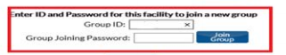
- Step 4: Immediately after joining the MassHealth NHSN Group, the “Hospital’s NHSN Facility Administrator” will be directed to a screen listing the data EOHHS is requesting access to for each of the infections listed in Section 9.A of this manual. Note that a hospital joining the MassHealth NHSN Group does not have access to any data from other facilities.
- Step 5: The “Hospital’s NHSN Facility Administrator” then REVIEWS and ACCEPTS the Data Rights Template. When the data rights template is accepted, the data sharing feature is activated, and the facility is added to the MassHealth NHSN Group. This step completes the process of enrollment. For detail on NHSN protocol for joining a group and accepting the confer rights go to https://www.cdc.gov/nhsn/enrollment/index.html
- Hospital Compliance. The MassQEX vendor monitors all hospital enrollment via the NHSN generated “Rights Acceptance Report” and will notify EOHHS of non-compliance with requirements.
- MassQEX Data Extraction: The MassQEX vendor extracts each hospital’s reported HAI measure results from the NHSN by updating and freezing the data at a specific point in time before generating hospital output reports. Once the “NHSN Analysis Tool” generates the hospital data report the “date last generated” screen is updated.

3. Data Accuracy and Completeness
The MassHealth protocol to ensure data accuracy and completeness of NHSN registry reported healthcare associated infection (HAI) measures data are outlined as follows.
- Technical Reporting: Hospitals are expected to comply with NHSN technical HAI measures collection guidelines and reporting protocols, including review and resolve any NHSN submission warnings to ensure data is accurate and complete.
Both CDC and CMS have established protocols to ensure data accuracy and reliability of HAI data reporting and adherence to the NHSN specifications. The CMS and CDC joint arrangement for HAI data requirements clarify distinctions for general NHSN data reporting protocols versus CMS hospital inpatient quality program reporting requirements.
Details on the CDC and CMS joint reminder of reporting accuracy and completeness is posted on https://www.cdc.gov/nhsn/cms/cms-reporting.html.
- Accurate Data: is defined as data collected or abstracted from records that meet the specific inclusion criteria in accordance with CDC and CMS guidelines. MassQEX will review each Hospital’s “NHSN Participation Alerts” for status checks of each HAI measure period to ensure accurate and complete data is in accordance with NHSN protocols.
NOTE: Inaccurate data that is due to the hospitals NHSN submission error is not considered a reason for requesting a recalculation of MassHealth SIR results after the defined dataset used for the MassQEX report has been extracted. EOHHS accepts the hospital SIR results as accurate based on the dataset that was accessed and extracted by the MassQEX vendor at the date of data pull no earlier than 4 ½ months after the end of the reporting quarter. EOHHS does not consider data to be “inaccurate” because a hospital did not make necessary corrections to their HAI data before the MassQEX freeze date stamp.
- Missing or Invalid Data: Missing data refers to data fields required by NHSN that have no values (blank) for submitted data and invalid data refers to data values that are outside range of allowable values defined by NHSN. MassQEX will review each hospital’s “NHSN Monthly Report Plan” which provides the number of months each facility submitted and complies with adherence to NHSN warnings associated with each HAI measure period calculated.
- Data Completeness Assessment
- NHSN completeness met: the hospital must meet the data accuracy criteria previously described and have sufficient data in accordance with NHSN criteria (e.g.: submit at least 12 months of data, more than nine surgeries total in prior year for SSI’s). The predicted number of infections must be >1.0 before SIR is to be computed.
- MassHealth completeness met: The hospital’s adherence to NHSN submission warning reports described above are reviewed separately when assessing data completeness for each HAI measure. MassHealth also confirms each HAI measure exemption entered on the “MassHealth Hospital DACA Form” as follows:
  - Valid Exemption – If the hospital form checked measure exemptions for the HAIs listed and no data is available in NHSN database then HAI annual results are not computed.
  - Invalid Exemption - If the hospital form checked measure exemptions for the HAIs listed but data is available in the NHSN database then HAI data is extracted for annual results.

4. Measure Calculation Method
- Measurement Period: MassQEX will extract each hospital’s HAI measures for the data period listed in Section 1.D of this EOHHS manual.
- NHSN Analysis Tools: The MassQEX vendor will access the “NHSN Analysis Reports Tool Set” as part of the CDC arrangement made with EOHHS to establish MassHeath NHSN Group. This NHSN Analysis Tool will be utilized to generate measure results by acute hospital facility for each of the HAI measures previously listed in Section 9.B.1.
- Standardized Infection Ratio (SIR): is the result available for each healthcare-associated infection in the NHSN database that is calculated by CDC for each HAI measure using the following formula:
- Standard Infection Ratio = Number of Observed Infections / Number of Predicted Infections
- Number of Observed Infections: is the number of HAIs for a specific location/facility over a period (also listed as event count)
- Number of Predicted Infections: is computed by using multivariate regression models generated from nationally aggregated data during a baseline period.
- SIR Result: The SIR compares the actual number of HAIs reported to the number that would be predicted based on the standard population baseline, adjusting for risk factors found to be significantly associated with differences in infection incidence. If the SIR is >1.0 then more HAIs were observed than predicted. If the SIR is < 1.0, then fewer HAIs were observed than predicted. If the SIR is equal to 1.0 then the same number of HAIs were observed as predicted. The SIR is not generated in NHSN if the expected infection rate is less than 1.0.
Refer to the NHSN Guide to SIR (April 2022) for more details at: https://www.cdc.gov/nhsn/ps-analysis-resources/
Contact the MassQEX Helpdesk at: massqexhelp@telligen.com for questions on HAI results.

Section 10. Patient Experience Domain Measures
This section outlines the EOHHS data collection and calculation guidelines that apply to the nationally reported Hospital Consumer Assessment Health Provider Systems (HCAHPS) Survey Composite required by the MassHealth Clinical Quality Incentive (CQI) Program.

Measure Description
Measure Name: Hospital Consumer Assessment Health Provider Systems (HCAHPS) Survey Composite includes seven dimensions of the conceptually related questions summarized below.
Table 10-1: HCAHPS Composite Survey Dimensions
Survey Dimension | Description | # of questions
Nurse Communication | - how well nurses explained things  - nurses - courtesy & respect | - 3 items
Doctor Communication | - doctors explain in understandable language  - doctors - courtesy & respect | - 3 items
Responsiveness of Hospital staff | - responsiveness after using call button  - help getting to bathroom  - help using bedpan | - 2 items
Communication about medicines | - explained reason for medicine  - explained medicine side effect | - 2 items
Discharge information | - staff asked about help needed after Discharge  - got written info on health/symptoms to expect | - 2 items
Care Transition (3-item) | - hospital staff took patient preference into account  - understanding responsibility to manage my health  - understood purpose for taking medications | - 3 items
Overall rating | - patients rating of the hospital | - 1 item
Type of Measure: Outcome
Risk Adjustment: Yes, the HCAHPS survey is patient-mix and survey-mode adjusted.
Results Reported as: Top box responses for each survey dimension.
Improvement Noted as: Increase in rate.
Measure Interpretation: Analysis of top box responses can be used to identify areas for improvement.
National Data Source: CMS requires that hospitals adhere to the HCAHPS Quality Assurance Guidelines specifications, meet rules of participation, attest accuracy of data collection process, and submit quarterly data. For details go to: https://www.hcahpsonline.org/en/quality-assurance/

MassHealth Data Extract Procedures
The following procedures described apply to EOHHS collection and analysis of patient experience survey measures data required under the MassHealth Acute Hospital CQI program.
- Measurement Period: Refer to Section 1.D. of this EOHHS manual for the evaluation data periods that apply to rate year HCAHPS measures analysis.
- MassQEX Data Extract: The MassQEX Vendor is designated to manage all aspects of data extraction and analysis of HCAHPS measures listed previously in Section 11.A, on behalf of EOHHS. The 12-month data snapshots reflect the final results downloaded from the CMS Provider Data Catalog website after the national reporting correction deadlines associated with the measurement period have passed.
- Hospital Dataset. The MassQEX vendor will access the Massachusetts hospital-level HCAHPS survey dimension measure data results from the CMS Provider Data Catalog website posted on: https://data.cms.gov/provider-data/
- Step 1 – Download dataset for Massachusetts acute hospitals from the following location:
https://data.cms.gov/provider-data/dataset/dgck-syfz,
- Step 2 - Download dataset for PPS-exempt cancer hospitals from the following location: https://data.cms.gov/provider-data/dataset/9g7e-btyt,
NOTE: The above URL’s host data for the current report and will no longer archive data after reporting cycles roll over.

Data Accuracy and Completeness
The MassHealth procedures to ensure data accuracy and completeness of nationally reported HCAHPS survey dimension data are as follows:
  - Technical Reporting. Hospitals are expected to comply with CMS technical data collection HCAHPS quality assurance guidelines on data accuracy, including review and correct any CMS submission warnings to ensure complete and accurate data. For more detail go to: https://www.hcahpsonline.org/en/quality-assurance/
  - Case Minimum. MassHealth adopts the minimum case standard used by CMS for evaluating the hospitals publicly posted data results as follows:
- Reliable: Hospital results with ≥ 100 surveys in a four-quarter period are considered reliable and will be used for assessing hospital performance.
- Unreliable: Hospital results with < 100 surveys in a four-quarter period are considered less reliable for assessing hospital performance.
  - Missing Data. Refers to no HCAHPS survey data being available for MassHealth to compute hospital measure results. Missing data may be due to measure exemption status granted for specific IPPS hospitals under the CMS Inpatient Quality Reporting Program (IQR), or not meeting CMS reporting requirements. CMS Provider Data Catalog website displays a footnote when no survey results are available.
  - Data Completeness Assessment:
- CMS data completeness met - Hospitals that comply with CMS technical data collection and reporting deadline requirements will be used to establish baseline and comparison period results. Hospitals must have sufficient data, defined as at least 100 surveys for calendar year to be posted on CMS Provider Data Catalog website.
- MassHealth data completeness met - the hospitals measure exemption status on the “MassHealth Hospital DACA Form” is verified against the CMS Provider Data Catalog files as follows:
  - Valid Exemption: If the hospital DACA form checked HCAHPS measure exemption and no data is available on CMS Provider Data Catalog then HCAHPS results are not computed.
  - Invalid Exemption: If the hospital DACA form checked HCAHPS measure exemption and data is available on CMS Provider Data Catalog database the HCAHPS measure results will be computed.

Measure Calculation Methods
- Data File Preparation. Hospital datasets extracted from CMS Provider Data Catalog website will undergo an additional data cleaning process in preparation for analysis. This includes adjustments within each file that does not correspond to the calendar year data periods, removal of hospitals marked with data results “not available” or “suppressed” as posted by CMS website.
- Measure Results. The MassQEX report will display the top box responses for each of the survey dimensions listed in following table via the CMS Provider Data Catalog website.
Table 10-2: HCAHPS Composite Top Box Results
Metric ID # | Top Box Response Description
HCOMP-1A-P | Patients reporting their nurses “Always” communicated well
HCOMP-2A-P | Patients reporting their doctors “Always” communicated well
HCOMP-3A-P | Patients reporting they “Always” received help as soon as they wanted
HCOMP-5A-P | Patients reporting staff “Always” explained medicines before giving it to them
HCOMP-6Y-P | Patients reporting “YES” were given info about what to do during recovery at home.
HCOMP-7SA | Patients reporting “Strongly agree” they understood their care when they left hospital.
HOSP-RTG | Patients who gave a hospital rating of 9 or 10 (highest).
Contact the MassQEX Helpdesk at massqexhelp@telligen.com if you have questions about HCAHPS measure calculation and report results.

