Commonwealth of Massachusetts
Executive Office Health and Human Services

RY2024 EOHHS Hospital Clinical Quality
Incentive Program Release Notes
(Version 2.1)
Supplement to:
RY2024 EOHHS Hospital Clinical Quality Incentive
Program Technical Specifications Manual (v2.0)
Published: May 29, 2024

Introduction

A. Purpose
The EOHHS Release Notes provide hospitals with interim updates on MassHealth Acute Hospital Clinical Quality Incentive (CQI) Program quality data collection and reporting requirements applicable to the current rate year EOHHS Technical Specifications Manual content posted on the Mass.Gov website.
- Section 1.D., Table 1-2 Modification: Update CQI 2024 Performance Period for Medication Continuation Following Inpatient Psychiatric Discharge (BHC-2) measure.
- Changes to Chart-Abstracted Measure Specifications:
  - All Chart-Abstracted Measures – (CCM 1, 2, 3, SUB-2, SUB-3, MAT-4, NEWB-3): Update to remove “Sex” data element to align with the most recently published specifications from The Joint Commission (TJC). The TJC removal of the Sex data element is pending future alignment with new CMS data elements for sex and gender identity.
  - Section 4.C.1. Perinatal Care Domain - Cesarean Birth (MAT-4):
    - “Included Populations”: Include guidance to use the TJC code table for “Term Gestational Age” (Code Table 11.10)
    - “Excluded Populations”: Update name of the TJC Code Table 11.09 to “Multiple Gestations, Abnormal Presentations, and Conditions Justifying Cesarean Delivery”
- Changes to Other Claims-Based and Readmission Measures:
  - Care Coordination and Integration of Care Domain - CHIA Readmission Measure (CCI-1):
    - Measure name changed from “Hospital-Wide Adult All-Payer Readmissions” to “Hospital-Wide Adult Readmissions.”
    - Added language to clarify that CHIA Readmission Measure (CCI-1) includes patients with MassHealth as any payer and is calculated using data from CHIA’s Hospital Inpatient Discharge Database.
- Update to MassQEX Portal Registration Process: Effective with Release Notes publication, EOHHS will no longer require Chief Executive Officer (CEO) signature approval on the MassQEX registration form and will instead require authorization from the Key Quality Contact designated on the EOHHS Hospital Quality Contacts Form. During registration, the hospital user will indicate that they are registering for the CQI program in the “Hospital Program” section.
- Update to “Extraordinary Circumstance Exception” (Section 3.G.4): Effective with Release Notes publication, added language applicable to the Extraordinary Circumstance Exception (ECE) process: “ECE Request Forms received past the due date may be reviewed at the discretion of EOHHS.” Removed language that EOHHS will share decision on ECE request to hospital CEO.
- Effective Date: The outlined updates to measure specifications will be effective with Q3-2024 discharges (July 1, 2024 - September 30, 2024) for the December 2024 submission cycle, unless otherwise noted.

B. EOHHS Manual Versions.
The CQI Release Notes version 2.1 document should be used in conjunction with the RY2024 EOHHS Hospital Clinical Quality Incentive Program Technical Specifications Manual (v2.0). Hospitals are responsible for downloading and using the appropriate versions of EOHHS Manual and Appendix data tools that apply to each quarterly data period being collected and submitted. Failure to adhere to appropriate versions of data collection tools will result in MassQEX portal rejecting data files.

C. Specifications Manual for Joint Commission National Quality Measures.
EOHHS intends to align all CQI Technical Specifications and Release Notes with the most current version of nationally published Technical Specifications. For chart-abstracted measures, hospitals should use the applicable version of the Joint Commission specifications that align with the discharge period being submitted. For example, when submitting Q3-2024 discharges, hospitals can reference Joint Commission specifications for the Q3-2024 discharge period (v2024B).
For chart-abstracted measures, hospital and vendor users of the Specifications Manual are responsible for updating their software and associated documentation based on the Joint Commission (TJC) and Center for Medicare and Medicaid Services (CMS) published manual production timelines.

D. Release Notes Guideline.
Updates in the EOHHS Release Notes are organized to supplement the EOHHS Manual table of contents core sections and appendices using the following headings:
- Key Impact – identifies the EOHHS manual section that is impacted by the change listed (i.e.: measure specifications, data tools, dictionary, etc.). A key impact is defined as information that will substantively affect data collection and reporting file requirements.
- Description of Change – identifies the specific content within the manual section where the change was made. (i.e.: measure specifications, flowcharts, data format, reporting values, etc.).
- Rationale – a brief statement on the reason why the change was made.
Contact MassQEX Helpdesk at massqexhelp@telligen.com for any questions about the contents of this Release Notes document.

Section I: Changes in CQI Release Notes (v2.1)
The content below is organized to follow the Table of Contents in the RY2024 Clinical Quality Incentive Program Technical Specifications Manual (v2.0). This section summarizes the key impact, description of change, and rationale for the updated requirements.

Table A – Changes to Data Reporting Specifications
Key Impact | Description of Change | Rationale
Table 1-2, Section 1.D. CY2024 Performance Period CQI Program Measures | - Update CQI Performance Period for Medication Continuation Following Inpatient Psychiatric Discharge (BHC-2) to January 1, 2023 – December 31, 2024 | - Clarify performance period for BHC-2 measure
Section 3.F and G.4: EOHHS Request Procedure | - Revised language:  - Added statement: “ECE Request Forms received past the due date may be reviewed at the discretion of EOHHS.”  - Removed language that EOHHS will share decision on ECE request to hospital CEO. | - Simplify Extraordinary Circumstance Exception (ECE) request and decision notification process.
Section 4.C.1: Cesarean Birth (MAT-4) measure description | Update Measure Description:  - Update Denominator Included Populations to add “ICD-10-CM Principal Diagnosis Code or ICD-10-CM Other Diagnosis Codes for term gestational age as defined in Appendix A, Table 11.10 Term Gestational Age”  - Update to Denominator Excluded Populations, Table 11.09 name change to “Multiple Gestations, Abnormal Presentations, and Conditions Justifying Cesarean Delivery Less than 8 years of age” | - Harmonize specification with the Joint Commission measure updates.
Section 4.C.1: Cesarean Birth (MAT-4) Flowchart | - Update to MAT-4 Flowchart: Update to include Table 11.10 (found in Specifications Manual for Joint Commission National Quality Measures v2024B, Appendix A). | - Harmonize specification with the Joint Commission measure updates.
Section 6.D: Data Validation Scoring | - Update Table 7.1 non-scored elements for validation to remove Sex data element. | - Update to reflect change to remove Sex data element.
Section 8.C.1.I: CHIA Readmission Measure (CCI-1) | - Update measure name from Hospital-Wide Adult All-Payer Readmission to Hospital-Wide Adult Readmissions. | - Update measure name to reflect payer population for measure.
Appendix A-4, MAT-4 Abstraction Tool: Gestational Age | - Update to abstraction tool to add check for Table 11.10. | - Harmonize specification with the Joint Commission measure updates.
Appendix A-1, A-2, A-3, A-4, and A-5:  All Chart-measure Abstraction Tools | - Update all chart-measure abstraction tools to remove Sex data element | - Update to reflect change to remove Sex data element.
Appendix A-8, Data Dictionary: Gestational Age data element | - Update to Gestational Age Data Element: Language added to use Table 11.10 “Term Gestational Age” to identify gestational age. | - Provide abstraction guidance on TJC measure update.
Appendix A-8, Data Dictionary: Sex data element | - Update Data Dictionary (applicable to all chart-abstracted measure, including CCM 1, 2, 3): Remove Sex data element. Removed reference to data element. | - Harmonize specifications with published Joint Commission updates, pending alignment with new CMS data elements for sex and gender identify.
Appendix A-6:  XML Schema:  MassHealth Chart  Measures File (2.1) | - Remove Sex data element | - Provide guidance on submission for removed data element.

Section 1.D: Modification to Table 2-1: CY2024 Performance Period CQI Program Measures
Section 1.D. CQI Program Measures and Performance Periods
The table below clarifies measure names, measure domains, timelines, and measure types for the CQI Program measures that will be effective in the RY2024 CQI program (CY2024 performance period).
Table 1-2. CY2024 Performance Period CQI Program Measures
Quality Measure | CQI Program Domain | Collection Method | Payment for RY2024 | Comparison Period | CQI 2024 Performance Period
Reconciled Medication List Received by Discharge Patient (CCM-1) | Care Coordination / Integration | Chart-Abstracted | P4P | Jan 1 – Dec 31, 2023 | Jan 1 – Dec 31, 2024
Transition Record with Specified Elements Received by Discharge Patient (CCM-2) | Care Coordination / Integration | Chart-Abstracted | P4P | Jan 1 – Dec 31, 2023 | Jan 1 – Dec 31, 2024
Timely Transmittal of Transition Record (CCM-3) | Care Coordination / Integration | Chart-Abstracted | P4P | Jan 1 – Dec 31, 2023 | Jan 1 – Dec 31, 2024
Alcohol Use Brief Intervention Provided or Offered (SUB-2) | Care for Acute and Chronic Conditions | Chart-Abstracted | P4R | N/A | Jan 1 – Dec 31, 2024
Alcohol & Other Drug Use Disorder Treatment Provided/ Offered at Discharge (SUB-3) | Care for Acute and Chronic Conditions | Chart-Abstracted | P4R | N/A | Jan 1 – Dec 31, 2024
Cesarean Birth (MAT-4) | Perinatal Care | Chart-Abstracted | P4P | Jan 1 – Dec 31, 2023 | Jan 1 – Dec 31, 2024
Unexpected Newborn Complications in Term Infants (NEWB-3) | Perinatal Care | Chart-Abstracted | P4R | N/A | Jan 1 – Dec 31, 2024
Safe Use of Opioids- Concurrent Prescribing (OP-1e) (eCQM) | Care for Acute and Chronic Conditions | Data Entry | P4R | N/A | Jan 1 – Dec 31, 2024
Screening for Metabolic Disorders (BHC-3) | Behavioral Health Care | Data Entry | P4P | Jan 1 – Dec 31, 2023 | Jan 1 – Dec 31, 2024
Severe Obstetric Complications (SOC) (eCQM) | Perinatal Care | Data Entry | P4R | N/A | Jan 1 – Dec 31, 2024
Perinatal Morbidity Structural Measure (PMSM-1) | Perinatal Care | Survey | P4R | N/A | Jan 1 – Dec 31, 2024
Follow-up After ED Visit for Mental Illness (CCI-2) | Care Coordination / Integration | Claims-based | P4P | Jan 1 – Dec 31, 2023 | Jan 1 – Dec 31, 2024
Follow-up after ED Visit for Alcohol or Drug Abuse Dependence (CCI-3) | Care Coordination / Integration | Claims-based | P4P | Jan 1 – Dec 31, 2023 | Jan 1 – Dec 31, 2024
Avoidance of Antibiotic Treatment for Acute Bronchitis/Bronchiolitis (PED-2) | Care for Acute and Chronic Conditions | Claims-based | R | N/A | Jul 1 2023 – June 30, 2024
Follow-Up After Hospitalization for Mental Illness (CCI-4) | Care Coordination / Integration | Claims-based | R | N/A | Jan 1 – Dec 31, 2024
CHIA Readmission Measure (CCI-1) | Care Coordination / Integration | CHIA’s Hospital Inpatient Discharge Database | R | N/A | Jul 1 2022 – Jun 30 2023
Pediatric All-Condition Readmission (PED-1) | Care Coordination / Integration | Claims-based | R | N/A | Jan 1 – Dec 31, 2024
Medication Continuation Following Inpatient Psychiatric Discharge (BHC-2) | Behavioral Health Care | Claims-based | P4P | Jan 1, 2022 – Dec 31, 2023 | Jan 1, 2023– Dec 31, 2024
Patient Safety & Adverse Events (PSI-90) | Patient Safety | Claims-Based | P4P | N/A | Jan 1, 2023 – June 30, 2024 (18-mths)
Healthcare-Associated Infections (CLABSI, CAUTI, MRSA, CDI, SSI) | Patient Safety | National Registry-Based | P4P | N/A | Jan 1 – Dec 31, 2023 (12-months)
Patient Experience and Engagement (HCAHPS) | Patient Experience | National Survey-Based | P4P | Jan 1 - Dec 31, 2022 | Jan 1- Dec 31, 2023

Section 3.E/F: Updates to MassQEX Portal Registration Process
Effective with the publication of release notes, the MassQEX portal registration will no longer require hospital Chief Executive Officer (CEO) signature. Going forward the hospital Key Quality Contact, designated on the EOHHS Hospital Quality Contacts Form, will provide signature to authorize all new users for their hospital. All other user registration requirements will remain the same.
Please see Section 3.E of the RY2024 Clinical Quality Incentive (CQI) Program Technical Specifications Manual (v2.0) for additional information about the user registration process.
The updates to Section 3.E of the RY2024 Clinical Quality Incentive (CQI) Program Technical Specifications Manual (v2.0) are shared below.
E. User Accounts Registration
The EOHHS Contractor (Telligen) will establish and manage all aspects of MassQEX portal user accounts system for hospitals participating in the MassHealth CQI Program in accordance with EOHHS Medicaid Acute Hospital RFA contract requirements. This includes validating each user registration form and monitoring MassQEX user activity. Steps to register a new user are as follows.
- Opening an Account: All hospitals must set up user accounts to access the secure web portal using the on-line registration form. Each hospital must identify the individual users that will be authorized to submit and conduct all data transactions on the hospital’s behalf. The users can be individuals from hospital staff and/or hospital third-party vendors. When requesting to open an account, the user requesting registration should indicate in the online registration form “Hospital Program” drop-down menu if they are registering to use the MassQEX portal for the Hospital Clinical Quality Incentive (CQI) Program, the Hospital Quality and Equity Incentives Program (HQEIP), or both the CQI and HQEIP programs.
- Completing the Registration Forms: The new user must complete a registration form. The hospital Key Quality Contact, as designated on the EOHHS Hospital Quality Contacts Form, must sign the form to authorize the individual designated to be the registered user for that hospital site.
Note to Vendors: A vendor user registers only once and receives one account that allows access to all hospitals represented by the vendor. A copy of each vendor user registration form (page 1) must be submitted to the hospital Key Quality Contact for signature for each hospital represented.

Section 3.G: Update to EOHHS ECE Request Procedure
Section 3.G.4: EOHHS Request Procedure
- Timeline to Submit Request: The hospital must notify EOHHS directly of intent to submit a request for a data exception within ten (10) calendar days of the date that the extraordinary circumstance event occurred. At the latest, the MHECR form packet must be received no later than 60 days from the last date of the quarter data period exception requested (e.g.: if last date of Q3 period is September 30 then the request should be submitted no later than November 30). ECE Request Forms received past the due date may be reviewed at the discretion of EOHHS.
- EOHHS Notification Process: EOHHS will confirm receipt of the hospital’s request via email sent to the hospital key quality representative. The EOHHS final written decision on the request for data reporting exception will be sent to the key quality representative designee. Non-adherence to terms of acceptance will NULLIFY the initial granted request.

Section 4. Chart-Abstracted Measures (All Measures)
Effective with Q3-2024 discharges, the Sex data element is removed from the measure flowchart for all chart abstracted measures: Care Coordination Measures (CCM-1, CCM-2, CCM-3), Substance Use Measures (SUB-2, SUB-3), Cesarean Birth (MAT-4), and Unexpected Complications in Term Newborns (NEWB-3).
The Sex data element is a demographic element and does not impact the measure algorithm logic or scoring.

Section 4.C: Updates to Cesarean Birth (MAT-4) Measure Description and Flowchart

Section 4.C.1: Cesarean Birth (MAT-4) Measure Description
1. Cesarean Birth, NTSV (MAT-4)
Measure Name: Cesarean Birth
Description: Nulliparous women with a term, singleton baby in vertex position delivered by cesarean birth.
Numerator statement: Patients with cesarean births.
Included population: ICD-10-PCS Principal Procedure Code or ICD-10-PCS Other Procedure Codes for cesarean birth as defined in Appendix A, Table 11.06 of the Specifications Manual for Joint Commission National Core Measures applicable version.
Excluded population: None
Data Elements:
- ICD-10-PCS Other Procedure Codes
- ICD-10-PCS Principal Procedure Code
Denominator statement: Nulliparous patients delivered of a live term singleton newborn in vertex presentation.
Included population:
- ICD-10-PCS Principal Procedure Code or ICD-10-PCS Other Procedure Codes for delivery (as defined in Appendix A: Table 11.01.1 of the Specifications Manual for Joint Commission National Core Measures applicable version)
- Nulliparous patients with ICD-10-CM Principal Diagnosis Code or ICD-10-CM Other Diagnosis Codes for outcome of delivery as defined in Appendix A, Table 11.08 (of the Specifications Manual for Joint Commission National Core Measures applicable version) and with a delivery of a newborn with 37 weeks or more of gestation completed
- ICD-10-CM Principal Diagnosis Code or ICD-10-CM Other Diagnosis Codes for term gestational age as defined in Term Gestational Age, Appendix A, Table 11.10 (of the Specifications Manual for Joint Commission National Core Measures applicable version)
Excluded populations:
- ICD-10-CM Principal Diagnosis Code or ICD-10-CM Other Diagnosis Codes for multiple gestations, abnormal presentations and conditions justifying cesarean delivery as defined in Appendix A, Table 11.09 (of the Specifications Manual for Joint Commission National Core Measures applicable version)
- Less than 8 years of age
- Greater than or equal to 65 years of age
- Gestational age < 37 weeks or UTD
Data Elements:
- Admission Date
- Birthdate
- Discharge Date
- Gestational Age
- ICD-10-CM Other Diagnosis Codes
- ICD-10-CM Principal Diagnosis Code
- Previous Births
Risk adjustment: No
Data Collection: See data abstraction tool (Appendix A-4) and data dictionary (Appendix A-8) of this manual for detailed instruction.
Measure Type: Outcome Measure
Data Accuracy: See TJC Core Specifications Manual for applicable discharge period for detail that apply.
Measure Analysis Suggestions: See TJC Core Specifications Manual for applicable discharge period for detail that apply.
Sampling: Yes. Refer to Section 5 of EOHHS Hospital Clinical Quality Incentive Program Technical Specifications Manual (v2.0) for details on sample size requirements.
Data reported as: Aggregate rate reported from count data.
Improvement noted as: Decrease in rate.

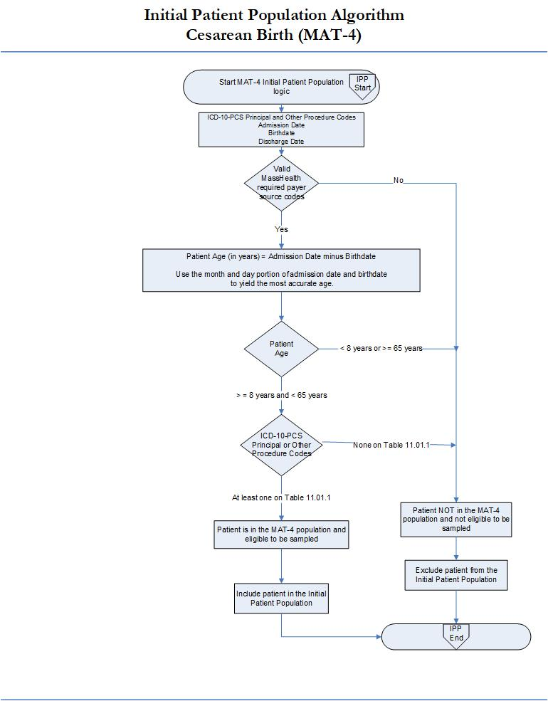

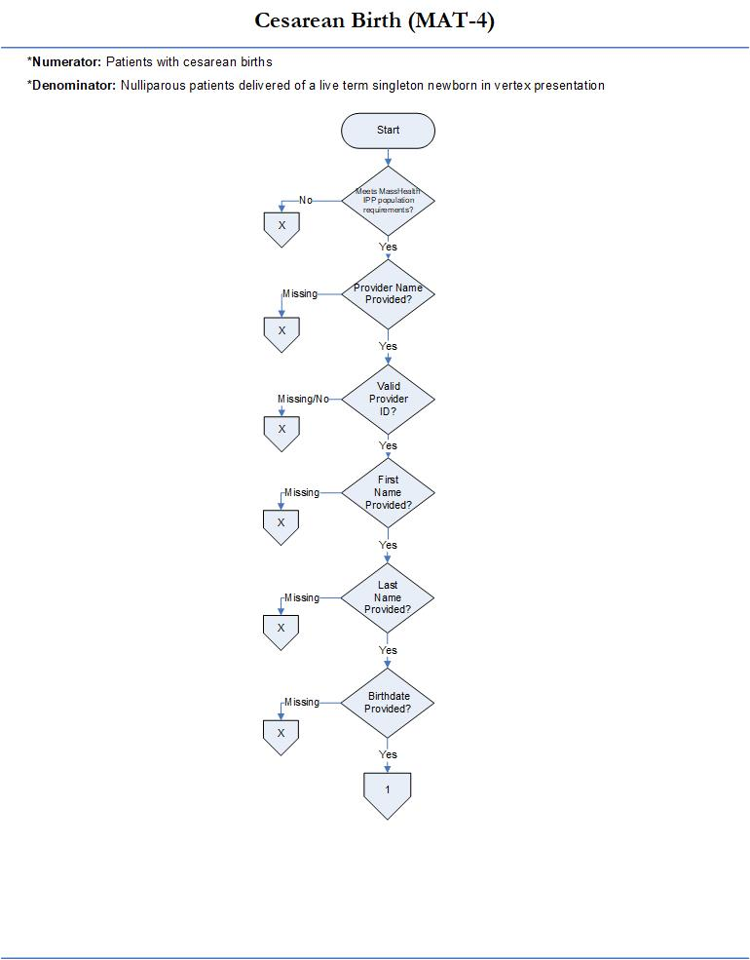

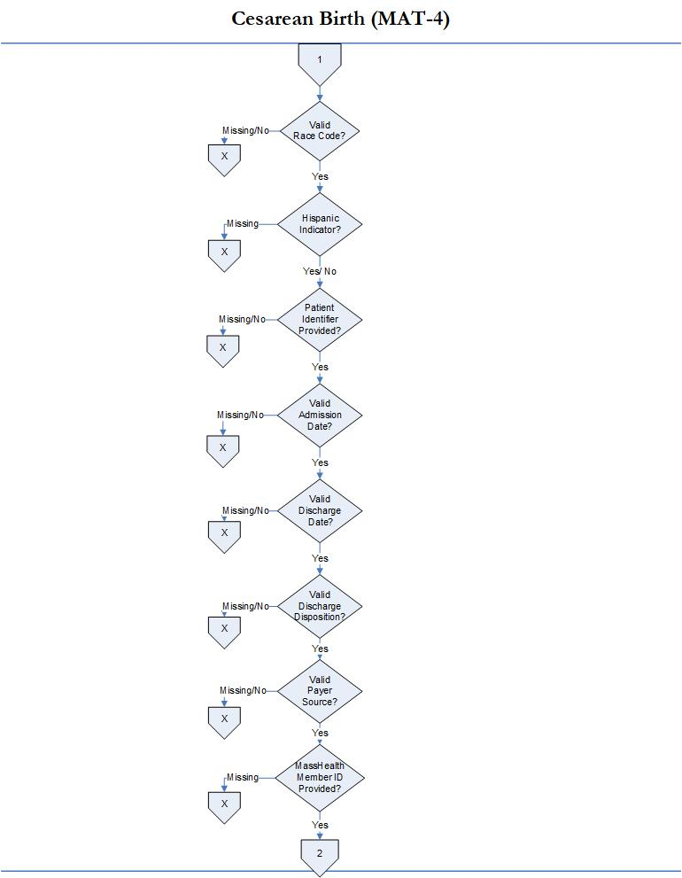
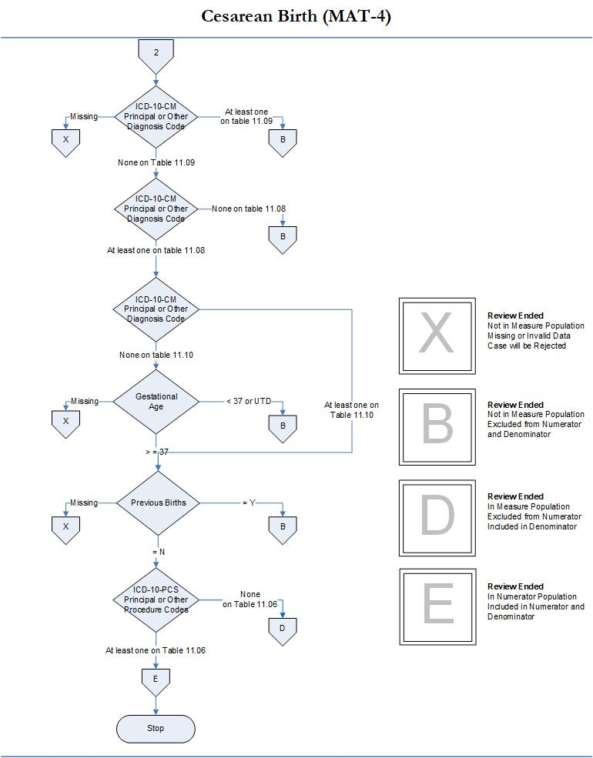

Section 7: Update to Data Validation Scored Elements
Data Element Scoring. Update to Table 7.1 in RY2024 EOHHS Hospital Clinical Quality Incentive Program Technical Specifications Manual (v2.0) to remove the Sex data element as of the Q3-2024 discharge period from the Non-Scored Data Elements list. Please note, the Sex data element is a non-scored data element and not used to calculate overall validation rate.

Section 8: Updates to Other Claims-Based and Readmission Measures
Section 8.C.1.I: CHIA Readmission Measure (CCI-1)
Measure Name: Hospital-Wide Adult Readmissions (CCI-1)
Description: An unplanned hospitalization for any reason within 30 days of an eligible discharge from an acute care hospital.
Measure Steward: Center for Health Information and Analysis (CHIA)
Denominator: The number of eligible hospital index discharges
Numerator Statement: The number of unplanned readmissions for any reason that occurred within 30 days of index discharge
Risk Adjustment: Yes
Improvement Noted as: Decrease in rate
Payer Population: The CHIA Readmissions measure includes patients with MassHealth as any payer and is calculated using data from CHIA’s Hospital Inpatient Discharge Database.
Data Calculation Approach: The CHIA Readmissions measure will be calculated using data submitted quarterly to CHIA’s Hospital Inpatient Discharge Database. No direct electronic data file reporting to EOHHS is required for this measure.

Appendix A-8: Updates to MassHealth Data Dictionary

A. Update to Sex Data Element
Effective with Q3-2024 discharges, EOHHS Hospital CQI will align with most recently published TJC specifications to remove reference to the Sex data element from the MassHealth Data Dictionary. Per TJC specifications, the data element is being removed pending alignment with new CMS data elements for sex and gender identity.

B. Update to Gestational Age Data Element
Data Element Name:
Gestational Age

Collected For: MAT-4
Definition: The weeks of gestation completed at the time of delivery.
Gestational age is defined as the best obstetrical estimate (OE) of the newborn’s gestation in completed weeks based on the birth attendant’s final estimate of gestation, irrespective of whether the gestation results in a live birth or a fetal death. This estimate of gestation should be determined by all perinatal factors and assessments such as ultrasound, but not the newborn exam. Ultrasound taken early in pregnancy is preferred (source: American College of Obstetricians and Gynecologists reVITALize Initiative).
Suggested Data
Collection Question: How many weeks of gestation were completed at the time of delivery?

Format: Length: 3 or UTD
Type: Alphanumeric
Occurs: 1
Allowable Values: UTD = Unable to Determine
1-50
Notes for Abstraction:
Gestational age should be rounded off to the nearest completed week, not the following week.
- For example, an infant born on the 5th day of the 36th week (35 weeks and 5/7 days) is at a gestational age of 35 weeks, not 36 weeks.
Gestational age should be documented by the clinician as a numeric value between 1-50. Gestational age (written with both weeks and days, eg. 39 weeks and 0 days) is calculated using the best obstetrical Estimated Due Date (EDD) based on the following formula:
- Gestational Age = (280 - (EDD - Reference Date)) / 7 (source: American College of Obstetricians and Gynecologists reVITALize Initiative).
The clinician, not the abstractor, should perform the calculation to determine gestational age.
The delivery or operating room record should be reviewed first for gestational age; documentation of a valid number should be abstracted.

If the gestational age in the delivery or operating room record is missing, obviously incorrect (in error, e.g. 3.6), or there is conflicting data, then continue to review the following data sources, starting with the document completed closest to or at the time of the delivery until a positive finding for gestational age is found:
- History and physical
- Clinician admission progress note
- Prenatal forms
Gestational age documented closest to or at the time of delivery (not including the newborn exam) should be abstracted.
The phrase "estimated gestational age" is an acceptable descriptor for gestational age.
If no gestational age was documented (e.g. the patient has not received prenatal care), select allowable value UTD.
Documentation in the acceptable data sources may be written by the following clinicians:
- Physician
- Certified nurse midwife (CNM)
- Advanced practice nurse/physician assistant (APN/PA)
- Registered nurse (RN)
It is acceptable to use data derived from vital records reports received from state or local departments of public health, delivery logs or clinical information systems if they are available and are directly derived from the medical record with a process in place to confirm their accuracy. If this is the case, these may be used in lieu of the acceptable data sources listed below.
It is acceptable to identify gestational age with ICD-10-CM Principal Diagnosis Code or ICD-10-CM Other Diagnosis Codes. If the gestational age codes identified were not on Table 11.10 Term Gestational Age, the gestational age code could still be used to determine the gestational age abstracted for this data element. If there is conflicting documentation select the gestational age documented in the medical record according to priority per the notes for abstraction guidance.
The EHR takes precedence over a handwritten entry if different gestational ages are documented in equivalent data sources, e.g., delivery record and delivery summary.
Suggested Data Sources: ONLY ACCEPTABLE SOURCES:
- Delivery or Operating room record, note or summary
- History and physical
- Admission clinician progress notes
- Prenatal forms
Guidelines for Abstraction:
Inclusion | Exclusion
None | None

