Statewide Advisory Council (SAC) Meeting minutes
Location: Microsoft Teams
Date: 4/4/2023
Attendees: Alexandria N. Dunn, Ashley Dillon, Bonnie Bryce, Casey Seaman, Chris Klaskin, Chris Thompson, Christine Cob, Christine Shane, Commissioner Jane Ryder, Diane Glennon, Dianne Huggon, Ed Jalowiec, Ed Underwood, Elizabeth Morse, Elizabeth Sandblom, Jeanne Clapper, Jill Scibelli, Jose Costa, Joyce LaBelle, Kathleen Gallagher, Katie Casarant, Lotte Diomede, Lucie Chanskey, Lydia Sheehey, Maital Adam, Maren Jacobs, Mary Petricone, Michelle Harris, Nick Dantzer, Patti MacPhee, Susan Barber, Susan Griffin, Susan Loring, Tim Cahill, Victor Hernandez
Time: 3p-4:30p

Agenda items

- Welcome and Approval of February 2023 Meeting Minutes- Alexandria N. Dunn, Chair
- Commissioner’s Update – Commissioner Ryder
- Residential Alternative Committee – Liz Sandblom/Rick O’Meara
- Assistive Technology update – Jennifer Petersen
- Update ARPA/ Respite Development – Tim Cahill
- Turning 22 Update – Victor Hernandez
- Adjourn

Approval of Prior Meeting Minutes
- Motion to Approve

Commissioners Updates- Jane F. Ryder
- Secretary Kate Walsh visited Central Office
- She will visit programs and learn Agencies at EHS
- Monthly Newsletter – sign up link for distribution list
- DDS testified for the Joint committee way/means budget process
- Upcoming budget meeting w/ Legislative to introduce leadership and members of the committee working with DDS
- Budget increase specifics – House 1 Budget
- 14% budget increase
- $50,000,000-dollar incentives
- $1,000,000 service equity review

Residential Alternative Committee – Liz Sandblom/ Rick O’Meara

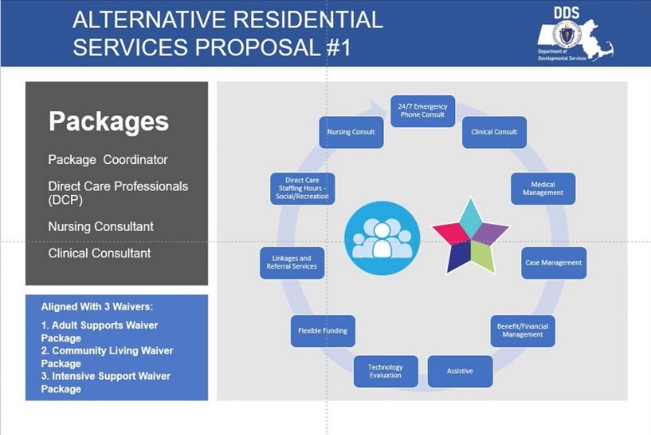
- Residential Model of Services
- Cease development of group homes in 5 years
- Closing sheltered workshops
- Closing of state schools
- Self-Direction is the future
- HBRS- Home Base Residential Supports
- 24/7 services Remote Support/ Monitoring Services
- Implementation to deliver services
- Attractive Model – Marketing/ Outreach
- Prioritize P1 & P2
- level of support and scripts that are individually specific
- Support managed by a designated team
- Assistive Technology Packages
- Latham – High-Risk Group
- Remote service to eliminate overnight staff
- Remote service provider – “Safe in Home”
- Home alone time
- Camera
- Access to food
- Med dispensing remotely
- Life Stream Pilot
- Shared Living
- Home alone w/a provider
- Accessed for risk
- Can leave the home
- South Shore Support
- Respite Home
- Learn technology for remote support
- 3 Waivers/ IDD population
- Waiver language in conflict with remote supports
- How to bill at each level of service

Question: Who is eligible for Priority 1 placement?
Answer: Priorities to residential placement tie into Waivers. Developing packages into waivers focuses on priority 1 as a higher-level service.

Assistive Technology Update – Jennifer Petersen
- Low Tech – MidTech – High Tech individually tailored levels
- Staff Dependence to Remote Independence
- RSM Service continually changing
- Bondry Care, Grand Care, Alexa Together
- Eval/ Assessment
- Pre- Employment Transition Services
- MassMatch- Regional Centers
- ADL support w/ Technology
- Ex: Wall Mount soap shampoo dispensers
- Ex: Hologram prompting in the shower
- Upcoming Assistive Technology Fairs

ARPA/ Respite Development – Timothy Cahill
- New initiatives goal to provide more families/caregivers new opportunities
- ARPA funded until March 2025
- Use funding for Respite Options
- School Vacation Program
- Drop-in respite (weekend programs)
- Hotel respite (cultural enrichment activities/ getaway)
- Medical respite (overnight)
- Flexible Funding Stipend to increase # of families receiving services
- 38 drop-ins
- 21 Hotel
- 5 overnights
- 19 school vacation
- 41 stipends
- Day Trips, concerts, sporting events, movie nights

Turning 22 Update – Victor Hernandez
- Check the Legislative Report
- Turning 22 Budget Summary
- Funding $25,051,713
- Have funding available to fully fund Residential programs

Meeting Adjourned

