Policy
DPH Infant Safe Sleep Policy

Videos
Safe Sleep for Your Baby – English and Spanish

Safe Infant Sleep for Grandparents and Other Trusted Caregivers – English and Spanish

DPH recommendations on sleep position, environment, and best practices.

Educational video about ways to reduce SIDS for parents and caregivers.

Educational video about ways to reduce SIDS for grandparents and caregivers, and emphasizes on the safe sleep environment.

Fact Sheets
Video quiz used to engage parents in conversations about safe sleep and breastfeeding recommendations.
How Sleep Savvy Are You?
What Does A Safe Sleep Environment Look Like?
Breastfeed Your Baby to Reduce the Risk of SIDS
Keeping Sleep Time Safe (for parents)

Illustrates a safe infant sleep environment and best practices to reduce SIDS and other sleep-related causes of infant death.
Information about providing a safe sleep environment and breastfeeding to reduce the risk of SIDS for the infant.
Information on safe sleep practices and facts about SIDS.

Information on safe sleep practices and facts about SIDS.
Keeping Sleep Time Safe (for providers) – English, Spanish, and Portuguese

Materials
All Babies Cry

MA Health Promotion Clearinghouse

Safe Sleep Door Knob Hangers – Multiple Languages

Helpful tips for parents and caregivers on how to soothe a crying baby.
Free health promotion materials for MA residents and health and social services providers.
Features "Shhhhh... I'm Sleeping Safely Inside!" on one side, and instructions for keeping your baby sleeping safely on the other.

SAFE SLEEP RESOURCE GUIDE z zz
Features instructions for keeping your baby sleeping safely.
Safe Sleep Flyers – Multiple Languages

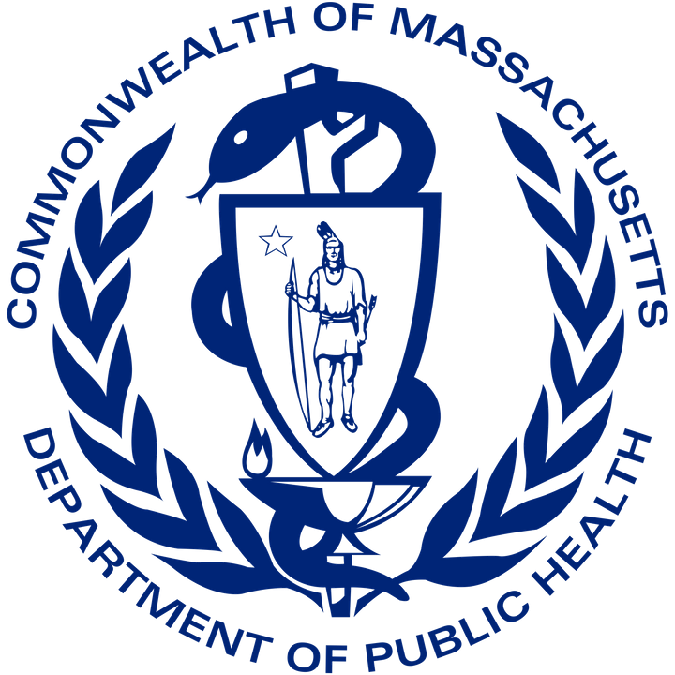
For additional information and resources, please visit mass.gov/infant-safe-sleep

