Massachusetts Department of Public Health

Peer-to-Peer Webinar:
Safe Transitions of Care for Residents

Muting and Unmuting
- Mute microphone when not speaking
  - Left bottom corner of your screen
- Remember to unmute before speaking
- If on the phone, press *6 to unmute
To indicate your name and facility
- Click on the three dots on your small screen or click “Participants”
- Choose “rename”
- Type your name(s) and your facility’s name

Helpful tips

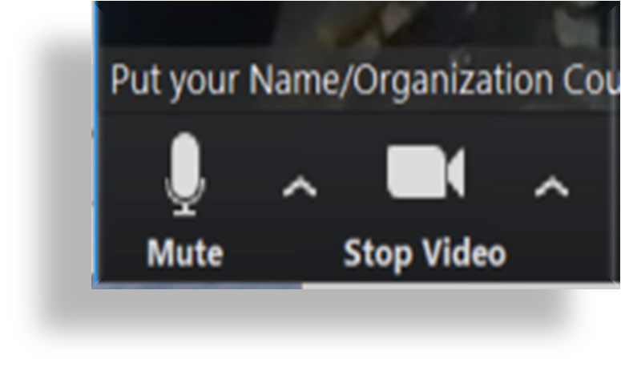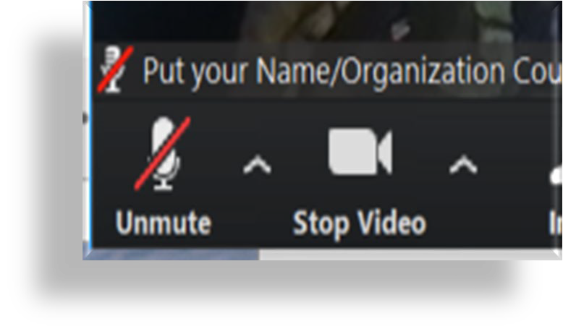

Helpful tips (cont.)

- Use chat function for comments and questions
  - Use chat function to submit names of all attendees for your site for
attendance
  - You can chat to “everyone” or another participating group or individual

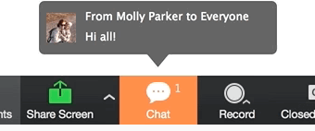

Rules of Engagement

Can we agree to support each other in following these guidelines?
- Sharing. We are here to learn from one another. Take turns sharing and be concise to maximize our time together.
- Ask genuine questions and make comments that stay on topic. Enables focused conversation, fosters understanding of various viewpoints, and elicits curiosity about differing viewpoints.
- Actively listen. Listen to whoever is speaking instead of mentally preparing a response.
- Honor all experience and expertise equally. They come in many forms.
- Confidentiality. If using a real-life example, don’t use any personal identifiers, like names.

Polling Question

Which of the following options best describes your organization?
- Nursing home or rest home
- Office-Based Opioid/Addiction Treatment (OBOT/OBAT) Program
- Opioid Treatment Program (OTP)
- Community resources
- Other

Overview of Transitions of Care
from Long-Term Care Facilities to Home

Transition Process for Residents with OUD and/or StUD

Hospital to LTCF

Prior to hospital discharge, refer patient with OUD and/or StUD to an OTP or OBOT/OBAT,
as appropriate.

Before LTCF admission, complete a QSOA with the LCTF and OTP or OBOT/OBAT.

Complete a ROI before LTCF admission.

Reconcile medication list.

Print hard copy of discharge instructions.

LTCF to Community

Print hard copy of discharge instructions.

Reconcile medication list.

Determine resident’s community primary care provider.

Determine resident’s home status.

Connect residents with support for SUD including resources and available options in their community.

Alert OTP or OBOT/OBAT of
discharge and resident’s location.

Scheduled patient’s appointment for
OTP or OBOT/OBAT.

Polling Question

How many residents at your facility with opioid use disorder (OUD) and/or stimulant use disorder (StUD) have been discharged with services in the past year?

- More than 10 residents
- Between 5 – 10 residents
- Less than 5 residents
- None

Components of Standard Transitions of Care

- Prior to discharge provide:
  - Education as needed
  - Hard copy of discharge instructions
  - Schedule follow-up appointments and referral information
  - Accurate, reconciled medication list
  - Summary of clinical information, including medications to outpatient providers
  - Support person with information and education, if applicable

Discharge to Community – Housing Considerations

- Determine on admission if the resident is housing secure.
- What does it mean to be housing insecure?
  - “Housing insecurity is an umbrella term that encompasses several dimensions of housing problems people may experience, including affordability, safety, quality, insecurity, and loss of housing.” (www.huduser.gov)

Although it is not within the purview of the LTCF to secure housing placement for residents being discharged, for those who are housing insecure, the LTCF should work as best as possible to connect the resident with federal or state entities who may be able to assist the resident to find housing.

Discharge to Community – Housing Insecure

- What’s available in Massachusetts?
  - Housing Consumer Education Centers of Massachusetts

- What is the housing application process?
  - Massachusetts Department of Housing and Community Development: A Guide to Obtaining Housing Assistance

- What are the funding options?
  - Funding options include subsidized and vouched opportunities, depending on the program
    - Department of Housing and Urban Development (HUD): Housing Choice Vouchers
    - HUD-Veterans Affairs: Supportive Housing (HUD-VASH) Program

Discharge to Community

- Communicate with the OTP or OBOT/OBAT:
  - Schedule follow-up appointment prior to discharge
  - OTP – complete last dose letter OR
  - OBOT/OBAT – complete discharge summary with updated medications
- Determine whether the residents will need services at home:
  - Connect and inform home health agency that resident is on medications for opioid use disorder (MOUD) and/or is receiving treatment related StUD
  - If home without services, connect with Aging Services Access Points (ASAP), and other community resources, as needed

Discharge to Community (cont.)

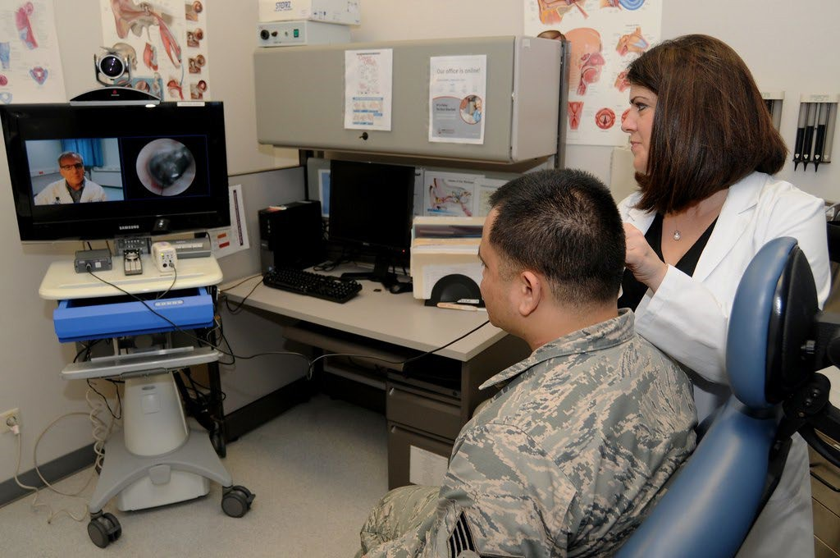
- Involve identified support person in care plan.
- Alert primary care physician of discharge.
- Share resources with the resident for transportation to appointments:
  - Is it possible to set-up prior to discharge?
  - Discuss whether telehealth is an option.

Polling Question

What barriers do you encounter when discharging residents with OUD and/or StUD?
- Lack of availability for recovery resources
- Lack of standardized documentation
- Lack of family/caregiver or support person
- Lack of primary care physician in the community
- Transportation challenges
- Other

Discussion

How do you mitigate these barriers?

Residential Treatment Programs & Recovery Supports

- Types of residential treatment programs:
Massachusetts Substance Use Helpline
  - Under 30 days
  - Over 30 days
  - Recovery Homes
  - Clinical Stabilization Services
  - VA services
- Ensure collaboration between LTCFs and residential treatment programs.
- At discharge, provide the resident with eligibility details and a list of available resources.

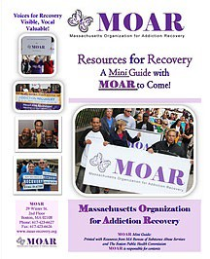
Peer Recovery Supports

- Peer Recovery Supports:
  - Recovery coach or recovery support navigator
  - Check eligibility for community Support Program (CSP) or Community Health Worker
  - Access the Massachusetts Peer Recovery Support Centers

17

Polling Question

What resources are available to you?
- Community based organizations
- Residential treatment programs
- Recovery houses
- Peer navigator or recovery coach
- Other

Polling Question

What additional information do treatment providers need to ensure continuity of care?

- Additional medical history
- Additional social history
- Medication list
- Resources with which the resident has been provided or connected
- Other

Resources for Residents (cont.)

Mutual Help Groups
- Narcotics Anonymous: 12-step recovery program
- Nar-Anon: 12-step recovery program for family and friends
- SMART Recovery®: For all addictive behaviors focusing on self-regulating thoughts, emotions, and actions
- Dual Recovery Anonymous: 12-step recovery program for people with SUDs with simultaneous emotional or psychiatric illness

“Going to meetings has kept me clean when nothing else could, talking to other addicts, service work and surrounding myself with this program has been invaluable." – Terry
Source: West Tennessee Area Narcotics Anonymous

Resources for Residents (cont.)

- Local services
  - Massachusetts Substance Use Helpline, 1-800-327-5050
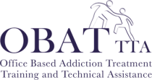
    - English
    - Spanish
  - BMC OBAT-TTA
- National Helpline
  - SAMHSA’s National Helpline, 1-800-662-HELP (4357)
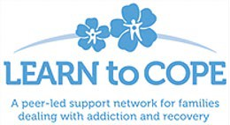
- Learn to Cope
  - Is a non-profit support network for parents, family members, and friends coping with a loved one addicted to opioids or other drugs.
  - (508) 738-5148

Massachusetts Department of Public Health

Thank you!

Connect with DPH
23

@MassDPH
Massachusetts Department of Public Health DPH blog
https://blog.mass.gov/publichealth

www.mass.gov/dph

