INDOOR AIR QUALITY ASSESSMENT
OF
PROPOSED SCHOOL SITE FOR
NEWMAN ELEMENTARY SCHOOL

Saint Mary’s School
420 High Street
Dedham, Massachusetts

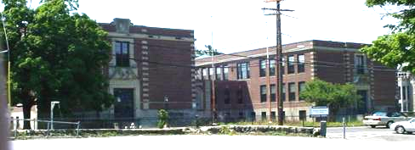

Prepared by:
Massachusetts Department of Public Health
Bureau of Environmental Health
Indoor Air Quality Program
August 2008

Background/Introduction
At the request of Michael Bergeron, Assistant to the Director of Finance, Needham Public Schools, an indoor air quality assessment was conducted at the Saint Mary’s School, 420 High Street, Dedham, Massachusetts. This assessment was conducted by the Massachusetts Department of Public Health (MDPH), Bureau of Environmental Health (BEH), Indoor Air Quality (IAQ) Program. On July 18, 2008, a visit was made to this building by Michael Feeney, the Director of the BEH’s IAQ Program and Sharon Lee, an IAQ Inspector within BEH’s IAQ Program. Mr. Feeney and Ms. Lee were accompanied by Mr. Bergeron. This assessment was conducted to ascertain the current conditions/needs of this building. The Saint Mary’s School is the proposed relocation site for students and staff of the Newman Elementary School during renovations of that building.
The Saint Mary’s School is a two-story, freestanding parochial school constructed in 1935. An addition to the original building was constructed in 1957. The school complex currently consists of two, two-story wings that are connected at the lower and basement levels. The original building contains classrooms and basement church teen center. The 1957 structure consists of classrooms and basement auditorium. The connecting wing consists of administrative offices, with a kitchen and the boiler room in the basement level. Windows are openable throughout the school complex. The school was not in use at the time of the assessment.

Methods
The evaluation consisted primarily of a site visit/visual inspection. Since the building is currently unoccupied, standard tests for indoor air quality were not appropriate.

Discussion
As previously mentioned, the intent is for full occupancy of this building in the fall, with the exception of the youth center located in the basement of the original building. Plans for renovations of the building complex prior to the occupancy were not clear at this time. The following conditions were observed at this building.

Ventilation
Each wing of the school complex is serviced by a different type of heating, ventilating, and air conditioning (HVAC) system. Ventilation is provided to each room in the 1935 wing via a large vent located near the ceiling (Picture 1) and connected to an air-handling unit (AHU) located in the basement (Picture 2). Fresh air for the AHU is drawn through air intakes located at ground level on north side of the building (Picture 3). This type of ventilation system does not have the capacity for filtering outdoor air, which would allow normally occurring outdoor pollutants (i.e., airborne mold particles and pollen) to be drawn into the ventilation system and distributed to classrooms.
Of note is the condition of the ductwork connected to the AHU for the 1935 wing. It appears that the AHU and its ductwork have been repeatedly exposed to water, as demonstrated by the water staining on the exterior of the ductwork and AHU casing (Picture 2). Repeated exposure to water can cause damage/deterioration of ductwork and AHU casing, likely resulting in water penetration to AHU equipment. Repeated water-damaged has likely created conditions for mold growth within the AHU equipment, which could then distribute mold particles/odors to classrooms connected to the system. At minimum, an extensive cleaning of this system would be required prior to any use of this equipment. It is, however, most likely that this equipment would need to be replaced.
Exhaust ventilation in 1935 wing classrooms is provided by wall or cubby exhaust systems (Picture 1), which are connected via ductwork to rooftop exhaust (Picture 5). Whether the exhaust system on the roof was motorized could not be determined, since the roof of the 1935 wing could not be accessed during the assessment. Frequently, ventilation systems of this age and design do not incorporate rooftop fans, but rely on the fresh air system to pressurize the building. Air forced into the exhaust system would move up vertical air shafts and exit through the rooftop vent system. The efficacy of this system could not be determined during the course of this assessment.
Fresh air is supplied to classrooms in the 1957 wing unit ventilators (univents) (Picture 5). The univents appear to be original equipment (i.e., installed when the wing was built). These univents do not have any means to filter air, allowing normally occurring outdoor air pollutants (i.e., airborne mold particles and pollen) to be distributed into classrooms. Exhaust ventilation in these classrooms is provided by vents that are located in the ceiling of classroom closets (Picture 6). In this configuration, when closet doors are closed, stored materials will block the free flow of air to the exhaust vents.
To maximize air exchange, the MDPH recommends that both supply and exhaust ventilation operate continuously during periods of school occupancy. In order to have proper ventilation with a univent and exhaust system, the systems must be balanced to provide an adequate amount of fresh air to the interior of a room while removing stale air from the room. It is recommended that existing ventilation systems be re-balanced every five years to ensure adequate air systems function (SMACNA, 1994). Prior to occupancy of this building, it would be recommended that the ventilation system in all wings be re-balanced. Based on the configuration, age and condition of the ventilation systems in both wings, re- balancing will be very difficult to achieve.

Microbial/Moisture Concerns
As mentioned previously, the mechanical room housing the 1935 wing’s HVAC system is subject to water damage. This condition is likely the result of the basement area being located directly below a grass area adjacent to a driveway. It is likely that water runoff and melting ice impinges against the foundation wall and then passes through the concrete into the basement.
Water-damaged ceiling/wall plaster was noted in several classrooms located on the top floor of each wing. In the case of the 1957 wing, this water penetration is likely due to accumulation of rainwater in low lying roof areas (Picture 7). As this pooling water freezes and thaws, the roof membrane can become damaged, allowing moisture to pass through into the ceilings. These ceilings are made of plaster, which resists mold growth.
Peeling paint was observed in a classroom in the 1935 wing (Picture 8). The surface below the paint appears to be similar to the stone block walls found in the hallways. Moisture accumulation below the surface of the paint most likely caused it to peel; however, the materials to which the paint was applied are not likely to support mold growth.
As indicated by Mr. Bergeron, Needham town officials who visited the school reported musty odors in the cafeteria area. The walls of this area are covered with wood-paneling, which appears to have begun splaying in two areas along the exterior wall. Wall-paneling is a material that can support mold growth if exposed repeatedly to water. One potential source of water in this area is leaking steam pipes, as suggested by a note written on a panel displaying significant delamination (Pictures 9 and 10). Another possible source resulting in water penetration to this area may be the lack of functional drainage around the foundation of the building. The cafeteria area appears to be flanked on its north and south walls by large cement lined pits (Picture 11). In locations where drains were most likely located in these pits, large plants were found growing (Pictures 12 and 13). If not properly drained, water will accumulate in these areas and then penetrate through the foundation wall and into the cafeteria area.
The exterior wall of the building had a number of areas displaying either water-damaged mortar or damaged sealants (Picture 14). Damaged mortar and joint seals can lead to water penetration into the interior of the building.

Other Concerns
The boiler room contains a gas-fired water heater (Picture 15). Exhaust pipes for the water heater runs upwards to a 90° turn, which then runs parallel (Picture 16) to the floor until it makes a second 90° turn before connecting to the chimney (Picture 17). A water heater exhaust vent that runs parallel to the floor and of this length should likely be connected to a power vent in order to ensure that products of combustion are vented from the building appropriately. If not, products of combustion of gas, such as carbon monoxide, will not be vented from the boiler room as needed. Under these conditions, pollutants will likely accumulate and penetrate into the kitchen and/or the teen center since the doors to this building are used to pass between the basement areas of each wing.
Wall-to-wall carpeting was observed in many classrooms throughout the building. It appears that this wall-to-wall carpeting was installed over an original tile floor (Picture 18). Frequently, these types of tiles will contain asbestos. The composition of the floor tiles (i.e. asbestos containing) should be determined prior to any removal of carpeting. Where asbestos-containing materials are found damaged, these materials should be removed or remediated in a manner consistent with Massachusetts asbestos remediation laws (MDLI, 1993).

Recommendations
In view of these findings, the following recommendations for remediation of the building with regard to indoor air quality issues are made.
- Contact a ventilation engineer to determine whether the ventilation equipment in the 1935 wing can be cleaned and repaired to prevent further water damage and possible distribution of microbial growth within ventilation equipment into classrooms. If this system cannot be made clean and functional, the 1935 wing does not have a functional mechanical ventilation system.
- Contact a ventilation engineer to determine whether the exhaust ventilation system in the 1935 wing is functional.
- Determine whether or not the each HVAC system in both wings can be outfitted with appropriate filters.
- Clean and restore all drains around the exterior walls of the building.
- Repair all cracks crevices and holes in the exterior walls of the to prevent further water damage.
- Remove carpeting with musty odors. Prior to any carpet removal, contact a licensed asbestos inspector to examine all floor tiles.
- Remove all water-damaged wood paneling in the cafeteria area. The source of water damaging the cafeteria wall paneling should be identified and repaired.
- Consider installing a power event on the exhaust event for the water heater

References
MDLI. 1993. Regulation of the Removal, Containment or Encapsulation of Asbestos, Appendix 2. 453 CMR 6,92(I)(i).
SMACNA. 1994. HVAC Systems Commissioning Manual. 1st ed. Sheet Metal and Air Conditioning Contractors’ National Association, Inc., Chantilly, VA.

Picture 1

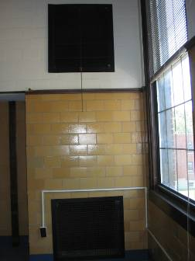

Supply (top) and Exhaust (bottom) Vents in 1935 wing classrooms
Picture 2

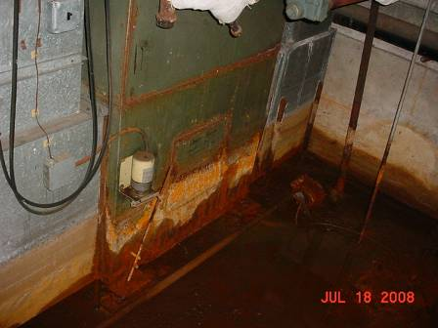

Base of the AHU That Is Located In the Basement, Note High Water Mark
On Duct and AHU Cabinet

Picture 3

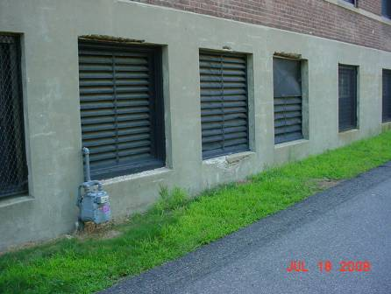

Fresh Air Intakes for AHU

Picture 4

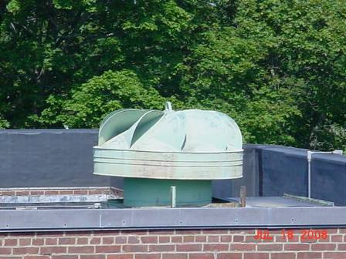

Rooftop Exhaust, 1935 Building

Picture 5

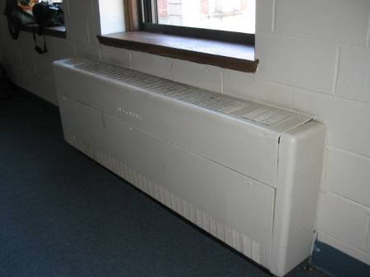

Univent

Picture 6

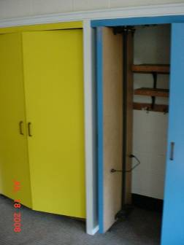

Exhaust Vents in Classroom Closet
Picture 7

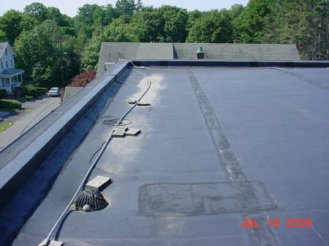

Low Lying Area on Roof, Note Debris Accumulation, Which Roughly Corresponds To Location of Ceiling Plaster Damage in the Top Floor Classrooms

Picture 8

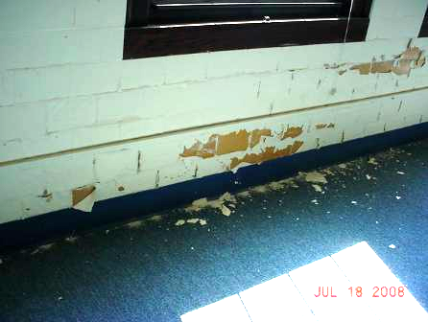

Peeling Paint on Stone Classroom Wall
Picture 9

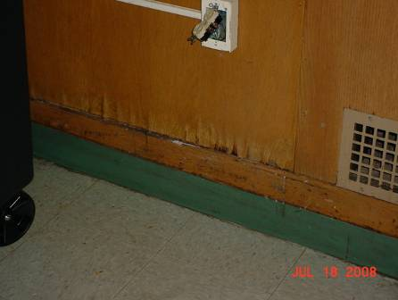

Delaminating Wood Panel

Picture 10

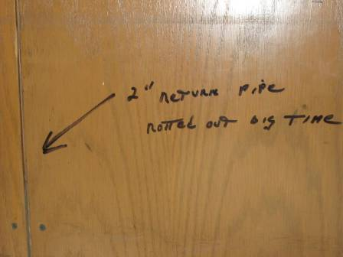

Handwritten Note on Delaminating Panel,
Note Reads "2” Return Pipe Rotted Out Big Time”

Picture 11

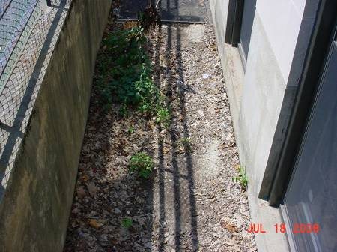

Example Cement Lined Pit outside Cafeteria

Picture 12

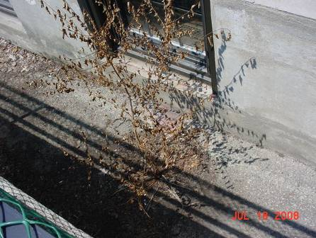

Plant Growing From Likely Location of Drain, South Exterior Wall of Cafeteria
Picture 13

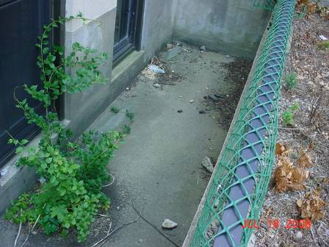

Plant Growing From Likely Location of Drain, North Exterior Wall of Cafeteria

Picture 14

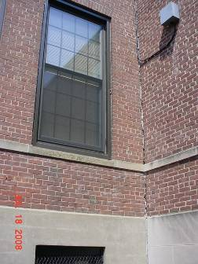

Damage Seam Sealant, Rear of Building
Picture 15

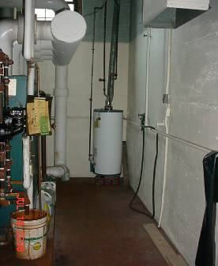

Water Heater in Boiler Room

Picture 16

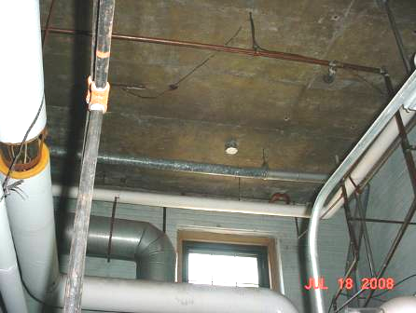

Water Heater Exhaust Pipe Parallel to the Floor, Note Bend in Exhaust Pipe

Picture 17

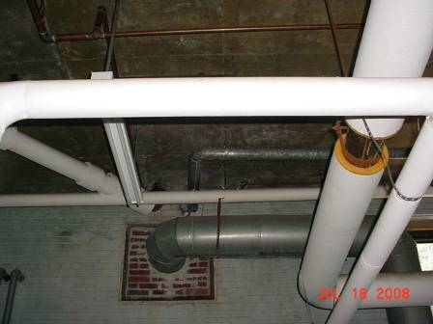

Water Heater Exhaust Pipe Connected Into the Main Chimney, Note Lack of Power Vent

Picture 18

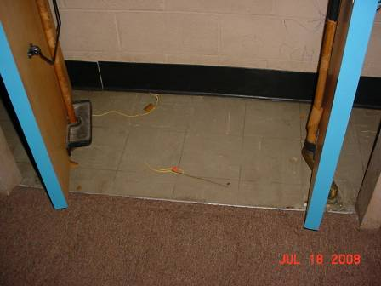

Carpet Installed On Floor Tile

The univent were manufactured by the John J. Nesbitt Co., which now operates under Nesbitt Aire. These specific univents are likely over fifty years old.

