INDOOR AIR QUALITY ASSESSMENT
OF
PROPOSED SCHOOL SITE FOR
NEWMAN ELEMENTARY SCHOOL

Saint Patrick’s School
44 Central Avenue
Natick, Massachusetts



Prepared by:
Massachusetts Department of Public Health
Bureau of Environmental Health
Indoor Air Quality Program
August 2008

Background/Introduction
At the request of Michael Bergeron, Assistant to the Director of Finance, Needham Public Schools, an indoor air quality assessment was conducted at the Saint Patrick’s School, 44 Central Avenue, Dedham, Massachusetts. This assessment was conducted by the Massachusetts Department of Public Health (MDPH), Bureau of Environmental Health (BEH), Indoor Air Quality (IAQ) Program. On July 18, 2008, a visit was made to this building by Michael Feeney, the Director of the BEH’s IAQ Program and Sharon Lee, an IAQ Inspector within BEH’s IAQ Program. Mr. Feeney and Ms. Lee were accompanied by Mr. Bergeron. This assessment was conducted to ascertain the current conditions/needs of this building. The Saint Patrick’s School is the proposed relocation site for students and staff of the Newman Elementary School during renovations of that building.
The Saint Patrick’s School is a two-story, freestanding parochial school built in the 1930s. A circa-1970s two-story addition was made to the western wall of the original building. The building contains classrooms, a church teen center with a function room, cafeteria and kitchen in the basement level. Windows are openable throughout the school. A summer camp was in session at the time of assessment.

Methods
The evaluation consisted primarily of a site visit/visual inspection. Since the building is currently unoccupied, standard tests for indoor air quality were not appropriate.

Discussion
As previously mentioned, the intent is for full occupancy of this building in the fall, with the exception of the teen center located in the basement of the original building. Plans for renovations of the building complex prior to the occupancy were not clear at the time assessment. The following conditions were observed at this building.

Ventilation
Classrooms in each wing of the school complex are equipped with unit ventilators (univents) that serve as the heating, ventilating, and air conditioning (HVAC) systems. The original building has fresh air provided by Sturtevant univents (Picture 1). The univents appear to be original equipment, installed when the wing was built. These univents draw fresh air from the exterior of the building through air intakes (Picture 2). The louvers that control the percentage of fresh air to room return air are set by hand using a lever that exists on the exterior of the cabinets of the unit ventilator (Picture 3). Sturtevant univents do not have any means to filter air. Lack of filtration would lead to univent fresh air intakes capturing and distributing normally occurring outdoor air pollutants (i.e., airborne mold particles and pollen) into classrooms. In addition, some fresh air intakes for the original building appear to be bricked over (Picture 4), eliminating the ability for these units to draw fresh air. Exhaust ventilation in this older section of the building is provided by vents located at floor level (Picture 5). These vents were found to be sealed at the time of assessment (Picture 6). BEH staff could not determine the functionality of the exhaust system at the time of the visit.
Univents in the newer edition appear to be modern (Picture 7). In some cases, univent fresh air intakes appeared to be sealed (Picture 8). Exhaust ventilation is located in the ceiling of closets (Picture 9). All exhaust vents were sealed at the time of assessment; thus the functionality could not be determined.
To maximize air exchange, the MDPH recommends that both supply and exhaust ventilation operate continuously during periods of school occupancy. In order to have proper ventilation with a univent and exhaust system, the systems must be balanced to provide an adequate amount of fresh air to the interior of a room while removing stale air from the room. It is recommended that existing ventilation systems be re-balanced every five years to ensure adequate air systems function (SMACNA, 1994). Prior to occupancy of this building, it would be recommended that the ventilation system in all wings be re-balanced. Based on the configuration, age and condition of the ventilation systems in both wings, re- balancing will be very difficult to achieve.

Microbial/Moisture Concerns
The cafeteria and a function room are located in the basement level. Of note was pooling water in the cafeteria which had no apparent source either from leaks through foundation walls or from the plumbing system. Due to the hot humid weather on the day of this assessment, it is likely that this water is the result of condensation accumulating on the floor. Condensation accumulation is not itself an indoor air quality concern. If such conditions also exist in the large carpeted function room, then the potential for a microbial growth problem exists due to the presence of wall-to-wall carpeting on the floor. Considering the lack of control over indoor temperature and relative humidity, it is likely that the function room carpeting becomes moistened on a regular basis which may lead to the carpeting becoming mold colonized. The US Environmental Protection Agency (US EPA) and the American Conference of Governmental Industrial Hygienists (ACGIH) recommends that porous materials be dried with fans and heating within 24 to 48 hours of becoming wet (US EPA, 2001; ACGIH, 1989). If porous materials are not dried within this time frame, mold growth may occur. Cleaning cannot adequately remove mold growth from water-damaged porous materials. The application of a mildewcide to mold contaminated, porous materials is not recommended.
As mentioned previously, the building was being used for the summer camp at the time of assessment. In room 5, BEH observed the maple tongue-in-groove flooring to be chronically moistened from an inflatable pool placed directly on the floor in this room (Picture 10). While maple flooring is resistant to mold colonization, the chronic moistening can cause the floorboards to swell and become uneven. In addition, moisture can accumulate in sub-flooring. Prior to any reuse of this classroom, steps should be taken to dry the floor thoroughly.
The exterior wall to the right of the main, front entrance appears to be the buckling outwards (Pictures 11 and 12). With the exterior wall in this state, wind driven rain from a northeasterly direction would likely penetrate through the exterior wall and into the building interior. Water penetration can result in damage to interior walls.
Some areas of the building contained a suspended ceiling. Several of these areas have water-damaged ceiling tiles. Water-damaged ceiling tiles can be a mold growth medium and should be replaced after the source of water is remediated.

Other Concerns
The kitchen area contains a gas fired water heater (Picture 13). No carbon monoxide detectors could be identified in or around the location of this water heater. Since it is located in an occupied space of the building, the water heater should likely be connected to a power vent in order to ensure that products of combustion are vented from the building in an appropriate manner. If not, products of combustion of gas will not be vented from the kitchen area as needed.

Recommendations
In view of these findings, the following recommendations for remediation of the building with regard to indoor air quality issues are made.
- Contact a ventilation engineer to determine whether the Sturtevant ventilation equipment can be cleaned and repaired. If this system cannot be made clean and functional, the older section of the school will not have functional mechanical ventilation system. The ventilation engineer should also determine whether the exhaust ventilation system is functional.
- Determine whether univents in both wings can be outfitted with appropriate filters.
- The floor of Room 5 needs to be mechanically dried. This room should be examined for musty odors and be remediated as needed once dried. It is also recommended that the floor be refinished in order to seal any cracks and/or crevices that exist in the floor material after floor is appropriately dried.
- All cracks crevices and holes in the exterior walls of the building need to be repaired in order to prevent further water damage.
- Carpeting with musty odors should be removed, particularly in the function room. Prior to any carpet removal it is recommended that all floor tile be examined by a licensed asbestos inspector.
- Consideration should be given to installing the power event on the exhaust event for the water heater.
- Carbon monoxide detectors should be installed in the basement due to the presence of the gas-fired water heater.

References
ACGIH. 1989. Guidelines for the Assessment of Bioaerosols in the Indoor Environment. American Conference of Governmental Industrial Hygienists, Cincinnati, OH.
SMACNA. 1994. HVAC Systems Commissioning Manual. 1st ed. Sheet Metal and Air Conditioning Contractors’ National Association, Inc., Chantilly, VA.
Tocco, V., 2006. Sturtevant Company history website. http://www.sturtevantfan.com/index.html
US EPA. 2001. “Mold Remediation in Schools and Commercial Buildings”. Office of Air and Radiation, Indoor Environments Division, Washington, DC. EPA 402-K-01-001. March 2001. Available at: http://www.epa.gov/iaq/molds/mold_remediation.html

Picture 1

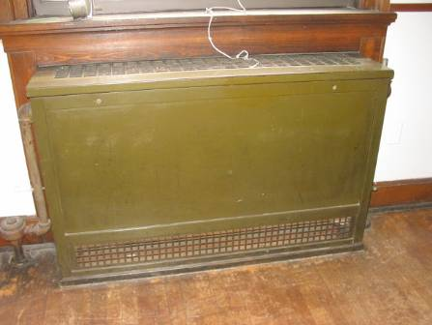

Sturtevant Univent in Original Building

Picture 2

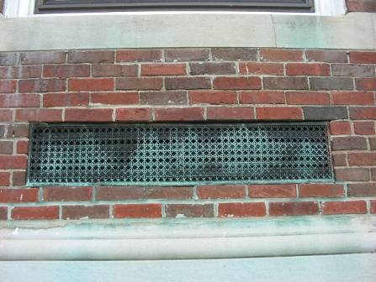

Fresh Air Intake
Picture 3

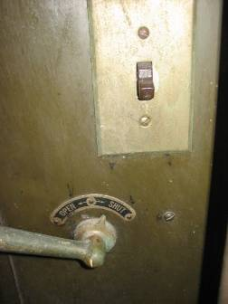

Lever That Set Univent Louver, Note Open-Shut Label

Picture 4

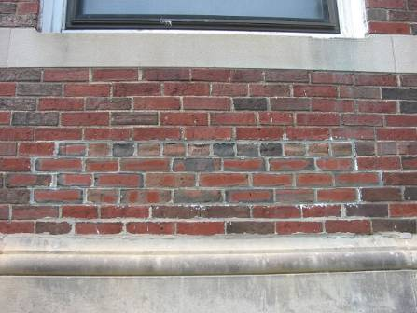

Bricked In Fresh Air Intake

Picture 5

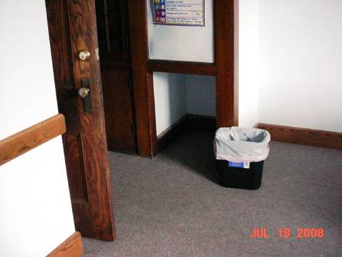

Exhaust Vent in Original Building

Picture 6

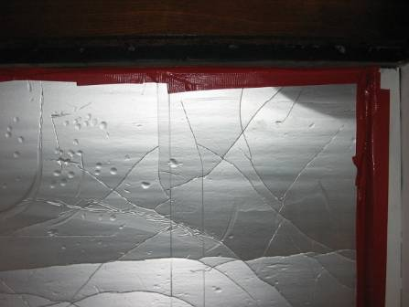

Sealed Exhaust Vent in Original Building

Picture 7

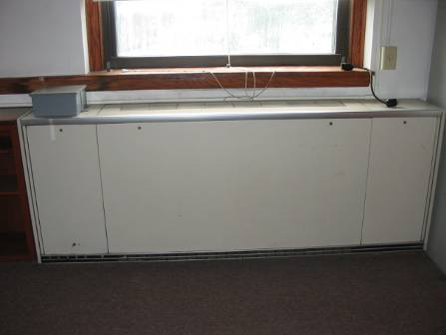

Univent in Newer Wing

Picture 8

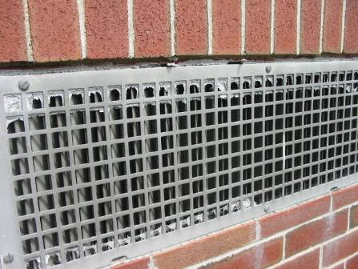

Remnants of Materials Used To Seal Univent Fresh Air Intakes

Picture 9

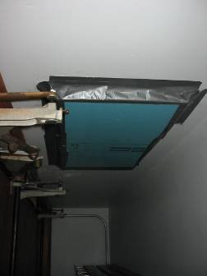

Sealed Exhaust Vents in Classroom Closets

Picture 10

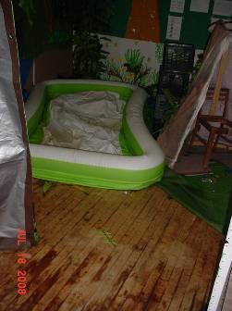

Inflatable Pool in Room 5, Note Water Damage to Maple Floor

Picture 11

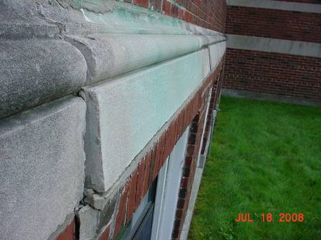

Buckling Wall In Front Of Building

Picture 12

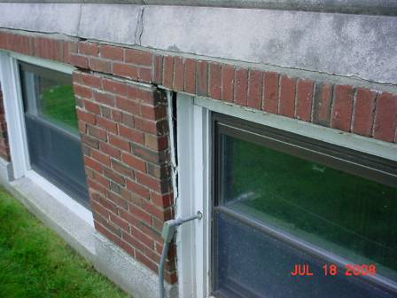

Buckling Wall In Front Of Building

Picture 13

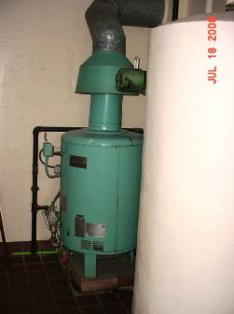

Gas-Fired Water Heater

The univent were manufactured by the B. F. Sturtevant Company of Boston, MA. It appears that the production of B. F. Sturtevant Company ceased after Westinghouse acquired the company around 1945 (Tocco, V., 2006).

