SAMPLE Dental Consent and Medical History Form for an Adult

____________________________________________________________________________

(Name of Public Health Dental Hygienist and/or Program)

Please print in ink

Name: _________________ __________________________

Date of Birth: _ _/_ _ /_ _ _ _  Male  Female Email Address: _______________________________

Address: __________________________________________________________________________________________
(Street) (City/town) (State) (Zip Code

Phone: ________________________________ Email: _____________________________________________

Social Security Number __ __ __ -__ __- __ __ __ __ Adult/Long Term Care Facility ____________________

Please tell us your race:
 American Indian/Alaskan Native  Asian  Black/African American  Hispanic/Latino  White  Other

Health Information:
1. Are you taking any medication now?  YES  NO

If yes, please list both prescribed and over the counter medications that you take in the space below:

2. Has a dentist or physician ever told you that you need to take antibiotics (penicillin) before having dental treatment?  YES  NO

3. Please check any illnesses or conditions you have EVER had:
 Alcohol abuse |  Drug Abuse |  Rheumatic Fever
 Allergies to Medicine(s) |  Epilepsy |  Shingles
 Anemia or blood problems |  Glaucoma |  Sinus problems
 Any Heart Ailments |  Heart Murmur |  Stroke
 Arthritis |  Hepatitis A, B, C |  Thyroid Problems
 Artificial Joint |  High Blood Pressure |  Tuberculosis
 Asthma |  Immune system, HIV, AIDS, ARC |  Ulcer or colitis
 Cancer or Chemotherapy |  Kidney problems |  Use of tobacco, cigarettes, chew
 Diabetes |  Liver problems |  Sexually Transmitted Disease
 |  Psychiatric care/emotional problems

4. Do you have any other health conditions?  YES  NO

If yes, please list.__________________________________________________________________________

5. Do you have any allergies? If yes, please check all that apply:  YES  NO

 Penicillin  Antibiotics  Anesthetics  Colophonium  Aspirin  Foods  Latex  Resins  Other: __________

6. Do you have a dentist?  YES  NO
Name of dentist and office location: __________________________________________________________

When did you last see your dentist? ____________________________________________________________

7. What do you do to take care of your teeth and gums?
 Daily tooth brushing  Daily flossing  Inter-dental stimulators  Water jet device

8. Do you have any pain in your mouth today?  YES  NO

9. Do you have DENTAL INSURANCE?  YES  NO

If you have dental insurance, please check which one and complete below:

 Blue Cross/Shield  Delta Dental  Mass Health/Medicaid Other ______________________

Delta Dental, CMSP, or Other Dental Insurance

Company_____________________________________
Address______________________________________
Subscriber____________________________________
Subscriber ID #________________________________
Subscriber’s Date of Birth _____ /______/_________
Subscriber’s Social Security Number_ _ _/_ _/_ _ _ _
Group/Policy #________________________________
Employer Name_______________________________

MassHealth
MassHealth RID Number
_______________________________

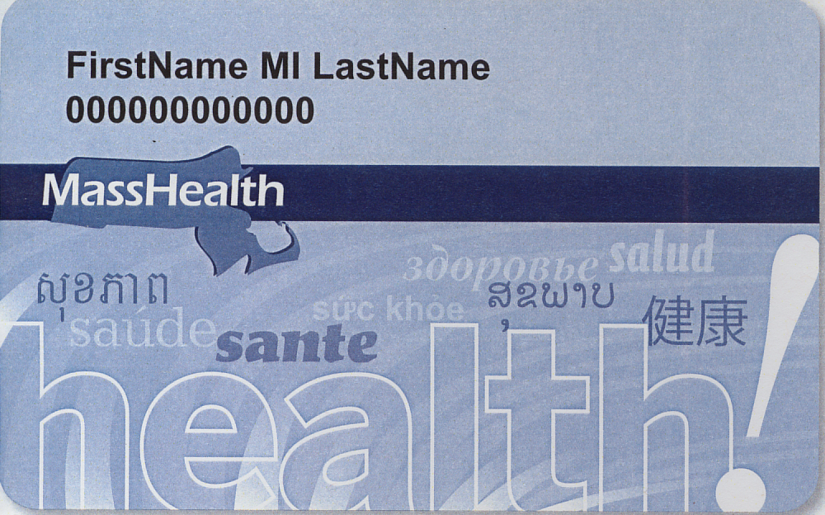

I understand that the dental provider, __________________________________, may use my health information for treatment, payment and health care operations. I have been given a copy of the Dental Provider’s Notice of Privacy Practices.

I have read and understand the services that may be provided to me by this dental program and I consent to participate. I understand that I may continue to obtain dental care through any other provider. I understand that these services are not a substitute for an examination by a dentist. I understand that I should obtain a dental examination by a dentist within 90 days, if I have not had one, and if needed, this program will provide me with a list of dentists in my area.

I authorize the dental provider to consult with my medical provider(s) as may be appropriate to my health and the provision of dental care. If applicable, I authorize the dental program to provide a written summary of the examination and services provided to the official designee of my long term care facility or residential facility or institution.

If I have dental insurance, I authorize my insurance carrier to be billed for any services provided. I understand that this treatment may affect my future rights and benefits under my dental insurance. If I do not have dental insurance, I will pay the Dental Provider for all dental services that are charged to me.

X____________________________________ Date: ___/___/___ Relationship to Patient: ____________________

Patient/Legal Representative Signature
_______________________________ ___________________________ ______________________________
Print Name Daytime Phone Number Cell Phone

