Commonwealth of Massachusetts

Department of Labor Standards

OSHA Consultation Program

mass.gov/dols/consult

Sample Written Heat Illness Prevention Plan
(Revised March of 2024)

Company Name: ______________________________________________________________

Purpose
The purpose of this plan is to protect our employees from the hazards of hot working environments. Work activities that could potentially expose our employees to these hazards include: _____________________________________________________________________________

Scope
This plan implements efficient and safe work practices that will prevent both indoor and outdoor heat-related illnesses among employees at our workplace. It will be used as part of training for new employees and for the annual refresher training of employees.

Background
Heat-related illnesses can happen if workplace activities in a hot environment overwhelm the body’s ability to cool itself. This becomes more likely if any of the risk factors are present. Examples include working in a hot environment without adequate access to water for rehydration, working in protective gear that does not allow air circulation across the skin, or working where the humidity is too high for sweat to evaporate.

Risk Factors
The following are environmental risk factors for heat illness:
- Air temperature above 90 degrees Fahrenheit
- Relative humidity above 40 percent
- Radiant heat from the sun and other sources
- Conductive heat sources such as dark-colored work surfaces
- Lack of air movement
- Physical effort needed for the work
- Use of nonbreathable protective clothing and other personal protective equipment (PPE)
The following are personal risk factors for heat illness:
- Lack of acclimation to warmer temperatures
- Poor general health
- Dehydration
- Alcohol consumption
- Caffeine consumption
- Previous heat-related illness
- Use of prescription medications that affect the body’s water retention or other physiological responses to heat such as beta blockers, diuretics, antihistamines, tranquilizers, and antipsychotics

Heat-Related Illnesses
- Heat rash is the most common health problem in hot work environments. It is caused by sweating and looks like a red cluster of pimples or small blisters. Heat rash usually appears on parts of the body that overlap or rub other parts of the body, such as in the groin area, under the arms or breasts, and in knee or elbow creases. If an employee has symptoms of heat rash, provide a cooler, less humid work environment, if possible. Advise the employee to keep the area dry and not to use ointments and creams that make the skin warm or moist, which can make the rash worse.
- Heat exhaustion can best be prevented by being aware of one’s physical limits in hazardous environments on hot, humid days. The most important factor is to drink enough clear fluids (especially water, not alcohol or caffeine) to replace those lost to perspiration. Signs and symptoms of heat exhaustion typically include:
  - Profuse sweating
  - Weakness and fatigue
  - Nausea and vomiting
  - Muscle cramps (associated with dehydration)
  - Headache
  - Light-headedness or fainting; fainting or loss of consciousness is potentially serious and should be treated as a medical emergency.
- When you recognize that an employee has symptoms of heat exhaustion, you must intervene; stop the activity, and move the employee to a cooler environment. Cooling off and rehydrating with water (or electrolyte replacing sports drinks) is the cornerstone of treatment for heat exhaustion. If the employee resumes work before their core temperature returns to normal levels, symptoms may quickly return.
- If there is no intervention and the body’s temperature regulation fails, heat exhaustion can rapidly progress to heat stroke, a life-threatening condition.
- Heat stroke requires an immediate emergency medical response. The person may stop sweating, become confused or lethargic, and may even have a seizure. The internal body temperature may exceed 106 degrees Fahrenheit. Signs and symptoms of heat stroke typically include:
  - Absence of sweating
  - Dry skin
  - Agitation or strange behavior
  - Dizziness, disorientation, or lethargy
  - Seizures or signs that mimic those of a heart attack
Ensure that emergency responders are summoned immediately if heat stroke is suspected. While waiting for emergency responders to arrive, cool the employee; move the employee to an air-conditioned environment or a cool, shady area; and help the employee remove any unnecessary clothing. Do not leave the employee unattended. Heat stroke requires immediate medical attention to prevent permanent damage to the brain and other vital organs that can result in death.
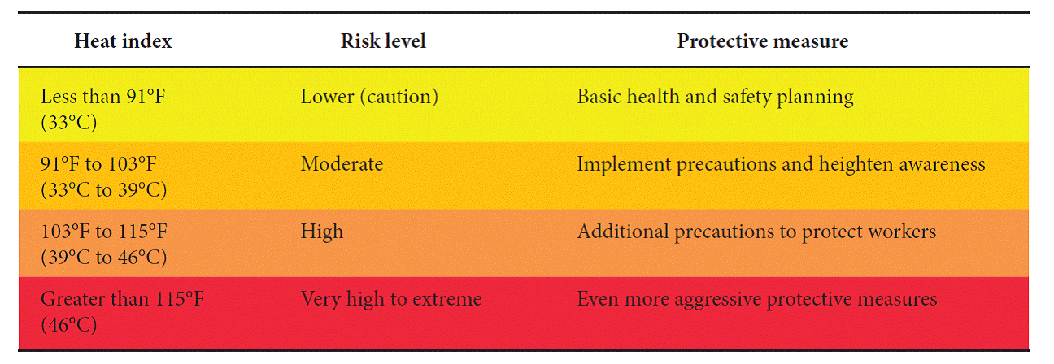

Preventing Heat-Related Illnesses
- Gradually increase workloads and allow more frequent breaks during the first week of work so that employees become acclimatized to higher temperatures, especially those who are new to working in the heat or have been away from that work for a week or more.
- Encourage employees to frequently drink small amounts of water before they become thirsty to stay hydrated. During moderate activity, in moderately hot conditions, employees should drink about 8 ounces of liquid every 15 to 20 minutes. Employees can monitor their hydration with a urine chart. Urine should be clear or slightly colored; dark urine is a warning sign. See urine color chart below.
- Encourage employees to eat regular meals and snacks as they provide enough salt and electrolytes to replace those lost through sweating. It is important that employees consume copious amounts of water.
- Provide a buddy system where employees encourage each other to drink water, use shade to stay cool, and to watch each other for symptoms of heat-related illness.
- Educate employees that drinking extreme amounts of water can also be harmful (more than
12 quarts in a 24-hour period).
- Schedule frequent rest periods with water breaks in shaded or air-conditioned recovery areas. Note that air-conditioning does not result in loss of heat tolerance.
- Ensure employees are aware of the signs of heat-related illnesses and encourage them to report immediately when they or their co-workers show symptoms.
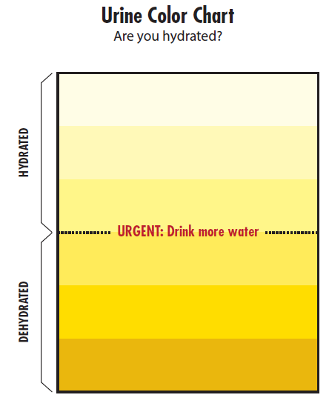
- Monitor weather reports daily and reschedule jobs with high heat exposure to cooler times of the day, if possible. Be extra vigilant when air temperatures rise quickly. When possible, schedule routine maintenance and repair projects for the cooler parts of the year.
- Provide shade or cool areas for breaks

Responsibilities
All employees are responsible for protecting themselves from heat illnesses by following these guidelines for prevention and immediately reporting any signs or symptoms to his or her supervisor.
_____________________________________ is responsible for conducting initial training with new employees and for the annual refresher training.
is responsible for administering the provisions of this plan.
Provision of Water
Water is located throughout the work area. Locations include:

Access to Shade/Cooling Areas
Shade or cooling areas are located:

Determination of Heat Index
For our employees that work in buildings or structures that do not have a mechanical cooling system we will:
measure the relative humidity and temperatures inside these structures or
use the NIOSH Heat Stress app to determine the heat index outdoors and assume that it is the
same indoors and inform you/our employees of the heat index and the risk of our employees
experiencing a heat-related illnesses based upon the chart in the Heat-Related Illnesses section.

NIOSH Heat Stress Application (App)
All supervisors, managers, and employees that download the Heat Stress Application found at: cdc.gov/niosh/topics/heatstress/heatapp.html should watch a short video located on the Oregon OSHA website: https://osha.oregon.gov/media/videos-online/Pages/heat-safety-app-tutorial.aspx.

Heat Index Chart
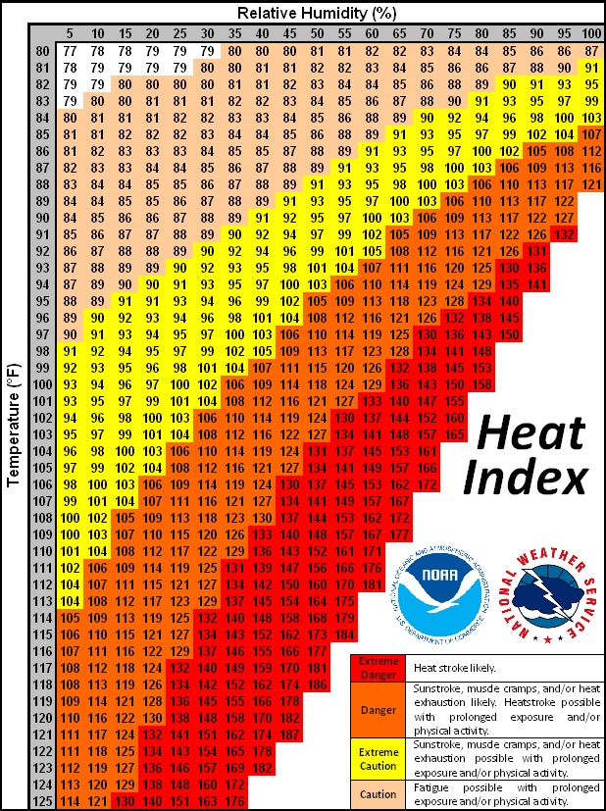
Other Methods of Prevention

For when Heat Index is at Least 80 degrees Fahrenheit:
When the heat index reaches at least 80 degrees Fahrenheit, the following methods of prevention for heat illness should be used:
- Access to shade/cooling areas
- Provision of drinking water
- Follow CDC acclimatization recommendations (Appendix A)

For when Heat Index exceeds 90 degrees Fahrenheit:
When the heat index exceeds 90 degrees Fahrenheit, the following additional high-heat practices should be used:
- Mandatory rest break periods (Appendix B)
- Two-way communication between employee and supervisors
- A designated employee at the worksite should be equipped and authorized to call 911 for emergency medical services
Training Requirements
These are the topics that our employees will be trained on prior to working in hot environments:
- Environmental and personal risk factors (see above for examples)
- Our procedures for heat illness prevention, including, but not limited to, our responsibility to provide water, heat index information (including the risks to experiencing a heat-related illness), shade/cooling areas, preventative rest breaks, and access to first aid
- The importance of frequent consumption of small quantities of water, up to 32 ounces per hour, when the work environment is hot, and employees are likely to be sweating more than usual in the performance of their duties
- The concept, importance, and methods of the acclimatization plan pursuant to the employer’s procedures
- The different types, the common signs and symptoms, and the appropriate first aid and emergency response to the different types of heat illness. Training should include how heat illness may progress quickly from mild signs and symptoms to a serious and life-threatening condition (see above);
- The importance for employees to immediately report signs and symptoms of heat illness in themselves or in others, directly to the employer or supervisor, and
- The effects of nonoccupational factors (drugs, alcohol, obesity, etc.) on tolerance to occupational heat stress.
Documentation of training will be maintained by: ________________________________________

Appendix A

CDC Acclimatization Recommendations
According to the Centers for Disease Control (CDC), acclimatization is the beneficial physiological adaptations that occur during repeated exposure to a hot environment.
The CDC recommends the following:
- New workers should only spend 20% of their first day exposure to heat. On each following day, new workers can be exposed to heat at 20% increments.
- For workers who have had previous experience with the job and are returning to work after a leave, the acclimatization regimen should be no more than a 50% exposure to heat on day 1, 60% on day 2, 80% on day 3, and 100% on day 4.
The level of acclimatization each worker reaches is relative to the initial level of physical fitness and the total heat stress experienced by the individual.

Maintaining acclimatization
Workers can maintain their acclimatization even if they are away from the job for a few days, such as when they go home for the weekend. However, if they are absent for a week or more then there may be a significant loss in the beneficial adaptations leading to an increased likelihood of heat-related illness and a need to gradually reacclimate to the hot environment.
The CDC offers some additional information on maintaining acclimatization:
- It can often be regained in 2 to 3 days upon returning to a hot job
- It appears to be maintained better by those who are physically fit
- Seasonal shifts in temperatures may result in difficulties
- Air conditioning will not affect acclimatization

Appendix b

NIOSH Work/Rest Schedule

Work/rest schedules for workers wearing normal work clothing*
Adjusted  temperature (°F)† | Light work  (minutes work/rest) | Moderate work  (minutes work/rest) | Heavy work  (minutes work/rest)
90 | Normal | Normal | Normal
91 | Normal | Normal | Normal
92 | Normal | Normal | Normal
93 | Normal | Normal | Normal
94 | Normal | Normal | Normal
95 | Normal | Normal | 45/15
96 | Normal | Normal | 45/15
97 | Normal | Normal | 40/20
98 | Normal | Normal | 35/25
99 | Normal | Normal | 35/25
100 | Normal | 45/15 | 30/30
101 | Normal | 40/20 | 30/30
102 | Normal | 35/25 | 25/35
103 | Normal | 30/30 | 20/40
104 | Normal | 30/30 | 20/40
105 | Normal | 25/35 | 15/45
106 | 45/15 | 20/40 | Caution‡
107 | 40/20 | 15/45 | Caution‡
108 | 35/25 | Caution‡ | Caution‡
109 | 30/30 | Caution‡ | Caution‡
110 | 15/45 | Caution‡ | Caution‡
111 | Caution‡ | Caution‡ | Caution‡
112 | Caution‡ | Caution‡ | Caution‡
*With the assumption that workers are physically fit, well-rested, fully hydrated, under age 40, and have adequate water intake, and that there is 30% RH [relative humidity] and natural ventilation with perceptible air movement.
†Note: Adjust the temperature reading as follows before going to the temperature column in the table:
Full sun (no clouds): Add 13°
Partly cloudy/overcast: Add 7°
No shadows visible/work is in the shade or at night: no adjustment
Per relative humidity:
10%: Subtract 8°
20%: Subtract 4°
30%: No adjustment
40%: Add 3°
50%: Add 6°
60%: Add 9°
‡High levels of heat stress; consider rescheduling activities.

