

May 10, 2004
Dear MassHealth Prescriber:
RE: The Use of Medication Samples in MassHealth Members

MassHealth recognizes the common practice of dispensing sample medications, provided to prescribers from drug manufacturers. Access to and utilization of these medications can be very important to those who may not otherwise be able to afford these therapies.

Nevertheless, MassHealth asks that prescribers consider the MassHealth Drug List when choosing to provide samples to its members. Some medications on the MassHealth Drug List require prior authorization (PA). Approval of a prior authorization request is not guaranteed as a result of the member having used samples. It could be inconvenient to both members and providers if the prescriber has not considered the prior authorization status of a drug before beginning a member on the drug. The MassHealth Drug List is frequently updated and can be found at: http://www.state.ma.us/dma/.

In addition, Massachusetts Department of Public Health regulations on the dispensing and labeling of sample medications permit prescribers to only dispense up to a 30-day supply of Schedule VI sample medications. Samples dispensed by a prescriber must also meet all labeling and inventory requirements as though that medication were dispensed from a registered pharmacy (see M.G.L. c. 94C and 105 CMR 700.010 @ http://www.state.ma.us/dph/dphhome.htm).

MassHealth asks prescribers to be mindful of these considerations when providing sample medications to members insured by MassHealth. Thank you for your cooperation.

Sincerely,

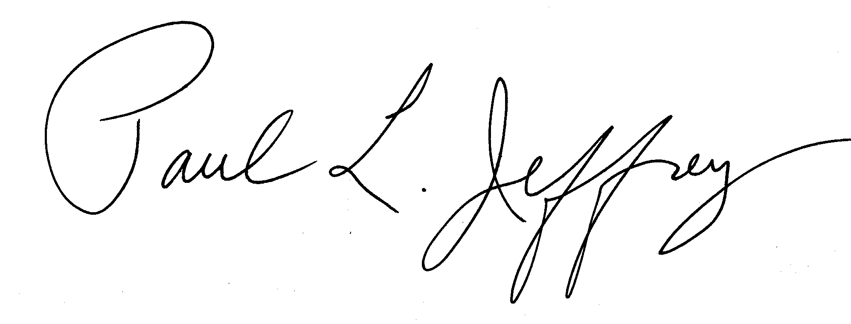
Paul Jeffery, Pharm.D. Ron Steingard, M.D.
Pharmacy Director Medical Director

