New Mental Health and Substance Use Services in Massachusetts
High-quality mental health and substance use care is critical, and Massachusetts has just made it more accessible than ever before. This January, Massachusetts launched its new Behavioral Health Help Line and established 25 Community Behavioral Health Centers, which together form a new “front door” to mental health and substance use care. Now, with one phone call or text, you can get connected to the mental health and substance use services you need, when and where you need them.
Click here or read on to learn more about the new programs.
Massachusetts Behavioral Health Help Line
Massachusetts' new Behavioral Health Help Line (BHHL) went live on January 3, 2023, offering direct connection to mental health and substance use care for anyone in the Commonwealth – no insurance needed. Available 24/7, in more than 200 languages, the BHHL is a phone, text, and online chat line whose clinically trained staffed will work with you to determine the care that best fits your needs and directly connect you to treatment, including outpatient, urgent care, and immediate crisis care. Click here to learn more about the Help Line.
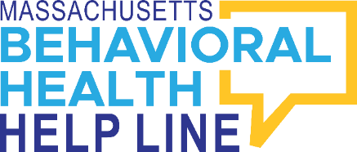
If you’re interested in getting mental health or substance use help, but not sure where to start:
Call or text the Massachusetts Behavioral Health Help Line at 833-773-2445 or chat online at masshelpline.com.

Community Behavioral Health Centers
A network of 25 Community Behavioral Health Centers (CBHCs) just opened across Massachusetts, serving every community across the state. CBHCs provide a wide variety of mental health and substance use services, including crisis services that anyone in Massachusetts can access, regardless of insurance coverage.
If you feel that you need immediate mental health or substance use care, instead of going to the Emergency Room, you can now just call or walk into your closest CBHC, and ask for crisis services. The CBHC crisis intervention teams will work with you to assess your situation, evaluate your options, and determine the best path forward to meet your individual needs. Every crisis team is also fully mobile, meaning, if you’d like, a trained mental health or substance use team will meet you at your home or any other community-based location of your choosing.
CBHCs also offer a suite of routine outpatient services, including individual and group therapy, recovery coaching, medication for addiction treatment, and psychiatric consultations. These services are available free of charge to all MassHealth members. They also may be covered by some commercial insurers.
Click here to learn more about CBHCs and locate your nearest center.

